Supplement

climwin
Table S1: Results of the climwin-analysis for the influence of daily maximum temperature (T max), daily minimum temperature (T min) and mean daily temperature (T mean) during the birth year on the adult forearm length (FAL) on individuals from northern Germany (NSH) and southern Germany (WB). Function = tests for linear effect of the climate variable, ∆AICc = ∆AICc of the best model compared to the intercept model, best model window = sensitive time window of the best supported model (number of days before 30.09.), median window = sensitive time window of models averaged from the 95 % confidence set, model falling into 95 % confidence set = % of models that make up the top 95 % of model weights, range: analyzed time span.
Region | climate variable | function | ∆AICc | best model window | median window | models falling into 95 % confidence set | range
NSH  1990-2020  N=520 | T max | linear | -22.68 | 29-28 | 134-23 | 26 % | 01.05.-30.09.
NSH  1990-2020  N=520 | T min | linear | -23.79 | 36-10 | 117-12 | 23 % | 01.05.-30.09.
NSH  1990-2020  N=520 | T mean | linear | -28.12 | 20-20 | 131-17 | 25 % | 01.05.-30.09.
NSH reduced  2012-2020  N=112 | T max | linear | -16.84 | 141-141 | 147-81 | 16 % | 01.05.-30.09.
NSH reduced  2012-2020  N=112 | T min | linear | -13.40 | 11-11 | 134-56 | 43 % | 01.05.-30.09.
NSH reduced  2012-2020  N=112 | T mean | linear | -17.12 | 141-141 | 144-68 | 23 % | 01.05.-30.09.
WB  2012-2020  N=112 | T max | linear | -6.11 | 88-31 | 109-40 | 66 % | 01.05.-30.09.
WB  2012-2020  N=112 | T min | linear | -8.03 | 107-49 | 112-35 | 56 % | 01.05.-30.09.
WB  2012-2020  N=112 | T mean | linear | -7.14 | 103-54 | 111-41 | 64 % | 01.05.-30.09.

Like in the analysis with the full dataset, the climwin analysis for the reduced NSH dataset from 2012-2020 revealed, that higher mean temperatures led to larger individuals (best model: by +0.31 mm per °C, ∆AICc = -17.12, p < 0.001, R-squared: 0.16, Fig. S1). However, the median time window where mean temperatures had an effect on FAL was shorter than in the analysis with the full dataset and ranged from May 9th to July 24th.
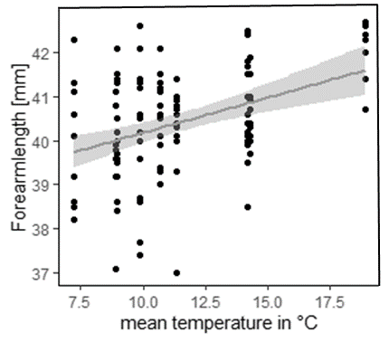
Figure S1: Results from the restricted NSH dataset: predicted response of the best supported model for mean temperatures. Forearm length (mm) increases with warmer mean summer temperatures also for females in the reduced NSH dataset (2012-2020).

Temperatures through years
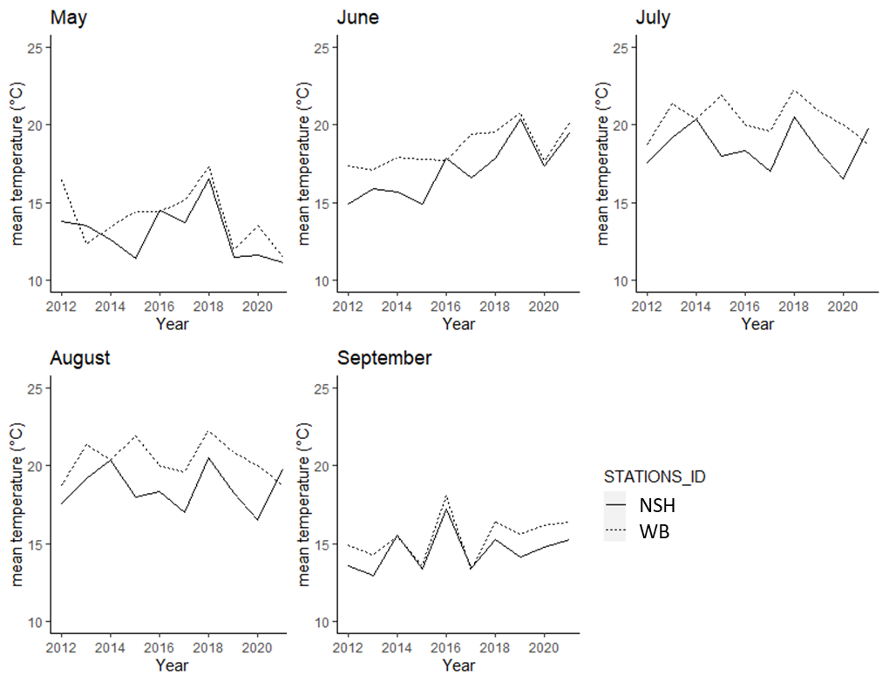
Figure S2: Mean temperatures during the investigated time window (May, 1st – September 30th) in NSH (northern Germany, solid line) and WB (southerm Germany, scattered line).

Survival analysis
Tab. S2: Results of the survival models: survival probability (ɸ): FAL = forearm length, colony size = mean colony size, year = year of observation, region = WB vs. NSH; recapture probability (p): year = year of recapture, region = WB vs. NSH, box area = TUP, WT, Bossow or WB, effort = how many capture-events per year and box area; npar=number of parameters in the model, QAIC = AIC adjusted for overdispersion (c-hat 1.5).
model nr. | model | npar | QAIC
1 | ɸ(~FAL)p(~year * region) | 45 | 3109.91
2 | ɸ(~region + FAL)p(~year * region) | 46 | 3111.435
3 | ɸ(~FAL + colony size)p(~year * region) | 46 | 3111.548
4 | ɸ(~region)p(~year * region) | 45 | 3112.809
5 | ɸ(~colony size)p(~year * region) | 45 | 3112.943
6 | ɸ(~region * FAL)p(~year * region) | 47 | 3113.285
7 | ɸ(~FAL * colony size)p(~year * region) | 47 | 3113.309
8 | ɸ(~FAL)p(~year + box area) | 37 | 3135.549
9 | ɸ(~region + FAL)p(~year + box area) | 38 | 3137.294
10 | ɸ(~FAL + colony size)p(~year + box area) | 38 | 3137.443
11 | ɸ(~region)p(~year + box area) | 37 | 3138.764
12 | ɸ(~year + FAL)p(~year * region) | 76 | 3138.878
13 | ɸ(~colony size)p(~year + box area) | 37 | 3138.944
14 | ɸ(~region * FAL)p(~year + box area) | 39 | 3139.091
15 | ɸ(~FAL * colony size)p(~year + box area) | 39 | 3139.13
16 | ɸ(~year)p(~year * region) | 75 | 3140.724
17 | ɸ(~FAL)p(~year + region) | 35 | 3152.109
18 | ɸ(~region + FAL)p(~year + region) | 36 | 3153.797
19 | ɸ(~FAL)p(~year) | 34 | 3153.824
20 | ɸ(~FAL + colony size)p(~year + region) | 36 | 3153.874
21 | ɸ(~FAL)p(~year * box area) | 97 | 3154.689
22 | ɸ(~region + FAL)p(~year) | 35 | 3155.304
23 | ɸ(~region)p(~year + region) | 35 | 3155.326
24 | ɸ(~FAL + colony size)p(~year) | 35 | 3155.419
25 | ɸ(~colony size)p(~year + region) | 35 | 3155.42
26 | ɸ(~FAL * colony size)p(~year + region) | 37 | 3155.576
27 | ɸ(~region * FAL)p(~year + region) | 37 | 3155.597
28 | ɸ(~region + FAL)p(~year * box area) | 98 | 3156.317
29 | ɸ(~FAL + colony size)p(~year * box area) | 98 | 3156.541
30 | ɸ(~region)p(~year) | 34 | 3156.809
31 | ɸ(~FAL)p(~year * box area + effort) | 98 | 3156.814
32 | ɸ(~colony size)p(~year) | 34 | 3156.944
33 | ɸ(~region * FAL)p(~year) | 36 | 3157.111
34 | ɸ(~FAL * colony size)p(~year) | 36 | 3157.127
35 | ɸ(~region)p(~year * box area) | 97 | 3157.736
36 | ɸ(~FAL)p(~year + effort) | 35 | 3157.832
37 | ɸ(~colony size)p(~year * box area) | 97 | 3158.004
38 | ɸ(~region * FAL)p(~year * box area) | 99 | 3158.172
39 | ɸ(~FAL * colony size)p(~year * box area) | 99 | 3158.302
40 | ɸ(~region + FAL)p(~year * box area + effort) | 99 | 3158.42
41 | ɸ(~FAL + colony size)p(~year * box area + effort) | 99 | 3158.54
42 | ɸ(~region + FAL)p(~year * effort) | 67 | 3158.906
43 | ɸ(~colony size)p(~year + effort) | 35 | 3158.924
44 | ɸ(~FAL + colony size)p(~year * effort) | 67 | 3159.039
45 | ɸ(~FAL * colony size)p(~year + effort) | 37 | 3159.106
46 | ɸ(~region + FAL)p(~year + effort) | 36 | 3159.512
47 | ɸ(~FAL + colony size)p(~year + effort) | 36 | 3159.618
48 | ɸ(~region)p(~year * box area + effort) | 98 | 3159.792
49 | ɸ(~colony size)p(~year * box area + effort) | 98 | 3160.005
50 | ɸ(~FAL)p(~year * effort) | 66 | 3160.01
51 | ɸ(~region * FAL)p(~year * box area + effort) | 100 | 3160.173
52 | ɸ(~region)p(~year * effort) | 66 | 3160.35
53 | ɸ(~FAL * colony size)p(~year * box area + effort) | 100 | 3160.463
54 | ɸ(~colony size)p(~year * effort) | 66 | 3160.508
55 | ɸ(~FAL * colony size)p(~year * effort) | 68 | 3160.738
56 | ɸ(~region)p(~year + effort) | 35 | 3161.047
57 | ɸ(~region * FAL)p(~year + effort) | 37 | 3161.285
58 | ɸ(~region * FAL)p(~year * effort) | 68 | 3163.595
59 | ɸ(~year + FAL)p(~year + box area) | 68 | 3167.022
60 | ɸ(~year)p(~year + box area) | 67 | 3168.573
61 | ɸ(~year * FAL)p(~year * region) | 107 | 3178.286
62 | ɸ(~year + FAL)p(~year + region) | 66 | 3180.096
63 | ɸ(~year + FAL)p(~year) | 65 | 3181.372
64 | ɸ(~year)p(~year + region) | 65 | 3182.006
65 | ɸ(~year)p(~year) | 64 | 3183.286
66 | ɸ(~year + FAL)p(~year + effort) | 66 | 3183.337
67 | ɸ(~year)p(~year + effort) | 65 | 3185.211
68 | ɸ(~year + FAL)p(~year * effort) | 97 | 3187.139
69 | ɸ(~year + FAL)p(~year * box area) | 128 | 3188.369
70 | ɸ(~year)p(~year * effort) | 96 | 3188.736
71 | ɸ(~year)p(~year * box area) | 127 | 3189.96
72 | ɸ(~year + FAL)p(~year * box area + effort) | 129 | 3190.37
73 | ɸ(~year)p(~year * box area + effort) | 128 | 3191.961
74 | ɸ(~year * FAL)p(~year + box area) | 99 | 3206.898
75 | ɸ(~year * FAL)p(~year + region) | 97 | 3220.037
76 | ɸ(~year * FAL)p(~year) | 96 | 3221.23
77 | ɸ(~year * FAL)p(~year + effort) | 97 | 3223.19
78 | ɸ(~year * FAL)p(~year * effort) | 128 | 3225.755
79 | ɸ(~year * FAL)p(~year * box area) | 159 | 3225.931
80 | ɸ(~year * FAL)p(~year * box area + effort) | 160 | 3229.759
81 | ɸ(~FAL)p(~boxarea) | 6 | 3240.866
82 | ɸ(~region + FAL)p(~box area) | 7 | 3242.453
83 | ɸ(~FAL + colony size)p(~box area) | 7 | 3242.604
84 | ɸ(~region)p(~boxarea) | 6 | 3244.017
85 | ɸ(~colony size)p(~box area) | 6 | 3244.194
86 | ɸ(~region * FAL)p(~box area) | 8 | 3244.308
87 | ɸ(~FAL * colony size)p(~box area) | 8 | 3244.365
88 | ɸ(~FAL)p(~region) | 4 | 3251.685
89 | ɸ(~region + FAL)p(~region) | 5 | 3253.314
90 | ɸ(~FAL + colony size)p(~region) | 5 | 3253.361
91 | ɸ(~region)p(~region) | 4 | 3254.956
92 | ɸ(~colony size)p(~region) | 4 | 3255.016
93 | ɸ(~FAL * colony size)p(~region) | 6 | 3255.128
94 | ɸ(~region * FAL)p(~region) | 6 | 3255.179
95 | ɸ(~FAL)p(~effort) | 4 | 3256.957
96 | ɸ(~region + FAL)p(~effort) | 5 | 3257.9
97 | ɸ(~FAL + colony size)p(~effort) | 5 | 3258.027
98 | ɸ(~year + FAL)p(~box area) | 37 | 3259.382
99 | ɸ(~region)p(~effort) | 4 | 3259.418
100 | ɸ(~colony size)p(~effort) | 4 | 3259.565
101 | ɸ(~region * FAL)p(~effort) | 6 | 3259.8
102 | ɸ(~FAL * colony size)p(~effort) | 6 | 3259.832
103 | ɸ(~year)p(~boxarea) | 36 | 3260.482
104 | ɸ(~year + FAL)p(~region) | 35 | 3269.331
105 | ɸ(~year)p(~region) | 34 | 3270.45
106 | ɸ(~year + FAL)p(~effort) | 35 | 3270.971
107 | ɸ(~year)p(~effort) | 34 | 3271.839
108 | ɸ(~year * FAL)p(~box area) | 68 | 3299.158
109 | ɸ(~year * FAL)p(~region) | 66 | 3308.692
110 | ɸ(~year * FAL)p(~effort) | 66 | 3310.411

Tab. S3: Model parameters of the best model ɸ(~FAL)p(~year*region): Parameter nr. = model parameter number, Parameter = parameter description, Estimate = maximum likelihood estimates
Parameter nr. | Parameter | Estimate
1 | Phi.(Intercept) | -2.57980429
2 | Phi.size | 0.09635972
3 | p.(Intercept) | 12.52426769
4 | p.time1991 | 20.96590099
5 | p.time1992 | 24.76838139
6 | p.time1993 | 26.20063297
7 | p.time1994 | 27.34071902
8 | p.time1995 | -10.11790519
9 | p.time1996 | -10.63087764
10 | p.time1997 | -10.47408559
11 | p.time1998 | -11.11062346
12 | p.time1999 | -9.78896001
13 | p.time2000 | -12.05772005
14 | p.time2001 | -9.04108832
15 | p.time2002 | -10.52903270
16 | p.time2003 | -10.66614971
17 | p.time2004 | -11.13171446
18 | p.time2005 | -12.05005026
19 | p.time2006 | -12.65930540
20 | p.time2007 | -11.57284307
21 | p.time2008 | -12.37870493
22 | p.time2009 | -11.78977948
23 | p.time2010 | -12.16122038
24 | p.time2011 | -12.02550372
25 | p.time2012 | -12.19610116
26 | p.time2013 | -13.17977519
27 | p.time2014 | -11.00623701
28 | p.time2015 | -11.17577095
29 | p.time2016 | -10.61095531
30 | p.time2017 | -11.08079943
31 | p.time2018 | -9.63118972
32 | p.time2019 | -7.52639176
33 | p.time2020 | -9.69226957
34 | p.time2021 | -9.84432282
35 | p.regionWB | 9.06188927
36 | p.time2012:regionWB | 21.32627520
37 | p.time2013:regionWB | 21.27190081
38 | p.time2014:regionWB | 31.69895633
39 | p.time2015:regionWB | -6.50120964
40 | p.time2016:regionWB | -8.59250872
41 | p.time2017:regionWB | -8.30945583
42 | p.time2018:regionWB | -11.42536238
43 | p.time2019:regionWB | -12.30597120
44 | p.time2020:regionWB | -8.94991641
45 | p.time2021:regionWB | -9.15055016

Tab. S4: Results for estimated recapture probability (estimated p) by year and region, lower confidence level (lcl) and upper confidence level (ucl) from the model ɸ(~FAL)p(~year*region).
year | region | estimate | lcl | ucl
2021 | NSH | 0.936 | 0.798 | 0.982
2021 | WB | 0.93 | 0.685 | 0.988
2020 | NSH | 0.944 | 0.883 | 0.974
2020 | WB | 0.95 | 0.857 | 0.984
2019 | NSH | 0.993 | 0.954 | 0.999
2019 | WB | 0.852 | 0.736 | 0.923
2018 | NSH | 0.948 | 0.895 | 0.975
2018 | WB | 0.629 | 0.507 | 0.737
2017 | NSH | 0.809 | 0.729 | 0.869
2017 | WB | 0.9 | 0.786 | 0.957
2016 | NSH | 0.871 | 0.794 | 0.923
2016 | WB | 0.915 | 0.814 | 0.964
2015 | NSH | 0.794 | 0.711 | 0.858
2015 | WB | 0.98 | 0.874 | 0.997
2014 | NSH | 0.82 | 0.724 | 0.888
2014 | WB | 1 | 0 | 1
2013 | NSH | 0.342 | 0.251 | 0.446
2013 | WB | 1 | 0 | 1
2012 | NSH | 0.581 | 0.471 | 0.684
2012 | WB | 1 | 0 | 1
2011 | NSH | 0.622 | 0.511 | 0.722
2010 | NSH | 0.59 | 0.476 | 0.694
2009 | NSH | 0.676 | 0.567 | 0.769
2008 | NSH | 0.536 | 0.431 | 0.638
2007 | NSH | 0.721 | 0.609 | 0.811
2006 | NSH | 0.466 | 0.356 | 0.58
2005 | NSH | 0.616 | 0.506 | 0.716
2004 | NSH | 0.801 | 0.69 | 0.879
2003 | NSH | 0.865 | 0.752 | 0.931
2002 | NSH | 0.88 | 0.729 | 0.953
2001 | NSH | 0.97 | 0.819 | 0.996
2000 | NSH | 0.615 | 0.459 | 0.75
1999 | NSH | 0.939 | 0.792 | 0.984
1998 | NSH | 0.804 | 0.634 | 0.907
1997 | NSH | 0.886 | 0.709 | 0.961
1996 | NSH | 0.869 | 0.706 | 0.948
1995 | NSH | 0.917 | 0.775 | 0.973
1994 | NSH | 1 | 0 | 1
1993 | NSH | 1 | 0 | 1
1992 | NSH | 1 | 0 | 1
1991 | NSH | 1 | 0 | 1
1990 | NSH | 1 | 0 | 1

Tab. S5: Results for estimated survival probabaility (estimated ɸ) depending on forearm length (FAL, in mm), lower confidence level (lcl) and upper confidence level (ucl) from the model ɸ(~FAL)p(~year*region).
FAL | estimated ɸ | lcl | ucl
36.9 | 0.726 | 0.671 | 0.775
37.0 | 0.728 | 0.675 | 0.776
37.1 | 0.73 | 0.679 | 0.776
37.2 | 0.732 | 0.682 | 0.777
37.4 | 0.736 | 0.689 | 0.778
37.6 | 0.739 | 0.696 | 0.779
37.7 | 0.741 | 0.7 | 0.779
37.8 | 0.743 | 0.703 | 0.78
37.9 | 0.745 | 0.706 | 0.78
38.0 | 0.747 | 0.71 | 0.781
38.1 | 0.749 | 0.713 | 0.781
38.2 | 0.75 | 0.716 | 0.782
38.3 | 0.752 | 0.72 | 0.782
38.4 | 0.754 | 0.723 | 0.783
38.5 | 0.756 | 0.726 | 0.783
38.6 | 0.758 | 0.729 | 0.784
38.7 | 0.759 | 0.732 | 0.785
38.8 | 0.761 | 0.735 | 0.785
38.9 | 0.763 | 0.738 | 0.786
39.0 | 0.765 | 0.741 | 0.787
39.1 | 0.766 | 0.744 | 0.787
39.2 | 0.768 | 0.747 | 0.788
39.3 | 0.77 | 0.75 | 0.789
39.4 | 0.771 | 0.752 | 0.789
39.5 | 0.773 | 0.755 | 0.79
39.6 | 0.775 | 0.758 | 0.791
39.7 | 0.777 | 0.76 | 0.792
39.8 | 0.778 | 0.763 | 0.793
39.9 | 0.78 | 0.765 | 0.794
40.0 | 0.782 | 0.767 | 0.795
40.1 | 0.783 | 0.769 | 0.797
40.2 | 0.785 | 0.771 | 0.798
40.3 | 0.786 | 0.773 | 0.799
40.4 | 0.788 | 0.775 | 0.801
40.5 | 0.79 | 0.776 | 0.803
40.6 | 0.791 | 0.778 | 0.804
40.7 | 0.793 | 0.779 | 0.806
40.8 | 0.794 | 0.78 | 0.808
40.9 | 0.796 | 0.781 | 0.81
41.0 | 0.798 | 0.782 | 0.812
41.1 | 0.799 | 0.783 | 0.814
41.2 | 0.801 | 0.784 | 0.816
41.3 | 0.802 | 0.785 | 0.818
41.4 | 0.804 | 0.786 | 0.82
41.5 | 0.805 | 0.787 | 0.822
41.6 | 0.807 | 0.787 | 0.825
41.7 | 0.808 | 0.788 | 0.827
41.8 | 0.81 | 0.789 | 0.829
41.9 | 0.811 | 0.789 | 0.831
42.0 | 0.813 | 0.79 | 0.833
42.1 | 0.814 | 0.791 | 0.836
42.2 | 0.816 | 0.791 | 0.838
42.3 | 0.817 | 0.792 | 0.84
42.4 | 0.818 | 0.792 | 0.842
42.5 | 0.82 | 0.793 | 0.844
42.6 | 0.821 | 0.793 | 0.846
42.7 | 0.823 | 0.794 | 0.848
42.8 | 0.824 | 0.794 | 0.85
42.9 | 0.825 | 0.795 | 0.852
43.1 | 0.828 | 0.796 | 0.856
43.5 | 0.834 | 0.798 | 0.864

Colony size
The number of individuals in a colony in a given year (colony size) was calculated as the number of all adult individuals captured, plus the number of all adult individuals that were not captured, but alive, as they had been recaptured in a later year. On the first capture occasion and if the recapture rate of individuals of a specific colony in a given year dropped below 70 %, we interpolated colony size in this specific year using the na_ma function (weighted moving average) of the package imputeTS (Moritz 2017). Moreover, high proportion of unmarked adult bats and the strongly increasing colony sizes during first years in the colonies WT1, WT2, obererTUP, untererTUP and WB indicated a bad coverage of the colonies during the first years. Therefore, we also interpolated the colony size for the first years in these colonies (see green dots in Fig. S3). We then calculated the mean colony size for each colony across the years.
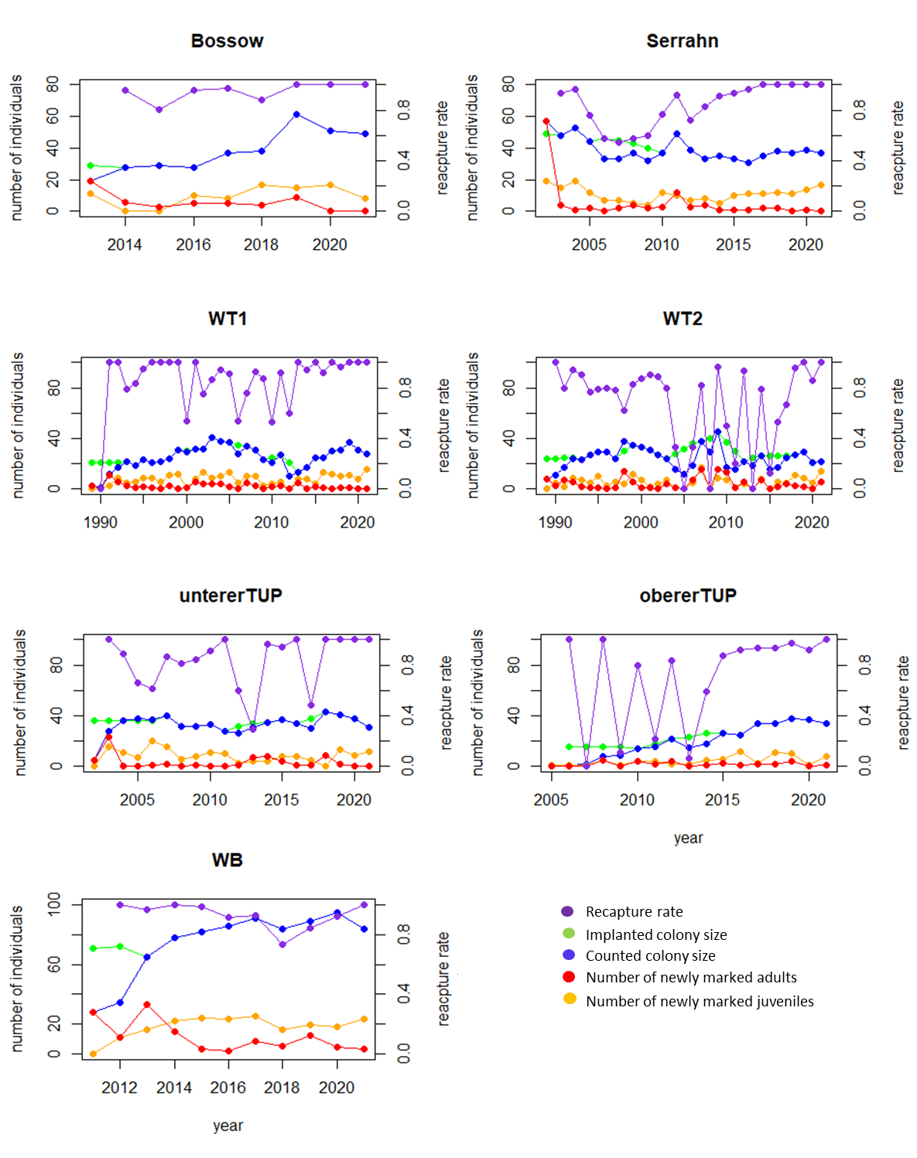

Fig. S3: Overview of recapture rate (violet, right y-axis), interpolated colony size (green, left y-axis), counted colony size (blue, left y-axis), number of newly marked adult individuals (red, left y-axis) and number of newly marked juvenile individuals (yellow, left y-axis) for each year.

