Foliar functional and genetic variation in a keystone Hawaiian tree species estimated through spectroscopy
Seeley, M.^{1,2}, Stacy, E.³, Martin, R.E.^{1,2}, & Asner, G.P.^{1,2}

Supplementary Information

Table SI 1: The eight leaf chemical traits estimated from reflectance spectra according to Asner et al., (2018).

Chemistry | Abbreviation | Units
Total Nitrogen | N | %
Phenols | Phenols | mg g⁻¹
Chlorophyll a+b | Chl | mg g⁻¹
Cellulose | Cellulose | %
Tannins | Tannins | mg g⁻¹
Lignin | Lignin | %
Total Carbon | C | %
Nonstructural Carbohydrates | NSC | %

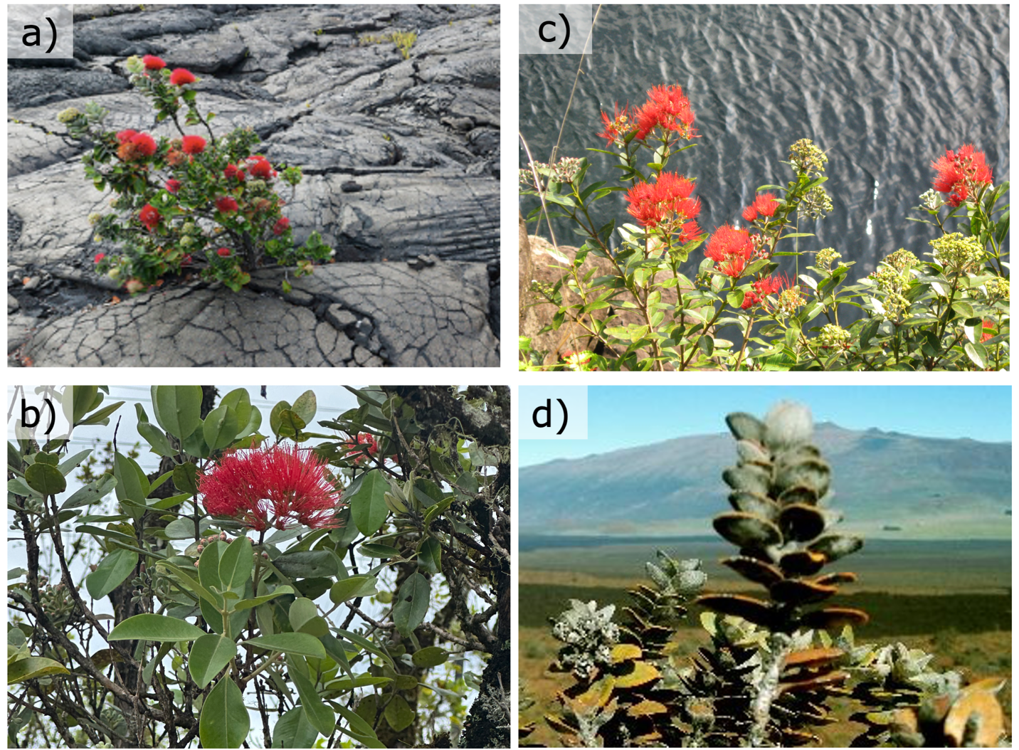
Figure SI 1: The four varieties of Metrosideros polymorpha on Hawaii Island. a) M. polymorpha var. incana. b) M. polymorpha var. glaberrima. c) M. polymorpha var. newellii. d) M. polymorpha var. polymorpha.

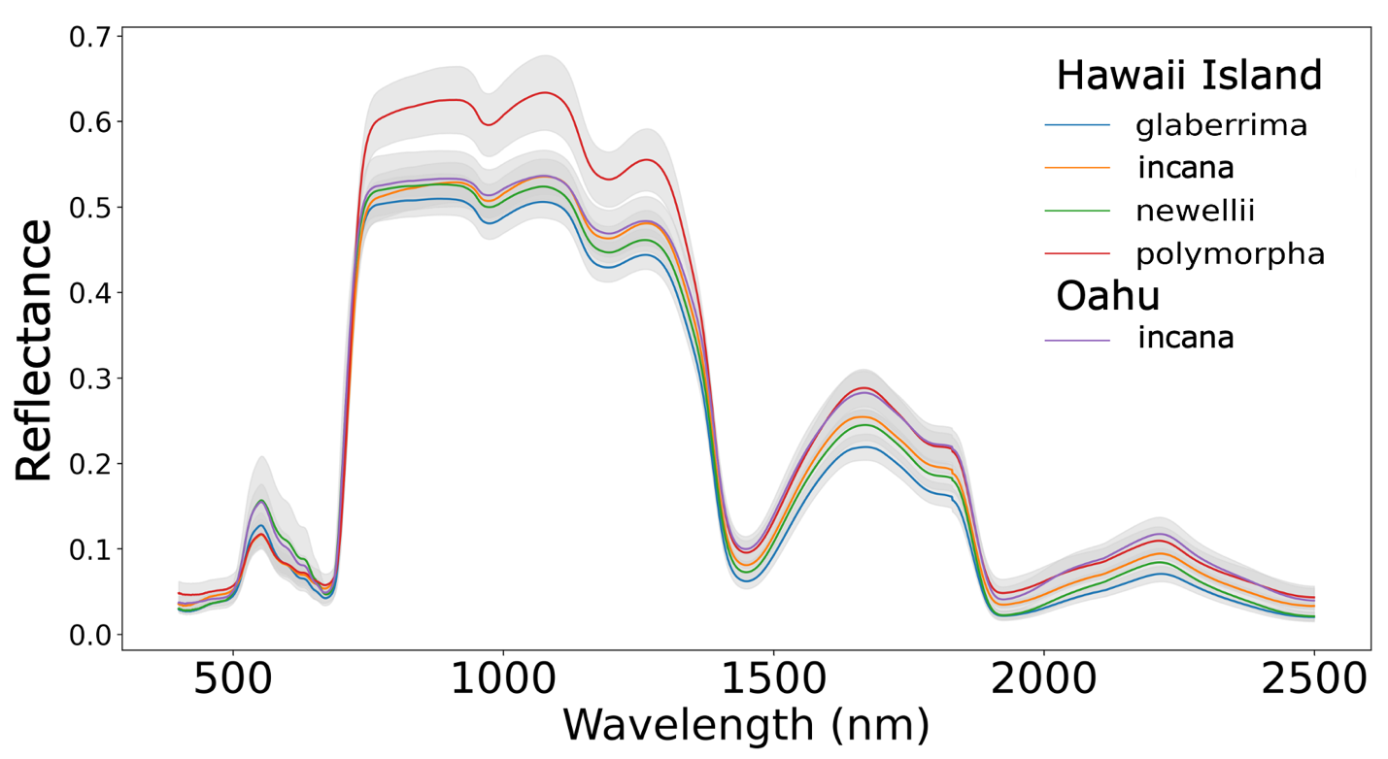
Figure SI 2: Reflectance of the four Hawaii Island varieties before brightness-normalization.

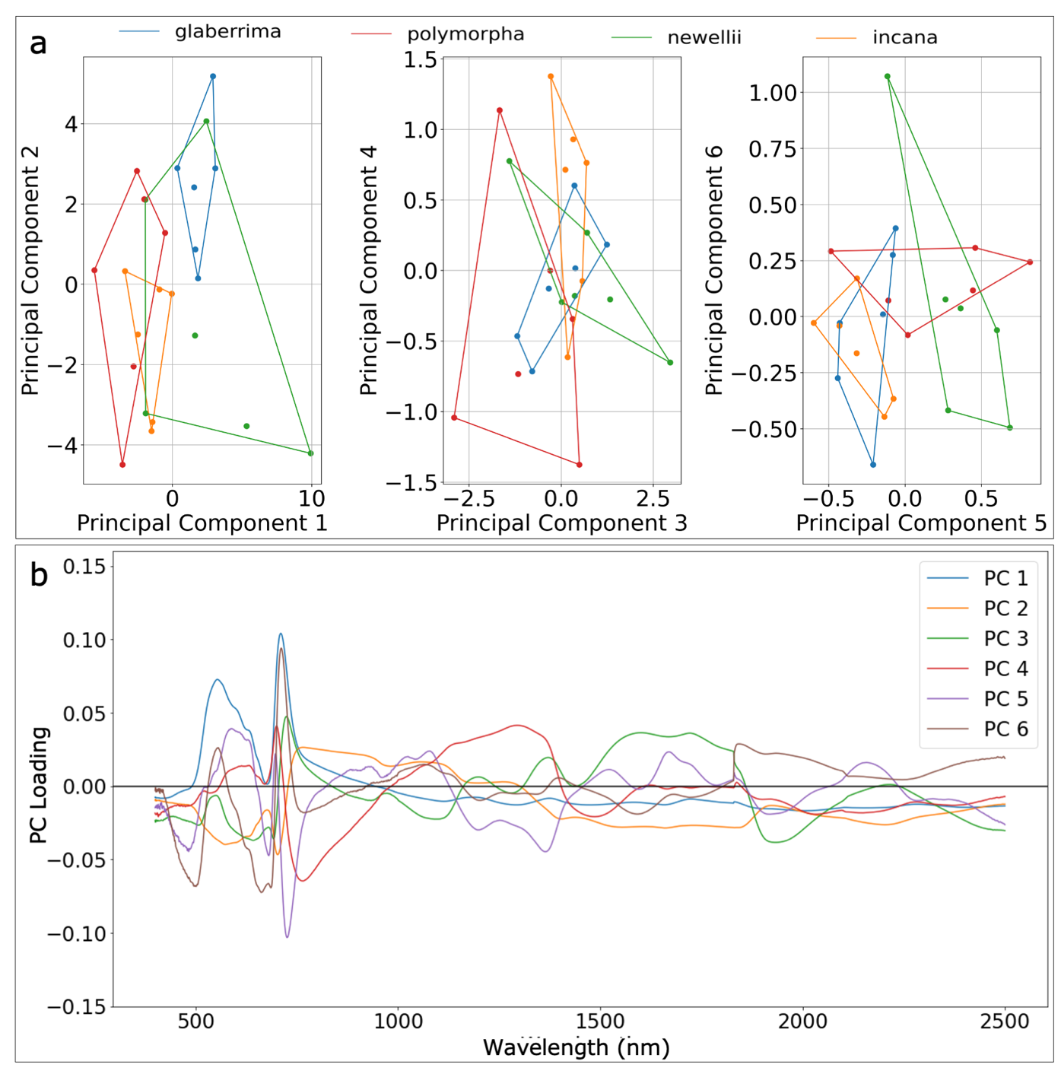Figure SI 3: a) Reflectance data of the four Hawaii Island Metrosideros polymorpha varieties plotted in principal component (PC) analysis space. Axes on the three plots represent different PCs. b) PC loadings of the first 6 PC plotted across the VSWIR spectra.

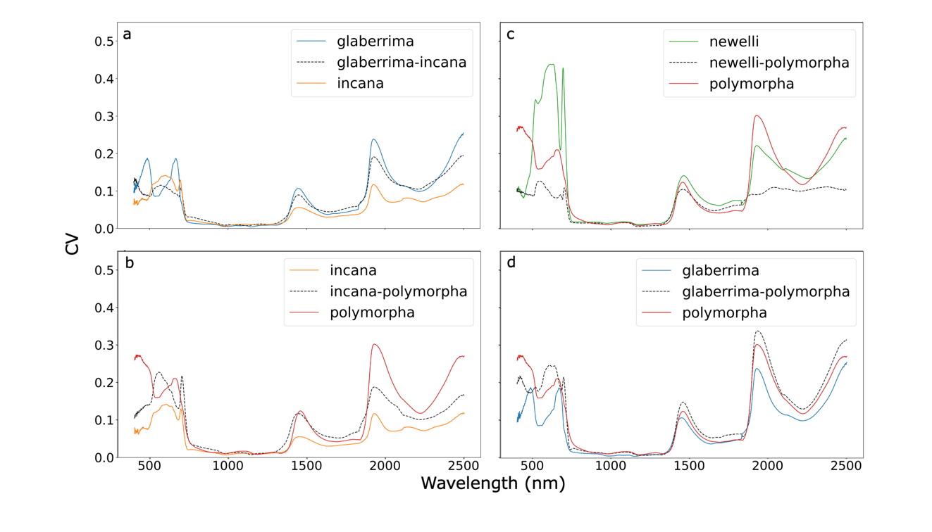
Figure SI 4: Coefficient of variation (CV) of reflectance of the F1 hybrids alongside their parental taxa: a) glaberrima-incana (GI), glaberrima (G) and incana (I); b) incana-polymorpha (IP), incana (I) and polymorpha (P); c) newellii-polymorpha (NP), newellii (N) and polymorpha (P); d) glaberrima-polymorpha (GP), glaberrima (G) and polymorpha (P).

Figure SI 5: Reflectance data of four Hawaii Island Metrosideros polymorpha hybrids along with their parent varieties plotted in principal component analysis (PCA) space. PCA was applied separately to each data set grouping.

