Supplementary material to:

Body size mediates latitudinal population differences in the response to chytrid fungus infection in two amphibians

Sara Meurling¹, Mattias Siljestam¹, Maria Cortazar-Chinarro^{1,2,3}, David Åhlen⁴, Patrik Rödin-Mörch¹, Erik Ågren⁵, Jacob Höglund¹ and Anssi Laurila¹*

¹Animal Ecology/ Department of Ecology and Genetics, Uppsala University, Sweden
²MEMEG/Department of Biology, Lund University, Lund, Sweden
³Department of Earth, Ocean and Atmospheric Sciences, University of British Columbia, Vancouver, Canada
⁴Department of Ecology, Environment and Plant Sciences, Stockholm University, Sweden
⁵Department of Pathology and Wildlife Diseases, National Veterinary Institute, Uppsala, Sweden

*Corresponding author: anssi.laurila@ebc.uu.se

Authors’ contributions: SM, MCC, JH and AL conceived and designed the experiments, SM, MCC and DÅ performed the experiments and EÅ provided advice and logistic help, SM, PRM and MS analysed the data, SM and AL wrote the paper with input from all the authors.

Table S1. Coordinates for the collection sites

Species | Region | Population | N | E
Rana arvalis | North | NG1 | 65.519974 | 21.685978
Rana arvalis | North | NG2 | 65.488998 | 21.378151
Rana arvalis | South | M | 55.699774 | 13.360416
Rana arvalis | South | K | 55.722114 | 13.284693
Bufo bufo | North | NP1 | 65.583139 | 22.319458
Bufo bufo | North | NP2 | 65.56554 | 22.37404
Bufo bufo | South | PM | 56.217897 | 13.731548
Bufo bufo | South | PH | 55.539031 | 14.009702

Table S2. Results from final general linear models on infection load. a) R. arvalis ($n=73$, one outlier removed), b) B. bufo ($n=91$)

 | Sum of squares | Df | F | P
Size | 5.5 | 1 | 7.54 | 0.008
Region | 8.8 | 1 | 12.11 | < 0.001
Size x Region | 4.7 | 1 | 6.50 | 0.013
Residuals | 50.3 | 69

 | Sum of squares | Df | F | P
Bd-strain | 0.8 | 1 | 1.70 | 0.196
Size | 31.9 | 1 | 64.45 | < 0.001
Strain x Size | 1.8 | 1 | 3.66 | 0.059
Residuals | 43.0 | 87

Table S3. Results from final generalized linear models on survival. a) R. arvalis: the analyses only cover the northern population and the two Bd-treatments as survival in the southern population and control treatment were complete ($n=28$). b) B. bufo: only the two Bd-treatments are included as survival was complete in the control treatment ($n=91$).

 | LR chisquared | Df | P
Size | 6.5 | 1 | 0.011
Residuals | 12.6 | 26

 | Sum of squares | Df | F | P
Bd-strain | 0.2 | 1 | 0.24 | 0.624
Size | 9.3 | 1 | 13.10 | < 0.001
Infection load (IL) | 19.7 | 1 | 27.61 | < 0.001
Strain x IL | 5.0 | 1 | 7.05 | 0.009
Error | 61.3 | 86

Table S4. Results from general linear models on growth. a) R. arvalis all alive individuals ($n=112$, excluding the three dead individuals), b) R. arvalis, alive Bd-infected individuals ($n=71$, excluding the three dead individuals), c) B. bufo all alive individuals ($n=98$, excluding 55 dead individuals), d) B. bufo, Bd-infected individuals only ($n=46$, excluding 55 dead individuals),

 | Sum of squares | Df | F | P
Infection load (IL) | 0.000328 | 1 | 46.59 | < 0.001
Size | 0.000055 | 1 | 7.76 | 0.006
Residuals | 0.000766 | 109

b)
 | Sum of squares | Df | F | P
Infection load (IL) | 0.000038 | 1 | 5.10 | 0.027
Bd-strain | 0.000052 | 1 | 6.95 | 0.010
Size | 0.000049 | 1 | 6.61 | 0.012
Residuals | 0.000501 | 67

c)
 | Sum of squares | Df | F | P
Bd-infection | 0.000088 | 1 | 0.03 | 0.003
Region | 0.000022 | 1 | 2.32 | 0.131
Size | 0.000545 | 1 | 56.15 | < 0.001
Bd-infection x Region | 0.000031 | 1 | 3.20 | 0.077
Bd-infection x Size | 0.000080 | 1 | 8.22 | 0.005
Residuals | 0.000892 | 92

d)
 | Sum of squares | Df | F | P
Bd-strain | 0.000024 | 1 | 2.90 | 0.096
Region | 0.000081 | 1 | 9.87 | 0.003
Size | 0.000067 | 1 | 8.17 | 0.007
Bd-strain x Size | 0.000050 | 1 | 6.15 | 0.017
Residuals | 0.000335 | 41

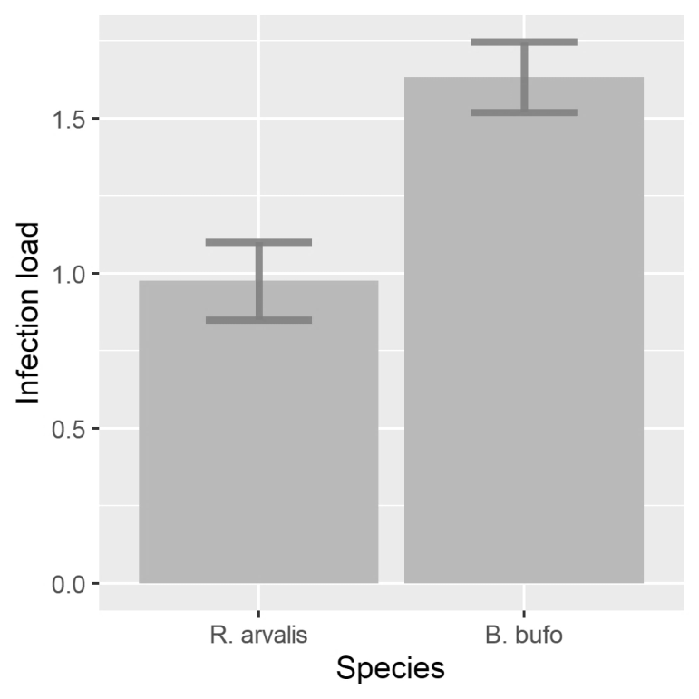
Fig. S1. Infection load (genomic equivalents) in R. arvalis ($n=115$) and B. bufo ($n=143$)

