<A>Supplemental Materials

Fig 1. Difference in a) CPUE and b) frequency of occurrence for key species between 16-foot and 30-foot survey.

Fig 2. Dendrograms from hierarchical cluster analysis for environmental variables (top) and species abundances (bottom) for the a) 30-foot trawl and b) 16-foot survey.

Fig 3. Dendrogram from hierarchical cluster of CCA loadings for a) 16-foot and b) 30-foot survey. Colored shapes correspond to those shown in Figure 4.

Fig 4. Log CPUE (number of individuals per area swept), species richness, and species diversity by temperature (°C), salinity (parts per thousand), dissolved oxygen (% saturation), and depth (meters). Points represent observations, lines represent LOESS curve fit with standard error. Star represents statistical significance of p<0.01 from Pearson correlation.

Fig 5. Scree plots for evaluation of clusters in hierarchical cluster analysis for both environmental (temperature, salinity, dissolved oxygen, and depth) measures and species abundances by station for the 30-foot and 16-foot surveys.

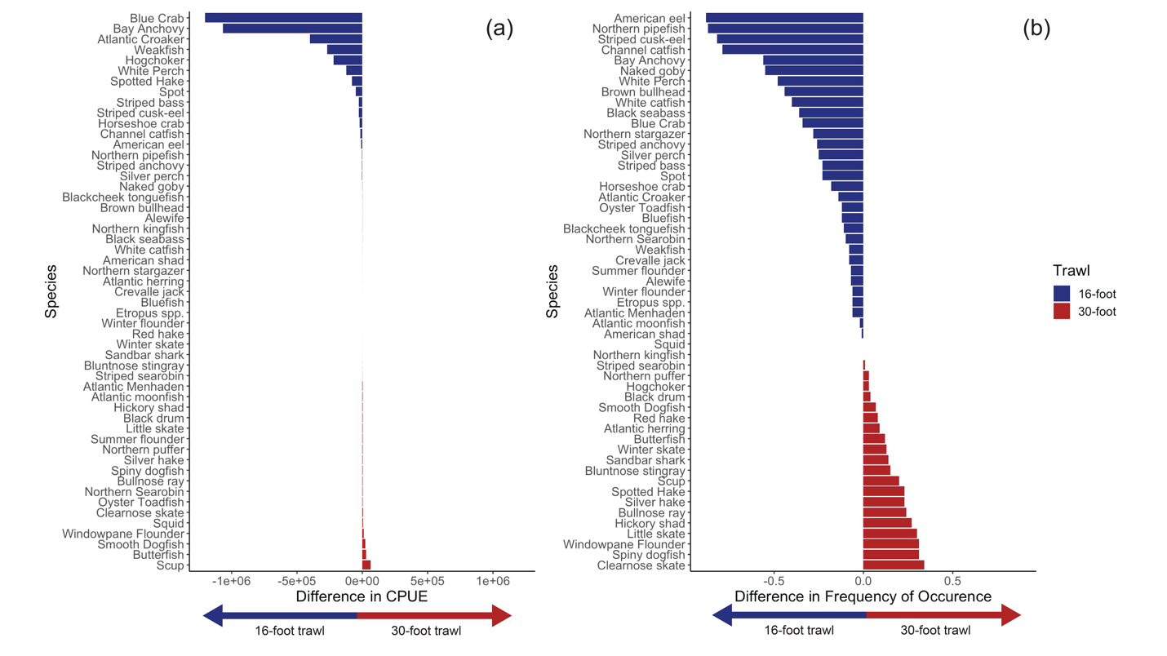
Fig 1

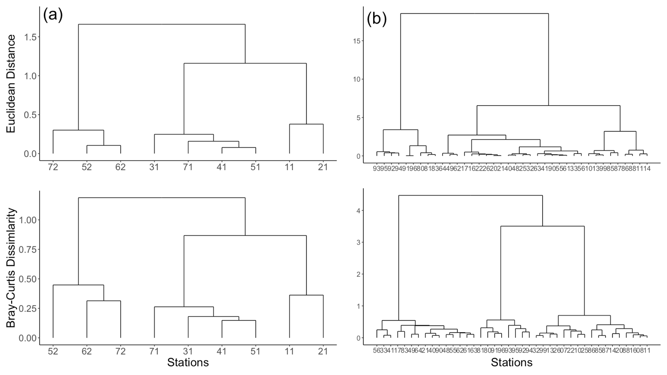
Fig 2

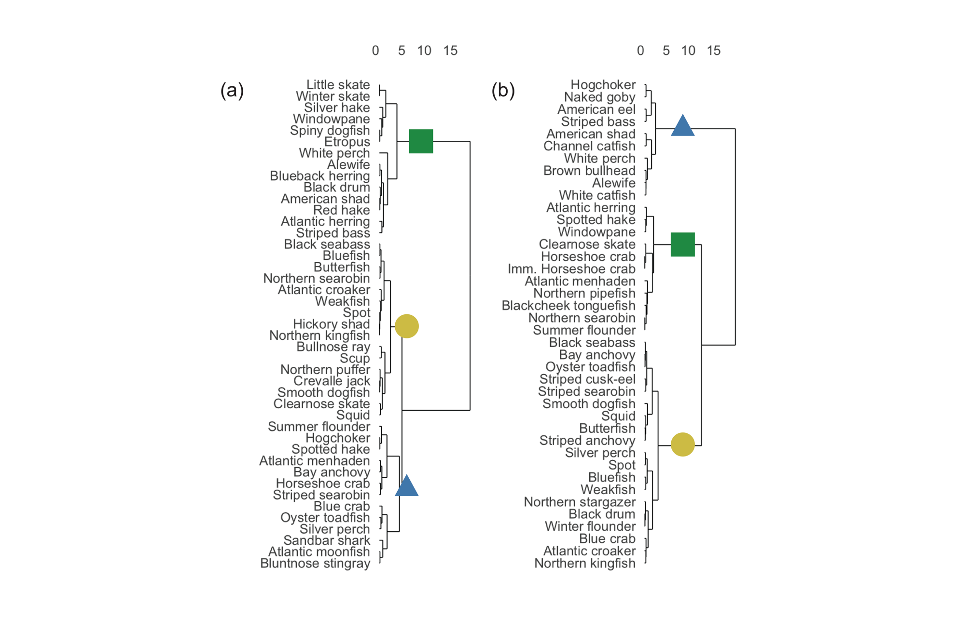

Fig 3

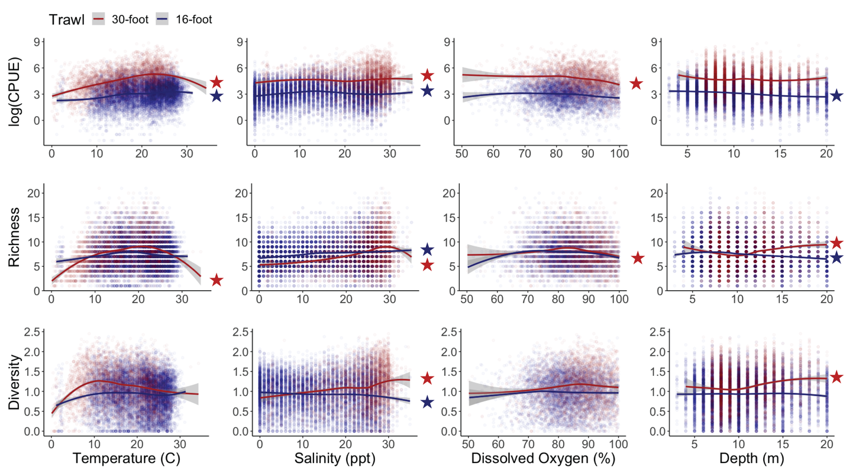
Fig 4

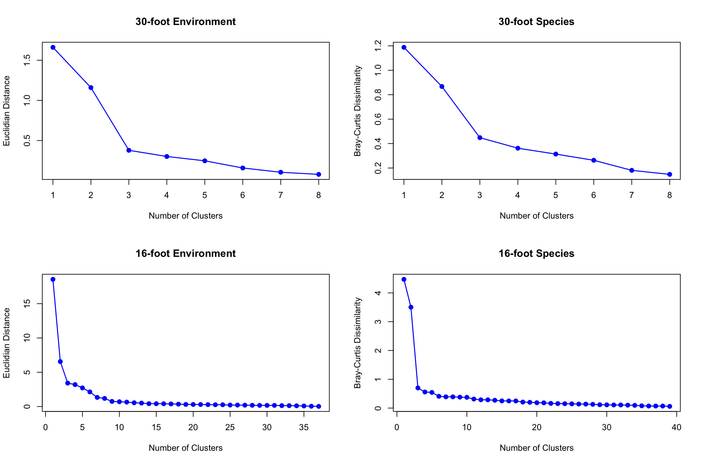
Fig 5

Table 1. Overall mean surface and bottom temperature (°C), salinity (parts per thousand), and dissolved oxygen (% saturation) for both surveys across all years and stations sampled.

Variable | 30-foot Survey | 16-foot Survey
Surface Temperature (℃) | 16.5 (± 7.0) | 20.5 (± 5.5)
Bottom Temperature (℃) | 16.1 (± 6.7) | 19.5 (± 4.9)
Surface Salinity (ppt) | 20.5 (± 7.5) | 14.1 (± 9.0)
Bottom Salinity (ppt) | 23.1 (± 7.0) | 15.2 (± 9.3)
Surface Dissolved Oxygen (%) | 96.2 (± 14.8) | 83.8 (± 9.2)
Bottom Dissolved Oxygen (%) | 90.5 (± 12.9) | 78.33 (± 10.9)

