Electronic supplemental material 1 (ESM1)

Plasticity in biomass allocation underlies tolerance to leaf damage in native and non-native populations of Datura stramonium

Franco Liñán-Vigo¹, Juan Núñez-Farfán¹

¹ Laboratorio de Genética Ecológica y Evolución, Departamento de Ecología Evolutiva, Instituto de Ecología. Universidad Autónoma de México, Circuito Exterior, Ciudad Universitaria, 04510 México, Ciudad de México, México
*Corresponding author: Juan Núñez-Farfán, email: farfan@unam.mx

Table S1 Nested ANOVAs for plasticity of traits from the first experiment. Significant effects (P<0.05) in bold letters.
Trait | Factor | DF | SS | MS | F | P-value
Leaf area | Region | 1 | 0.51 | 0.51 | 15.35 | 0.0002
 | Population (Region) | 2 | 0.54 | 0.27 | 8.22 | 0.0007
 | Error | 62 | 2.05 | 0.03
Biomass | Region | 1 | 0.05 | 0.05 | 0.81 | 0.3703
 | Population (Region) | 2 | 0.04 | 0.02 | 0.32 | 0.7308
 | Error | 62 | 3.64 | 0.06
Reproductive | Region | 1 | 0.01 | 0.01 | 0.17 | 0.6774
mass | Population (Region) | 2 | 0.42 | 0.21 | 3.38 | 0.0405
 | Error | 62 | 3.82 | 0.06
Seed number | Region | 1 | 0.00 | 0.00 | 0.01 | 0.9414
 | Population (Region) | 2 | 0.85 | 0.43 | 3.72 | 0.0299
 | Error | 62 | 7.10 | 0.11
LMF | Region | 1 | 0.00 | 0.00 | 0.02 | 0.8921
 | Population (Region) | 2 | 0.40 | 0.20 | 2.13 | 0.1276
 | Error | 62 | 5.84 | 0.09
SMF | Region | 1 | 0.00 | 0.00 | 0.15 | 0.7027
 | Population (Region) | 2 | 0.01 | 0.01 | 0.37 | 0.6926
 | Error | 62 | 1.15 | 0.02
RMF | Region | 1 | 0.05 | 0.05 | 0.75 | 0.3895
 | Population (Region) | 2 | 0.20 | 0.10 | 1.46 | 0.2411
 | Error | 62 | 4.34 | 0.07
Reproductive | Region | 1 | 0.07 | 0.07 | 1.61 | 0.2090
effort | Population (Region) | 2 | 0.13 | 0.07 | 1.58 | 0.2140
 | Error | 62 | 2.57 | 0.04

Table S2 Nested ANOVAs for plasticity of traits from the second experiment. Significant effects (P<0.05) in bold letters. Marginal significance (0.05<P<0.1) indicated by italics.
Trait | Factor | DF | SS | MS | F | P-value
Leaf area | Region | 1 | 0.16 | 0.16 | 3.41 | 0.0734
 | Population (Region) | 2 | 0.25 | 0.13 | 2.71 | 0.0809
 | Error | 34 | 1.59 | 0.05
Biomass | Region | 1 | 0.03 | 0.03 | 0.81 | 0.3752
 | Population (Region) | 2 | 0.09 | 0.04 | 1.13 | 0.3363
 | Error | 34 | 1.34 | 0.04
SLA | Region | 1 | 0.31 | 0.31 | 3.65 | 0.0645
 | Population (Region) | 2 | 0.00 | 0.00 | 0.02 | 0.9762
 | Error | 34 | 2.93 | 0.09
LMF | Region | 1 | 0.00 | 0.00 | 0.01 | 0.9087
 | Population (Region) | 2 | 0.04 | 0.02 | 0.50 | 0.6132
 | Error | 34 | 1.30 | 0.04
SMF | Region | 1 | 0.01 | 0.01 | 0.42 | 0.5229
 | Population (Region) | 2 | 0.01 | 0.01 | 0.38 | 0.6901
 | Error | 34 | 0.60 | 0.02
RMF | Region | 1 | 0.03 | 0.03 | 0.48 | 0.4930
 | Population (Region) | 2 | 0.11 | 0.06 | 1.03 | 0.3686
 | Error | 34 | 1.86 | 0.05
Seed number | Region | 1 | 0.00 | 0.00 | 0.04 | 0.8502
 | Population (Region) | 2 | 0.28 | 0.14 | 2.16 | 0.1305
 | Error | 34 | 2.22 | 0.07
Seed mass | Region | 1 | 0.01 | 0.01 | 0.15 | 0.7049
 | Population (Region) | 2 | 0.34 | 0.17 | 3.66 | 0.0362
 | Error | 34 | 1.56 | 0.05
Seed mean | Region | 1 | 0.00 | 0.00 | 0.07 | 0.7973
mass | Population (Region) | 2 | 0.06 | 0.03 | 1.48 | 0.2415
 | Error | 34 | 0.69 | 0.02

Table S3 Traits related to fitness (seed number) in absence of damage (control treatment) in each experiment. The relationships were obtained after a stepwise regression (entrance level of P = 0.15, stay level of P = 0.10) where the response variable was seed number in absence of damage and the response variable was the other vegetative traits. The analysis was run for each region and combining them
 | Region | Trait | Estimate | Cum. R² | P-value
Experiment 1 |  | Leaf area | 0.452 | 0.192 | 0.0001
Experiment 2 |  | Stem mass fraction | 0.574 | 0.127 | 0.0006
 |  | Leaf area | 0.452 | 0.281 | 0.0056
Experiment 1 | Native | Not significant | - | - | -
 | Non-native | Leaf area | 0.451 | 0.251 | 0.0062
 |  | Leaf mass fraction | -0.282 | 0.315 | 0.072
Experiment 2 | Native | Stem mass fraction | 0.511 | 0.161 | 0.0365
 |  | Leaf area | 0.528 | 0.288 | 0.0682
 | Non-native | Leaf area | 0.558 | 0.178 | 0.0364

Table S4 Cost of tolerance (correlation coefficient) in native and non-native populations of Datura stramonium in two experiments.
 | Native populations | Non-native populations | z value
Experiment 1 | -0.498 (n=37) | -0.717(n=29) | -1.362 (P =0.173)
Experiment 2 | -0.414 (n=18) | -0.682 (n=20) | -1.108 (P =0.268)

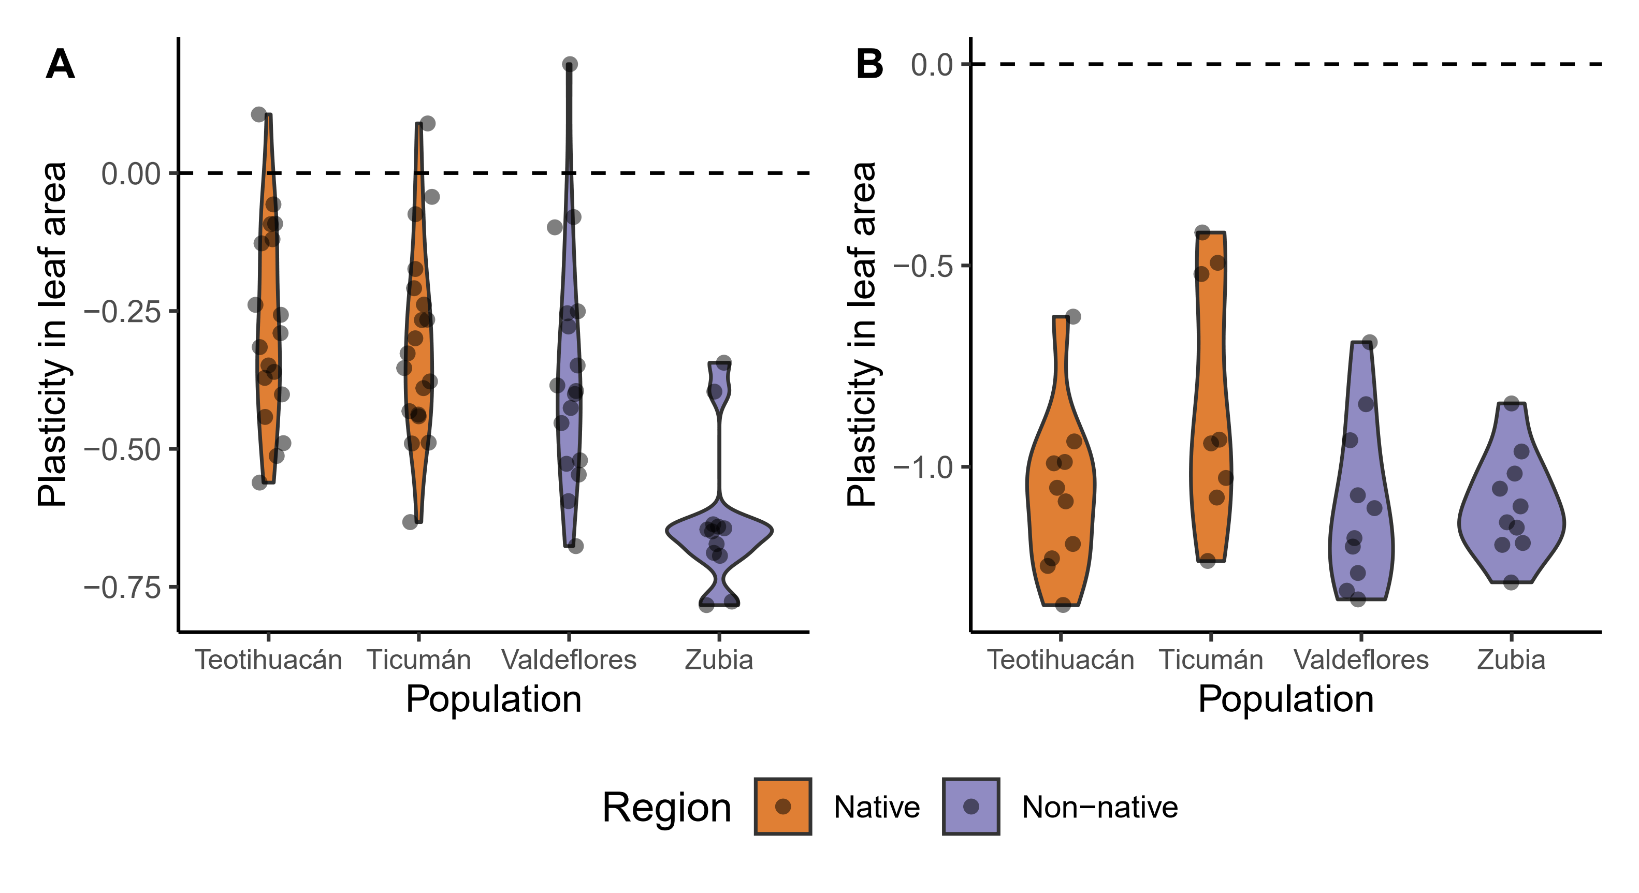
Figure S1 Plasticity in leaf area for native Mexican populations and non-native Spanish populations of Datura stramonium. A. values for experiment 1. B. values for experiment 2.

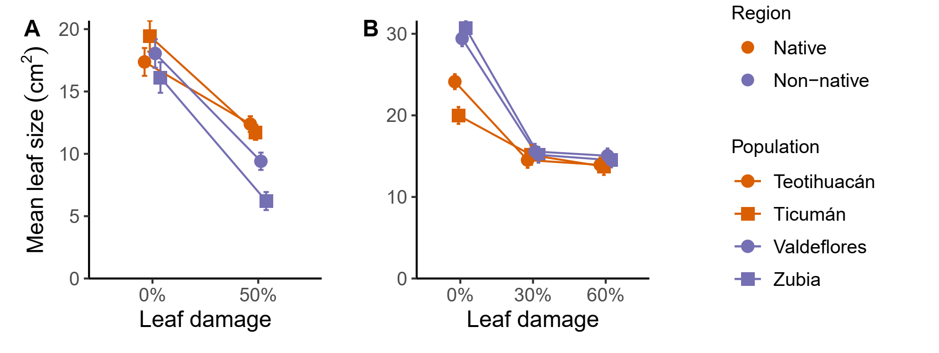
Figure S2 Mean leaf size of plants of native and non-native populations of D. stramonium. Least square means and one standard error are represented. A. values for experiment 1. B. values for experiment 2. Native Mexican populations: Teotihuacán and Ticumán, Non-native Spanish populations: Valdeflores and Zubia.

Table S5 Range for tolerance values found in previous studies.
Study | Species | Tolerance measurement | Tolerance range
Croy et al. 2020 | Phragmites australis | log response ratio | approximately from -1.0 to 0.5
Fornoni et al. 2003 | Datura stramonium | slope | from - 1.6 to 0.5
Garrido et al. 2010 | Datura stramonium | slope | approximately from -0.7 to 0.2
Giraldo 2015 | Datura stramonium | slope | approximately from -0.6 to 0.6
Vargas-Ortiz 2015 | Amaranthus cruentus | slope | approximately from -0.8 to -0.1
Wise et al. 2008 | Solanum carolinense | slope* | approximately from -0.4 to 0.7
Experiment 1 | Datura stramonium | slope | from -0.6 to 0.8
Experiment 2 | Datura stramonium | slope | from -0.5 to 0.6
*Estimated from reaction norms (Fig.4 in Wise et al. 2008)

References
Croy JR, Meyerson LA, Allen WJ, et al (2020) Lineage and latitudinal variation in Phragmites australis tolerance to herbivory: implications for invasion success. Oikos 129:1341–1357. https://doi.org/10.1111/oik.07260
Fornoni J, Valverde PL, Núñez-Farfán J (2003) Quantitative genetics of plant tolerance and resistance against natural enemies of two natural populations of. Evolutionary Ecology Research 5:1049–1065
Garrido E, Bennett AE, Fornoni J, Strauss SY (2010) Variation in arbuscular mycorrhizal fungi colonization modifies the expression of tolerance to above‐ground defoliation. Journal of Ecology 98:43–49. https://doi.org/10.1111/j.1365-2745.2009.01586.x
Giraldo Kalil LJ (2015) Efecto del sistema de apareamiento de Datura stramonium en las estrategias de defensa contra herbívoros. Tesis de Maestría, UNAM
Vargas-Ortiz E, Délano-Frier JP, Tiessen A (2015) The tolerance of grain amaranth (Amaranthus cruentus L.) to defoliation during vegetative growth is compromised during flowering. Plant Physiology and Biochemistry 91:36–40. https://doi.org/10.1016/j.plaphy.2015.03.007
Wise MJ, Cummins JJ, De Young C (2008) Compensation for floral herbivory in Solanum carolinense: identifying mechanisms of tolerance. Evol Ecol 22:19–37. https://doi.org/10.1007/s10682-007-9156-x

