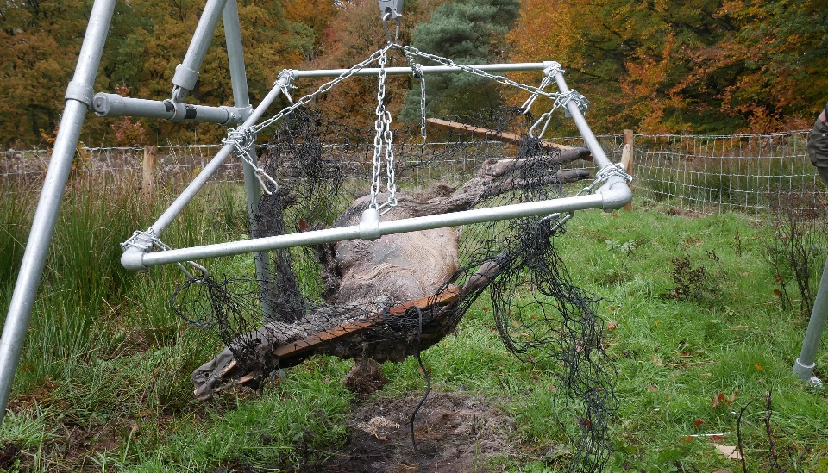
Figure S1.1 A carcass (treatment 2) in the transportable scaffolding. This was used to lift the carcasses (to access the soil) and to put them back in exactly the same position as before.

