Table S4.1 Test statistics belonging to the interaction terms of treatment and sampling week of the the LMMs of the soil samples beneath the carcasses.

Element | Sum of Squares | Numerator Degrees of Freedom | Denominator Degrees of Freedom | F value | Adjusted p value
B | 0.577507 | 3 | 258.210 | 0.587 | 0.993
Ca | 0.86183 | 3 | 259.473 | 0.420 | 0.993
Cu | 21.81054 | 3 | 252.529 | 5.917 | 0.004
K | 5.013046 | 3 | 260.122 | 0.040 | 0.993
Mg | 0.042968 | 3 | 259.226 | 0.029 | 0.993
Mn | 0.110249 | 3 | 259.673 | 0.032 | 0.993
Mo | 0.239433 | 3 | 259.644 | 0.051 | 0.993
Ni | 0.638478 | 3 | 258.516 | 1.357 | 0.940
P | 1.230962 | 3 | 259.139 | 0.550 | 0.993
S | 2.126002 | 3 | 259.683 | 0.537 | 0.993
Zn | 482.2165 | 3 | 259.013 | 7.795 | <0.001

Table S4.1.1 Test statistics belonging to the Tukey post hoc tests of the statistically significant elements in Table S4.1.

 |  | Estimate | SE | df | t.ratio | p value
Element: Cu
Treatment 1 | Treatment 2 | -0.211 | 0.207 | 256 | -1.020 | 0.738
Treatment 1 | Treatment 3 | 0.054 | 0.204 | 257 | 0.264 | 0.994
Treatment 1 | Treatment 4 | -1.251 | 0.203 | 256 | -6.171 | <0.001
Treatment 2 | Treatment 3 | 0.265 | 0.188 | 253 | 1.409 | 0.495
Treatment 2 | Treatment 4 | -1.040 | 0.188 | 252 | -5.532 | <0.001
Treatment 3 | Treatment 4 | -1.305 | 0.184 | 252 | -7.104 | <0.001
Element: Zn
Treatment 1 | Treatment 2 | -0.270 | 0.833 | 264 | -0.324 | 0.988
Treatment 1 | Treatment 3 | -0.381 | 0.829 | 265 | -0.459 | 0.968
Treatment 1 | Treatment 4 | -6.025 | 0.829 | 264 | -7.269 | <0.001
Treatment 2 | Treatment 3 | -0.111 | 0.753 | 259 | -0.147 | 0.999
Treatment 2 | Treatment 4 | -5.755 | 0.757 | 258 | -7.599 | <0.001
Treatment 3 | Treatment 4 | -5.644 | 0.747 | 258 | -7.555 | <0.001

Table S4.2 Test statistics belonging to the interaction terms of treatment and sampling week of the LMMs of the root samples on the edge of the carcasses.

Element | Sum of Squares | Numerator Degrees of Freedom | Denominator Degrees of Freedom | F value | Adjusted p value
B | 54.14095 | 3 | 255.390 | 0.303 | 0.906
Ca | 41.50442 | 3 | 255.192 | 1.191 | 0.575
Cu | 248.2412 | 3 | 239.049 | 7.234 | <0.001
K | 2076.519 | 3 | 255.020 | 1.609 | 0.575
Mg | 36.21557 | 3 | 255.029 | 0.948 | 0.657
Mn | 3112.679 | 3 | 256.796 | 0.007 | 0.999
Mo | 10.00443 | 3 | 251.365 | 0.690 | 0.769
Ni | 14.53721 | 3 | 252.024 | 1.310 | 0.575
P | 70.89681 | 3 | 255.040 | 2.015 | 0.575
S | 144.1816 | 3 | 256.041 | 1.197 | 0.575
Zn | 324.5851 | 3 | 253.847 | 0.347 | 0.906

Table S4.2.1 Test statistics belonging to the Tukey post hoc tests of the statistically significant elements in Table S4.2.

 |  | Estimate | SE | df | t.ratio | p value
Element: Cu
Treatment 1 | Treatment 2 | 0.369 | 0.627 | 240 | 0.588 | 0.936
Treatment 1 | Treatment 3 | 0.330 | 0.630 | 241 | 0.523 | 0.953
Treatment 1 | Treatment 4 | -2.751 | 0.652 | 240 | -4.220 | <0.001
Treatment 2 | Treatment 3 | -0.039 | 0.573 | 239 | -0.068 | 0.999
Treatment 2 | Treatment 4 | -3.119 | 0.598 | 239 | -5.212 | <0.001
Treatment 3 | Treatment 4 | -3.080 | 0.594 | 239 | -5.185 | <0.001

Table S4.3 Test statistics belonging to the interaction terms of treatment and sampling week of the the LMMs of the shoot samples on the edge of the carcasses.

Element | Sum of Squares | Numerator Degrees of Freedom | Denominator Degrees of Freedom | F value | Adjusted p value
B | 1.347867 | 3 | 242.822 | 1.631 | 0.287
Ca | 1.000824 | 3 | 245.073 | 1.717 | 0.287
Cu | 14.08744 | 3 | 241.221 | 0.709 | 0.602
K | 27.80677 | 3 | 245.036 | 2.418 | 0.184
Mg | 1.406854 | 3 | 246.009 | 3.570 | 0.054
Mn | 0.566442 | 3 | 245.842 | 1.051 | 0.453
Mo | 1.77177 | 3 | 244.941 | 3.896 | 0.053
Ni | 1.280269 | 3 | 243.979 | 1.207 | 0.423
P | 5.027666 | 3 | 244.859 | 4.062 | 0.053
S | 4.784123 | 3 | 245.271 | 1.714 | 0.287
Zn | 6.093634 | 3 | 243.778 | 0.050 | 0.985

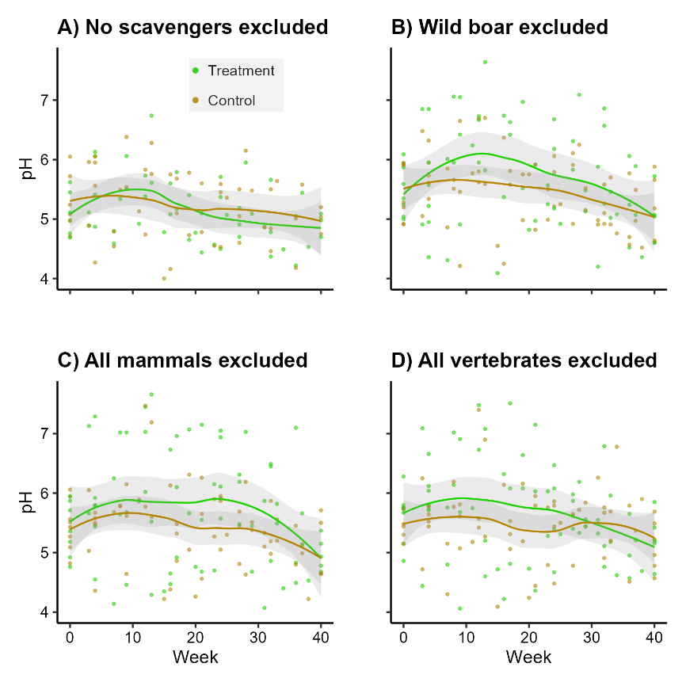
Fig. S4.1 Soil pH over time per scavenger exclusion treatment.

Table S4.4 Test statistics belonging to the interaction terms of treatment and sampling week of the the LMMs of the soil pH.
Treatment | Sum of Squares | Numerator Degrees of Freedom | Denominator Degrees of Freedom | F value | p value
Treatment 1 | 0.00229 | 1 | 97.058 | 0.0198 | 0.888
Treatment 2 | 0.00024 | 1 | 125.04 | 0.0010 | 0.975
Treatment 3 | 0.00489 | 1 | 130.92 | 0.0134 | 0.908
Treatment 4 | 0.93792 | 1 | 128.84 | 2.9003 | 0.091

