Supplementary Material

Fig. S1. Map of the sites where the photographs of Sphenarium grasshoppers were taken: S. purpurascens (19.31N, 99.19W), S. borrei (19.92N, 101.74W), S. occidentalis (18.66N, 101.65W), S. cypticum (18.18N, 100.65W), S.rugosum (18.68N, 99.53W), S. planum (18.48N, 97.45W), S. histrio (16.93N, 96.42N), S. variabile (16.93N, 96.42N), S. miztecum (16.37N, 98.47W), S. adelinae (17.43N, 99.47W), S. macrophallicum (19.38N, 100.39W), S. tarascum (19.20N, 101.73W), S. infernalis (18.94N, 101.81W), S. zapotecum (17.07N, 97.83N), S. mexicanum (17.75N, 96.31W), S. minimum (19.09N, 97.03W), and S. totonacum (19.72N, 96.68W)

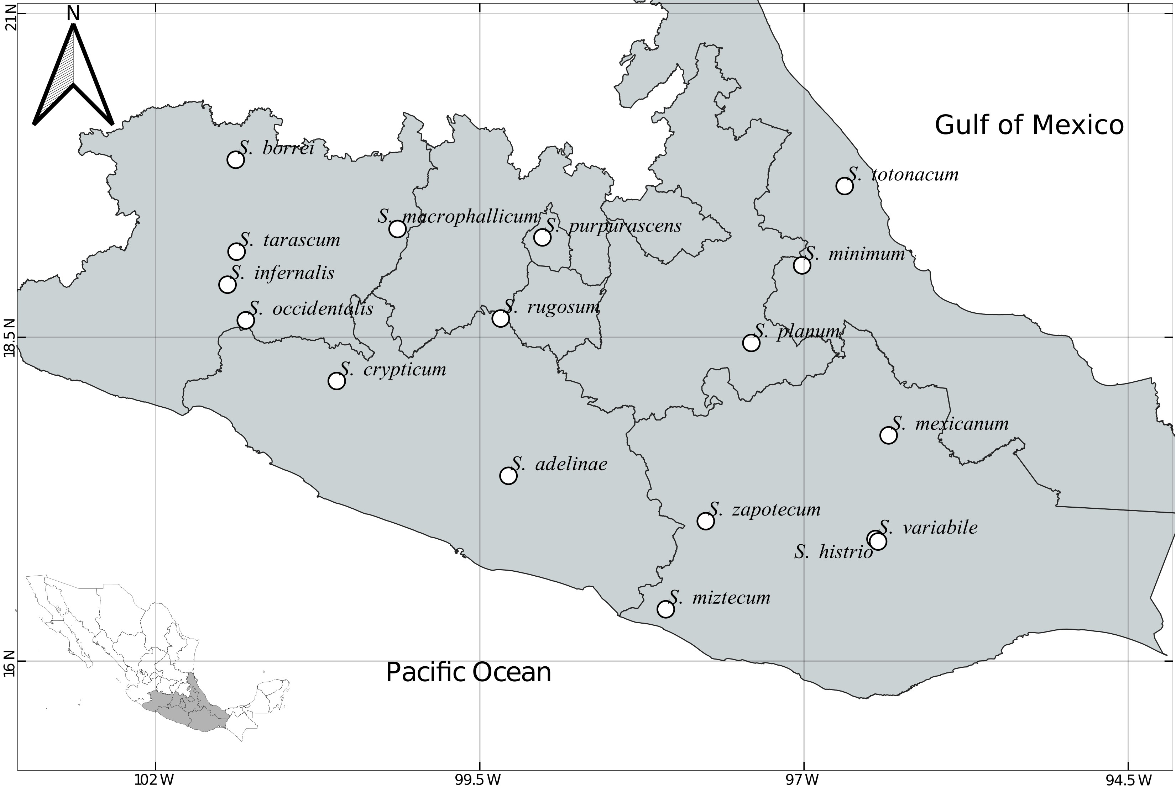

Table S1. Sites where Sphenarium species were collected. Locality names, geographic coordinates, and their elevation.
Species | Locality name | Geographic Coordinates | Elevation (masl)
S. purpurascens | Pedregal de San Angel, Ciudad de México | 19.31N, 99.19W | 2324
S. borrei | Villa Jiménez, Michoacán | 19.92N, 101.74W | 1985
S. occidentalis | Churumuco, Michoacán | 18.66N, 101.65W | 190
S. cypticum | Near Ciudad Altamirano, Michoacán | 18.18N, 100.65W | 540
S. rugosum | Near Cacahuamilpa, Guerrero | 18.68N, 99.53W | 1523
S. planum | Tehuacán, Puebla | 18.48N, 97.45W | 1731
S. histrio | Near Mitla, Oaxaca | 16.93N, 96.42W | 1653
S. variabile | Near Mitla, Oaxaca | 16.93N, 96.42W | 1653
S. miztecum | Near Santiago Tepextla, Oaxaca | 16.37N, 98.47W | 77
S. adelinae | Near Chilpancingo, Guerrero | 17.43N, 99.47W | 1298
S. macrophallicum | Presa del Bosque, Michoacán | 19.38N, 100.39W | 1760
S. tarascum | Ario de Rosales, Michoacán | 19.20N, 101.73W | 1939
S. infernalis | Near La Huacana, Michoacán | 18.94N, 101.81W | 575
S. zapotecum | San Isidro Paz y Progreso, Oaxaca | 17.07N, 97.83W | 1563
S. mexicanum | Yetla, Oaxaca | 17.75N, 96.31W | 202
S. minimum | Near Cosomatepec de Bravo, Veracruz | 19.09N, 97.03W | 1479
S. totonacum | Tierra Blanca, Veracruz | 19.72N, 96.68W | 1090

Table S2. Chromatic and precipitation data for females and males of 17 grasshopper species of the genus Sphenarium. M: Male; F: Female. n: Sampled size; Grasshoppers Hue1 and Hue 2: G Hue1, G Hue 2; Background Brightness: B Brightness; Background Saturation: B Saturation; Background Hue1 and Hue 2: B Hue1, B Hue2; Grasshoppers overall patterns contrast: G OPS; Grasshoppers dominant marking size: G DMS; Grasshopper patterns diversity: G PD; Background overall patterns contrast: B OPC; Background dominant marking size: B DMS; Background patterns diversity: B PD; Precipitation of the driest trimester (mm):PTD; Precipitation of the wettest trimester (mm): PWT.
Species | Sex | n | Brightness | Saturation | G Hue1 | G Hue2 | B Brightness | B Saturation | B Hue1 | B Hue2 | G OPC | G DMS | G PD | B OPC | B DMS | B PD | PDT | PWT
S. adelinae | F | 18 | 18120.06 | 82222.30 | 1.04 | 0.78 | 17018.47 | 84098.96 | 1.01 | 0.81 | 419.41 | 36.92 | 0.10 | 234.67 | 22.20 | 0.11 | 20 | 690
S. adelinae | M | 22 | 20603.26 | 78002.31 | 1.14 | 0.75 | 19071.46 | 80588.84 | 1.01 | 0.79 | 1656.26 | 20.73 | 0.13 | 363.22 | 35.60 | 0.11 | 20 | 690
S. borrei | F | 20 | 19090.26 | 80570.76 | 1.07 | 0.76 | 17992.41 | 82418.64 | 1.02 | 0.81 | 502.54 | 40.94 | 0.11 | 403.98 | 45.15 | 0.11 | 23 | 595
S. borrei | M | 10 | 18167.83 | 82160.64 | 1.09 | 0.75 | 19453.90 | 79937.14 | 1.02 | 0.78 | 573.91 | 25.71 | 0.11 | 489.10 | 21.99 | 0.12 | 23 | 595
S. crypticum | F | 5 | 19162.99 | 80427.77 | 1.02 | 0.76 | 17317.53 | 83586.36 | 0.98 | 0.80 | 539.56 | 38.47 | 0.10 | 223.74 | 18.59 | 0.10 | 8 | 753
S. crypticum | M | 17 | 17330.72 | 83585.20 | 1.04 | 0.76 | 16656.08 | 84723.73 | 0.99 | 0.79 | 552.10 | 13.96 | 0.11 | 172.98 | 12.70 | 0.10 | 8 | 753
S. histrio | F | 27 | 19436.35 | 79959.28 | 1.06 | 0.77 | 17879.71 | 82626.50 | 1.02 | 0.80 | 542.42 | 43.66 | 0.10 | 317.32 | 32.10 | 0.11 | 17 | 305
S. histrio | M | 22 | 18907.22 | 80845.44 | 1.11 | 0.82 | 18861.69 | 80983.23 | 1.02 | 0.79 | 1161.15 | 13.39 | 0.13 | 365.14 | 32.58 | 0.11 | 17 | 305
S. infernalis | F | 8 | 20707.17 | 77904.95 | 1.01 | 0.77 | 20799.73 | 77866.38 | 1.01 | 0.75 | 582.94 | 56.14 | 0.12 | 524.26 | 55.19 | 0.11 | 7 | 562
S. infernalis | M | 12 | 19738.88 | 79488.58 | 1.04 | 0.75 | 20103.50 | 78860.48 | 1.04 | 0.77 | 747.60 | 31.60 | 0.11 | 432.85 | 49.56 | 0.12 | 7 | 562
S. macrophallicum | F | 17 | 20011.63 | 79028.64 | 1.09 | 0.76 | 20562.32 | 78076.89 | 1.04 | 0.77 | 495.93 | 44.77 | 0.11 | 437.96 | 31.94 | 0.12 | 24 | 550
S. macrophallicum | M | 15 | 18724.45 | 81234.70 | 1.09 | 0.72 | 18505.84 | 81591.29 | 1.03 | 0.77 | 644.76 | 24.54 | 0.10 | 405.44 | 21.14 | 0.11 | 24 | 550
S. mexicanum | F | 13 | 16082.06 | 85708.00 | 1.00 | 0.80 | 17657.35 | 83010.61 | 0.99 | 0.82 | 297.34 | 39.11 | 0.10 | 253.40 | 45.46 | 0.10 | 245 | 2065
S. mexicanum | M | 16 | 16335.67 | 85300.20 | 1.01 | 0.77 | 15722.06 | 86310.18 | 0.97 | 0.83 | 490.50 | 12.72 | 0.11 | 143.29 | 16.26 | 0.10 | 245 | 2065
S. minimum | F | 15 | 16209.63 | 85498.14 | 1.01 | 0.77 | 15715.47 | 86323.82 | 0.98 | 0.83 | 235.56 | 36.60 | 0.12 | 126.46 | 28.20 | 0.11 | 134 | 1022
S. minimum | M | 12 | 15762.27 | 86258.80 | 1.06 | 0.80 | 16036.23 | 85768.66 | 0.98 | 0.83 | 264.45 | 22.14 | 0.12 | 179.12 | 28.03 | 0.11 | 134 | 1022
S. miztecum | F | 24 | 24192.45 | 72072.83 | 1.08 | 0.68 | 21331.20 | 76769.07 | 1.03 | 0.78 | 728.95 | 29.77 | 0.11 | 487.96 | 25.71 | 0.11 | 6 | 951
S. miztecum | M | 28 | 26505.17 | 69450.37 | 1.15 | 0.70 | 24119.28 | 72086.76 | 1.05 | 0.75 | 2809.16 | 14.47 | 0.14 | 650.25 | 20.71 | 0.11 | 6 | 951
S. occidentalis | F | 17 | 24645.27 | 71399.37 | 1.07 | 0.67 | 23656.96 | 72862.32 | 1.03 | 0.73 | 709.06 | 34.26 | 0.11 | 327.79 | 74.06 | 0.11 | 9 | 398
S. occidentalis | M | 10 | 26454.81 | 68280.15 | 1.17 | 0.66 | 23984.26 | 72390.42 | 1.10 | 0.72 | 1581.81 | 13.66 | 0.14 | 670.16 | 17.09 | 0.13 | 9 | 398
S. planum | F | 43 | 18490.40 | 81589.16 | 1.02 | 0.76 | 18768.93 | 81085.47 | 1.00 | 0.80 | 263.54 | 43.45 | 0.10 | 431.07 | 41.30 | 0.11 | 11 | 234
S. planum | M | 34 | 17064.07 | 84025.50 | 1.04 | 0.78 | 18910.83 | 80844.94 | 1.02 | 0.80 | 306.49 | 61.31 | 0.11 | 449.75 | 18.80 | 0.11 | 11 | 234
S. purpurascens | F | 43 | 19896.90 | 79189.40 | 1.08 | 0.77 | 19726.22 | 79459.15 | 1.03 | 0.79 | 433.46 | 31.56 | 0.11 | 780.92 | 37.59 | 0.11 | 24 | 501
S. purpurascens | M | 44 | 17172.25 | 83843.16 | 1.05 | 0.78 | 20488.75 | 78152.29 | 1.00 | 0.79 | 496.64 | 28.00 | 0.11 | 966.32 | 14.77 | 0.12 | 24 | 501
S. rugosum | F | 26 | 16132.21 | 85629.48 | 1.04 | 0.79 | 16833.31 | 84425.40 | 1.00 | 0.79 | 376.69 | 43.16 | 0.11 | 186.74 | 20.26 | 0.10 | 21 | 676
S. rugosum | M | 35 | 16073.29 | 85730.63 | 1.06 | 0.81 | 17225.75 | 83739.06 | 0.99 | 0.82 | 376.69 | 43.16 | 0.11 | 213.88 | 23.16 | 0.10 | 21 | 676
S. tarascum | F | 18 | 21166.79 | 77024.98 | 1.06 | 0.76 | 19067.58 | 80604.10 | 1.02 | 0.79 | 593.72 | 50.83 | 0.11 | 301.94 | 36.77 | 0.11 | 16 | 762
S. tarascum | M | 33 | 19028.84 | 80687.47 | 1.10 | 0.75 | 18809.87 | 81035.64 | 1.02 | 0.78 | 751.02 | 24.46 | 0.12 | 354.27 | 36.12 | 0.11 | 16 | 762
S. totonacum | F | 8 | 16813.65 | 84444.38 | 1.02 | 0.79 | 17627.16 | 83056.94 | 1.00 | 0.78 | 519.50 | 37.66 | 0.11 | 323.19 | 61.56 | 0.12 | 165 | 713
S. totonacum | M | 9 | 16564.54 | 84877.03 | 1.05 | 0.80 | 17177.45 | 83808.83 | 0.99 | 0.82 | 523.30 | 30.65 | 0.11 | 227.19 | 52.01 | 0.11 | 165 | 713
S. variabile | F | 38 | 20573.09 | 78026.30 | 1.09 | 0.77 | 20561.92 | 78054.94 | 1.06 | 0.79 | 610.56 | 46.30 | 0.11 | 349.01 | 25.56 | 0.11 | 17 | 305
S. variabile | M | 22 | 18660.26 | 81268.61 | 1.13 | 0.82 | 19697.72 | 79499.34 | 1.06 | 0.80 | 1086.42 | 14.25 | 0.13 | 422.10 | 27.67 | 0.11 | 17 | 305
S. zapotecum | F | 18 | 15702.49 | 86373.98 | 1.09 | 0.79 | 15349.90 | 86971.74 | 1.03 | 0.80 | 317.52 | 28.17 | 0.11 | 177.96 | 32.36 | 0.11 | 22 | 893
S. zapotecum | M | 33 | 16443.98 | 85109.07 | 1.17 | 0.79 | 16359.43 | 85250.42 | 1.05 | 0.78 | 852.79 | 12.69 | 0.14 | 253.45 | 33.35 | 0.11 | 22 | 893

