Rapid recovery of an arctic lake ecosystem from a pulse disturbance caused by thermokarst failure

SUPPLEMENTARY MATERIAL

Phaedra Budy^{1,2}, Casey. A. Pennock³, Sarah Messenger^{4a}, Hunter Pehrson², Emily Adler^{2b}, Gary P. Thiede², Natasha R. Christman⁵, Byron C. Crump⁵, Anne E. Giblin⁴, and George W. Kling⁶

¹U.S. Geological Survey, Utah Cooperative Fish and Wildlife Research Unit, Utah State University, Logan, Utah
²Department of Watershed Sciences, Utah State University, Logan, Utah
³Department of Evolution, Ecology, and Organismal Biology and Aquatic Ecology Laboratory, The Ohio State University, Columbus, Ohio
⁴The Ecosystems Center Marine Biological Laboratory, Woods Hole, Massachusetts
⁵College of Earth, Ocean, and Atmospheric Sciences, Oregon State University, Corvallis, Oregon
⁶Department of Ecology and Evolutionary Biology, University of Michigan, Ann Arbor, Michigan

ªCurrent address: MIT-WHOI Joint Program in Oceanography and Applied Ocean Science and Engineering, Department of Marine Chemistry and Geochemistry, Woods Hole Oceanographic Institution, Woods Hole, Massachusetts
^{b}Current address: Department of Integrative Biology, University of Wisconsin, Madison, Wisconsin

Correspondence: Phaedra Budy phaedra.budy@usu.edu

Table S1: Number of sampling occasions per year from 2010 to 2021 for multiple physico-chemical (10 July – 13 August) and biological (2 July – 26 August) variables from the reference and thermokarst lake in arctic Alaska near Toolik Field Station. “Fish diets” are number of diets collected.
Lake | Year | Temperature, DO, chlorophyll a,  Nutrients | Secchi  depth | Zooplankton | Benthic  macroinvertebrates | Bacterioplankton | Fish  diets
Reference | 2010 | 3 | 2 |  |  | 1
 | 2011 | 3 | 3 |  |  | 1
 | 2012 | 3 | 3 |  |  | 1
 | 2013 | 3 | 3 |  |  | 2
 | 2014 | 3 | 3 |  |  | 1
 | 2015 | 3 | 3 |  |  | 1
 | 2016 | 3 | 3 | 3 |  | 1
 | 2017 | 3 | 3 | 3 |  | 1
 | 2018 | 2 | 2 | 2 | 1 | 1 | 22
 | 2019 | 8 | 6 | 8 | 1 | 1 | 15
 | 2020 | 2 | 2 | 2 | 1 | 1 | 6
 | 2021 | 5 | 5 | 5 | 2 | 2 | 4
Thermokarst | 2010 | 3 | 2 |  |  | 1
 | 2011 | 3 | 3 |  |  | 1
 | 2012 | 3 | 3 |  |  | 1
 | 2013 | 3 | 3 |  |  | 2
 | 2014 | 3 | 3 |  |  | 1
 | 2015 | 3 | 3 |  |  | 1
 | 2016 | 3 | 3 | 3 |  | 1
 | 2017 | 3 | 3 | 4 |  | 1
 | 2018 | 2 | 2 | 2 | 1 | 1 | 23
 | 2019 | 8 | 6 | 8 | 1 | 1 | 11
 | 2020 | 2 | 2 | 2 | 1 | 1 | 3
 | 2021 | 2 | 2 | 5 | 2 | 2 | 7

Table S2: Coefficient estimates from linear mixed effects models using Before-After Control-Impact design with year as a random effects. R²_{m} is the variance explained by the fixed effects and R²_{c} is the variance explained by the fixed effects and random effects combined.
Response | Fixed effect | Coefficient | SE | R²_{m} | R²_{c}
Water transparency (n = 77) | Intercept | 4.08 | 0.29 | 0.47 | 0.64
 | July | 0.30 | 0.25
 | August | 0.45 | 0.25
 | After | 0.14 | 0.46
 | Impact | -0.87 | 0.23
 | After*Impact | -1.72 | 0.39
Temperature (n = 82) | Intercept | 9.87 | 0.60 | 0.45 | 0.55
 | July | 4.65 | 0.55
 | August | 2.28 | 0.56
 | After | -0.55 | 0.85
 | Impact | -0.66 | 0.52
 | After*Impact | -0.27 | 0.87
Dissolved oxygen (n = 82) | Intercept | 84.66 | 2.72 | 0.03 | 0.03
 | July | 4.12 | 2.86
 | August | 3.98 | 2.90
 | After | -2.26 | 3.25
 | Impact | -0.23 | 2.78
 | After*Impact | 1.61 | 4.59
DIN (n=76) | Intercept | 1.00 | 0.26 | 0.15 | 0.62
 | July | -0.42 | 0.17
 | August | -0.23 | 0.17
 | After | -0.33 | 0.46
 | Impact | 0.25 | 0.15
 | After*Impact | 0.76 | 0.28
SRP (n=76) | Intercept | 0.04 | 0.01 | 0.13 | 0.15
 | July | -0.004 | 0.01
 | August | 0.01 | 0.01
 | After | 0.01 | 0.01
 | Impact | 0.01 | 0.01
 | After*Impact | 0.003 | 0.01
Chlorophyll a (n = 76) | Intercept | 0.97 | 0.12 | 0.16 | 0.19
 | July | -0.12 | 0.13
 | August | 0.01 | 0.13
 | After | 0.10 | 0.16
 | Impact | 0.08 | 0.12
 | After*Impact | 0.36 | 0.22
Bacterial production (n = 28) | Intercept | 2.45 | 0.35 | 0.46 | 0.71
 | After | 2.22 | 0.69
 | Impact | -0.76 | 0.36
 | After*Impact | -0.70 | 0.67

Table S3: Coefficient estimates from a GLMM of total zooplankton counts and GLM of total benthic macroinvertebrate counts and biomass of total fish gut content using a Before-After Control-Impact design. R²_{m} is the variance explained by the fixed effects and R²_{c} is the variance explained by the fixed effects and random (year) effects combined, in the case of zooplankton.
Response | Fixed effect | Coefficient | SE | R²_{m} | R²_{c}
Zooplankton (n = 87) | Intercept | 9.32 | 0.25 | 0.21 | 0.42
 | Volume sampled | -0.04 | 0.13
 | July | 0.28 | 0.14
 | August | 0.16 | 0.13
 | After | -0.50 | 0.25
 | Impact | -0.13 | 0.30
 | After*Impact | 0.08 | 0.20
Benthic macroinvertebrates (n = 22) | Intercept | 5.87 | 0.54 | 0.64
 | August | 0.25 | 0.56
 | Year2019 | -0.97 | 0.76
 | Year2020 | -0.66 | 0.70
 | Year2021 | -3.12 | 0.73
 | Impact | -0.85 | 0.66
 | Year2019*Impact | 1.11 | 1.01
 | Year2020*Impact | 0.46 | 0.96
 | Year2021*Impact | 1.43 | 0.87
Total gut content (n = 90) | Intercept | -2.75 | 0.52 | 0.75
 | Total length | 0.01 | 0.001
 | July | -0.20 | 0.25
 | August | -0.94 | 0.33
 | Year2019 | -0.39 | 0.33
 | Year2020 | -1.18 | 0.49
 | Year2021 | -0.79 | 0.56
 | Lake trout | 0.02 | 0.45
 | Impact | -0.22 | 0.30
 | Lake trout*Impact | 0.72 | 0.48
 | Year2019*Lake trout | 0.16 | 1.07
 | Year2020*Lake trout | -2.33 | 0.67
 | Year2021*Lake trout | -2.18 | 0.44
 | Year2019*Impact | -0.07 | 0.44
 | Year2020* Impact | 0.27 | 0.81
 | Year2021* Impact | 0.52 | 0.64

Table S4: Long-term means (SD) of biotic and abiotic variables from a reference lake and a nearby lake that was impacted by a thermokarst failure. Calculations include data prior to the thermokarst failure (2010-2018).
 | Lake
Variable | Reference lake (I1) | Thermokarst lake (I2)
Photosynthetically active radiation | 0.49 (0.16) | 0.71 (0.28)
Water transparency (Secchi depth) | 4.32 (1.05) | 3.48 (0.75)
Temperature | 12.50 (2.60) | 11.60 (3.01)
Oxygen saturation (%) | 87.50 (16.6) | 87.70 (14.5)
Soluble reactive phosphorus | 0.04 (0.02) | 0.05 (0.02)
Dissolved inorganic nitrogen | 0.77 (0.84) | 1.02 (1.02)
Chlorophyl a | 0.93 (0.41) | 1.01 (0.55)
Bacterial production | 2.56 (0.91) | 1.81 (0.97)

Table S5: NCBI accession numbers for 16S rRNA gene amplicon sequences analyzed for this study. Lake I1 is the reference lake and Lake I2 is the thermokarst lake.
DNA sequences | sample number | Date | Site | Depth (m) | latitude | longitude | NCBI BioProject number | NCBI Accession number
LTREB2014.160.273 | DNA2014-160 | July 14, 2010 | lake I2 | 1 | 68.57104 | -149.5652 | PRJNA356108 | SRR7809184
LTREB2014.161.273 | DNA2014-161 | July 14, 2010 | lake I2 | 14 | 68.57104 | -149.5652 | PRJNA356108 | SRR7809183
LTREB2014.162.273 | DNA2014-162 | July 14, 2010 | lake I1 | 1 | 68.5684 | -149.5862 | PRJNA356108 | SRR7809182
LTREB2014.163.273 | DNA2014-163 | July 14, 2010 | lake I1 | 9 | 68.5684 | -149.5862 | PRJNA356108 | SRR7809181
LTREB2015.148.288 | DNA2015-148 | July 13, 2011 | lake I2 | 1 | 68.57104 | -149.5652 | PRJNA356108 | SRR7809207
LTREB2015.149.288 | DNA2015-149 | July 13, 2011 | lake I2 | 14 | 68.57104 | -149.5652 | PRJNA356108 | SRR7809208
LTREB2015.150.288 | DNA2015-150 | July 13, 2011 | lake I1 | 1 | 68.5684 | -149.5862 | PRJNA356108 | SRR7809209
LTREB2015.151.288 | DNA2015-151 | July 13, 2011 | lake I1 | 9 | 68.5684 | -149.5862 | PRJNA356108 | SRR7809210
LTREB2016.166.349 | DNA2016-166 | July 11, 2012 | lake I2 | 1 | 68.57104 | -149.5652 | PRJNA356108 | SRR7809519
LTREB2016.167.349 | DNA2016-167 | July 11, 2012 | lake I2 | 14 | 68.57104 | -149.5652 | PRJNA356108 | SRR7809524
LTREB2016.169.349 | DNA2016-169 | July 11, 2012 | lake I1 | 9 | 68.5684 | -149.5862 | PRJNA356108 | SRR7809522
LTREB2017.043.685 | DNA2017-043 | July 10, 2013 | lake I2 | 1 | 68.57104 | -149.5652 | PRJNA356108 | SRR27115361
LTREB2017.044.685 | DNA2017-044 | July 10, 2013 | lake I2 | 14 | 68.57104 | -149.5652 | PRJNA356108 | SRR27114777
LTREB2017.045.685 | DNA2017-045 | July 10, 2013 | lake I1 | 1 | 68.5684 | -149.5862 | PRJNA356108 | SRR27114766
LTREB2017.046.685 | DNA2017-046 | July 10, 2013 | lake I1 | 9 | 68.5684 | -149.5862 | PRJNA356108 | SRR27115188
LTREB2019.162.812 | DNA2019-162 | July 15, 2015 | lake I2 | 1 | 68.57104 | -149.5652 | PRJNA356108 | SRR27115194
LTREB2019.163.812 | DNA2019-163 | July 15, 2015 | lake I2 | 14 | 68.57104 | -149.5652 | PRJNA356108 | SRR27115193
LTREB2019.164.812 | DNA2019-164 | July 15, 2015 | lake I1 | 1 | 68.5684 | -149.5862 | PRJNA356108 | SRR27115192
LTREB2019.165.812 | DNA2019-165 | July 15, 2015 | lake I1 | 9 | 68.5684 | -149.5862 | PRJNA356108 | SRR27115191

Reference lake
Thermokarst lake

Fig. S1 Areal primary production relative to values in 2017 (100%) in a lake impacted by a thermokarst failure (black circles; Lake I2) and a nearby reference lake (grey circles; Lake I1).
Reference lake
Thermokarst lake

Fig. S2 Theoretical predicted depth to 1% of surface light from PAR profiles in a lake effected by thermokarst failure in 2019 (black circles; Lake I2) and a nearby reference lake (grey circles; Lake I1). Maximum lake depths (Zmax) are denoted next to symbol label. Because the relationship is based on a theoretical prediction based on empirical data, it is possible for the predicted depth of 1% light to be deeper than the known maximum depth, as for the reference lake.

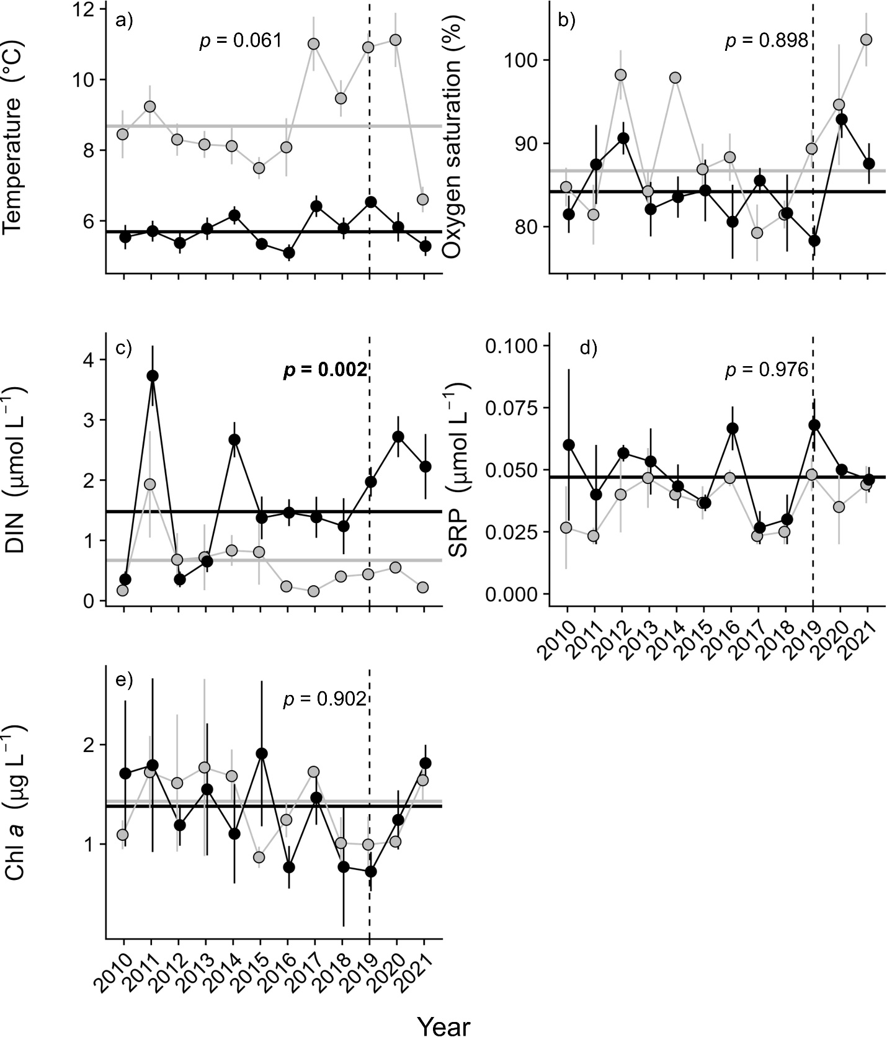
Fig. S3 Time series of metalimnetic temperature (a), dissolved oxygen saturation (b), DIN (c), soluble reactive phosphorus (d), and chlorophyll a (e) in two arctic lakes before (2010-2018) and after (2019-2012) a thermokarst failure (dashed vertical line) occurred in the thermokarst lake (black circles). The reference lake is denoted with grey circles. Values represent means (± SE) of data collected in summer during ice-off (June-August). Horizontal lines are means calculated before the thermokarst failure across the time series for the thermokarst (black) and reference (grey) lakes. P-values from linear mixed effects models are presented for the Before-After Control-Impact interactive effect (Table 2).

Fig. S4 Fish catch per unit effort (CPUE) in a thermokarst (black circles) and reference (grey circles) lake before (2017-2018) and after (2019-2021) a thermokarst failure (dashed vertical line). Fish CPUE values represent annual means across fishing efforts in late June-August. Horizontal lines are means calculated before the thermokarst failure across the time series for the thermokarst (black) and reference (grey) lakes.

