Electronic Supplementary Material for: Early post-fire declines of mammals in a tree-and-shrub savanna
Stijn Verschueren^{1,2*}, Maria Laura Ruozzi^{1,3}, Laurie Marker¹, Herwig Leirs³ & Bogdan Cristescu^{1,4,5}
¹Cheetah Conservation Fund, Otjiwarongo, Namibia
²Division of Conservation Biology, University of Bern, Bern, Switzerland
⁴School of Agriculture and Natural Resources Sciences, Namibia University of Science and Technology, Windhoek, Namibia
⁵School of Applied Sciences, University of Brighton, Brighton, United Kingdom
*Corresponding author: stijn@cheetah.org
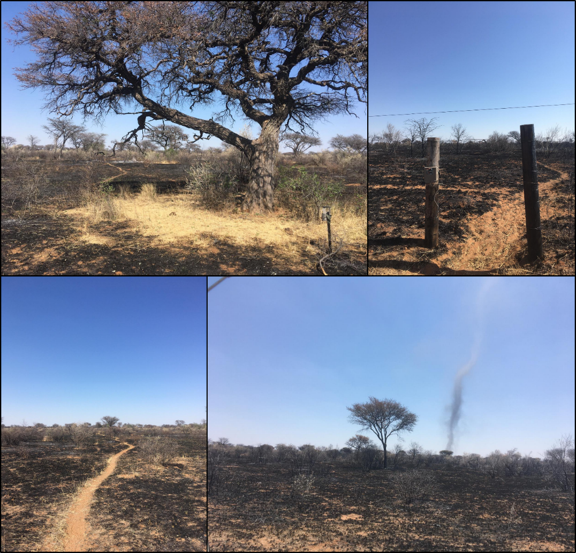
Figure S1. Images from the burned area (13 October 2021), illustrating postfire conditions and camera trap deployment. Top left: Large tree with surrounding vegetation persisting post-fire, providing a buffering microclimate and monitored by camera traps and dataloggers. Top right: Camera trap at road-wildlife trail intersection (road deployment). Bottom left: Wildlife trail through burned landscape. Bottom right: Dust devil redistributing ash.
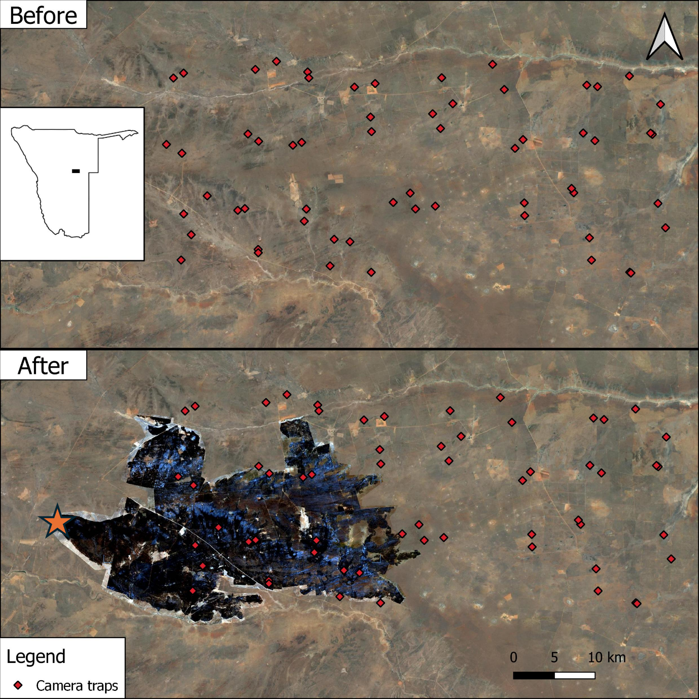
Figure S2. Satellite images of the study area one week before and after the wildfire. The fire originated in the western section (orange star) and expanded eastwards following the prevailing wind conditions.

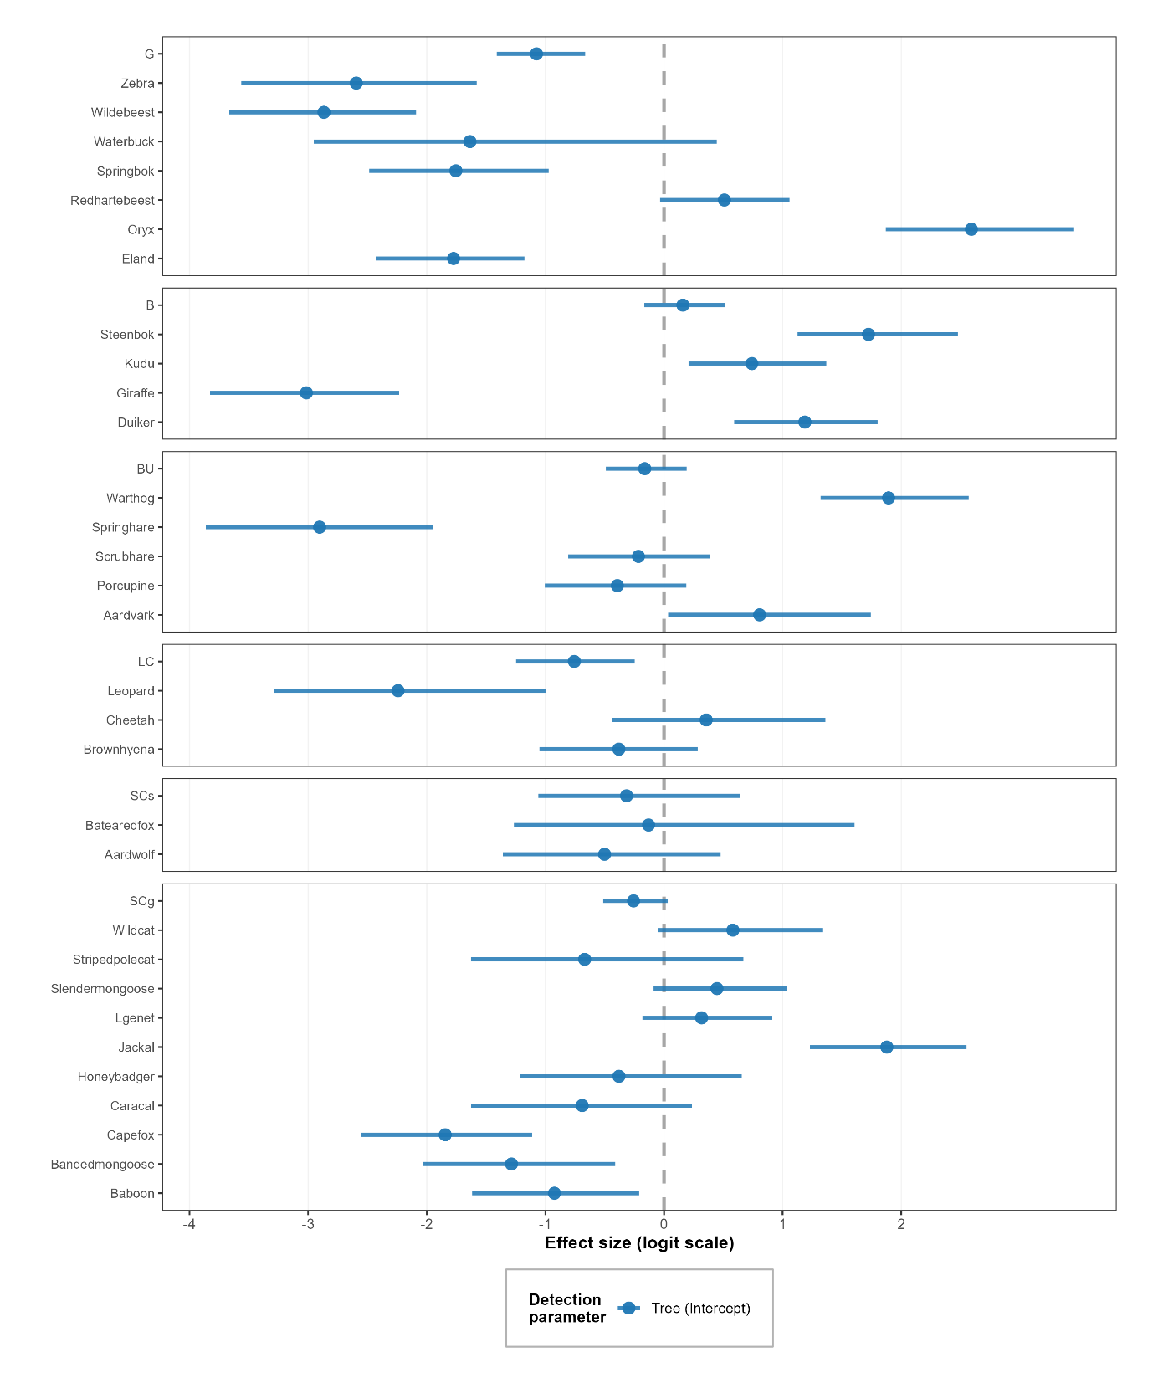
Figure S3. Detection probability estimates for tree versus road camera traps for all 31 species organized by functional group. Horizontal lines = 95% credible intervals; points = posterior means. Grazers (G; n=7), Browsers (B; n=4), Burrow-users (BU; n=5), Large carnivores (LC; n=3), Small carnivore specialists (SCs; n=2), Small carnivore generalists (SCg; n=10).
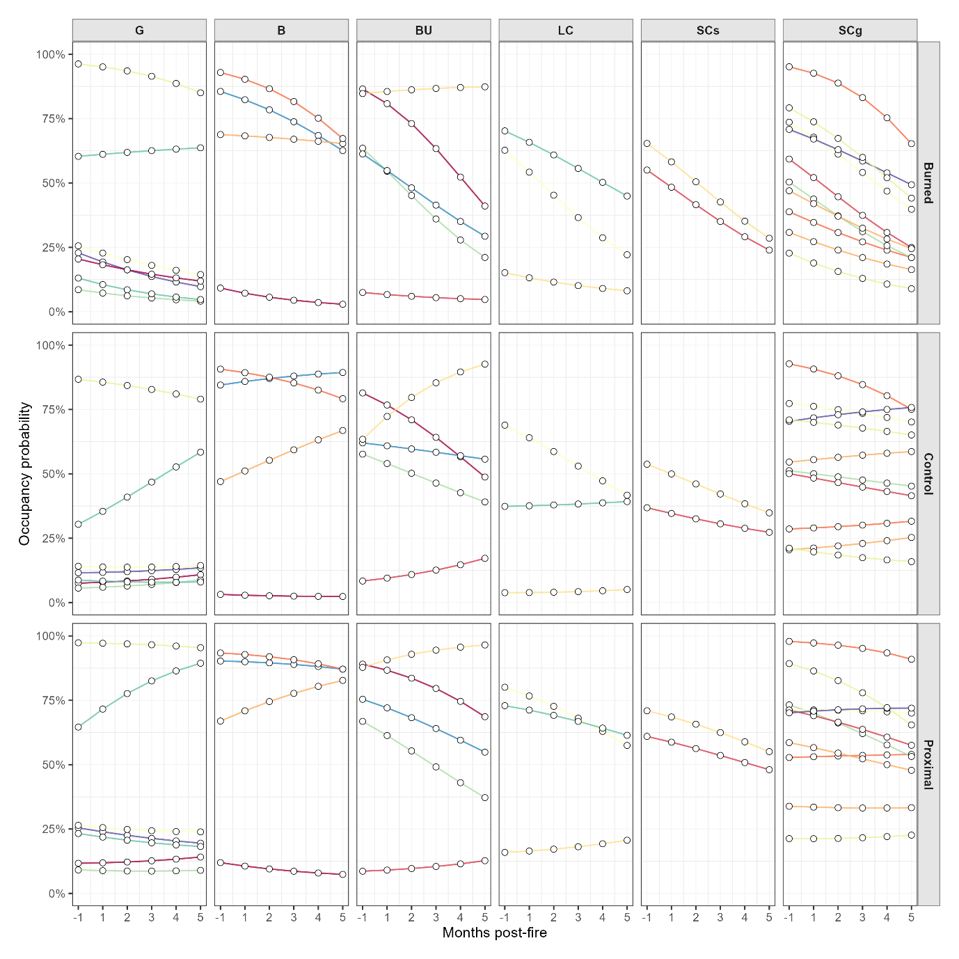
Figure S4. Species-level occupancy trajectories during 6 months (1 month pre-fire baseline and 5 months post-fire) in burned, proximal and control areas. Grazers (G; n=7), Browsers (B; n=4), Burrow-users (BU; n=5), Large carnivores (LC; n=3), Small carnivore specialists (SCs; n=2), Small carnivore generalists (SCg; n=10). Individual species legends are omitted for clarity due to the high number of species and color codes. Please see Figure 4 in the main manuscript for species-specific responses and identification.

Table S1. Number of independent detections (>30min) of 31 mammalian wildlife species (>1kg) recorded in burned, control and proximal areas. Model convergence diagnostics are presented by the Gelman–Rubin factor (R̂) and the effective sample size (ESS). Grazers (G; n=7), Browsers (B; n=4), Burrow-users (BU; n=5), Large carnivores (LC; n=3), Small carnivore generalists (SCg; n=10), Small carnivore specialists (SCs; n=2).
Group | Species | Burned | Control | Proximal | R̂ | ESS
G | Eland | 30 | 47 | 255 | 1.014 | 750
G | Oryx | 1555 | 1635 | 2311 | 1.006 | 750
G | Red hartebeest | 642 | 116 | 313 | 1.027 | 750
G | Springbok | 145 | 2 | 6 | 1.003 | 775
G | Waterbuck | 15 | 0 | 12 | 1.096 | 91
G | Wildebeest | 6 | 43 | 35 | 1.025 | 750
G | Zebra | 0 | 11 | 39 | 1.016 | 411
B | Giraffe | 22 | 6 | 245 | 1.002 | 750
B | Duiker | 270 | 574 | 661 | 1.012 | 750
B | Steenbok | 236 | 414 | 444 | 1.011 | 750
B | Kudu | 104 | 161 | 233 | 1.003 | 750
BU | Aardvark | 45 | 132 | 121 | 1.059 | 599
BU | Porcupine | 46 | 119 | 94 | 1.012 | 704
BU | Scrubhare | 221 | 542 | 395 | 1.021 | 371
BU | Springhare | 1 | 25 | 24 | 1.021 | 600
BU | Warthog | 905 | 1321 | 1448 | 1.02 | 843
LC | Brown hyena | 35 | 127 | 110 | 1.014 | 864
LC | Cheetah | 53 | 32 | 47 | 1.024 | 271
LC | Leopard | 5 | 0 | 12 | 1.02 | 337
SCg | Baboon | 19 | 43 | 98 | 1.025 | 616
SCg | Banded mongoose | 12 | 35 | 60 | 1 | 471
SCg | Cape fox | 21 | 55 | 35 | 1.013 | 750
SCg | Caracal | 5 | 59 | 61 | 1.024 | 552
SCg | Honey badger | 13 | 37 | 54 | 1.011 | 393
SCg | Jackal | 927 | 1760 | 2611 | 1.002 | 1028
SCg | Lgenet | 166 | 288 | 165 | 1.011 | 1104
SCg | Slender mongoose | 203 | 379 | 176 | 1.034 | 750
SCg | Striped polecat | 1 | 50 | 66 | 1.058 | 260
SCg | Wild cat | 52 | 176 | 155 | 1.002 | 750
SCs | Aardwolf | 21 | 26 | 49 | 1.035 | 450
SCs | Bat-eared fox | 11 | 20 | 30 | 1.163 | 113

Table S2. Species-level occupancy parameters from the multi-species multi-season occupancy model (logit scale), including means and 95% confidence intervals. Grazers (G; n=7), Browsers (B; n=4), Burrow-users (BU; n=5), Large carnivores (LC; n=3), Small carnivore generalists (SCg; n=10), Small carnivore specialists (SCs; n=2).
Group | Species | Burned area occupancy |  |  | Control effect |  |  | Proximal effect |  |  | Temporal trend
Group | Species | Mean | CI_2.5 | CI_97.5 | Mean | CI_2.5 | CI_97.5 | Mean | CI_2.5 | CI_97.5 | Mean | CI_2.5 | CI_97.5
G | Eland | -1.774 | -2.429 | -1.177 | -0.231 | -0.991 | 0.486 | 0.486 | -0.194 | 1.159 | -0.389 | -0.752 | 0.003
G | Oryx | 2.591 | 1.869 | 3.450 | -0.944 | -1.922 | -0.184 | 0.903 | 0.019 | 1.898 | -0.589 | -1.000 | -0.148
G | Redhartebeest | 0.509 | -0.034 | 1.058 | -0.759 | -1.428 | -0.083 | 0.919 | 0.273 | 1.662 | 0.055 | -0.344 | 0.464
G | Springbok | -1.755 | -2.485 | -0.972 | -0.649 | -1.506 | 0.208 | -0.246 | -1.126 | 0.547 | -0.247 | -0.680 | 0.159
G | Waterbuck | -1.636 | -2.952 | 0.444 | -0.458 | -1.566 | 0.635 | 0.360 | -0.510 | 1.278 | -0.303 | -0.801 | 0.239
G | Wildebeest | -2.867 | -3.665 | -2.090 | 0.185 | -0.760 | 1.069 | 0.465 | -0.438 | 1.288 | -0.302 | -0.746 | 0.167
G | Zebra | -2.595 | -3.564 | -1.579 | 0.040 | -0.986 | 1.039 | 1.155 | 0.384 | 2.055 | -0.431 | -0.882 | 0.065
B | Duiker | 1.187 | 0.592 | 1.801 | 0.795 | -0.006 | 1.614 | 0.980 | 0.278 | 1.799 | -0.489 | -0.873 | -0.087
B | Giraffe | -3.015 | -3.827 | -2.234 | -0.738 | -1.876 | 0.292 | 0.661 | -0.178 | 1.460 | -0.474 | -0.929 | -0.033
B | Kudu | 0.741 | 0.207 | 1.368 | -0.442 | -1.109 | 0.215 | 0.455 | -0.284 | 1.128 | -0.064 | -0.488 | 0.317
B | Steenbok | 1.724 | 1.126 | 2.477 | 0.186 | -0.626 | 1.059 | 0.729 | -0.079 | 1.580 | -0.728 | -1.286 | -0.278
BU | Aardvark | 0.806 | 0.035 | 1.743 | -0.044 | -0.810 | 0.737 | 0.755 | -0.006 | 1.561 | -0.887 | -1.427 | -0.439
BU | Porcupine | -0.393 | -1.004 | 0.189 | 0.325 | -0.302 | 1.017 | 0.485 | -0.198 | 1.105 | -0.727 | -1.133 | -0.383
BU | Scrubhare | -0.216 | -0.808 | 0.385 | 0.586 | -0.087 | 1.233 | 0.898 | 0.298 | 1.519 | -0.519 | -0.915 | -0.145
BU | Springhare | -2.903 | -3.863 | -1.946 | 0.819 | -0.092 | 1.820 | 0.634 | -0.225 | 1.501 | -0.183 | -0.675 | 0.331
BU | Warthog | 1.893 | 1.319 | 2.569 | -0.310 | -1.105 | 0.432 | 0.876 | 0.148 | 1.686 | 0.086 | -0.340 | 0.550
LC | Brownhyena | -0.381 | -1.050 | 0.283 | 0.621 | -0.142 | 1.391 | 1.272 | 0.539 | 2.095 | -0.694 | -1.100 | -0.258
LC | Cheetah | 0.355 | -0.440 | 1.360 | -0.857 | -1.782 | 0.018 | 0.470 | -0.440 | 1.313 | -0.426 | -0.876 | 0.026
LC | Leopard | -2.242 | -3.288 | -0.993 | -1.140 | -2.466 | -0.068 | 0.591 | -0.382 | 1.399 | -0.275 | -0.755 | 0.308
SCg | Baboon | -0.924 | -1.618 | -0.210 | 0.049 | -0.663 | 0.716 | 1.070 | 0.394 | 1.807 | -0.337 | -0.730 | 0.055
SCg | Bandedmongoose | -1.286 | -2.031 | -0.411 | 0.011 | -0.763 | 0.741 | 0.562 | -0.225 | 1.277 | -0.323 | -0.730 | 0.074
SCg | Capefox | -1.845 | -2.549 | -1.113 | 0.292 | -0.539 | 1.061 | 0.518 | -0.180 | 1.211 | -0.424 | -0.878 | -0.027
SCg | Caracal | -0.690 | -1.626 | 0.235 | 0.619 | -0.129 | 1.590 | 1.302 | 0.572 | 2.240 | -0.531 | -1.025 | -0.113
SCg | Honeybadger | -0.380 | -1.217 | 0.655 | 0.205 | -0.638 | 1.008 | 1.050 | 0.314 | 1.960 | -0.591 | -1.066 | -0.148
SCg | Jackal | 1.879 | 1.229 | 2.551 | 0.003 | -0.759 | 0.784 | 1.353 | 0.556 | 2.402 | -0.918 | -1.423 | -0.470
SCg | Genet | 0.317 | -0.182 | 0.914 | 0.760 | 0.146 | 1.488 | 0.598 | -0.022 | 1.234 | -0.556 | -0.897 | -0.184
SCg | Slendermongoose | 0.446 | -0.087 | 1.038 | 0.598 | -0.050 | 1.287 | 0.498 | -0.193 | 1.205 | -0.355 | -0.730 | 0.004
SCg | Stripedpolecat | -0.669 | -1.627 | 0.669 | 0.968 | 0.064 | 1.991 | 0.825 | 0.008 | 1.614 | -0.410 | -0.903 | 0.023
SCg | Wildcat | 0.581 | -0.048 | 1.341 | 0.205 | -0.574 | 0.904 | 0.871 | 0.198 | 1.604 | -0.618 | -1.084 | -0.199
SCs | Aardwolf | -0.501 | -1.357 | 0.478 | -0.302 | -1.110 | 0.459 | 0.716 | 0.052 | 1.511 | -0.542 | -0.995 | -0.109
SCs | Batearedfox | -0.130 | -1.265 | 1.606 | -0.106 | -1.127 | 0.921 | 0.815 | -0.032 | 1.768 | -0.662 | -1.255 | -0.152

