Supplementary Material

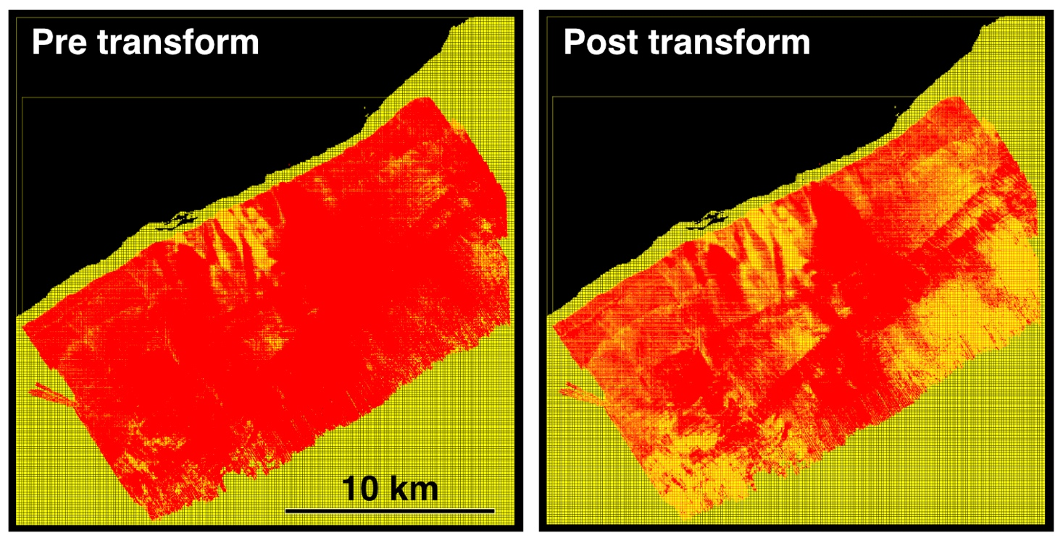

Supplementary Figure 1. Point clouds of 2006 bathymetry (yellow) and 2018 bathymetry (red) from the Pu’u ‘O’o ocean entry were aligned via an iterative closest point matching algorithm in the software package CloudCompare. The rigid transformation allowed rotation and translation in X Y Z and is described by the transformation matrix:

1.000000 -0.000146 0.000279 1.108594
0.000146 1.000000 -0.000399 -1.371916
-0.000279 0.000399 1.000000 -6.185664
0.000000 0.000000 0.000000 1.000000

The last row indicates that there was no scaling applied in the transformation. The first three elements in column four indicates the scale of the translation in X Y and Z. Columns one to three define a rotation of ~0.03 degrees (CW) about an axis of (0.7848; 0.5494; 0.2867) from the origin of the 2006 data. The transformation was calculated for the entirety of the 2018 data relative to the 2006 data.

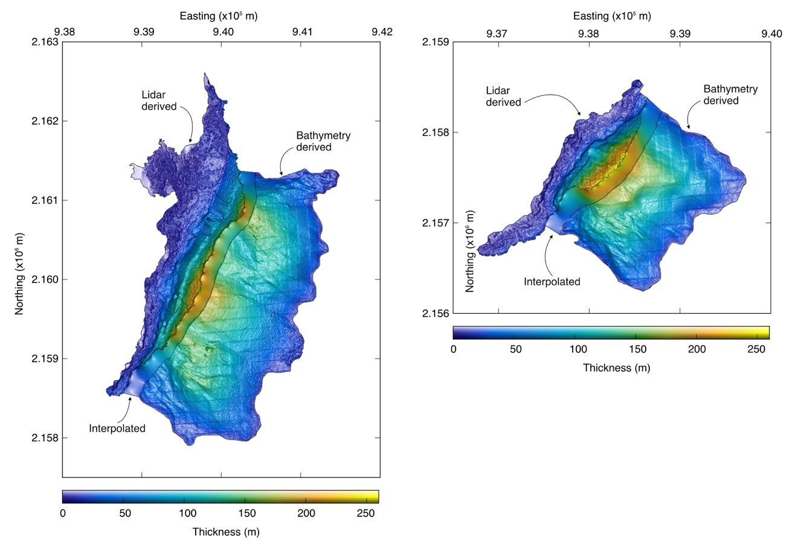
Supplementary Figure 2. The composite thickness maps for the deltas are shown for the Kapoho (left) and Ahalanui (right) deltas. Total volume for the deltas includes the submarine portion imaged by the 2018 bathymetric surveys, the volume deposited below sea level beneath new land imaged by lidar and UAS, and the region between the land and sea surveys interpolated via Matlab’s natural neighbor method within the scattered interpolant algorithm.

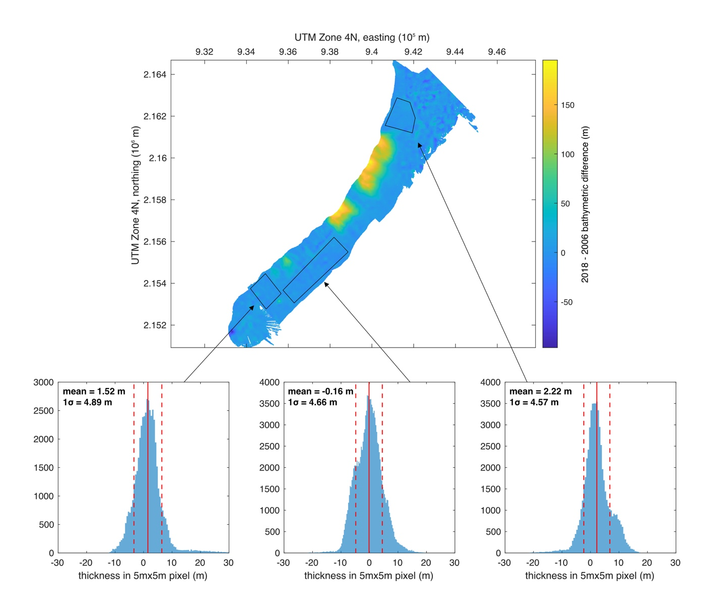
Supplementary Figure 3. Areas of no seafloor change were examined to evaluate the uncertainty in delta volume measurements. The depth difference for all the pixels in each unchanged area define a roughly gaussian distribution, with a mean from -0.16 to 2.22 m and a standard deviation (1𝜎) from 4.57 to 4.89 m. These results indicate that 5 m is likely the minimum depth difference that can be resolved from these data and ±10 m (2𝜎) is used to determine the uncertainty of volume estimates (Friant et al., 2010).

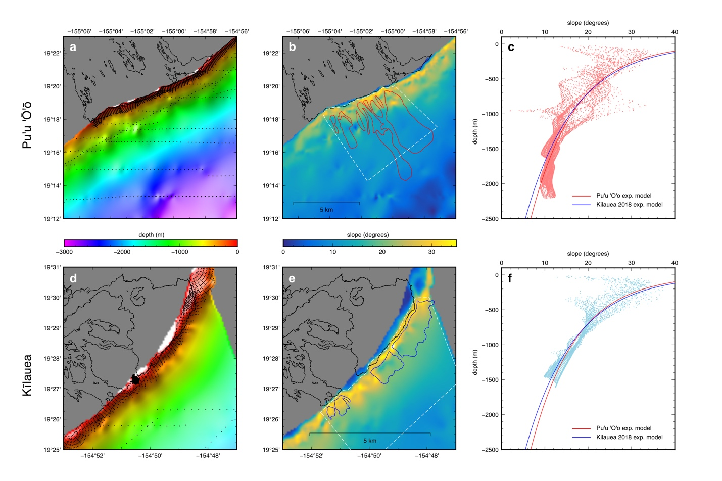
Supplementary Figure 4. NOAA single-beam bathymetric surveys in 1980 are used to compare pre-eruption slopes at the Puʻu ʻOʻo and 2018 lava delta sites. Bathymetric survey points indicated by black dots are interpolated via Matlabʻs biharmonic spline interpolation algorithm (a, d). Slopes derived from interpolated bathymetry are shown with areas of delta deposition indicated by red (Puʻu ʻOʻo) and blue (2018 Kilauea) lines (b, e). The distribution of slopes as a function of depth within the areas surrounded by dashed white lines in b and e are shown for Puʻu ʻOʻo (red) and 2018 Kilauea (blue) along with exponential fits to the distributions (c, f). There is large variability in slopes, but the exponential fits are very similar between the two areas.

Supplementary Table 1
 |  |  |  | Oxides in wt%
Sample | Lon | Lat | Depth (m) | SiO2 | TiO2 | Al2O3 | Fe2O3 | MnO | MgO | CaO | Na2O | K2O | P2O5 | Total
NA100-111 | -154.799 | 19.48707 | 719 | 50.15 | 2.40 | 13.11 | 12.45 | 0.18 | 8.24 | 10.47 | 2.27 | 0.44 | 0.24 | 99.95
NA100-113 | -154.802 | 19.48424 | 692 | 49.83 | 2.41 | 13.07 | 12.42 | 0.18 | 8.23 | 10.36 | 2.26 | 0.44 | 0.25 | 99.45
NA100-115 | -154.802 | 19.48449 | 649 | 50.01 | 2.44 | 13.17 | 12.39 | 0.18 | 7.97 | 10.41 | 2.27 | 0.44 | 0.25 | 99.52
NA100-123 | -154.802 | 19.48463 | 637 | 49.96 | 2.43 | 13.14 | 12.41 | 0.17 | 8.00 | 10.42 | 2.29 | 0.44 | 0.25 | 99.50
*BHVO-1 |  |  |  | 49.42 | 2.71 | 13.60 | 12.27 | 0.18 | 7.04 | 11.42 | 2.30 | 0.53 | 0.28 | 100.01
*BHVO-2 |  |  |  | 49.44 | 2.72 | 13.50 | 12.38 | 0.18 | 7.16 | 11.40 | 2.19 | 0.51 | 0.28 | 99.75

Supplementary Table 2
 | Trace Elements in ppm
Sample | Nb | Zr | Y | Sr | U | Rb | Th | Pb | Ga | Zn | Ni | Cr | V | Ce | Ba | La
NA100-111 | 13.7 | 153 | 24.3 | 319 | 0 | 7.5 | 2 | 1 | 19 | 113 | 169 | 463 | 267 | 30 | 97 | 8
NA100-113 | 14.3 | 155 | 24.4 | 320 | 0 | 7.7 | 1 | 1 | 19 | 113 | 168 | 465 | 275 | 33 | 102 | 9
NA100-115 | 14.3 | 157 | 24.8 | 322 | 0 | 7.6 | 2 | 1 | 19 | 114 | 157 | 446 | 278 | 31 | 101 | 7
NA100-123 | 14.3 | 156 | 24.6 | 321 | 0 | 7.8 | 2 | 2 | 19 | 110 | 151 | 449 | 270 | 31 | 100 | 9
*BHVO-1 | 18.3 | 179 | 24.5 | 376 | 0 | 8.9 | 1 | 2 | 20 | 111 | 111 | 294 | 293 | 38 | 128 | 14

Supplementary Tables 1 and 2. Major and trace element concentrations in samples from the Kilauea 2018 lava deltas as well as standards BHVO-1 and BHVO-2 (marked with *). Compositions were measured by XRF at UMass Amher

