Online Resource 5
Dynamic pressure evolution within the 18 May 1980 Mount St. Helens pyroclastic density current: evidence from tree damage
Bulletin of Volcanology
Nicole K. Guinn, James E. Gardner, Mark A. Helper
Department of Geological Sciences, Jackson School of Geosciences, The University of Texas at Austin, Austin, TX 78712-0254, USA
nkg425@utexas.edu

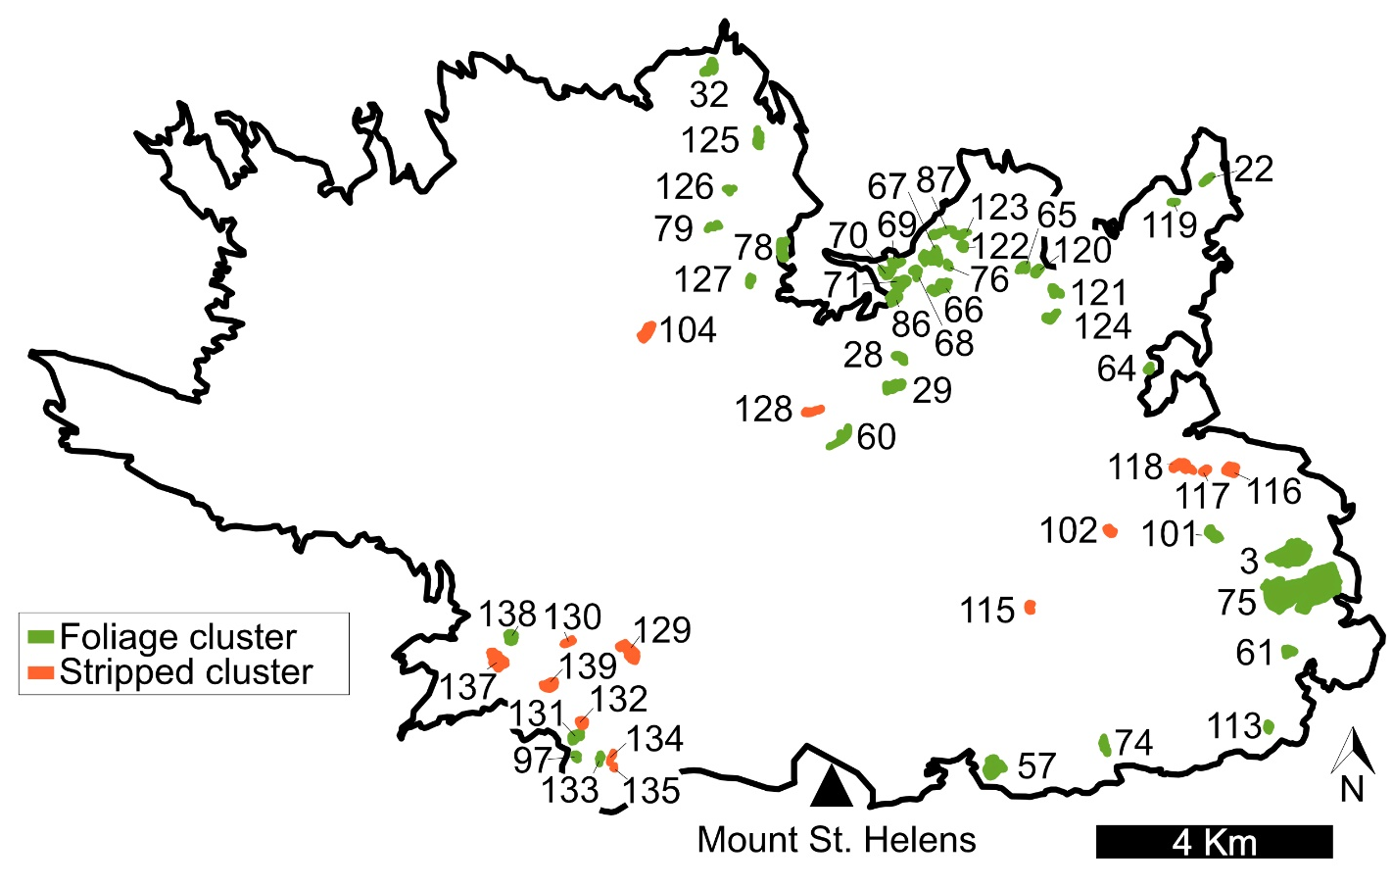
Online Resource 5: Numbered clusters in the blowdown zone. Numbers corresponding to Online Resource 6.

