Supplementary Materials (In a single document)

Materials and Methods (Statistical analysis and Melting experiments)
Supplementary Figures
Fig S1 : Starting material (Nescher, PDC, France). ABCD: SEM pictures, EFGH: Minerals under binocular microscope, I: Whole rock chemical analysis:
Fig S2 : SEM images of the starting material which is very rich in pumice fragments, glas shards and minerals. There is no a secondary melting traces.
Fig S3 : Anhydrous samples after melting experiments. Botryoidal texture is dominant but pumices and minerals are mainly conserved. Secondary mineral growths are presents
Fig S4 : SEM images of Hydrous sample after melting experiments. Pumices, glass shards and minerals show the melting textures and the basement represents the mineraloid melt with intensive secondary mineralisations.
Fig S5 : SEM-FIB laser engraving, we see acicular feldspars forming vaguely below the surface as phantom minerals in mineral gel (in hydrous sample). Step like melting is obvious in hydrous sample interior
Table S1. Compilation of encounters of aircraft with volcanic ash clouds, 1953–2009, as a Microsoft Excel 93–2007 spreadsheet file (.xls) (modified from Guffanti et al., 2010, the columns in red have been added).
Table S2 : Statistical distribution of the damage

Supplementary Materials for
“Volcanic Jets to Commercial Jets: Synopsis and Diagnosis”
Erkan Aydar¹, H. Evren Çubukçu¹, Cagdas Hakan Aladag², Nicolas Cluzel³, Orkun Ersoy¹, Çağatay Bal⁴, Didier Laporte³,
¹ Hacettepe University, Geological Engineering Department, 06800 Beytepe, Ankara, Turkey
² Hacettepe University, Department of Statistic, 06800 Beytepe, Ankara, Turkey
³ Université Clermont Auvergne, Laboratoire Magmas et Volcans, OPGC, CNRS, 6, Avenue Blaise Pascal 63178 Aubières-France
⁴ Muğla Sıtkı Koçman University, Department of Statistics, Muğla Sıtkı Koçman Üniversitesi,
48000 Kötekli/Muğla, Turkey

Statistical Study
Logistic Regression

By the definition of Plinian dry, we mean only the Plinian eruptions without external water contribution. Otherwise, we do not mean the presence of dissolved and volatile water in explosive magmas. In addition, Plinian-wet corresponds to the eruptions that the water is added from outside into the volcanic eruption and/or eruptive column. This addition may happen if the initial phase was mainly phreatomagmatic/vulcanian-wet eruptions for vent clearing or crater opening before forming the eruption plume. Or the heavy rain, if any, may also contribute to eruption clouds. The plumes may also be under the influence of a typhoon, or they can contain ice and ice-coated ash.
Moreover, under the Subplinian-Strombolian group, we collected eruptions of different energies, generally basaltic. Vulcanian eruptions have been clustered as dry and wet and discussed the wet ones together with the Phreatomagmatic explosions.

Categories:
Area 00.00-23.27 => Tropic => 1
23.27-40.00 => Subtropic => 2
40.00-66.33 => Tzone => 3
66.33+ => Frigid => 4
Type dry-wet+wet => wet => 1
dry => dry => 0
Explosion
Strombolian => 1
Vulcanian-dry => 2
Pelean => 3
Plinian-dry => 4
Plinian-wet => 5
Vulcanian-wet => 6
Phreatomagmatic => 7

Damage1 Engine Fail => 1
Other => 0

Damage2 Engine fail => 1
Engine problem => 2
Windshield problem => 3
Other damage => 4
No damage => 5

Binary Classification
Damage1 has two categories. There is damage or not. For this reason, Binary Logistic Regression analysis was applied. Binary Logistic Regression is regression analysis used in binary classification problems. Here, it is aimed to determine the effects and explanation levels of the available variables on the explosion (explosion), type (type) and area (independent variables), Damage1 (dependent variable), which indicates the fall of the aircraft, with regression analysis. Regression analysis shows the effect of a 1-unit change in the independent variable on the dependent variable. Analyzes were made in SPSS program. Missing observations of the relevant independent variables were excluded from the analysis, so the analysis was performed with 99 rows. In addition to the independent variables related to the model, new variables (interactions) containing the effects of these variables together were created and it was aimed to create a meaningful model containing these variables by backward elimination method.
Variables in the Equation
 |  | B | S.E. | Wald | df | Sig. | Exp(B) | 95% C.I.for EXP(B)
 |  |  |  |  |  |  |  | Lower | Upper
Step 1ª | explosion7_100 | -2.655 | 2.092 | 1.611 | 1 | .204 | .070 | .001 | 4.242
Step 1ª | type_100 | -12.401 | 7.716 | 2.583 | 1 | .108 | .000 | .000 | 15.203
Step 1ª | area_100 | -4.508 | 4.402 | 1.049 | 1 | .306 | .011 | .000 | 61.535
Step 1ª | exp_type | 2.059 | 1.426 | 2.084 | 1 | .149 | 7.839 | .479 | 128.375
Step 1ª | exp_area | .775 | .909 | .728 | 1 | .394 | 2.171 | .366 | 12.889
Step 1ª | type_area | 4.138 | 3.829 | 1.168 | 1 | .280 | 62.676 | .034 | 113914.948
Step 1ª | exp_type_area | -.688 | .678 | 1.030 | 1 | .310 | .503 | .133 | 1.897
Step 1ª | Constant | 15.947 | 9.061 | 3.098 | 1 | .078 | 8425098.491
Step 2ª | explosion7_100 | -1.016 | .781 | 1.690 | 1 | .194 | .362 | .078 | 1.675
Step 2ª | type_100 | -7.523 | 4.301 | 3.059 | 1 | .080 | .001 | .000 | 2.477
Step 2ª | area_100 | -1.109 | 1.670 | .441 | 1 | .507 | .330 | .012 | 8.708
Step 2ª | exp_type | .982 | .549 | 3.196 | 1 | .074 | 2.669 | .910 | 7.831
Step 2ª | type_area | 1.499 | 2.032 | .544 | 1 | .461 | 4.478 | .083 | 240.241
Step 2ª | exp_type_area | -.147 | .212 | .484 | 1 | .487 | .863 | .570 | 1.307
Step 2ª | Constant | 9.433 | 3.930 | 5.762 | 1 | .016 | 12493.687
Step 3ª | explosion7_100 | -1.299 | .641 | 4.103 | 1 | .043 | .273 | .078 | .959
Step 3ª | type_100 | -5.700 | 2.863 | 3.963 | 1 | .047 | .003 | .000 | .916
Step 3ª | exp_type | .947 | .497 | 3.624 | 1 | .057 | 2.577 | .972 | 6.828
Step 3ª | type_area | .267 | .819 | .106 | 1 | .744 | 1.306 | .262 | 6.499
Step 3ª | exp_type_area | -.042 | .141 | .088 | 1 | .767 | .959 | .728 | 1.264
Step 3ª | Constant | 8.113 | 3.087 | 6.909 | 1 | .009 | 3337.454
Step 4ª | explosion7_100 | -1.321 | .633 | 4.353 | 1 | .037 | .267 | .077 | .923
Step 4ª | type_100 | -5.449 | 2.673 | 4.157 | 1 | .041 | .004 | .000 | .810
Step 4ª | exp_type | .901 | .464 | 3.775 | 1 | .052 | 2.462 | .992 | 6.111
Step 4ª | type_area | .031 | .185 | .029 | 1 | .866 | 1.032 | .718 | 1.482
Step 4ª | Constant | 8.250 | 3.023 | 7.447 | 1 | .006 | 3828.255
Step 5ª | explosion7_100 | -1.284 | .588 | 4.774 | 1 | .029 | .277 | .088 | .876
Step 5ª | type_100 | -5.253 | 2.358 | 4.962 | 1 | .026 | .005 | .000 | .532
Step 5ª | exp_type | .873 | .426 | 4.194 | 1 | .041 | 2.395 | 1.038 | 5.523
Step 5ª | Constant | 8.087 | 2.823 | 8.206 | 1 | .004 | 3250.848
a. Variable(s) entered on step 1: explosion7_100, type_100, area_100, exp_type, exp_area, type_area, exp_type_area.

According to the first findings obtained, it is seen that the variables related to the model, in which the contribution of each independent variable in the model is significant, are the variables that include the combined effect of the explosion, type and explosion-type variables.
The analysis tables with detailed results for the 3 independent variables mentioned are given below.

Case Processing Summary
Unweighted Casesª |  | N | Percent
Selected Cases | Included in Analysis | 99 | 100.0
Selected Cases | Missing Cases | 0 | .0
Selected Cases | Total | 99 | 100.0
Unselected Cases |  | 0 | .0
Total |  | 99 | 100.0
a. If weight is in effect, see classification table for the total number of cases.
As can be seen, the analysis was carried out with 99 observations for each variable.
Dependent Variable Encoding
Original Value | Internal Value
Engine Fail | 0
Other | 1

As can be seen, engine failure is taken as the reference variable and therefore the results obtained will be interpreted accordingly.

Omnibus Tests of Model Coefficients
 |  | Chi-square | df | Sig.
Step 1 | Step | 11.667 | 3 | .009
Step 1 | Block | 11.667 | 3 | .009
Step 1 | Model | 11.667 | 3 | .009

It is seen in the omnibus test results that the established model is significant.

Model Summary
Step | -2 Log likelihood | Cox & Snell R Square | Nagelkerke R Square
1 | 108.074ª | .111 | .158
a. Estimation terminated at iteration number 5 because parameter estimates changed by less than .001.

The r square value of the model was measured as 0.158.

Classification Tableª
 | Observed |  | Predicted
 |  |  | damage2_100 |  | Percentage Correct
 |  |  | Engine Fail | Other | Percentage Correct
Step 1 | damage2_100 | Engine Fail | 7 | 22 | 24.1
Step 1 | damage2_100 | Other | 5 | 65 | 92.9
Step 1 | Overall Percentage |  |  |  | 72.7
a. The cut value is .500

The classification table was obtained with a performance of 72.7%.

Variables in the Equation
 |  | B | S.E. | Wald | df | Sig. | Exp(B) | 95% C.I.for EXP(B)
 |  |  |  |  |  |  |  | Lower | Upper
Step 1ª | explosion7_100 | -1.284 | .588 | 4.774 | 1 | .029 | .277 | .088 | .876
Step 1ª | type_100 | -5.253 | 2.358 | 4.962 | 1 | .026 | .005 | .000 | .532
Step 1ª | exp_type | .873 | .426 | 4.194 | 1 | .041 | 2.395 | 1.038 | 5.523
Step 1ª | Constant | 8.087 | 2.823 | 8.206 | 1 | .004 | 3250.848
a. Variable(s) entered on step 1: explosion7_100, type_100, exp_type.

It can be seen in the table that the variables related to the model are significant. It is seen that the explosion variable is statistically significant and affects the dependent variable with an effect of approximately 1.3 units in the negative direction. In other words, for this variable, which is described as Strombolian – 1, Vulcanian-dry – 2, Pelean – 3, Plinian-dry – 4, Plinian-wet – 5, Vulcanian-wet – 6, Phreatomagmatic – 7, as the explosion type increases, the 'engine agent' state emerges. output can also be interpreted as increasing. It is seen that the type variable is statistically significant and affects the dependent variable with an effect of approximately 5.2 units in the negative direction. In other words, for this variable, which is described as dry and wet, as the wetness increases, the emergence of the 'engineer fail' situation also increases. It is seen that the independent variable formed by the variables of Explosion and type together (interaction) affects the dependent variable positively and has an odds ratio of 2.4. If we interpret it, if the Explosion and type variables together increase by 1 unit, that observation will be 2.4 times more likely to be in the 'other' category in the dependent variable.

Multinomial Classification (For Damage 2 variable)

Case Processing Summary
 |  | N | Marginal Percentage
damage5 | Engine Fail | 11 | 11.1%
damage5 | Engine Problem | 18 | 18.2%
damage5 | Windshield Problem | 29 | 29.3%
damage5 | Other Damage | 11 | 11.1%
damage5 | No Damage | 30 | 30.3%
Valid |  | 99 | 100.0%
Missing |  | 0
Total |  | 99
Subpopulation |  | 19ª
a. The dependent variable has only one value observed in 4 (21.1%) subpopulations.

As can be seen in the frequency table of 5 categories, the number of observations in each category varies. It is noteworthy that the number of observations in the `Engine Fail` and `Other Damage` categories is quite low.

Model Fitting Information
Model | Model Fitting Criteria |  |  | Likelihood Ratio Tests
Model | AIC | BIC | -2 Log Likelihood | Chi-Square | df | Sig.
Intercept Only | 197.177 | 207.557 | 189.177
Final | 195.992 | 279.035 | 131.992 | 57.185 | 28 | .001

It is observed that the model is significantly different from the model with only constant values. In other words, the other independent variables added to the model against the 5 category dependent variables provided a statistically significant contribution.

Likelihood Ratio Tests
Effect | Model Fitting Criteria |  |  | Likelihood Ratio Tests
Effect | AIC of Reduced Model | BIC of Reduced Model | -2 Log Likelihood of Reduced Model | Chi-Square | df | Sig.
Intercept | 200.751 | 273.415 | 144.751ª | 12.760 | 4 | .013
area | 201.393 | 274.057 | 145.393ª | 13.402 | 4 | .009
explosion7 | 197.155 | 269.818 | 141.155 | 9.163 | 4 | .057
type | 199.074 | 271.737 | 143.074ª | 11.082 | 4 | .026
exp_type | 198.943 | 271.607 | 142.943 | 10.952 | 4 | .027
exp_area | 200.794 | 273.458 | 144.794 | 12.803 | 4 | .012
type_area | 198.851 | 271.514 | 142.851ª | 10.860 | 4 | .028
exp_type_area | 200.132 | 272.795 | 144.132 | 12.140 | 4 | .016
The chi-square statistic is the difference in -2 log-likelihoods between the final model and a reduced model. The reduced model is formed by omitting an effect from the final model. The null hypothesis is that all parameters of that effect are 0.
a. Unexpected singularities in the Hessian matrix are encountered. This indicates that either some predictor variables should be excluded or some categories should be merged.

It can be seen that the 3 main independent variables and their interaction variables all contribute significantly to the model individually. Only the Explosion variable can be interpreted as 'borderline statistically significant'.

Parameter Estimates
damage5ª |  | B | Std. Error | Wald | df | Sig. | Exp(B) | 95% Confidence Interval for Exp(B)
 |  |  |  |  |  |  |  | Lower Bound | Upper Bound
Engine Fail | Intercept | -101.412 | 936.666 | .012 | 1 | .914
Engine Fail | area | 44.560 | 312.231 | .020 | 1 | .887 | 22493678159816147000.000 | 3.806E-247 | 1.329E+285
Engine Fail | explosion7 | 10.551 | 6.562 | 2.585 | 1 | .108 | 38201.498 | .099 | 14708405068.847
Engine Fail | type | 61.686 | 468.351 | .017 | 1 | .895 | 616255672000868150000000000.000 | .000 | .^{b}
Engine Fail | exp_type | -7.329 | 2.651 | 7.642 | 1 | .006 | .001 | 3.634E-6 | .119
Engine Fail | exp_area | -5.751 | 1.293 | 19.771 | 1 | .000 | .003 | .000 | .040
Engine Fail | type_area | -30.427 | 156.173 | .038 | 1 | .846 | 6.106E-14 | 7.091E-147 | 5.258E+119
Engine Fail | exp_type_area | 4.406 | .000 | . | 1 | . | 81.920 | 81.920 | 81.920
Engine Problem | Intercept | -33.729 | 12.275 | 7.551 | 1 | .006
Engine Problem | area | 19.039 | 7.753 | 6.031 | 1 | .014 | 185616131.229 | 46.698 | 737788944150258.200
Engine Problem | explosion7 | 5.970 | 2.581 | 5.351 | 1 | .021 | 391.428 | 2.489 | 61559.606
Engine Problem | type | 29.165 | 11.160 | 6.830 | 1 | .009 | 4635639781918.747 | 1468.243 | 14635969132560864000000.000
Engine Problem | exp_type | -5.165 | 2.009 | 6.611 | 1 | .010 | .006 | .000 | .293
Engine Problem | exp_area | -3.421 | 1.509 | 5.140 | 1 | .023 | .033 | .002 | .629
Engine Problem | type_area | -17.027 | 7.291 | 5.453 | 1 | .020 | 4.030E-8 | 2.506E-14 | .065
Engine Problem | exp_type_area | 3.079 | 1.352 | 5.184 | 1 | .023 | 21.740 | 1.535 | 307.927
Windshield Problem | Intercept | -35.202 | 12.075 | 8.498 | 1 | .004
Windshield Problem | area | 24.753 | 7.516 | 10.846 | 1 | .001 | 56260493866.545 | 22509.549 | 140617795454452096.000
Windshield Problem | explosion7 | 6.498 | 2.500 | 6.753 | 1 | .009 | 663.631 | 4.938 | 89196.114
Windshield Problem | type | 29.509 | 11.142 | 7.015 | 1 | .008 | 6539535558906.987 | 2146.568 | 19922747580148360000000.000
Windshield Problem | exp_type | -5.488 | 1.981 | 7.675 | 1 | .006 | .004 | 8.525E-5 | .201
Windshield Problem | exp_area | -4.698 | 1.504 | 9.757 | 1 | .002 | .009 | .000 | .174
Windshield Problem | type_area | -20.721 | 7.029 | 8.690 | 1 | .003 | 1.002E-9 | 1.042E-15 | .001
Windshield Problem | exp_type_area | 3.934 | 1.315 | 8.948 | 1 | .003 | 51.134 | 3.883 | 673.435
Other Damage | Intercept | -19.730 | 29.390 | .451 | 1 | .502
Other Damage | area | 17.192 | 12.106 | 2.017 | 1 | .156 | 29270326.635 | .001 | 590799383359996420.000
Other Damage | explosion7 | 2.989 | 5.194 | .331 | 1 | .565 | 19.873 | .001 | 523718.994
Other Damage | type | 17.653 | 29.018 | .370 | 1 | .543 | 46386981.858 | 9.244E-18 | 232772539727019600000000000000000.000
Other Damage | exp_type | -3.413 | 4.828 | .500 | 1 | .480 | .033 | 2.559E-6 | 424.148
Other Damage | exp_area | -3.037 | 2.186 | 1.930 | 1 | .165 | .048 | .001 | 3.484
Other Damage | type_area | -15.455 | 11.822 | 1.709 | 1 | .191 | 1.940E-7 | 1.679E-17 | 2241.056
Other Damage | exp_type_area | 2.959 | 2.037 | 2.111 | 1 | .146 | 19.284 | .356 | 1044.902
a. The reference category is: No Damage.
b. Floating point overflow occurred while computing this statistic. Its value is therefore set to system missing.

When the other categories are evaluated individually against the `No Damage` category, which is determined as the reference category, the low number of observations in the `Engine Fail` and `Other Damage` categories among the models established, leads to the conclusion that the models established for these categories are not significant. Therefore, it can be concluded that the independent variables of the main model for all categories will not yield significant results.

Parameter Estimates
damage5ª |  | B | Std. Error | Wald | df | Sig. | Exp(B) | 95% Confidence Interval for Exp(B)
 |  |  |  |  |  |  |  | Lower Bound | Upper Bound
Engine Fail | Intercept | -2.965 | .934 | 10.074 | 1 | .002
Engine Fail | area | 1.142 | .466 | 6.016 | 1 | .014 | 3.134 | 1.258 | 7.809
Engine Problem | Intercept | -1.895 | .736 | 6.636 | 1 | .010
Engine Problem | area | .852 | .404 | 4.446 | 1 | .035 | 2.344 | 1.062 | 5.175
Windshield Problem | Intercept | -2.250 | .699 | 10.363 | 1 | .001
Windshield Problem | area | 1.261 | .372 | 11.526 | 1 | .001 | 3.531 | 1.704 | 7.314
Other Damage | Intercept | -3.250 | .974 | 11.139 | 1 | .001
Other Damage | area | 1.275 | .472 | 7.316 | 1 | .007 | 3.580 | 1.421 | 9.022
a. The reference category is: No Damage.

When a multinominal logit regression model including only the variable `area` is constructed, it is observed that the variable `area` is significant for each category in the individual comparisons of the reference category and the other categories in the independent variable and that for each 1 unit increase in the ODDs rates, the probability of selecting the other categories is approximately 3 times higher than the reference category. In other words, as the `area` variable increases, the probability of having a `problem` increases approximately 3 times.
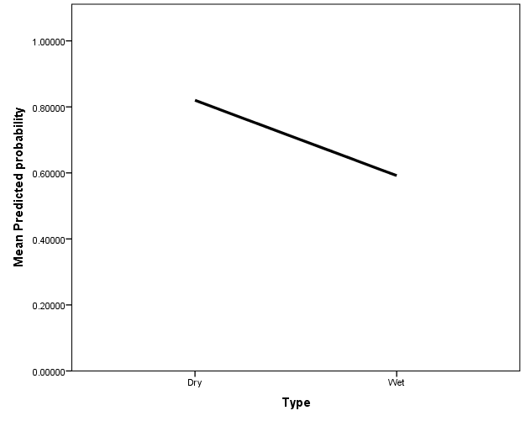

Looking at the relationship of the variable `Type` alone against the predicted probabilities of the model's output, we can see that the predicted probability of the output of the reference category `Other` decreases with increasing wetness. That is, as dryness increases, the likelihood of the model generating the `Other` output increases, while as wetness increases, the likelihood of the model generating the `Engine Fail` output increases.

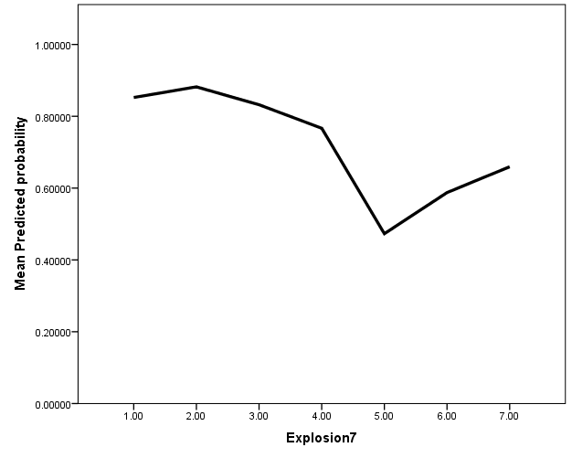
Looking at the relationship of the variable `Explosion` alone against the estimated probabilities of the model's output, it can be seen that the estimated probability of the output for the reference category `Other` decreases for explosion values 2-3-4-5 and increases for 1-6-7.

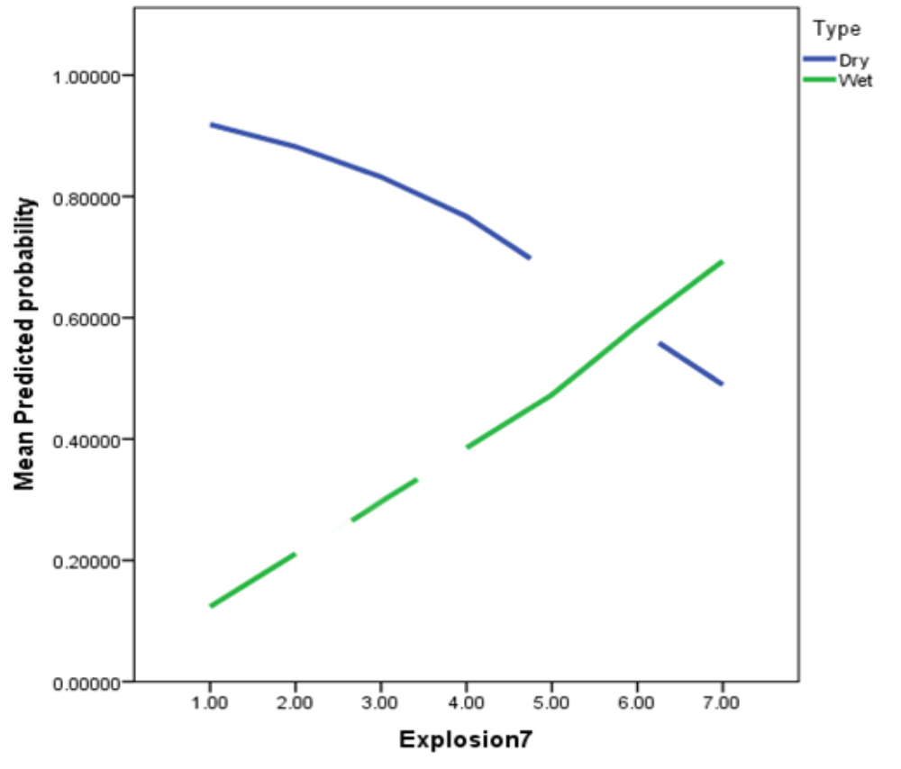

Looking at the relationship between the variables `Explosion` and `Type` in relation to the estimated probabilities of the model's output, it is observed that the estimated probability of the output for the reference category `Other` increases as the value of `Explosion` increases, while the value of `Type` increases as the value of `Explosion` increases to give the output `Other` in the wet case and `Engine Fail` in the dry case.

explosion7
 |  | Frequency | Percent | Valid Percent | Cumulative Percent
Valid | 1.00 | 12 | 12.1 | 12.1 | 12.1
Valid | 2.00 | 13 | 13.1 | 13.1 | 25.3
Valid | 3.00 | 5 | 5.1 | 5.1 | 30.3
Valid | 4.00 | 18 | 18.2 | 18.2 | 48.5
Valid | 5.00 | 8 | 8.1 | 8.1 | 56.6
Valid | 6.00 | 25 | 25.3 | 25.3 | 81.8
Valid | 7.00 | 18 | 18.2 | 18.2 | 100.0
Valid | Total | 99 | 100.0 | 100.0

Type
 |  | Frequency | Percent | Valid Percent | Cumulative Percent
Valid | Dry | 50 | 50.5 | 50.5 | 50.5
Valid | Wet | 49 | 49.5 | 49.5 | 100.0
Valid | Total | 99 | 100.0 | 100.0

 |  |  |  | damage2
 |  |  |  | Engine Fail |  | Other
 |  |  |  | Count | Row N % | Count | Row N %
Type | Dry | explosion7 | 1.00 | 0 | 0.0% | 11 | 100.0%
Type | Dry | explosion7 | 2.00 | 1 | 7.7% | 12 | 92.3%
Type | Dry | explosion7 | 3.00 | 3 | 60.0% | 2 | 40.0%
Type | Dry | explosion7 | 4.00 | 4 | 22.2% | 14 | 77.8%
Type | Dry | explosion7 | 5.00 | 0 | 0.0% | 0 | 0.0%
Type | Dry | explosion7 | 6.00 | 0 | 0.0% | 0 | 0.0%
Type | Dry | explosion7 | 7.00 | 1 | 33.3% | 2 | 66.7%
Type | Wet | explosion7 | 1.00 | 1 | 100.0% | 0 | 0.0%
Type | Wet | explosion7 | 2.00 | 0 | 0.0% | 0 | 0.0%
Type | Wet | explosion7 | 3.00 | 0 | 0.0% | 0 | 0.0%
Type | Wet | explosion7 | 4.00 | 0 | 0.0% | 0 | 0.0%
Type | Wet | explosion7 | 5.00 | 5 | 62.5% | 3 | 37.5%
Type | Wet | explosion7 | 6.00 | 8 | 32.0% | 17 | 68.0%
Type | Wet | explosion7 | 7.00 | 6 | 40.0% | 9 | 60.0%

In the frequency tables and crosstabulation above for the `Type` and `explosion` variables, the frequency distribution for the `Engine Fail` and `Other` categories are given with the `Type` variable and the `explosion` category as a subcategory. Since the variable `Explosion` consists of 7 different categories and the number of observations representing each category varies significantly, it is observed that this variable alone is less able to explain the dependent variable than the variable `Type`. This finding is also evident from the coefficient in the logistic regression model. In addition to this, the fact that `Type` is equally distributed and consists of only 2 categories indicates that it is a significant variable in terms of making more consistent inferences. Similarly, the coefficient in the logistic regression model shows that this variable alone has a significant effect. Finally, the skewness of the distribution of observations in the crosstabulation questions to what extent the combined effect of `Type` and `explosion` can be effective.

Melting Experiment Methodology
Neschers PDC ashes were first dried in an oven at 80°C for 24 hours. The larger grains were discarded by sieving under 325 microns. About 38 mg of starting powder were loaded into gold capsules (with 20 mm in length, 3 and 4 mm outer diameter and wall thickness of 0.2 mm for dry and wet experiment, respectively). Two types of conditions were tested: dry (on two samples) or with 1.68 wt% added water (on one sample). In preliminary experiments with more than 2 wt% added water, the capsules did not withstand the internal pressure and bursted, so we decided to reduce the amount of added water to 1.68 wt% and to increase the size of the capsule. The experiments were conducted in an externally-heated pressure vessel, which is mounted on a nitrogen pressure line. The maximum operating pressure is approximately 300 MPa, and the maximum temperature ranges from 800-850°C at high pressure to 900-950°C at low pressure (≤ 100 MPa). The autoclave is equipped with a rapid quench extension and an automatic decompression system^{49,50}.
Recognizing that fast heating is necessary to more closely reproduce the natural conditions during ash ingestion by aircraft engines, we chose a procedure that allows the sample to be rapidly subjected to the targeted experimental conditions (900°C and 40 bar). After welding, the capsules were loaded into the pressure vessel at the level of the cooling circuit (cold spot). The vessel was then pressurized to 40 bar and then heated to 900°C. Once the temperature of 900°C was reached, the capsules were positioned almost instantaneously (a few seconds) at the hot spot of the pressure vessel by lifting the sample holder using an external electromagnet. After 30 minutes at 900°C-40 bar, the experiment was quenched by dropping the capsules at the cold spot. Then the samples studied under SEM and FIB-SEM.

Supplementary Document
Supplementary Figures

Fig.S1. Starting material (Nescher, PDC, France). ABCD: SEM pictures, EFGH: Minerals under binocular microscope, I: Whole rock chemical analysis

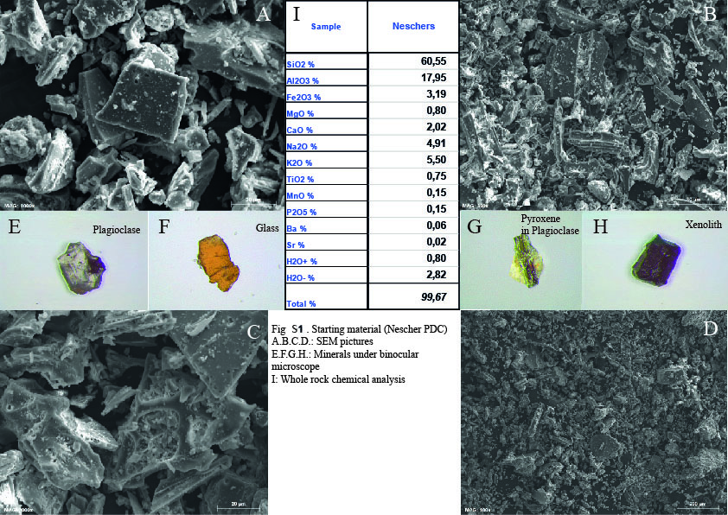

FigS2. SEM images of the starting material which is very rich in pumice fragments, glas shards and minerals. There is no a secondary melting traces.

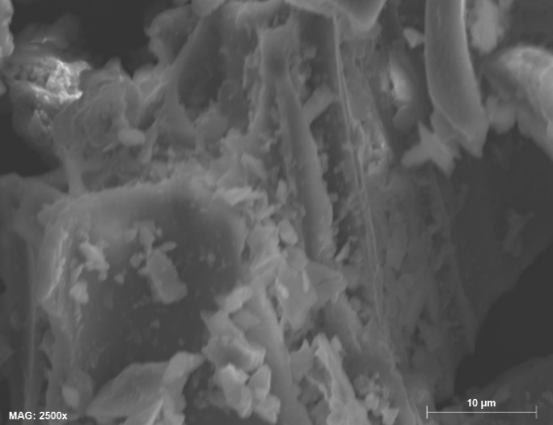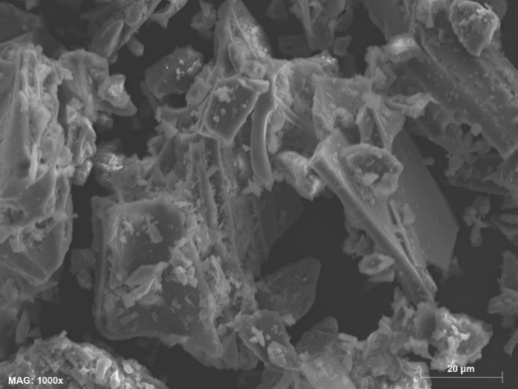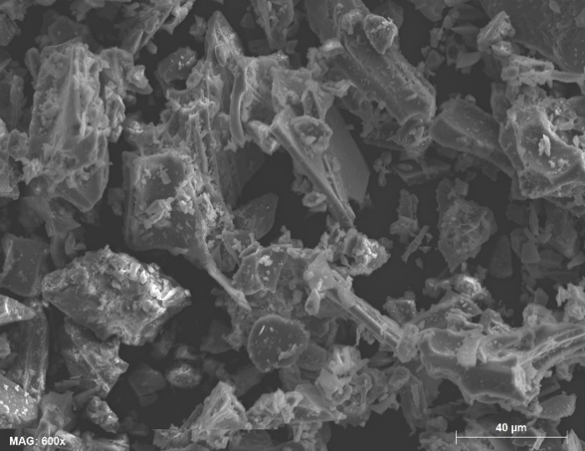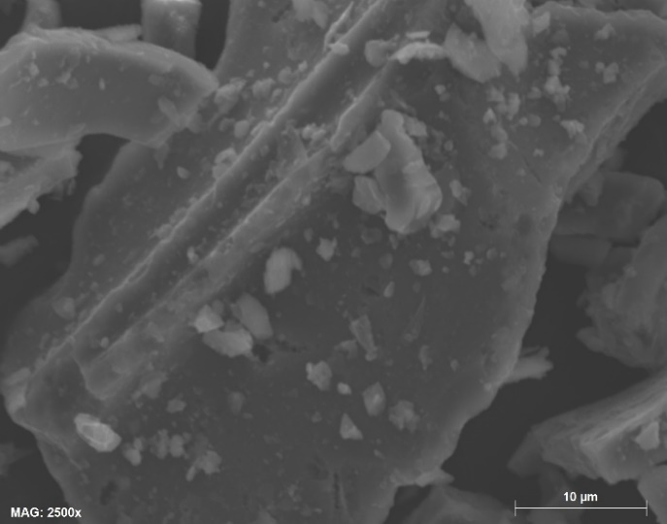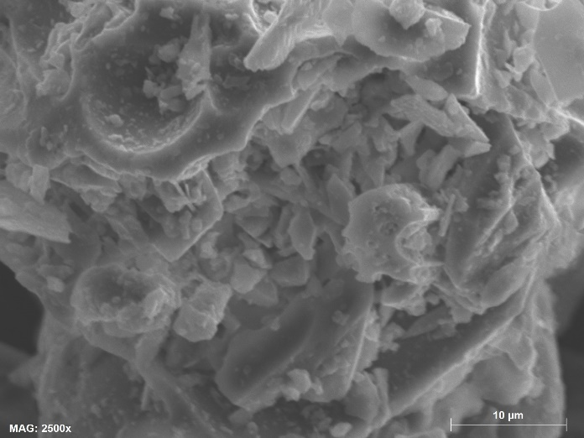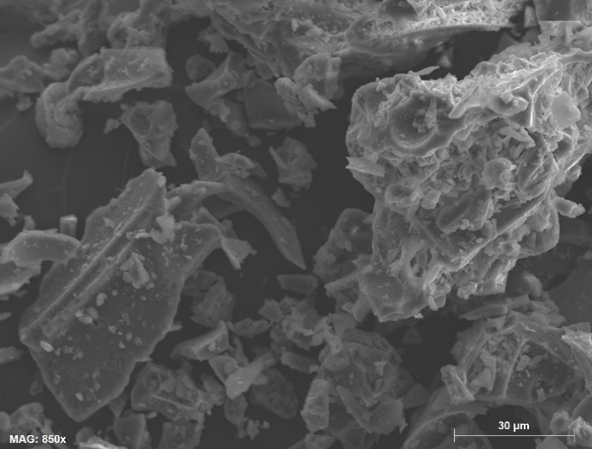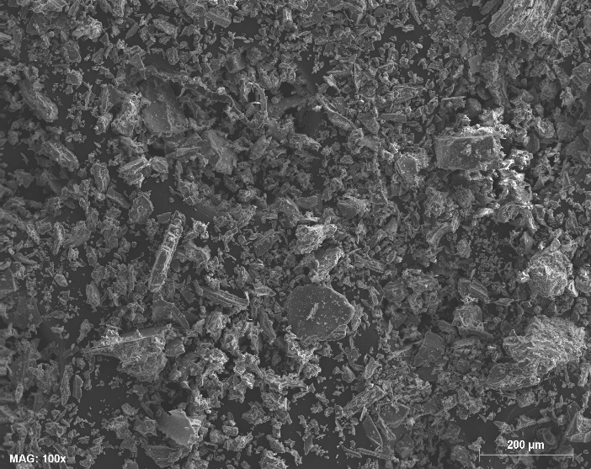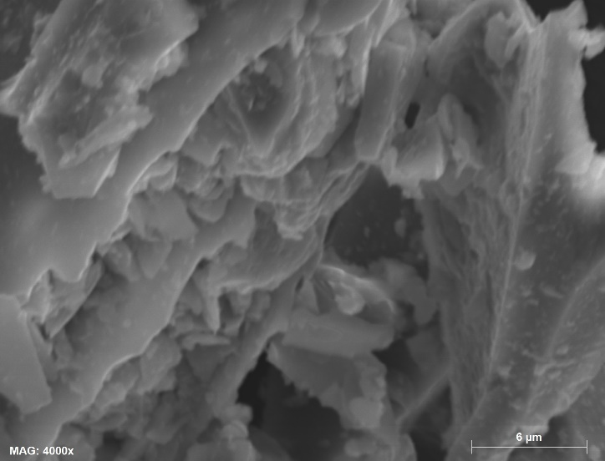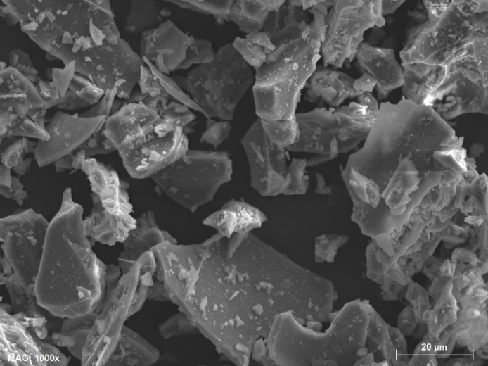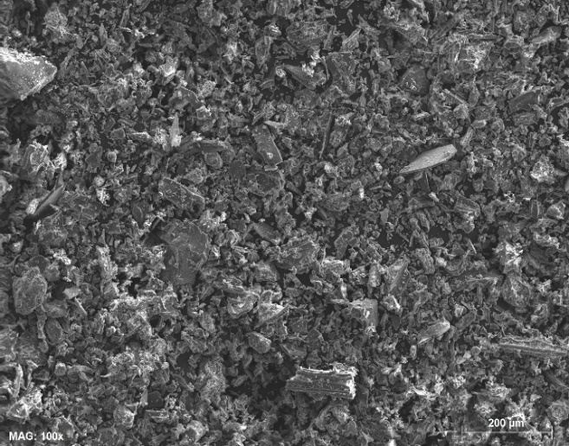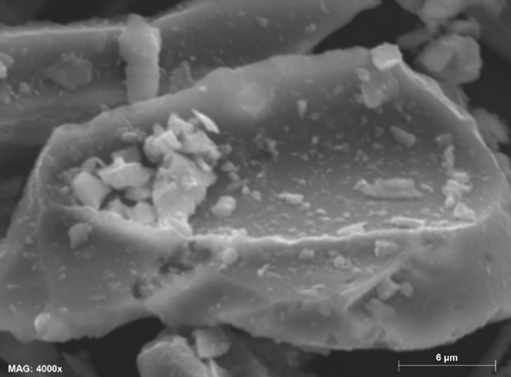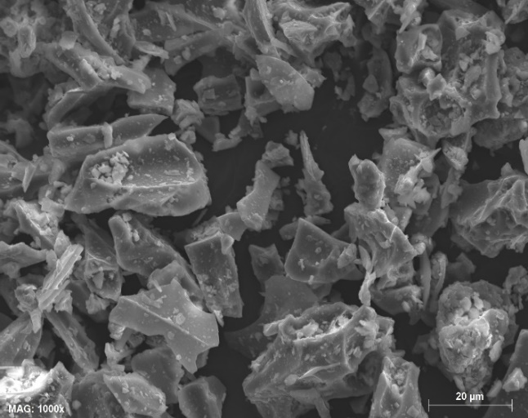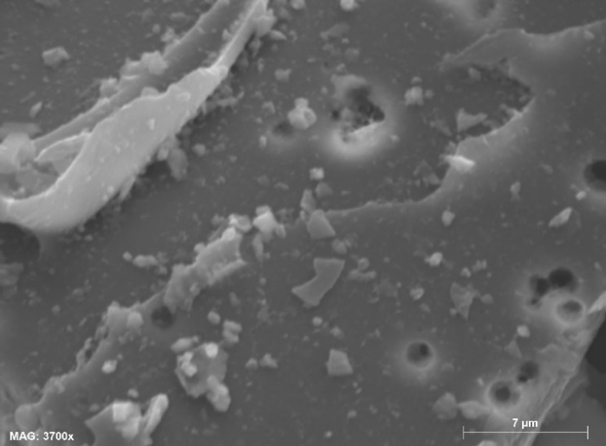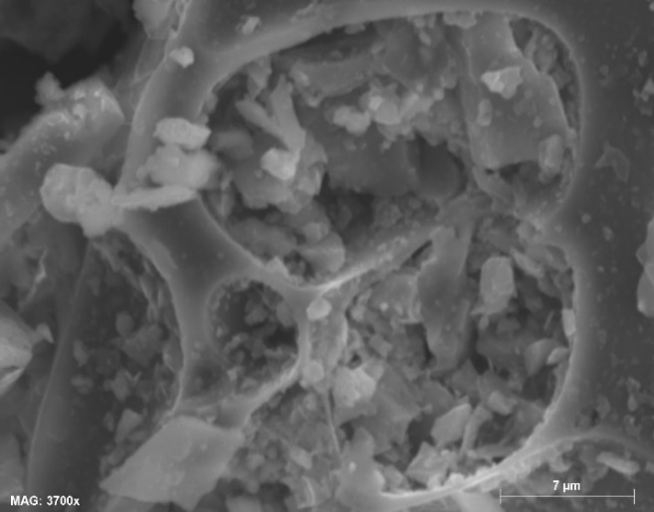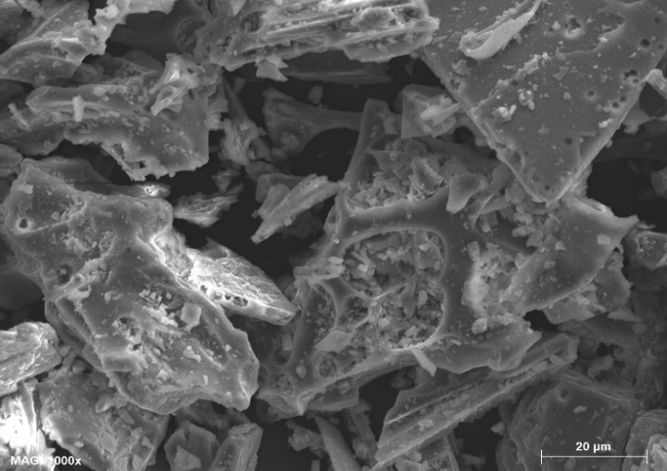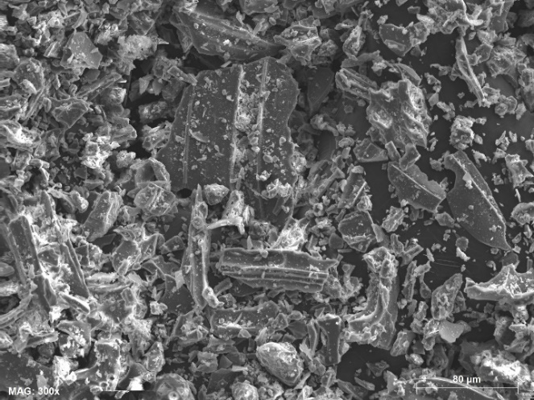
FigS2.end

Fig.S3. Anhydrous samples after melting experiments. Botryoidal texture is dominant but pumices and minerals are mainly conserved. Secondary mineral growths are presents

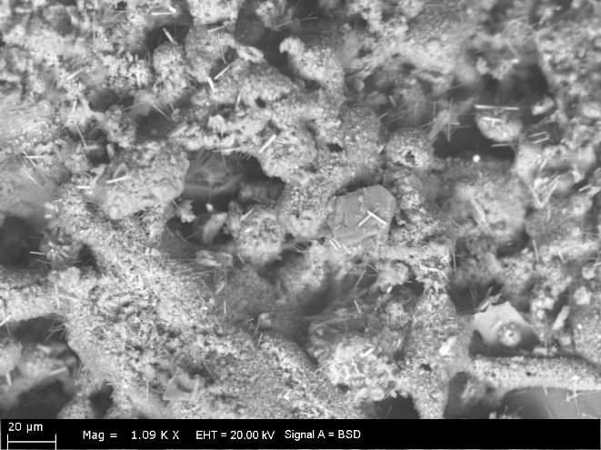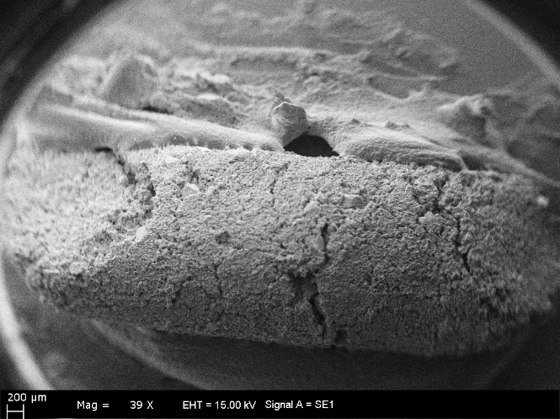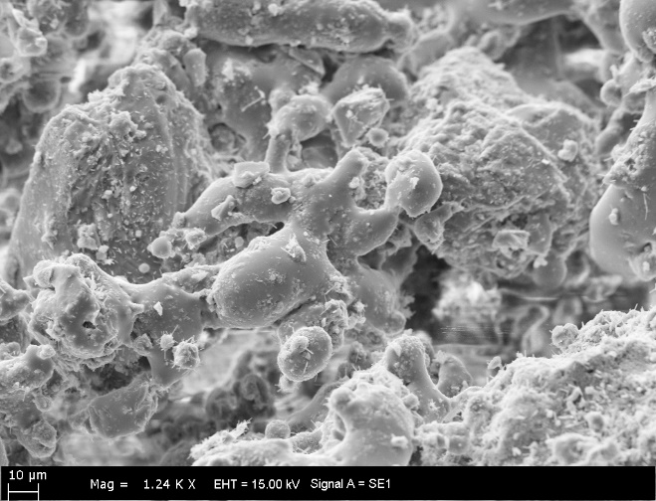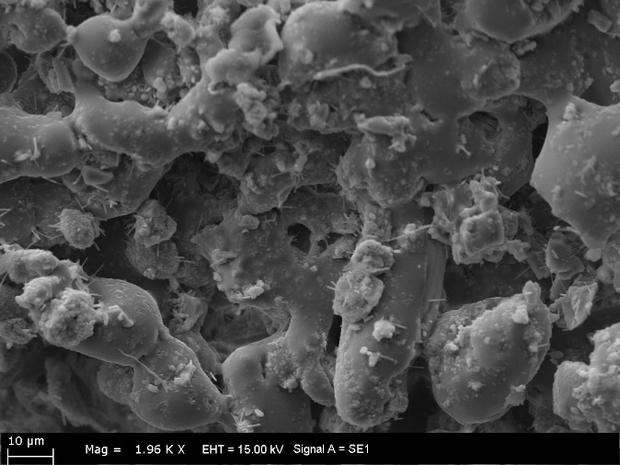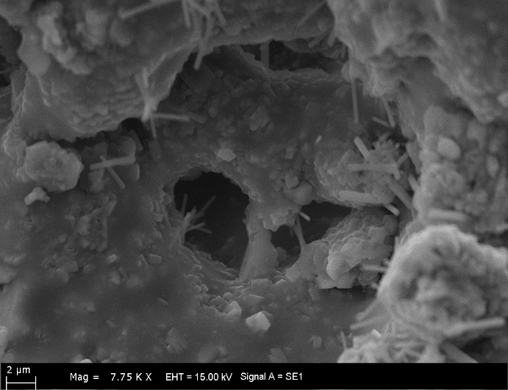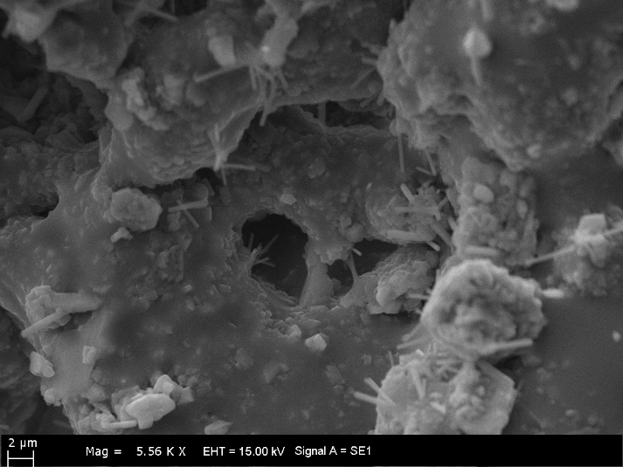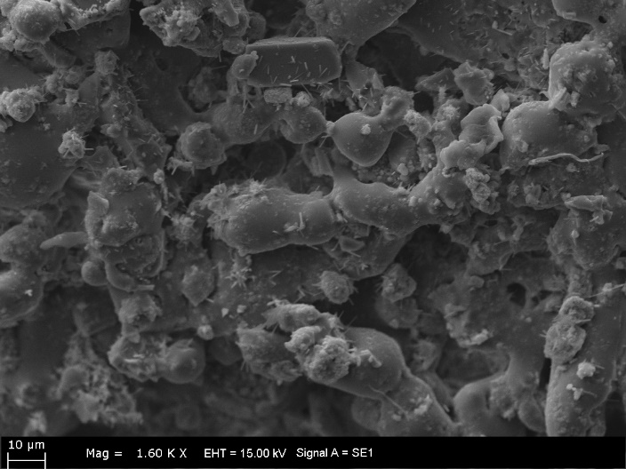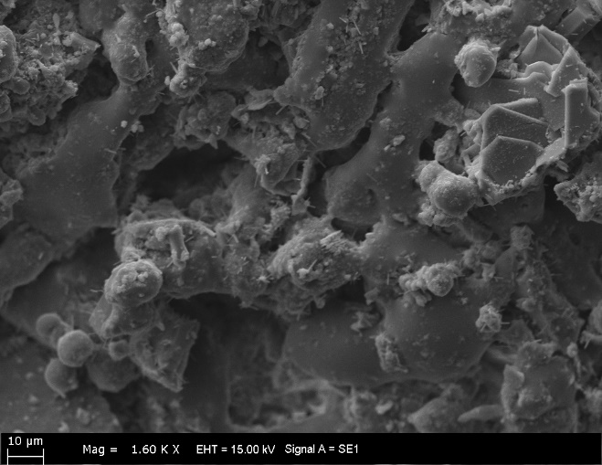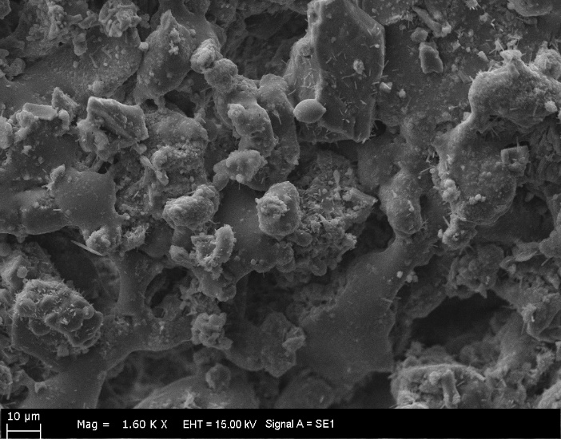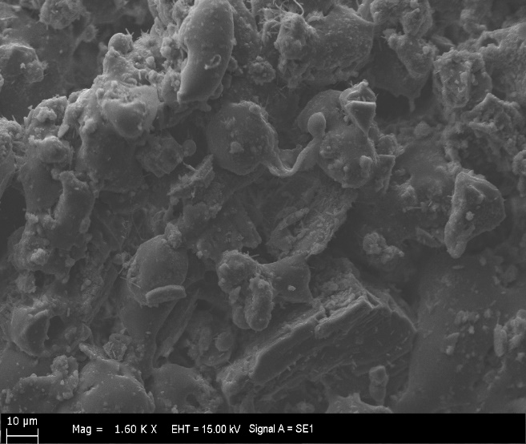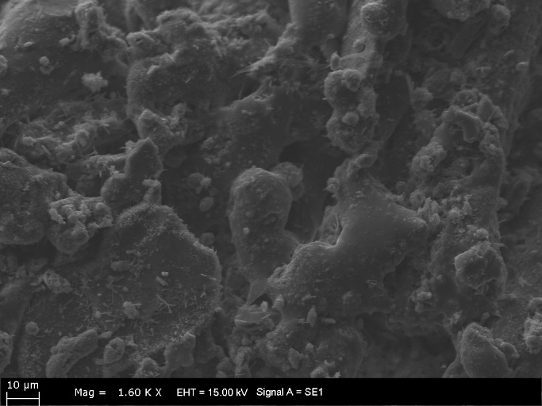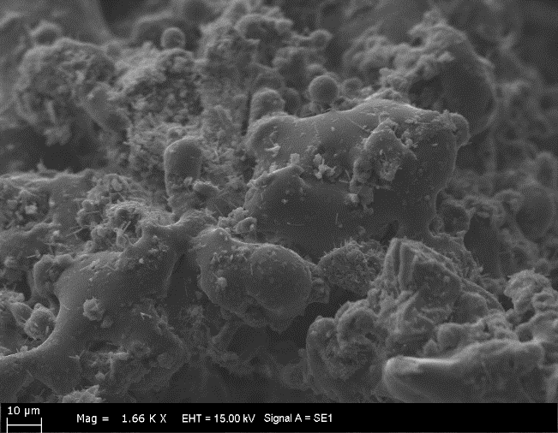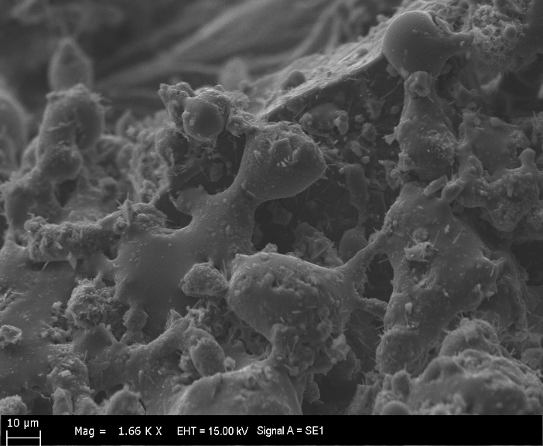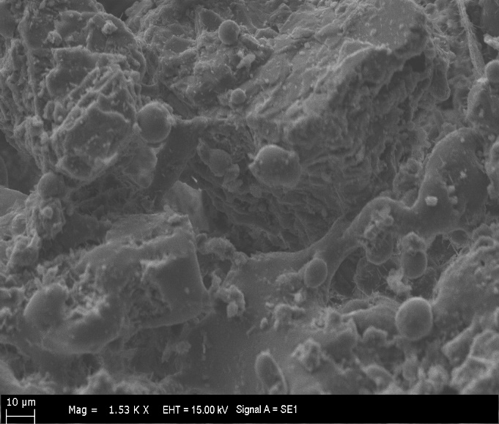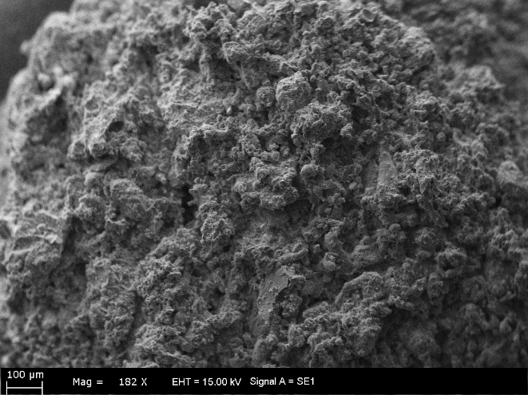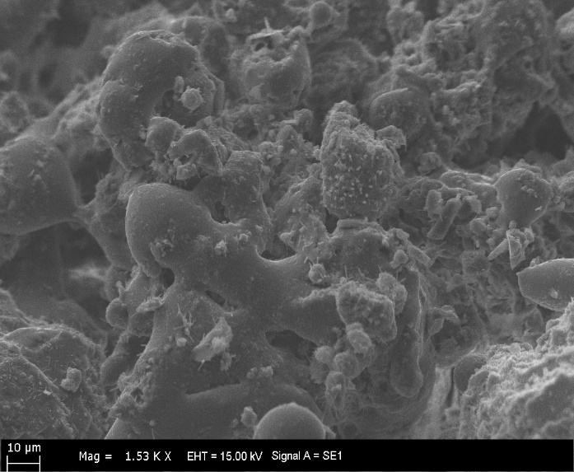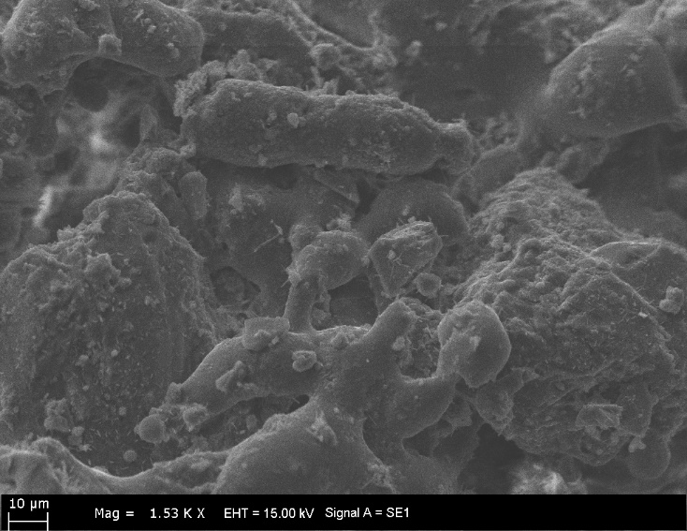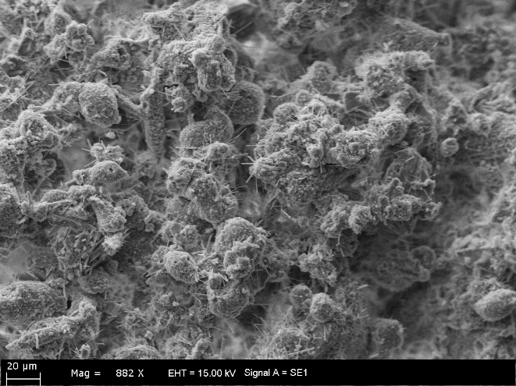
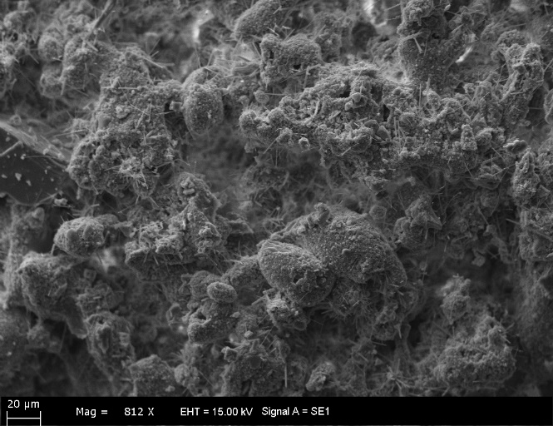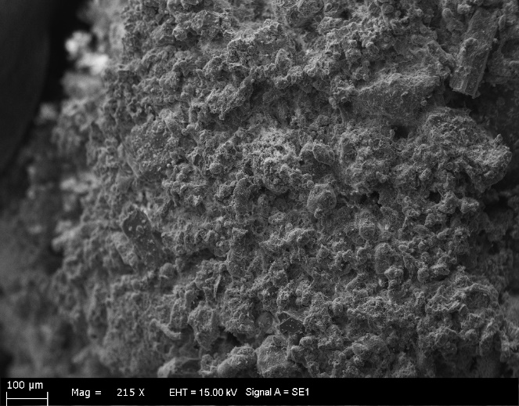
Fig.S3.end

Fig.S4. SEM images of Hydrous sample after melting experiments. Pumices, glass shards and minerals show the melting textures and the basement represents the mineraloid melt with intensive secondary mineralisations.

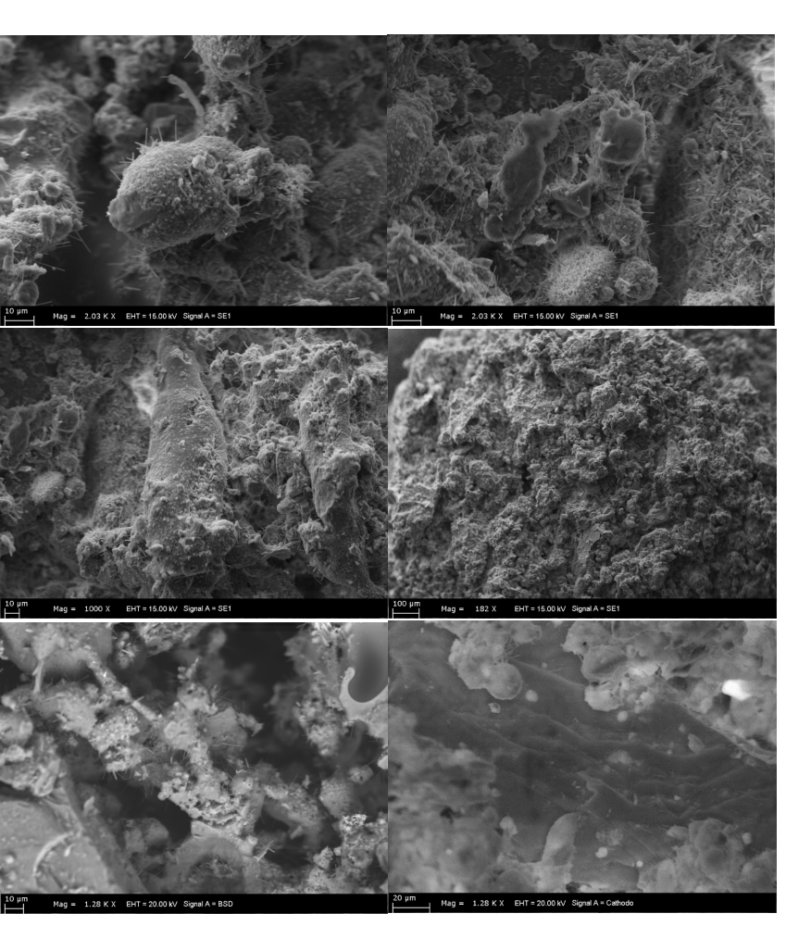
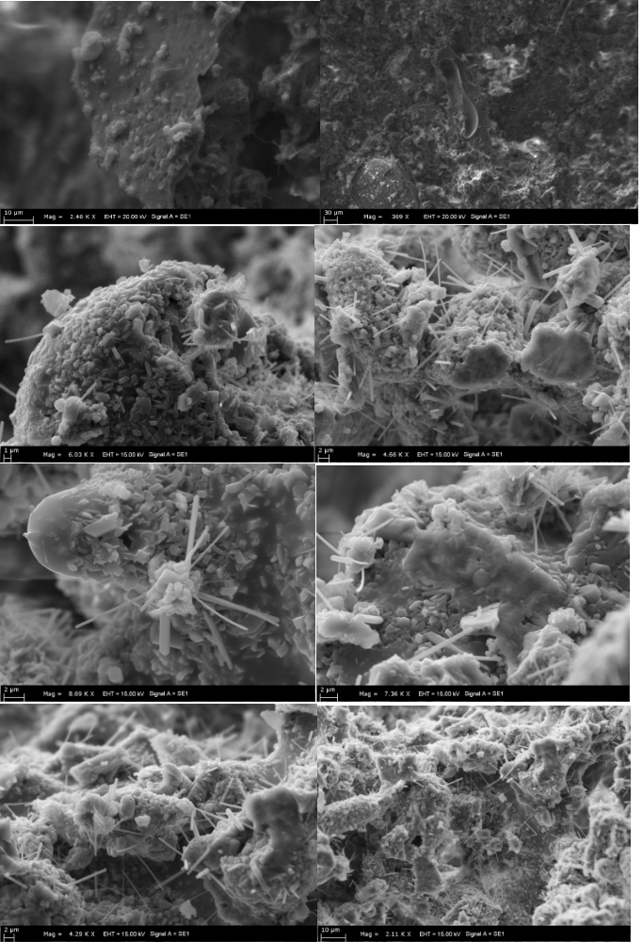
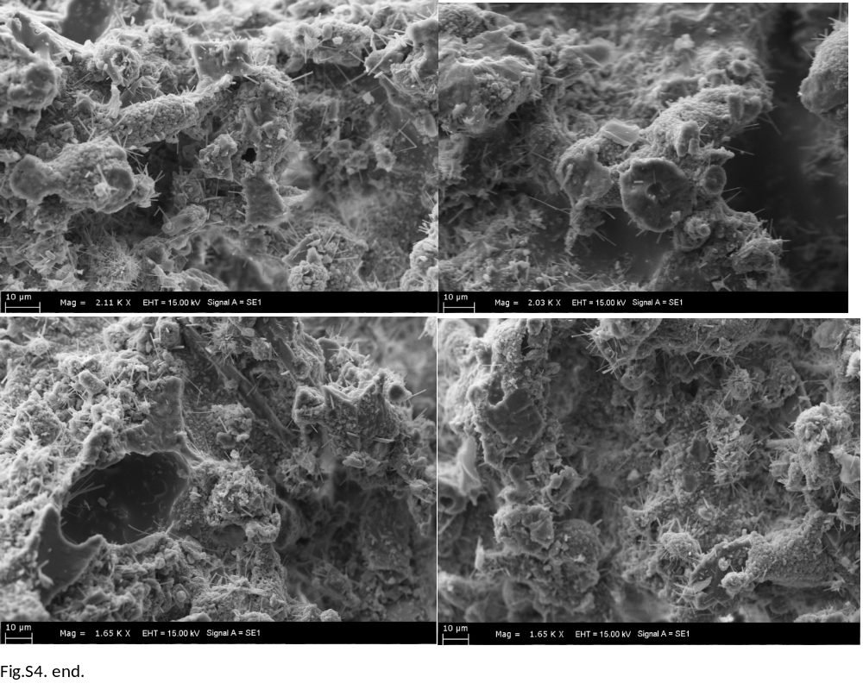

Fig.S5. SEM-FIB laser engraving, we see acicular feldspars forming vaguely below the surface as phantom minerals in mineral gel (in hydrous sample). Step like melting is obvious in hydrous sample interior
