Supplementary Information for:
The in-flight deformation of pyroclasts: insights from analogue experiments

Chiedozie C. Ogbuagu^{1,2,3*}, Thomas J. Jones⁴

Affiliations:
[1] Department of Earth, Ocean and Ecological Sciences, University of Liverpool, Liverpool L69 3GP, UK
[2] Department of Engineering and System Science, National Tsing Hua University, Hsinchu 30013, Taiwan
[3] Department of Geology, University of Nigeria, Nsukka 410001, Enugu State, Nigeria
[4] Lancaster Environment Centre, Lancaster University, Lancaster LA1 4YQ, UK
*Corresponding author: Chiedozie.Ogbuagu@liverpool.ac.uk

Descriptions of Supplementary Information
Table S1: Critical Weber numbers (We) for droplet deformation previously established in the literature
Table S2: Comprehensive list of materials and the experiment methods adopted in this study
Figure S1: The processing of experimental data to obtain viscosity values
Figure S2: Shape parameters and their changes for solid spherical balls in-flight
Figure S3: Shape parameters for droplets dropped from 0.5 and 1 m in Set A experiments
Figure S4: Shape parameters for droplets dropped from 0.5 m, with increasing gas pressures, in Set B and C experiments
Figure S5: Maximum changes in each shape parameter at different times of droplet flight
Figure S6: Critical Weber (We) and Ohnesorge (Oh) numbers responsible for the maximum changes in shape parameters, across all the experiment sets

Supplementary Information

Table S1 Droplet breakup regimes as a function of Weber number, 𝑊𝑒, modified from Jain et al. (2015)
Breakup regime | Hinze (1955) | Pilch and Erdman (1987) | Krzeczkowski (1980) | Hsiang and (Faeth 1992) | Guildenbecher et al. (2009) | Jain et al. (2015)
No deformation |  | 𝑊𝑒 < 12 | 𝑊𝑒 < 10 | 𝑊𝑒 < 1.1 | 𝑊𝑒 < 11 | 𝑊𝑒 < 12
Non-oscillatory deformation |  |  |  | 𝑊𝑒 > 1.1
Oscillatory deformation |  |  |  | 𝑊𝑒 > 3
Bag | 𝑊𝑒 $≈$ 13 | 12 < 𝑊𝑒 < 50 | 10 < 𝑊𝑒 < 18 | 𝑊𝑒 > 13 | 11 < 𝑊𝑒 < 35 | 12 < 𝑊𝑒 < 24
Bag-stamen |  | 50 < 𝑊𝑒 < 100 | 18 < 𝑊𝑒 < 30 |  | 35 < 𝑊𝑒 < 80 | 24< 𝑊𝑒 < 45
Bag/plume |  |  |  |  |  | 45 < 𝑊𝑒 < 65
Multimode breakup |  |  |  | 𝑊𝑒 > 35 |  | 65 < 𝑊𝑒 < 85
Shear breakup |  |  | 𝑊𝑒 > 63 | 𝑊𝑒 > 80 | 80 < 𝑊𝑒 < 350 | 120 > 𝑊𝑒 > 85

Table S2 Materials and methods deployed for the experiments sets. (WPM = Wilhelmy Plate Method, DNRM = Du Noüy Ring Method, SSM = super slow motion)
 | Experiment setup | Procedure | Materials |  | Measured parameters |  |  |  |  | Calculated parameters
A | Gravitational fall experiments in 20 cm diameter tube (Set A) | At heights of 0.5 and 1.0 m above the base of the cylindrical tube, single droplet of each fluid was released from pipette. | Fluids |  | Field of View  (Length $×$ Width) |  | Surface tension | Density  (measured with) | Viscosity  (measured with) | - Mass of the droplet, M_{D} (M_{A} – M_{B})  - Volume of droplet  - Equivalent diameter of droplet (from volume of equivalent sphere)  - Droplet fall velocity,$U$(from SSM video)  - Differential velocity
A |  |  | 100% Glycerine |  | 10.19 cm $×$18.11 cm |  | WPM | 25.48 cm³ pycnometer | C60/1° Ti L cone plate
A |  |  | 100% Dyed glycerine |  | 9.98 cm $×$17.75 cm |  | WPM | 26.07 cm³ pycnometer | C60/1° Ti L cone plate
A |  |  | 100% Rapeseed oil |  | 9.65 cm $×$17.16 cm |  | WPM | 26.07 cm³ pycnometer | C60/1° Ti L cone plate
A |  |  | 100% Golden syrup (bottle) |  | 9.99 cm $×$17.76 cm |  | DNRM | 25.48 cm³ pycnometer | C35/1° Ti L cone plate
A |  |  | 95% Golden syrup (tin) |  | 10.49 cm $×$18.66 cm |  | DNRM | 25.48 cm³ pycnometer | C35/1° Ti L cone plate
A |  |  | 95% Treacle syrup |  | 9.55 cm $×$16.97 cm |  | DNRM | 25.48 cm³ pycnometer | C35/1° Ti L cone plate
A |  |  | - 20 cm (internal diameter, ID) acrylic cylindrical tube  - Steel mesh  - Metallic funnel  - Silicone sealant  - Camera  - Flashlight | - Dropping Pipette  - Weighing balance  - Digital thermometer  - Measuring tape  - Metre rule and a spirit level |  |  | - Dropping height  - Mass of empty pipette (M_{P})  - Mass of pipette + mass of fluid (before drop) = M_{A}  - Mass of pipette + mass of fluid (after drop) = M_{B}  - Temperature of the fluid (T)  - Density at T  - Viscosity at T  - Air-liquid surface tension  - Shape parameters (from SSM video)
100 % Dyed* glycerine refers to 100% glycerine (no dilution) mixed with Wilton violet gel. Dying/mixing ratio across all experiment sets was 90.4 g (glycerine): 0.5g (violet gel).
95%* Treacle syrup refers to a mixture of treacle syrup and distilled water at concentration ratio of 95:5, i.e. 95% treacle syrup and 5% distilled water.
Golden syrup (bottle/tin*): Bottle syrup refers to Lyle’s golden syrup packaged in bottles, while tin refers to the golden syrup packaged in tin cans.
B | Air compressor-aided experiments in 20 cm diameter tube (Set B) | For gas outlet pressures of 20, 40 and 60 psi; single droplet of each fluid was released from pipette at 0.5 m, above the base of the cylindrical tube. | Fluids |  |  | Field of View  (Length $×$ Width) |  | Density  (measured with) |  | - Mass of the droplet, M_{D} (M_{A} – M_{B})  - Volume of droplet  - Equivalent diameter of droplet (from volume of equivalent sphere)  - Droplet fall velocity,$U$ (from SSM video)  - Volumetric flow rate, $Q$  - Air velocity,$u$  - Differential velocity
B |  |  | 100% Glycerine |  |  | 13.94 cm $×$24.78 cm |  | 25.48 cm³ pycnometer
B |  |  | 100% Dyed glycerine |  |  | 15.42 cm $×$27.42 cm |  | 25.48 cm³ pycnometer
B |  |  | 100% Rapeseed oil |  |  | 17.08 cm $×$30.36 cm  14.57 cm $×$25.9 cm |  | 26.07 cm³ pycnometer
B |  |  | - 24L direct driven air compressor  - Compressor hose (ID = 8 mm)  - Compressor fittings  - 20 cm (ID) acrylic cylindrical tube  - Steel mesh  - Metallic funnel  - Silicone sealant |  | - Camera  - Flashlight  - Dropping Pipette  - Weighing balance  - Digital thermometer  - Measuring tape  - Metre rule and a spirit level |  |  | - Mass of empty pipette (M_{P})  - Mass of pipette + mass of fluid (before drop) = M_{A}  - Mass of pipette + mass of fluid (after drop) = M_{B}  - Temperature of the fluid (T)  - Density at T  - Viscosity at T (same tools in set A)  - Air-liquid surface tension (same method in set A)  - Shape parameters (from SSM video)  - Air outlet pressure (in psi)
C | Air compressor-aided experiments in 5.4 cm diameter tube (Set C) | For gas outlet pressures of 20, 40 and 60 psi; a single droplet of each fluid was released from pipette at 0.5 m, above the base of the cylindrical tube. | Fluids |  |  | Field of View  (Length $×$ Width) |  | Density  (measured with) |  | - Mass of the droplet, M_{D} (M_{A} – M_{B})  - Volume of droplet  - Equivalent diameter of droplet (from volume of equivalent sphere)  - Droplet fall velocity,$U$(from SSM video)  - Volumetric flow rate, $Q$  - Air velocity,$u$  - Differential velocity
C |  |  | 100% Glycerine |  |  | 15.77 $×$28.03 cm |  | 25.48 cm³ pycnometer
C |  |  | 100% Dyed glycerine |  |  | 16.9 cm $×$30.04 cm |  | 25.48 cm³ pycnometer
C |  |  | 100% Rapeseed oil |  |  | 15.29 cm $×$27.19 cm |  | 26.07 cm³ pycnometer
C |  |  | - 24L direct driven Air compressor  - Compressor hose (ID = 8 mm)  - Compressor fittings  - 5.4 cm (ID) acrylic cylindrical  - Metallic mesh  - Plastic funnel  - Silicone sealant |  | - Camera  - Flashlight  - Dropping Pipette  - Weighing balance  - Digital thermometer  - Water bath  - Measuring tape  - Metre rule and a spirit level |  |  | - Mass of empty pipette (M_{P})  - Mass of pipette + mass of fluid (before drop) = M_{A}  - Mass of pipette + mass of fluid (after drop) = M_{B}  - Temperature of the fluid (T)  - Density at T  - Viscosity at T (same tools in set A)  - Air-liquid surface tension (same method in set A)  - Shape properties (from SSM video)  - Air outlet pressure (in psi)

Composition of the fluids used in the study:
- The syrups, golden syrup (GSB, GSt) and treacle syrup (TS), are inverted sugar syrup made from refining sugar canes. They are rich in fructose, sucrose and glucose compounds (see https://www.lylesgoldensyrup.com/our-products/).
- Glycerine or glycerol, used in this study, was vegetable glycerine from Lubrisolve™ (see https://www.lubrisolve.com/base-liquids/1-vegetable-glycerine-epusp-grade). It was derived from rapeseed and has 99.5% minimum purity.
- Rapeseed oil was purchased from a major grocery store in the UK, Tesco (see. https://www.tesco.com/groceries/en-GB/products/258732959). This is 100% made from rapeseed with lower saturated fats and high in Omega 3 fatty acid. Other ingredients are rapeseed oil and an anti-foaming agent: di-methyl polysiloxane (E900).
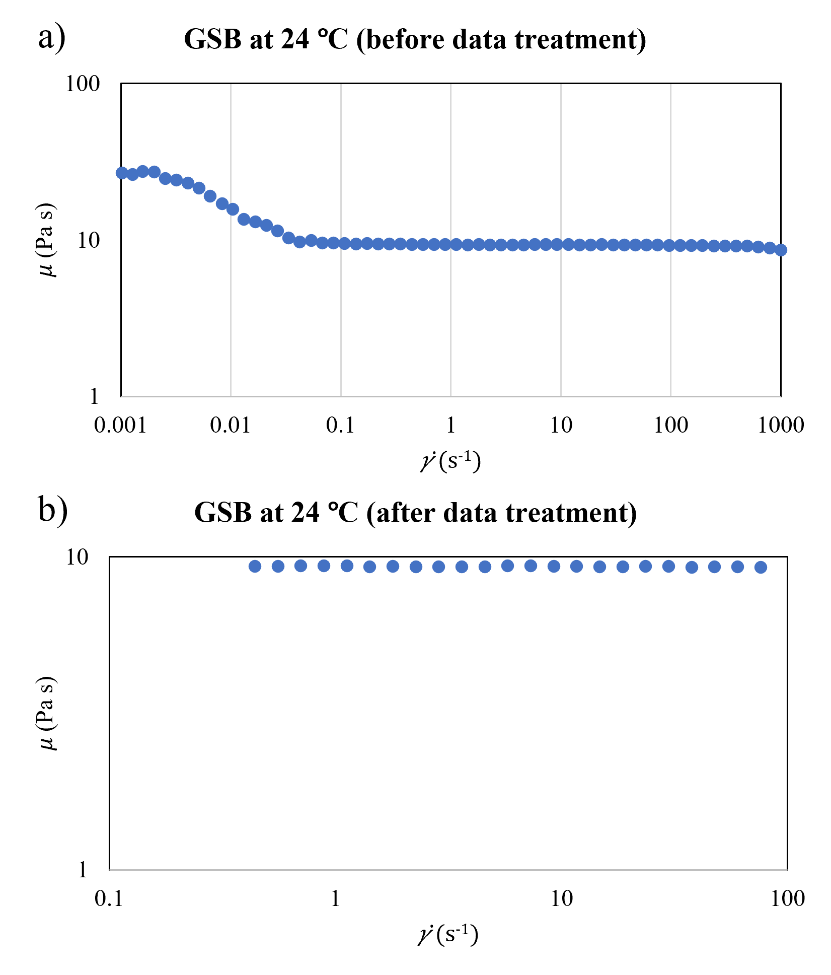
Fig. S1 Treatment of viscosity data to remove erroneous values caused by viscous overheating or realignment of the sample after initial loading. A single measurement for golden syrup (bottle-pack) at 24 $°$C is shown as an example, (a) before and (b) after data treatment
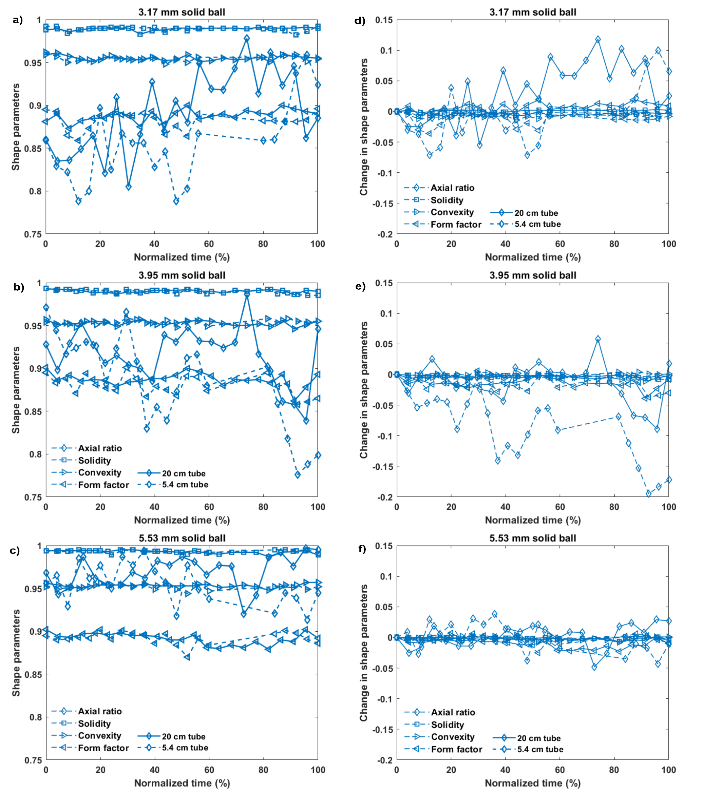
Fig. S2 (a-c) Shape parameters (axial ratio, solidity, convexity, and form factor) and (d-f) changes in the shape parameters, for the solid spherical balls falling from 0.5 m height in 20 cm (straight line) and 5.4 cm (dashed line) tubes

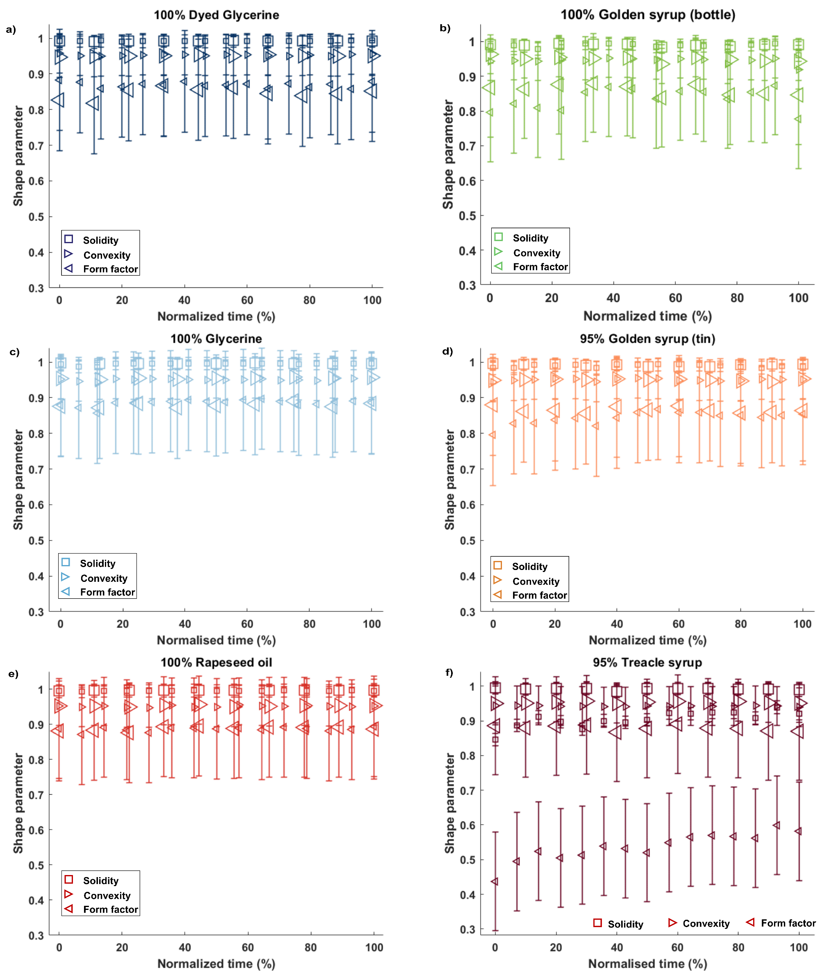
Fig. S3 Measured shape parameters as the fluid droplets fall from 0.5 m (small-sized markers) and 1 m (large-size markers), as observed from the field of view in Set A experiments. Estimated deviation for each SP is shown by the error bar. The sequential figure panels are for the following fluids: (a) 100% dyed glycerine, (b) 100% golden syrup (bottle), (c) 100% glycerine, (d) 95% golden syrup (tin), (e) 100% rapeseed oil, and (f) 95% treacle syrup
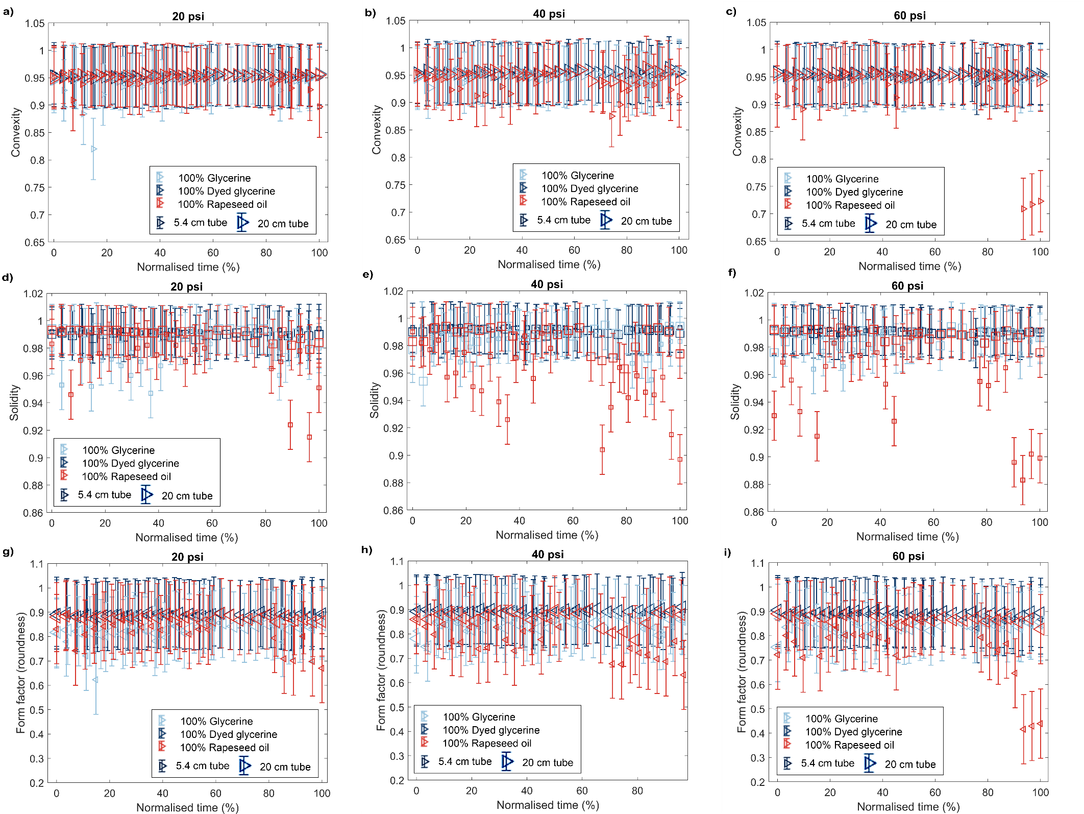
Fig. S4 Measured (a-c) convexity, (d-f) solidity and (g-h) form factor for compressor-aided experiments (sets B and C) at 20, 40 and 60 psi input gas pressures. Estimated deviation for each SP is shown by the error bar
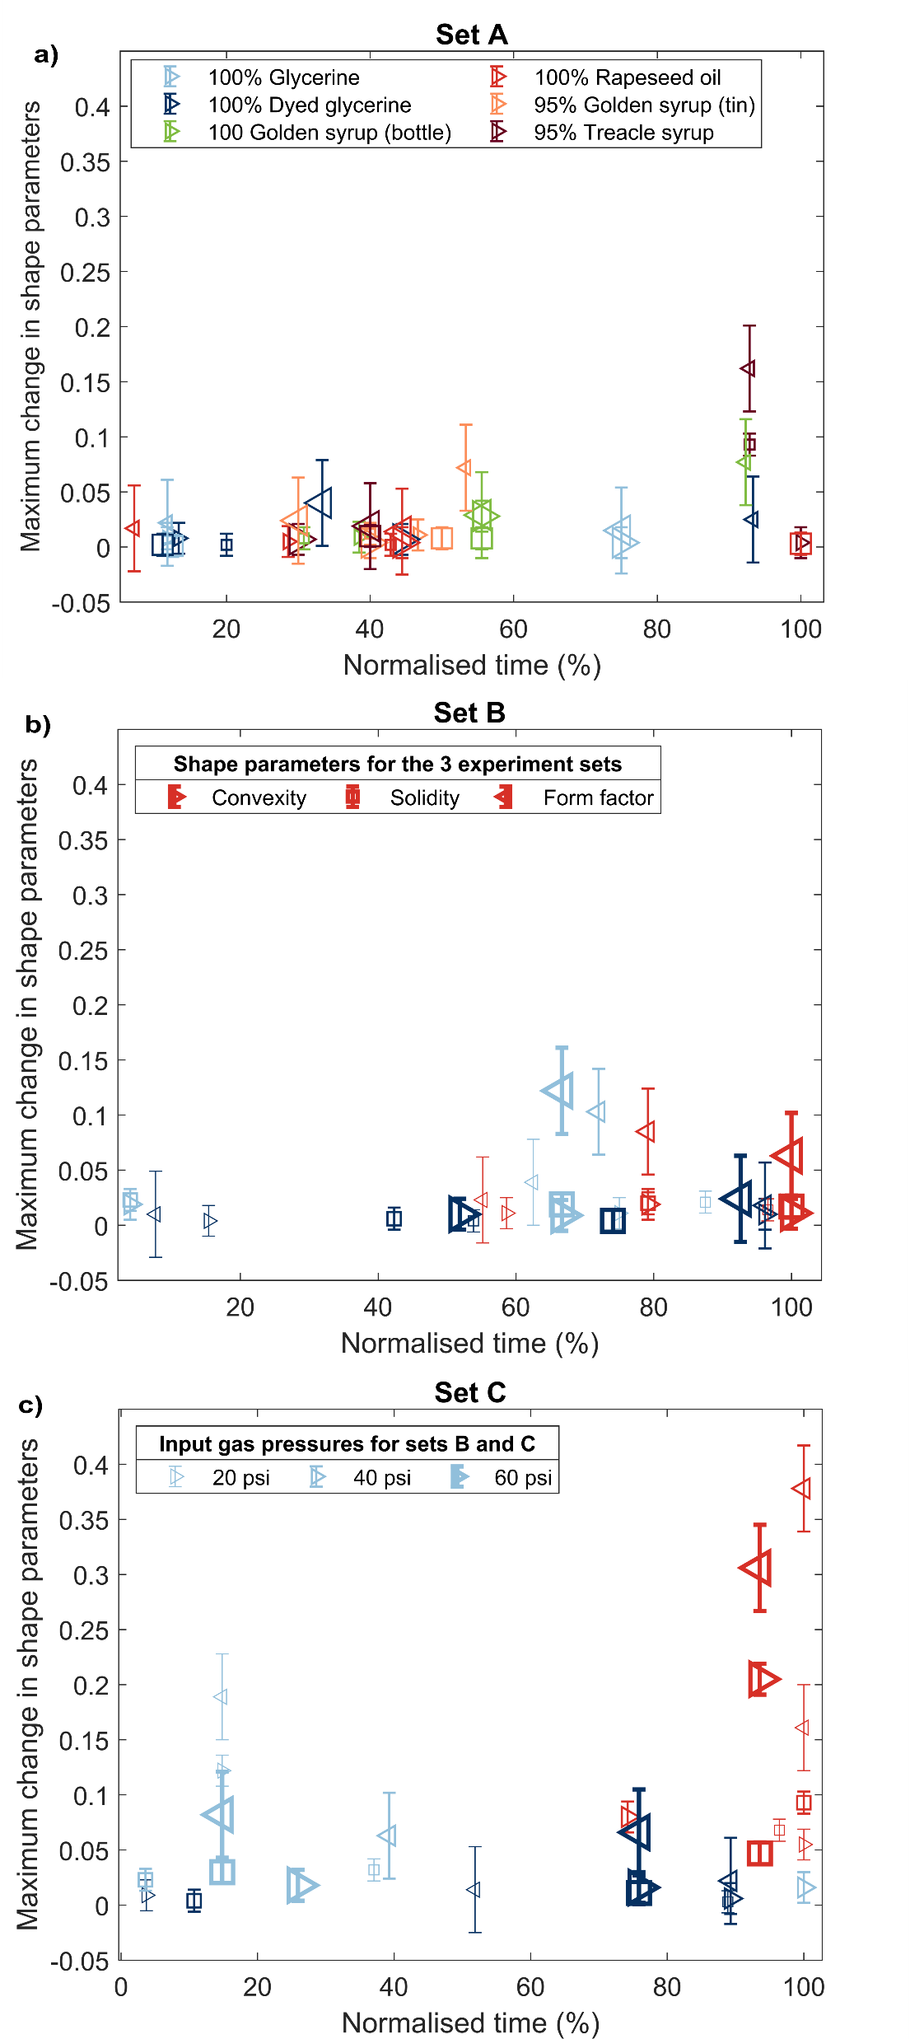
Fig. S5 Maximum change (positive or negative) in shape parameters recorded in (a) Set A, (b) Set B and (c) Set C experiment setups, at varying times (within the FOV) and experiment conditions; FOV = field of view. Error bars represent one standard deviation

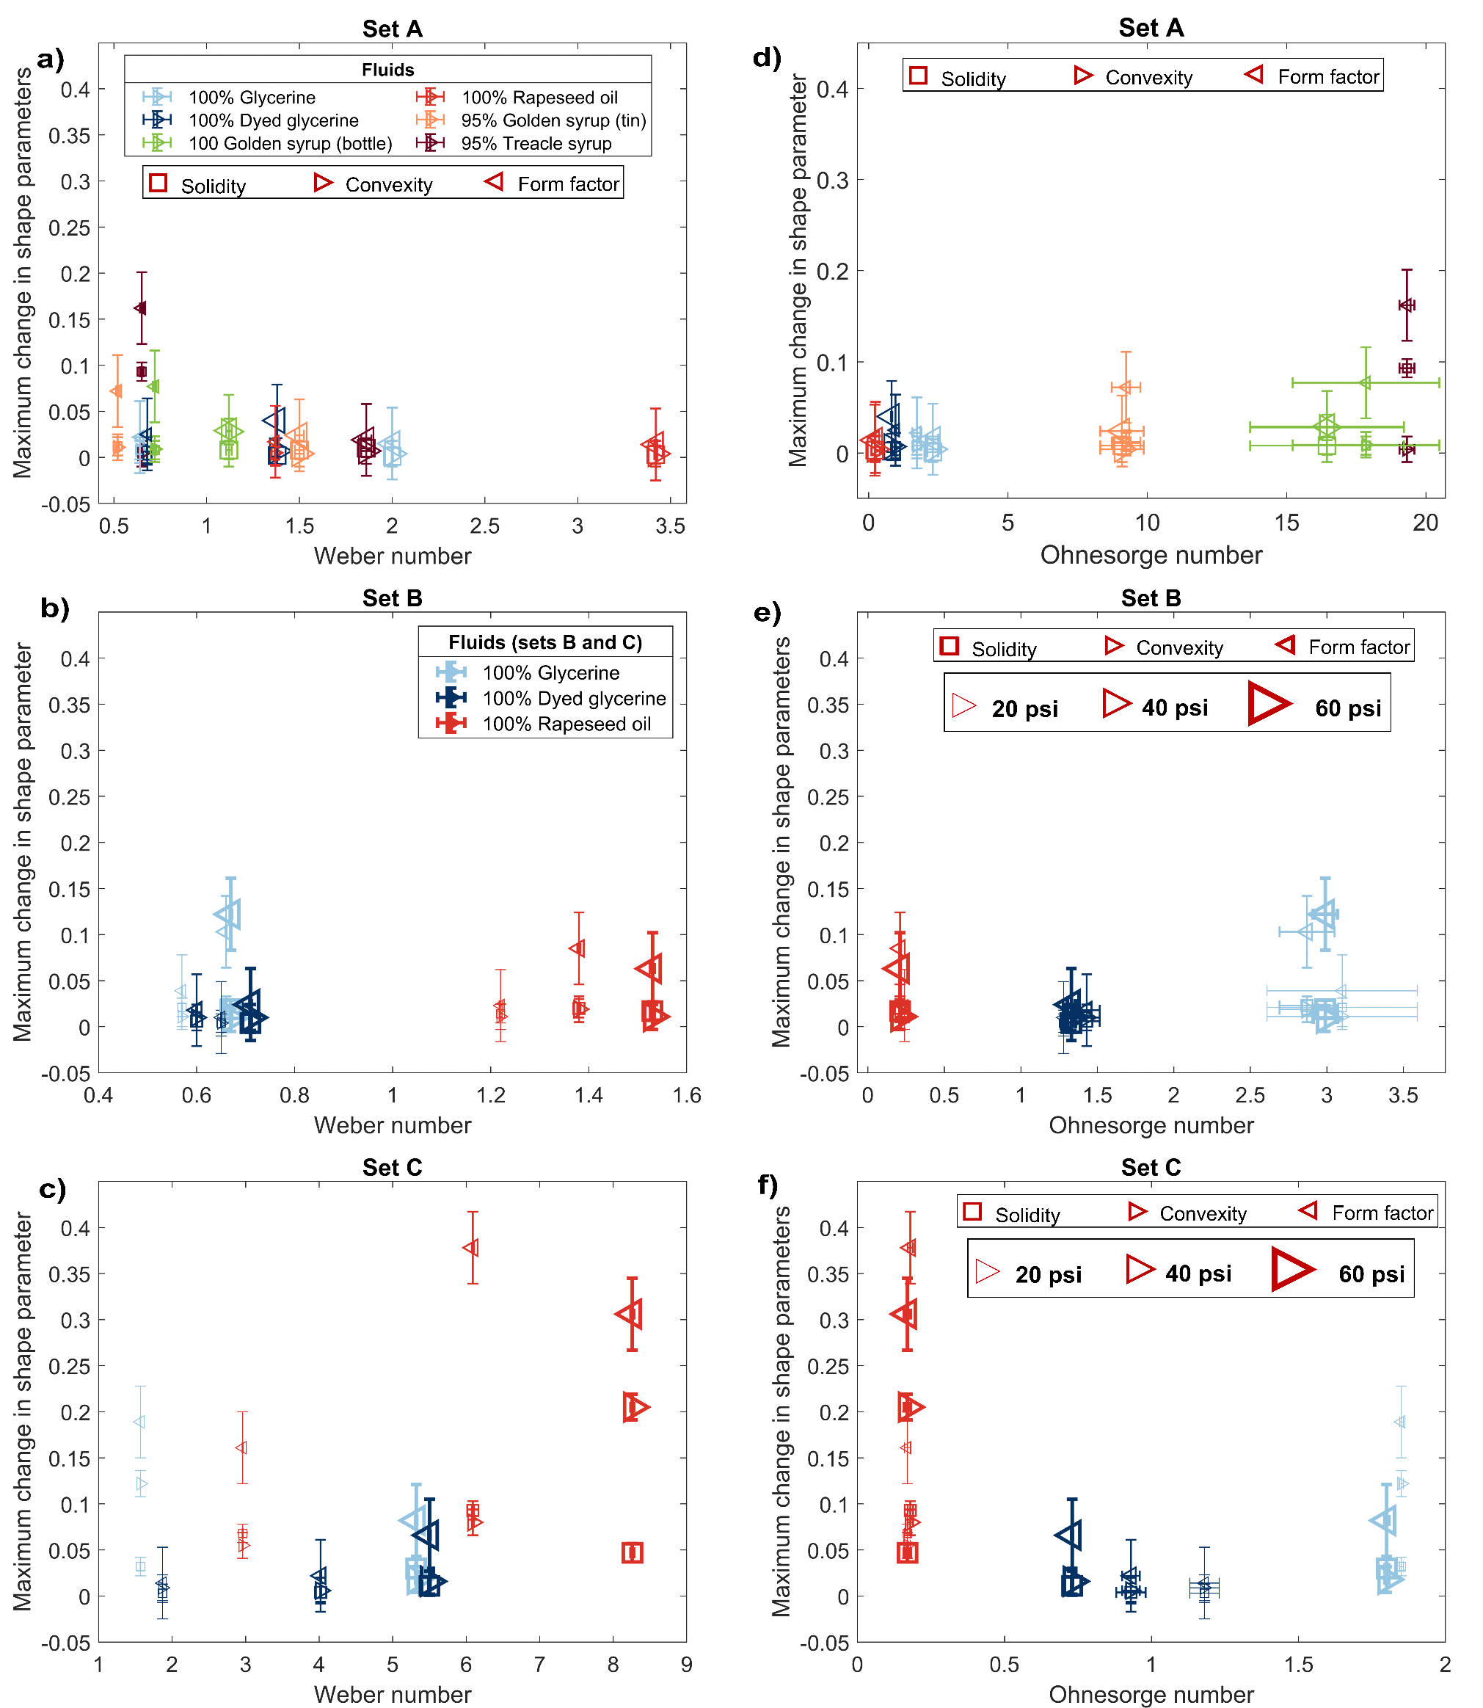
Fig. S6 (a - c) Weber and (d – f) Ohnesorge numbers for experiments with the highest changes in each shape parameters across the three experiment set ups (sets A, B and C). Square markers represent solidity, while left- and right-pointed triangle markers represent form factor and convexity, respectively. Standard deviations of the dimensionless number and shape parameters are shown by the error bars

References
Guildenbecher DR, López-Rivera C, Sojka PE (2009) Secondary atomization. Exp Fluids. https://doi.org/10.1007/s00348-008-0593-2
Hinze JO (1955) Fundamentals of the hydrodynamic mechanism of splitting in dispersion processes. AIChE J. https://doi.org/10.1002/aic.690010303
Hsiang LP, Faeth GM (1992) Near-limit drop deformation and secondary breakup. Int J Multiph Flow 18:635–652. https://doi.org/10.1016/0301-9322(92)90036-G
Jain M, Prakash RS, Tomar G, Ravikrishna R V. (2015) Secondary breakup of a drop at moderate Weber numbers. Proc R Soc A Math Phys Eng Sci 471:. https://doi.org/10.1098/rspa.2014.0930
Krzeczkowski SA (1980) Measurement of liquid droplet disintegration mechanisms. Int J Multiph Flow 6:227–239. https://doi.org/10.1016/0301-9322(80)90013-0
Pilch M, Erdman CA (1987) Use of breakup time data and velocity history data to predict the maximum size of stable fragments for acceleration-induced breakup of a liquid drop. Int J Multiph Flow. https://doi.org/10.1016/0301-9322(87)90063-2

