Supplementary Materials to:

Mobilizing mush: Assembly and eruption of modern monotonous basaltic andesite magma at Momotombo volcano, Nicaragua

Samantha Tramontano^{1,2,3*}, John Zayac^{1,2}, Eveling Espinoza⁴, Silvio Aldebot², Cissy Ming⁵, Maureen Feineman⁵, Peter La Femina⁶, Armando Saballos⁴, Brian Monteleone⁷, and Marc-Antoine Longpré^{2,1}

¹Earth and Environmental Sciences, The Graduate Center, City University of New York, New York, NY 10016, USA
²School of Earth and Environmental Sciences, Queens College, City University of New York, Queens, NY 11367, USA
³American Museum of Natural History, New York, NY 10024, USA
⁴Instituto Nicaragüense de Estudios Territoriales, Managua, Nicaragua
⁵Department of Geosciences, The Pennsylvania State University, University Park, PA 16802, USA
⁶Alfred Wegener Institute – Helmholtz Center for Polar and Marine Research
⁷Department of Geology and Geophysics, Woods Hole Oceanographic Institution, Woods Hole, MA 02543, USA
*Corresponding author email: stramontano@amnh.org

This file contains Appendix A:
Supplementary methods A1
- A1.1 SIMS data quality analysis
- A1.2 EPMA data quality analysis
Supplementary Figures A1 to A7.
Fig. A1. X-ray maps of melt inclusions
Fig. A2. SIMS analysis standard calibration curves for volatile elements.
Fig. A3. SIMS in-run analyses of glass standard and background.
Fig. A4. TiO₂ vs. SiO₂ in erupted products
Fig. A5. Clinopyroxene tests for equilibrium

Supplementary Tables are available in Appendix B as a separate Excel file:
Table B1: Major-, minor-, trace element, volatile element composition and molar volatile ratios composition of bulk rocks, melt inclusions and glasses.
Table B2: Major- and minor element composition of host minerals.
Table B3: Melt inclusion and matrix glass major element and volatile compositions
Table B4: Degassing model results
Table B5: Melt-plagioclase K₂O inversion model results
Table B6: MELTS plagioclase-H2O phase diagrams
Table B7: SIMS calibration curves
Table B8: In-run standards for SIMS analysis used in this study.
Table B9: In-run standards for EPMA analysis used in this study.

A1. Supplementary Methods

A1.1 Secondary ion mass spectrometry (SIMS)

In preparation for SIMS analysis, we hand-ground plagioclase- and pyroxene-hosted melt inclusions in epoxy mounts to expose melt inclusions one by one. Upon melt inclusion exposure, we excavated host minerals with a handheld soldering tool and mounted in another epoxy mount for polishing. Crystals were re-mounted a third time in indium metal, then given a final polish with a 0.3 μm alumina oxide suspension prior to gold coating. We cleaned the final indium mount with DI and MilliQ water. The mount was dried and stored overnight in a vacuum oven at 100 ˚C. The mount was further allowed to outgas in the SIMS machine airlock for ~24 hours prior to analysis. Sample chamber pressures during analysis were <7.20 x 10⁻¹⁰ Torr. A primary ¹³³Cs⁺ beam was used to produce the detected secondary ions (¹²C, ¹⁶O¹H, ¹⁹F, ³⁰Si, ³²S and ³⁵Cl) under the following analytical conditions: beam current of ~ 1 nA, an acceleration voltage of 10 kV, a 20 x 20 μm raster area, and 240 s of pre-sputter. A defocused electron beam (or cloud) was centered above the sputtering ion crater on the sample surface in order to compensate for any positive charging during analysis. Counting times of 10 s were used for ¹²C, and 5 s for ¹⁶O¹H, ¹⁹F, ³⁰Si (reference mass), ³²S and ³⁵Cl. Data were acquired over five blocks (Fig. A3). Calibration curves for ¹²C/³⁰Si, ¹⁶O¹H/³⁰Si, ¹⁹F/³⁰Si, ³²S/³⁰Si and ³⁵Cl/³⁰Si versus the respective volatile component were established using eight basaltic to basaltic andesite glass standards (Table B4, Fig. A2). The standard errors on the slopes of the calibration curves are 1.160 % for CO₂, 0.600 % for H₂O, 1.042 % for F, 1.321 % for S, and 1.855 % for Cl.
Over two subsequent days of analysis, CO₂, H₂O, S, F and Cl concentrations were measured in 30 plagioclase-hosted melt inclusions, 8 clinopyroxene-hosted melt inclusions, and 5 matrix glass chips. We performed a total of 56 analyses, including 8 of in-run standards, 3 of mineral “blanks,” 7 of matrix glass chips, and 38 of melt inclusions. The ³⁰Si signal ranged between 6.21E+04 and 4.65E+05 counts per second indicating consistency during our analysis. To check data quality, relative standard deviation (rsd in %) vs. the measured isotope ratio (in counts per second) was plotted. The rsd reflects the stability of the signal during the five analysis blocks. Analyses that exhibited rsd larger than 5% were evaluated block by block to and discarded if there were any indications of surface contamination.

A1.2 Electron probe micro-analysis (EPMA)

Following SIMS analyses, the gold coating was carefully removed from the sample mount, and a carbon coating was applied prior to EPMA analyses. Major element compositions were acquired for 30 plagioclase-hosted melt inclusions, 8 clinopyroxene-hosted melt inclusions, the 37 host minerals, and 5 matrix glass chips. Elements analyzed include Si, Ti, Al, Fe, Mn, Mg, Ca, Na, K, P. Minerals were analyzed using a focused, 1 μm beam at 15 kV and 20 nA with peak counting times of 20 s for all selected elements, except Cr in pyroxene (60s) and Mg in plagioclase (60 s). Glass analyses were done using a beam current of 10 nA, an acceleration voltage of 15 kV, and beam diameters of 5 μm, 10 μm, or 15 μm, depending on the size of the available glass patches.
We performed analyses on glasses, plagioclase crystals, and pyroxene crystals, including: 1) 45 point analyses and two core-to-rim transects of clinopyroxene crystals, 2) 10 point analyses and three core-to-rim transects of orthopyroxene crystals, 3) 85 point analyses and seven core-to-rim transects of clinopyroxene crystals, 4) 235 analyses of in-run standards, 5) 38 of melt inclusions, and 6) 142 of matrix glasses (Tables B1,B2,B3,B9). We utilized the following in-run glass standards: andesite glass AGV-1, basaltic glass VG-2, and basaltic glass P1326-2. For minerals, check standards included San Carlos Olivine, Lake County Plagioclase, Biotite-3, Hornblende-Kakanui, and cpx-05-118. The standard error (%) on each in-run standard relative to reference values is presented in Table B9. We report accurate and precise measurements on all elements relevant to this study.
When measuring the host mineral major element composition, we analyzed locations in the mineral core, mineral rim, and mineral adjacent to the melt inclusion. Analyses adjacent to melt inclusions are used to evaluate any post-entrapment modification to the melt inclusion chemistry and in mineral-melt equilibria calculations. We note the occurrence of three outliers at low Na₂O contents in melt inclusions, the origin of which is unclear but may potentially relate to Na loss during EPMA work (despite mitigation measures), as the three data points with the lowest Na₂O contents were acquired with a smaller beam size (5 μm, versus 10 μm for most other inclusions).
We acquired X-ray maps on the same EPMA instruments for 7 representative melt inclusions (3 pyroxene-hosted and 4 plagioclase-hosted) and, using the software XMapTools 2.5.2 (Lanari et al. 2014, 2019), we checked for compositional homogeneity within and around each melt inclusion (Fig S1). The analyses were done using a beam current of 40 nA, an acceleration voltage of 15 kV, and dwell time of 0.2 sec. The beam was rastered over each melt inclusion, recording relative concentration intensity using a step size of 1 μm. A comparison of Fe, Mg, P, K, and Al intensity across these melt inclusions reveals low concerns of significant post-entrapment effects. All inclusions display a sharp compositional boundary between the melt inclusion wall and host mineral indicating little to no evidence of diffusive loss (Fig. S1a-S1g). We do not apply correction for PEC in plagioclase- and clinopyroxene-hosted melt inclusions.

Supplementary Figures
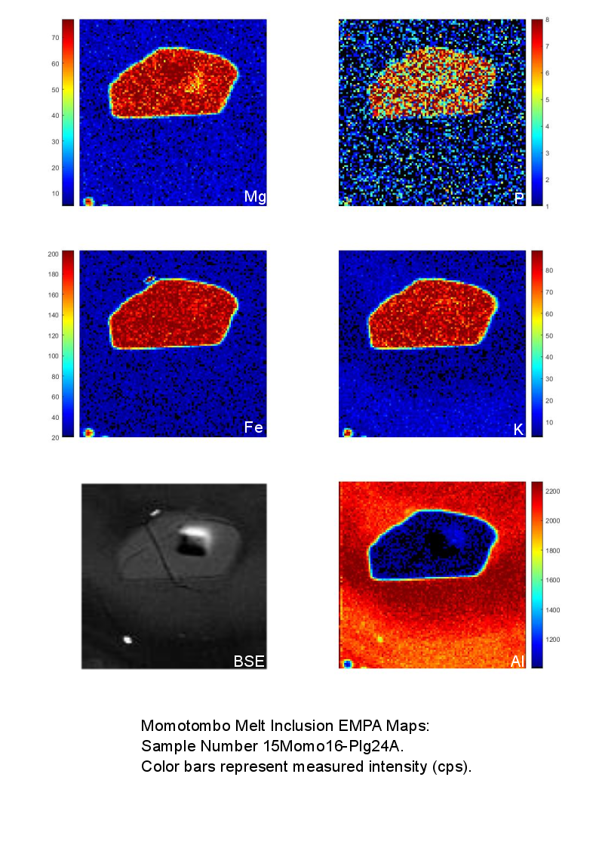
Fig. A1a.

Fig. A1b.

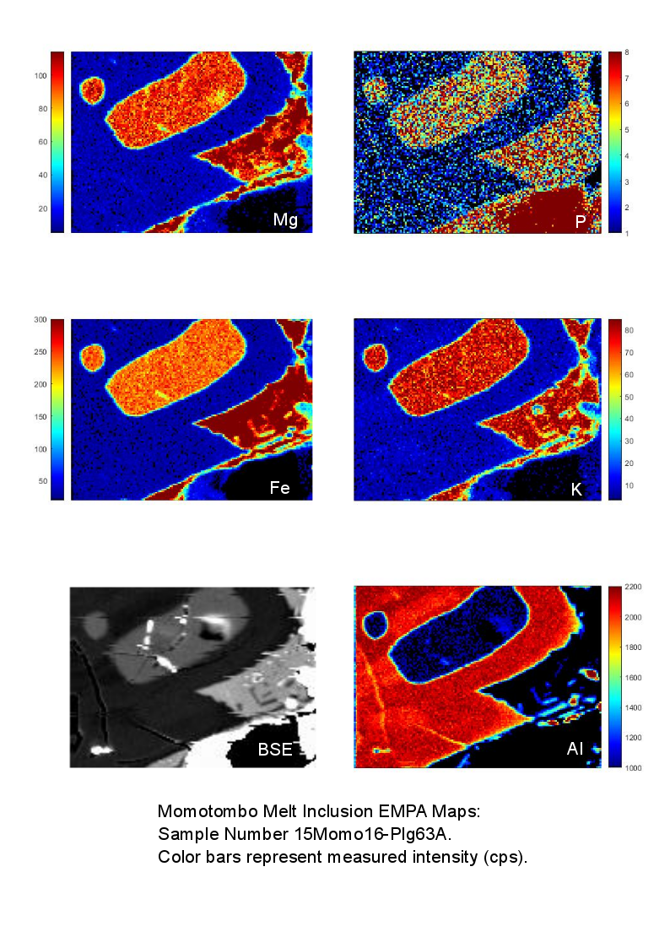
Fig. A1c.
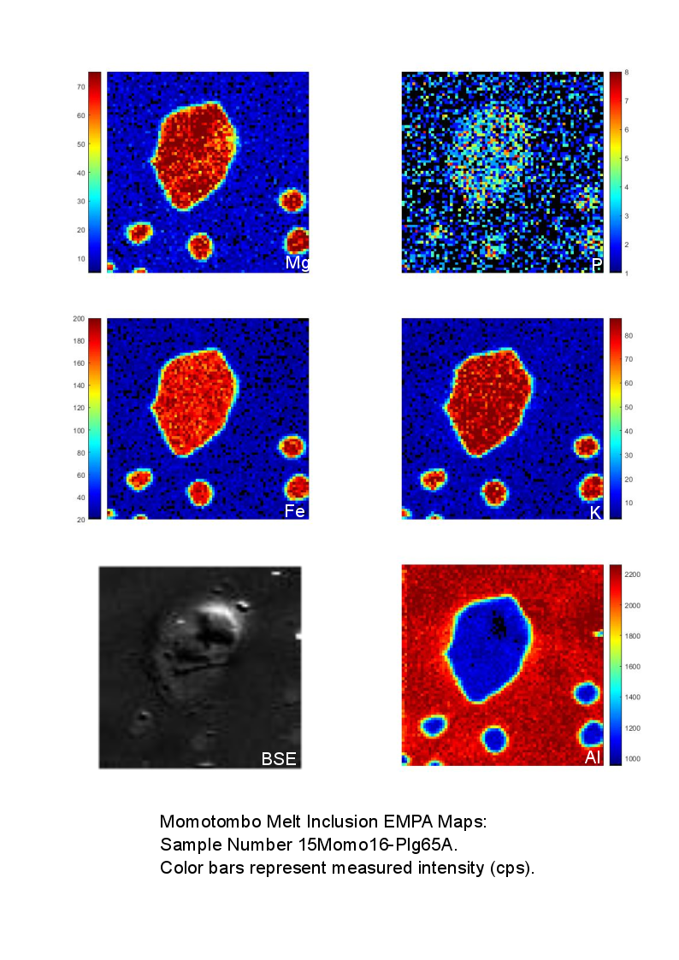
Fig. A1d.

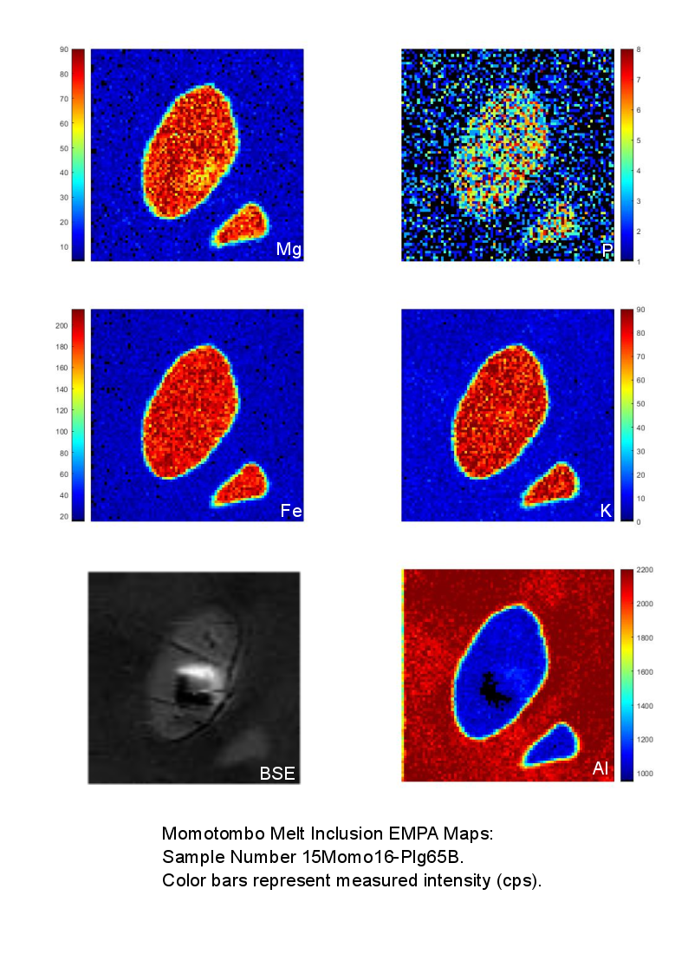
Fig. A1e.
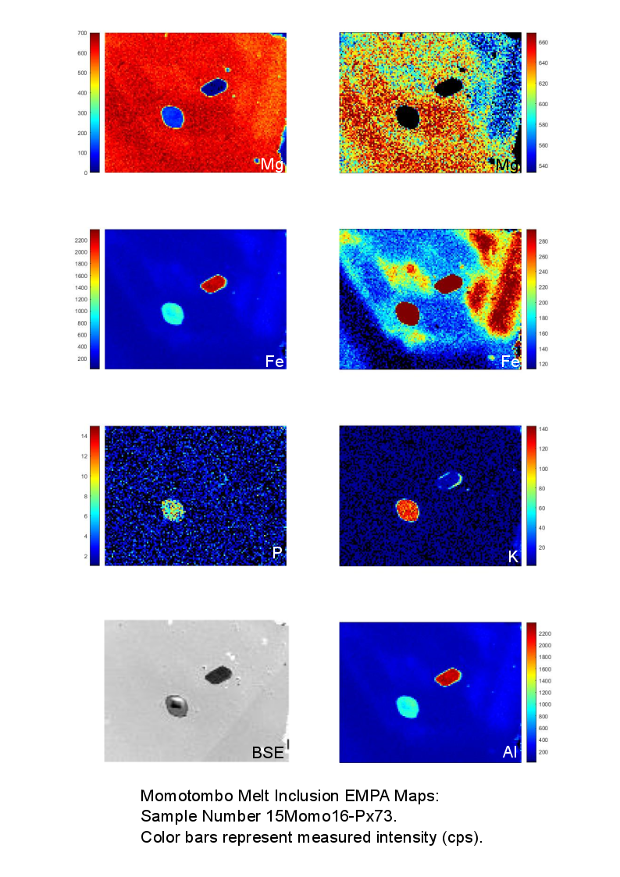
Fig. A1f.

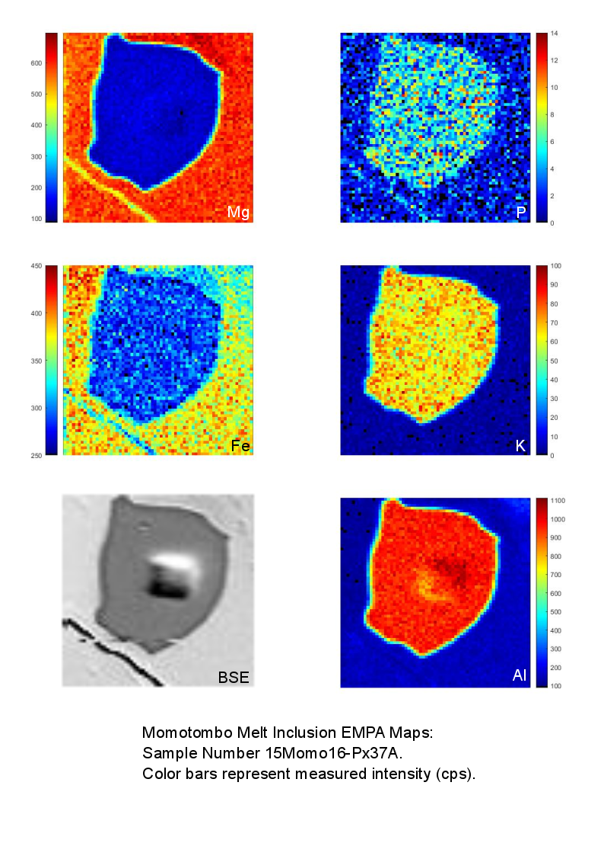
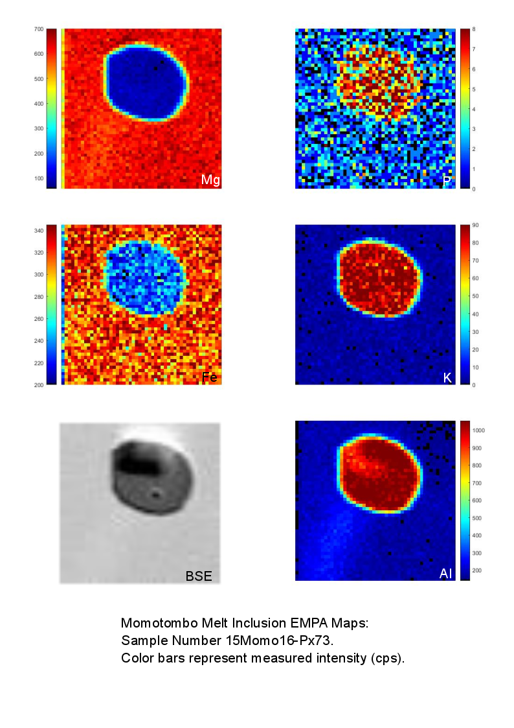
Fig. A1g.
Fig. A1. EPMA X-ray maps of 4 plagioclase-hosted melt inclusions (S1a-d) and 3 pyroxene-hosted melt inclusions (S1e-g) show sharp boundaries between the glass and the host mineral. Color bars are applied using the software XMapTools (Lanari et al. 2014, 2019) and represent relative intensity of the selected element (Mg, P, Fe, K, Al), with the exception of the backscattered electron image (left bottommost panels).

Fig. A2. SIMS analysis standard calibration curves for volatiles. Known concentrations for standards, with 10% vertical error bars, are plotted against measured isotope ratios (counts per second/counts per second). Linear regression (solid line), with 95% confidence interval (dashed line), were plotted through the origin. The slope (m), its standard error (StdErr), and coefficient of determination (R²) are given for each curve.

Fig. A3. SIMS in-run analyses of glass standard, ALV 519-4-1 (n=8), and background, represented by values of olivine host mineral (n=3, solid line) and Suprasil synthetic glass (n=6, dashed line). The upper panels present raw counts for all isotopes, while the bottom panels display isotope/³⁰Si ratios. Data were acquired over five blocks.

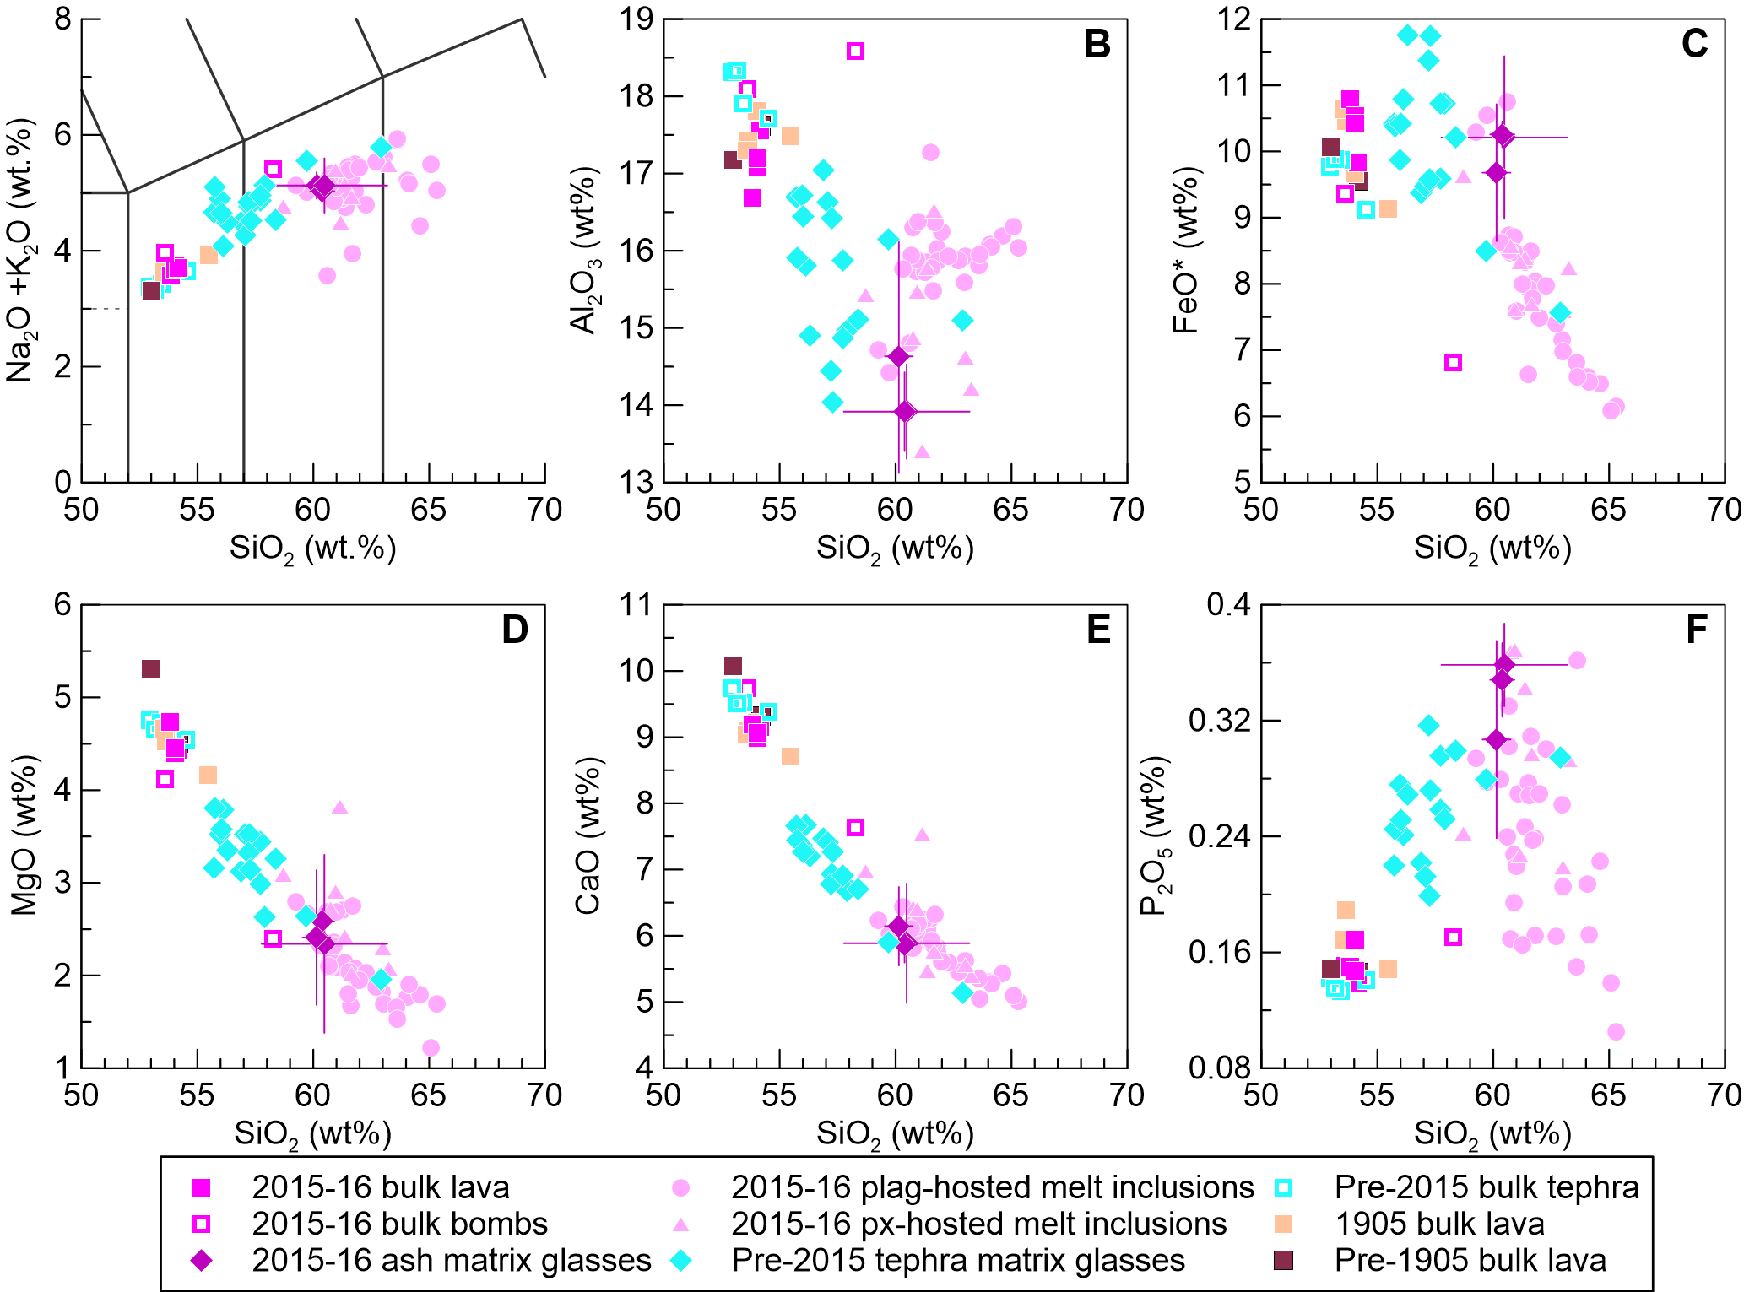
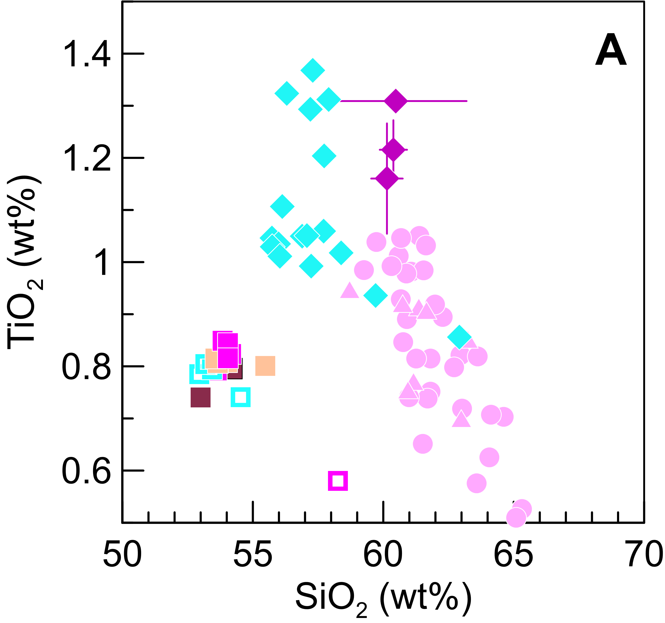

Fig. A4. A) TiO2 vs. SiO2 in Momotombo erupted products. Inflection point at 57–58 wt.% SiO₂ suggests saturation of Fe–Ti oxide minerals.

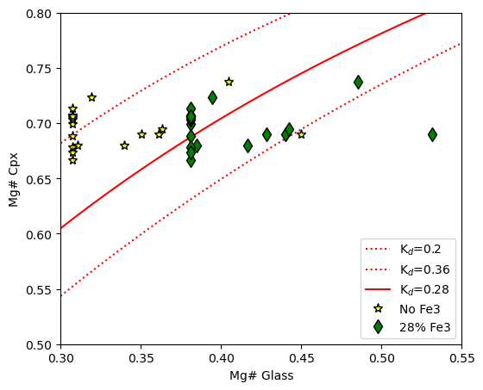

Fig. A5. Clinopyroxene equilibrium tests following equilibrium temperature and pressure calculations on Thermobar v. 1.0.52 (Wieser et al., 2022), where in a Rhodes Diagram (after Putirka, 2008), we compare Mg# (Mg#= Mg/(Fe_{tot}+Mg)), between the mineral core points adjacent to melt inclusion glasses points and in mineral rim points adjacent to the matrix glass average from day 2 tephra (highlighted in blue).
Supplemental Reference List

Lanari, P., Vidal, O., Andrade, V. De, Dubacq, B., Lewin, E., Grosch, E.G., Schwartz, S., (2014).
Computers & Geosciences XMapTools : A MATLAB © -based program for electron
microprobe X-ray image processing and geothermobarometry. Computers and Geosciences
62, 227–240. https://doi.org/10.1016/j.cageo.2013.08.010

Lanari, P., Vho, A., Bovay, T., Airaghi, L., Centrella, S., (2019). Quantitative compositional mapping of mineral phases by electron probe micro-analyser. Geological Society of London, Special Publications 478, 39-63. https://doi.org/10.1144/SP478.4

Putirka, K.D., (2008), Thermometers and Barometers for Volcanic Systems: Reviews in Mineralogy and Geochemistry, v. 69, p. 61–120, doi:10.2138/rmg.2008.69.3.

Wieser, P., Petrelli, M., Lubbers, J., Wieser, E., Özaydin, S., Kent, A.J. and Till, C., (2022). Thermobar: an open-source Python3 tool for thermobarometry and hygrometry

