Supporting information for:
Fluid inclusion constraints on the geometry of the magmatic plumbing system beneath Mauna Loa - Part 1: Extrusive products
Penny E. Wieser¹, Sarah C. Shi¹, Matthew Gleeson¹, Berenise Rangel¹, Charlotte L. DeVitre¹, Alexander T. Bearden¹, Kendra J. Lynn², Marie Camille-Caumon³
¹ Earth and Planetary Sciences, University of California, Berkeley, CA 94270, USA
² U. S. Geological Survey, Hawaiian Volcano Observatory, Hilo, HI 96720, USA
³GeoRessources Laboratory, Université de Lorraine, CNRS, BP 70239, F-54506 Vandœuvre-lès-Nancy, France

Description of Supporting Files
Online resource 1 contains sample information, fluid inclusion and host analyses, EBSD results, and secondary standard analyses. Online resource 2 contains the results of the different sulfur degassing models. The code used for the sulfur diffusion model is available on GitHub, along with pictures of fluid inclusions, and examples of EBSD maps with their classification. We also include the Jupyter Notebooks used to make the plots in the main text, reading from the Online Resource files. https://github.com/PennyWieser/MaunaLoa_FIs_Extrusives_2025/

Sample Details
Eruption | Sample Code (USGS) | Lab Code | Coordinate (N, WGS) | Coordinate (W, WGS)
8870 ¹⁴C year BC | N/A | 79e | 19.02231 | -155.57708
1852 AD | L-86-281 | MP2 | 19.55822 | -155.42072
1855-1856 AD | L-22-50 | M85 | 19.513196 | -155.533296
1868 AD | L-93-208 | MLP | 19.06459 | -155.68595
1949 AD | L-22-76 | M49 | 19.45682 | -155.60589
1950 AD | ML_23_58R_A | M58 | 19.315830 | -155.699945
1984 AD | L-22-84 | M84 | 19.468272 | -155.59561
2022 AD (F3) | ML22-87 | M22 | 19.51449 | -155.53148
Table S1 – Sample table for the tephra and reticulite samples collected by U.S. Geological Survey (USGS) Hawaii Volcano Observatory, in the WGS84 co-ordinate system. The latitude and longitude for the 8870 flow were provided by Amy Gaffney (written comms).
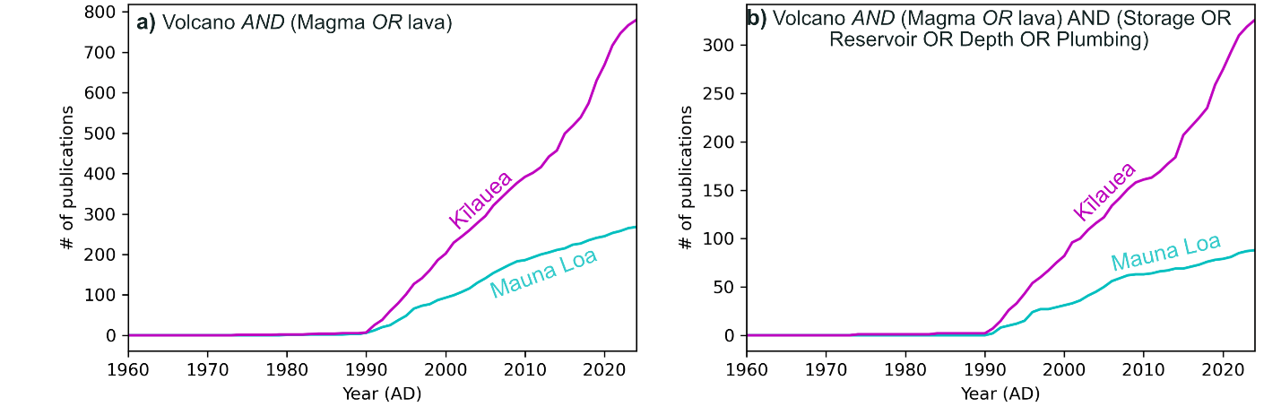
Supporting Fig. 1 – Web of science search showing the number of publications with the stated search criteria within the abstract. We appreciate that some key publications prior to 1990 are missing (e.g. professional papers, likely because of difficulties indexing abstracts), however, there is no reason to think the database would be more incomplete for one volcano than the other.

Raman measurements
The sample was heated to 37±2 ℃ using a Peltier plate with a central hole for illumination, and a type K thermocouple stuck onto the surface of the sample with tape used to monitor temperature. Fluid inclusions were focused optically through a 50X or 100X objective, and excited with a 532.046 nm green laser. Laser powers were monitored using the WITec TruPower system, and kept as low as possible to produce quality signals without excessive heating (DeVitre et al., 2023; Hagiwara et al., 2021). The majority of spectra were collected at 10-12 mW as measured on the WITec TruPower system, with stronger signals collected at 5-8 mW. Neon lines were used to correct for instrument drift following the approach of Lamadrid et al. (2017). Spectra were fit using the open-source python package DiadFit (Wieser and DeVitre, 2024) to determine the splitting (distance between the two peaks). DiadFit propagates uncertainty from peak fitting, the gas densimeter, and the neon line correction model to obtain an uncertainty for each fluid inclusion. Splittings were converted into CO₂ densities using a calibration line developed with a gas calibration cell for this specific Raman instrument and acquisition approach (see DeVitre and Wieser, 2024).

Quantifying SO₂ abundances
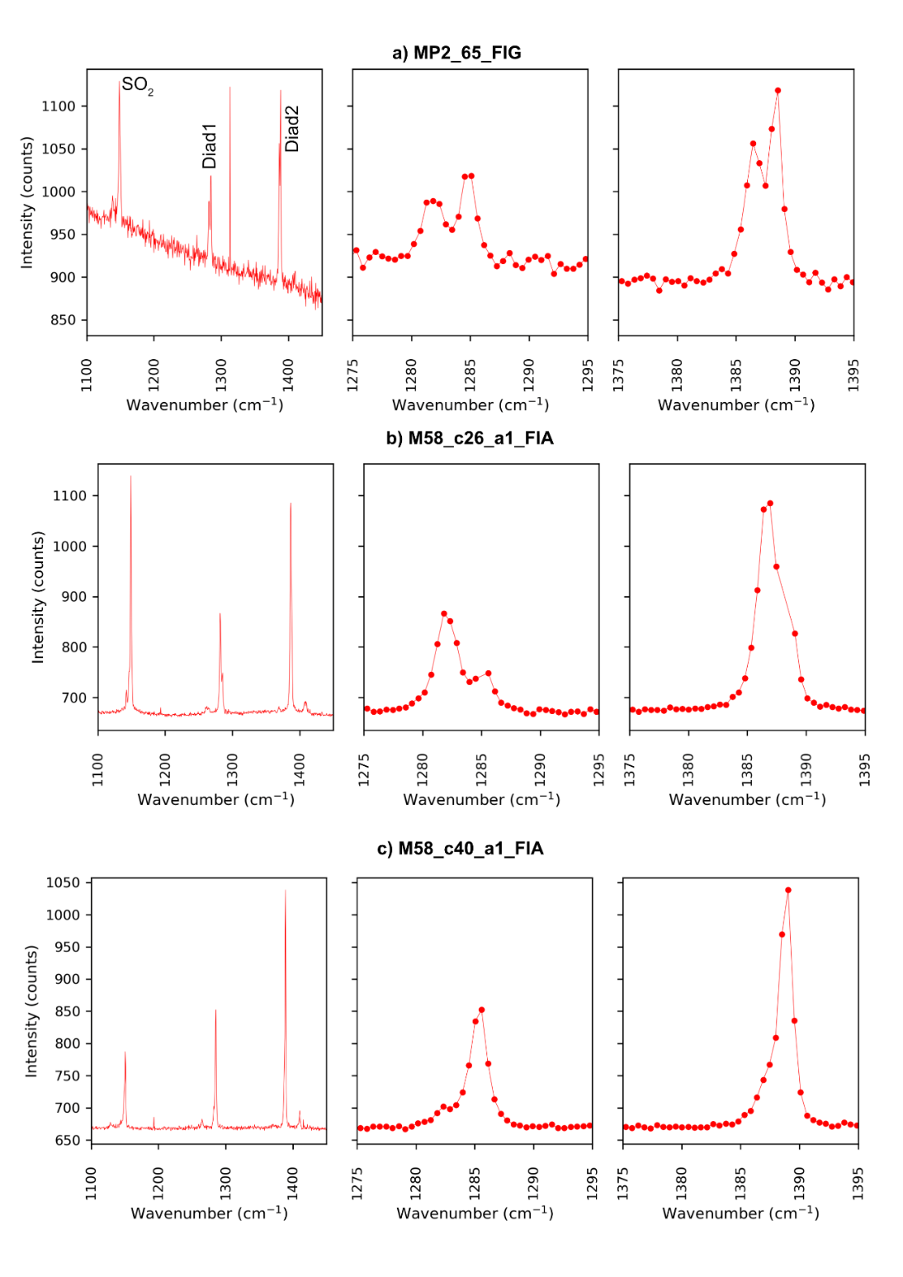
Supporting Fig. S2 – Three fluid inclusions where there was so much SO₂, the diad peaks were split in two (a-b), or clearly skewed (c). The two peaks show that the laser is interacting with a separate liquid and vapour phase. The skewed peaks result from the same phenomena, but either the geometry of the two phases, or their relative abundances don’t result in such a clear distinction.

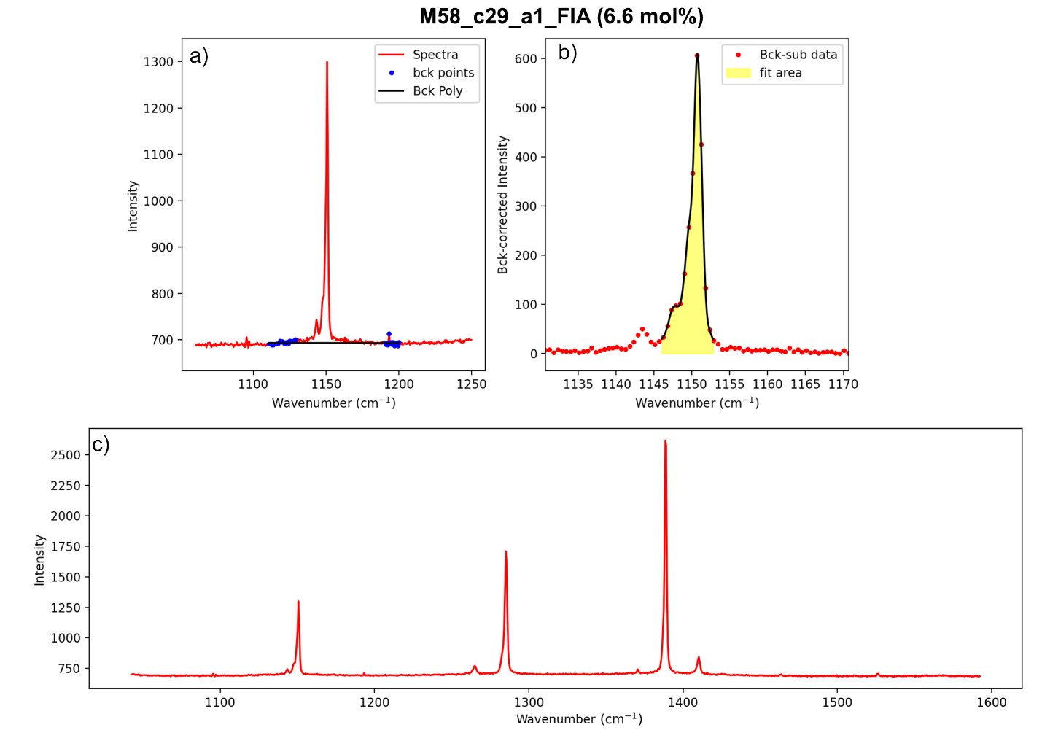
Supporting Fig. S3 – Example spectra showing a moderate SO₂ peak that doesn’t affect the diad skewness drastically. The area of the SO₂ peak was quantified in DiadFit (Wieser and DeVitre, 2024). The peak consists of the main ³²S peak at ~1151 cm⁻¹ (600 cts here), with the shoulder shifted ~3 wavenumbers (cm⁻¹) to the left forming from the ³²S¹⁶O hot band, and the smaller peak shifted ~7.3 cm⁻¹ to the left of the main peak results from³⁴S¹⁶O (Brooker and Eysel, 1981). It is unclear in published cross sections which of these peaks were used. Given the difficulty deconvoluting the hot band and main peak in most spectra, we fit a spline to the overall area.
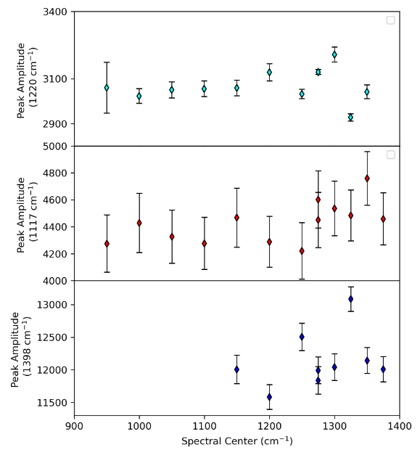
Supporting Fig. S4 – The amplitude (area) of three different Neon lines was tracked as the spectral center was gradually changed. The relatively flat trends demonstrate that there are no coherent variations in signal intensity depending on where on the spectrometer grating the signal arrives. Thus, when quantifying the SO₂ mole proportion, the instrument efficiency was assumed to be 1. The error bars are from peak parameters estimated by lmfit.
We take wavelength-independent cross sections (Σ) from the literature compilation of Schrotter and Klockner (1979) and calculate the corresponding wavelength-specific cross sections (σ) for our specific laser wavelength (532.046 nm) using Eq. 1 of Burke (2001):
$σ= \frac{Σ}{\frac{{(v_{o}-v_{i})}^{-4}}{{(v_{o}-2331)}^{-4}} ×(1-e^{\frac{-hcv_{i}}{kT}} )}$ (Equation 1)
Where Σ is the wavelength independent cross section,$v_{o}$ is the laser wavelength converted to cm⁻¹, $v_{i}$ is the Raman shift in cm⁻¹ of the peak of interest (e.g. 1151 cm⁻¹ for SO₂), h is planks constant (6.626 X 10⁻²⁷ erg s), c is the speed of light (2.998 X 10¹⁰ cm/s), k is Boltzmann’s constant (1.381 X 10⁻¹⁶ erg/K), and T is the temperature in Kelvin. This equation follows the cgs system of units given Raman shifts are commonly quoted in cm⁻¹.
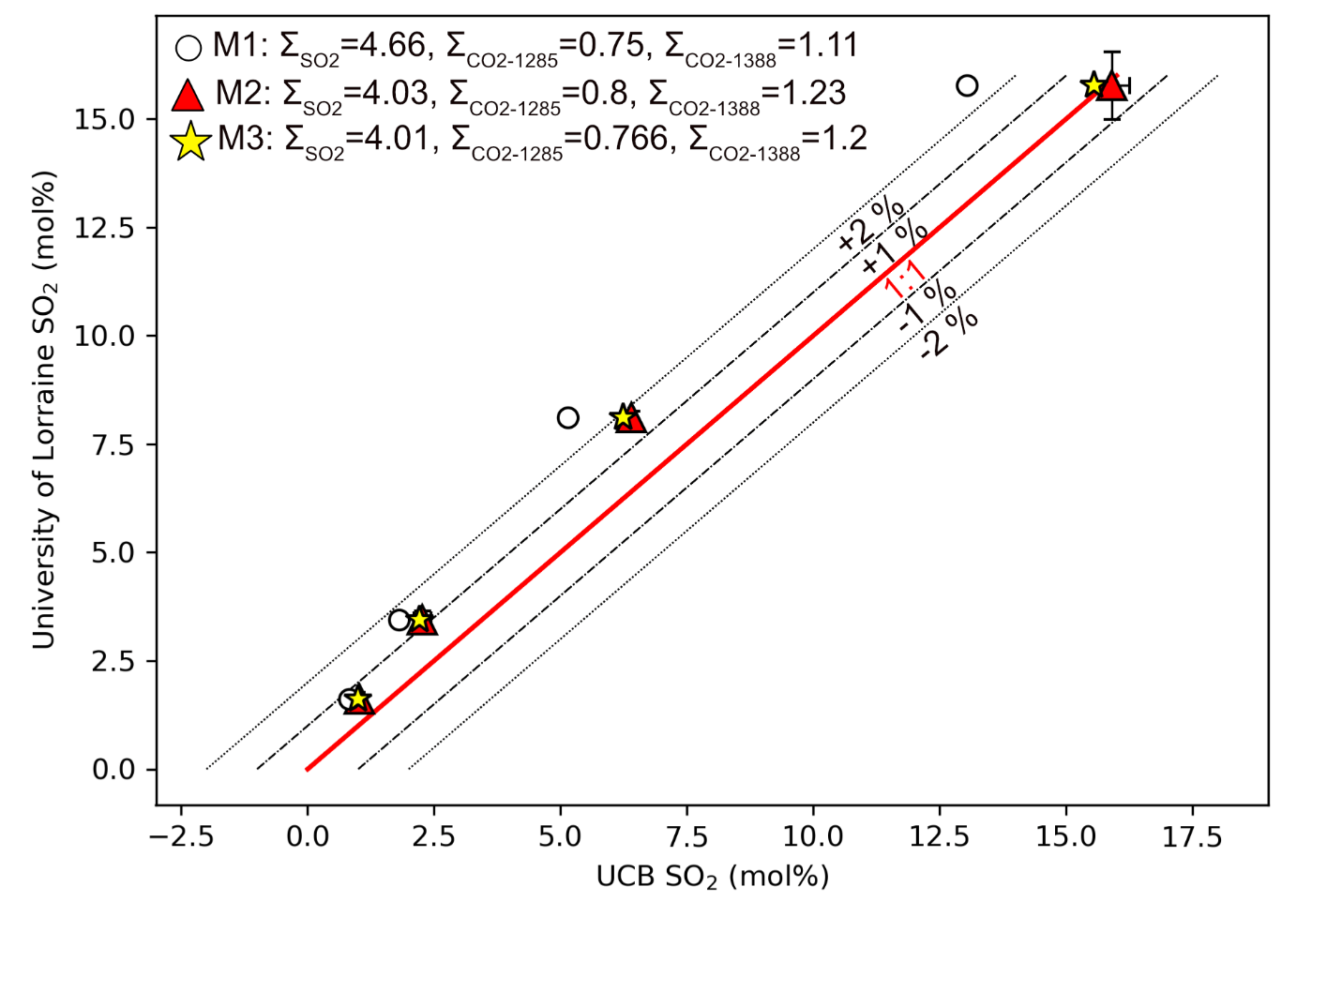
Supporting Fig. S5 – Four fluid inclusions were sent to the GeoRessources laboratory at the University of Lorraine (UL) and analysed by Marie-Camille Caumon, using their own inhouse peak fitting routines and CO₂ absorption coefficients (Le et al., 2021, 2019), and the 514 nm coefficient for SO₂ from Burke (2001). To reduce the UC Berkeley data, we try three different sets of wavelength independent coefficients (M1-M3), corrected to our laser wavelength (532 nm) using Equation 1. M1 uses the average wavelength-independent values from Table 4.2 of Schrotter and Klockner (1979), derived from measurements made with 337-515 nm lasers. M2 uses the preferred values of Burke (2001), and M3 uses the data collated by Burke (2001) but averages all values. The error bars on the red triangles show the standard deviation of repeated measurements in each laboratory. We use the M2 model in the main text, as it shows the best agreement with the measurements made at University of Lorraine. From the scatter observed here, we show a conservative error bar of ±2 mol% on our data.

Mineral Analyses

EPMA at Menlo Park
Analyses were performed using a JEOL JXA 8530 F+ EPMA at the U.S. Geological Survey (USGS) EPMA in Menlo Park, California. Samples were coated with a 22 nm carbon coat (the same as the standards). Beam conditions were a 20 kV accelerating voltage and a 1 µm beam size with a 40 nA current. Counting times for olivine analyses were 20 s for Si, Mg and Fe, 40 s for Ca, Mn, Ti and Cr and 60 s for Ni, Al and Na on the peak with half the peak counting times on each side of the peak for backgrounds. San Carlos olivine (USNM 111312/444; Jarosewich et al. 1980) was measured regularly throughout the analyses to monitor for instrumental drift. Standards were Synthetic Fayalite for Si and Fe, San Carlos olivine for Mg, a synthetic nickel-oxide for Ni, Mn₂O₃ for Mn, Cr₂O₃ for Cr, Kakanui Pyrope Garnet (USNM 143968) for Al and Ti, Wollastonite for Ca and Tiburon Albite for Na. Two-sigma relative precision, based on repeated analyses of San Carlos olivine, are 0.40 wt% for SiO₂, 0.65 wt% for MgO, 0.12 wt% for FeO, and 0.01 wt% for MnO, NiO, CaO, Cr₂O₃, Al₂O₃ and Na₂O (See Supporting Information 1). Two-sigma relative precision of Fo is 0.19 mol%.

SEM-based EDS-WDS at Berkeley
Mineral chemistry was measured using quantitative Energy Dispersive Spectroscopy (Oxford UltimMax 100) and Wavelength Dispersive Spectroscopy (Oxford Wave) on a JEOL IT800HL Scanning Electron Microscope in the Department of Earth and Planetary Science, University of California Berkeley. Samples were coated with a 15 nm C coat (same as the standards). EDS and WDS measurements were made using a working distance of 10 mm, 20 kV of beam current, and aperture 1 (110 µm, the largest aperture on this instrument). The beam conditions in the JEOL software were set to Standard mode 40 for EDS (giving a beam current of 2 nA measured with an in-column Faraday cup), and Analysis 59 for WDS (beam current of 100 nA). EDS measurements can be made on the EDS or the WDS side of the software. On the EDS side, the beam associate step is conducted by analyzing a pure metal standard (Fe) to determine a count rate per second. This is independent of the beam current, so it must be recalibrated if the beam drifts. We monitored the beam current through the day using the Probe Current Detector (PCD, and there was no drift outside of noise (generally ranging from 1.997 to 1.999 nA within a single analytical session). The beam associate step on the WDS side also uses a pure metal standard, but accounts for the beam current (so the associate step is updated throughout the day as PCD measurements are made). In both cases, beam drift was so negligible to not make a difference to results (drift of ~0.1 %). The advantage of performing analyses on the WDS side is that an element can later be analysed by WDS. Thus, we perform most measurements on the WDS side, allowing us the option to add trace elements like Ni or Cr to check the performance of the EDS. When WDS analyses were run, we would first collect EDS spectra on ~20 olivines with the EDS detector in with 2 nA of beam current. After an EDS spectra was collected for ~20 olivines, the EDS detector was retracted, and the beam current was increased to ~100 nA, and a WDS spectra was added to each analysis.
EDS calibration standards were as follows. Initially, the standard recovery using the factory standards was very good, and for later runs, we recalibrated using Ian Carmichael’s standard block at UC Berkeley.
Table S2 – Calibration materials for olivine EDS analyses:
Si | Synthetic Fayalite (Factory)  Or Diopside (I Carmichael)
Fe | Synthetic Fayalite (Factory) then Fe metal (I Carmichael)
Mg | San Carlos Olivine USNM 111312/444 (Factory), then MgO (I Carmichael standard)
Ca | Wollastonite (Factory), then Diopside (I Carmichael)
Ni | Ni metal

Table S3 – Calibration materials for glass EDS analyses (all in 1 session):
Si | Forsterite (I Carmichael)
Al | Al₂O₃ (Factory)
Ca | Diopside (I Carmichael)
Fe | Fe metal (Factory)
K | KBr (Factory)
Mg | MgO (Factory)
Mn | Mn metal (Factory)
Na | Nepheline (I Carmichael)
S (EDS) | FeS₂ (Factory)
Ti | Ti metal (Factory)

Ni for WDS quantification was calibrated on a Ni metal standard, and Cr on a Cr metal standard. Secondary standard materials from Ian Carmichael’s collection, and a new standard block from Microanalytical Consultants (MAC) were run every ~6 hrs. These repeated analyses show no clear drift through the day.
Supporting Fig. S6-S7 compares analyses of the same region of olivine grains at UCB and USGS. Major elements are within 5 % of one another, and minor elements mostly within 10 %. Fig S4 shows EDS vs. WDS measurements of Ni. Initially, tests on our standards revealed that EDS Ni was far too high. We attribute this to the presence of a Ni-plating on the sample holder. After sanding off this coating and performing numerous EDS and WDS measurements of Ni, we concluded that the results were within error of one another, so later Ni measurements were made using EDS only on the EDS side of the software. Analyses of multiple standards show that the EDS and WDS side of the software give extremely similar EDS results (within uncertainty of the beam associate step).
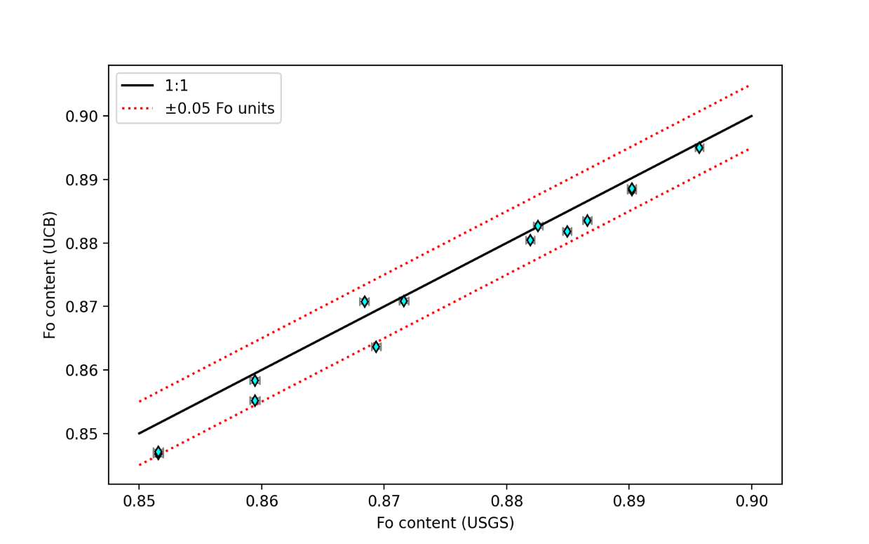
Supporting Fig. S6 – Comparing Fo contents for olivine core analyses. Similar magnitude offsets were noted between EPMA facilities in U.S. Geological Survey (USGS), Stanford and Cambridge by DeVitre and Wieser (2024).

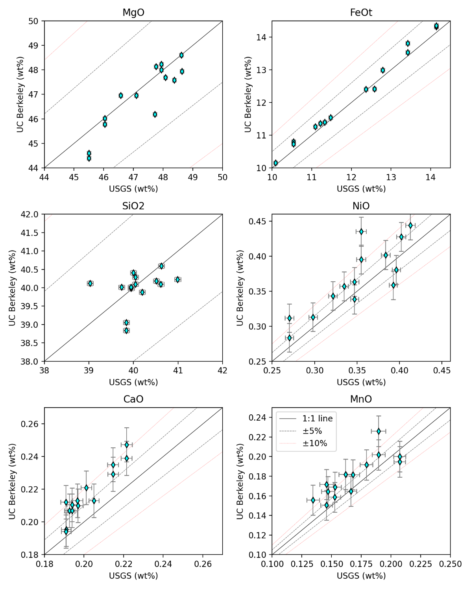
Supporting Fig. S7 – Comparing oxide contents measured by EPMA at the U.S. Geological Survey (USGS) microprobe vs. by EDS on the University of California Berkeley (UC Berkeley) SEM. We note that samples were repolished between these two analyses, because of scratches introduced during transport, so it was not possible to analyse exactly identical spots. We estimate that analyses were made within 20-30 µm of the original spot. 5 % offsets are common between laboratories as a result of differences in primary calibration standards (Gale et al., 2013; Wieser et al., 2023).
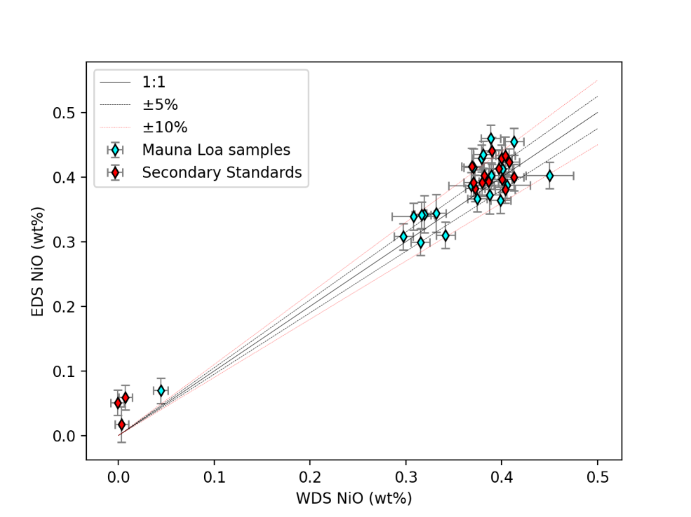
Supporting Fig. S8 – Comparing Ni data collected by EDS vs. WDS on the JEOL SEM. The lowest values are the Springwater olivine, which has no Ni. EDS is more susceptible to picking up X-rays from a larger area, and this standard is mounted in a Ni-containing brass mount.

EBSD analyses
Acquisition parameters in Aztec used to collect EBSD data are shown in Table S4.
Table S4 – EBSD acquisition parameters.
Aztec (EDS) Acquisition Parameters
Step size | 6-10 µm
EBSD camera binning mode | Speed 1 (622 X 512 pixels)
EBSD Camera exposure time | 2-6 ms
EBSD Camera Gain | 2
Frame Averaging | 1 frame
Static background correction | Off
Auto background correction | On
Hough Resolution | 60
Band detection mode | Centers
Number of bands | 12
Indexing mode | Refined accuracy
JEOL (SEM) Acquisition Parameters
Voltage | 20 kV
Aperture | 4
Beam current | 10-25 nA (depending on charging)
Working distance | 25 mm at top of 1” stub, 28 mm near the bottom

EOS calculations
We perform CO₂-H₂O calculations using the temperature-Fo relationship developed by DeVitre and Wieser (2024) for Kīlauea. Briefly, this relationship was determined by compiling literature glasses from Kīlauea, and for each glass, calculating the equilibrium olivine content and the temperature using the K_{D} model and thermometer of Shea et al. (2022). The resulting Temp-Fo relationship was fitted with a 3rd degree polynomial:
y = 2.217e+04 Fo³ - 4.633e+04 Fo²+ 3.243e+04 Fo– 6481
Where Fo is decimal (e.g. Fo=0.8).
The paucity of high MgO glass at Mauna Loa means it is not currently possible to develop such a relationship. We can assess how different Mauna Loa temperatures may be by comparing the thermometer of Helz and Thornber (1987), developed for Kīlauea:
T (°C) = 20.1 MgO + 1014
The thermometer of Montierth et al. (1995) developed for Mauna Loa:
T (°C) = 23 MgO + 1012
And the thermometer of Shea et al. (2022) for Hawaiian tholeiites more generally:
T (°C) = 21.2 MgO + 1017
The difference between these thermometers is well within the ±50 K uncertainty on temperature used for EOS calculations (supporting Fig. S5a).
We also measure FI in pyroxenes. We take a similar approach to calculate temperature. Using the Kīlauea set of glasses, we calculate the equilibrium pyroxene content using the K_{D} expression of Putirka, (2008):
K_{D} = 0.4805 – 0.3733 X_{Si}
And then fit a 3rd degree polynomial to the resulting Mg# vs. Temp trend (Supporting Fig. S14c):
y = 3.041e+04 Fo³- 6.59e+04 Fo²+ 4.777e+04 Fo - 1.045e+04
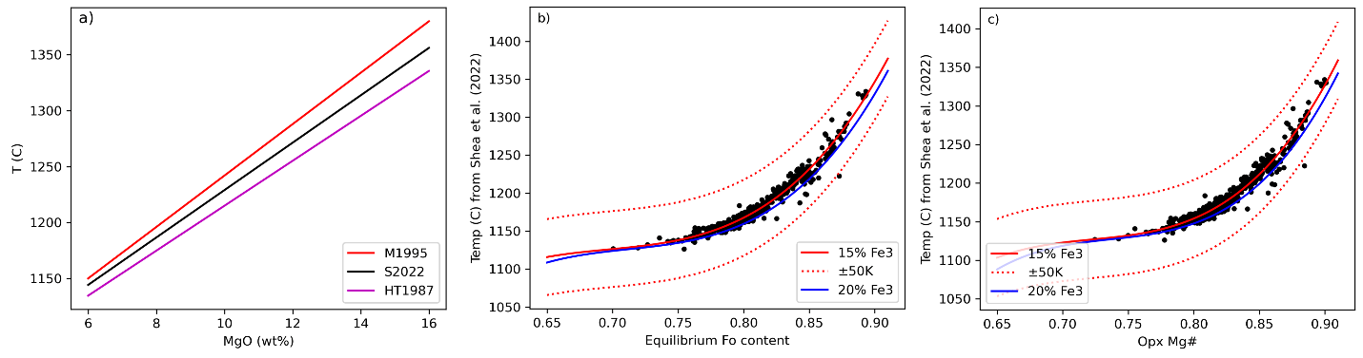
Supporting Fig. S9– Temperature relationships. a) Comparison of different liquid-only thermometers for Hawaiian lavas. b) Fo vs. Temperature relationship from DeVitre and Wieser (2024). c) Opx Mg# vs. Temperature developed for this study. In both cases, we use the 15 % Fe³⁺ trend.
We use the X_{H2O}-pressure relationship from DeVitre and Wieser (2024), based on the absence of published melt inclusions from Mauna Loa that measured CO₂ in the vapour bubble. Based on the similar H₂O contents of Mauna Loa and Kīlauea melt inclusions we believe this relationship is a good approximation to the likely trends at Mauna Loa (Supporting Fig. S10).
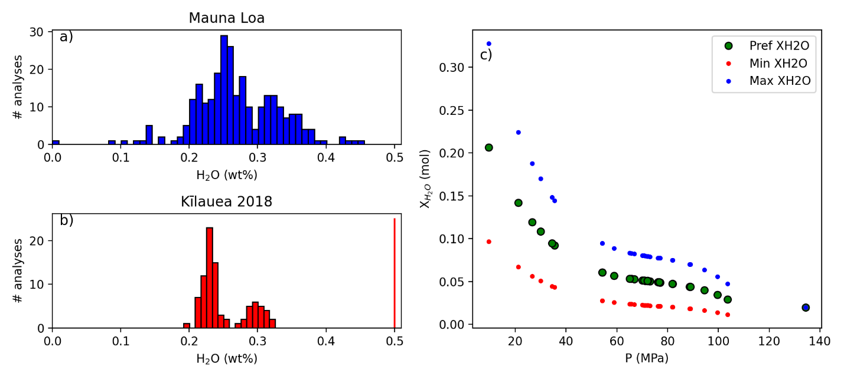
Supporting Fig. S10– X_{H2O} vs. pressure relationship used for equation of state (EOS) calculations (also used by Lynn et al. 2024 for the 2022 eruption of Mauna Loa). H₂O contents from Mauna Loa are from Marske and Hauri, (2018). The red histogram (b) shows the contents of H₂O in the 2018 eruption used to parametrize this relationship at Kīlauea (the eruption with the most CO₂ data in the bubble). c) shows the trends in X_{H2O} vs. pressure for the 2018 eruption of Kīlauea, with a generous bound on uncertainty (upper values = blue dots, lower values = red dots). This uncertainty is propagated through EOS calculations using DiadFit.

Sulfur_X degassing models
Sulfur_X degassing models were run using a starting composition based on erupted matrix glass data (Table S5), with model parameters show in Table S6.
SiO2 | Al₂O₃ | FeO_{t} | MgO | CaO | Na₂O | K₂O | P₂O₅ | MnO | TiO₂ | CO_{2 (ppm)} | H₂O  _{(wt%)} | Fe3/FeT | Fe3/Fe2 | S _{(ppm)}
51.94 | 13.94 | 10.14 | 7.44 | 10.27 | 2.53 | 0.49 | 0.26 | 0.16 | 2.06 | 900 | 0.5 | 0.18 | 0.107 | 1400
Table S5 - Starting composition in wt%
Parameter | Value | Explanation
Delta_FMQ | 0.5 and 0.3 | Two different redox states to get the full range of S⁶⁺/S_{T} ratios
COH_model | 1 | VolatileCalc option for the C-H solubility model, because Iacono-Marziano shows very unstable results.
fO2_tracker | 1 | Allows fO₂ to change by S degassing and S-Fe electron exchange
Monte_carlo | 0 | Doesn’t run Monte-Carlo simulations
l | 1000 | Total steps of pressure from initial P to 1 bar
m | 1000 | Total number of runs along degassing
open_degassing | 0 | Closed system degassing
S_Fe_choice | 100 | Uses the ‘Muth’ option for the for the S⁶⁺/S_{T} ratio (code 100), adjusting the final coefficient between 4.3 and 7.2 to get different S⁶⁺/S_{T} ratios
sigma | 0.025 | log₁₀(fO₂) tolerance
Table S6 – Sulfur_X model parameters. The S_Fe_choice parameter sets the relationship between S and Fe redox in Sulfur_X. The options provided to the user in the S_Fe.py code include the model of Nash et al. (2019), O’Neill and Mavrogenes (2022) and an empirical parameterization of Muth and Wallace (2021). These S-Fe models can show vastly different results (see Wieser and Gleeson, 2023; Wieser et al., 2020). In the Sulfur_X paper, Ding et al. (2023) tweak the coefficient in the Muth parameterization to obtain a relationship between Fe-S that best fits the data. In Sulfur_X, tweaking this coefficient is the only way to investigate the effect of different S⁶⁺/S_{T} on the degassing path, without being tied to the T- S⁶⁺/ST relationships defined by Nash and O’Neill.
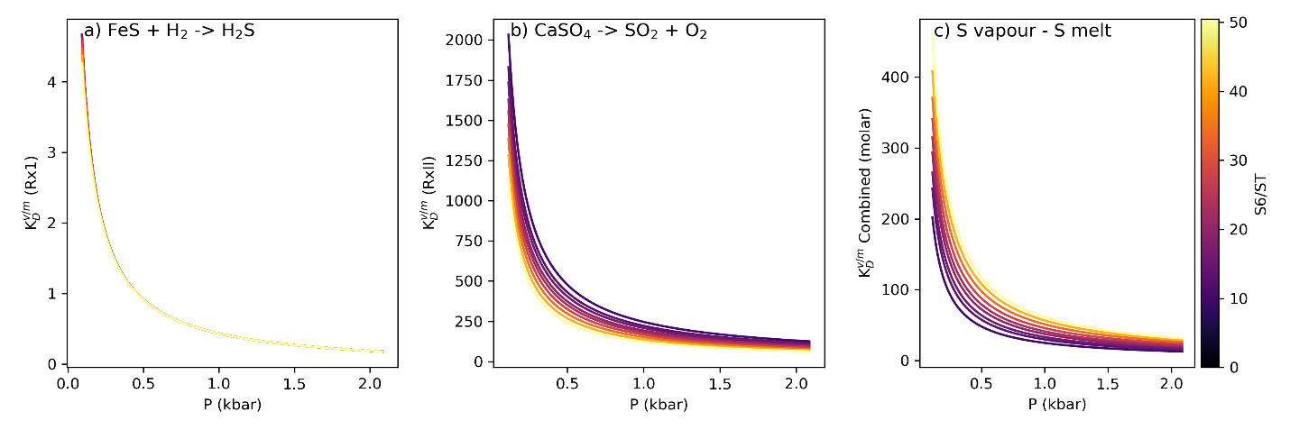
Supporting Fig. S11 – Comparison of K_{D} values for different S redox states. a) The partition coefficient for Rx1 is most sensitive to pressure, with very little variability with S redox. The partition coefficient for Rx2 actually decreases slightly with increasing S⁶⁺/S_{T}, because of the -0.5 ln fO₂ term in this equation. However, the bulk partition coefficient increases with increasing S⁶/S_{T}, because there is more SO₄ in the melt.

DCompress degassing models
The initial conditions for DCompress calculations are shown in the two screenshots below:

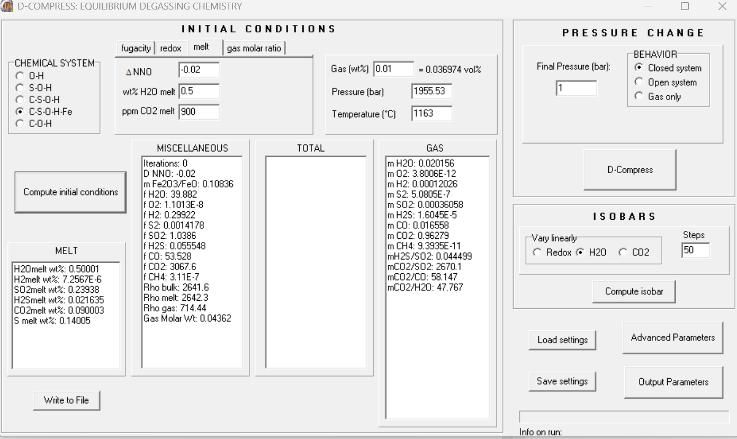
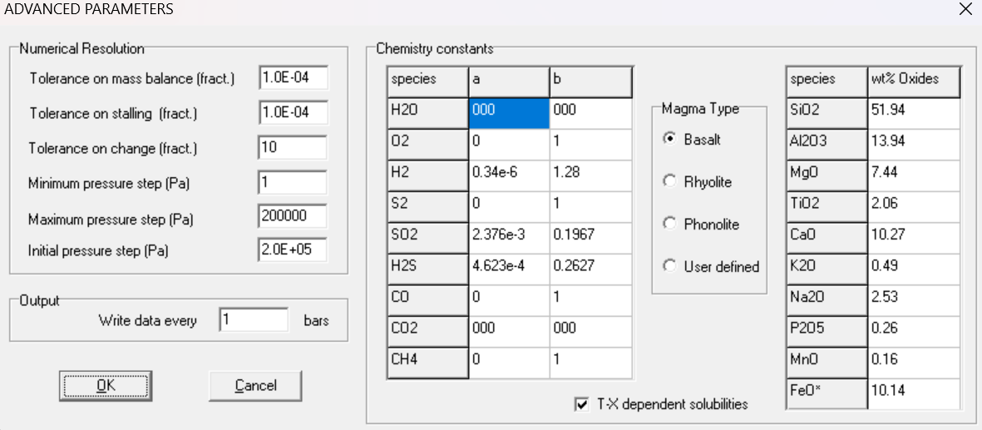

Sulfur diffusion model
Diffusion Methods
To assess the timescales required for S to enter a bubble within a degassing magma, we simulate diffusion of S across a melt-fluid interface and the resulting diffusion of S within the surrounding melt phase. We assume a spherical geometry, with a total radius (melt plus fluid) of $r_{total}$ (typically assumed to be 200 µm in the models shown). At the center of our system, we simulate the presence of a fluid inclusion with a radius of $r_{FI}$.
Within the system we consider three domains: (i) the fluid inclusion, which we assume has a fixed volume and a homogenous S concentration (i.e., diffusion and/or mixing of S across the fluid is instantaneous at the timestep used in these calculations); (ii) a ‘melt-film’, representing the portion of the melt phase at the interface with the bubble; and (iii) the outer melt, diffusion of S within this region results from loss of S from the melt film to the bubble, setting up a concentration gradient within the melt. Our model is set up in two steps: 1. calculate the flux of S across the melt-fluid interface; 2. diffusion within the melt phase.
Step 1: We calculate the flux of S across the melt-fluid interface using a numerical solution to Fick’s First Law:
$J= -D(\frac{C_{mf}-\frac{C_{FI}}{K_{D}}}{Δr})$ (Eq. 1)
where $D$ is the diffusion coefficient of S in the melt phase (see discussion below), $Δr$ represents the radial step size (in meters) of the diffusion model, $C_{mf}$ represents the concentration of S in the melt film (ppm), $C_{FI}$ represents the concentration of S in the bubble/fluid inclusion (ppm), and $K_{D}$ is the equilibrium partitioning relationship between a melt and fluid at the conditions of interest (see discussion below), i.e., for a system at equilibrium (no net diffusion):
$K_{D}= \frac{C_{FI}}{C_{mf}}$ (Eq. 2)
For each time step in our diffusion model, we can then calculate the loss of S (in ppm) from the melt film due to diffusive flux across the bubble-melt film interface as:
${∆S}_{mf}=\frac{J*A_{bubble}*∆t}{V_{mf}}$ (Eq. 3)
where $A_{bubble}$ is the surface area of the bubble-melt film interface (m²), $V_{mf}$ is the volume of the melt film (m³), and $∆t$ is the time step used in the diffusion model. This can also be used to calculate the total transfer of S (in kg) to the bubble/fluid inclusion:
$∆S_{FI}^{kg}= {-∆S}_{mf}*V_{mf}*ρ_{mf}*{10}^{-6}$ (Eq. 4)
We assume that S dissolved into the melt is converted into SO₂ in the fluid by gaining oxygen from the melt. Therefore, at each time step $t$ the total mass of the fluid and the mass of SO₂ in the fluid will both change according to:
$M_{FI_total}^{t}= M_{FI_total}^{t-1}+∆S_{FI}^{kg}*2$ (Eq. 5)
$M_{FI_SO2}^{t}= M_{FI_SO2}^{t-1}+∆S_{FI}^{kg}*2$(Eq. 6)
where the value of $∆S_{FI}^{kg}$ is multiplied by 2 because of the different molecular weight of S vs. SO₂. After each step of the diffusion model, we can therefore calculate the new concentration of S (in ppm) in the bubble ($C_{FI}$) using:
$C_{FI}=\frac{{0.5*M}_{FI_SO2}^{t}}{M_{FI_total}^{t}}*{10}^{6}$ (Eq. 7)
Step 2: The spherical geometry used here allows us to simulate diffusion within the melt phase surrounding the bubble using a 1D radial diffusion equation in spherical coordinates. We consider diffusion within the scalar concentration field $C(r, t)$ with radial coordinate $r$ at time $t$. Assuming the symmetry of the sphere, the concentration will solely depend on radial coordinate $r$ and will be independent of angular coordinates $θ$ and $ϕ$. Thus, Fick’s Second Law of Diffusion in spherical coordinates can be expressed as:
$\frac{∂C}{∂t}=D∇^{2}C=D\frac{1}{r^{2}}\frac{∂}{∂r}(r^{2}\frac{∂C}{∂r})$ (Eq. 8)
and using the product rule this becomes:
$\frac{∂C}{∂t}=D\frac{1}{r^{2}}(r^{2}\frac{∂^{2}C}{∂r^{2}}+2r \frac{∂C}{∂r})$ (Eq. 9)
and can be simplified to:
$\frac{∂C}{∂t}=D(\frac{∂^{2}C}{∂r^{2}}+\frac{2}{r} \frac{∂C}{∂r})$ (Eq. 10)
We discretize the spherical domain from $r=r_{FI}$ (the edge of the fluid inclusion) to $r=r_{melt}$ (the outer boundary of the melt). The radial domain is divided into $N_{r}$ grid points with uniform spacing $∆r$, set to be equal to the $r_{mf}$ (the radius of the melt film). At each grid point $i$, we approximate the spatial derivative of Equation 10 with a finite difference scheme, second-order and centered in space:
${\left.\frac{∂C}{∂t}\right|}_{i}≈D\left[\frac{C_{i+1}-2C_{i}+C_{i-1}}{{\left(∆r\right)}^{2}}+\frac{2}{r_{i}}\frac{C_{i+1}-C_{i-1}}{2∆r}\right]$ (Eq. 11)
and update $C_{i}$ with a first-order, explicit (forward) Euler method in time:
$C_{i}^{t+1}=C_{i}^{t}+∆t(\frac{∂C_{i}^{t}}{∂t})$ (Eq. 12)
Hence, this scheme is second-order in space and first-order in time.
To ensure numerical stability, we use the Courant-Friedrichs-Lewy (CFL) stability condition to select timestep $∆t$:
$∆t≤α(\frac{ ∆r}{D})$ (Eq. 13)
where $α=0.25$. The chosen $α$ is conservative, compared to the usual $α=0.50$, to ensure stability and to prevent unphysical results.
We assume a zero-flux boundary condition at the outer margin of the melt phase (i.e., $C_{i=Nr}^{t}= C_{i=Nr-1}^{t}$) and use our calculations of the melt transfer into the fluid to set the boundary condition at the boundary interface between the melt and fluid (we term the melt film, as the final shell of melt next to the fluid). In other words, the concentration in the melt film is described using a similar approach to that outlined in Equation 11 above, but corrected for by the loss of S to the bubble:
${\left.\frac{∂C}{∂t}\right|}_{i}≈D\left[\frac{C_{i+1}-C_{i}}{{\left(∆r\right)}^{2}}+\frac{2}{r_{i}}\frac{C_{i+1}-C_{i}}{∆r}\right]-{∆S}_{mf}$ (Eq. 14)
where $i$ represents the position of the melt film and ${∆S}_{mf}$ is taken from Equation 3 above.
Choice of parameters
The main parameters within the diffusion calculations shown above are the diffusivity of S within the melt phase ($D$), the equilibrium partition coefficient between the melt and fluid ($K_{D}$), the initial concentration of S in the melt phase ($C_{init}$), the radii of the different components in the model ($r_{FI}, r_{mf}, r_{melt}$) and the value of $∆r$. We emphasize that this model is a first approximation, given the large uncertainty regarding many of these parameters (D, K_{D}), and the exact geometry of the fluid inclusion and surrounding melt as a crystal traps the inclusion. However, we believe this model provides a good first estimate of whether it is plausible that the scatter in SO₂ amounts reflects disequilibrium degassing, or whether the required timescales are orders of magnitude different from olivine growth rates.
To determine an appropriate choice of $D$, we consider the parameterization of Zhang et al., (2007):
$\ln{D}= -8.21- \frac{27692-651.6 H_{2}O (wt\%) }{T}$ (Eq. 15)
and the anhydrous basalt parameterization of (Freda et al., 2005)
$D=2.19{∙10}^{-4}\exp{(\frac{-226.3 ±58.3 {X10}^{3} }{RT})}$ (Eq. 16)
where T is in Kelvin for both equations. We calculate $D$ at a range of temperatures appropriate to Hawaiian magmatism, yielding diffusion coefficients between 10⁻¹⁰ and 10⁻¹². Results from these calculations for temperatures of interest are shown in Table S8 and Fig. S.11. For most calculations shown in this study, we use $D={10}^{-12} m^{2}/s$ although the influence of uncertainties in this parameter was also investigated (different lines in Fig. 13). A better understanding of diffusion coefficients in high-temperature tholeiitic melts, such as those in Hawai‘i and Iceland, would help clarify the processes controlling magma transport and storage (see also Nicholson et al., 2024).
The value of $K_{D}$ was selected based on outputs from Sulfur_X degassing calculations ($K_{D}=50-100$; Fig. S.12) and the initial concentration of S in the melt phase was set to 1400 ppm based on melt inclusion measurements from (Marske and Hauri, 2018). $r_{FI}$ was varied between 8 and 15 μm (see Fig. 4, spanning 40-75 percentile), with the radius of the entire system ($r_{total}$) set at 200 μm. $∆r$ was set at 0.1 – 0.2 μm, with the radius of the melt film set equivalent to $∆r$. The latter two parameters (r and $∆r)$ made no different to models once r was sufficiently large and $∆r$ was sufficiently small.

Table S8 – Sulfur diffusion coefficients calculated for different temperatures. The sigma values represent the calculation performed using the stated error bar on the coefficient in Eq16.
Temp ℃ | T_K | D_Freda | D_Zhang | D_Freda (+1 σ) | D_Freda (-1 σ)
1150 | 1423.15 | 1.1E-12 | 1.2E-12 | 1.5E-10 | 7.7E-15
1200 | 1473.15 | 2.1E-12 | 2.3E-12 | 2.4E-10 | 1.8E-14
1250 | 1523.15 | 3.8E-12 | 4.3E-12 | 3.8E-10 | 3.8E-14
1300 | 1573.15 | 6.6E-12 | 7.6E-12 | 5.7E-10 | 7.7E-14
1350 | 1623.15 | 1.1E-11 | 1.3E-11 | 8.5E-10 | 1.5E-13

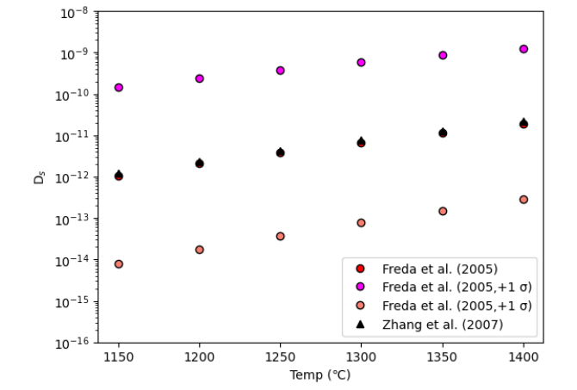
Supporting Fig. S12 – Graphical representation of diffusion coefficients given in Table S8, for the range of temperatures relevant to Mauna Loa magmas.
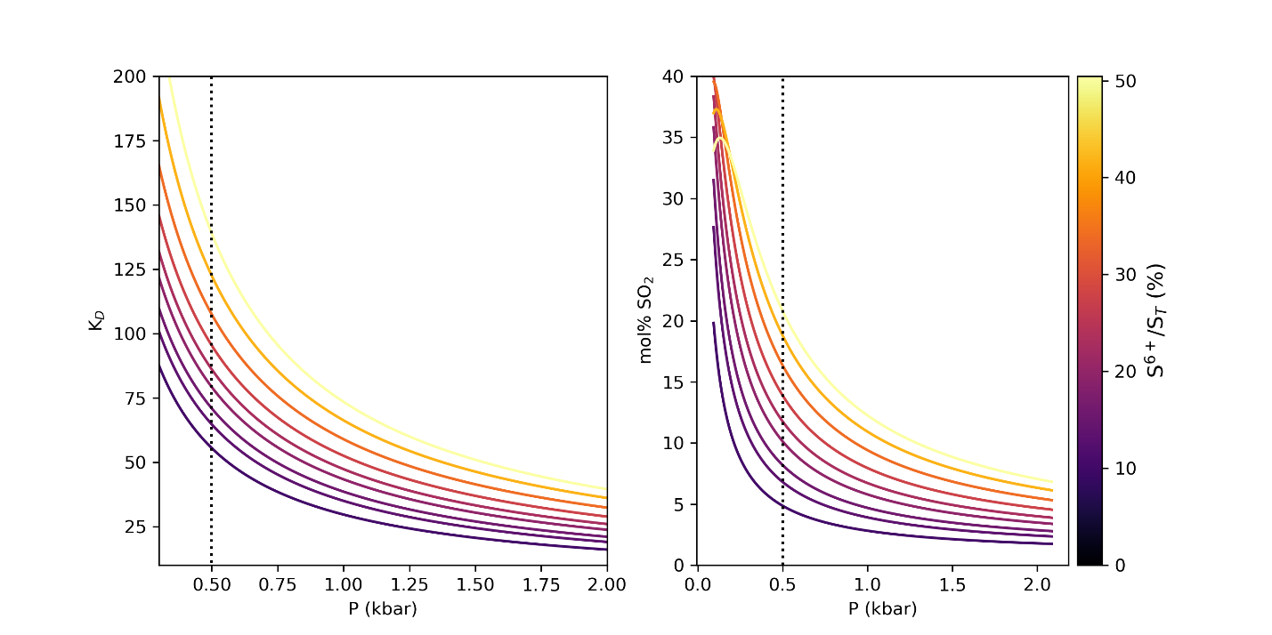
Supporting Fig. S13 – Bulk K_{D} output from Sulfur_X. The black dotted line indicates the approximate pressure for a fluid inclusion with $ρ_{CO2}=0.16$ g/cm³. K_{D}=50 is shown in the text as a lower limit of reasonable K_{D}, representing a worst case scenario for preserving disequilibrium given measured olivine growth rates. The higher the K_{D} value, the easier to achieve the observed disequilibrium for a given entrapment time.

Variability in CO₂ density as a function of SO₂
To assess whether SO₂ is affecting the calculated pressures, we look at the correlation between SO₂ mol % and CO₂ density in FI trapped within the same crystals. Some correlations could be real—FI trapped progressively shallow would be expected to record lower CO₂ densities and higher SO₂ mol %. However, some variability in SO₂ mol % will be caused by sluggish diffusion for FI trapped at the same densities so this is still a useful exercise. There is no coherence in trends, and FI with different SO₂ proportions record similar densities. Each plot shows an individual crystal, and plots are sorted from largest to smallest variability in SO₂.
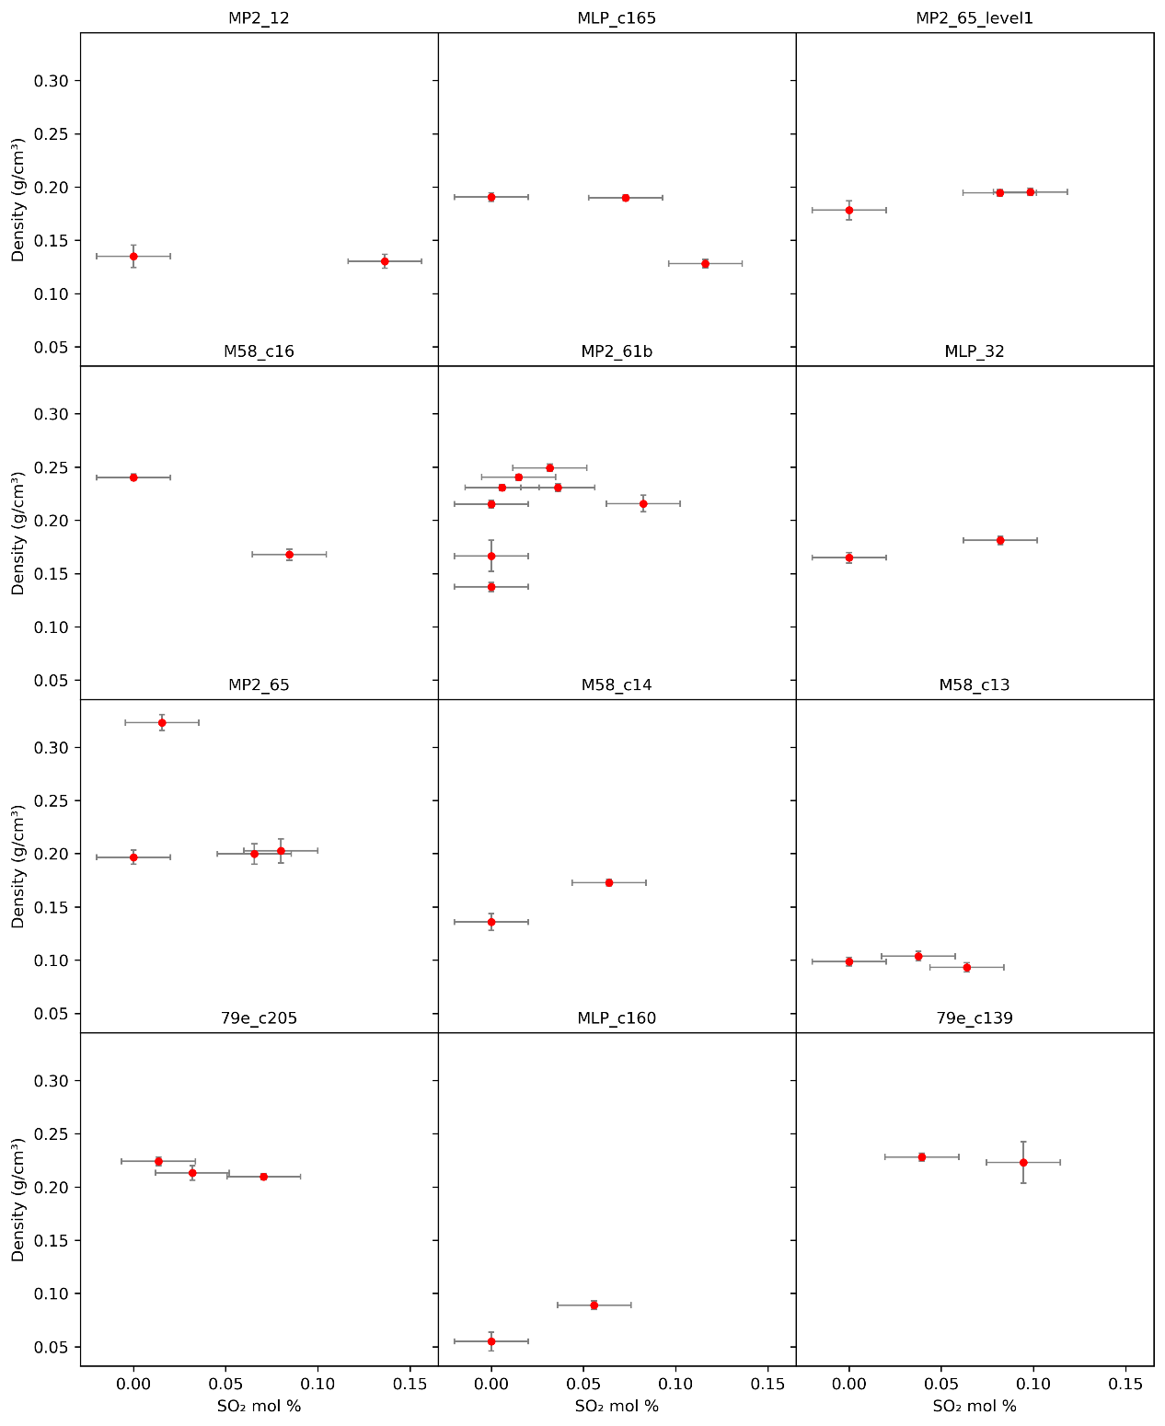
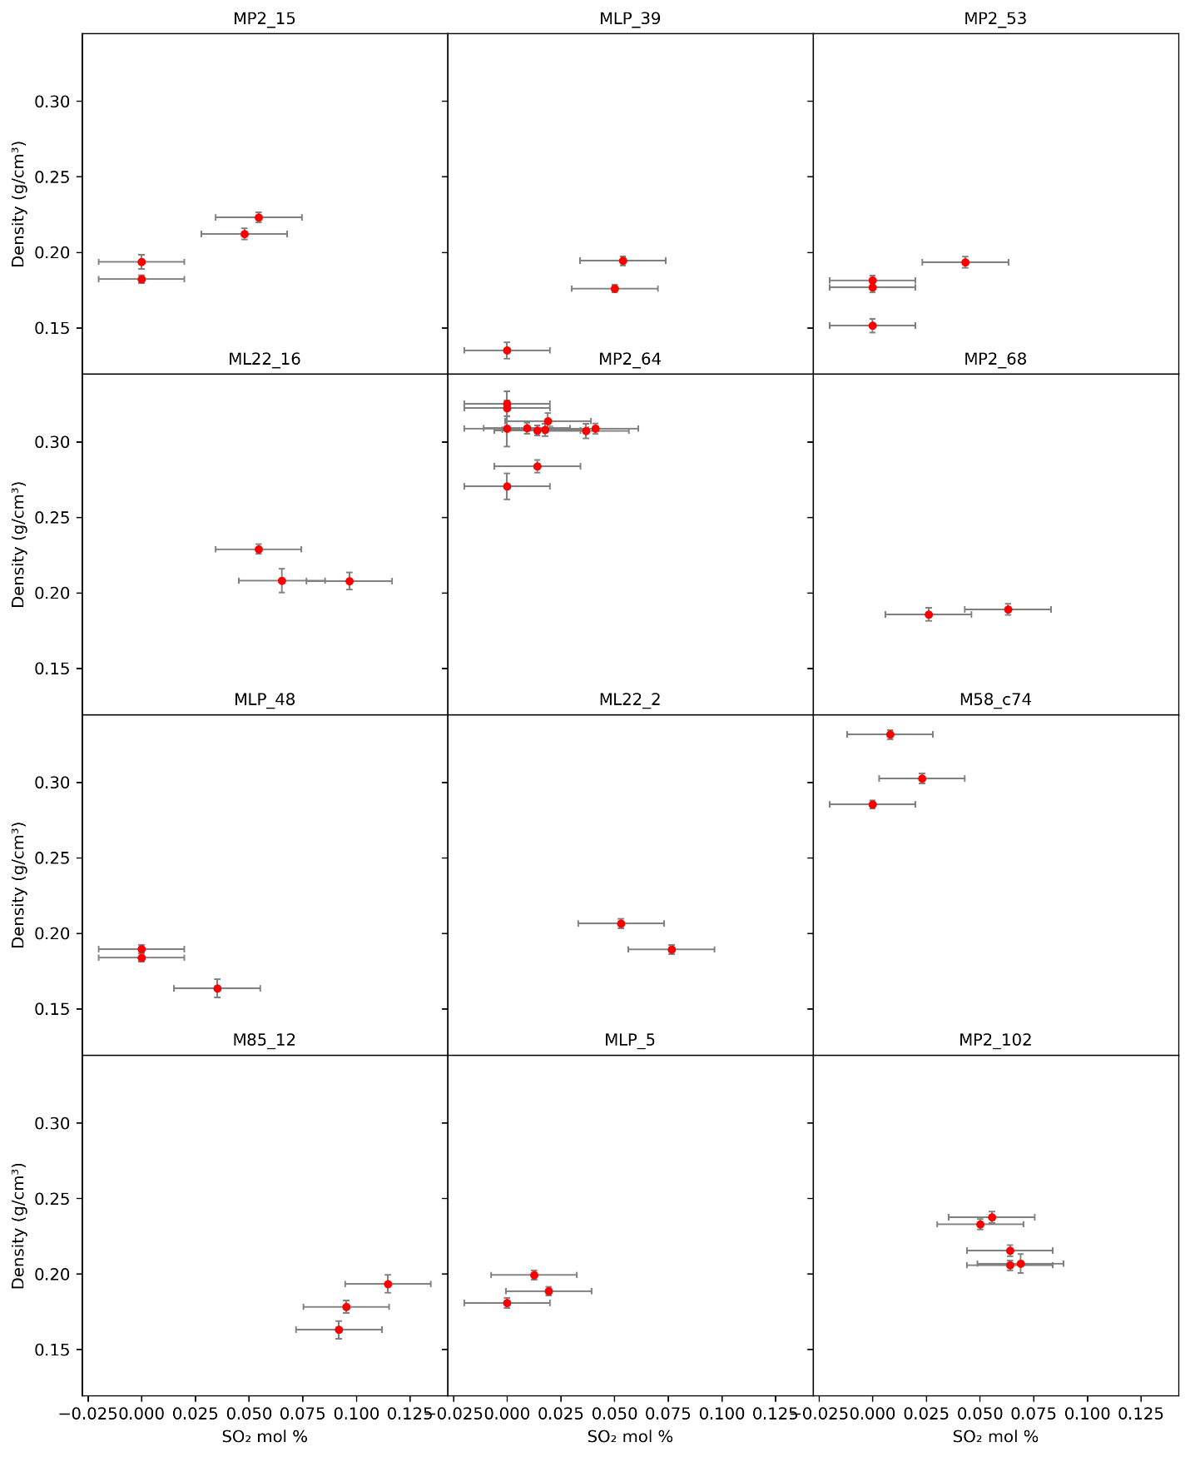
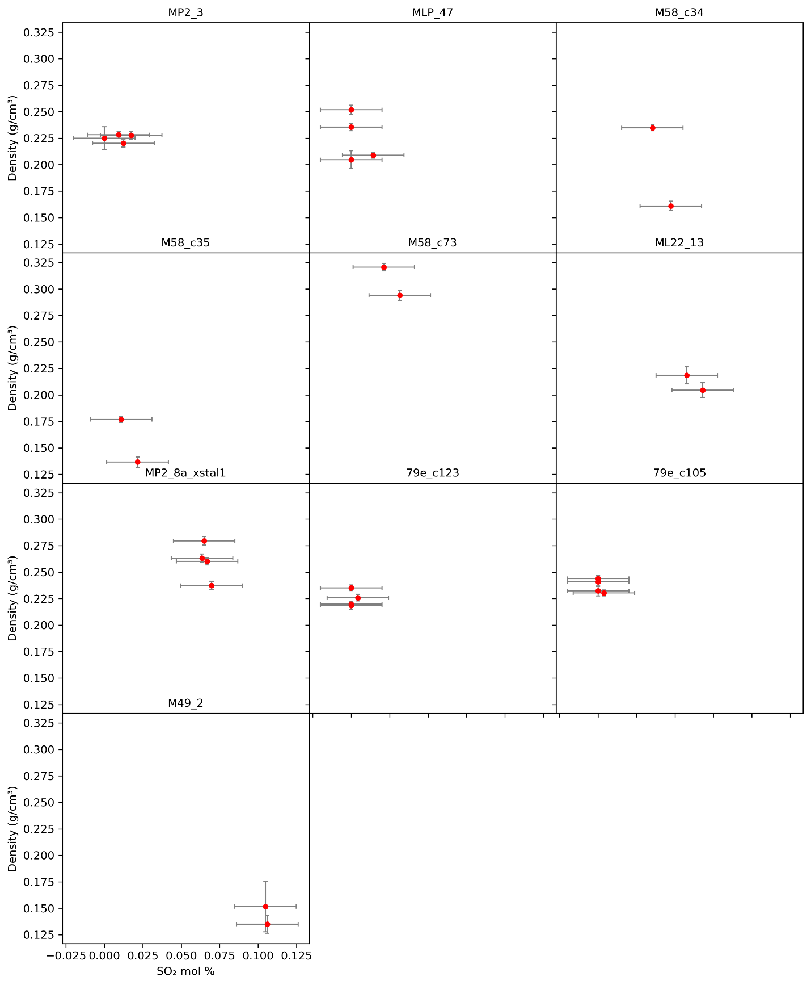
Supporting Fig. S14 – Variability in SO₂ mol % and CO₂ density within each crystal with >1 FI.
We also examine the distribution of densities for those with and without SO2, and in each bin. This is where we would expect to see declining densities with increasing SO₂ when binning, given that SO₂ degassing is pressure dependent.
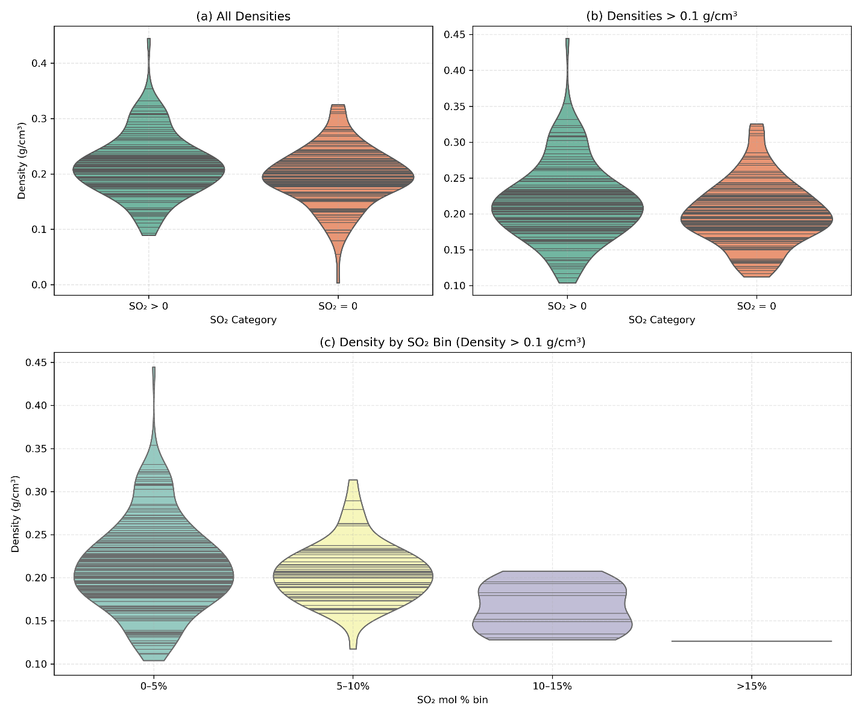
Supporting Fig. S15 – Comparison of distribution of densities for those with and without SO₂. a) The overall distribution is similar, and our inference of the main magma storage region at ~3 km would not be drastically shifted by only including those without SO₂. b) Removing the lowest density FI most affected by degassing. c) Comparison binned by amount of SO₂. The decline is expected here, given that SO₂ only strongly degasses at shallower pressures and thus the highest proportions will be seen in lower density FI.
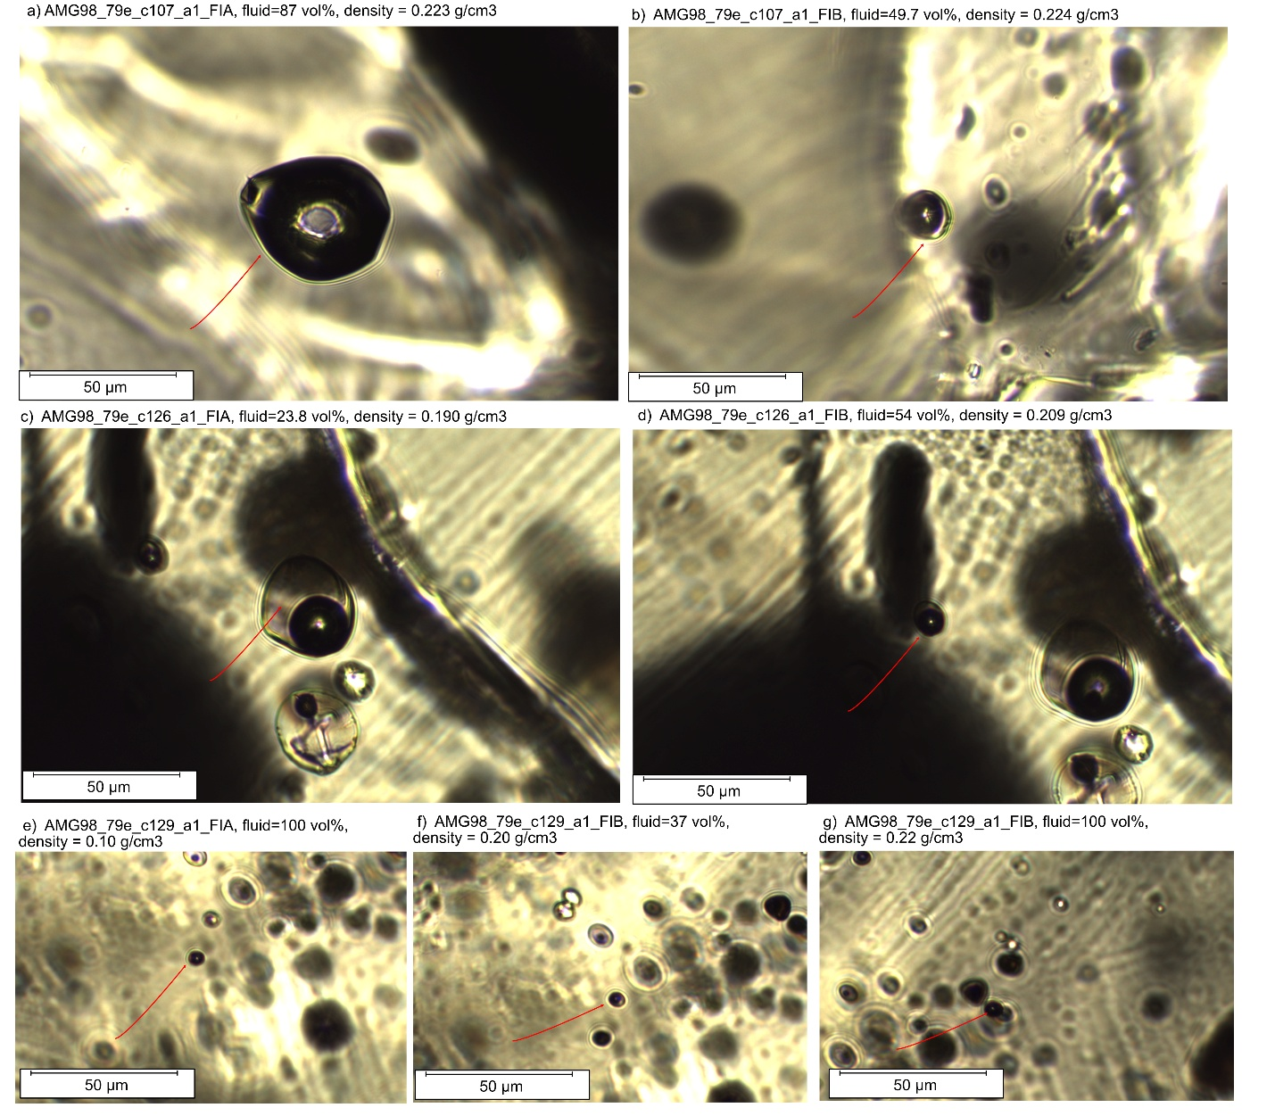
Supporting Fig. S16 – Examples of some FI with varying proportions of melt:fluid. Each row represents a unique crystal. a-b) despite the differences in melt proportion, the densities are very similar. b) shows a FI where refraction makes it hard to estimate the % fluid accurately. c) a melt-dominated fluid inclusion. d) just fluid dominated. e-g) very small FI, there is no clear correlation between density and presence of melt films (only seen in f). We discard all FI with <40% melt by volume (e.g. c).
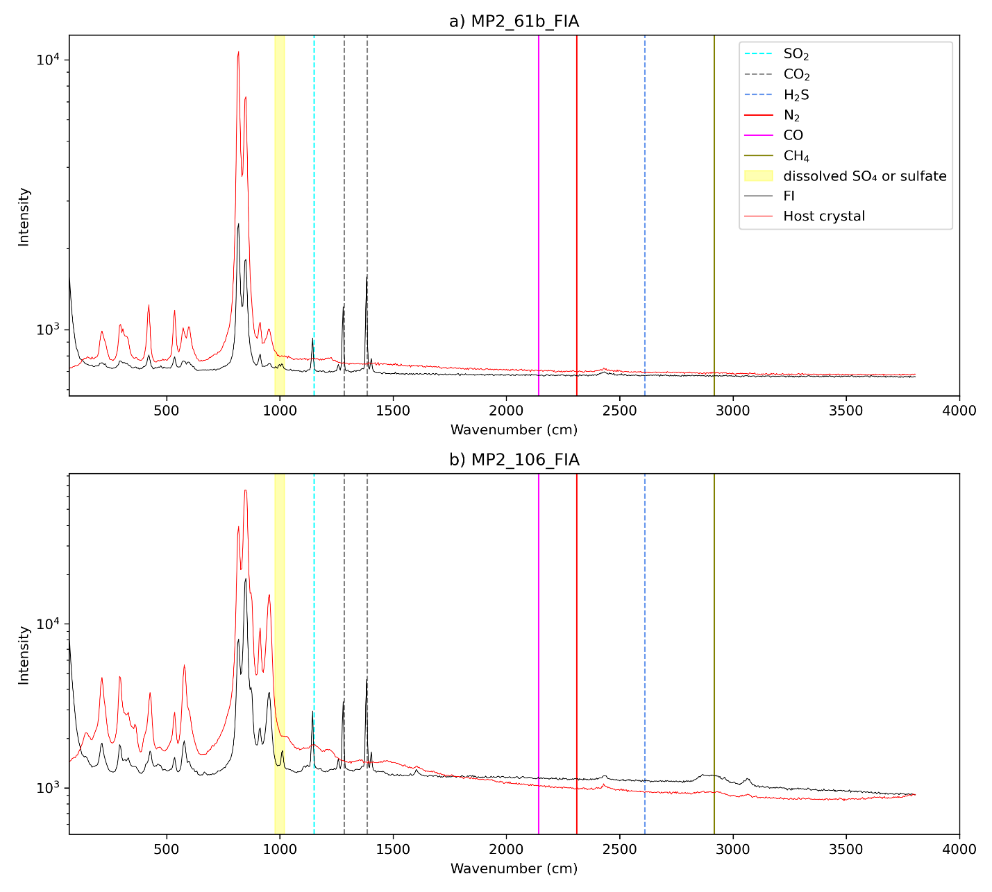
Supporting Fig. S17 – 300 g scans collected on fluid inclusions (black) and their mineral host (black, pyroxene for a, olivine for b-c). The position of other common gaseous and aqueous species are shown.

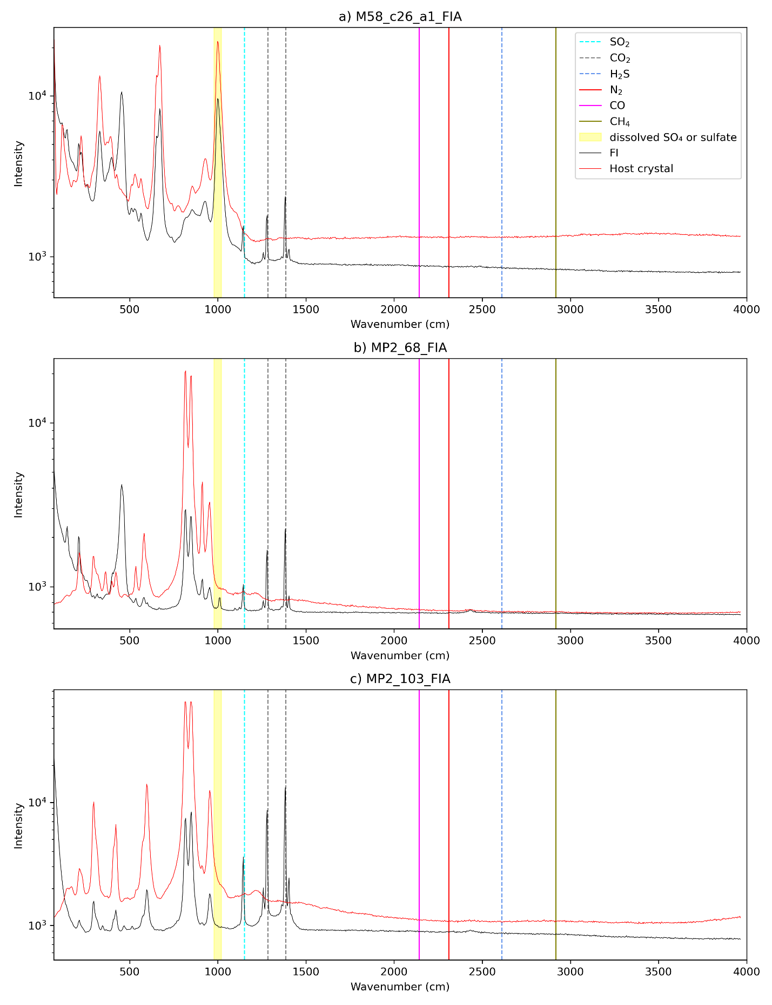
Supporting Fig. S18 – 300 g scans collected on fluid inclusions (black) and their mineral host (black, pyroxene for a, olivine for b-c). The position of other common gaseous and aqueous species are shown.
Any use of trade, firm, or product names is for descriptive purposes only and does not imply endorsement by the U.S. Government
Supporting References
Brooker, M.H., Eysel, H.H., 1981. Raman spectroscopic studies of S¹⁶ O₂ and S¹⁸ O₂ in the gas phase: Hot band assignment. J Raman Spectroscopy 11, 322–325. https://doi.org/10.1002/jrs.1250110506
Burke, E.A.J., 2001. Raman microspectrometry of fluid inclusions. Lithos 55, 139–158. https://doi.org/10.1016/S0024-4937(00)00043-8
DeVitre, C.L., Allison, C.M., Gazel, E., 2021. A high-precision CO2 densimeter for Raman spectroscopy using a Fluid Density Calibration Apparatus. Chemical Geology 584, 120522. https://doi.org/10.1016/j.chemgeo.2021.120522
DeVitre, C.L., Dayton, K., Gazel, E., Pamukçu, A., Gaetani, G., Wieser, P.E., 2023. Laser heating effect on Raman analysis of CO2 co-existing as liquid and vapor in olivine-hosted melt inclusion bubbles. Volcanica 6, 201–219. https://doi.org/10.30909/vol.06.02.201219
DeVitre, C.L., Wieser, P.E., 2024. Reliability of Raman analyses of CO2-rich fluid inclusions as a geobarometer at Kīlauea. Geochem. Persp. Let. 29, 1–8. https://doi.org/10.7185/geochemlet.2404
Ding, S., Plank, T., Wallace, P.J., Rasmussen, D.J., 2023. Sulfur_X: A Model of Sulfur Degassing During Magma Ascent. Geochem Geophys Geosyst 24, e2022GC010552. https://doi.org/10.1029/2022GC010552
Freda, C., Baker, D.R., Scarlato, P., 2005. Sulfur diffusion in basaltic melts. Geochimica et Cosmochimica Acta 69, 5061–5069. https://doi.org/10.1016/j.gca.2005.02.002
Gale, A., Dalton, C.A., Langmuir, C.H., Su, Y., Schilling, J.-G., 2013. The mean composition of ocean ridge basalts: MEAN MORB. Geochem. Geophys. Geosyst. 14, 489–518. https://doi.org/10.1029/2012GC004334
Hagiwara, Y., Yoshida, K., Yoneda, A., Torimoto, J., Yamamoto, J., 2021. Experimental variable effects on laser heating of inclusions during Raman spectroscopic analysis. Chemical Geology 559, 119928. https://doi.org/10.1016/j.chemgeo.2020.119928
Lamadrid, H.M., Moore, L.R., Moncada, D., Rimstidt, J.D., Burruss, R.C., Bodnar, R.J., 2017. Reassessment of the Raman CO 2 densimeter. Chemical Geology 450, 210–222. https://doi.org/10.1016/j.chemgeo.2016.12.034
Le, V.-H., Caumon, M.-C., Tarantola, A., 2021. FRAnCIs calculation program with universal Raman calibration data for the determination of PVX properties of CO2–CH4–N2 and CH4–H2O–NaCl systems and their uncertainties. Computers & Geosciences 156, 104896. https://doi.org/10.1016/j.cageo.2021.104896
Le, V.-H., Caumon, M.-C., Tarantola, A., Randi, A., Robert, P., Mullis, J., 2019. Quantitative Measurements of Composition, Pressure, and Density of Microvolumes of CO₂ –N₂ Gas Mixtures by Raman Spectroscopy. Anal. Chem. 91, 14359–14367. https://doi.org/10.1021/acs.analchem.9b02803
Marske, J.P., Hauri, E., 2018. Major- and trace-element compositions of 915 melt inclusions and host olivines from Hawaiian shield volcanoes. Interdisciplinary Earth Data Alliance (IEDA). https://doi.org/10.1594/IEDA/111193.
Montierth, C., Johnston, A.D., Cashman, K.V., 1995. An empirical glass-composition-based geothermometer for Mauna Loa Lavas, in: Rhodes, J.M., Lockwood, J.P. (Eds.), Geophysical Monograph Series. American Geophysical Union, Washington, D. C., pp. 207–217. https://doi.org/10.1029/GM092p0207
Muth, M.J., Wallace, P.J., 2021. Slab-derived sulfate generates oxidized basaltic magmas in the southern Cascade arc (California, USA). Geology 49, 1177–1181. https://doi.org/10.1130/G48759.1
Nash, W.M., Smythe, D.J., Wood, B.J., 2019. Compositional and temperature effects on sulfur speciation and solubility in silicate melts. Earth and Planetary Science Letters 507, 187–198. https://doi.org/10.1016/j.epsl.2018.12.006
Nicholson, E.J., Wieser, P.E., Hartley, M.E., Jenner, F.E., Kunz, B.E., Ilyinskaya, E., Thordarson, T., Edmonds, M., 2024. Sulfide saturation and resorption modulates sulfur and metal availability during the 2014–15 Holuhraun eruption, Iceland. Commun Earth Environ 5, 164. https://doi.org/10.1038/s43247-024-01249-2
O’Neill, H.St.C., Mavrogenes, J.A., 2022. The sulfate capacities of silicate melts. Geochimica et Cosmochimica Acta 334, 368–382. https://doi.org/10.1016/j.gca.2022.06.020
Putirka, K.D., 2008. Thermometers and Barometers for Volcanic Systems. Reviews in Mineralogy and Geochemistry 69, 61–120. https://doi.org/10.2138/rmg.2008.69.3
Schrotter, H., klockner, H., 1979. Raman scattering cross sections in gases and liquids, in: Raman Spectroscopy of Gases and Liquids. pp. 123–166.
Shea, T., K. Matzen, A., J. Mourey, A., 2022. Experimental study of Fe–Mg partitioning and zoning during rapid growth of olivine in Hawaiian tholeiites. Contrib Mineral Petrol 177, 114. https://doi.org/10.1007/s00410-022-01969-8
Wieser, P., Gleeson, M., 2023. PySulfSat: An Open-Source Python3 Tool for modelling sulfide and sulfate saturation (preprint). Earth Sciences. https://doi.org/10.31223/X5K360
Wieser, P.E., Jenner, F., Edmonds, M., Maclennan, J., Kunz, B.E., 2020. Chalcophile elements track the fate of sulfur at Kīlauea Volcano, Hawai’i. Geochimica et Cosmochimica Acta S0016703720303239. https://doi.org/10.1016/j.gca.2020.05.018
Wieser, P.E., Kent, A.J.R., Till, C.B., Donovan, J., Neave, D.A., Blatter, D.L., Krawczynski, M.J., 2023. Barometers Behaving Badly I: Assessing the Influence of Analytical and Experimental Uncertainty on Clinopyroxene Thermobarometry Calculations at Crustal Conditions. Journal of Petrology 64, egac126. https://doi.org/10.1093/petrology/egac126
Zhang, Y., Xu, Z., Zhu, M., Wang, H., 2007. Silicate melt properties and volcanic eruptions: SILICATE MELT PROPERTIES. Rev. Geophys. 45. https://doi.org/10.1029/2006RG000216

