Supplementary figures and tables for
Explosive eruptions of Kolumbo Central Volcano and associated tephra fallout hazards assessment
Federica Pardini ¹ · Andrea Bevilacqua ¹ · Matteo Cerminara ¹ · Mattia de’ Michieli Vitturi ¹ · Alessandro Tadini ¹ · Augusto Neri ¹ · R Stephen J Sparks ² · Georgios Vougioukalakis ³

1 Istituto Nazionale di Geofisica e Vulcanologia, Sezione di Pisa, Pisa, Italy.
2 School of Earth Sciences, University of Bristol, Bristol BS8 1RJ, UK.
3 Hellenic Survey of Geology and Mineral Exploration, Dep of Natural & Technological Hazards, S. Lui 1, Olympic Village, 13677 Aharne, Athens, Greece.
federica.pardini@ingv.it (corresponding author)

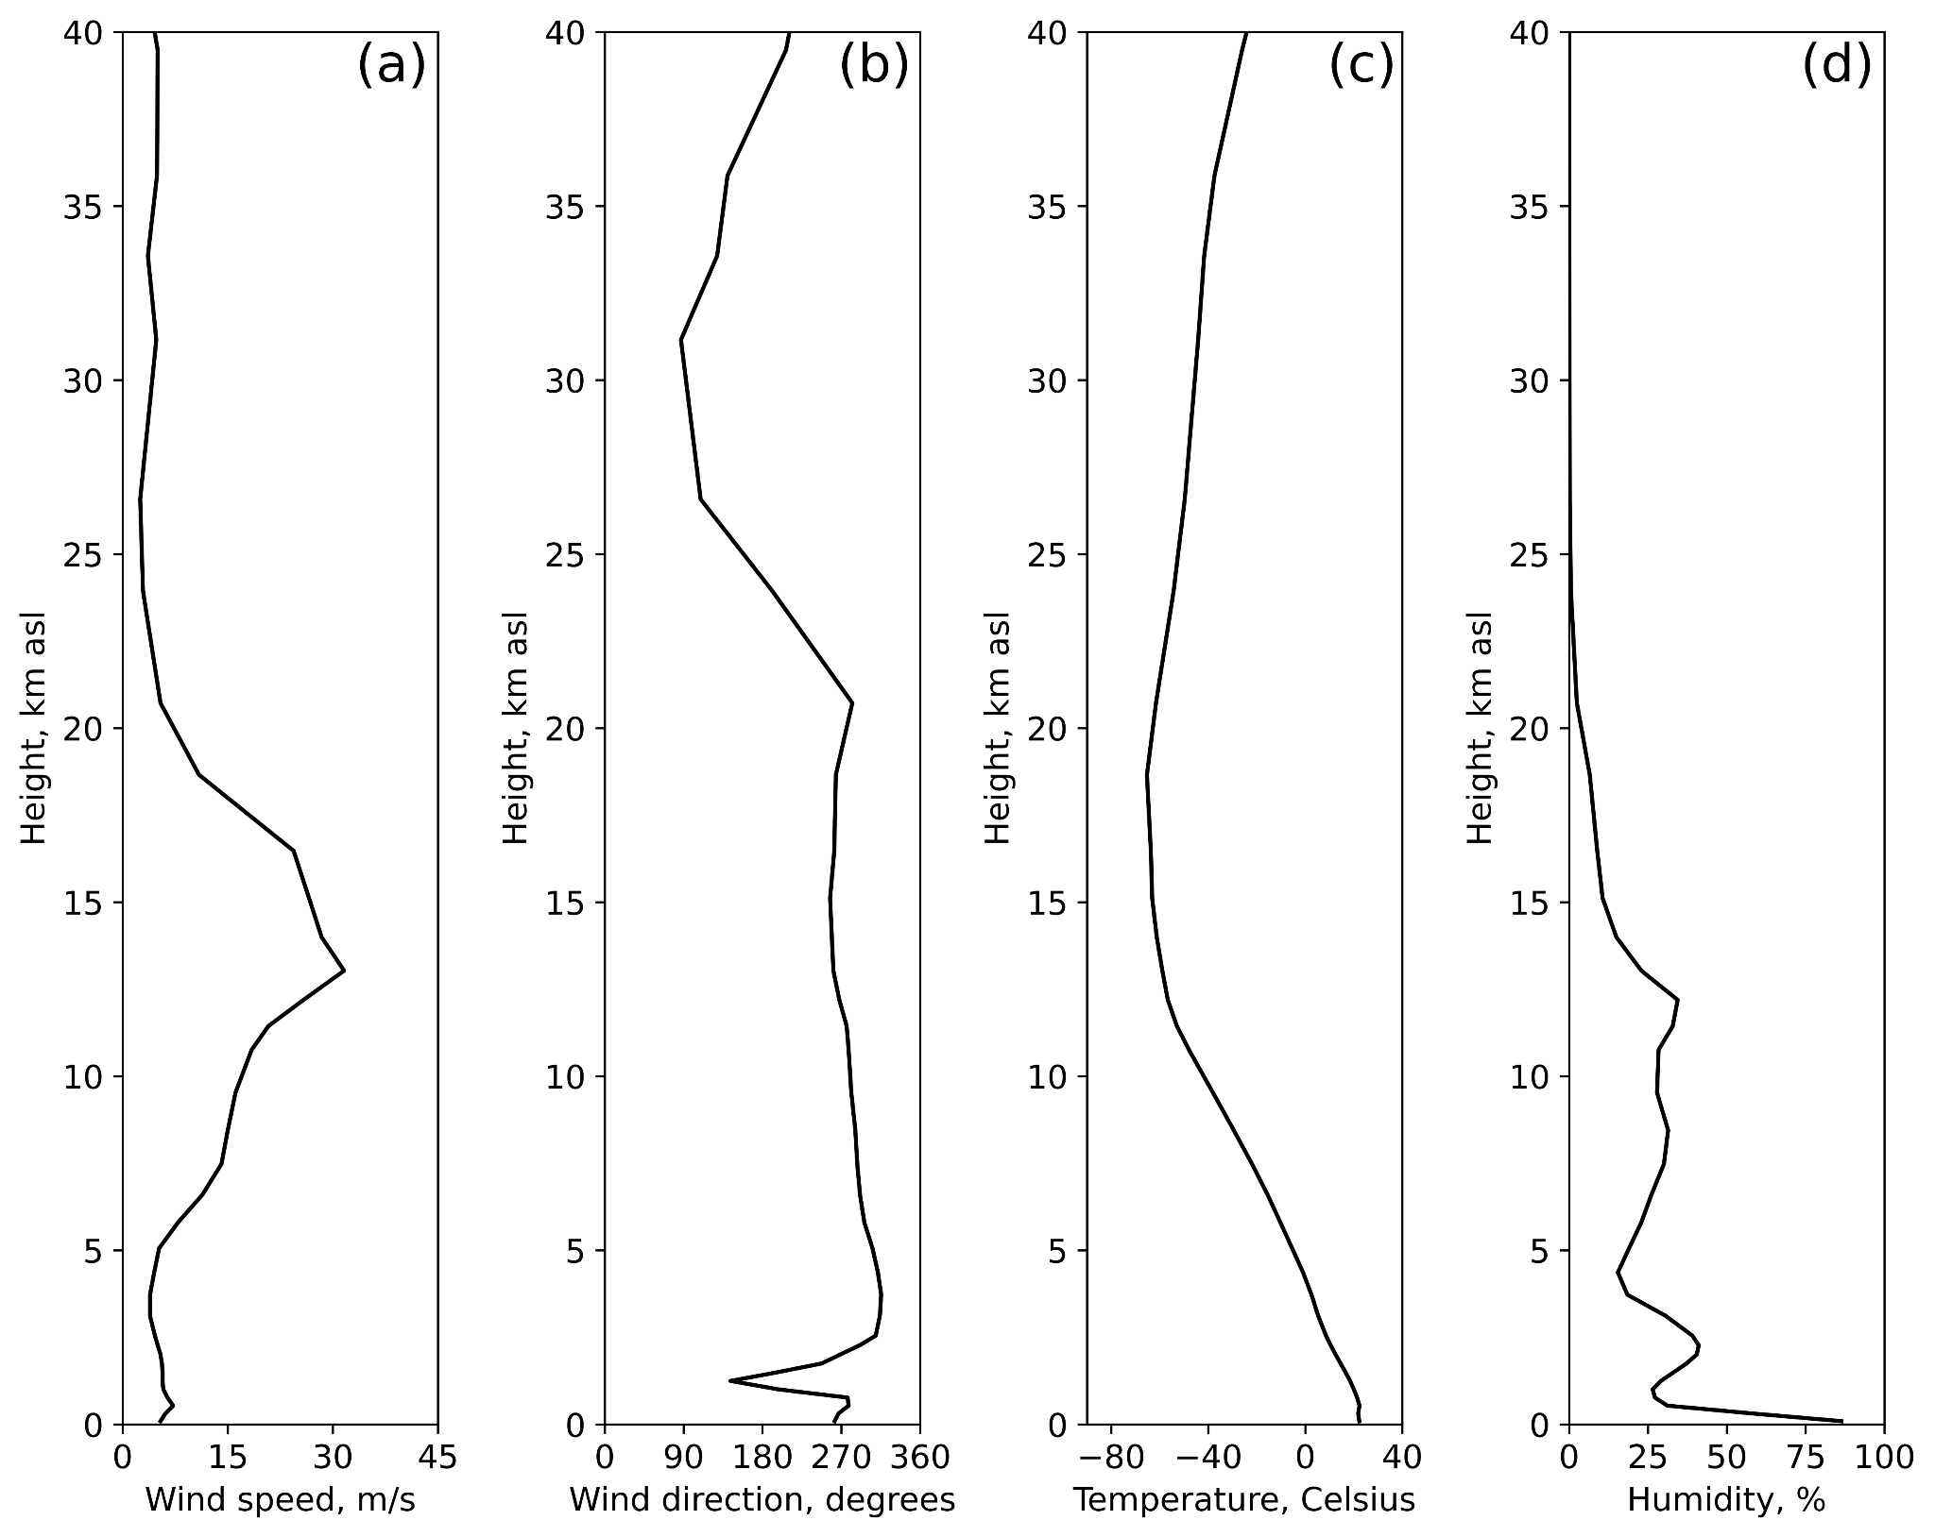

Fig. S1 Average atmospheric profiles for September 29, 2013. Panel (a) displays wind speed as a function of altitude, (b) shows wind direction, (c) illustrates atmospheric temperature, and (d) presents atmospheric humidity.

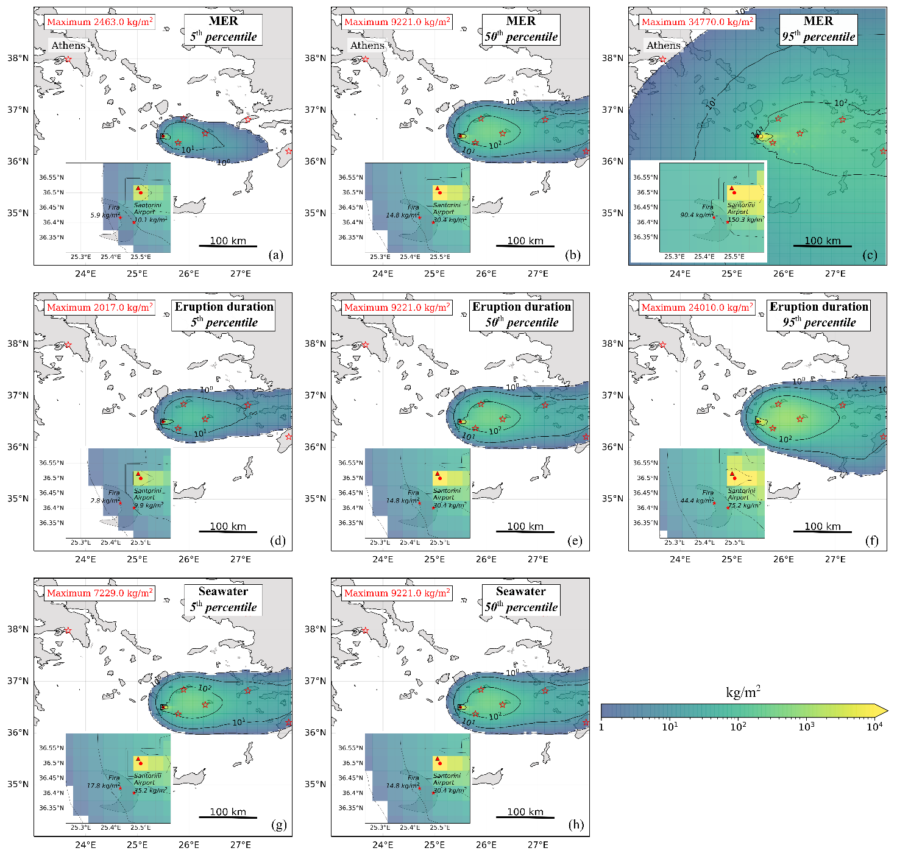
Fig. S2 Results of the deterministic PLUME-MoM-TSM and HYSPLIT simulations for the 1650 CE event, using the 5th, 50th, and 95th percentiles of eruption conditions derived from the elicitation. The panels display the tephra accumulation on the ground, expressed as ground load in kg/m². Contour lines indicate tephra ground loads of 1, 10, 100, and 1,000 kg/m². The meteorological data used is from 29 September 2013. Panels a, b, and c refer to simulations initialized with the 5th, 50th, and 95th percentiles of MER, while the other input parameters remain constant. Specifically, eruption duration and the amount of seawater are set to the 50th percentile values reported in Table 1. Panels d, e, and f show the results of simulations performed with the 5th, 50th, and 95th percentiles of eruption duration, while MER and the amount of seawater are fixed at their median values. Panels (g) and (h) refer to simulations initialized with the 5thand 50th percentiles of seawater, while the other input parameters remain constant. The red dot in each panel indicates the location where the maximum ground load value is reached.

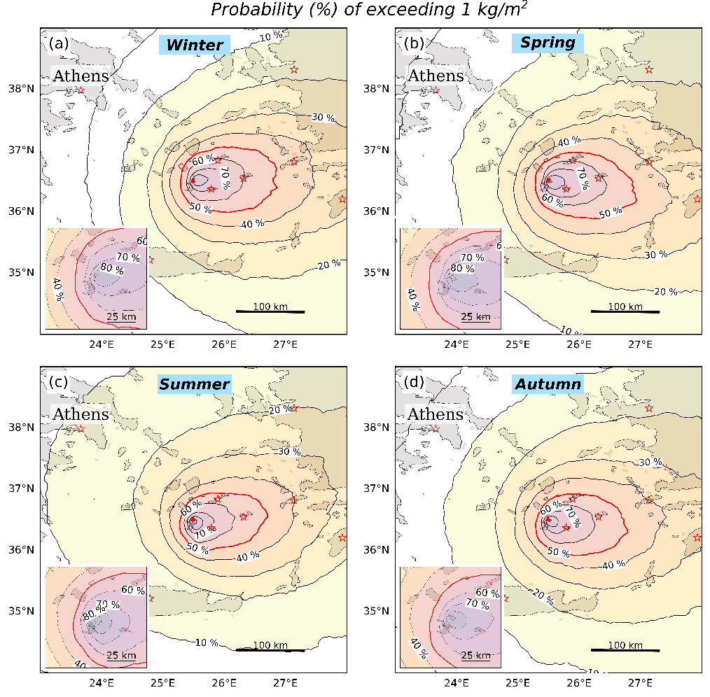

Fig S3 Seasonal probability map showing the likelihood of exceeding a ground load threshold of 1 kg/m². Panel (a) corresponds to winter, (b) to spring, (c) to summer, and (d) to autumn. Red stars mark the locations where hazard curves have been calculated. Each panel includes an inset providing a closer view of Santorini and the islands near the Kolumbo site. The red contours highlight the 50% probability threshold.

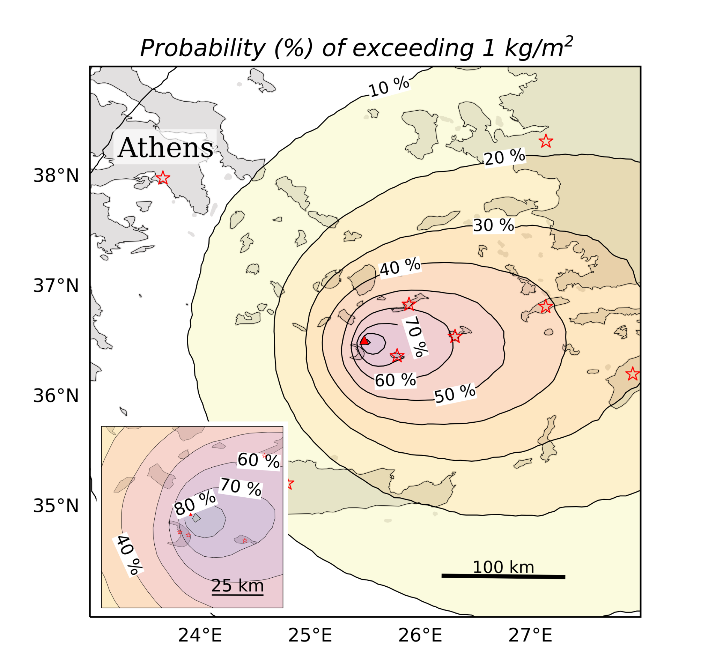
Fig S4 All-seasons probability map showing the likelihood of exceeding a ground load threshold of 1 kg/m².

Table S1 Main eruption source parameters derived from literature review and discussion, not from the elicitation session
Parameter | Unit | Value | Source
Vent elevation | m | 0 | The pressure-balance plume base is assumed at sea level
Vertical plume velocity | m/s | 200 | The plume is assumed to be pressure-balanced and this velocity is assumed at the plume base
Magma temperature | K | 973-1073 | Cantner et al. (2014)
Magma water content | wt% | 6.5 | Cantner et al. (2014)
Particle size distribution | φ | median 0  std 2.5 | Modified from Jenkins et al. (2015)
Particle density | km | 2300 | Jenkins et al. (2015)

Table S2 Setting of the numerical models for eruption column and tephra dispersal and deposition.

Eruption parameters (source term)
Vent latitude | 36.5166°N
Vent longitude | 25.4916°E
Vent elevation | 0.0
Mixture temperature | 1023.0 K
Exit velocity | 200.0 m/s
Water mass fraction | From elicitation results
Particle Density | 2300.0 kg/m3
Particle specific heat | 1100 J/kgK
Particle shapefactor | 0.8
Sedimentation model | Ganser (1993)
Mass flow rate | From elicitation results
Plume height | From elicitation results
Eruption duration | From elicitation results
Particle vertical distribution | From results of column model PLUME-MoM-TSM
Total Grain Size Distribution | mean value 0 phi  standar deviation 2,5 phi
HYSPLIT setting
Model top | 40000.00 m
Center latitude of the grid | 36.5166°N
Center latitude of the grid | 25.4916°E
span lat | 5.95°
span lon | 5.95°
Grid spacing | 0.05°
Particle type | Horizontal puff - vertical particle
Run duration | 24 h from the end of the eruption
Integration time step | 1 min for diam <= 1 phi
Integration time step | 10 min for diam > 1 phi and diam <= 4 phi,
Integration time step | 30 min for diam > 4 phi
Sampling Interval type | 0
Sampling Interval frequency | 10 min for diam <= 1 phi
Sampling Interval frequency | 10 min for diam > 1 phi and diam <= 4 phi,
Sampling Interval frequency | 30 min for diam > 4 phi
Meteorological dataset
ECMWF ERA5, hourly data on 37 pressure levels, horizontal resolution 0.25° x 0.25°
Ensemble definition and run
Numerical runs were performed on 192 processors at the computer facilities
of INGV - Sezione di Pisa.

Table S3 Footprint areas (in km²) for the contour curves of the three ground load values (1, 10, and 100 kg/m²) based on the runs shown in Fig. S2 and Fig. S3. The 50th Run column refers to the run conducted with the median values of MER, eruption duration, and seawater content. The 5th MER and 95th MER columns correspond to runs conducted with the 5th and 95th percentiles of MER, respectively, while eruption duration and seawater content were kept at their median values. The 5th Duration and 95th Duration columns present footprint areas for runs conducted with the 5th and 95th percentiles of eruption duration, while MER and seawater content were held at their median values. Finally, the 5th Seawater column indicates the run conducted with the 5th percentile of seawater content, with MER and eruption duration kept at their median values. Note that the 95th percentile seawater resulted in a collapsing column, and no fallout deposit was produced.

Ground load threshold (kg/m²) | Footprint areas (km²)
 | 50th Run | 5th MER | 95th MER | 5th Duration | 95th Duration | 5th Seawater
1 | 38,422 | 17,031 | 291,024 | 28,777 | 53,475 | 38,669
10 | 25,285 | 5,502 | 183,702 | 10,849 | 38,793 | 25,965
100 | 6,151 | 154 | 35,300 | 154 | 12,858 | 6,213

Table S4 Footprint areas (in km²) for three ground load values (1, 10, and 100 kg/m²) based on the runs shown in Fig. 6. The Run NE column refers to the run conducted with wind blowing from the northeast, while the Run SW column refers to the run conducted with wind blowing from the southwest.

Ground load threshold (kg/m²) | Footprint areas (km²)
 | Run NE | Run SW
1 | 83,397 | 29,550
10 | 46,706 | 10,911
100 | 7,387 | 1,669

References
Cantner, K., Carey, S., & Nomikou, P. (2014). Integrated volcanologic and petrologic analysis of the
1650 AD eruption of Kolumbo submarine volcano, Greece. Journal of Volcanology and Geothermal
Research, 269, 28-43.

Ganser, G. H. (1993). A rational approach to drag prediction of spherical and nonspherical particles. Powder technology, 77(2), 143-152.

Jenkins, S. F., Barsotti, S., Hincks, T. K., Neri, A., Phillips, J. C., Sparks, R. S. J., ... & Vougioukalakis, G. (2015). Rapid emergency assessment of ash and gas hazard for future eruptions at Santorini Volcano, Greece. Journal of Applied Volcanology, 4(1), 16.

