Supplementary Tables
Table S1 Common input parameters and constants for the simulations.
Variable | Value
Vent elevation | 0 m
Gravity body force | 9.81 m s^{–2}
A gas constant of volcanic gas | 462 J kg^{–1} K^{–1}
A gas constant of atmospheric air | 287 J kg^{–1} K^{–1}
Specific heat of solid pyroclasts | 1100 J kg^{–1} K^{–1}
Specific heat of volcanic gas at constant volume | 1348 J kg^{–1} K^{–1}
Specific heat of air at constant volume | 717 J kg^{–1} K^{–1}
Vent elevation | 0 m
Gravity body force | 9.81 m s^{–2}
A gas constant of volcanic gas | 462 J kg^{–1} K^{–1}
A gas constant of atmospheric air | 287 J kg^{–1} K^{–1}
Specific heat of solid pyroclasts | 1100 J kg^{–1} K^{–1}

Table S2 FALL3D model setup.
Parameter | Value | Sampling range
Meteorological conditions | ECMWF Reanalysis (ERA5) | 10% in horizontal components
Emission source profile | A=5 (Suzuki, 1983)* | [1, 9]
Column height (km) | 50 | [40, 60]
MFR (kg s^{–1}) | 5⨉10⁹ | [1⨉10⁹, 9⨉10⁹]
Duration (min) | 55** | [38.2, 71.8]
Viscosity (Pa·s) | 10⁵ | –
TGSD | Costa et al. (2016a)¹ | 50% in the bi-Gaussian mixing factor
Aggregates’ density (kg m^{–3}) | 500 | [100, 900]
*Bi-Gaussian distribution estimated from viscosity and column height
**consistent with observations (Yuen et al. 2022)

Table S3 FALL3D computational model configuration parameters.
Parameter | Value
Ensemble size | 32
Resolution | 0.01° × 0.01°
Number of grid points | 400 × 400 × 65
Species | 11 tephra bins
Run time | 50 hours

Supplementary Figures
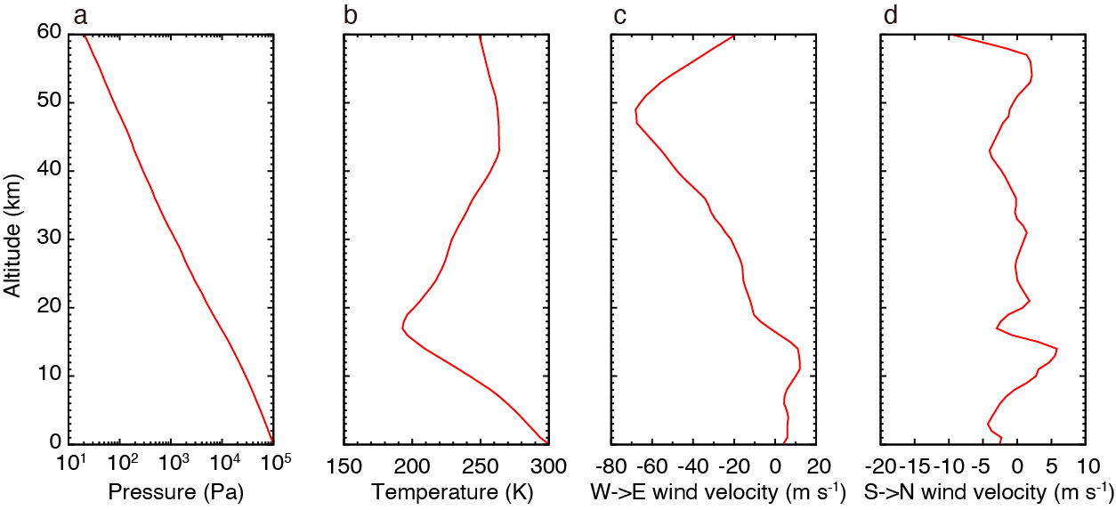
Fig. S1 Initial atmospheric conditions used for simulations. Vertical profiles of (a) pressure, (b) temperature, (c) wind velocity from west to east, and (d) wind velocity from south to north, calculated by the Global Spectral Model of the Japan Meteorological Agency.
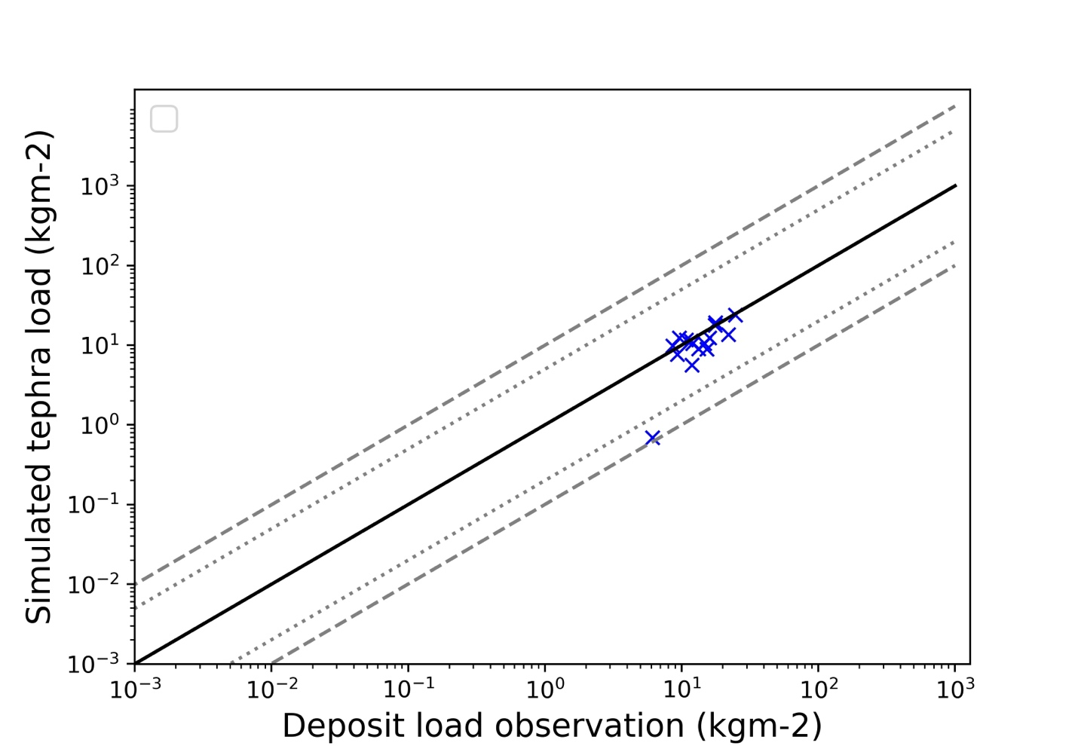
Fig. S2 Quantitative comparison between observed and simulated deposit mass load.

