Supplementary material for

Transient ground deformation observed by GNSS and InSAR during and following the 2021 Fagradalsfjall eruption, Iceland
Chiara Lanzi (1, 2), Halldór Geirsson (1), Michelle Maree Parks (2), Vincent Drouin (2), Freysteinn Sigmundsson (1)

(1) Nordic Volcanological Center, Institute of Earth Sciences, University of Iceland, Reykjavik, Iceland
(2) Icelandic Meteorological Office, Reykjavik, Iceland
*Corresponding author
Email address: chl7@hi.is

Table of content:
Text S1. Annual and semiannual amplitudes on the GNSS time series in Iceland.
Text S2. Uncertainties in GBIS.
Text S3. Young’s modulus evaluation in crustal layering at volcanic area.
Text S4. 3-D ground surface displacement and LOS displacement.
Figure S1. GNSS time series showing the comparison between the GAMIT-GLOBK and the GIPSY-AOSIS II processing solutions.
Figure S2. Residuals to the fit with the linear, annual and semiannual components removed for MOHA GNSS site.
Figure S3S7. GNSS time series showing the ground deformation between 19 March to 20 December 2021 on the Reykjanes Peninsula.
Figure S8. Line-of-Sight for two Sentinel-1 tracks, for T1 geodetic phase, 19 March – 10 May and T3, 1 August – 18 September 2021.
Figure S9. The finite element model setups for the lava loading model in a uniform elastic half-space with boundary conditions.
Figure S10-S14. Modelling results for the uncorrected six-months eruption and inferred probability density functions.
Figure S15S24. Modelling results for the lava loading corrected six-months eruption and inferred probability density functions.
Figure S25-S29. Modelling results for T2 geodetic phase and inferred probability density functions.
Figure S30. Topography investigation over the studied area.
Figure S31-33. Modelling results for post-eruptive phase and inferred probability density functions
Table S1. GNSS sites network.

S1 – Annual and semiannual amplitudes on the GNSS time series in Iceland.
GNSS position time series often exhibit seasonal variations that repeat once or twice per year. These variations are primarily caused by environmental factors, including hydrological loading, snow accumulation, atmospheric pressure changes, and thermal effects, with smaller contributions from instrumental or reference frame effects. While tectonic motions generate long-term trends, seasonal signals reflect periodic, often site-specific influences on the crust.
In Iceland, GNSS time series show seasonal signals in both vertical and horizontal components, with the strongest deformation in the vertical direction often exceed 10 mm (Drouin et al. 2016). These variations are primarily driven by snow load and seasonal glacier mass balance, with additional contributions from hydrological, atmospheric, oceanic, and water reservoir loads that produce both annual and semiannual signals (Drouin et al. 2016).
In this study, we used Tsview (v2.02, MATLAB code, Herring, 2003) to estimate the annual and semiannual amplitudes and phases of the GNSS time series. Tsview fits a model including a linear trend and sinusoidal annual and semiannual components to the data and solves for the parameters using the least squares method. The resulting sine and cosine coefficients are then combined to compute the amplitude of each seasonal signal (Equation 1, Main Text).

S2 – Uncertainties in GBIS
To account for uncertainties in the GNSS data, the variance of each displacement component is included in the analysis. These variances form the diagonal of the variance-covariance matrix, while all off-diagonal elements are set to 0, reflecting the assumption that there is no spatial correlation in the errors. For InSAR, the variance and covariance are experimentally estimated fo reach interferogram (Bagnardi and Hooper, 2018). To account for spatial variations, semi-variograms are computed using data selected from non-deforming areas and removing linear ramps, then fitted with a theoretical function to build a covariance matrix (Webster and Oliver, 2007). This matrix is used in the inversion to propagate both individual uncertainties and spatial correlations, yielding more realistic estimates of source parameters and their confidence intervals. A weighting factor was applied to both the GNSS and LOS datasets in the inversion to balance their contributions to the misfit function. In GBIS, these weights are applied to the residuals of each dataset; therefore increasing a weight increases the influence of that dataset on the inversion results. Based on sensitivity tests, we used a GNSS-to-LOS ratio of 1:5, which yielded the most stable inversion results and meant that the LOS residuals were weighed five times more heavily than the GNSS residuals. This choice reflects the higher data density and lower noise of the LOS dataset compared to GNSS and produced stable, physically reasonable model parameters. Weights in joint inversions are generally adjusted based on data density, noise, and their effect on misfits (Trasatti et al., 2015, 2022).

S3 – Young’s modulus evaluation in crustal layering at volcanic area
In reality, crustal rocks are heterogeneous, with rock properties changing laterally and with depth, and the parameter choice is highly relevant as it strongly affects the calculated deformation (Heap et al., 2020; Geyer and Gottsmann, 2010; O’Hara, 2023). For example, Hautmann et al. (2013), evaluate static Young’s modulus (E) values between 6 and 42 GPa for the upper crust at Soufrière Hills Volcano when modelling the effects of an extrusion event in 2009, with mean value of E = 25 GPa at depth 5−6 km. The average Young’s modulus value for the Icelandic crust has been estimated to be E ~ 30 GPa (Drouin et al., 2016). Tor a two-layer model Auriac et al. (2013) found best-fitting values of E = 12.9−15.3 GPa in the upper layer (15−40 km-thick) and E = 67.3−81.9 GPa in a lower layer. We test two different values of E: 15 and 30 GPa to span the range of most likely values in the volcanic context in Iceland.

Text S4. Three-dimensional (3-D) ground surface displacement and Line-of-Sight (LOS) displacement.
According to the geometric principles of Synthetic Aperture Radar (SAR) imaging, the 3-D ground surface displacement can be related to the LOS displacement as follows (Hanssen, 2001):

$LOS=W\cos{θ}-\sin{θ [U_{N}\cos\left(α-\frac{3}{2}π\right)+U_{E}\sin\left(α-\frac{3}{2}π\right)}$] (1)

In this equation, W, U_{N} and U_{E} represent the vertical, north-south direction and the west-east deformations, respectively, while $θ$and $α$are the radar incidence angle and the satellite heading angle. Positive LOS displacement is defined along the radar line-of-sight toward the satellite. This relation shows how the three-dimensional ground displacement can be projected into the LOS displacement: the vertical component contributes according to the cosine of the incidence angle, while the horizontal components are projected according to the incidence angle and satellite heading.
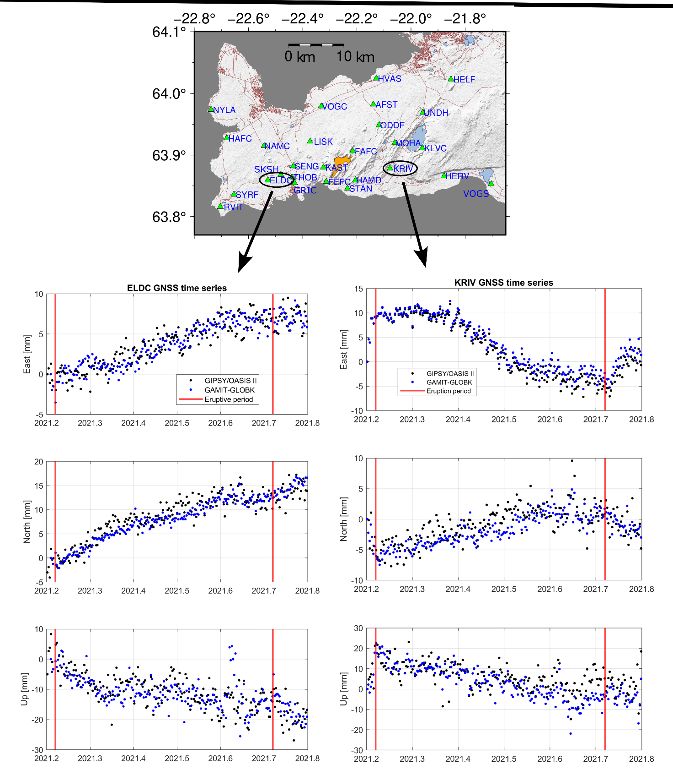Figure S1. Deformation from March to December 2021. The top panel shows the GNSS network (in green triangles) around the Reykjanes Peninsula with the Fagradalsfjall lava field at the end of the eruption (in orange). The lower panels display detrended ELDC (on the left) and NYLA (on the right) cGNSS times series solution for GAMIT-GLOBK solution (blue dots) and GIPSY-OASIS II (black dots).
Figure S2. Residuals to the fit with the linear, annual and semiannual components removed from time series from the MOHA GNSS site, for north, east and up displacement components. The red line is the model itself and the green lines in either side are +- 1 sigma estimates of the noise in the model.
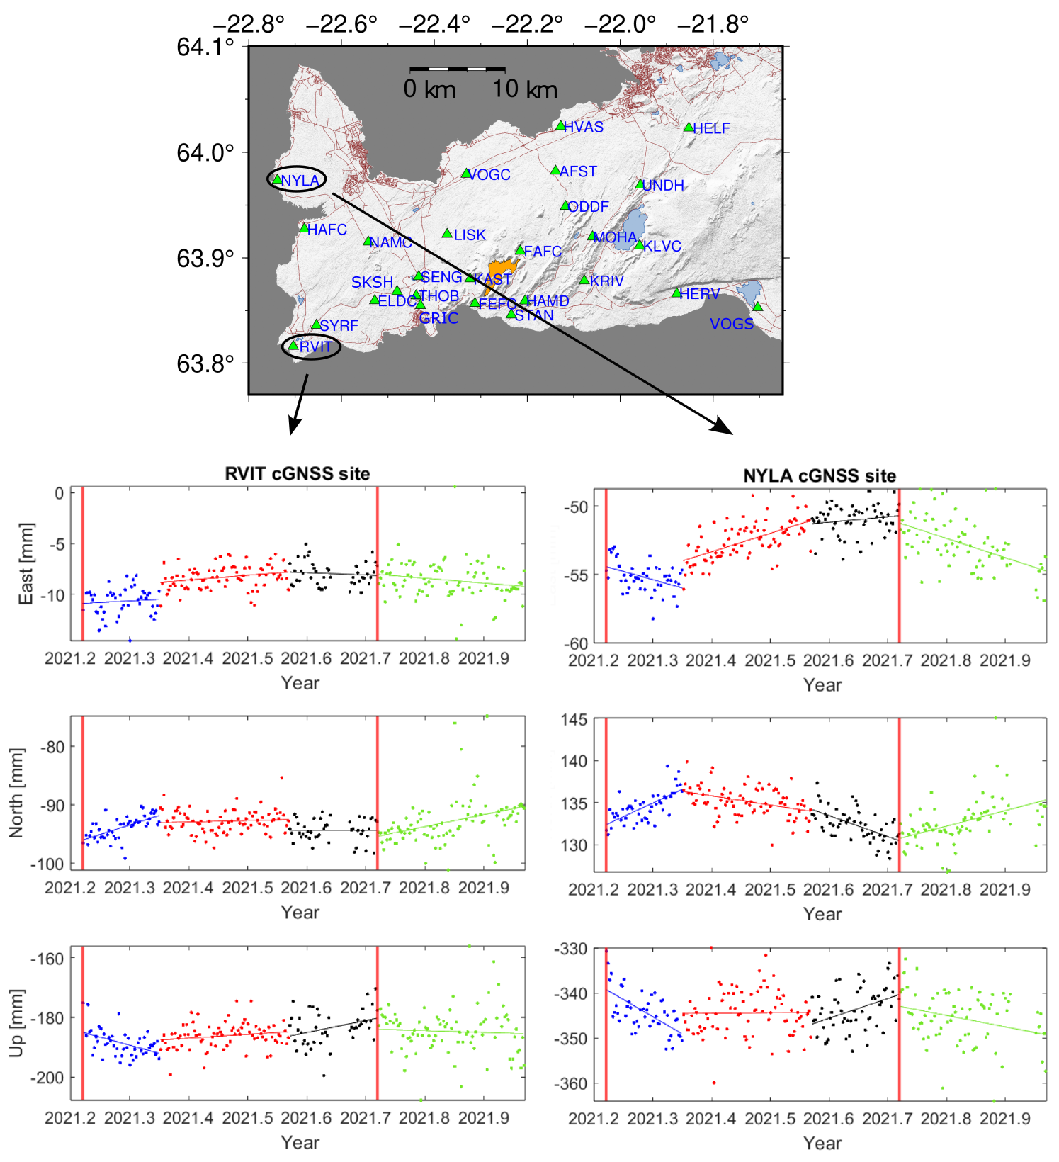Figure S3. Deformation 19 March to 20 December 2021. The top panel shows the GNSS network (in green triangles) around the Reykjanes Peninsula with the Fagradalsfjall lava field at the end of the eruption (in orange). The lower panels display detrended RVIT (on the left) and NYLA (on the right) cGNSS times series (both located west from the eruption side) with the three co-eruptive deformation periods: T1, 19 March – 10 May (blue dots), T2 11 May - 31 July (red dots), T3, 1 August – 18 September /black dots), and post-eruptive deformation, 19 September – 20 December (green dots). The vertical red line indicates the beginning and end of the eruption. The time series are in the ITRF2014 reference frame, and linear, annual and semi-annual trends have been removed.

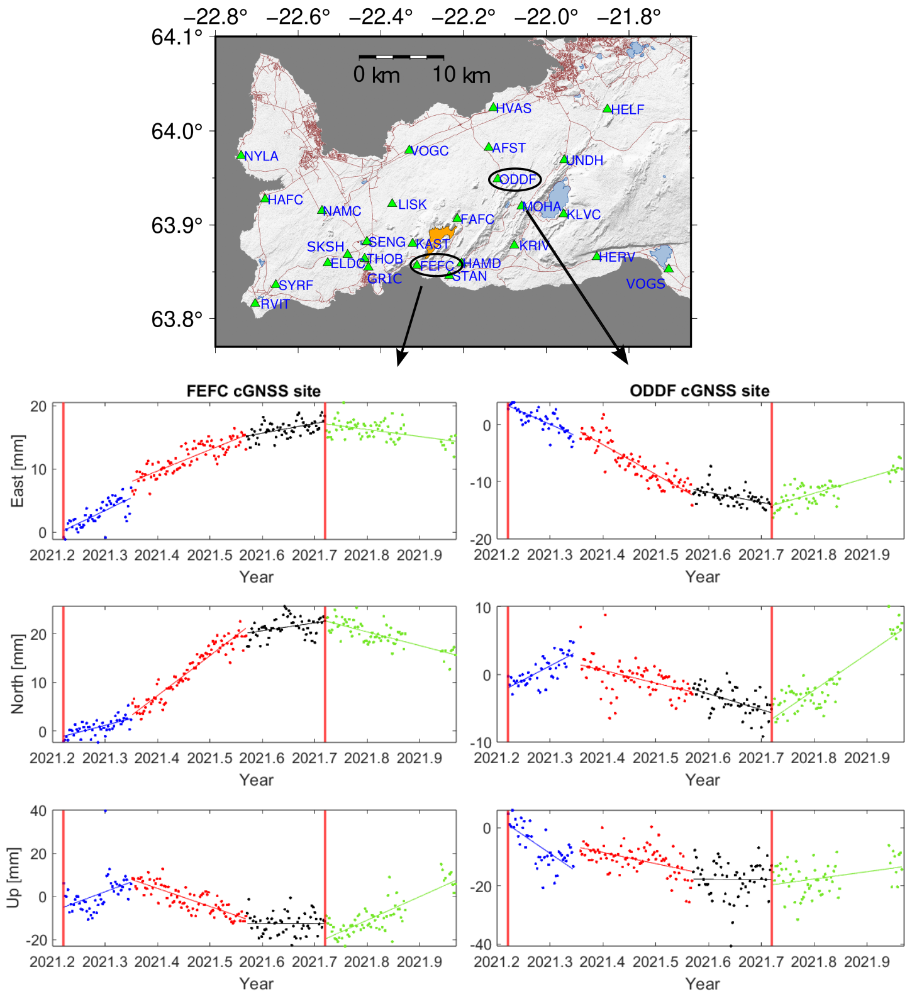
Figure S4. Deformation 19 March to 20 December 2021. The upper panel shows the GNSS network (in green triangles) around the Reykjanes Peninsula with the Fagradalsfjall lave field at the end of the eruption (in orange). The lower panels display FEFC (on the left) and ODDF (on the right) cGNSS times series (both located west from the eruption side) with the three co-eruptive deformation periods: T1: 19 March – 10 May (blue dots), T2: 11 May - 31 July (red dots), T3: 1 August – 18 September (black dots), and post-eruptive deformation, 19 September – 20 December (green dots). The vertical red line indicates the beginning and end of the eruption. The blue, red, black and green lines show the least-square fit for the different geodetic phases. The time series are in the ITRF2014 reference frame.

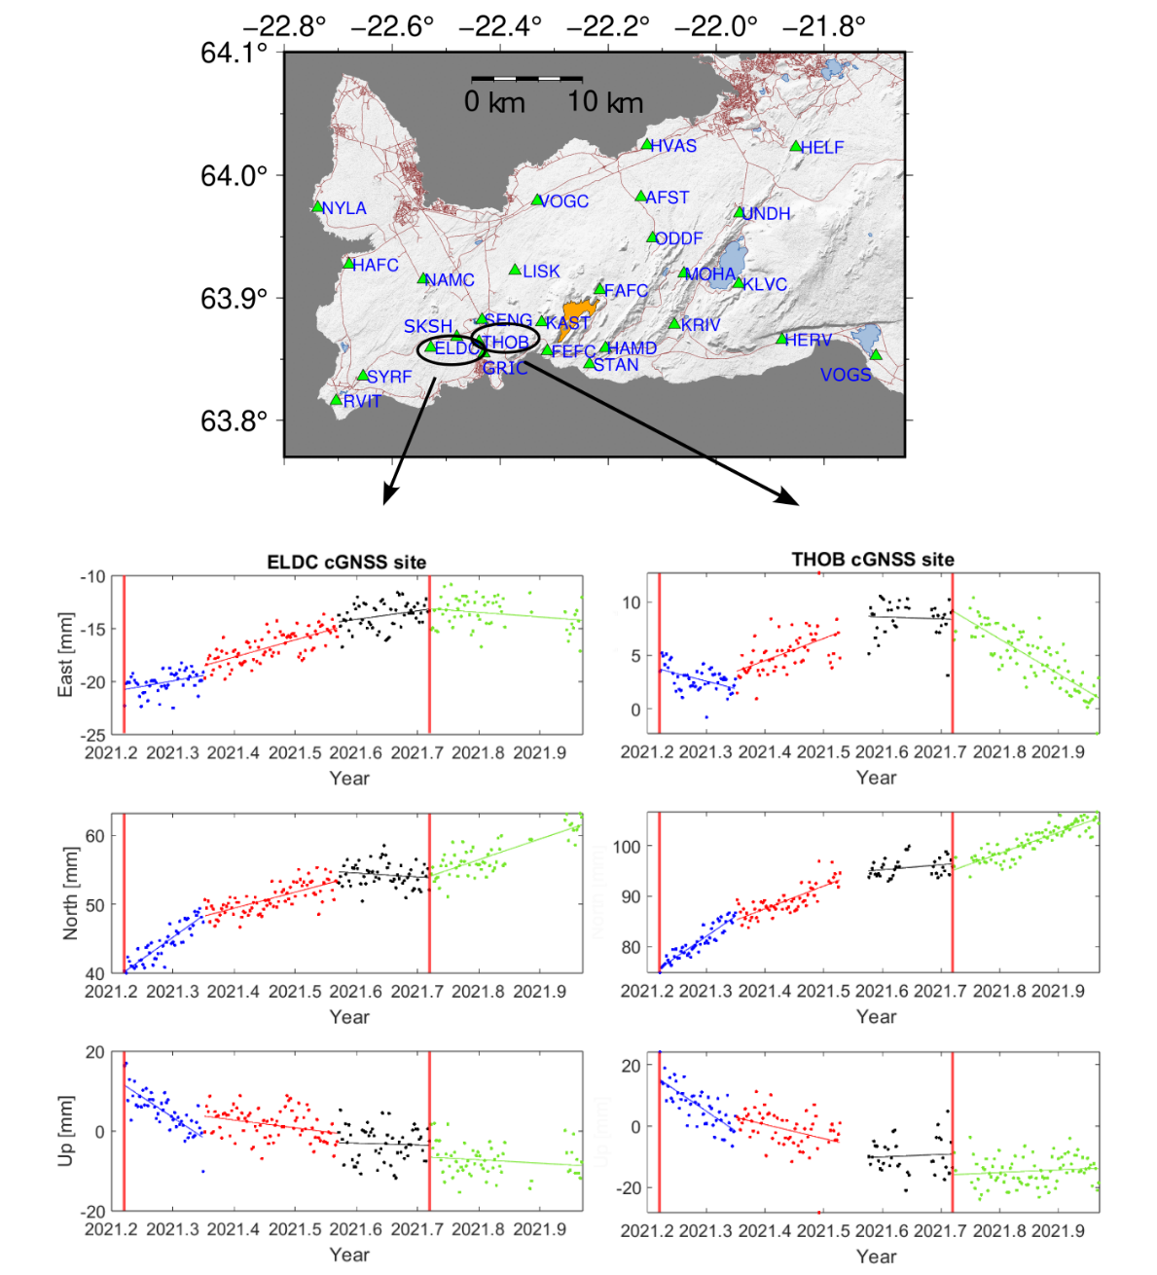
Figure S5. Deformation 19 March to 20 December 2021. The upper panel shows the GNSS network (in green triangles) around the Reykjanes Peninsula with the Fagradalsfjall lave field at the end of the eruption (in orange). The lower panels display ELDC (on the left) and THOB (on the right) cGNSS times series (both located west from the eruption side) with the three co-eruptive deformation periods: T1: 19 March – 10 May (blue dots), T2: 11 May - 31 July (red dots), T3: 1 August – 18 September (black dots), and post-eruptive deformation, 19 September – 20 December (green dots). The vertical red line indicates the beginning and end of the eruption. The blue, red, black and green lines show the least-square fit for the different geodetic phases. The time series are in the ITRF2014 reference frame.

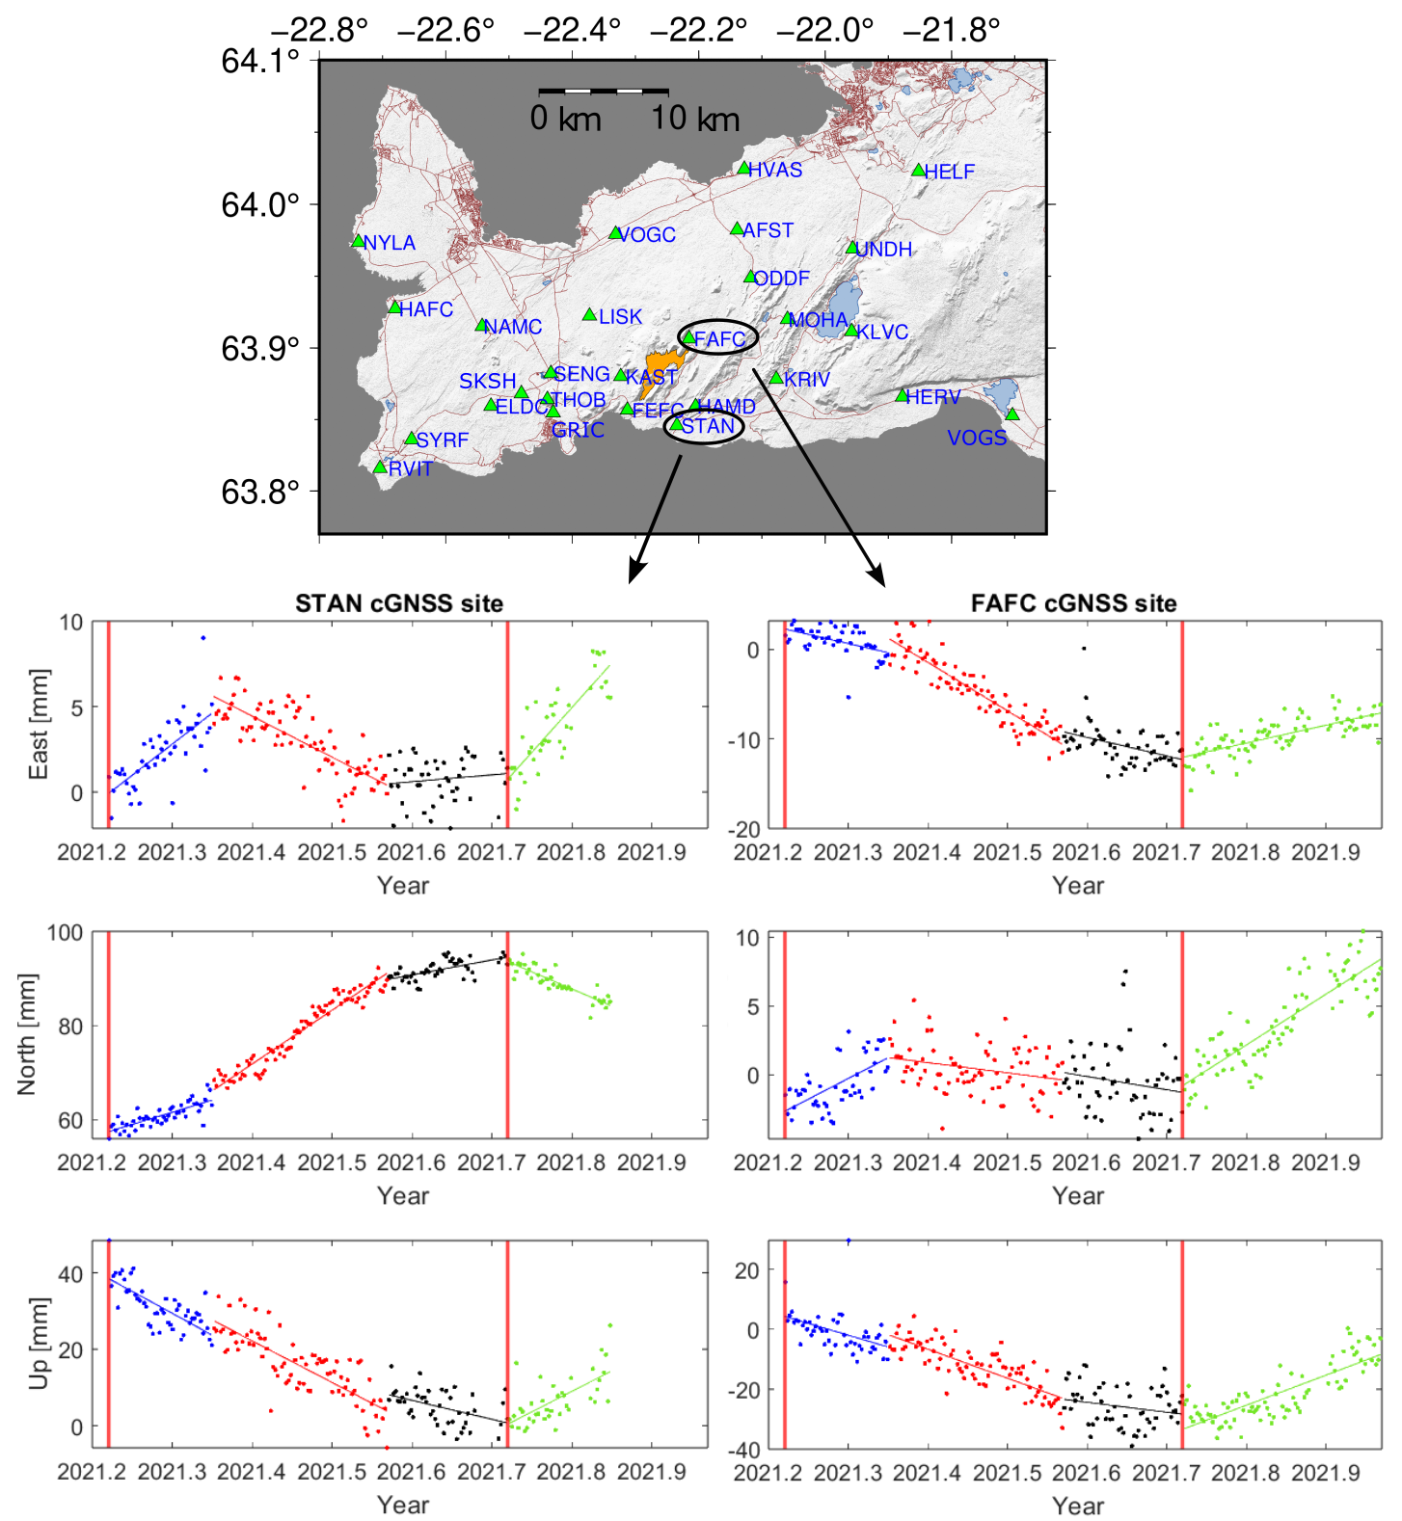

Figure S6. Deformation 19 March to 20 December 2021. The upper panel shows the GNSS network (in green triangles) around the Reykjanes Peninsula with the Fagradalsfjall lave field at the end of the eruption (in orange). The lower panels display STAN (on the left) and FAFC (on the right) cGNSS times series (both located west from the eruption side) with the three co-eruptive deformation periods: T1: 19 March – 10 May (blue dots), T2: 11 May - 31 July (red dots), T3: 1 August – 18 September (black dots), and post-eruptive deformation, 19 September – 20 December (green dots). The vertical red line indicates the beginning and end of the eruption. The blue, red, black and green lines show the least-square fit for the different geodetic phases. The time series are in the ITRF2014 reference frame.

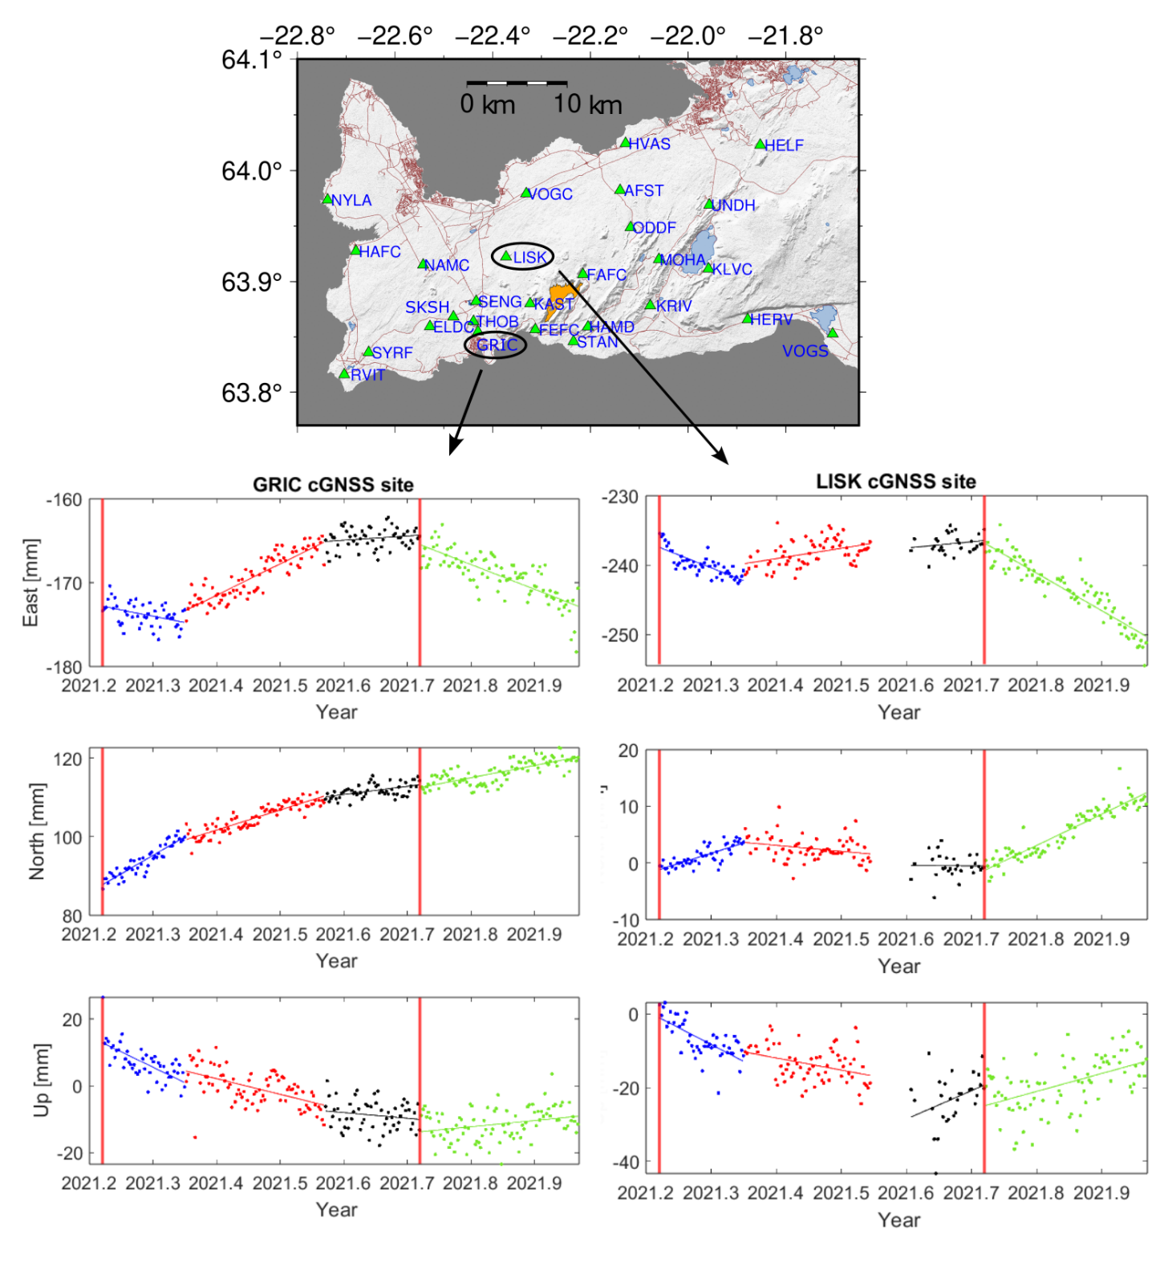

Figure S7. Deformation 19 March to 20 December 2021. The upper panel shows the GNSS network (in green triangles) around the Reykjanes Peninsula with the Fagradalsfjall lave field at the end of the eruption (in orange). The lower panels display SKSH (on the left) and GRIC (on the right) cGNSS times series (both located west from the eruption side) with the three co-eruptive deformation periods: T1: 19 March – 10 May (blue dots), T2: 11 May - 31 July (red dots), T3: 1 August – 18 September (black dots), and post-eruptive deformation, 19 September – 20 December (green dots). The vertical red line indicates the beginning and end of the eruption. The blue, red, black and green lines show the least-square fit for the different geodetic phases. The time series are in the ITRF2014 reference frame.

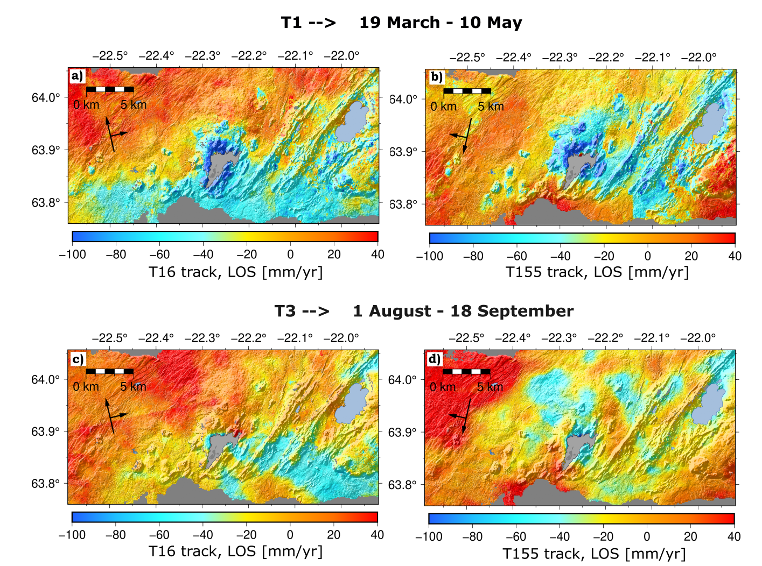
Figure S8. Line-of-Sight for two Sentinel-1 tracks, T16 (on the left) and T155 (on the right); T1 geodetic phase in a) and b), and T3 geodetic phase in c) and d). Black arrows show the heading and look direction of the satellite. In light grey, the Fagradalsfjall lava field at the end of the eruption and in light blue the lake Kleifarvatn to the east. Dark grey indicates the ocean.

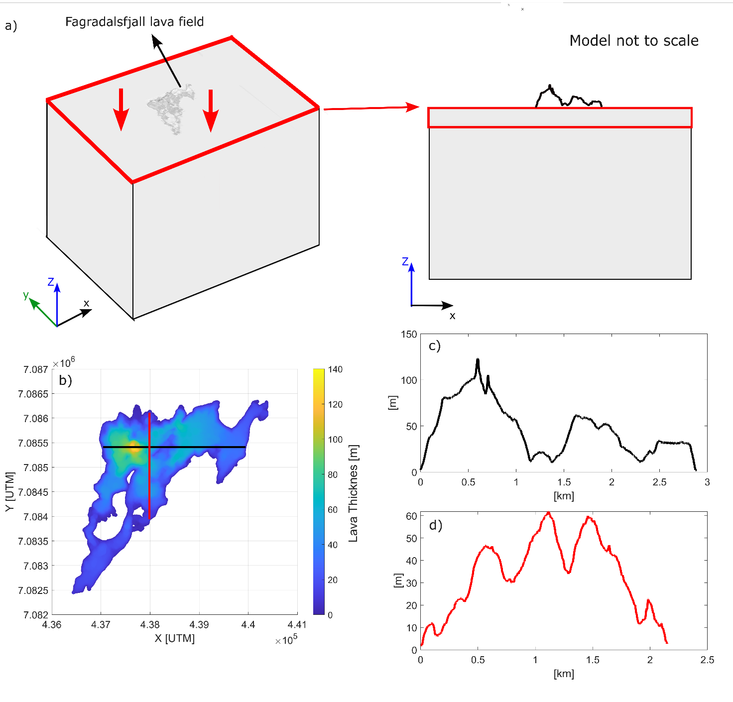
Figure S9. a) The finite element model setups. Model geometry for the lava loading model in a uniform elastic half-space. The boundary conditions are set as follows (panel on the left): a load (vertical red arrows) is applied at the surface in the form of: -rho*g*z, where rho is the density of the material, 2600 kg/m³, g is the gravitational acceleration, 9.81 m³/s, and z relates to the thickness of the lava field. Roller condition at the lateral sides of the block (yz and zx faces); that is, the displacement is zero in the direction perpendicular (normal) to the boundary, but the boundary is free to move in the tangential direction. The bottom of the model is fixed. An exaggerated schematic xy view of the “loaded” horizontal layer applied to combine the lava DEM and the underlying half space. The W-E profile of the lava field is displayed in map view in black solid line in b) and profile in real scale in panel c), while panel d) shows the E-W (red) profile to show the irregular ending (≠ 0 thickness) of the lava DEM.

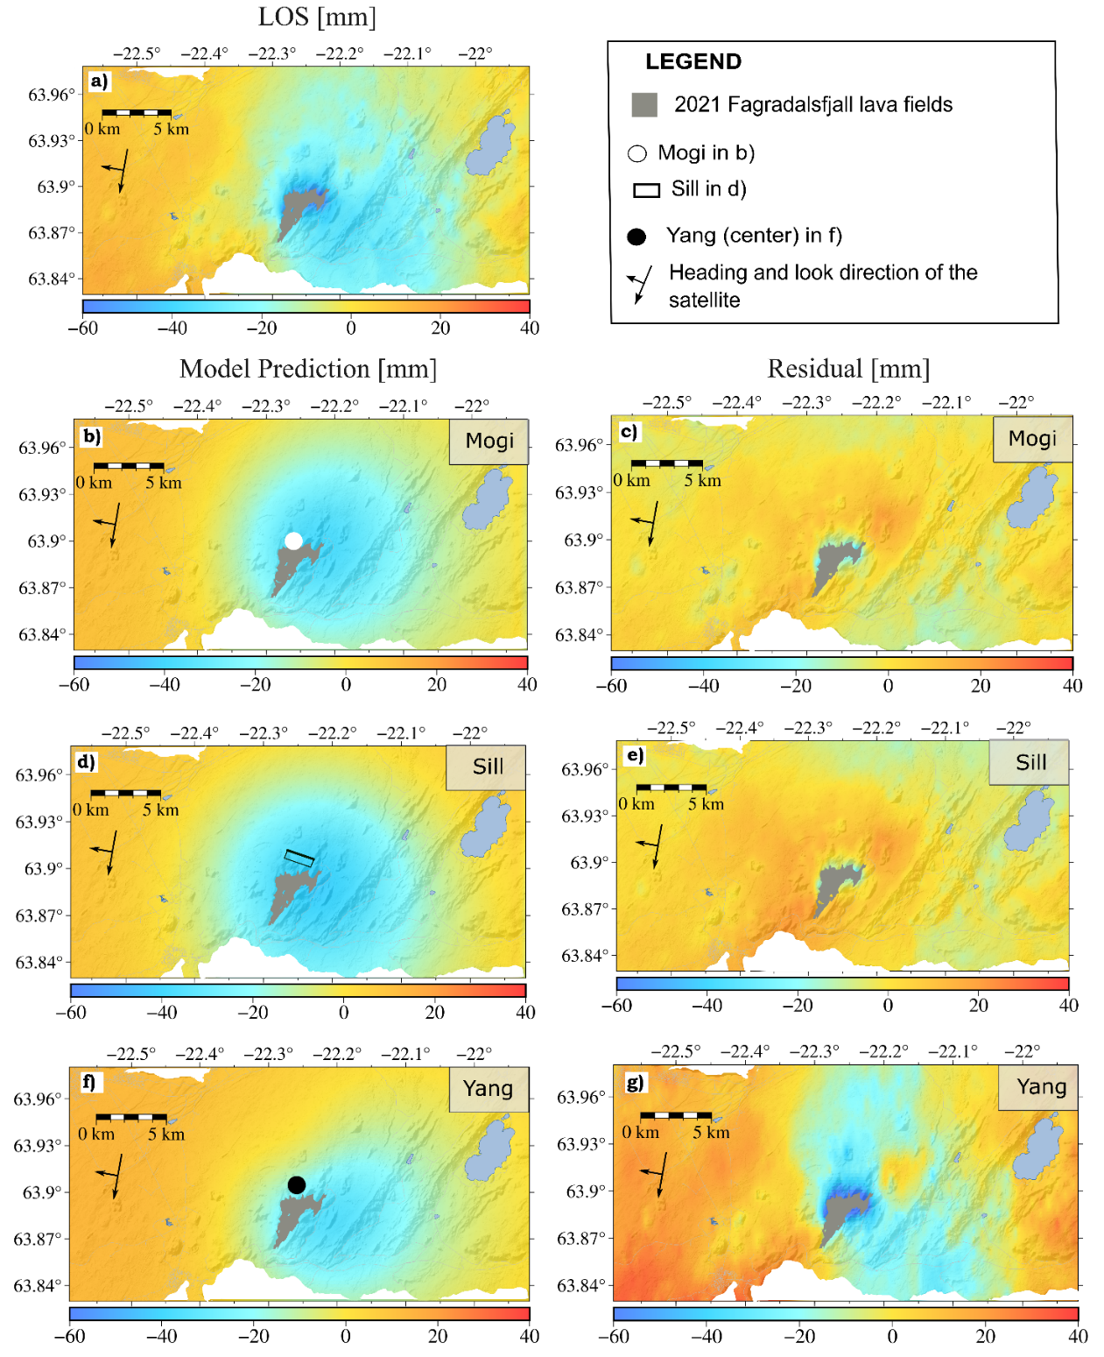
Figure S10. Modelling results for the uncorrected six-months data of the T155 InSAR track. (a) LOS data; (b), (d), and (f) show the model predictions, while (c), (e), and (g) display the residuals for the Mogi, sill, and Yang sources, respectively. Black outline in (d) shows the projection at surface of the modelled deflating sill, with the thicker line indicating the bottom of the sill best-fit solution at 12.6 km depth (95% confidence interval: 11.9−13.1 km). The white circle in (b) indicates the best-fit Mogi source at 8.8 km depth (95% confidence interval: 8.3−9.2 km). The black circle in (f) indicates the location of the Yang source at 7.4 km depth (95% confidence interval: 7.1−8 km).In light blue the lake Kleifarvatn to the east. White indicates the ocean.
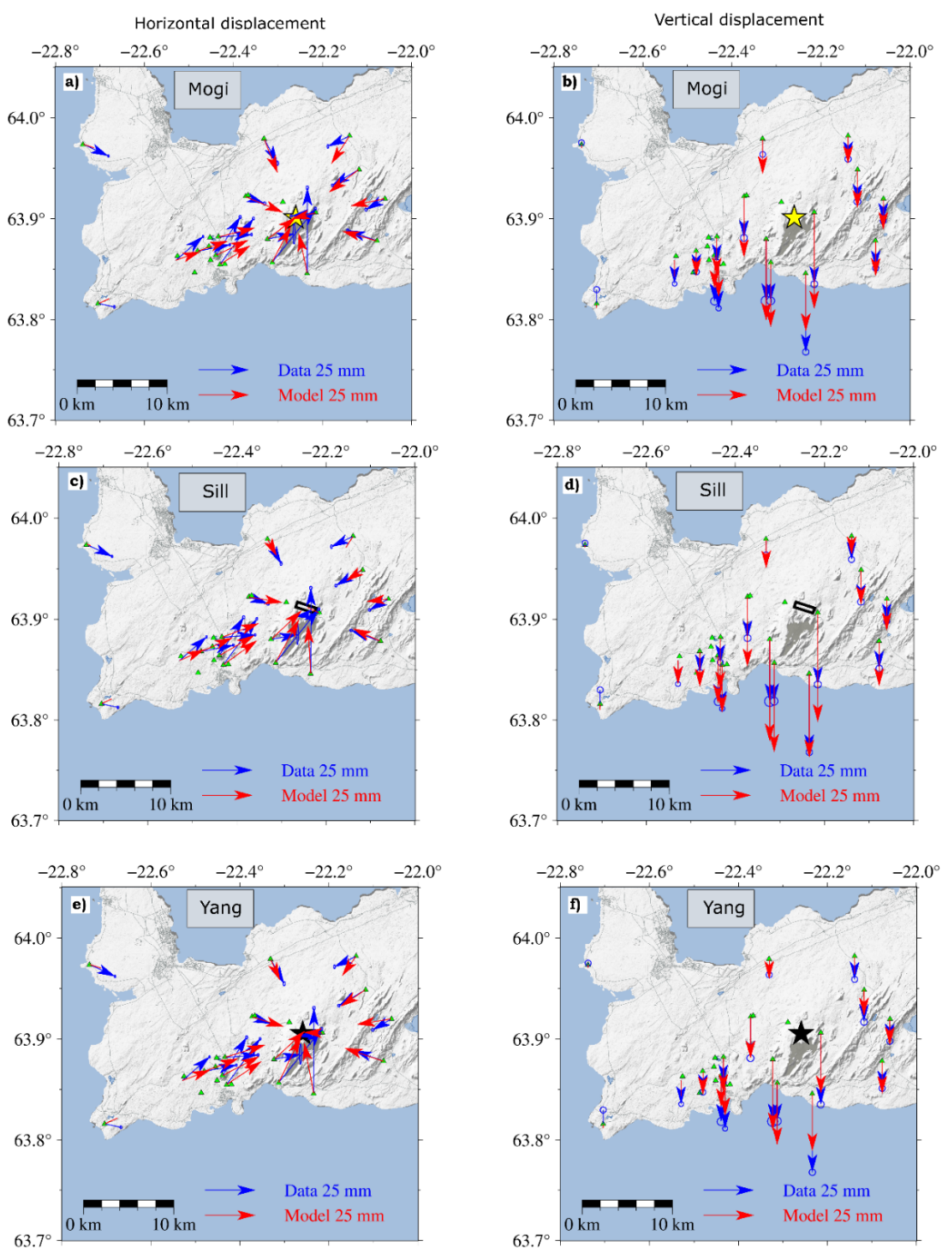
Figure S11. Modelling results for the uncorrected six-months eruption data. (a) and (b) show the horizontal and vertical data and modelled displacements for a Mogi (yellow star indicates the best-fit solution) at 8.8 km depth (95% confidence interval: 8.3−9.2 km). c) and d) panels show the horizontal and vertical data and modelled displacement for sill B case. Black outline in (c) and (d) shows the projection at surface of the modelled deflating sill, which bottom is inferred at 12.6 km depth (95% confidence interval: 11.9−13.1 km). In (e) and (f) panels the horizontal and vertical data and modelled displacement for best-fit Yang B case, which center is located at 7.4 km depth (95% confidence interval: 7.1−8 km). In light grey, the Fagradalsfjall lava field at the end of the eruption and in light blue are indicated lakes and the ocean.

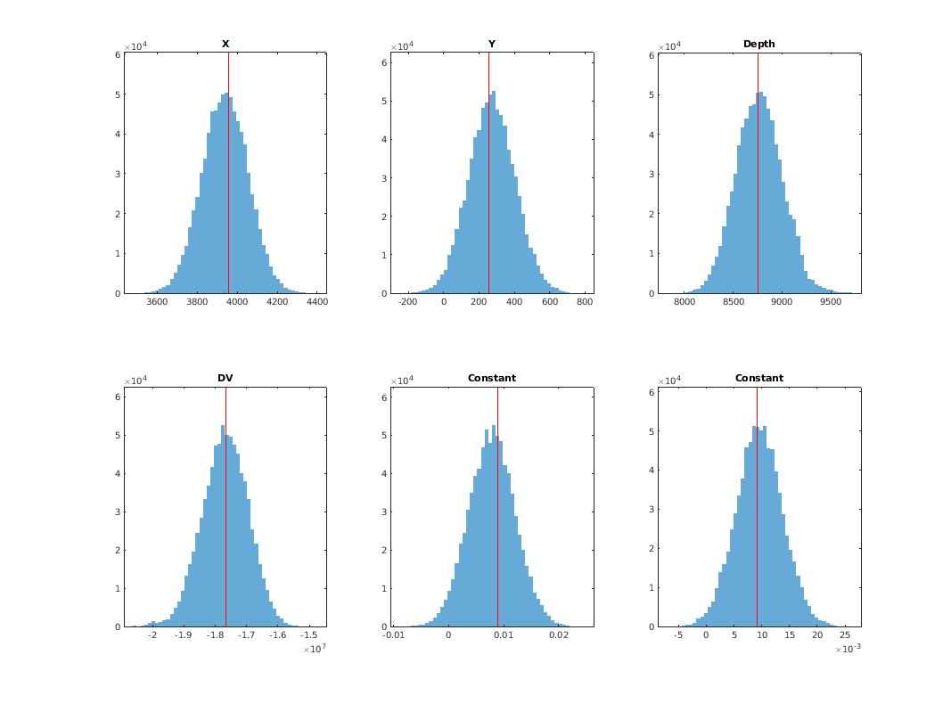
Figure S12. Inferred probability density functions for Mogi model parameters (GBIS) for the uncorrected case. Source location (X and Y local coordinates in meters), depth in meters and volume change (ΔV) in m³. Also inferred by the inversion are two offset parameters (InSAR Const.) for each of the InSAR satellite tracks used, as the input displacement fields may have an arbitrary offset. The InSAR Const. is a shift estimated in the LOS direction since all INSAR measurements are relative to an arbitrary reference point and it is in meter, the first panel is for the T16 and the second for the T155 track. The red lines indicate the optimal value of the parameter.

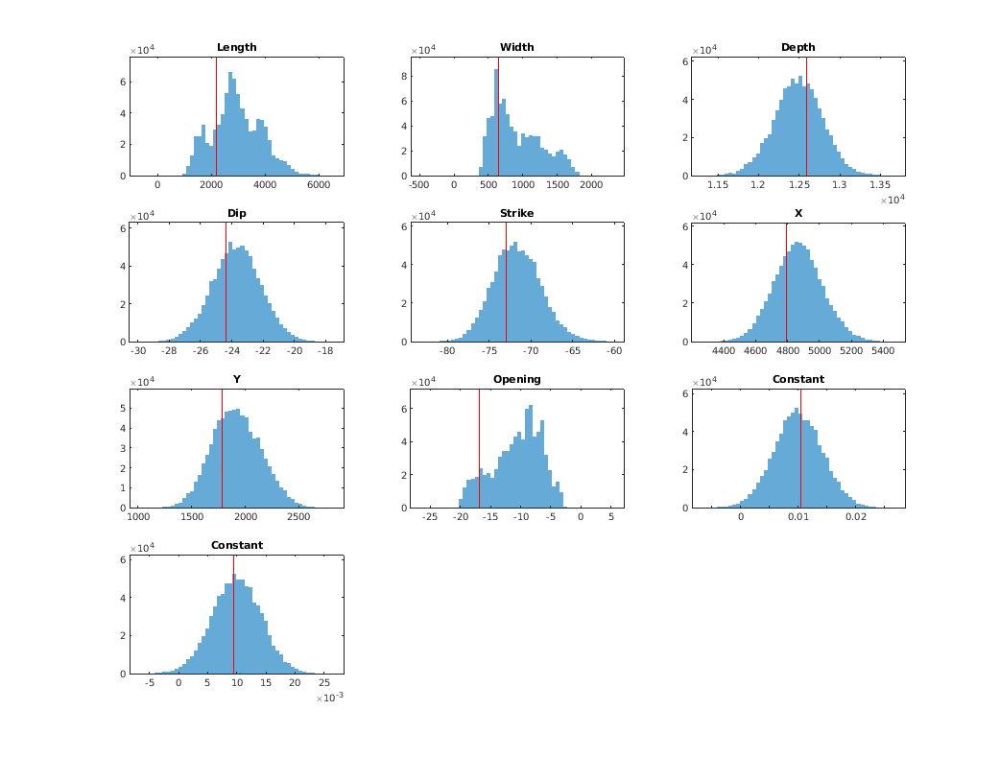
Figure S13. Inferred probability density functions for sill (uncorrected data) case model parameters (GBIS). Source location (X and Y local coordinates in meters), source depth, length, width and opening of the sill in meters; strike and dip are in degrees. Also inferred by the inversion are two offset parameters (InSAR Const.) for each of the InSAR satellite tracks used, as the displacement fields may have an arbitrary offset. The InSAR Const. is a shift applied to the entire dataset and it is in meter, the first panel is for the T16 and the second for the T155 track.The red line indicates the optimal value of the parameter.
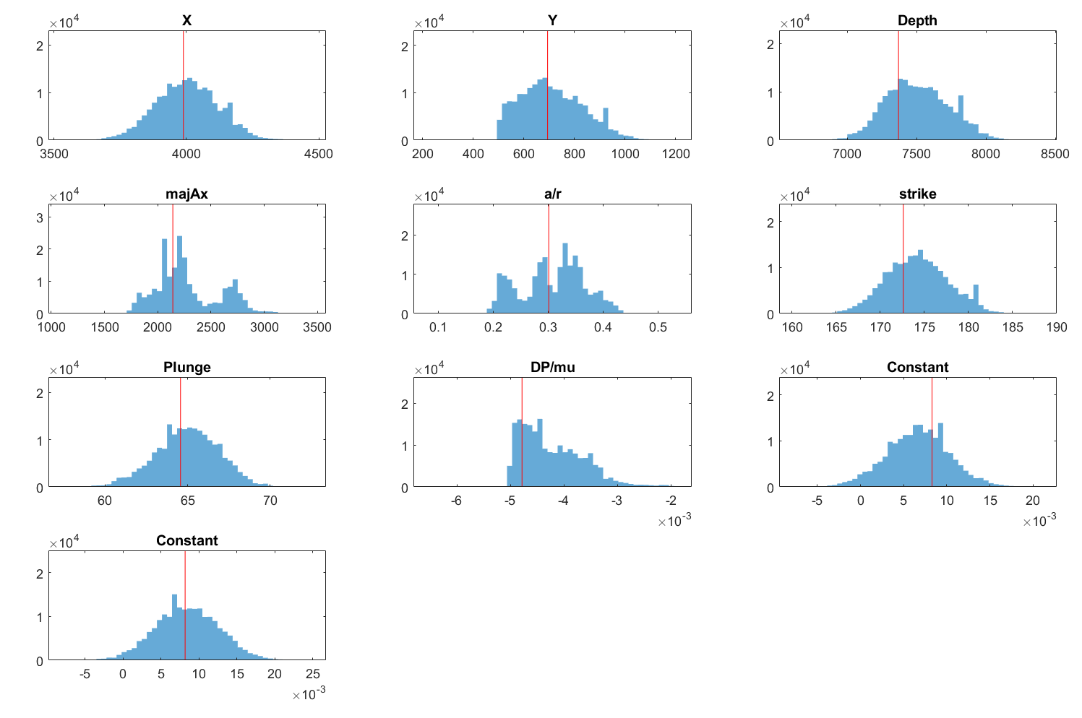Figure S14. Inferred probability density functions for Yang (uncorrected data) best-fit model parameters (GBIS). Source location (X and Y local coordinates in meters), semimajor axis length, aspect ratio in meters; strike and plunge are in degrees, and the ratio DP/mu is dimensionless. Here, DP refers to the pressure change and mu is the shear modulus of the halfspace. Also inferred by the inversion are two offset parameters (InSAR Const.) for each of the InSAR satellite tracks used, as the displacement fields may have an arbitrary offset. The InSAR Const. is a shift applied to the entire dataset and it is in meter, the first panel is for the T16 and the second for the T155 track. The red line indicates the optimal value of the parameter.

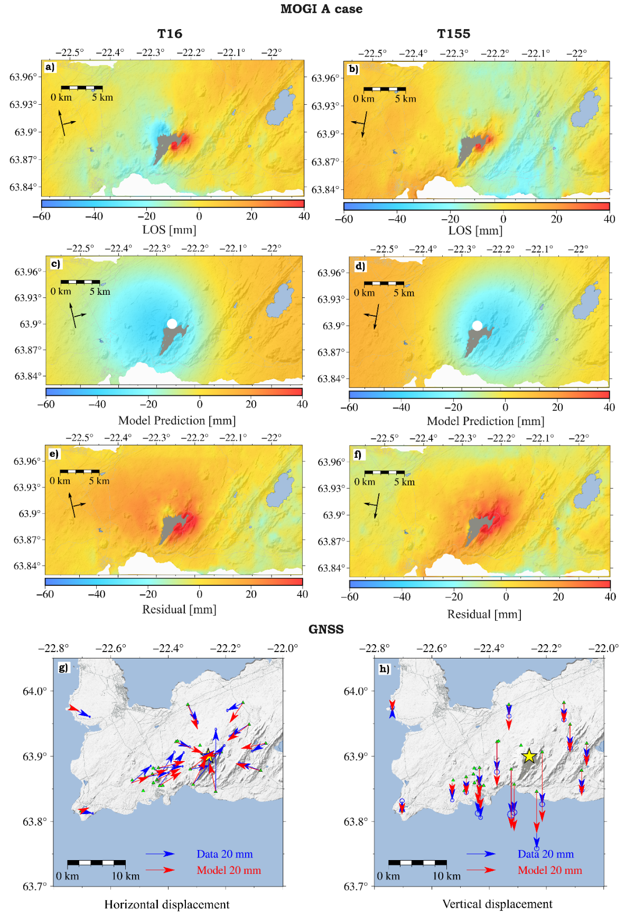
Figure S15. Modelling results for the loading corrected Mogi A case for the six-months eruptive period. a) data, b) model prediction; c) residual for track T16, d) data, e) model prediction and f) residual for track T155. The white circle indicates the best-fit solution of the Mogi source at 9.5 km depth (95% confidence interval: 8.7−9.3 km). Black arrows show the heading and look direction of the satellite. g) and h) show the horizontal and vertical data and modelled displacement. The yellow start indicates the best-fit Mogi location. The WRSS estimated is 0.99 mm and 0.94 mm for the Mogi and sill geometry. In light grey, the Fagradalsfjall lava field at the end of the eruption and in light blue are indicated lakes and the ocean
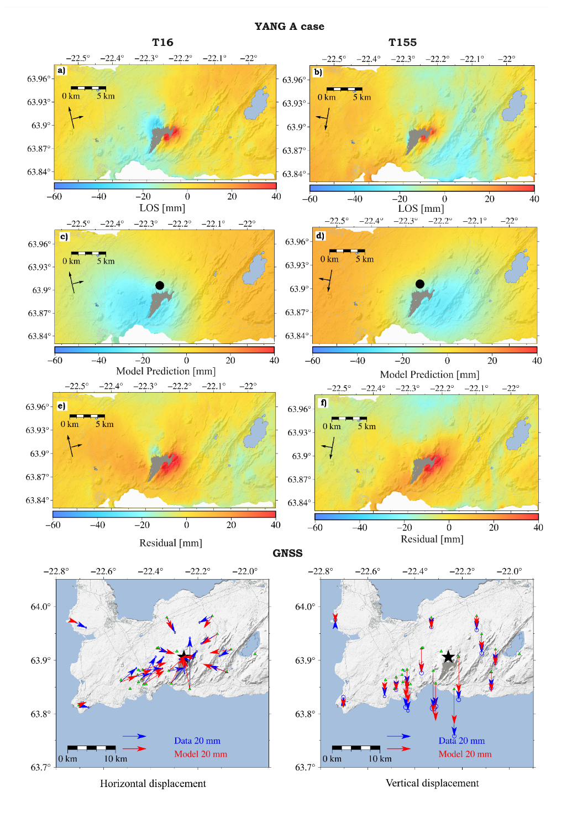
Figure S16. Modelling results for the loading corrected Yang A for the corrected six-month eruptive period. a) data, b) model prediction; c) residuals for track T16, d) data, e) model prediction and f) residual for track T155. Black star indicate the center location of the best-fit Yang source at 7.5 km depth (95% confidence interval: 7.2–7.8 km depth). Black arrows show the heading and look direction of the satellite. g) and h) show the horizontal and vertical data and modelled Yang ellipsoid model.. In light grey, the Fagradalsfjall lava field at the end of the eruption and in light blue are indicated lakes and the ocean.

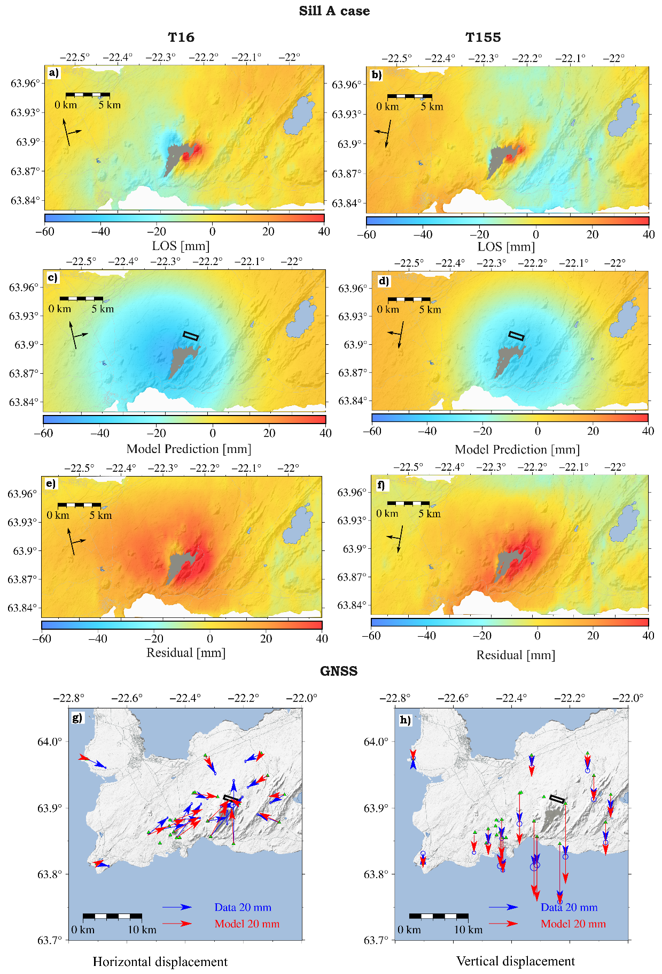
Figure S17. Modelling results for the loading corrected sill A case for the six-months eruptive period. a) data, b) model prediction; c) residual for track T16, d) data, e) model prediction and f) residual for track T155. Black lines indicate the best-fit solution of the sill source at 13.1 km depth (95% confidence interval: 12.7–13.5) km depth. Black arrows show the heading and look direction of the satellite. g) and h) show the horizontal and vertical data and modelled displacement. In light grey, the Fagradalsfjall lava field at the end of the eruption and in light blue are indicated lakes and the ocean.
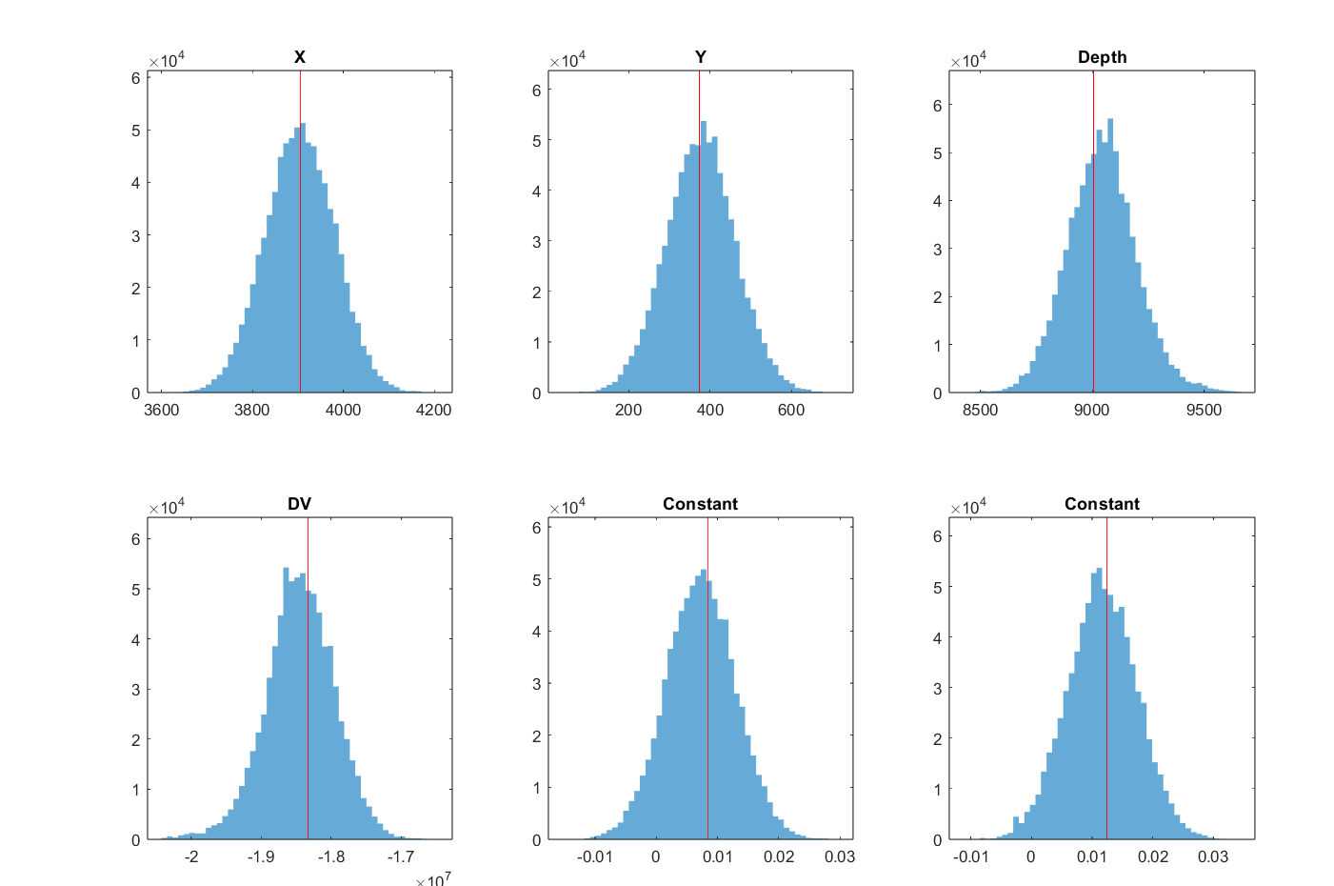
Figure S18. Inferred probability density functions for model parameters (GBIS) for Mogi A case. Source location (X and Y local coordinates in meters), depth in meters and volume change (ΔV) in m³. Also inferred by the inversion are two offset parameters (InSAR Const.) for each of the InSAR satellite tracks used, as the input displacement fields may have an arbitrary offset. The InSAR Const. is a shift applied to the entire dataset and it is in meter, the first panel is for the T16 and the second for the T155 track. The red lines indicate the optimal value of the parameter.

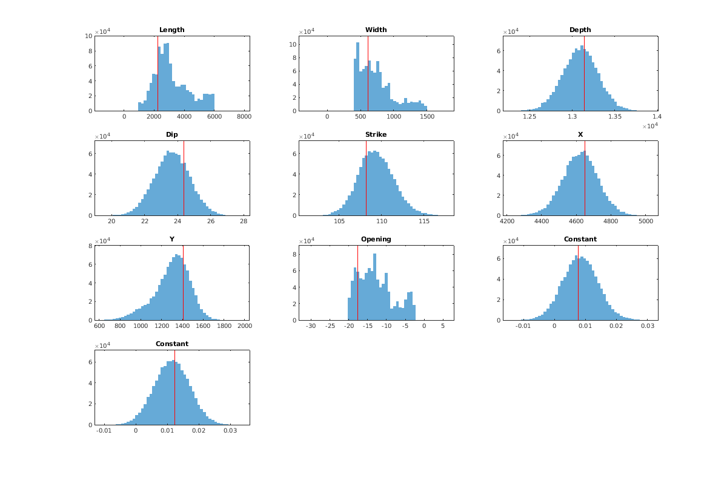
Figure S19. Inferred probability density functions for sill A case model parameters (GBIS). Source location (X and Y local coordinates in meters), source depth, length, width and opening of the sill in meters; strike and dip are in degrees. Also inferred by the inversion are two offset parameters (InSAR Const.) for each of the InSAR satellite tracks used, as the displacement fields may have an arbitrary offset The InSAR Const. is a shift applied to the entire dataset and it is in meter, the first panel is for the T16 and the second for the T155 track. The red lines indicate the optimal value of the parameter.

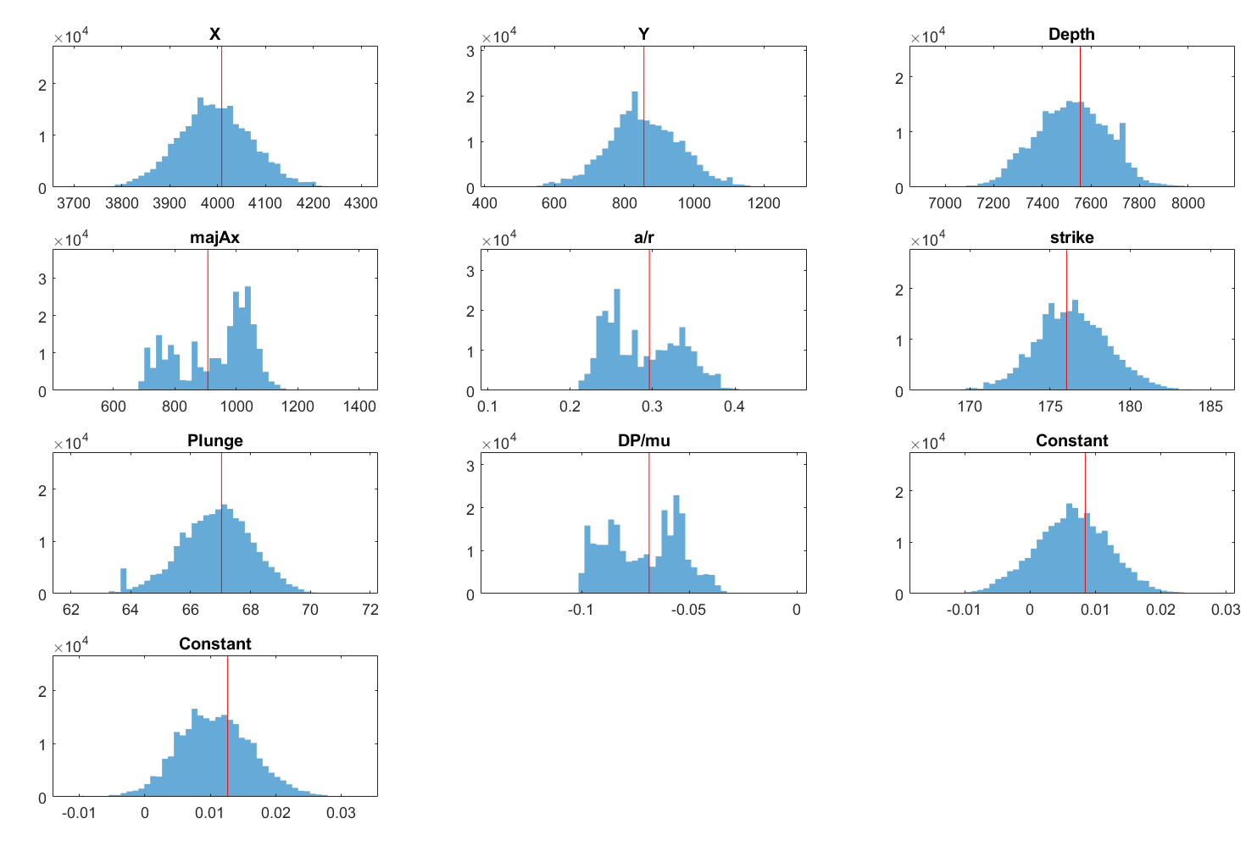
Figure S20. Inferred probability density functions for Yang A (E = 15GPa) model parameters (GBIS). Source location (X and Y local coordinates in meters), semimajor axis length, aspect ratio in meters; strike and plunge are in degrees, and the ratio DP/mu is dimensionless. Here, DP refers to the pressure change and mu is the shear modulus of the halfspace. Also inferred by the inversion are two offset parameters (InSAR Const.) for each of the InSAR satellite tracks used, as the displacement fields may have an arbitrary offset. The InSAR Const. is a shift applied to the entire dataset and it is in meter, the first panel is for the T16 and the second for the T155 track. The red line indicates the optimal value of the parameter.
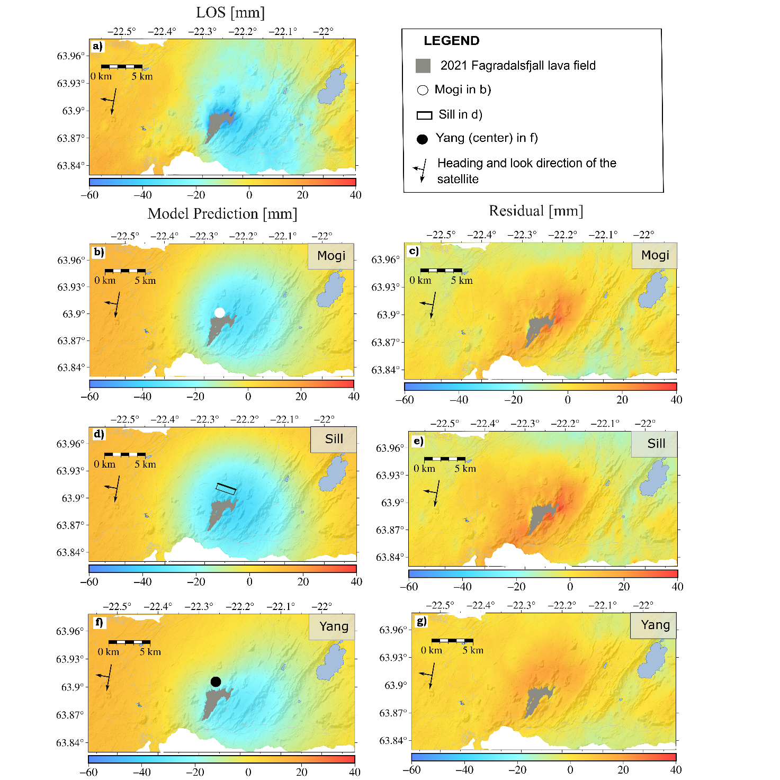
Figure S21. Modelling results for the lava loading corrected six-months LOS data (T155 InSAR track) for E = 30 GPa. (a) LOS data; (b), (d), and (f) show the model predictions, while (c), (e), and (g) display the residuals for the Mogi, sill, and Yang sources, respectively. Black outline in (d) shows the projection at surface of the modelled deflating sill, with the thicker line indicating the bottom of the sill best-fit solution at 12.6 km depth (95% confidence interval: 12.3 – 13.5 km). The white circle in (b) indicates the best-fit Mogi source at 8.8 km depth (95% confidence interval: 8.3−9.2 km), while the black circle indicate the best-fit Yang solution located at a depth of 7.6 km (95% confidence interval: 7.1−8.1 km). In light blue the lake Kleifarvatn to the east. White indicates the ocean.

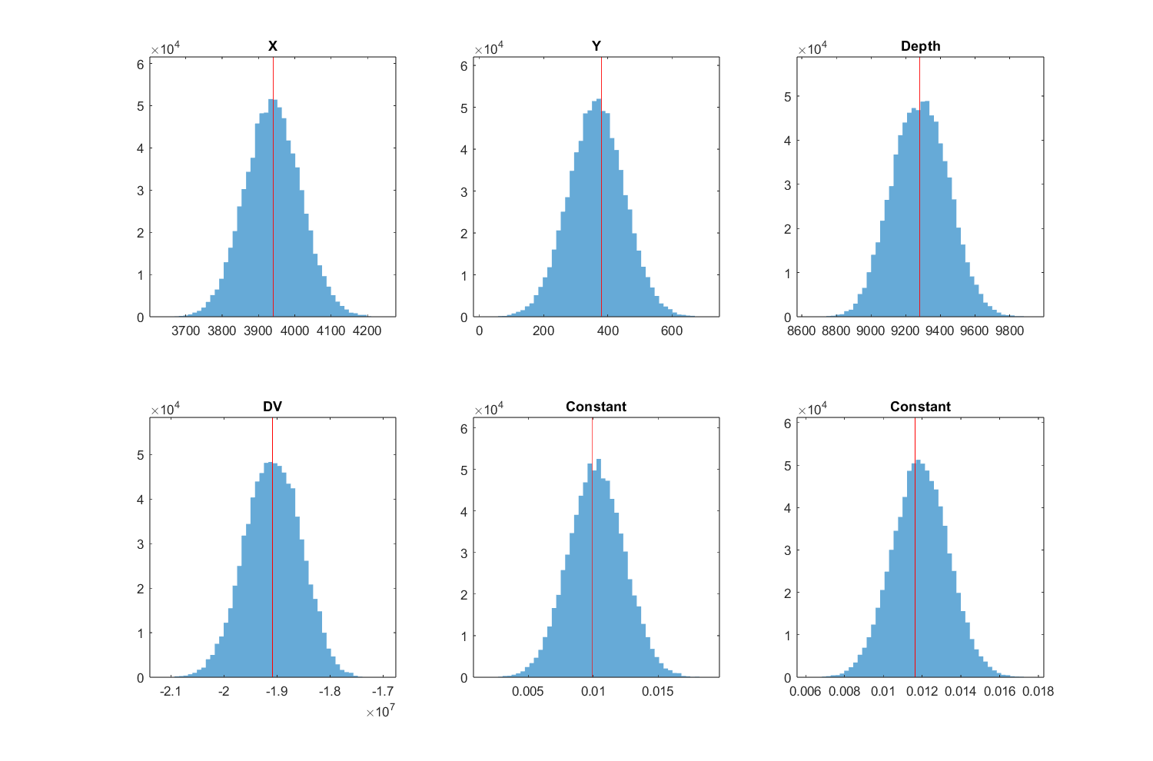
Figure S22. Inferred probability density functions for model parameters (GBIS) for Mogi B case. Source location (X and Y local coordinates in meters), depth in meters and volume change (ΔV) in m³. Also inferred by the inversion are two offset parameters (InSAR Const.) for each of the InSAR satellite tracks used, as the input displacement fields may have an arbitrary offset. The InSAR Const. is a shift applied to the entire dataset and it is in meter, the first panel is for the T16 and the second for the T155 track. The red line indicates the optimal value of the parameter.
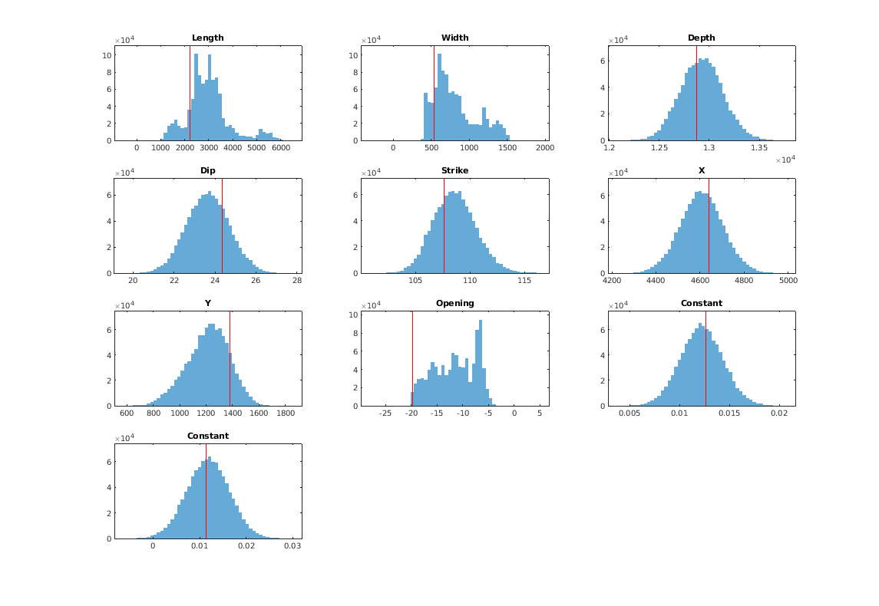

Figure S23. Inferred probability density functions for sill B case model parameters (GBIS). Source location (X and Y local coordinates in meters), source depth, length, width and opening of the sill in meters; strike and dip are in degrees. Also inferred by the inversion are two offset parameters (InSAR Const.) for each of the InSAR satellite tracks used, as the displacement fields may have an arbitrary offset. The InSAR Const. is a shift applied to the entire dataset and it is in meter, the first panel is for the T16 and the second for the T155 track. The red line indicates the optimal value of the parameter.

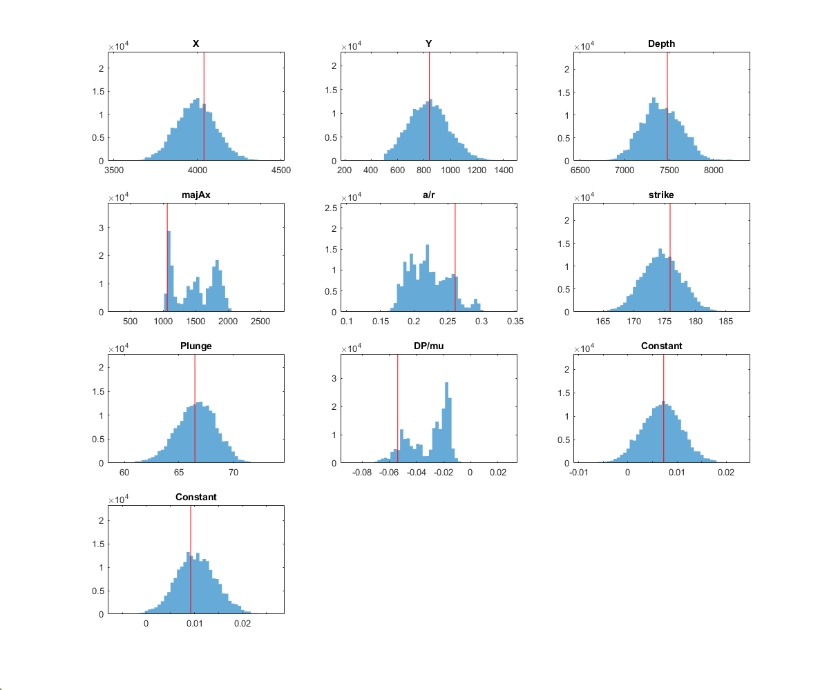Figure S24. Inferred probability density functions for Yang B case model parameters (GBIS). Source location (X and Y local coordinates in meters), semimajor axis length, aspect ratio in meters; strike and plunge are in degrees, and the ratio DP/mu is dimensionless. Here, DP refers to the pressure change and mu is the shear modulus of the halfspace. Also inferred by the inversion are two offset parameters (InSAR Const.) for each of the InSAR satellite tracks used, as the displacement fields may have an arbitrary offset. The InSAR Const. is a shift applied to the entire dataset and it is in meter, the first panel is for the T16 and the second for the T155 track. The red line indicates the optimal value of the parameter.

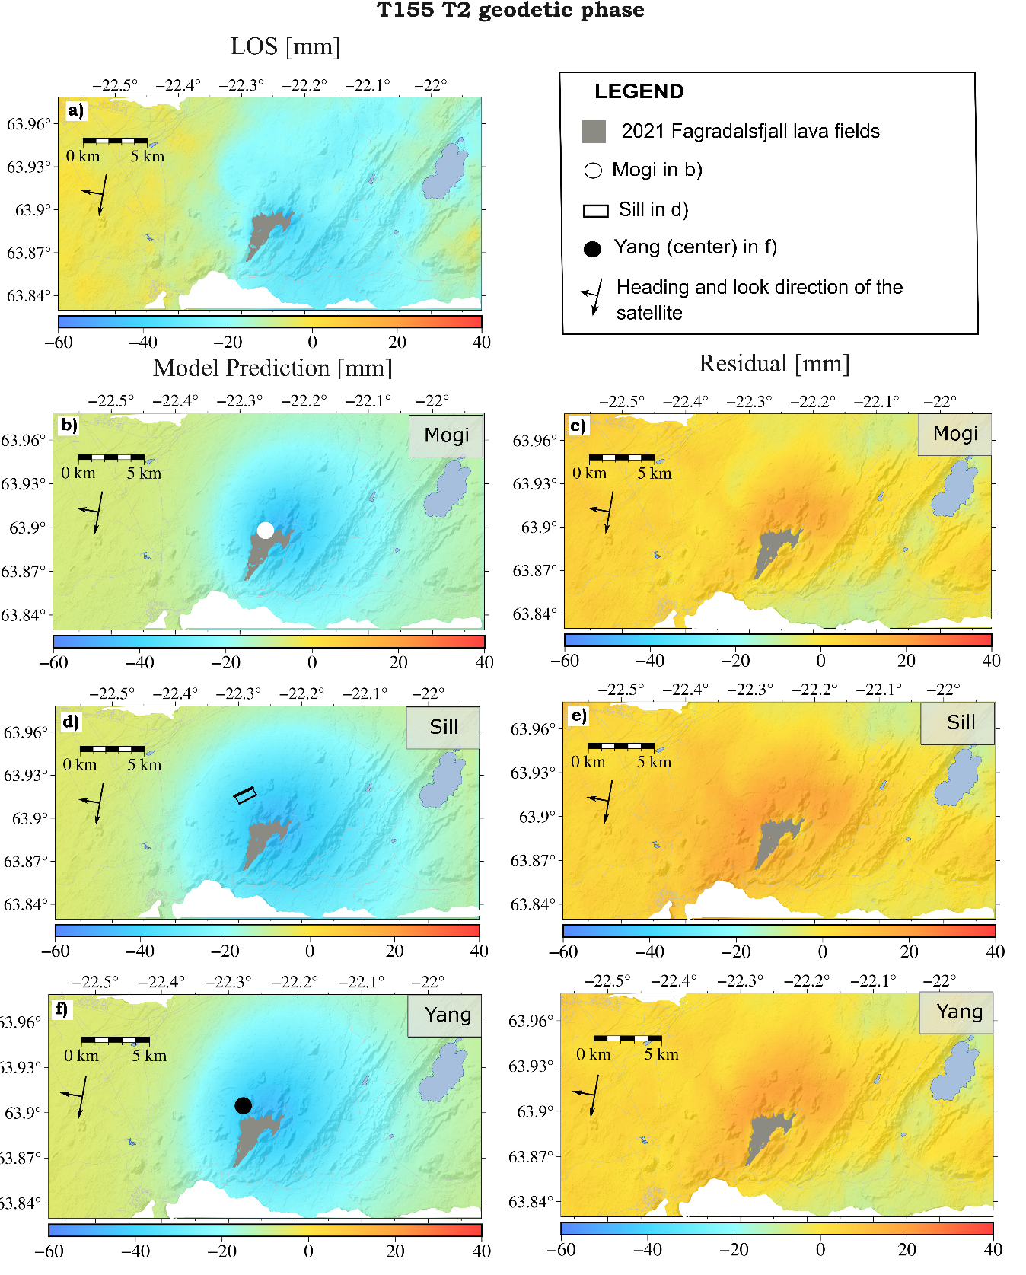
Figure S25.Modelling results for T2 geodetic phase of T155 InSAR track. (a) LOS data; (b), (d), and (f) show the model predictions, while (c), (e), and (g) display the residuals for the Mogi, sill, and Yang sources, respectively. The white circle in (b) indicates the best-fit solution of the Mogi source at 6.0 km (95% confidence interval: 5.66.3 km) depth. Black outlines in (e) show the projection at surface of the modelled best-fit deflating sill at 11.7 km (95% confidence interval: 11.1–12.4 km). The black circle in (f) show the best-fit location of the Yang’s center at 7.4 km (95% confidence interval: 7.2-8 km) In light blue the lake Kleifarvatn to the east and in white the ocean. Model parameters of the Mogi, sill and Yang sources are presented in Supplementary Figs. S27, S28 and S29 respectively.

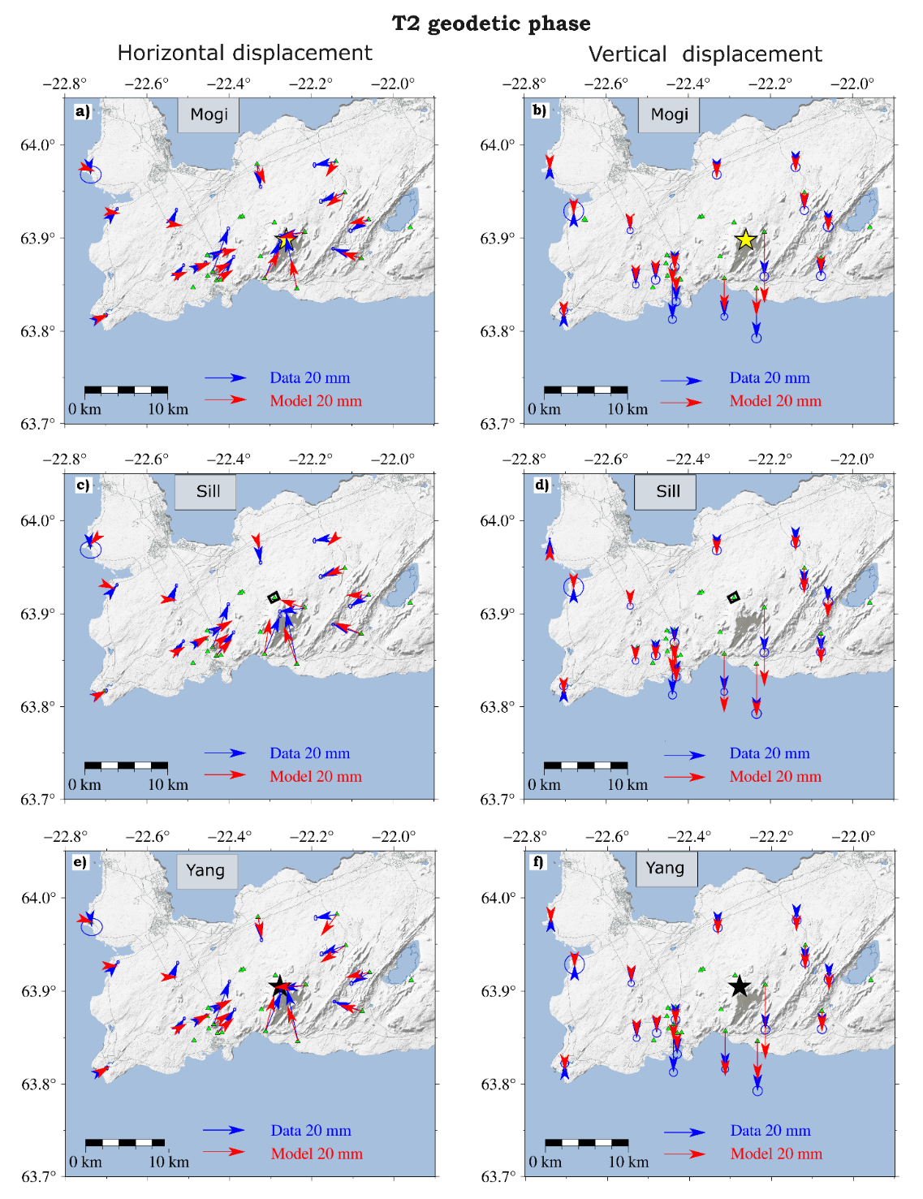
Figure S26. Modelling results for T2 geodetic phase for Mogi, sill and Yang sources. Horizontal a) and b) vertical GNSS data and model predictions for the Mogi source (yellow star) at 6.0 km depth ((95% confidence interval: 5.6−6.3) km depth located at -22.26°, 63.898°. Horizontal c) and Vertical d) data and model prediction for a sill source at a depth of 11.7 km (95% confidence interval: 11.1–12.4 km), (coordinate for the vertices: -22.285°, 63.923°, -22.302°, 63.918°, -22.296°, 63.912°, -22.277°, 63.917°). Horizontal (e) and vertical (f) GNSS data and model prediction for the Yang source, located at 7.4 km depth (coordinates: -22.2778°, 63.9046°) (95% confidence interval 7.2-8 km). Model parameter results for the Mogi are displayed in Supplementary Figure S27; for the sill, they are in Supplementary Figure S28, and for the Yang in Supplementary Figure S29 Black outlines show the projection at surface of the modelled deflating sill. In light grey, the Fagradalsfjall lava field at the end of the eruption and in light blue are indicated lakes and the ocean.
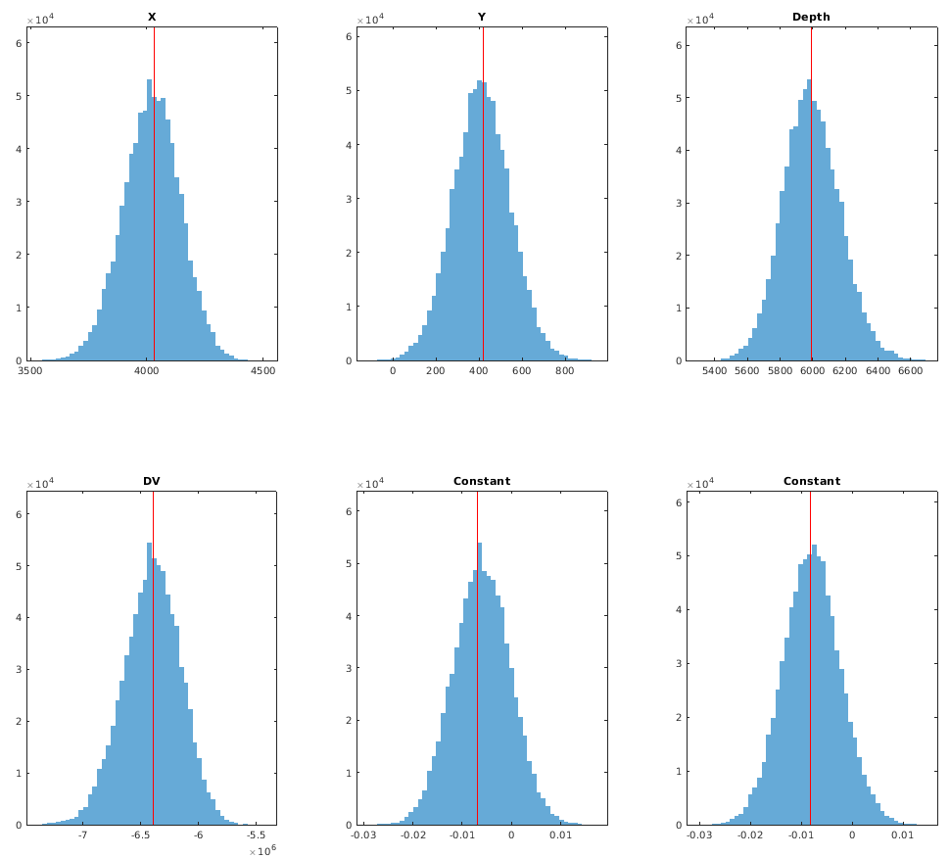
MODEL  PARAMETER | Optimal | 2.5 % | 97.5%
Depth (km) | 5.99 | 5.67 | 6.35
Deflating volume change (Mm³) | 6.39 | 6.91 | 5.95
Longitude | -22.258 | -22.263 | -22.253
Latitude | 63.883 | -63.881 | 63.886

Figure S27. Inferred probability density functions (pdf) for Mogi model parameters (GBIS) for the T2 geodetic phase with the parameter values in the table in terms of optimal, 2.5% and 97.5% results. Source location parameters X and Y are in local coordinates in meters in the pdf but presented in longitude and latitude in the table. Also inferred by the inversion are two offset parameters (InSAR Const.) for each of the InSAR satellite tracks used, as the input displacement fields may have an arbitrary offset. The InSAR Const. is a shift applied to the entire dataset and it is in meter, the first panel is for the T16 and the second for the T155 track. The red line indicates the optimal value of the parameter.

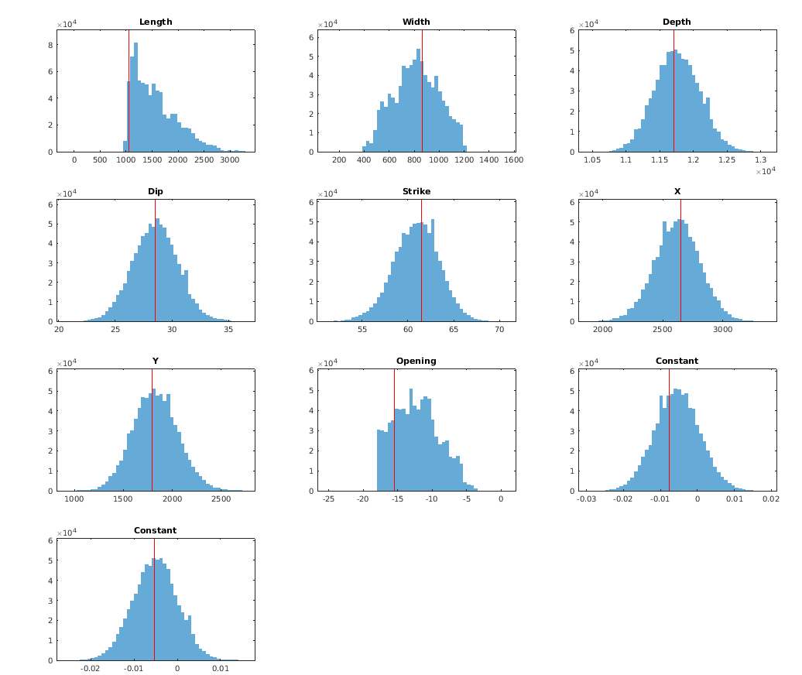
MODEL  PARAMETER | Optimal | 2.5 % | 97.5%
Depth (km) | 11.7 | 11.1 | 11.6
Length (km) | 1.06 | 1.03 | 2.59
Width (km) | 0.86 | 0.49 | 1.16
Strike (°) | 61 | 56 | 66
Dip (°) | 29 | 25 | 32
Longitude* | -22.286 | -22.294 | -22.279
Latitude* | 63.896 | 63.893 | 63.901

Figure S28. Inferred probability density functions for sill geometry during the T2 geodetic phase for the optimal, 2.5% and 97.5% values. Source location X and Y are in local coordinates in meters in the pdf; but converted in latitude and decimal degrees in the table; the values referred to the bottom edges of the dislocation. Also inferred by the inversion are two offset parameters (InSAR Const.) for each of the InSAR satellite tracks used, as the displacement fields may have an arbitrary offset. The InSAR Const. is a shift applied to the entire dataset and it is in meter, the first panel is for the T16 and the second for the T155 track. The red line indicates the optimal value of the parameter
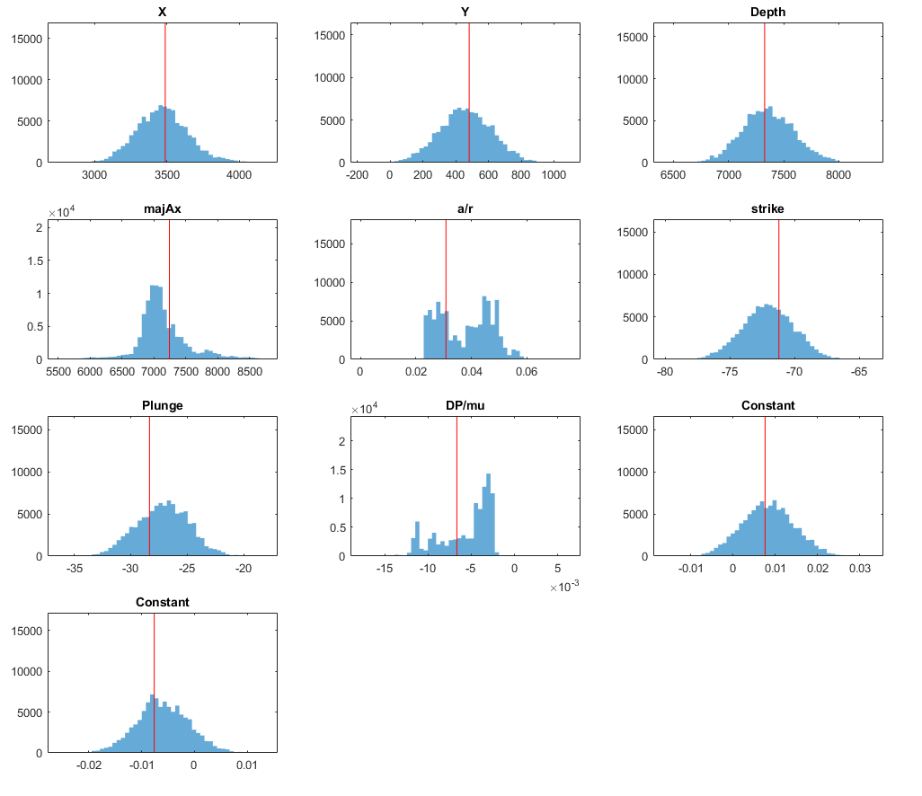
MODEL  PARAMETER | Optimal | 2.5% | 97.5%
Depth (km) | 7.3 | 6.9 | 7.8
Semi-major axis (km) | 7.2 | 6.3 | 8.2
Aspect ratio | 0.031 | 0.024 | 0.055
Strike (°) | -71 | -76 | -68
Plunge (°) | -28 | -32 | -22
DP/mu | -0.007 | -0.012 | -0.002
Longitude* | -22.269 | -22.276 | -22.261
Latitude* | 63.902 | 63.899 | 63.905
Figure S29. Inferred probability density functions for Yang geometry during the T2 geodetic phase. Source location (X and Y local coordinates in meters), semimajor axis length, aspect ratio in meters; strike and plunge are in degrees, and the ratio DP/mu is dimensionless. Here, DP refers to the pressure change and mu is the shear modulus of the halfspace. Also inferred by the inversion are two offset parameters (InSAR Const.) for each of the InSAR satellite tracks used, as the displacement fields may have an arbitrary offset. The InSAR Const. is a shift applied to the entire dataset and it is in meter, the first panel is for the T16 and the second for the T155 track. The red line indicates the optimal value of the parameter.

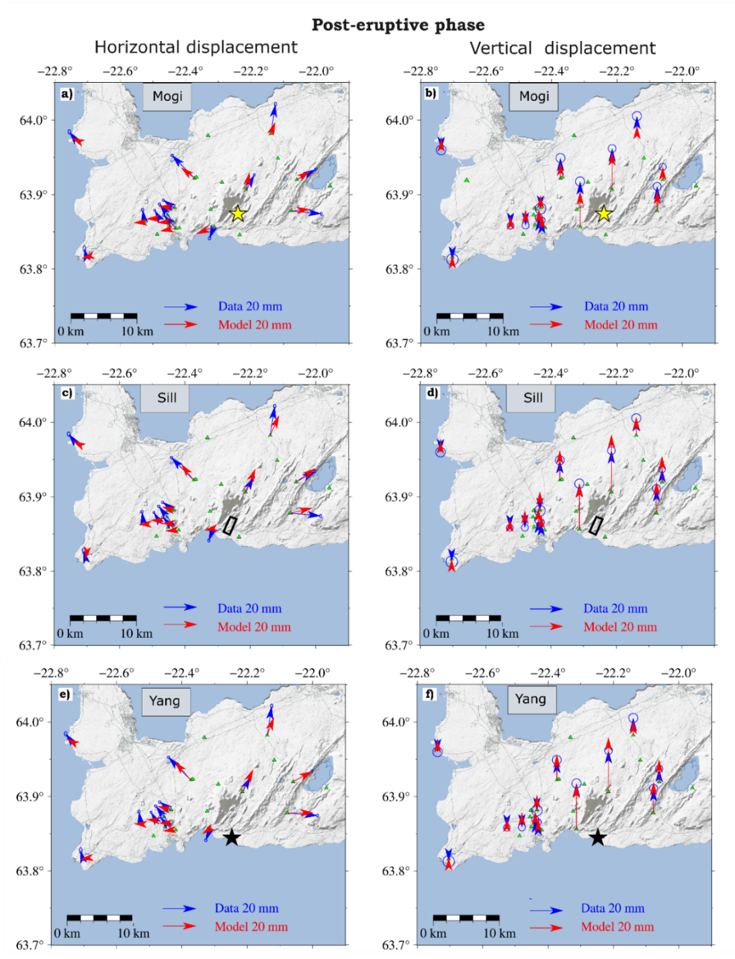
Figure S30. Modelling results for post-eruptive phase for Mogi and sill sources. Horizontal a) and b) vertical GNSS data and model predictions for the Mogi source (yellow star) at 8.00 km depth (95% confidence interval: 7.3-9.4 km). located at -22.26°, 63.89° (optimal values). Horizontal c) and Vertical d) data and model prediction for a sill source at a depth of 12.3 km depth (95% confidence interval: 11.5–13.7 km). Horizontal (e) and vertical (f) data and model prediction for a Yang solution (black star) at 9.1 km depth (95% confidence interval: 8.5-10.9 km). Model parameter results for the Mogi are displayed in Supplementary Figure S32; for the sill, they are in Supplementary Figure S33, while for the Yang ellipsoid are in Supplementary Figure S34Black outlines show the projection at surface of the modelled deflating sill with the thicker line indicating the top of the sill. In light grey, the Fagradalsfjall lava field at the end of the eruption and in light blue are indicated lakes in the area. Dark grey indicates the ocean.

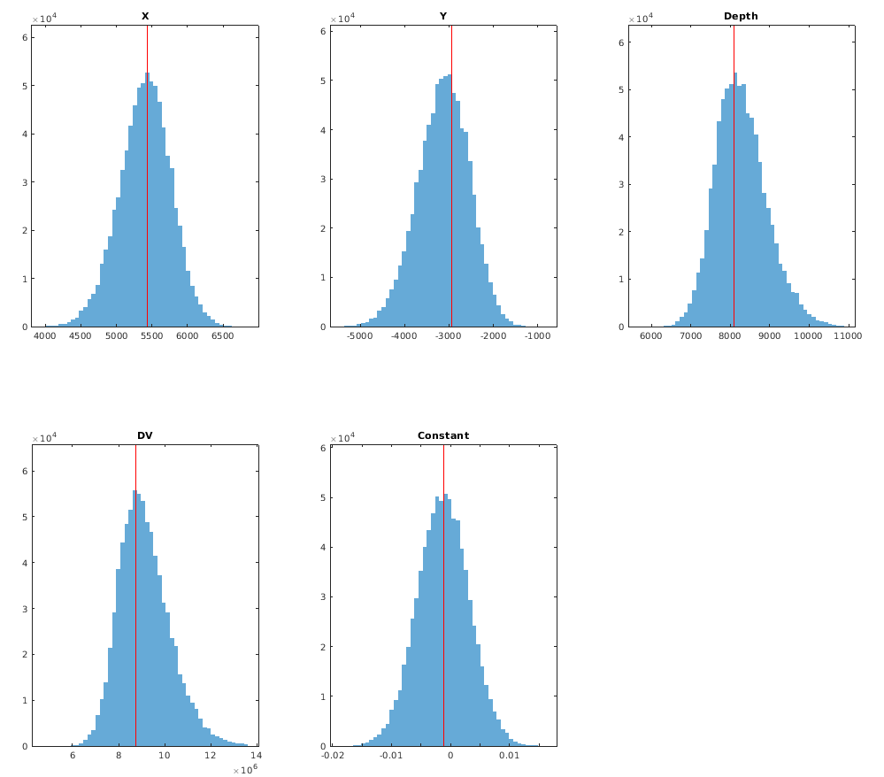
MODEL  PARAMETER | Optimal | 2.5 % | 97.5%
Depth (km) | 8.09 | 7.14 | 9.71
Deflating volume change (Mm³) | 8.76 | 7.28 | 11.7
Longitude | -22.229 | -22.245 | -22.216
Latitude | 63.854 | 63.935 | 63.862

Figure S31. Inferred probability density functions for Mogi model parameters (GBIS) for the post-eruptive phase modelling with the parameter values listed in the table below in terms of best-fit, 2.5% and 97.5% results. Source location parameters X and Y are in local coordinates in meters in the pdf but presented in longitude and latitude in the table. Also inferred by the inversion are two offset parameters (InSAR Const.) for each of the InSAR satellite tracks used, as the input displacement fields may have an arbitrary offset. The InSAR Const. is a shift applied to the entire dataset for track T16 and it is meters. The red line indicates the optimal value of the parameter.

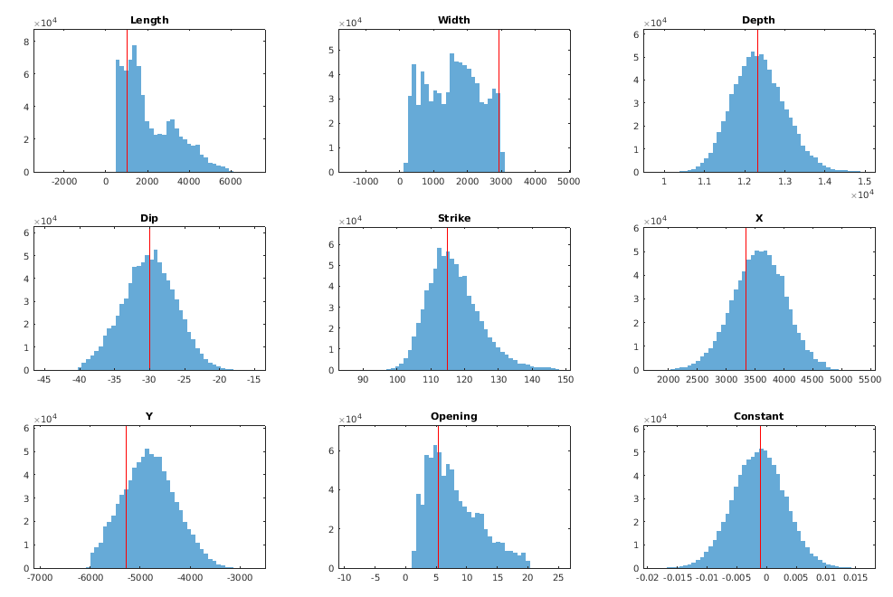
MODEL  PARAMETER | Optimal | 2.5% | 97.5%
Depth (km) | 12.3 | 11.2 | 13.7
Length (km) | 1.04 | 0.551 | 4.93
Width (km) | 2.92 | 0.315 | 2.92
Strike (°) | 115 | 104 | 135
Dip (°) | -30 | -37 | -23
Longitude* | -22.284 | -22.296 | -22.249
Latitude* | 63.838 | 63.828 | 63.828

Figure S32. Inferred probability density functions for sill geometry for the post-eruptive phase for the optimal, 2.5% and 97.5% values. Source location X and Y are in local coordinates in meters in the pdf, but converted in latitude and decimal degrees in the table; the values referred to the bottom edges of the dislocation. Also inferred by the inversion are two offset parameters (InSAR Const.) for each of the InSAR satellite tracks used, as the displacement fields may have an arbitrary offset. The InSAR Const. is a shift applied to the entire dataset and it is in meter, the first panel is for the T16 and the second for the T155 track. The red line indicates the optimal value of the parameter.
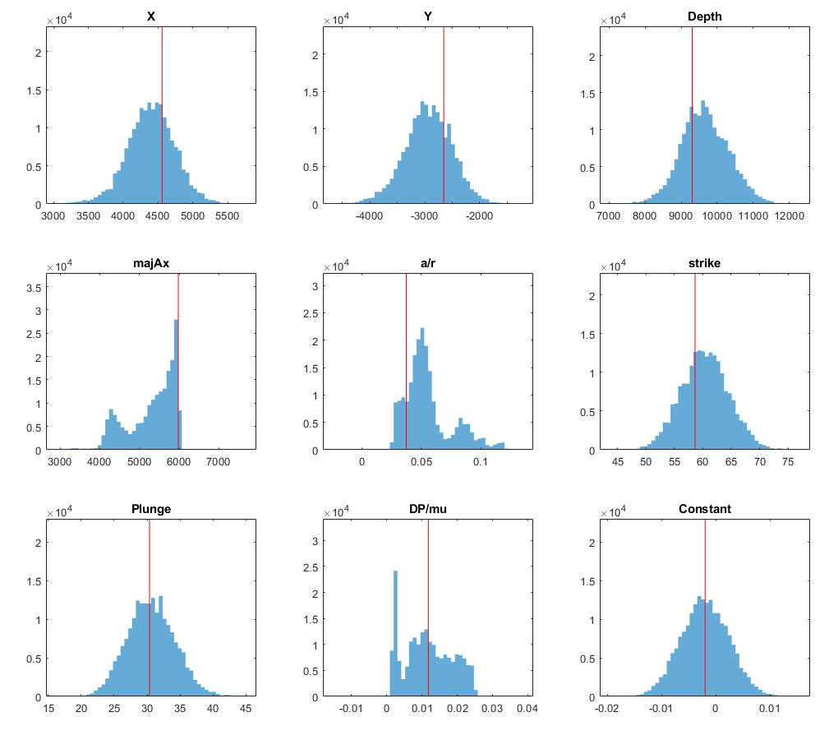
MODEL  PARAMETER | Optimal | 2.5% | 97.5%
Depth (km) | 9.3 | 8.4 | 11
Semi-major axis (km) | 6 | 4.1 | 6
Aspect ratio | 0.03 | 0.028 | 0.105
Strike (°) | 59 | 52 | 68
Plunge (°) | 30 | 23 | 37
DP/mu | 0.0118 | 0.00165 | 0.02404
Longitude* | -22.248 | -22.265 | -22.237
Latitude* | 63.874 | 63.864 | 63.879

Figure S33. Inferred probability density functions for Yang geometry for the post-eruptive phase for the optimal, 2.5% and 97.5% values. Source location (X and Y local coordinates in meters), semimajor axis length, aspect ratio in meters; strike and plunge are in degrees, and the ratio DP/mu is dimensionless. Here, DP refers to the pressure change and mu is the shear modulus of the halfspace. Also inferred by the inversion are two offset parameters (InSAR Const.) for each of the InSAR satellite tracks used, as the displacement fields may have an arbitrary offset. The InSAR Const. is a shift applied to the entire dataset and it is in meter, the first panel is for the T16 and the second for the T155 track. The red line indicates the optimal value of the parameter.
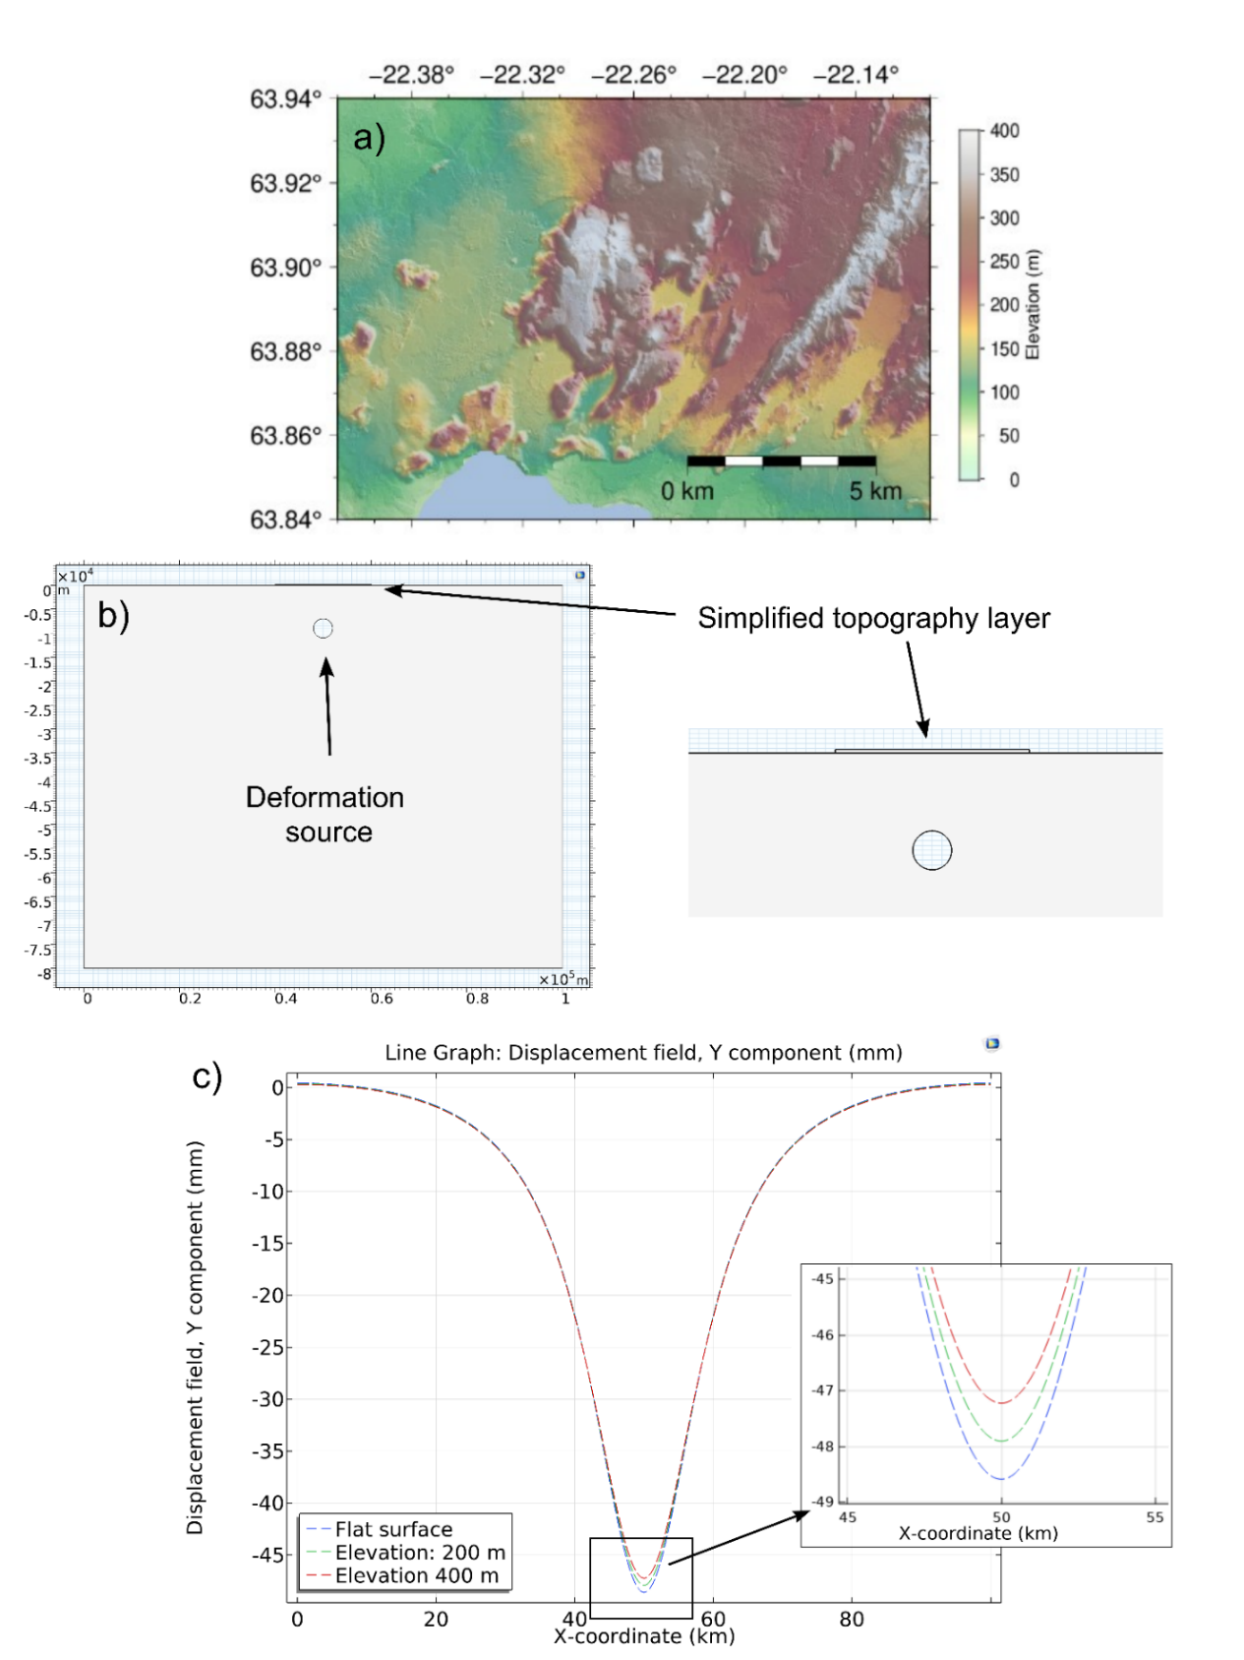
Figure S34. (a) Topography of the study area. (b) 2D finite element method (FEM) model illustrating a pressurized spherical source at 9 km depth. The source pressure (1 MPa) was determined based on the source strength required to reproduce values close to the maximum surface displacement observed in the geodetic data, considering the volume change inferred from the inversion results. Over the large domain (100 × 80 km), a simplified rectangular-shaped topography was used, with a lateral extent of 10 km and elevations of 200 m and 400 m. (c) Surface deformation profiles for topography elevations set to 0, 200, and 400 m.
TABLE S1. GNSS sites network.
GNSS Site Name | Longitude | Latitude | Linear velocity |  |  |  | Plate spreading signal removed according to the plate spreading model by Drouin & Sigmundsson (2019)
GNSS Site Name | Longitude | Latitude | East  (mm/yr) |  | North  (mm/yr) |  | East  (mm/yr) |  | North  (mm/yr)
Short time series
HAFC | -22.68 | 63.93 | 0.84 | -20.03 |  | -13.64 |  | 4.82
ELDC | -22.53 | 63.86 | -7.64 | -41.77 |  | -9.96 |  | 3.14
LISK | -22.37 | 63.92 | 0.65 | -35.15 |  | -11.88 |  | 3.63
THOB | -22.44 | 63.86 | -3.72 | -35.37 |  | -9.08 |  | 3.22
GRIC | -22.43 | 63.85 | -6.18 | -38.58 |  | -8.41 |  | 3.41
FAFC | -22.21 | 63.90 | 20.09 | -9.74 |  | -9.36 |  | 3.15
FEFC | -22.31 | 63.86 | -24.27 | -44.25 |  | - 6.91 |  | 3.88
ODDF | -22.12 | 63.94 | 28.12 | 5.33 |  | -11.05 |  | 3.22
AFST | -22.14 | 63.98 | 20.59 | -13.15 |  | -12.67 |  | 3.99
NAMC | -22.54 | 63.92 | -6.22 | -27.70 |  | - 12.76 |  | 4.17
VOGC | -22.33 | 63.98 | 3.11 | 4.42 |  | -13.42 |  | 4.59
HERV | -21.88 | 63.87 | 8.39 | -24.39 |  | -3.49 |  | 2.85
STAN | -22.23 | 63.85 | 1.04 | -54.37 |  | -5.18 |  | 3.89

References
Drouin V, Heki K, Sigmundsson F, et al (2016) Constraints on seasonal load variations and regional rigidity from continuous GPS measurements in Iceland, 1997–2014. Geophys J Int 205:1843–1858. https://doi.org/10.1093/gji/ggw122
Geyer A, Gottsmann J (2010) The influence of mechanical stiffness on caldera deformation and implications for the 1971–1984 Rabaul uplift (Papua New Guinea). Tectonophysics 483:399–412. https://doi.org/10.1016/j.tecto.2009.10.029
Hanssen, R. F. (2001). Radar Interferometry: Data Interpretation and Error Analysis (Vol. 2). Dordrecht: Springer Netherlands. https://doi.org/10.1007/0-306-47633-9
Hautmann S, Camacho AG, Gottsmann J, et al (2013) The shallow structure beneath Montserrat (West Indies) from new Bouguer gravity data. Geophysical Research Letters 40:5113–5118. https://doi.org/10.1002/grl.51003
Heap MJ, Villeneuve M, Albino F, et al (2020) Towards more realistic values of elastic moduli for volcano modelling. Journal of Volcanology and Geothermal Research 390:106684. https://doi.org/10.1016/j.jvolgeores.2019.106684
O‘Hara C (2023) Estimating deformation source parameters using a 3D elastic finite element model including topography and crustal heterogeneity at Askja, Iceland. Ms Thesis, University of Iceland. https://hdl.handle.net/1946/45701
Trasatti E (2022). Volcanic and seismic source modeling: An open tool for geodetic data modeling. Frontiers in Earth Science, 10. https://doi.org/10.3389/feart.2022.917222
Trasatti E, Polcari M, Bonafede M, Stramondo S, (2015). Geodetic constraints to the source mechanism of the 2011–2013 unrest at Campi Flegrei (Italy) caldera. Geophysical Research Letters, 42(10), 3847–3854. https://doi.org/10.1002/2015gl063621
Webster R, and Oliver MA (2007). Geostatistics for environmental scientists. John Wiley &
Sons.

