Supplementary Material
S1 Network detection
S2 Single station detection quality control
S3 Measurement of waveform features
S4 Identification of individual eruptions from SEVIRI satellite images
S5 Supplementary figures
Fig. S1 Spectra of daily seismograms at select stations
Fig. S2 Distribution of log amplitudes of earthquakes detected by the single station FAME
Fig. S3 Violin plots of attributes of the reclassified events
Fig. S4 Distribution of features used in classification
Fig. S5 Pairwise comparisons of waveform features
Fig. S6 Raw seismogram at the station FAME on the 29 June
Fig. S7 Historical earthquakes at Lake Afrera reported by ISC catalogue

S1 Network detection
We followed the workflow presented by Beaucé et al. (2023) with modifications and a detailed description is presented here.

Seismogram pre-processing
Day-long raw data were downloaded using ObsPy from IRIS (https://iris.edu/) with sufficient padding at both ends to avoid artefacts caused by filtering applied later. The raw traces are then filtered with a 2-Hz high-pass filter to minimise contamination from the volcanic tremor. These 2-Hz-highpassed seismograms were then used for PhaseNet detection or visual inspection.

Backprojection
We backproject and stack the transformed continuous seismic waveforms, i.e. probabilities of P and S waves from PhaseNet detection, at each station onto a 3D grid in the study region to form the beam power. Mathematically, the beam power can be written as
$$b_{k}\left(t\right)=Σ_{s,p}U_{s,p}\left(t+τ_{s,p}^{\left(k\right)}\right)$$
where is the beam power at grid point $k$ at time $t$, $U_{s,p}$ is the transformed seismogram at station $s$ for the phase $p$ (i.e. P or S wave), $τ_{s,p}^{\left(k\right)}$ is the theoretical moveout between the potential source at grid point $k$ and station $s$for the phase $p$. Here, we utilized the output of the PhaseNet, which contains the probability of P and S waves as a function of time, as the transformation of waveforms. The beamformed waveform feature $b_{k}\left(t\right)$ at each potential source location is thus correlated to the likelihood of an earthquake. The maximum of the beampower as a function of time is extracted for continuous earthquake detection,
$\tilde{b_{k^{*}}}\left(t\right)=\max_{k}{\{b_{k}\left(t\right)\}}$ with $k^{*}\left(t\right)=\arg{\max_{k}{\{b_{k}\left(t\right)\}}}$.
We set the detection threshold as 4. Thus when $\tilde{b_{k^{*}}}\left(t\right)≥4$, an event at location $k$ and time $t$ is declared. We require that events are declared with a minimum inter-event time of 1 minute to mitigate duplicated detection due to unfocused beam caused by the 1D velocity model in the heterogeneous region.

The volume of the study region is discretized into a 3D grid, with a horizontal resolution of 0.05 degrees and a vertical resolution of 0.5 km. The grid points are down-sampled to save memory usage and allow faster processing.

Relocation of the backprojected initial catalogue
We extracted 90 seconds from continuous seismograms for each earthquake and picked the P and S arrival times with PhaseNet. All the picks with a minimum probability of 0.2 are retained as candidate picks. To automatically guide us to find the picks relative to the earthquake we are trying to locate, we first choose the picks in a time window centred at the theoretical arrival time determined by the backprojected location and origin time. The probability of the picks are then multiplied by a Gaussian window centred at the theoretical arrival time. Then the pick with the highest windowed probability is chosen as the final pick. The earthquake is then located with the selected picks using NLLoc (Lomax et al. 2000, 2009).

NLLoc provides a probabilistic earthquake location method using octree importance sampling algorithm, which facilitates fast implementation of a global search. The equal differential time likelihood function implemented in the NLLoc provides a relatively robust estimation of the location of earthquakes in spite of incorrect velocity models and outlier picks. We try to locate earthquakes recorded by at least three stations with both P and S arrivals. After the first attempt of locating events with NLLoc, outlier picks whose traveltime residual lie 10% outside of the predicted traveltime are removed. The event is then located again with the cleaned-up picks. If an event is successfully located by NLLoc, the maximum likelihood hypocentre is saved otherwise the backprojection location is kept. In the further analysis, we only consider events that are locatable by NLLoc and have a maximum horizontal uncertainty no greater than 15km. All vertical uncertainties are high and therefore are not distinguishing features. Our preliminary tests on the dependence of hypocentres on the choice of velocity models around the Nabro caldera indicate that the hypocentres are dependent on the velocity model, especially in terms of depths of the earthquakes which are poorly constrained due to lack of nearby stations within half of the depth of the earthquakes.

Building the template database
We adopt the template matching approach to expand our catalogue and search for hidden earthquakes buried in the noise. We selected the template events by their inter-template similarity and horizontal location uncertainties. We excluded the malfunctioning channels and used the nearest 4 stations to compute the network-wise inter-template correlation. Each template has a length of 45s. For the vertical component, we extracted the waveform 3 seconds before the theoretical arrival of P wave as template; for the horizontal components, we extracted the waveforms 15 seconds prior to the theoretical arrival of S wave. We noticed that the long waveform window reduced the coherence between the templates. And the coherence generally decreases as an event is farther away from a station. Events whose separation of error ellipsoids are no more than 5km are examined for redundancy. So we set a relatively low threshold of network wise inter-template correlation coefficient at 0.25 based on visual examination of several groups of similar events to remove potentially duplicated ones. Events with inter-template correlation coefficient no less than 0.25 are grouped together as template groups. Within each group, the event with the smallest uncertainty is selected as a template.

Template matching can effectively detect signals similar to the known sources by cross correlating the continuous seismic waveforms with an existing template over a network of seismic stations. When the signals are coherent across the network, the network correlation coefficient CC should exceed the overall tendency. The network correlation coefficient as a function of time $t$ is defined as
$$CC\left(t\right)=Σ_{s,c}w_{s,c}Σ_{i=1}^{N}\frac{e_{s,c}\left(iΔt\right)u_{s,c}\left(t+iΔt+τ_{s,c}\right)}{\sqrt{\sum_{i=1}^{N}{e_{s,c}^{2}\left(iΔt\right)\sum_{i=1}^{N}{u_{s,c}^{2}\left(t+iΔt+τ_{s,c}\right)}}}},$$
where $τ_{s,c}$ is the moveout at station $s$ for component $c$ used to align the continuous waveform and the template waveform, $Δt$ is the sampling period in seconds, $N$ is the number of points in the template waveform, $e_{s,c}$ is the demeaned template waveform at station s for component $c$, and $u_{s,c}$ is the demeaned continuous waveform. $w_{s,c}$ is the weight for component c at station s with $\sum_{s,c}{w_{s,c}}=1$. A malfunctioning component is assigned $0$ weight, and the rest of the components are equally weighted.

We adopted a time-dependent threshold in template matching detection. The root-mean-square value of the network CC is computed every 30 minutes, and when the instantaneous network CC is above $12×\text{RMS}$, a new event is declared. For a given template on a given day, the template is used if the data are available for at least 3 stations and at least 8 channels.

Before the template matched earthquakes are located, they are examined based on the distance between the templates that detect the events, inter-event time, similarity of the templates to remove potential duplicate detections. Events whose error ellipsoid separations are less than 5km, and that occur within 3 seconds with inter-template correlation coefficient computed with the nearest 8 stations greater than 0.1, are considered redundant. And the event with the highest network cross-correlation coefficient is retained. The unique events are located following the same procedures used to relocate the backprojection catalogue.

Then the backprojection catalogue is merged with the template matching catalogue. The merged catalogue is further examined for redundancy. Event pairs whose inter-event time is less than 3 seconds are examined iteratively; if their epicentral distance is less than 15km, the event with larger horizontal uncertainty is excluded from the final catalogue. Although the redundancy of the final catalogue has been carefully examined at this point, there is no guarantee that the final catalogue is depleted of duplicated detections. This is due to our inability to locate an event precisely when not enough phase arrival information is available. When there are insufficient phase picks to locate a backprojected event, the grid point and origin time corresponding to the maximum beam power is assigned as the event location, and the maximum horizontal uncertainty and the maximum vertical uncertainty are assigned a default 15km, which are considerably a lower bound of the true uncertainties. Likewise, when we are unable to locate a template matched event, the event origin time is set from the time lag at the maximum network correlation, the event location is set as the template location, the event uncertainties are set as the uncertainties of the template event. When a fraction of the waveforms from a template could correlate well with the continuous waveforms even if the rest of the waveforms do not, the network correlation coefficient could still exceed the detection threshold. In this case, there is no guarantee that the matched event originates from a nearby place as the template event.

S2 Single station detection quality control
We implemented the following criteria to ensure high quality picks: (1) The probability of both P and S wave picks needs to be >0.5; (2) The product of the P and S wave probabilities need to be >0.5; (3) There must be at least 1 visibly clear P wave and three visibly clear S wave arrivals. In order to do so, we defined a P-wave signal window, an S-wave signal window, and a noise window. The P-wave signal window starts half a second before the P pick and ends at the S pick. The S-wave window starts half a second before the S pick and lasts for 5 s. The noise window ends half a second before the P pick and has the same length as the P-wave signal window. For the P wave quality, averages of absolute values are taken for the 3 components for both the P wave signal window and the noise window, and the channel-wise ratios of the P wave averages, and the noise averages are taken. If there is at least 1 channel that has a ratio above 2, the P wave is considered clear and visible. For the S wave, maximum amplitude is taken for each channel instead. If all 3 ratios of the maximum S wave amplitude to the maximum noise amplitude are greater than 3, the S wave is considered clear and visible.

S3 Measurement of waveform features
The decay time represents the time that takes the S wave and its coda to decay to a particular threshold of the background, measured using the root-mean-square of the two horizontal components of the seismogram. We extract 50-s waveforms for each earthquake, starting 5 s before the P arrival and ending 45 s after the P arrival. We first calculate the moving mean $x$ of the absolute value of the extracted signal with a window length of 1 s. The moving mean is then normalised by the following equation $x=\left(x-x_{k}\right)/\left(max\left(x\right)-x_{k}\right)$ where $x_{k}$is the k-th percentile of the moving mean. We find that the 20th percentile is a suitable value for our dataset that allows for classification into well-defined groups. In order to ensure that we measure the decay time in the time window where the energy drops significantly, we find the first data point counted from the S wave arrival and after which the normalised moving mean drops below $k/100$ (here, 0.2, reminiscent of the 20th percentile) for at least 0.5 s (half the moving mean window) and this segment of data is used to fit an exponential function for the decay time measurement. From visual inspection, we find the strategy robust and representative of the speed of the decay of the S waves.

The signal duration is measured in a straightforward way given that we have already adopted an estimation of the characteristic S-wave decay time. It is obtained by simply adding the traveltime difference and the S-wave decay time.

We use the ratio of the power of the S wave to the power of the noise preceding the P wave arrival to measure the signal-to-noise ratio (SNR). The SNR, like decay time and signal duration, is measured using the horizontal components only. We mainly use SNR as another quality control factor in addition to the P wave arrival probability and S wave arrival probability. In general, the arrival probability criterion has already successfully removed noisy and unclear signals, as can be seen from the fact that no remaining seismograms have a negative SNR, and 799 out of 801 earthquakes have an SNR greater than 6 dB. Following the tradition in signal processing (Kay 2013, p. 287), we define the power of a signal or a noise in Eq. S1.
$\hat{σ^{2}}=\frac{1}{N}Σ_{n=0}^{N-1}x^{2}\left[n\right]$ (S1)
where $x$ is the time series, and $N$ is the length of the time series.
Again, we define the signal-to-noise ratio in the following manner (Kay 2013, p. 376),
$\text{SNR}=10\log_{10}{\frac{\hat{σ_{\text{signal}}^{2}}}{\hat{σ_{\text{noise}}^{2}}}}$ (S2)
The S pulse is trimmed from the start of the S pick and lasts for 4 s; the noise waveform ends a few data points from the P pick and lasts for 2 s.

To measure the amplitude ratio of the S wave to the P wave, we first define the S pulse as the waveform starting from the PhaseNet picked S arrival and lasting for 4 s. The P pulse is defined similarly but starts 1.5 s earlier than the PhaseNet picked P arrival and ends 3.3s after the picked P arrival to minimise the overlap between the P pulse and the S pulse. This choice of fixed window length for P and S waves works well for Nabro events as no events have a differential traveltime smaller than 3.4 s. The maximum absolute values of the S pulse and the P pulse are measured, and their ratio is recorded as a feature of the seismogram.

S4 Identification of individual eruptions from SEVIRI satellite images
Between 23 June and 1900 UTC (UTC time is used throughout the paper) 28 June, strong SO₂ emission can be observed in SEVIRI satellite images. Alongside the SO₂ eruption, 4 pauses of water vapour eruptions can be detected between 0645 23 June and 1500 23 June, between 0230 24 June and 1300 24 June, between 0415 25 June and 1945 25 June, and 0115 26 June and 1300 26 June. A strong volcanic ash plume (M1, FL200) mixed with SO₂ can be seen between 1400 June 26 and 0030 27 June. However, the start time cannot be pinned down due to thin cloud coverage.

Several short pulses of ash cloud can be seen between 1900 28 June and 0815 29 June, during which observation is partially obscured by intermittent cloud coverage. The sky started to become clear at about 0815UTC 29 June, and ash emission (A1, FL200) can be observed from the vent, which intensified at about 1100 29 June. This eruption stopped before 1500 29 June, and the end time cannot be specified due to thin clouds and dust storms moving west covering the venting area. From then on (1500 29 June) the eruption transformed into SO₂ degassing again, drifting south, seemingly non-stop (due to cloud coverage) until interrupted by a short impulsive ash eruption at 0600 30 June. The ash emission event was then followed by SO₂ degassing, whose intensity is modest. The SO₂ degassing seemed continuous or at least with multiple, spasmodic hiatus, due to cloud coverage limiting interpretability, sometimes co-existing with volcanic ash emissions, until it reached a pause at about 2045 05 July. The SO₂ restarted at 0615 UTC 06 July until it reached a short pause at 2045 07 July. The exact duration of this pause cannot be retrieved from the images due to cloud coverage starting 1 hour after the onset of the hiatus.

The first weak ash eruption (A2) mixed with SO₂ occurred between 1200 02 July and 2000 2 July; and the second strong (A3, FL200) ash event started at 1330 04 July and stopped 2230 04 July.

Following the 07 July hiatus were pauses of ash emissions (which might be continuous due to cloud coverage) between 0200 08 July and 1500 08 July (A4). Afterwards, the eruption continued as mild, or below-moderate SO₂ degassing, potentially accompanied by minor volcanic ash emission (barely visible due to its tininess or cloud coverage). This SO₂ eruption continued at least from 1500 08 July until 1400 10 July. The interpretation is obscured by clouds, and later by a dust storm moving south starting at 0345 11 July.

An active SO₂ degassing event can be observed between 0530 11 July and 1630 11 July. The cloud and dust storm again interfered with the interpretation between 1630 11 July and 2245 11 July. But during this period, a clear, albeit very weak SO₂ emission signal drifting SSE can be observed at 1930 11 July. After the passage of the cloud, an SO₂ cloud drifting SSE can be observed until about 0300 12 July. It was then cloudy for about 1 h, but this did not prevent our interpretation.

Between 0300 12 July and 0800 12 July the eruption transferred to an ash emission (A5) which was succeeded by an SO₂ and water-vapour eruption between 0800 12 July and 1200 12 July. A clear pink lineation trending SSW can be observed around 1400 12 July, but we are uncertain if it could be interpreted as an ash eruption due to co-existence of a dust storm moving in the same direction. The dust storm waned at approximately 0100 13 July.

An SO₂ eruption signal trending SSE nearly orthogonal to the local wind and dust direction can be observed from 0330 13 July until 0430 after which the signal at the vent was too weak to interpret the connectivity of the SO₂ plume to the vent.

A clear SO₂ signal can be observed between 1500 13 July and 1630 13 July, after which the venting area was almost continuously and completely covered by clouds until 0130 15 July. A clear ash plume mixed with SO₂ can be observed between 0345 15 July and 1115 15 July (A6), although the eruption might have initiated underneath clouds as early as 0130 15 July.

Another clear erupting ash plume can be detected from 0845 16 July until 1630 16 July (A7, FL181), sometimes accompanied by a tiny amount of SO₂. Again, we observe another ashy event (A8, FL180) with a bare amount of SO₂ between 0445 17 July and 1430 17 July. The observation of the later stage of this eruption is interfered with by the existence of a dust storm. No obvious eruptive activity can be observed afterwards until 24 July, which is out of the current observational period.

S5 Supplementary Figures
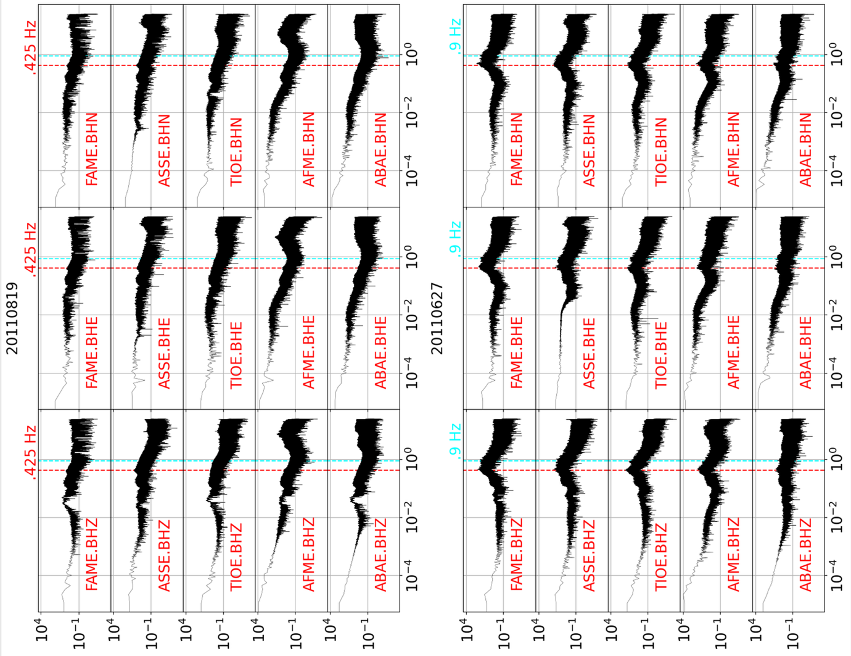
Fig. S1 Spectra of daily seismograms at select stations. Comparing the offshore station ASSE and the inland station ABAE on 19 August, the peak near .425 Hz at ASSE, which is absent from the station ABAE, indicates its oceanic origin. The elevated signal near .9 Hz on 27 June (when the eruption was ongoing) originated from the volcano as this signal was absent on 19 August
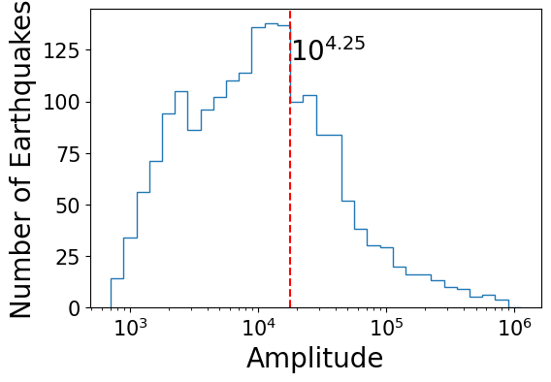
Fig. S2 Distribution of amplitudes of earthquakes on a logarithmic scale detected by the single station FAME

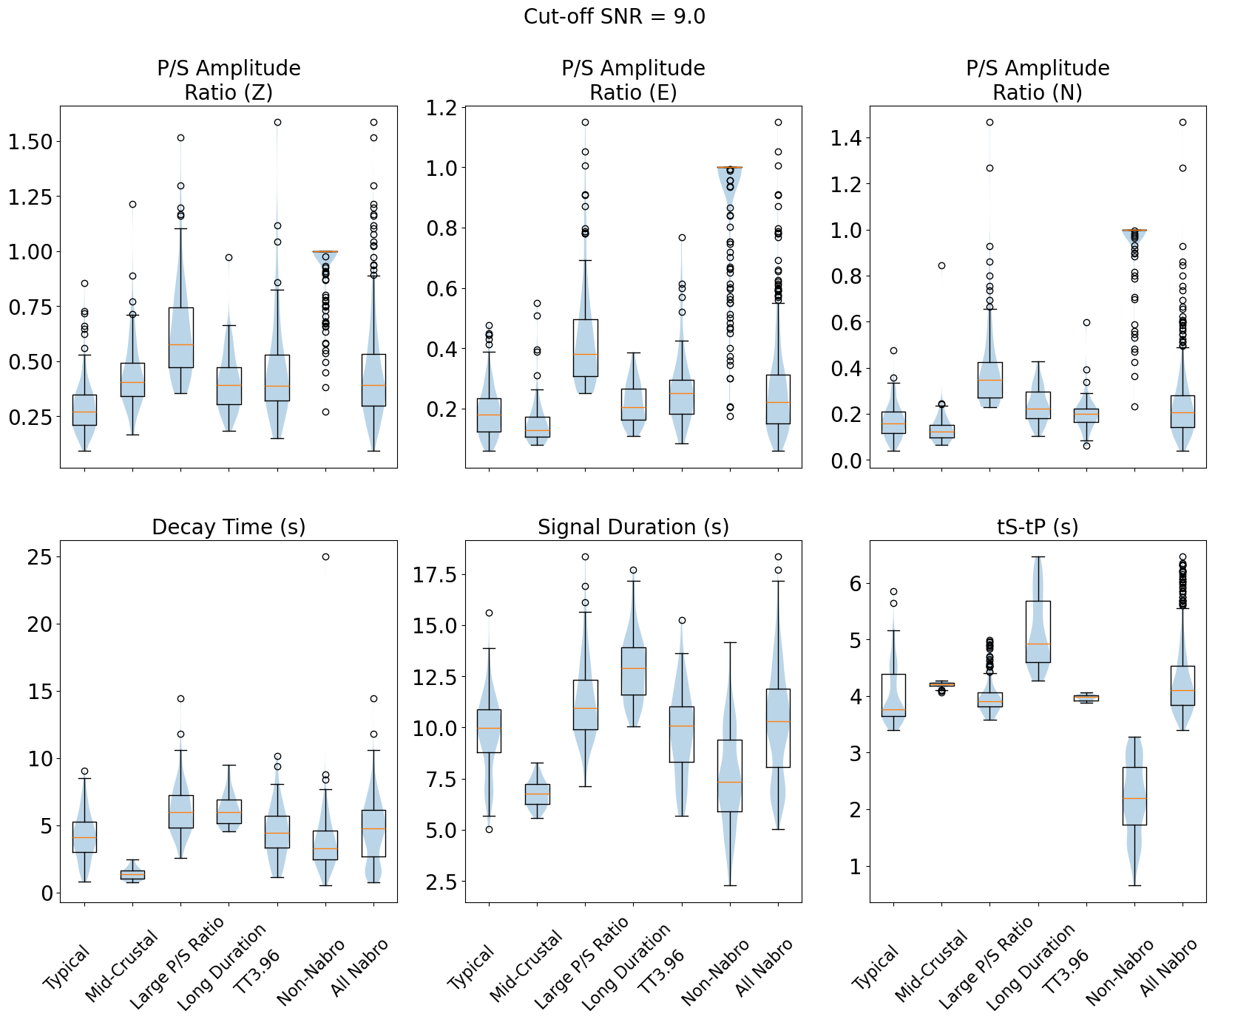
Fig. S3 Violin plots of attributes of the reclassified events. The subtitle of each figure refers to an attribute of the earthquakes, and the horizontal labels indicate the groups. Numbers of events in each category can be found in Table 1

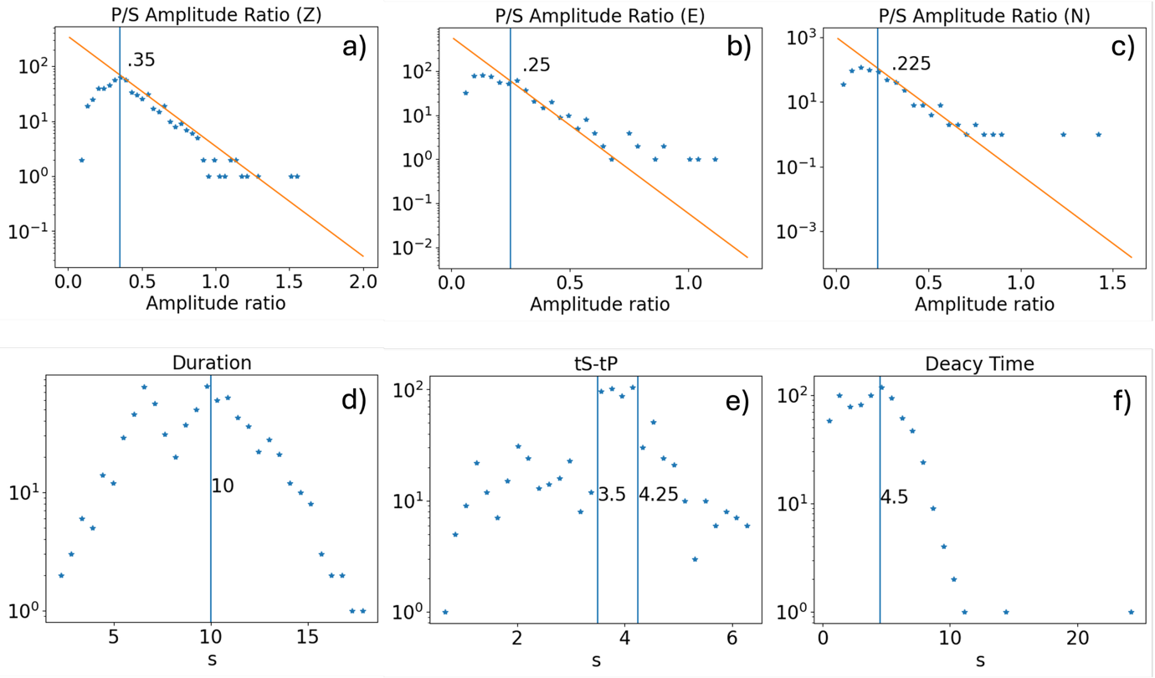
Fig. S4 Distribution of features used in classification. Vertical lines are labelled with the values used to separate populations. Orange lines in (a-c) are best fits to the data to the right of the limiting value

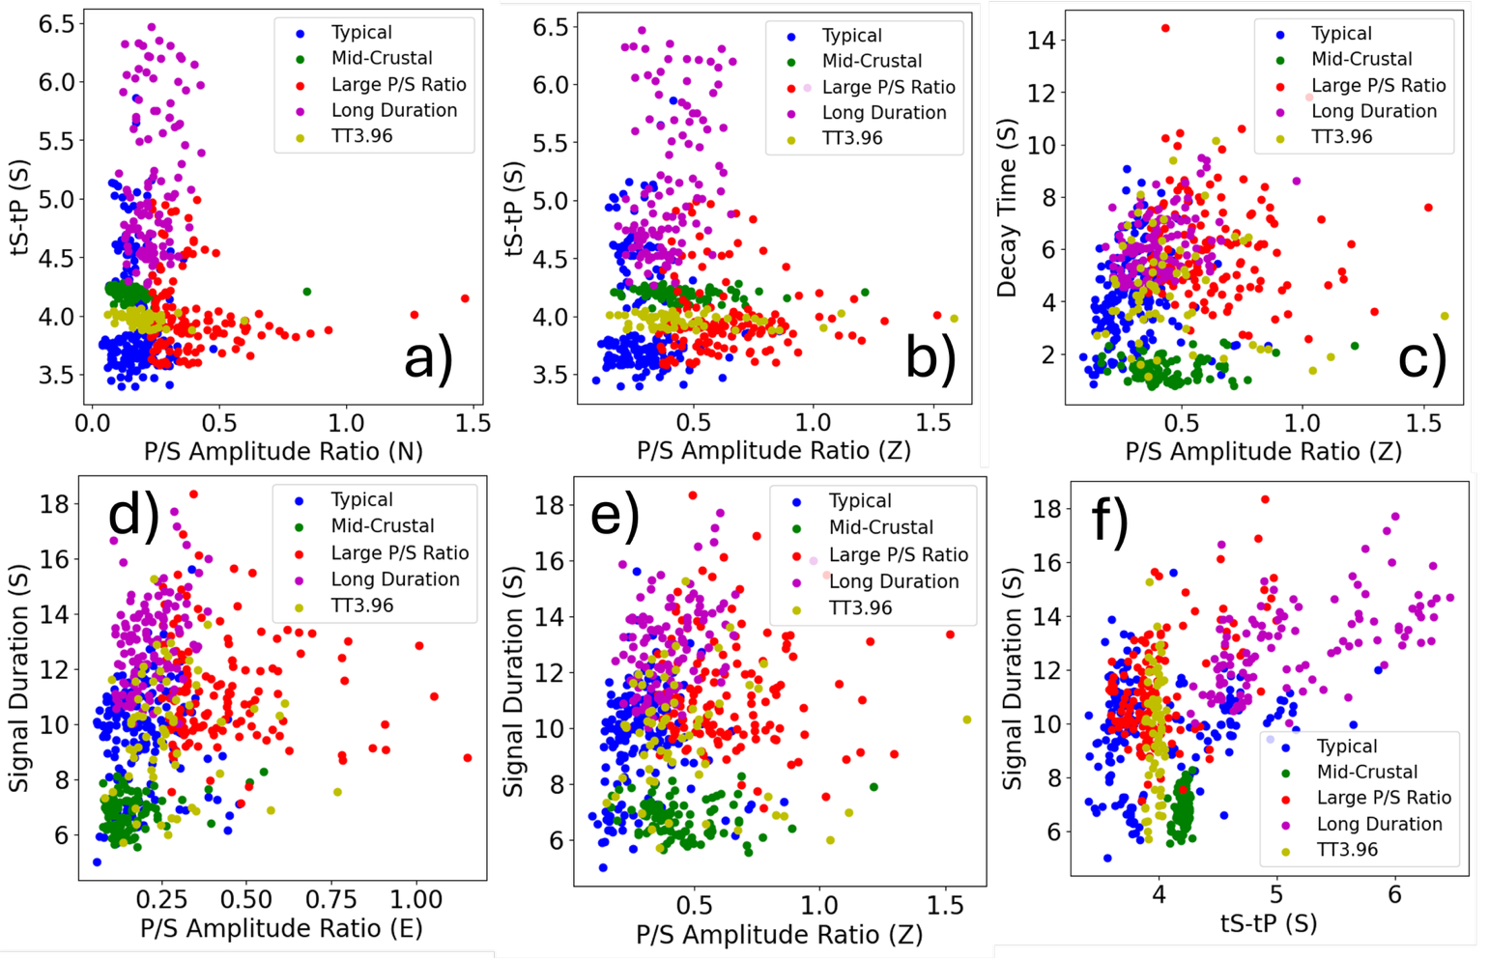
Fig. S5 Pairwise comparisons of waveform features. Different groups of earthquakes are coloured accordingly. a) The traveltime difference against the P/S amplitude ratio on the N component. b) The traveltime difference against the P/S amplitude ratio on the Z component. c) The decay time against the P/S amplitude ratio on the Z component. d) The signal duration against the P/S amplitude ratio on the E component. e) The signal duration against the P/S amplitude ratio on the Z component. f) The decay time against the traveltime difference

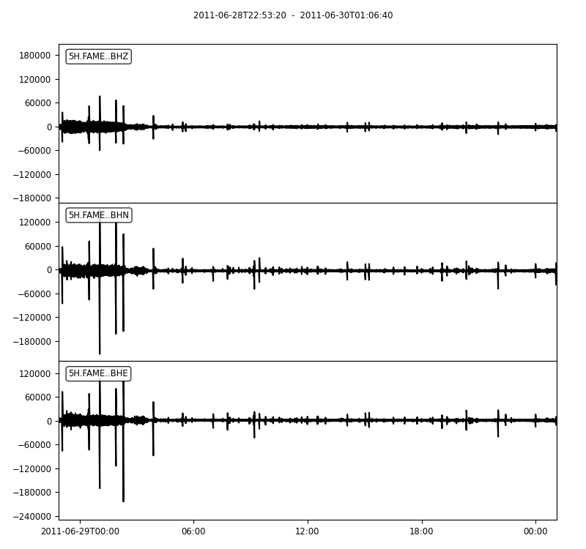
Fig. S6 Raw seismogram at the station FAME on the 29 June. A clear reduction of both noise and seismic activity can be observed starting at 0300 UTC and continued until at least the start of the next day, during which the eruption A1 occurred

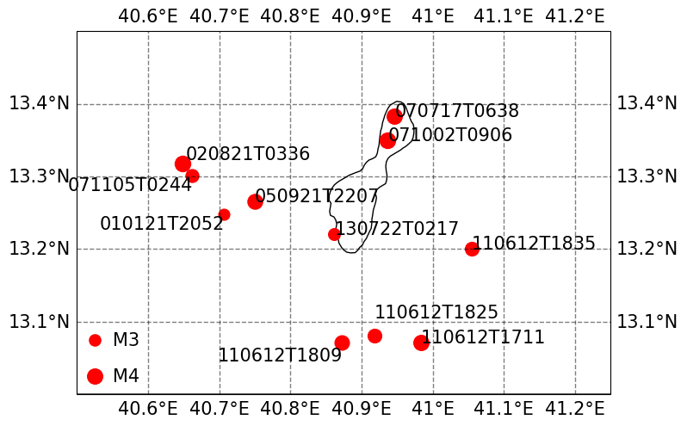
Fig. S7 Historical earthquakes at Lake Afrera reported by ISC catalogue. The earthquakes are plotted as red dots which are proportional to the magnitude squared. The texts indicate the dates in the format of YYMMDDTHHMM

References
Beaucé E, Frank WB, Seydoux L, et al (2023) BPMF: A Backprojection and Matched‐Filtering Workflow for Automated Earthquake Detection and Location. Seismol Res Lett 95:1030–1042. https://doi.org/10.1785/0220230230
Lomax A, Michelini A, Curtis A (2009) Earthquake Location, Direct, Global-Search Methods. In: Meyers RA (ed) Encyclopedia of Complexity and Systems Science. Springer New York, New York, NY, pp 1–33
Lomax A, Virieux J, Volant P, Berge-Thierry C (2000) Probabilistic Earthquake Location in 3D and Layered Models. In: Thurber CH, Rabinowitz N (eds) Advances in Seismic Event Location. Springer Netherlands, Dordrecht, pp 101–134

