Production and characterization of poly(3-hydoxybutyrate-co-3-hydroxyvalerate) copolymers from a pre-fermented hardwood hydrolysate
Warren Blunt^{1†}, Purnank Shah², Vinicio Vasquez¹, Meng Wei Ye¹, Christopher Doyle¹, Yali Liu¹, Sajjad Saeidlou³, and Fanny Monteil-Rivera^{1*}
¹Aquatic and Crop Resource Development Research Centre, National Research Council Canada, 6100 Royalmount Avenue, Montreal, Québec, Canada, H4P 2R2; ²FPInnovations, 570 Boulevard Saint-Jean, Pointe-Claire, Québec, Canada H9R 3J9; ³Automotive and Surface Transportation Research Centre, National Research Council Canada, 75 de Mortagne Boulevard, Boucherville, Québec, Canada, J4B 6Y4

*Author to whom correspondence should be addressed:
Fanny.Monteil-Rivera@cnrc-nrc.gc.ca

†Author present address: Department of Biosystems Engineering, University of Manitoba, Winnipeg, Manitoba, Canada, R3T 5V6, Email: Warren.Blunt@umanitoba.ca
Author emails: Warren.Blunt@cnrc-nrc.gc.ca; purnank.shah@fpinnovations.ca; Vinicio.Vasquez@cnrc-nrc.gc.ca; MengWei.Ye@cnrc-nrc.gc.ca; Christopher.Doyle@cnrc-nrc.gc.ca; Yali.Liu@cnrc-nrc.gc.ca; Sajjad.Saeidlou@cnrc-nrc.gc.ca; Fanny.Monteil-Rivera@cnrc-nrc.gc.ca

Supplementary Information

Fig S1 Mixed sugar uptake and VFA production from P. acidipropionici grown in MSM supplemented with 20 g L⁻¹ CSS and TMP-Bio sugars supplemented at an intial total sugar concentration of ca. 70 g L⁻¹ in a 1 L bioreactor. Symbols: ▲, acetate; ◆, propionate; ×, lactate; ○, glucose; ☐, xylose

a

b

Fig S2 P. sacchari grown in MSM medium with 10 g L⁻¹ glucose and supplemented with different concentrations of lactate. a) OD₆₀₀ profile over a 72-h cultivation and b) end-point analysis of total dry biomass and PHA synthesis.

a
b

Fig S3 H. pseudoflava grown in MSM medium with 10 g L⁻¹ glucose supplemented with different concentrations of lactate. a) OD₆₀₀ profile over a 72-h cultivation and b) end-point analysis of total dry biomass and PHA synthesis.

a
b
Fig S4 P. sacchari grown in MSM medium with 10 g L⁻¹ glucose supplemented with different concentrations of acetate. a) OD₆₀₀ profile over a 72-h cultivation and b) end-point analysis of total dry biomass and PHA synthesis

b
a
Fig S5 H. pseudoflava grown in MSM medium with 10 g L⁻¹ glucose supplemented with different concentrations of acetate. a) OD₆₀₀ profile over a 72-h cultivation and b) end-point analysis of total dry biomass and PHA synthesis

a
b
Fig S6 Total biomass synthesis rate (measured as increase in OD₆₀₀) as a function of concentration of either lactate, acetate, or propionate at different concentrations for a) P. sacchari and b) H. pseudoflava

a

b

Fig. S7 PHA synthesis data from MIC test using P. sacchari. a) Total biomass and PHA titer; and b) intracellular PHA content and 3-HV content of the polymer

b

Fig S8 PHA synthesis data from MIC test using H. pseudoflava. a) Total biomass and PHA titer; and b) intracellular PHA content and 3-HV content of the polymer

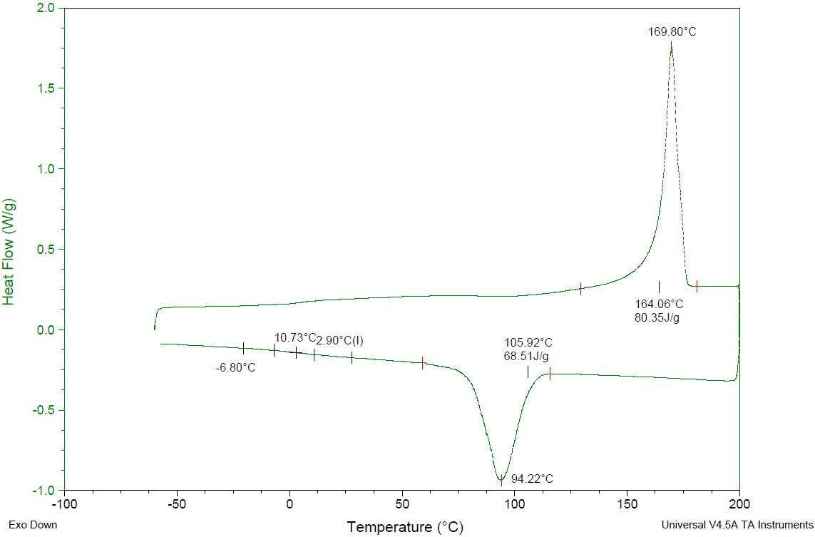

Fig S9 Thermal profile obtained by differential scanning calorimetry (DSC) of a P. sacchari PHBV copolymer synthesized from pre-fermented TMP-Bio sugars and containing 1.2 mol% 3-HV.

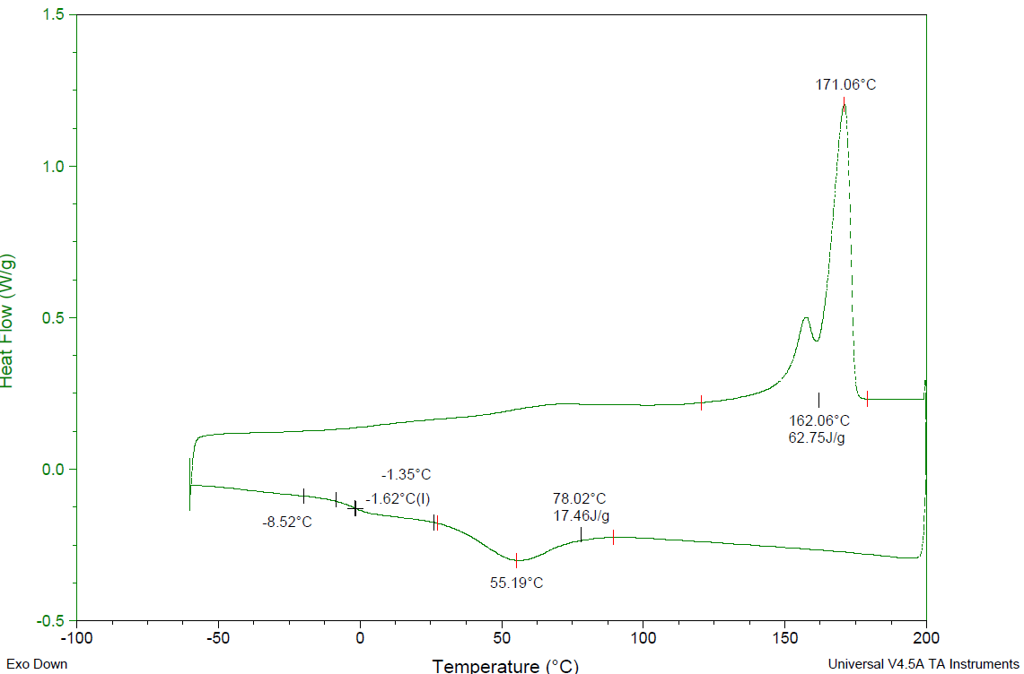

Fig S10 Thermal profile obtained by differential scanning calorimetry (DSC) of a P. sacchari PHBV copolymer synthesized from pre-fermented TMP-Bio sugars and containing 5.1 mol% 3-HV.

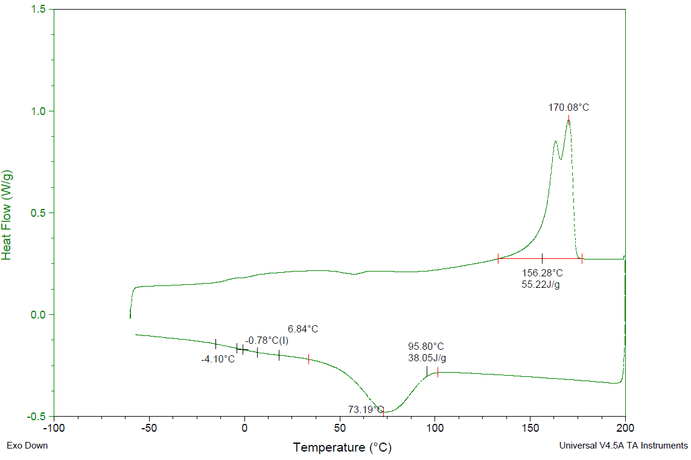

Fig S11 Thermal profile obtained by differential scanning calorimetry (DSC) of a H. pseudoflava PHBV copolymer synthesized from pre-fermented TMP-Bio sugars and containing 13.7 mol% 3-HV.

