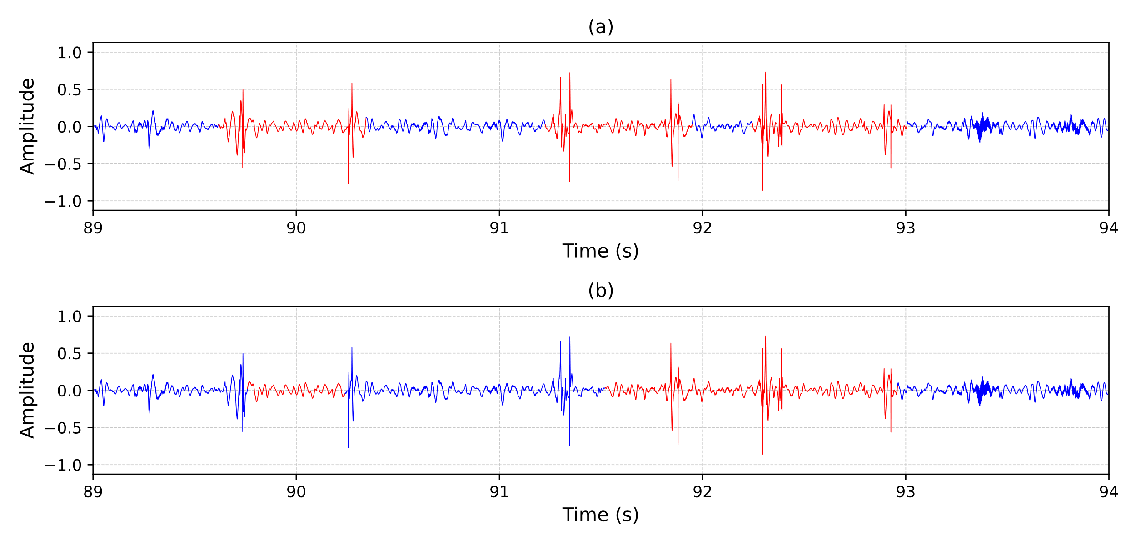
L
C
R
Swallow 1
Swallow 2
Swallow 3
Supplemental Figure 3: A zoomed-in five-second section showing the locations of three (a) true swallows (labelled as red); and (b) model-predicted swallows (labelled as red) of participant 21 in the testing dataset. Swallow 1 has been segmented into left (L), centre (C), and right (R) events.

