Supplementary file 4

PRISMA FLOWCHARTS

Topic 1: Bariatric surgery vs. non0surgical management

Topic 2: Preoperative workup

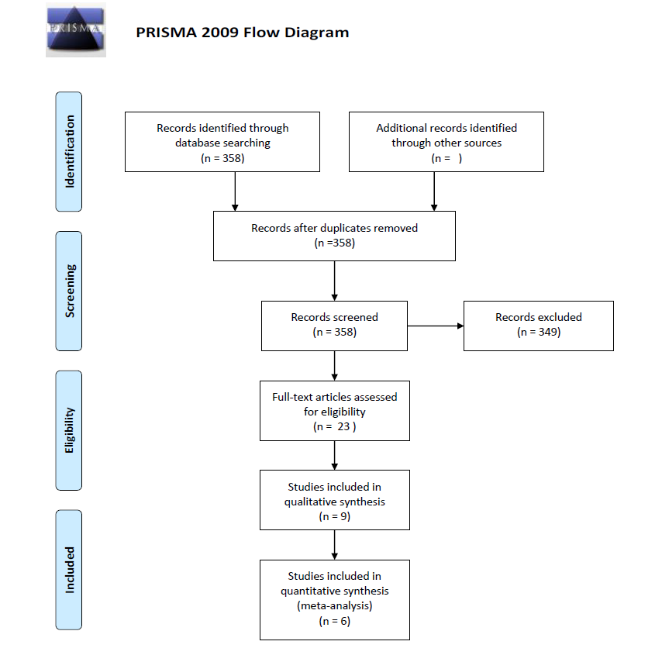

Topic 3: Perioperative management

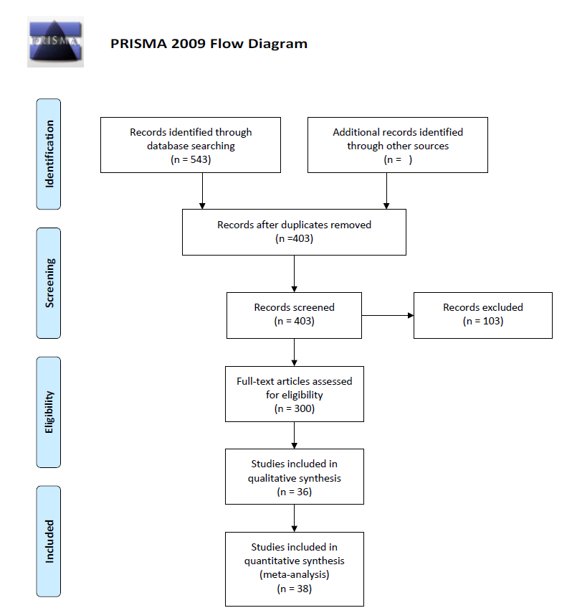

Topic 4: Adjustable gastric banding
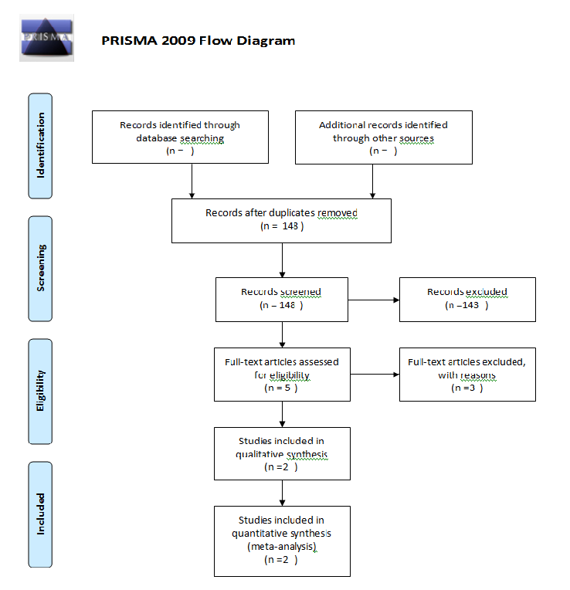

Topic 4: Sleeve gastrectomy

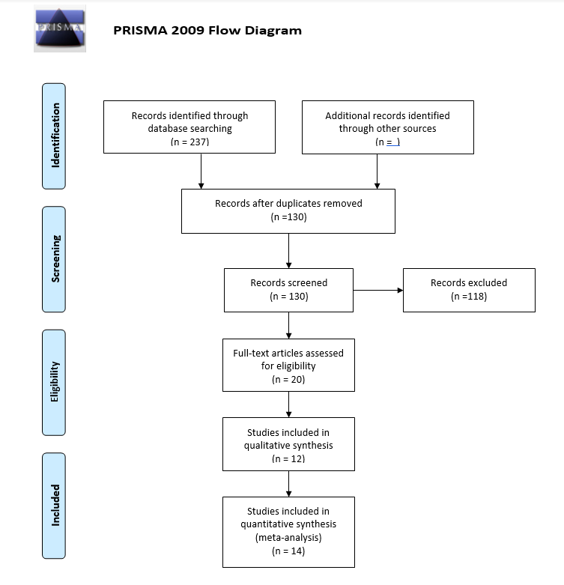

Topic 4: Roux-en-Y gastric bypass

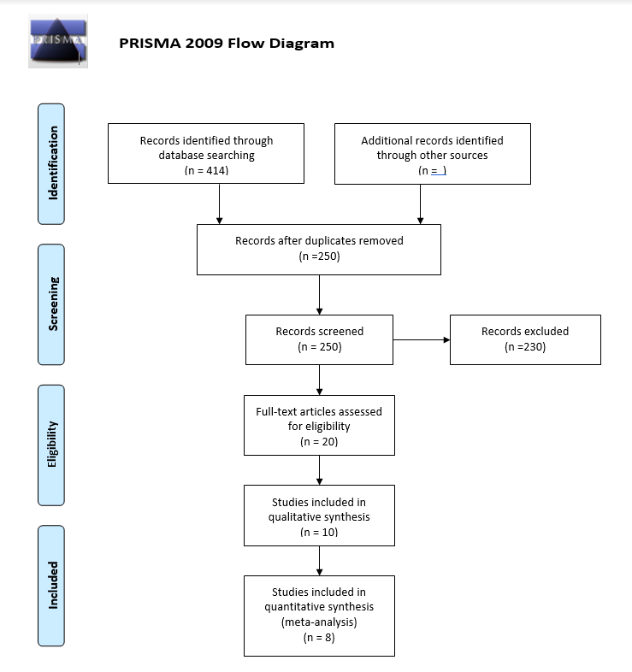

Topic 4: One anastomosis gastric bypass

Topic 4: Single-anastomosis duodeno-ileal switch

Topic 4: Biliopancreatic diversion with duodenal switch

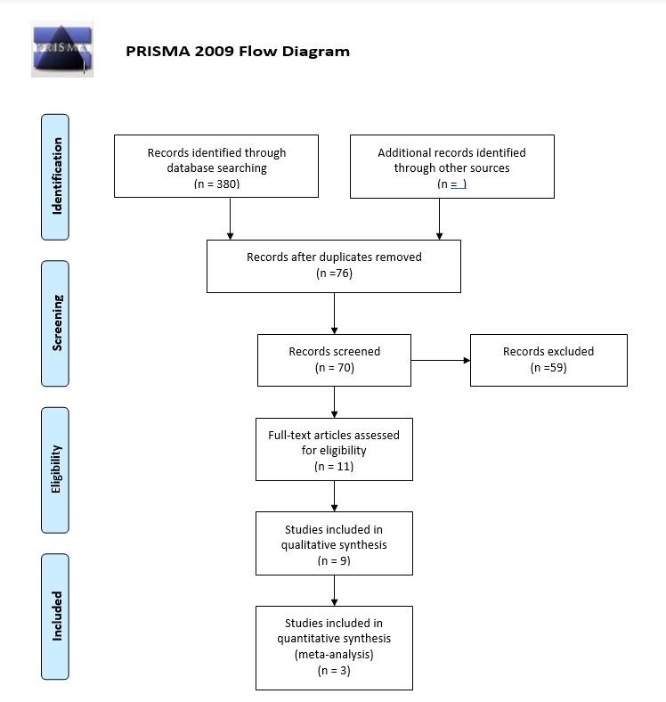

Topic 5: Revisional surgery

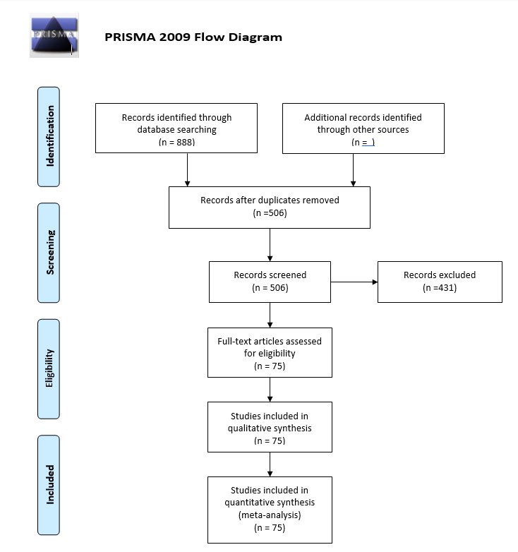

Topic 6: Postoperative care

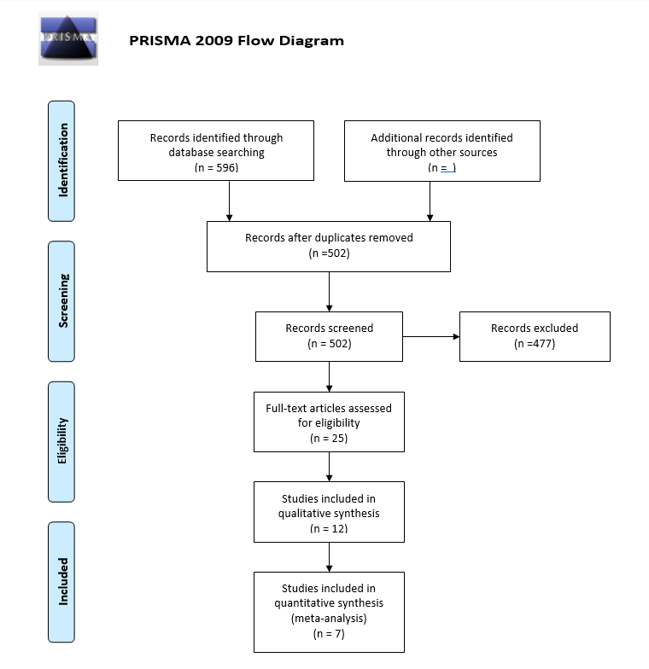

Topic 7: Investigational procedures

