Supplementary file 2
RESULTS OF ONLINE SURVEY
May 30 – June 12, 2019

Q1: Are you involved in the management of patients with obesity?
Answered: 220 Skipped: 0
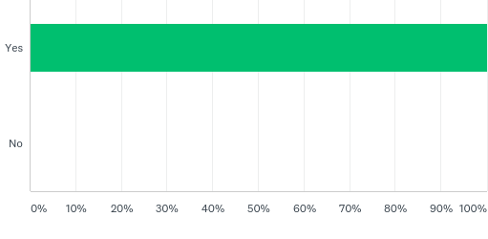
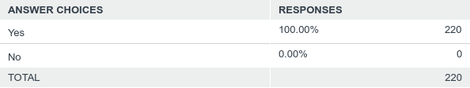

Q2: You are
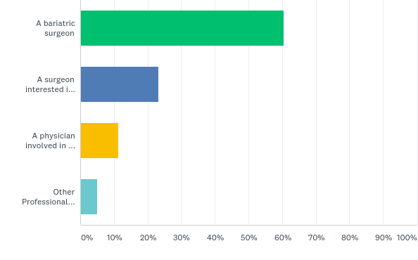
Answered: 220 Skipped: 0
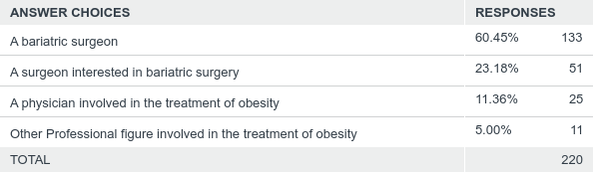

Q3: Are you a member of any of the following Scientific Societies? Please select all that apply
Answered: 220 Skipped: 0
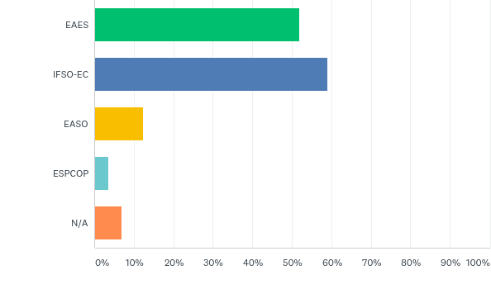
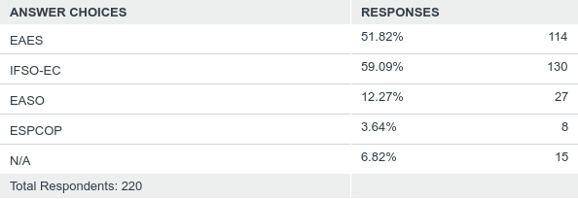

Q4: On average, how many bariatric operations do you perform each year?
Answered: 220 Skipped: 0
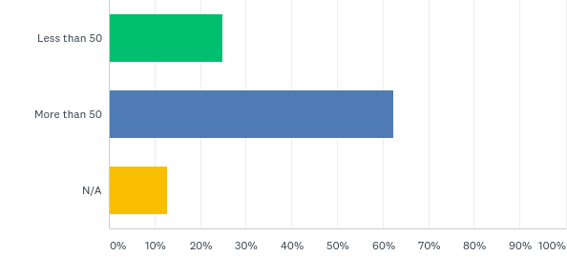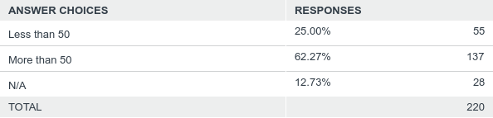

Q5: Recommendation: "Laparoscopic bariatric surgery should be considered for patients with BMI >40 kg/m2 and for patients with BMI 35-40 kg/m2 and associated co-morbidities that are expected to improve after surgery.Laparoscopic bariatric/metabolic surgery should be considered for patients with BMI 30-35 kg/m2 and type 2 diabetes and/or arterial hypertension with poor control despite optimal medical therapy". Is this applicable to your practice?
Answered: 220 Skipped: 0
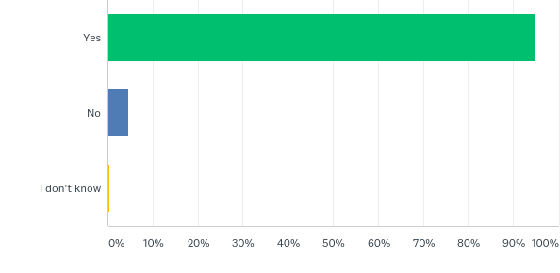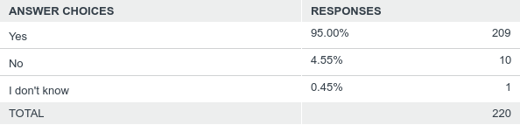

Q6: Recommendation: "No recommendation can be made for either routine Helicobacter pylori eradication or no eradication prior to bariatric surgery, on the basis of available evidence". Is this applicable to your practice?
Answered: 220 Skipped: 0
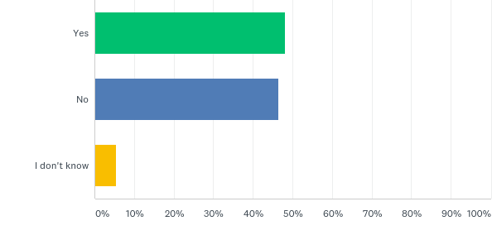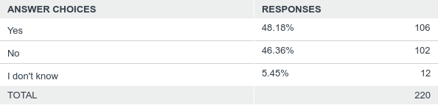

Q7: Recommendation: "Preoperative Dietician consultation should be considered for patients undergoing laparoscopic bariatric surgery". Is this applicable to your practice?
Answered: 220 Skipped: 0
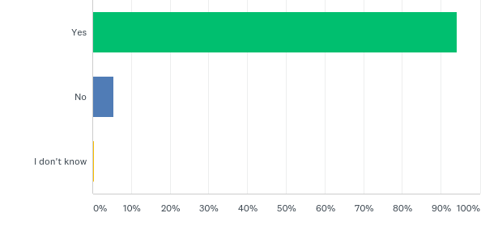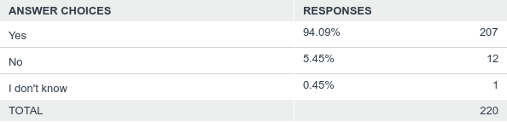

Q8: Recommendation: "Esophagogastroscopy can be considered as routine diagnostic test prior to laparoscopic bariatric surgery.". Is this applicable to your practice?
Answered: 220 Skipped: 0
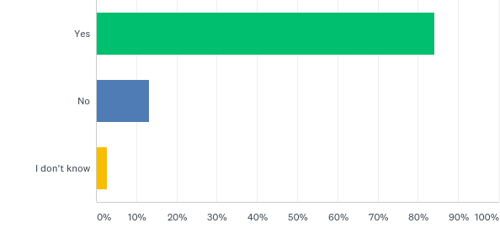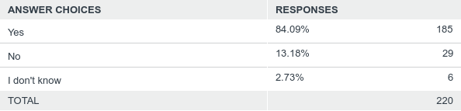

Q9: Recommendation: "Psychological evaluation can be considered before bariatric surgery.The presence of a previous diagnosis of binge eating or depression may not be considered an absolute contraindication to surgery". Is this applicable to your practice?
Answered: 220 Skipped: 0
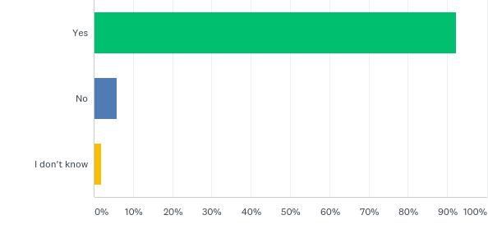
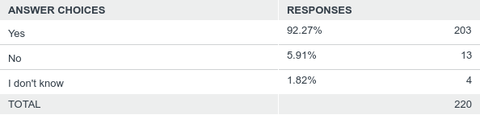

Q10: Recommendation: "Screening for obstructive sleep apnea using the STOP-BANG criteria can be considered prior to bariatric surgery".Is this applicable to your practice?
Answered: 219 Skipped: 1
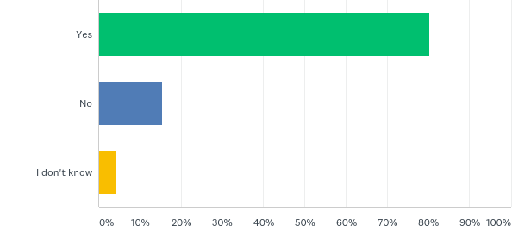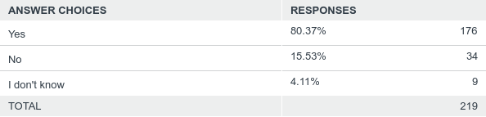

Q11: Recommendation: "Perioperative CPAP should be considered in patients with severe obstructive sleep apnea syndrome which are candidates for bariatric surgery".Is this applicable to your practice?
Answered: 220 Skipped: 0
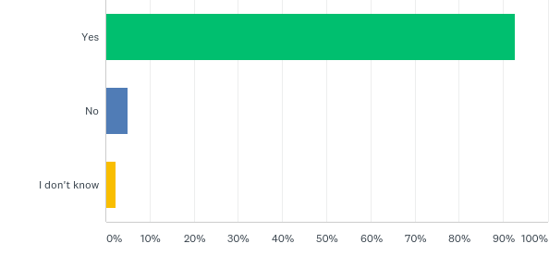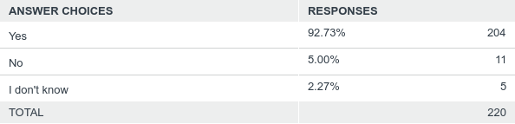

Q12: Recommendation: "No recommendation can be made on the dose and duration of pharmacological prophylaxis in patients after bariatric surgery". Is this applicable to your practice?
Answered: 220 Skipped: 0
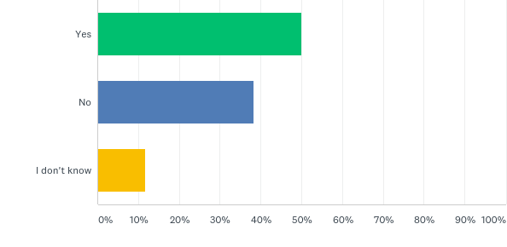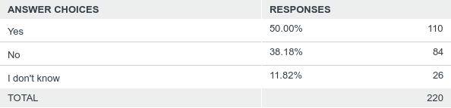

Q13: Recommendation: "Inferior vena cava filter is not recommended in patients undergoing bariatric surgery".Is this applicable to your practice?
Answered: 220 Skipped: 0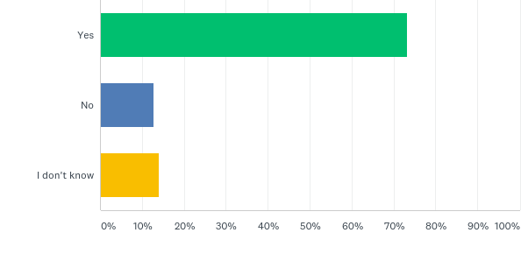 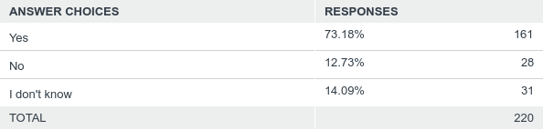

Q14: Recommendation: "No recommendation for either an ERAS protocol or standard care can be made on the basis of available evidence". Is this applicable to your practice?
Answered: 219 Skipped: 1
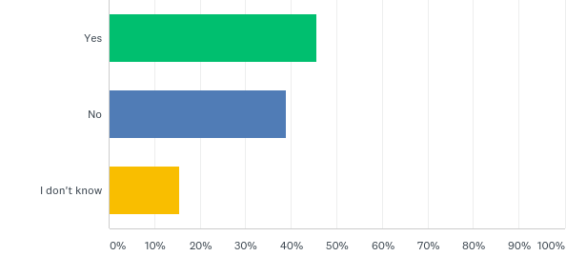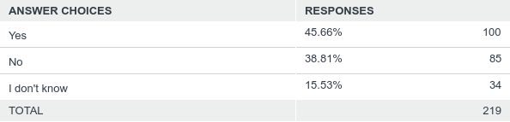

Q15: Recommendation: "Perioperative multimodal analgesia with minimal opioid use may be considered in patients undergoing bariatric surgery". Is this applicable to your practice?
Answered: 219 Skipped: 1
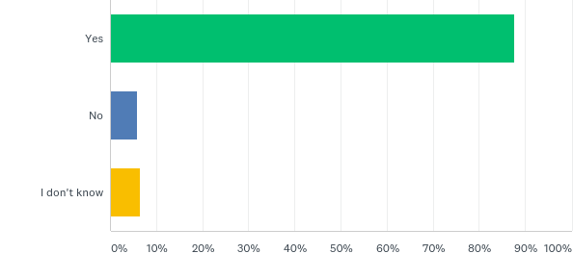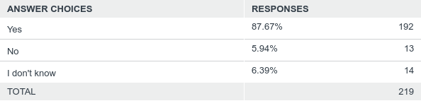

Q16: Position statement: "Adjustable Gastric Banding is associated with a high rate of reoperations for complications or conversion to another bariatric procedure for insufficient weight loss in the long term". Is this applicable to your practice?
Answered: 220 Skipped: 0
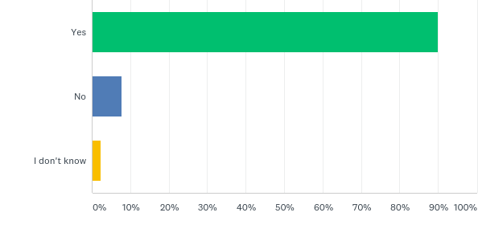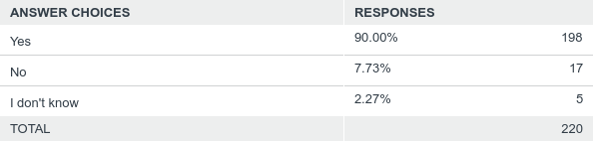

Q17: Recommendation: "Sleeve gastrectomy may be preferred over Adjustable Gastric Banding for weight loss and control or resolution of metabolic co-morbidities". Is this applicable to your practice?
Answered: 220 Skipped: 0
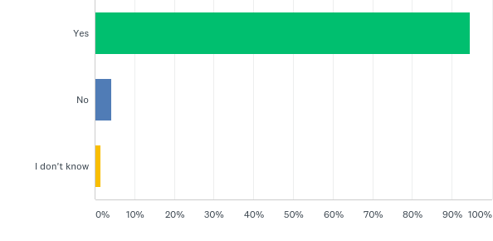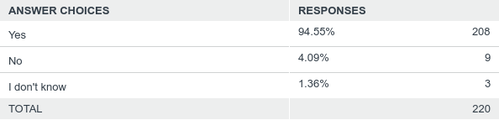

Q18: Position statement: "Sleeve gastrectomy may offer improved short-term weight loss and resolution of type 2 diabetes compared to gastric plication. No significant differences are observed at mid-term. Long-term comparative data on weight-loss and metabolic effects are, however, lacking". Is this applicable to your practice?
Answered: 220 Skipped: 0
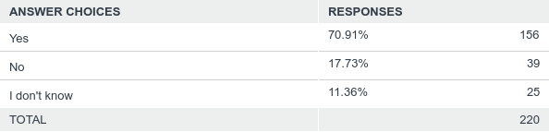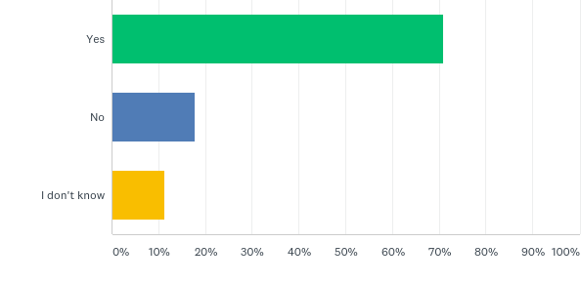

Q19: Position statement: "More extensive antral resection (2-3 cm from the pylorus versus >5cm antral preservation) seems to offer larger weight loss at short term without significant increase of the risk for post-operative complications but we are very uncertain. Long term data are, hovewer, lacking". Is this applicable to your practice?
Answered: 220 Skipped: 0
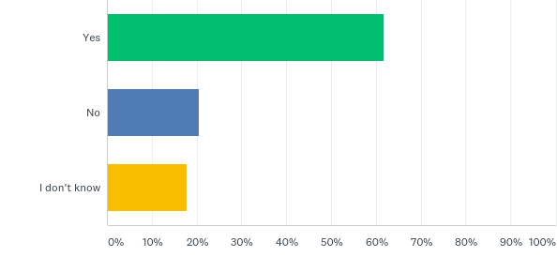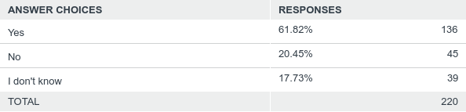

Q20: Recommendation: "A bougie size smaller than 36F compared to a bougie size 36F or more may be recommended for calibration in sleeve gastrectomy, as it is associated with larger weight loss in the mid-term". Is this applicable to your practice?
Answered: 220 Skipped: 0
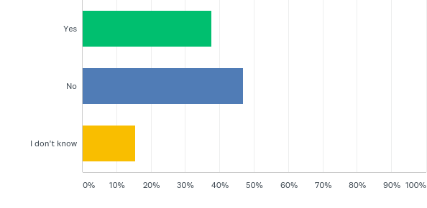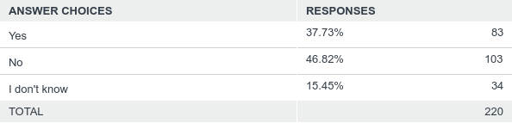

Q21: Recommendation: "Staple line reinforcement* in sleeve gastrectomy should be considered to reduce the risk of perioperative complications** ". Is this applicable to your practice?
*Buttress, glues, suturing, clips ** Overall mortality, bleeding
Answered: 220 Skipped: 0
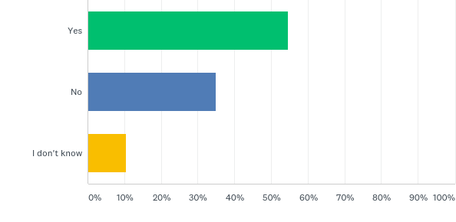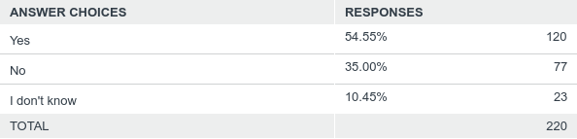

Q22: Position statement:"There is insufficient evidence to recommend routine staple line reinforcement to reduce the leak rate". Is this applicable to your practice?
Answered: 21 Skipped: 199
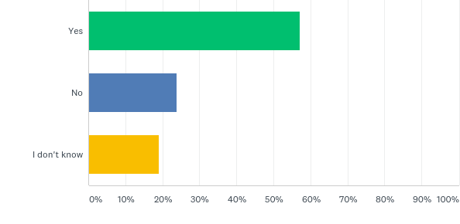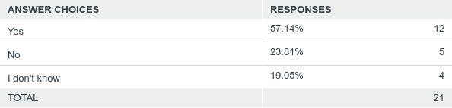

Q23: Position statement: "RYGB results in better weight loss and control/remission of insulin resistance and type 2 diabetes compared with gastric plication ". Is this applicable to your practice?
Answered: 220 Skipped: 0
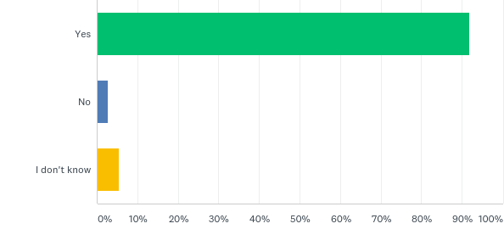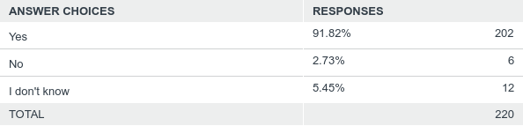

Q24: Recommendation: "RYGB should be preferred over Adjustable Gastric Banding". Is this applicable to your practice?
Answered: 220 Skipped: 0
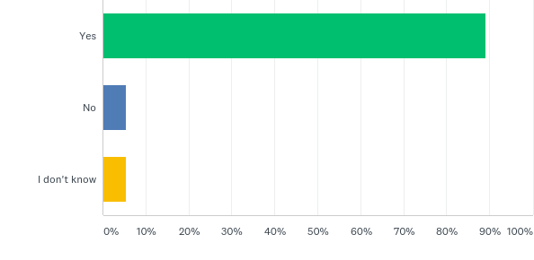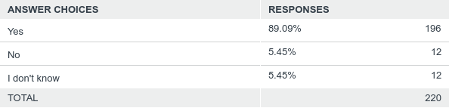

Q25: Position statement: "RYGB offers similar mid-term weight loss and control/remission of metabolic co-morbidities compared to sleeve gastrectomy. Long-term comparative data are, however, lacking". Is this applicable to your practice?
Answered: 220 Skipped: 0
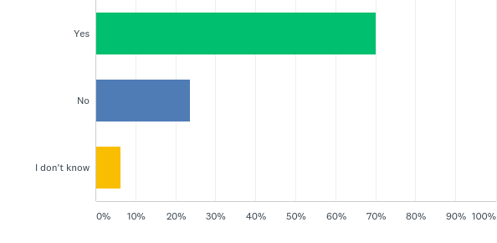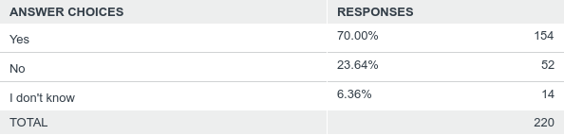

Q26: Recommendation: "RYGB may be preferred over sleeve gastrectomy in patients with severe gastroesophageal reflux disease and/or severe esophagitis". Is this applicable to your practice?
Answered: 220 Skipped: 0
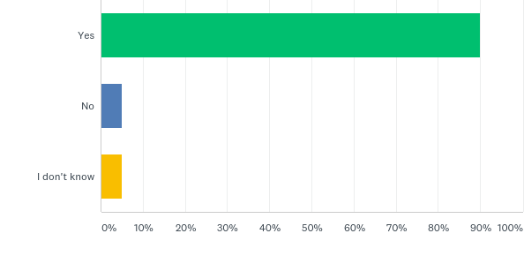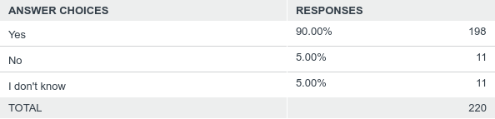

Q27: Position statement: "OAGB may offer better short-term weight loss compared to RYGB, gastric plication, adjustable gastric banding or sleeve gastrectomy. Long-term comparative data are, however, lacking. Nutritional deficiencies remain a controversial issue". Is this applicable to your practice?
Answered: 220 Skipped: 0
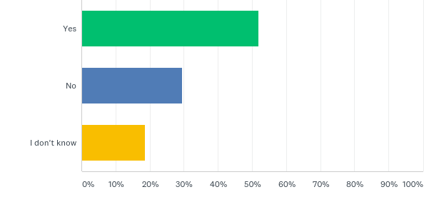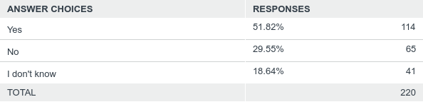

Q28: Recommendation: "No recommendation for either SADI-S, BPD/DS, RYGB or sleeve gastrectomy can be made on the basis of available comparative evidence".Is this applicable to your practice?
Answered: 220 Skipped: 0
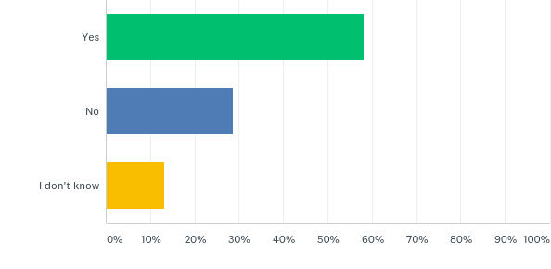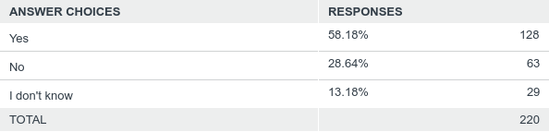

Q29: Positions statement: "With regard to mid-term weight loss there is no difference between BPD/DS and RYGB. BPD/DS is superior to RYGB for control/remission of type 2 diabetes. Long-term comparative data are, however, lacking". Is this applicable to your practice?
Answered: 220 Skipped: 0
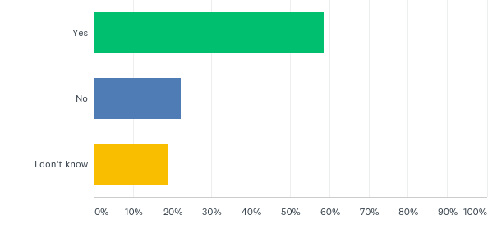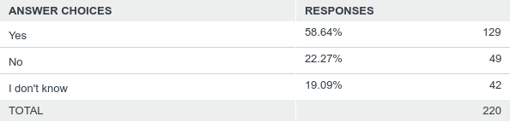

Q30: Recommendation: "No recommendation for either BPD/DS or sleeve gastrectomy can be made on the basis of available comparative evidence"
Answered: 220 Skipped: 0
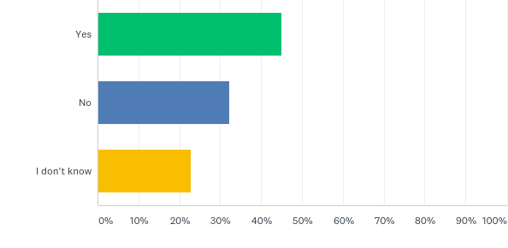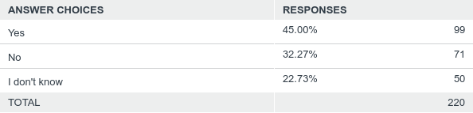

Q31: Position statement:"No evidence-based criteria for indication to Revisional Metabolic/Bariatric Surgery are available to date. The expert panel advises that the clinical decision to proceed to revisional bariatric surgery should be based on a complete multidisciplinary assessment of the patient, as recommended for the primary procedure" Is this applicable to your practice ?
Answered: 220 Skipped: 0
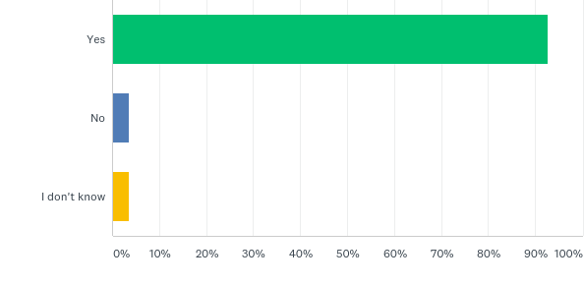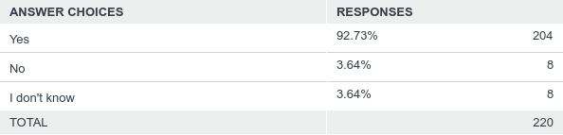

Q32: Recommendation: "Scheduled multidisciplinary post-operative follow up should be provided to every patient undergoing laparoscopic bariatric/metabolic surgery". Is this applicable to your practice?
Answered: 220 Skipped: 0
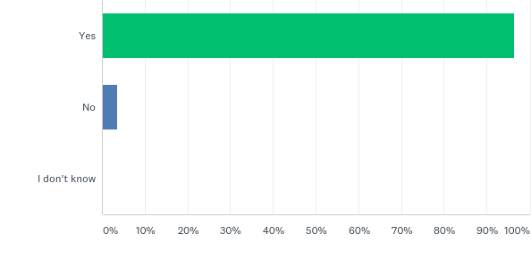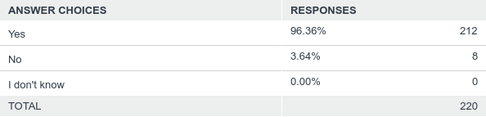

Q33: Recommendation: " Treatment with ursodeoxycolic acid could be considered during the weight loss phase to prevent gallstones formation". Is this applicable to your practice?
Answered: 220 Skipped: 0
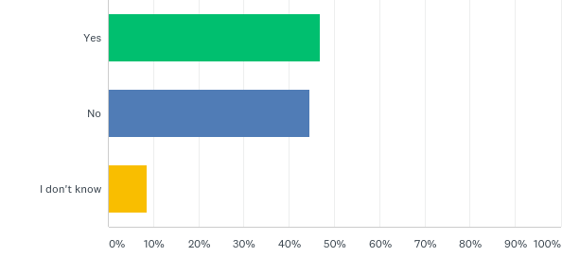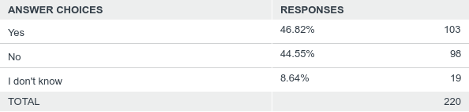

Q34: Recommendation: "Micro and/or macronutrients supplementation is recommended after bariatric surgery according to the type of the procedure and to the deficiencies documented during the follow up". Is this applicable to your practice?
Answered: 220 Skipped: 0
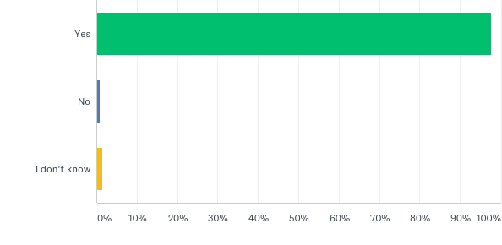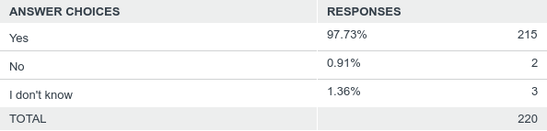

Q35: Recommendation: "PPI therapy should be given to patients undergoing bypass procedures for the prevention of marginal ulcers". Is this applicable to your practice?
Answered: 220 Skipped: 0
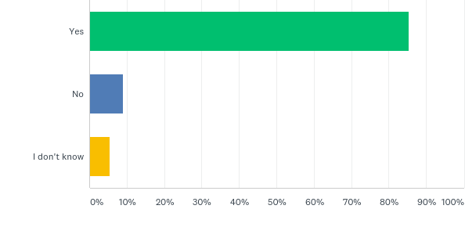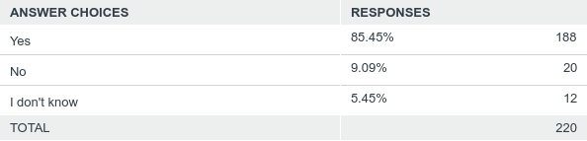

Q36: Recommendation: "Post-operative nutritional and behavioral advice should be provided to patients undergoing bariatric surgery". Is this applicable to your practice?
Answered: 220 Skipped: 0
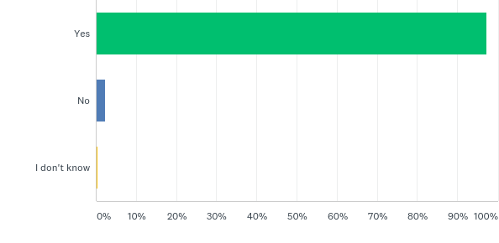
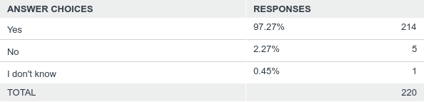

Q37: Recommendation: "Pregnancy following bariatric surgery should be delayed during the weight loss phase". Is this applicable to your practice?
Answered: 220 Skipped: 0
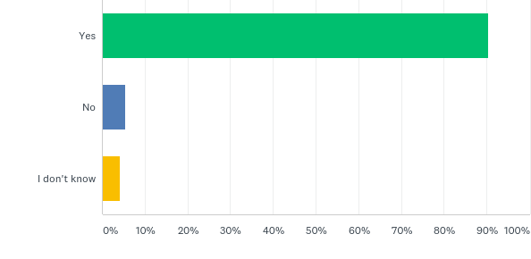
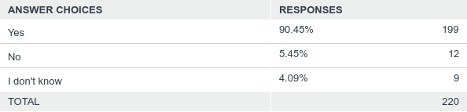

Q38: Position statement: " For duodenal-jejunal bypass sleeves, aspiration devices, gastric electrical stimulation, vagal blockade and duodenal mucosal resurfacing, the quality of evidence was too low to provide any recommendationsEndoluminal suturing procedures may have a role in the treatment of obese patients with BMI below 40 kg/m2". Is this applicable to your practice?
Answered: 220 Skipped: 0
