Appendix 2. Forest plots of secondary outcomes

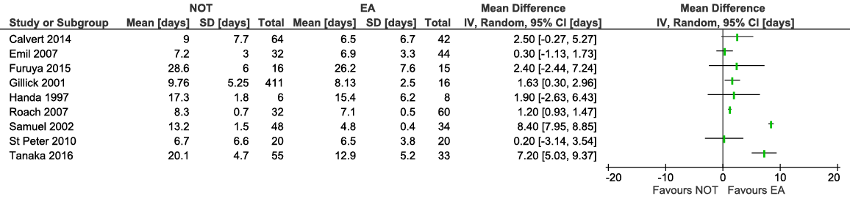
Total length of stay

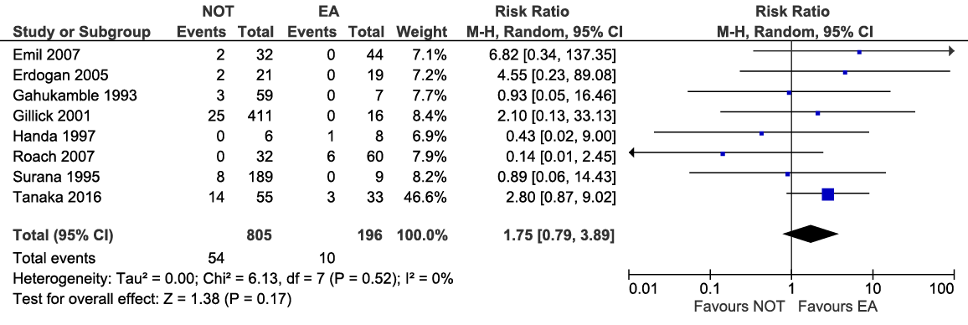
Readmission rate

