Supplement 2 Representation of selecting optimum lambda value using five-fold cross-validation based on minimum Bayesian Information Criterion (BIC)
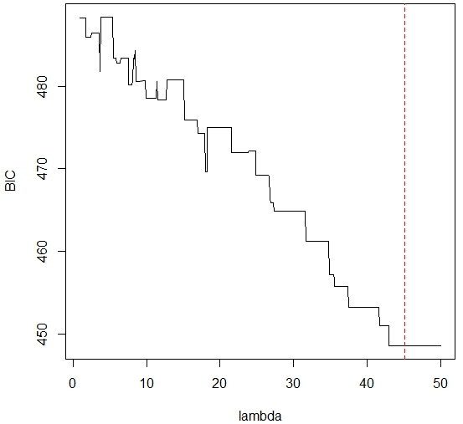  FLS peg transfer | 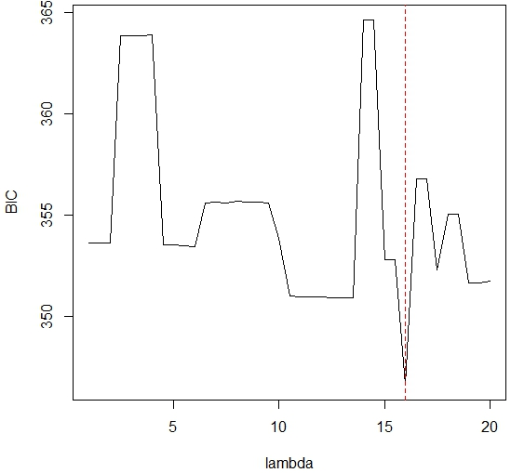  FLS pattern cut
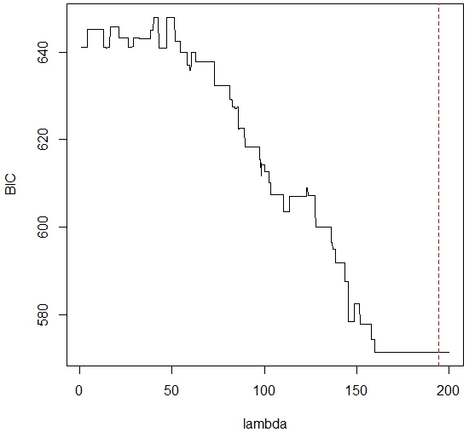
FLS suturing
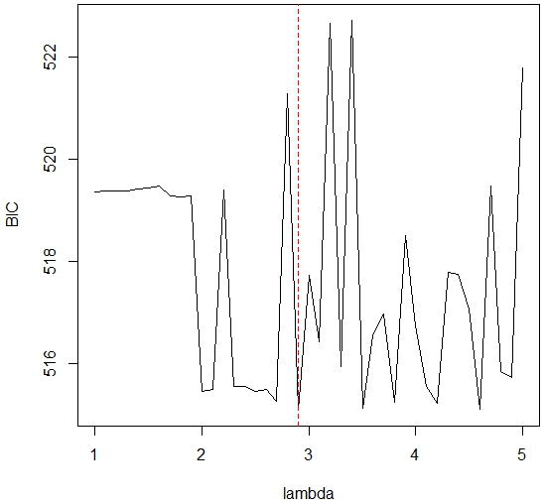  RAS pattern cut | 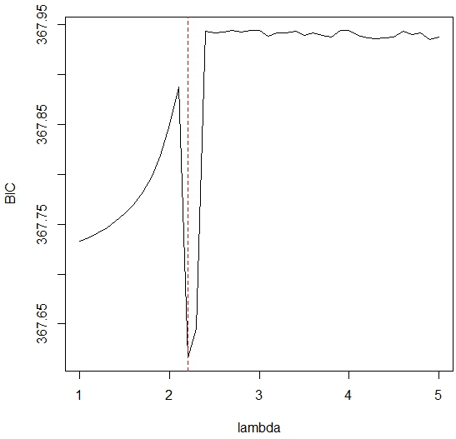  RAS tissue dissection

