SUPPLEMENTARY
The study “Does the Surgical Safety Checklist Need a Co-Pilot? Comparing Adherence in Gynecological Surgery Through Electronic Medical Records and OR Black Box Video Observation“ assessed adherence to the WHO SSC during gynecological surgeries using the modified checklist version to suit local conditions and workflows in our department. Video observed data and data reported in patient’s electronic medical record were compared.

FIGURE S1: WHO Surgical Safety Checklist and modified local version.
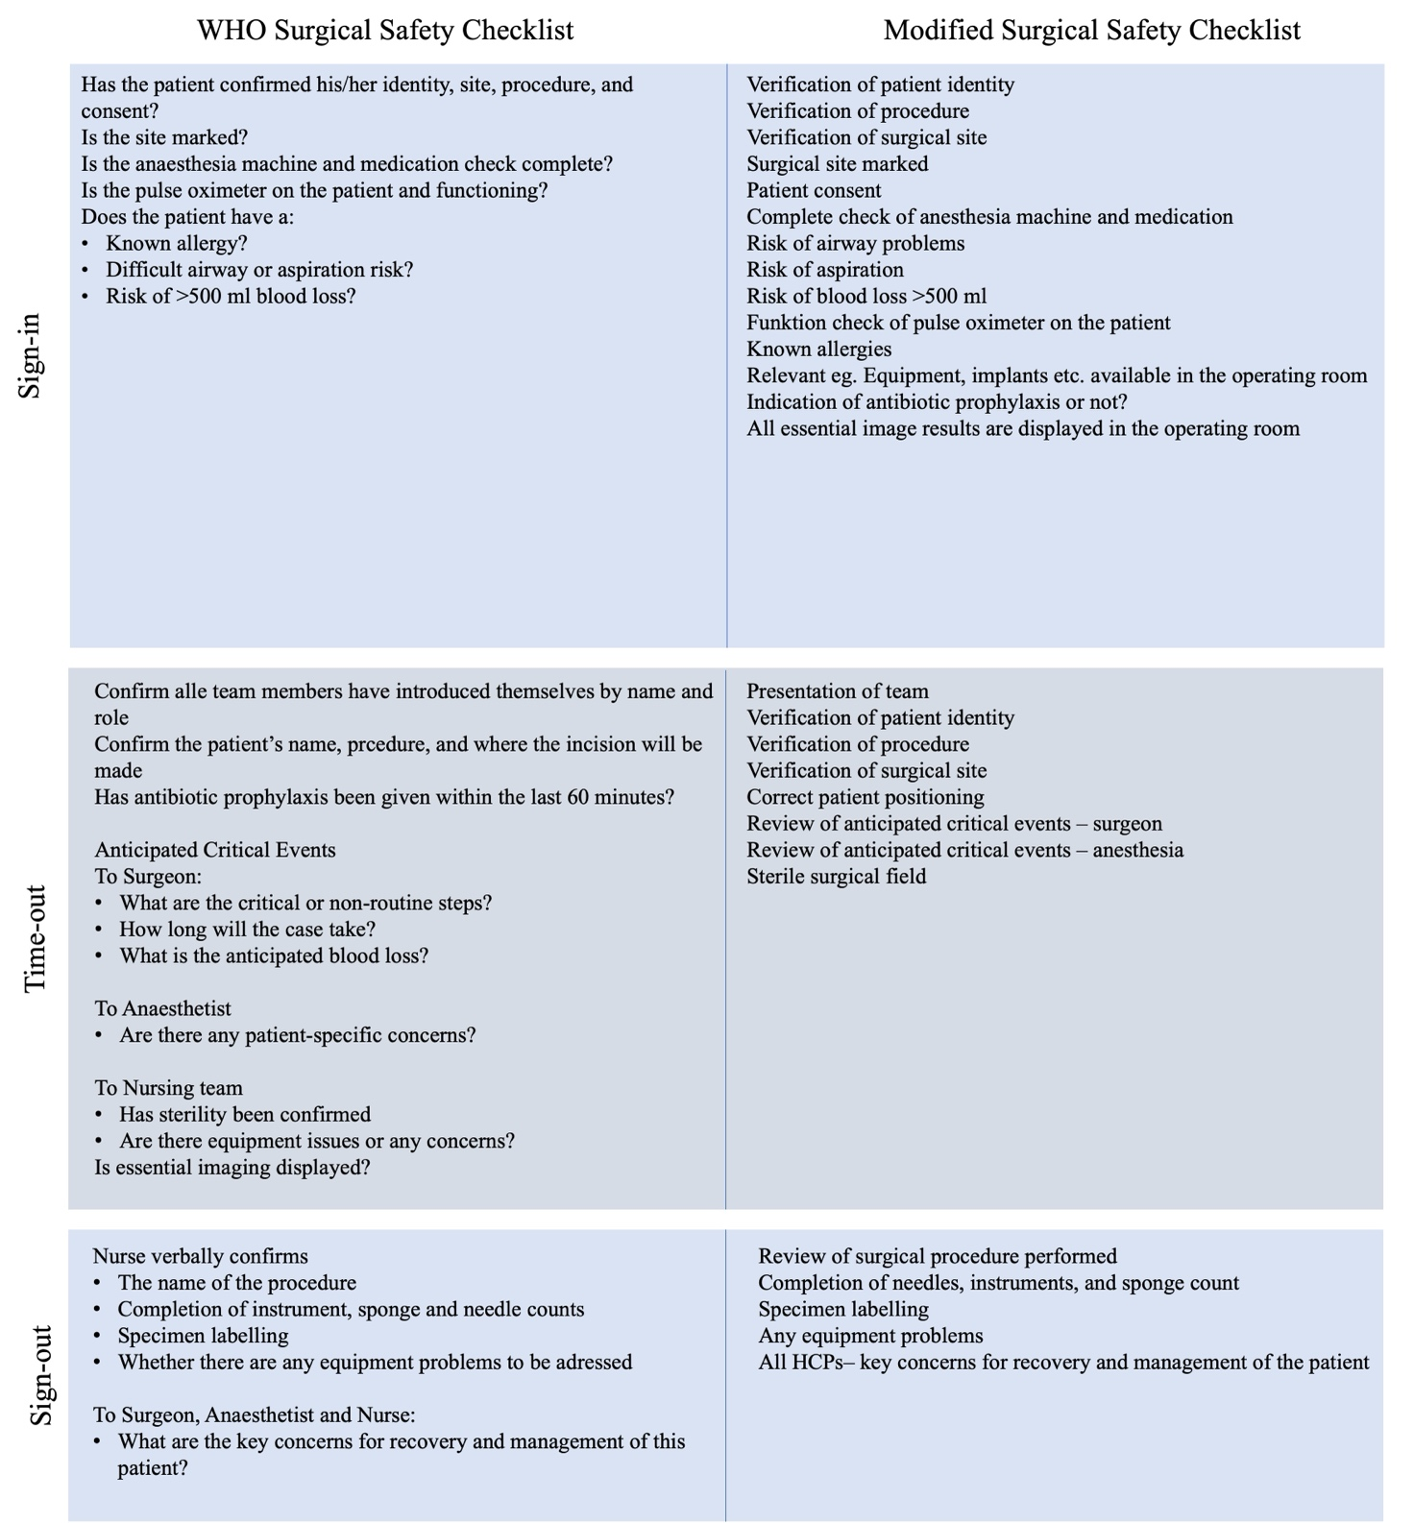

TABLE S1 – Presentation of the association between quality (percentage of items completed) and engagement scores (percentage of people focused out of people present in the operating room) based on observational OR Black Box data
 | Quality score  Items reviewed based on OR Black Box data, %,  Mean,  Median (IQR) | Engagement score  People focused/people present based on observed OR Black Box data, %,  Mean (SD), Median (IQR)  Range | Association between quality and engagement,  (95% CI)  p-value | Association between quality and engagement  (95% CI)*  p-value
Overall | 47  45 (37–54) | 76  76 (68–86)  45–94 | 0.2 (-0.1–0.5),  p=0.3 | 0.1 (-0.2–0.4)  p=0.4
Sign-In | 40  40 (33–47) | 86  100 (71–100)  20-100 | -0.1 (-0.2–0.1) p=0.2 | -0.1 (-0.2–0.1)  p=0.4
Time-Out | 47  50 (38–50) | 77  80 (63–86)  40–100 | 0.2 (-0.01–0.4), p=0.06 | 1.7 (-0.04–0.4)  p=0.1
Sign-Out | 57  60 (40–0) | 66  60 (50–80)  40–100 | 0.4 (0.1–0.8), p=0.02 | 0.4 (0.1–0.8)  p=0.02
* Adjusted for people present
IQR, Interquartile range; SD, standard deviation.

TABLE S2 – Quality score (percentage of items completed) based on OR Black Box data listed based on the profession that initiated and completed the Surgical Safety Checklist
 | Anesthesiologist |  | Gynecologist |  | Nurse anesthetist |  | OR Nurse
 | Initiated | Completed | Initiated | Completed | Initiated | Completed | Initiated | Completed
Sign-in  Quality score: mean  Median (IQR) | n=5  43  40 (40–47) | n=9  37  40 (33–40) | n=2  40  40 (37–43) | n=3  42  46 (40–47) | n=15  38  40 (27–47) | n=15  40  40 (27–47) | n=23  41  40 (33–47) | n=18  42  40 (35–47)
Time-out  Quality score: mean  Median (IQR) | - | - | n=21  49  50 (50–50) | n=43  47  50 (38–50) | n=2  44  44 (41–47) | - | n=22  45  38 (38–50) | n=2  38  38 (38–38)
Sign-Out  Quality score: mean  Median (IQR) | - | - | n=26  58  60 (40–75) | n=34  58  60 (40–80) | n=4  45  40 (20–65) | - | n=6  63  70 (45–80) | n=2  40  40 (40–40)
*IQR: Interquartile Range

TABLE S3 – Mean differences in overall quality score (percentage of item completion) and completion of individual Surgical Safety Checklist items (Completed versus not completed), and in overall engagement score (percentage of people focused out of the people present in the operating room) and completion of individual Surgical Safety Checklist items (Completed versus not completed.).

Surgical Safety Checklist phase | Surgical Safety Checklist items | OR Black Box data | Mean difference between overall quality score and checklist item  t-test | Mean difference between overall engagement score and checklist item
Surgical Safety Checklist phase | Surgical Safety Checklist items | Frequency of completion n (%) | (95 % CI), p-value | (95 % CI)*, p-value
Sign-In |  | 45 (100)
Procedural checks | Verification of patient identity | 45 (100) | - | -
Procedural checks | Known allergies | 37 (82) | 10 (2–18), p=0.02 | 2 (-4–7), p=0.5
Procedural checks | Patient consent | 32 (71) | 7 (-0.02–14), p=0.05 | 2 (-4–7), p=0.5
Procedural checks | Risk of aspiration | 30 (67) | 5 (-2–12), p=0.13 | 2 (-4–7), p=0.5
Procedural checks | Verification of procedure | 27 (60) | 7 (-0.02–13), p=0.05 | 2 (-4–7), p=0.6
Procedural checks | Verification of surgical site | 21 (47) | 7.1 (1–13), p=0.03 | 1 (-4–7), p=0.7
Procedural checks | Risk of airway problems | 15 (33) | 5 (-1–12), p=0.12 | 1 (-4–6), p=0.7
Procedural checks | Relevant, e.g., equipment and implants, available in operating room | 9 (20) | -0.09 (-8–8), p=0.98 | 2 (-3–6), p=0.5
Procedural checks | Indication of antibiotic prophylaxis or not | 5 (11) | 6 (-5–16), p=0.3 | 1 (-4–6), p=0.6
Procedural checks | Risk of blood loss (>500 ml) | 2 (4) | 23 (8–37), p=0.003 | 2 (-3–8), p=0.4
Procedural checks | All essential image results displayed in the operating room | 1 (2) | 5 (-17–28), p=0.65 | 2 (-4–7), p=0.5
Procedural checks | Surgical site marked | 0 (0) | - | -
Communication prompts | Anesthesia team present | 45 (100) | - | -
Communication prompts | Complete check of anesthesia machine and medication | 1 (2) | -12 (-34–10), p=0.29 | 2 (-3–7), p=0.5
Communication prompts | Function check of pulse oximeter on patient | 1 (2) | -5 (-28–17), p=0.65 | 2 (-4–7), p=0.5
Time-out |  | 45 (100)
Procedural checks | Verification of patient identity | 45 (100) | - | -
Procedural checks | Verification of procedure | 45 (100) | - | -
Procedural checks | Verification of surgical site | 34 (76) | 15 (8–22), p=0.0001 | 1 (-4–7), p=0.6
Procedural checks | Correct patient positioning | 0 (0) | - | -
Procedural checks | Sterile surgical field | 0 (0) | - | -
Communication prompts | Review of anticipated critical events - surgeon | 31 (69) | 15 (10–21), p<0.0001 | 1 (-4–6), p=0.6
Communication prompts | Review of anticipated critical events - anesthesia | 10 (22) | 12 (5–19), p=0.001 | 2 (-3–8), p=0.4
Communication prompts | Presentation of team | 3 (7) | 13 (1–26), p=0.04 | 2 (-4–7), p=0.5
Sign-out |  | 36 (80)
Procedural checks | Specimen labelling | 27 (75) | 14 (9–19), p<0.0001 | 1 (-5–7), p=0.7
Procedural checks | Completion of needles, instruments, and sponge count | 15 (42) | 12 (6–18), p=0.0002 | 2 (-3–7), p=0.4
Procedural checks | Any equipment problems | 3 (8) | 13 (0.2–26), p=0.05 | 2 (-3–7), p=0.4
Communication prompts | Review of surgical procedure performed | 34 (94) | 9 (2–16), p=0.01 | 2 (-4–7), p=0.5
Communication prompts | All HCPs – key concerns for recovery and management of patient | 23 (64) | 14 (8–19), p<0.0001 | -0.003 (-5.3–5.2), p=1.0
* Adjusted for people present.

