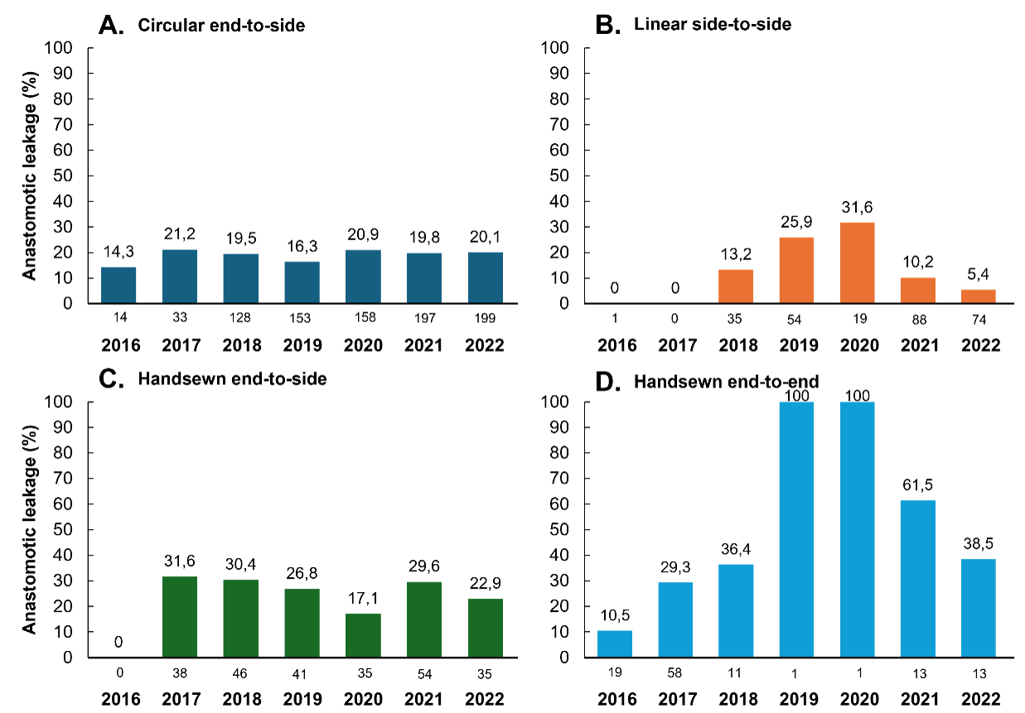
eFigure 1: Anastomotic leakage rates over time per anastomotic technique (A. Ciruclar end-to-side; B. Linear side-to-side; C. Handsewn end-to-side; D: Handsewn end-to-end)

