Supplementary material

Supplementary Table 1. Causes of open surgery
 | No. of patients (n = 26)
Primary tumor-related | 46.2%
Firmly fixed primary tumor | 6 (23.1)
Large primary tumor | 4 (15.4)
Adhesions after primary tumor surgery | 2 (7.7)
Peritoneal metastasis-related | 34.6%
Large ovarian mass | 4 (15.4)
Difficult location in the subphrenic area | 4 (15.4)
Firmly fixed peritoneal metastasis | 1 (3.8)
Extraperitoneal metastasis-related | 11.5%
Open surgery for combined hepatic metastasis | 3 (11.5)
Unknown | 2 (7.7)

Supplementary Table 2. Univariate and multivariate analyses of survival outcomes (before propensity score matching)
 | OS |  |  |  | PFS |  |  |  | P-PFS
 | Uni | Multivariate analysis |  |  | Uni | Multivariate analysis |  |  | Uni | Multivariate analysis
Variables (reference) | p | HR | 95% CI | p | p | HR | 95% CI | p | p | HR | 95% CI | p
L-CRS (O-CRS) | 0.336 | 0.88 | 0.39–1.96 | 0.745 | 0.291 | 0.89 | 0.40–1.96 | 0.765 | 0.607 | 1.21 | 0.49–2.97 | 0.681
PCI 6-10 (0-5) | 0.259 | 1.36 | 0.52–3.63 | 0.533 | 0.420 | 0.98 | 0.43–2.37 | 0.983 | 0.716 | 1.01 | 0.42–2.39 | 0.990
PCI 11-13 (0-5) | 0.167 | 2.66 | 1.07–6.62 | 0.036 | 0.418 | 1.58 | 0.61–4.12 | 0.345 | 0.819 | 1.24 | 0.38–4.07 | 0.728
CC-1 (CC-0) | 0.534 | 1.65 | 0.19–13.95 | 0.647 | 0.248 | 1.60 | 0.32–8.14 | 0.570 | 0.089 | 2.75 | 0.51–14.8 | 0.240
CC-2 (CC-0) | 0.012 | 4.39 | 0.33–58.16 | 0.262 | 0.982 | - | - | 0.975 | 0.982 | - | - | 0.984
Extraperitoneal metastasis R0 (no) | 0.228 | 1.52 | 0.72–3.76 | 0.361 | 0.569 | 1.13 | 0.49–2.60 | 0.771 | 0.417 | 0.67 | 0.22–2.02 | 0.669
Extraperitoneal metastasis R1 (no) | 0.006 | 3.32 | 1.04–10.63 | 0.043 | 0.015 | 4.60 | 1.43–14.77 | 0.010 | 0.524 | 0.67 | 0.08–5.52 | 0.666
Extraperitoneal metastasis R2 (no) | 0.016 | 4.32 | 1.38–13.52 | 0.012 | 0.010 | 3.45 | 1.23–9.70 | 0.019 | 0.026 | 2.65 | 0.95–7.40 | 0.064
Perioperative chemotherapy (no) | 0.735 | 1.49 | 0.39–5.57 | 0.556 | 0.689 | 0.91 | 0.26–3.20 | 0.878 | 0.530 | 1.23 | 0.27–5.56 | 0.786
OS, overall survival; PFS, progression-free survival; P-PFS, peritoneal-progression-free survival; Uni, univariate analysis; L-CRS, laparoscopic cytoreductive surgery; O-CRS, open cytoreductive surgery; PCI, peritoneal cancer index; CC, completeness of cytoreduction.
Supplementary Figure 1. Placement of inflow and outflow catheters for hyperthermic intraperitoneal chemotherapy following laparoscopic cytoreductive surgery. (A) Semiopen method using a surgical retractor. (B) Closed method.
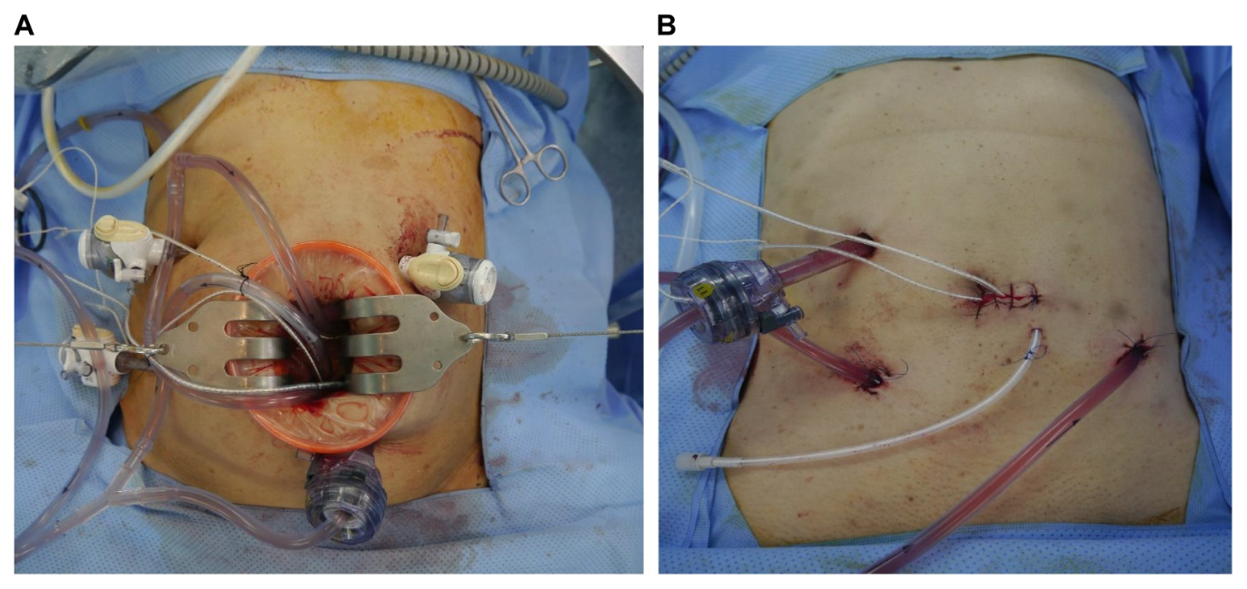

Supplementary Figure 2. Love plot was created and set the threshold to less than 0.5 to evaluate the balance of covariates
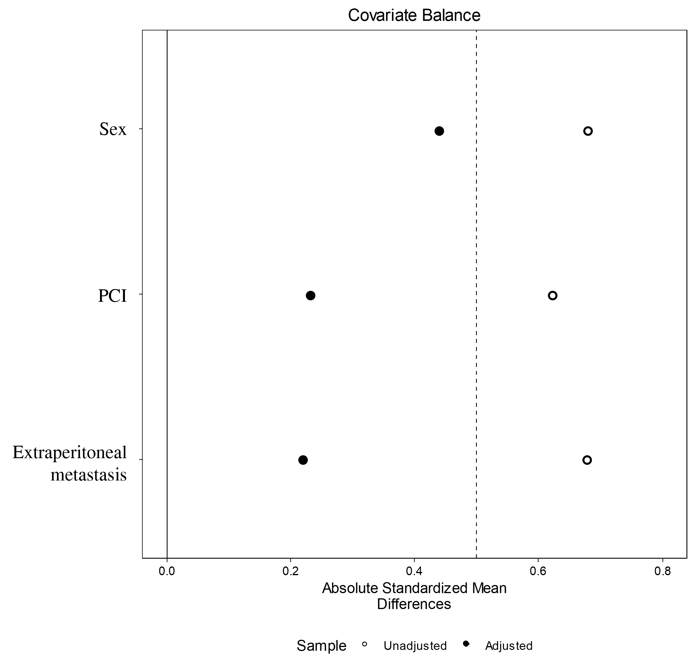

Supplementary Figure 3. Kaplan–Meier survival curves (before propensity score matching). (A) Overall survival. (B) Progression-free survival. (C) Peritoneal progression-free survival.
L-CRS, laparoscopic cytoreductive surgery; O-CRS, open cytoreductive surgery.

Supplementary Figure 4. Kaplan–Meier survival curves of patients with no history of extraperitoneal metastasis (before propensity score matching). (A) Overall survival. (B) Progression-free survival. (C) Peritoneal progression-free survival.
L-CRS, laparoscopic cytoreductive surgery; O-CRS, open cytoreductive surgery.

Supplementary Figure 5. Kaplan–Meier survival curves of patients with no history of extraperitoneal metastasis (after propensity score matching). (A) Overall survival. (B) Progression-free survival. (C) Peritoneal progression-free survival.
L-CRS, laparoscopic cytoreductive surgery; O-CRS, open cytoreductive surgery.

Supplementary Figure 6. Proportion of progression pattern (before propensity score matching). (A) All patients. (B) patients with only peritoneal metastasis.
L-CRS, laparoscopic cytoreductive surgery; O-CRS, open cytoreductive surgery

