Supplemental Table 1: Characteristics of the IPTW sensitivity-analysis cohort
 |  | Matched Cohort (IPTW)
Patient Characteristics | Drain (+) |  | Drain (-)
ESS | 263 |  | 88
[Patient background]
Age (median [IQR]) | 57 [44-70] |  | 56 [36-70]
Sex (Male) | 168 (63.8) |  | 58 (66.2)
BMI (median [IQR]) kg/m2 | 23 [21-25] |  | 23 [20-26]
Days (symptoms to surgery) (median [IQR]) days | 2 [1-3] |  | 2 [1-2]
Charlson Comorbidity Index (median [IQR]) | 3 [1-4] |  | 2 [0-4]
[Vital sign]
BT (median [IQR]) ℃ | 37.4 [36.9-38.1] |  | 37.5 [36.8-38.2]
sBP (median [IQR]) mmHg | 125 [114-139] |  | 125 [112-138]
HR (median [IQR]) bpm | 89 [80-100] |  | 89 [80-100]
RR (median [IQR]) | 18 [16-21] |  | 18 [16-20]
Sepsis | 7 (2.7) |  | 3 (3.4)
[Laboratory Data]
WBC (median [IQR]) /μL | 12900 [9522-16028] |  | 13600 [10288-16567]
Hb (median [IQR]) g/dL | 14.3 [12.9-15.5] |  | 14.5 [13.3-15.2]
CRP (median [IQR]) mg/dL | 11.4 [5.1-20.0] |  | 9.0 [4.8-19.4]
Alb (median [IQR]) g/dL | 4.0 [3.5-4.2] |  | 4.0 [3.7-4.3]
Cre (median [IQR]) mg/dL | 0.8 [0.7-1.0] |  | 0.9 [0.7-1.0]
[CT findings]
Abscess formation | 87 (33.2) |  | 27 (30.9)
Ascites
Localized/Pelvic | 155 (59.0) |  | 50 (56.9)
Generalized | 12 (4.7) |  | 2 (2.5)
[Intraoperating findings]
ASA-PS
≥3 | 40 (15.1) |  | 14 (16.4)
Contamination findings
Localized peritonitis | 170 (64.5) |  | 66 (74.6)
Generalized peritonitis | 56 (21.2) |  | 14 (15.5)
Stump closure
Stapler | 113 (43.0) |  | 38 (43.7)
Washing volume (median [IQR]) ml | 2000 [1000-3000] |  | 1500 [500-2500]
Note: Values are expressed as median [interquartile range, IQR] for continuous variables and as pooled effective sample size (percentage) for categorical variables. The propensity score was estimated using a generalized linear mixed-effects model (GLMM) with institution incorporated as a random intercept. Inverse Probability of Treatment Weighting (IPTW) was then applied using all baseline covariates listed in the table. To minimize the influence of extreme weights, IPTW weights were trimmed at the 1st and 99th percentiles. Missing data were handled using Multiple Imputation by Chained Equations (MICE) to generate 5 imputed datasets. The values shown are provided to describe the weighted sensitivity-analysis cohort and should not be interpreted as actual patient counts.
Abbreviations: IPTW, Inverse Probability of Treatment Weighting; GLMM, Generalized Linear Mixed-Effects Model; MICE, Multiple Imputation by Chained Equations; IQR, Interquartile Range; BMI, Body Mass Index; CCI, Charlson Comorbidity Index; BT, Body Temperature; sBP, Systolic Blood Pressure; HR, Heart Rate; WBC, White Blood Cell; Hb, Hemoglobin; CRP, C-reactive Protein; Alb, Albumin; Cre, Creatinine; ASA-PS, American Society of Anesthesiologists Physical Status; CT, Computed Tomography.

Supplemental Table 2: Characteristics of the propensity score-matched sensitivity-analysis cohort

 |  | Matched Cohort (PSM)
Patient Characteristics | Drain (+) |  | Drain (-)
n | 114 |  | 114
[Patient background]
Age (median [IQR]) | 55 [44-68] |  | 54 [37-70]
Sex (Male) | 74 (64.9) |  | 76 (66.7)
BMI (median [IQR]) kg/m2 | 22 [20-25] |  | 23 [20-25]
Days (symptoms to surgery) (median [IQR]) days | 2 [1-3] |  | 2 [1-2]
Charlson Comorbidity Index (median [IQR]) | 2 [1-4] |  | 2 [0-4]
[Vital sign]
BT (median [IQR]) ℃ | 37.3 [36.8-38.1] |  | 37.3 [36.8-37.9]
sBP (median [IQR]) mmHg | 128 [117-140] |  | 127 [115-140]
HR (median [IQR]) bpm | 90 [80-100] |  | 87 [78-102]
RR (median [IQR]) | 18 [15-20] |  | 18 [16-20]
Sepsis | 7 (6.1) |  | 7 (6.1)
[Laboratory Data]
WBC (median [IQR]) /μL | 12900 [9800-15400] |  | 12565 [9892-15850]
Hb (median [IQR]) g/dL | 14.0 [12.8-15.4] |  | 14.4 [12.7-15.2]
CRP (median [IQR]) mg/dL | 10.2 [4.6-18.4] |  | 8.0 [4.8-17.6]
Alb (median [IQR]) g/dL | 4.0 [3.5-4.2] |  | 4.0 [3.7-4.3]
Cre (median [IQR]) mg/dL | 0.8 [0.7-1.0] |  | 0.8 [0.7-1.0]
[CT findings]
Abscess formation | 44 (38.6) |  | 39 (34.2)
Ascites
Localized/Pelvic | 65 (57.0) |  | 62 (54.4)
Generalized | 4 (3.5) |  | 4 (3.5)
[Intraoperating findings]
ASA-PS
≥3 | 15 (13.2) |  | 15 (13.2)
Contamination findings
Localized peritonitis | 81 (71.1) |  | 82 (71.9)
Generalized peritonitis | 19 (16.7) |  | 11 (9.6)
Stump closure
Stapler | 25 (21.9) |  | 41 (36.0)
Operative time (median [IQR]) min | 92 [74-121] |  | 87 [68-121]
Washing volume (median [IQR]) ml | 2000 [1000-2500] |  | 1000 [500-2000]
Note: Values are expressed as median [interquartile range, IQR] for continuous variables and as number (percentage) for categorical variables. The propensity score was estimated using a generalized linear mixed-effects model (GLMM) with institution incorporated as a random intercept. Propensity Score Matching (PSM) was then performed using a 1:1 nearest-neighbor matching algorithm without replacement. The caliper width was set to 0.1 of the standard deviation of the logit of the propensity score. Missing data were handled using Multiple Imputation by Chained Equations (MICE) with 5 datasets. Matching was performed independently within each imputed dataset. The values shown are provided to describe the matched sensitivity-analysis cohort.
Abbreviations: PSM, Propensity Score Matching; GLMM, Generalized Linear Mixed-Effects Model; MICE, Multiple Imputation by Chained Equations; IQR, Interquartile Range; BMI, Body Mass Index; CCI, Charlson Comorbidity Index; BT, Body Temperature; sBP, Systolic Blood Pressure; HR, Heart Rate; WBC, White Blood Cell; Hb, Hemoglobin; CRP, C-reactive Protein; Alb, Albumin; Cre, Creatinine; ASA-PS, American Society of Anesthesiologists Physical Status; CT, Computed Tomography.

Supplemental Table 3: Postoperative outcomes and healthcare resource utilization in the IPTW and propensity score-matched sensitivity-analysis cohorts

 | Weighted Cohort (Pooled IPTW) |  |  | Matched Cohort (Pooled PSM)
Postoperative Course | Drain (+) | Drain (-) | P(GLMM) | Drain (+) | Drain (-) | P(GLMM)
n | 263 | 88 |  | 114 | 114
[Complications]
(Clavien Dindo Grade)
Appendiceal stump leakage | 2 (0.7) | 0 (0.4) | 0.741 | 2 (1.8) | 1 (0.9) | 0.691
1 | 0 (0.0) | 0 (0.0) | - | 0 (0.0) | 0 (0.0) | -
2 | 0 (0.0) | 0 (0.0) | - | 0 (0.0) | 0 (0.0) | -
Postoperative ileus | 35 (13.4) | 6 (6.5) | 0.281 | 13 (11.4) | 10 (8.8) | 0.608
1 | 17 (6.5) | 4 (4.8) | - | 6 (5.3) | 7 (6.1) | -
2 | 14 (5.3) | 1 (1.6) | - | 4 (3.5) | 3 (2.6) | -
3a | 2 (0.8) | 0 (0.2) | - | 0 (0.0) | 0 (0.0) | -
3b | 2 (0.8) | 0 (0.0) | - | 3 (2.6) | 0 (0.0) | -
Incisional surgical site infection | 12 (4.5) | 2 (2.8) | 0.598 | 4 (3.5) | 4 (3.5) | 0.546
1 | 12 (4.5) | 2 (2.8) | - | 4 (3.5) | 4 (3.5) | -
2 | 0 (0.0) | 0 (0.0) | - | 0 (0.0) | 0 (0.0) | -
3a | 0 (0.0) | 0 (0.0) | - | 0 (0.0) | 0 (0.0) | -
Intra-abdominal Abscess | 36 (13.6) | 10 (11.4) | 0.348 | 16 (14.0) | 12 (10.5) | 0.321
1 | 4 (1.6) | 0 (0.0) | - | 2 (1.8) | 0 (0.0) | -
2 | 22 (8.3) | 8 (8.6) | - | 9 (7.9) | 9 (7.9) | -
3a | 5 (1.9) | 2 (2.8) | - | 1 (0.9) | 3 (2.6) | -
3b | 5 (1.8) | 0 (0.0) | - | 4 (3.5) | 0 (0.0) | -
[Healthcare resource utilization]
Total hospital stays (median [IQR]) days | 9 [7-13] | 8 [6-10] | 0.027 | 10 [7-13] | 7 [5-10] | 0.002
Postoperative hospital stays (median [IQR]) days | 8 [7-12] | 7 [5-9] | 0.015 | 8 [6-12] | 6 [4-9] | <0.001
Death at Discharge | 0 (0.0) | 0 (0.0) | - | 0 (0.0) | 0 (0.0) | -
Readmission | 13 (4.9) | 3 (3.2) | 0.509 | 6 (5.3) | 4 (3.5) | 0.666
Total hospitalization cost
JPY | 1,054,040 [885,094-1,345,845] | 894,837 [761,226-1,121,426] | 0.037 | 1,023,985 [837,332-1,212,430] | 851,740 [728,794-1,072,010] | 0.002
USD | 7,026 [5,900-8,972] | 5,965 [5,074-7,476] | 0.037 | 6,826 [5,582-8,082] | 5,678 [4,858-7,146] | 0.002
Note: This table summarizes postoperative outcomes and healthcare resource utilization in the IPTW and propensity score-matched (PSM) sensitivity-analysis cohorts. The propensity score was estimated using a generalized linear mixed-effects model (GLMM) with institution incorporated as a random intercept. Missing baseline data were handled using Multiple Imputation by Chained Equations (MICE) with 5 imputed datasets, and all estimates and P-values were pooled using Rubin’s rules. For both the weighted IPTW cohort and the matched PSM cohort, outcome comparisons were performed using generalized linear mixed-effects models (GLMMs) with institution incorporated as a random intercept. In the IPTW model, extreme weights were trimmed at the 1st and 99th percentiles. In the PSM model, 1:1 nearest-neighbor matching without replacement was performed using a caliper width of 0.1 of the standard deviation of the logit of the propensity score.
Abbreviations: IPTW, Inverse Probability of Treatment Weighting; PSM, Propensity Score Matching; GLMM, Generalized Linear Mixed-Effects Model; MICE, Multiple Imputation by Chained Equations; IQR, Interquartile Range; CD, Clavien-Dindo Classification; JPY, Japanese Yen; USD, United States Dollar.
Supplemental Figure 1： Heterogeneity of intraoperative Washing Volume Across 21 Centers

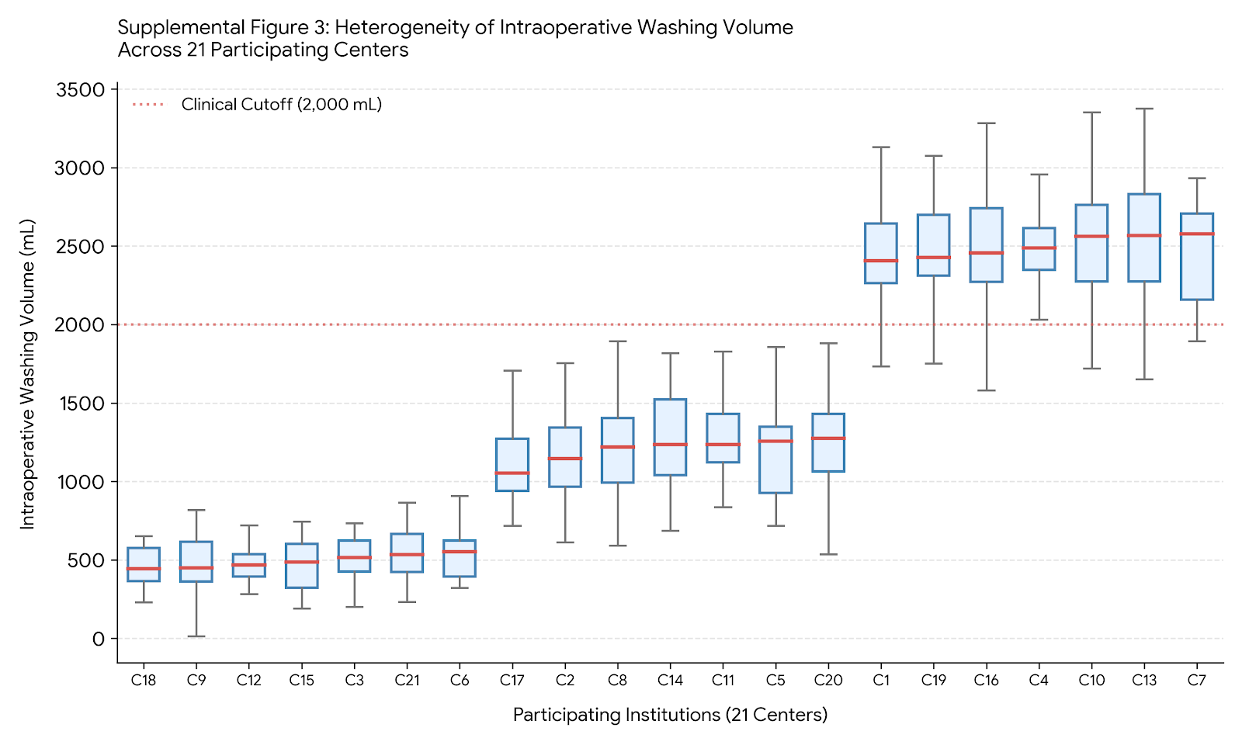

Supplemental Figure 2: Institutional Treatment Policies and Their Association with Prophylactic Drain Placement and Unadjusted IAA Rates Across 21 Centers
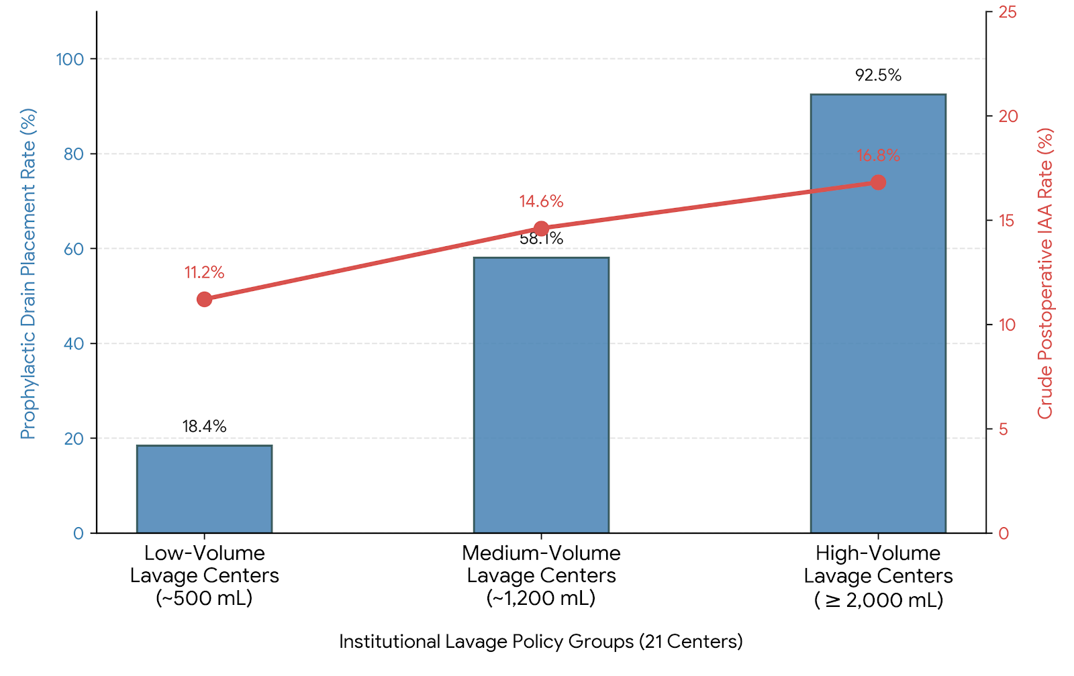

Supplemental Figure 3: Random Forest Variable Importance for Postoperative IAA Prediction

