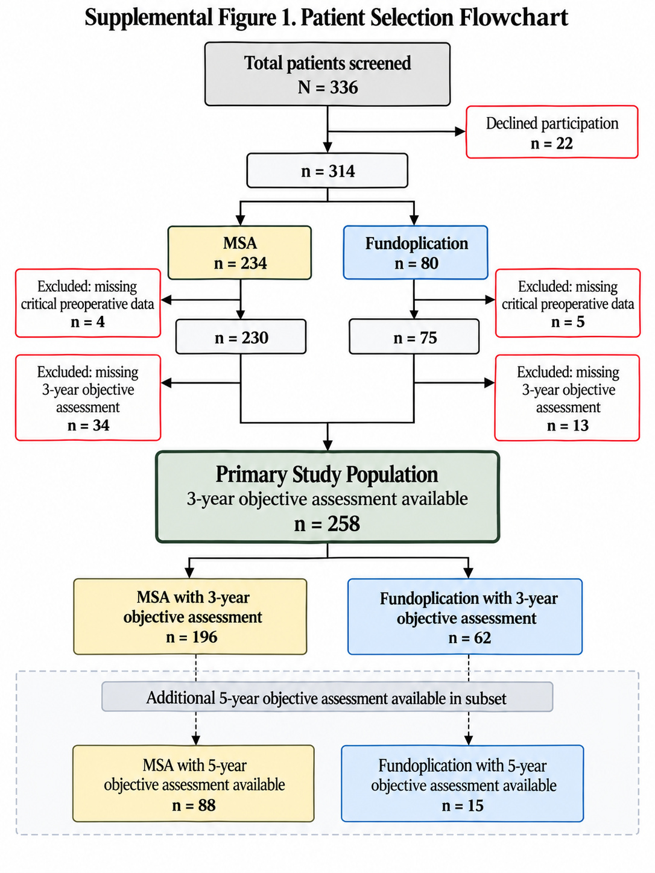

Supplemental Table 1. Comparison of demographics and preoperative clinical characteristics between included and excluded patients
Demographics | Included  (n=258) | Excluded  (n=56) | p-value
Age, years, mean (SD) | 61.6 (10.9) | 59.4 (12.4) | 0.194
Sex, n (%)
Male | 103 (39.9) | 16 (28.6) | 0.130
Female | 155 (60.1) | 40 (71.4)
BMI, kg/m2, mean (SD) | 29.0 (4.4) | 28.4 (4.6) | 0.424
Reflux symptoms
GERD-HRQL total score, mean (SD) | 18.0 (11.8) | 20.8 (13.4) | 0.235
GERD-HRQL dysphagia score, mean (SD) | 2.2 (2.7) | 3.2 (3.1) | 0.056
GERD-HRQL bloating score, mean (SD) | 1.7 (1.6) | 2.2 (1.8) | 0.090
Objective reflux-related findings
Axial length of hiatal hernia
3-5 cm, n (%) | 100 (38.8) | 20 (42.6) | 0.630
>5 cm, n (%) | 158 (61.2) | 27 (57.5)
Grade C/D esophagitis, n (%) | 16 (9.6) | 3 (7.9) | 1.000
Barrett’s esophagus, n (%) | 26 (21.7) | 7 (31.8) | 0.288
DeMeester score, mean (SD) | 50.8 (40.1) | 52.8 (49.5) | 0.786
DeMeester score ≥50, n (%) | 42 (35.6) | 9 (37.5) | 1.000
Manometric characteristics
LES resting pressure, mmHg, mean (SD) | 21.3 (15.0) | 18.1 (10.9) | 0.526
Integrated relaxation pressure, mmHg, mean (SD) | 7.5 (16.6) | 9.1 (4.7) | 0.035
Distal contractile integral, mmHg∙cm∙s, mean (SD) | 1332.6 (1016.6) | 1916.2 (2496.8) | 0.797
Distal wave amplitude, mmHg, mean (SD) | 75.5 (29.4) | 95.7 (53.7) | 0.413
Peristaltic swallows, % | 89.1 (18.7) | 95.8 (10.0) | 0.126
Antireflux Procedure
Fundoplication, n (%) | 62 (24.0) | 18 (32.1) | 0.236
Magnetic sphincter augmentation, n (%) | 196 (76.0) | 38 (67.9)
BMI, body mass index; GERD-HRQL, Gastroesophageal Reflux Disease–Health-Related Quality of Life; LES, lower esophageal sphincter; SD, standard deviation.

Supplemental Table 2. Distribution of procedures and 3-year objective hiatal hernia recurrence by study center and operative year
A. Distribution by study center
Study center | MSA |  | Fundoplication
Study center | Patients, N | Recurrence, n/N (%) | Patients, N | Recurrence, n/N (%)
Allegheny Health Network | 35 | 0/35 (0.0) | 4 | 1/4 (25.0)
East Carolina University | 28 | 0/28 (0.0) | 2 | 1/2 (50.0)
SoFi Research | 109 | 8/109 (7.3) | 25 | 7/25 (28.0)
South Florida Surgical Specialists | 4 | 0/4 (0.0) | 11 | 0/11 (0.0)
University of Southern California | 12 | 2/12 (16.7) | 3 | 1/3 (33.3)
University of Texas | 8 | 2/8 (25.0) | 17 | 3/17 (17.6)
Overall | 196 | 12/196 (6.1) | 62 | 13/62 (21.0)
B. Distribution by operative year
Operative year | MSA |  | Fundoplication
Operative year | Patients, N | Recurrence, n/N (%) | Patients, N | Recurrence, n/N (%)
2012 | 0 | — | 2 | 0/2 (0.0)
2013 | 0 | — | 1 | 0/1 (0.0)
2015 | 0 | — | 2 | 0/2 (0.0)
2016 | 8 | 0/8 (0.0) | 1 | 1/1 (100.0)
2017 | 19 | 1/19 (5.3) | 1 | 0/1 (0.0)
2018 | 50 | 1/50 (2.0) | 7 | 1/7 (14.3)
2019 | 51 | 3/51 (5.9) | 9 | 2/9 (22.2)
2020 | 43 | 6/43 (14.0) | 27 | 6/27 (22.2)
2021 | 25 | 1/25 (4.0) | 11 | 3/11 (27.3)
2022 | 0 | — | 1 | 0/1 (0.0)
Overall | 196 | 12/196 (6.1) | 62 | 13/62 (21.0)
MSA, magnetic sphincter augmentation. Center- and year-specific P values are not reported because of sparse cells and multiple comparisons.
Post hoc operative-era sensitivity: When the analysis was restricted to 2016–2021, the years in which both procedures were represented, recurrence was 12/196 (6.1%) after MSA and 13/56 (23.2%) after fundoplication (P<.001).

