Supplementary File 3
Supplementary Table S1. Study-level reconstruction of initial management strategy and outcome assignment. ERCP, endoscopic retrograde cholangiopancreatography; NS, non-surgical; NR, not reported or not reliably reconstructable; PCD, percutaneous drainage. *One Type III patient in Shimizu et al. subsequently underwent planned pancreaticoduodenectomy for underlying malignancy after the perforation had improved; this was not considered rescue surgery.
Study | Initial NS success/total | Upfront surgery success/total | Rescue surgery, n | Deaths: initial NS | Deaths: upfront surgery | Analysis use
Stapfer et al. [3] | 5/8 | 5/6 | 3 | 1/8 | 1/6 | Main
Avgerinos et al. [22] | 1/2 | 11/13 | 1 | 1/2 | 2/13 | Main
Bostancı et al. [23] | 15/18 | 1/2 | 3 | 0/18 | 1/2 | Main
Emori et al. [10] | 49/51 | 7/7 | 2 | 1/51 | 0/7 | Main
Kodali et al. [25] | 8/8 | 4/4 | 0 | 0/8 | 0/4 | Descriptive; universal success
Kumbhari et al. [9] | 45–47/52 | 8–9/9 | 4 | 1–2/52 | 0–1/9 | Sensitivity only
Miller et al. [27] | 11/19 | 6/8 | 7 | 6/19 | 2/8 | Main
Plecic et al. [12] | 7/7 | 1/1 | 0 | 0/7 | 0/1 | Descriptive; universal success
Rabie et al. [28] | 7/8 | 1/2 | 1 | 0/8 | 1/2 | Main
Sakallı et al. [13] | 5/20 | 3/3 | 12 | 3/20 | 0/3 | Main
Shi et al. [11] | 45/45 | 9/10 | 0 | 0/45 | 1/10 | Main
Weiser et al. [31] | 23/29 | 7/8 | 3 | 3/29 | 1/8 | Main
Polydorou et al. [32] | 32/37 | 5/7 | 5 | 0/37 | 2/7 | Main
Mousa et al. [33] | 2/4 | 1/2 | 1 | 1/4 | 1/2 | Main
Dahale et al. [14] | 6/6 | 10/12 | 0 | 0/6 | 2/12 | Main; ERCP subset
Shimizu et al. [34] | 11/11* | 4/4 | 0* | 0/11 | 0/4 | Descriptive; universal success
Jin et al. [36] | 39/44 | NR | 3 | NR | NR | Partial/narrative
Zhou et al. [35] | NR | NR | 1 possible immediate crossover | NR | NR | Narrative
Alfieri et al. [21] | NR | NR | ≥2 | NR | NR | Narrative
Jiménez-Cubedo et al. [24] | NR | NR | 7 delayed operations | NR | NR | Narrative
Krishna et al. [26] | Selected PCD cohort | Selected surgical cohort | NR | NR | NR | Narrative
Tavusbay et al. [29] | NR | NR | ≥1 | NR | NR | Narrative
Theopistos et al. [30] | 22/24 | NR | 2 | Single-arm | NR | Single-arm/narrative

Supplementary Table S2. GRADE certainty of evidence for principal outcomes. CI, confidence interval; GRADE, Grading of Recommendations Assessment, Development and Evaluation; LOS, length of stay; MD, mean difference; NS, non-surgical; RR, risk ratio.
Outcome | Evidence | Effect/observed outcome | Certainty | Main reasons
Overall initial-strategy success | 12 informative studies | RR 0.97 (95% CI 0.81–1.17) | Very low | Serious confounding by indication; imprecision
Overall mortality | 12 informative studies | RR 0.53 (95% CI 0.25–1.15) | Very low | Serious confounding; sparse events; imprecision
Overall LOS | 8 studies | MD +1.03 days (95% CI −3.35 to 5.40) | Very low | Serious confounding; very high inconsistency; imprecision
Type I success | 6 informative studies | RR 1.04 (95% CI 0.77–1.41) | Very low | Small selected cohorts; serious confounding and imprecision
Type I mortality | 6 informative studies | RR 1.47 (95% CI 0.56–3.86) | Very low | Sparse deaths; very serious imprecision
Type II success | 7 informative studies | RR 0.69 (95% CI 0.41–1.16) | Very low | Serious confounding; substantial inconsistency; imprecision
Type II mortality | 4 informative studies | RR 1.44 (95% CI 0.23–8.90) | Very low | Very sparse events; extremely wide CI
Type III success/mortality | Descriptive | NS success 46/49; mortality 1/49 | Very low | No meaningful surgical comparator; observational evidence
Type IV success/mortality | Descriptive | NS success 34/34; mortality 0/34 | Very low | No meaningful surgical comparator; observational case selection

Supplementary Table S3. Newcastle Ottawa Scale assessment of included studies. NOS, Newcastle–Ottawa Scale. Maximum scores: selection, 4; comparability, 2; outcome, 3; total, 9. Higher scores indicate greater methodological quality.
Study | Selection /4 | Comparability /2 | Outcome /3 | Total /9
Stapfer et al. [3] | 4 | 1 | 3 | 8
Avgerinos et al. [22] | 3 | 1 | 3 | 7
Krishna et al. [26] | 2 | 0 | 2 | 4
Polydorou et al. [32] | 4 | 1 | 3 | 8
Alfieri et al. [21] | 3 | 1 | 3 | 7
Jin et al. [36] | 4 | 2 | 3 | 9
Miller et al. [27] | 3 | 1 | 3 | 7
Rabie et al. [28] | 3 | 0 | 3 | 6
Kodali et al. [25] | 3 | 1 | 3 | 7
Kumbhari et al. [9] | 4 | 1 | 3 | 8
Tavusbay et al. [29] | 3 | 0 | 2 | 5
Weiser et al. [31] | 4 | 2 | 3 | 9
Bostancı et al. [23] | 3 | 1 | 3 | 7
Jiménez-Cubedo et al. [24] | 3 | 0 | 2 | 5
Theopistos et al. [30] | 3 | 0 | 3 | 6
Mousa et al. [33] | 2 | 0 | 2 | 4
Dahale et al. [14] | 3 | 1 | 3 | 7
Shimizu et al. [34] | 3 | 1 | 3 | 7
Shi et al. [11] | 4 | 2 | 3 | 9
Zhou et al. [35] | 4 | 2 | 3 | 9
Emori et al. [10] | 4 | 2 | 3 | 9
Plecic et al. [12] | 3 | 0 | 3 | 6
Sakallı et al. [13] | 3 | 1 | 3 | 7

Supplementary Table S4. Mortality following rescue surgery after initial non-surgical management. Rescue-specific mortality is presented descriptively because several included studies did not distinguish deaths after upfront surgery from deaths following rescue surgery, and rescue timing and clinical severity were heterogeneous.
Study | Rescue surgery, n | Deaths after rescue, n
Stapfer et al. [3] | 3 | 1
Avgerinos et al. [22] | 1 | 1
Bostancı et al. [23] | 3 | 0
Miller et al. [27] | 7 | 5
Rabie et al. [28] | 1 | 0
Sakallı et al. [13] | 12 | 0
Theopistos et al. [30] | 2 | 1
Weiser et al. [31] | 3 | 0
Total | 32 | 8 (25.0%)

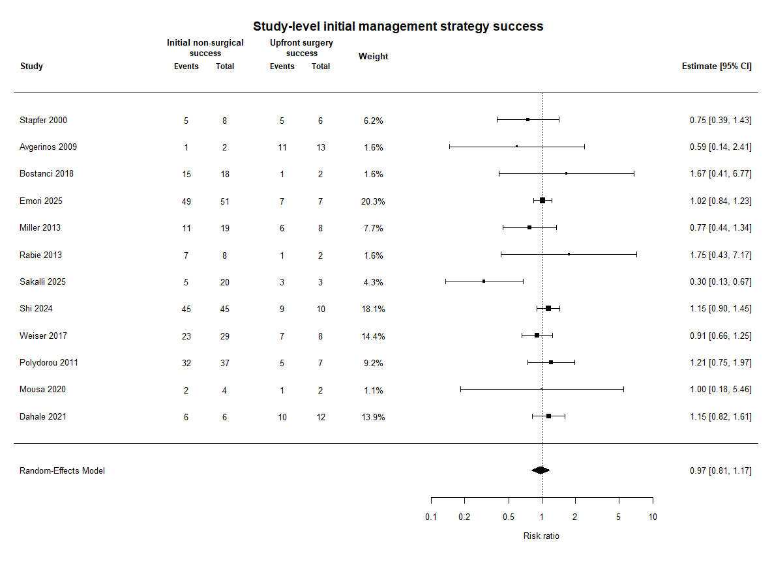
Supplementary Figure S1. Study-level random-effects forest plot for overall initial management strategy success.

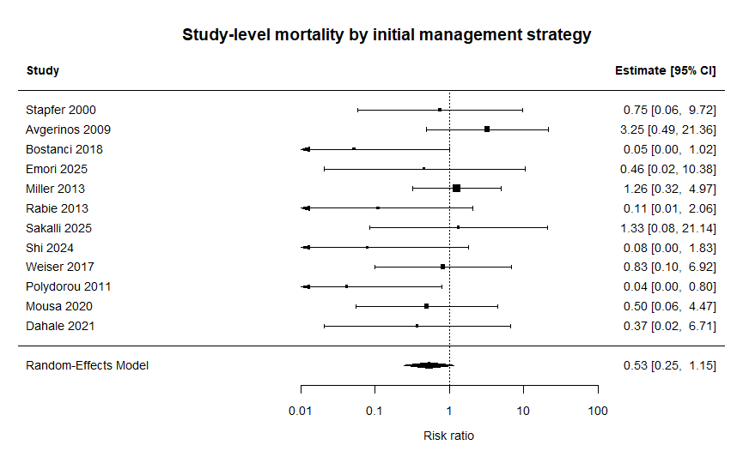
Supplementary Figure S2. Study-level random-effects forest plot for overall mortality.

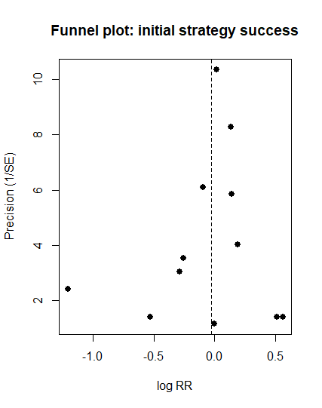
Supplementary Figure S3. Funnel plot for initial-strategy success. Egger regression p=0.36.
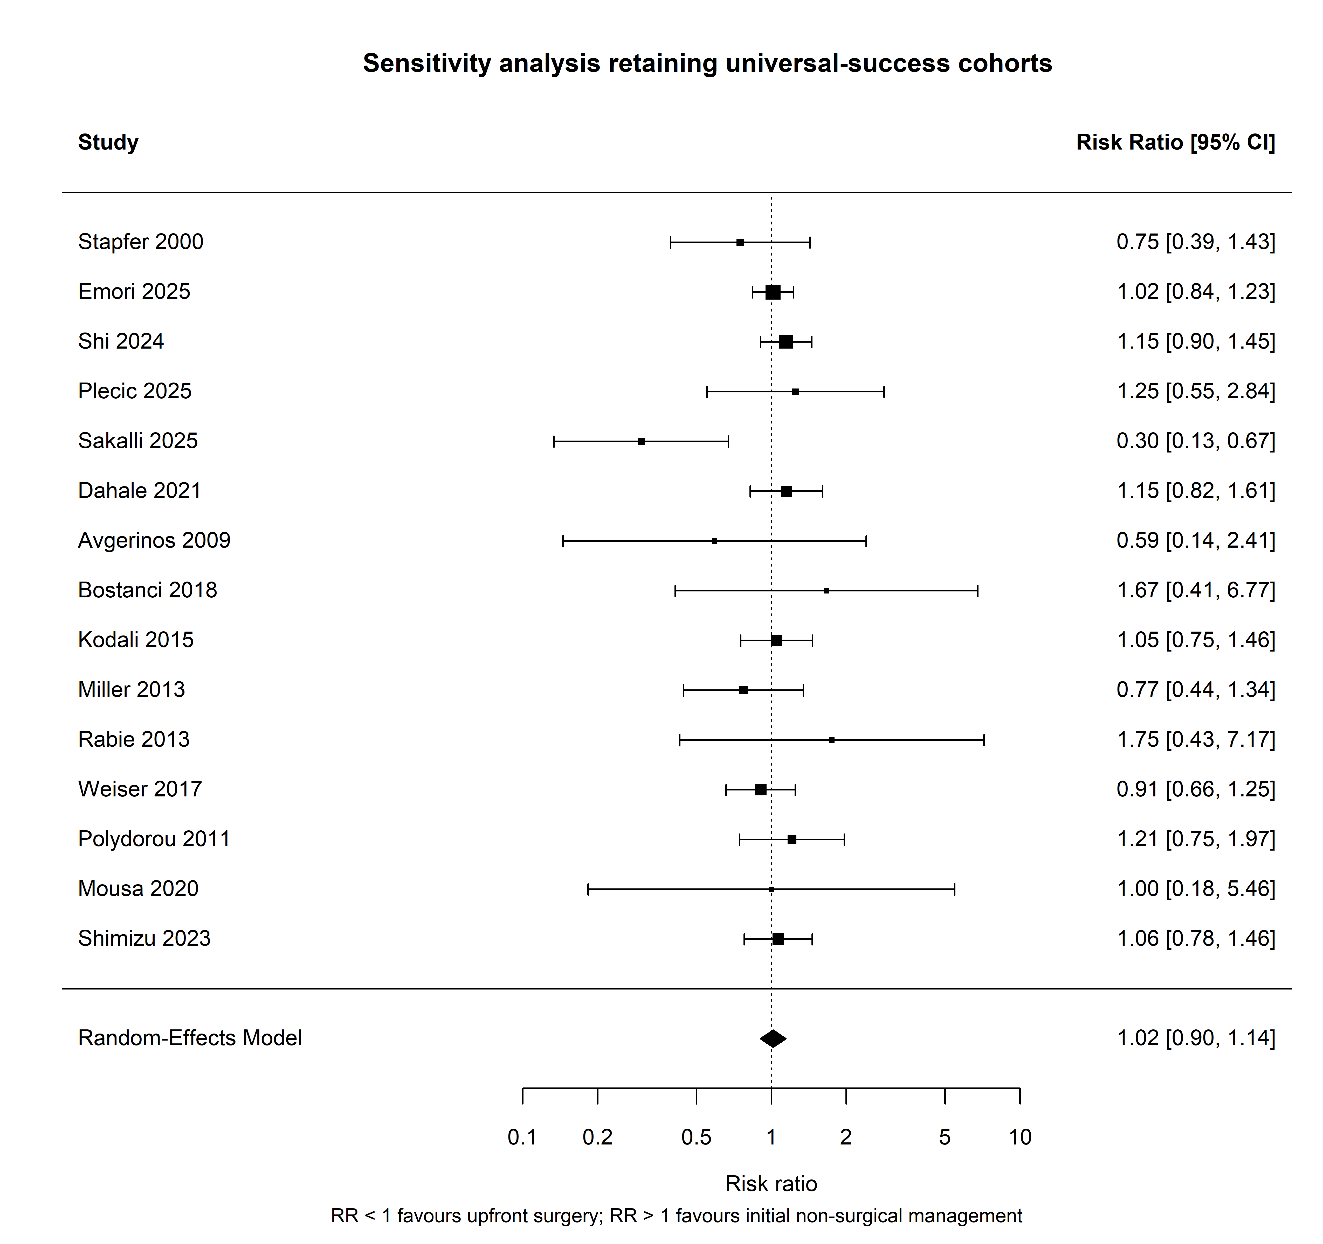
Supplementary Figure S4. Sensitivity analysis of initial-strategy success retaining studies with universal success in both treatment arms.

