Title: Dynamics of serum creatinine and creatinine clearance in extremely low birth weight neonates during the first six weeks of life
Journal: Journal of Pediatric Nephrology
Authors: Tamara van Donge, Karel Allegaert, Verena Gotta, Anne Smits, Elena Levtchenko, Djalila Mekahli, John van den Anker, Marc Pfister
Corresponding author:
Tamara van Donge, MSc
Pediatric Pharmacology and Pharmacometrics Research
Universitäts-Kinderspital beider Basel (UKBB)
Spitalstrasse 33, CH-4031 Basel, Switzerland
+41 61 704 12 12
tamara.vandonge@ukbb.ch
Online resource 3: Simulated creatinine and creatinine clearance
Figure S1: Simulated serum creatinine (Scr) concentrations for typical ELBW neonates, stratified per gestational age (GA). Panel A: ELBW neonates delivered by C-section, panel B: ELBW neonates born by vaginal delivery.
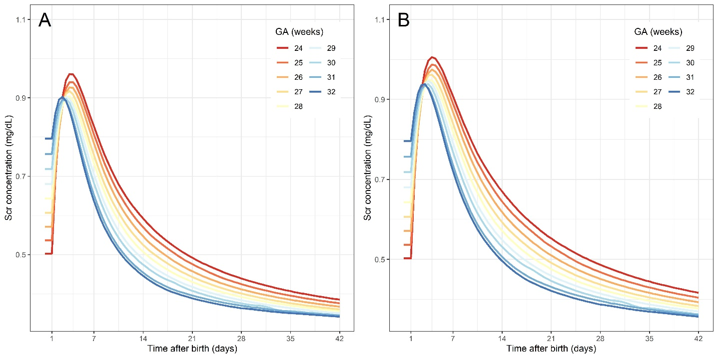

Figure S2: Simulated creatinine clearance for typical ELBW neonates, stratified per gestational age (GA). Panel A: ELBW neonates delivered by C-section, panel B: ELBW neonates born by vaginal delivery.
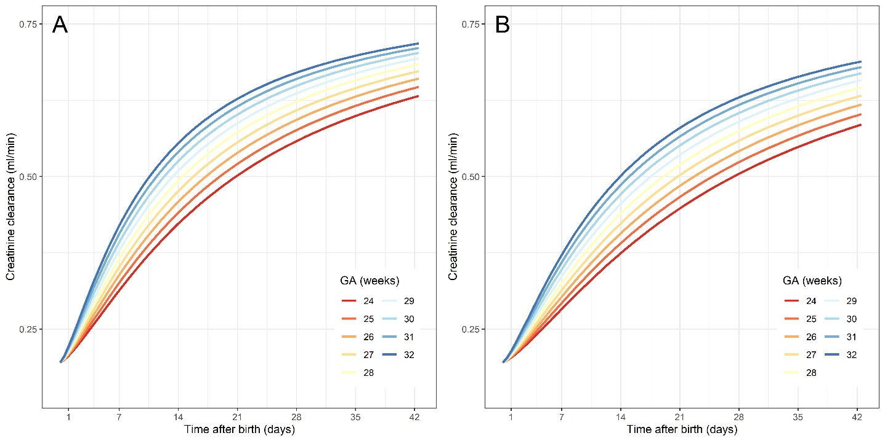

Figure S3: Simulated ratio of creatinine amount (creatinine production-to-elimination) for typical ELBW neonates, stratified per gestational age (GA).
