Supplementary Material to:

Efficacy and Safety of Lumasiran for Infants and Young Children with Primary Hyperoxaluria Type 1: 12-month Analysis of the Phase 3 ILLUMINATE-B Trial
Wesley Hayes, MBBChir¹; David J. Sas, DO²; Daniella Magen, MD³; Hadas Shasha-Lavsky, MD⁴; Mini Michael, MD⁵; Anne-Laure Sellier-Leclerc, MD⁶; Julien Hogan, MD, PhD⁷; Taylor Ngo, MPH^{8*}; Marianne T. Sweetser, MD, PhD⁸; John M. Gansner, MD, PhD⁸; Tracy L. McGregor, MD^{8*}; Yaacov Frishberg, MD⁹
*Tracy L. McGregor, MD, and Taylor Ngo, MPH, were employees of Alnylam Pharmaceuticals at the time of study.
¹Department of Paediatric Nephrology, Great Ormond Street Hospital, London, UK; ²Division of Pediatric Nephrology and Hypertension, Mayo Clinic, Rochester, MN, USA; ³Pediatric Nephrology Institute, Rambam Health Care Campus, Haifa, Israel; ⁴Paediatric Nephrology Unit, Galilee Medical Center, Nahariya, Israel; ⁵Division of Nephrology, Department of Pediatrics, Texas Children’s Hospital/Baylor College of Medicine, Houston, TX, USA; ⁶Hôpital Femme Mère Enfant and Centre d’Investigation Clinique Inserm, Hospices Civils de Lyon, ERKnet, Bron, France; ⁷Pediatric Nephrology Department, Hopital Robert-Debré, APHP, Paris, France; ⁸Alnylam Pharmaceuticals, Cambridge, MA, USA; ⁹Division of Pediatric Nephrology, Shaare Zedek Medical Center and Faculty of Medicine, Hebrew University of Jerusalem, Jerusalem, Israel
Corresponding Author:
Wesley Hayes, MBBChir, Consultant Paediatric Nephrologist
Department of Paediatric Nephrology
Great Ormond Street Hospital
Great Ormond Street, London WC1N 3JH
London, UK
Phone: +44 (0)20 7762 6822
Email: Wesley.Hayes@gosh.nhs.uk

Table S1. Dosing Regimen
Body Weight | Loading Dose | Maintenance Dose  (begin 1 month after the last loading dose)
<10 kg | 6.0 mg/kg once monthly for 3 doses | 3.0 mg/kg once monthly
10 kg to <20 kg | 6.0 mg/kg once monthly for 3 doses | 6.0 mg/kg once every 3 months (quarterly)
≥20 kg | 3.0 mg/kg once monthly for 3 doses | 3.0 mg/kg once every 3 months (quarterly)

Table S2. Plasma Pharmacokinetic Parametersª
 | <10 kg |  | 10 to <20 kg |  | ≥20 kg
 | Day 1 | Month 12 | Day 1 | Month 12 | Day 1 | Month 12
Parameter Statistic | 6.0 mg/kg | 3.0 mg/kg | 6.0 mg/kg | 6.0 mg/kg | 3.0 mg/kg | 3.0 mg/kg
t_{max}
n | 3 | 3 | 12 | 12 | 3 | 2
Median (min, max), hours | 4.22 (2, 8.1) | 2.25 (2, 4) | 2.97 (1.87, 7.83) | 3.83 (1.75, 7.25) | 3.93 (1.97, 7.1) | 4.15 (4.03, 4.27)
C_{max}
n | 3 | 3 | 12 | 12 | 3 | 2
Mean (%CV), ng/mL | 950 (32.2) | 1960 (80.1) | 1030 (33.6) | 1520 (55.5) | 950 (121.1) | 509 (19.0)
AUC_{0-last}
n | 3 | 3 | 12 | 12 | 3 | 2
Geometric mean (%CV), h•ng/mL | 6810 (19.7) | 7170 (126.5) | 9160 (21.2) | 10,500 (39.1) | 4940 (36.2) | 2960 (128.1)
t_{½}
n | 1 | 2 | 10 | 5 | 2 | 1
Geometric mean (%CV), hours | 5.46 | 2.12 (45.4) | 4.82 (46.4) | 3.81 (27.0) | 3.33 (181.8) | 6.64
CL/F/WT
n | 1 | 2 | 10 | 5 | 2 | 1
Geometric mean (%CV), L/h/kg | 0.908 | 0.459 (1.5) | 0.574 (18.8) | 0.461 (23.4) | 0.513 (33.6) | 0.444
AUC_{0-last}, area under the plasma concentration versus time curve from 0 to the last measurable concentration; %CV, percent coefficient of variation; CL/F, apparent total clearance of the drug from plasma; C_{max}, maximum plasma concentration; max, maximum; min, minimum; t_{½}, elimination half-life; t_{max}, time to reach maximum plasma concentration; WT, weight.
ªData presented are based on the initial dosing regimen.

Fig. S1 Mean (SEM) Ratio of Spot UOx:Cr to ULN (a) Percent Change From Baseline and (b) Actual Values at Each Visit

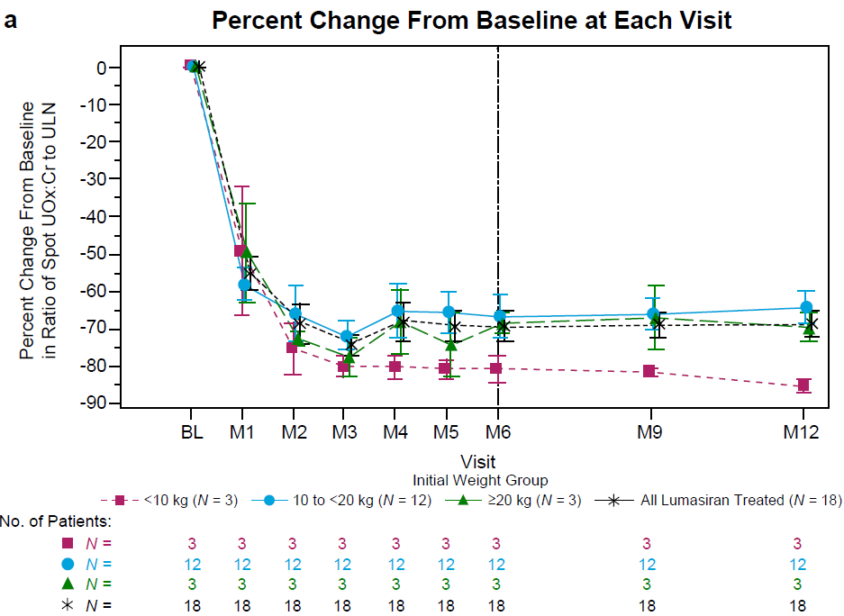

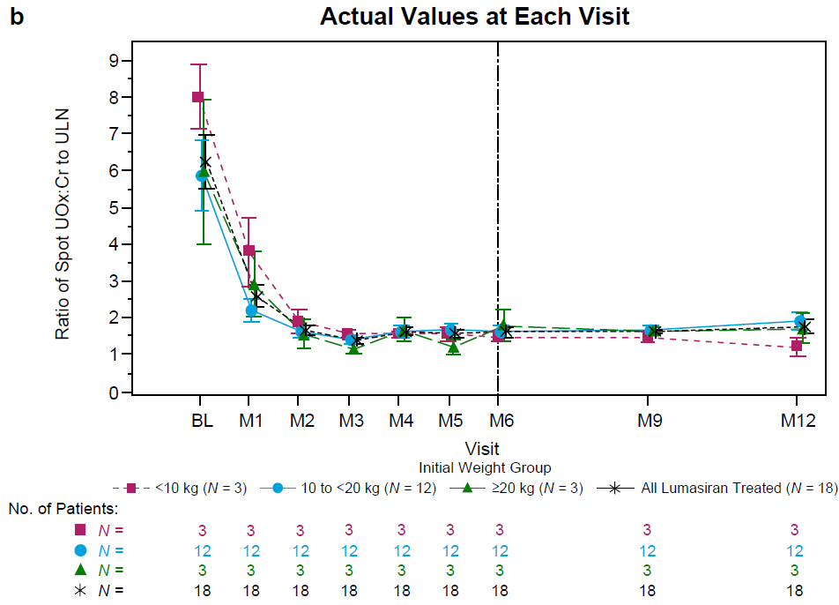

BL, baseline; M, month; ULN, upper limit of normal; UOx:Cr, urinary oxalate:creatinine ratio.

Fig. S2 Actual eGFR Values in Individual Patients (a) <10 kg (N = 3), (b) 10 to <20 kg (N = 12), and (c) ≥20 kg (N = 3)
Baseline value was the mean of all assessments collected prior to the first dose of lumasiran. eGFR was calculated in patients ≥12 months old at assessment. Two patients did not have eGFR calculated at baseline (age was <12 months).

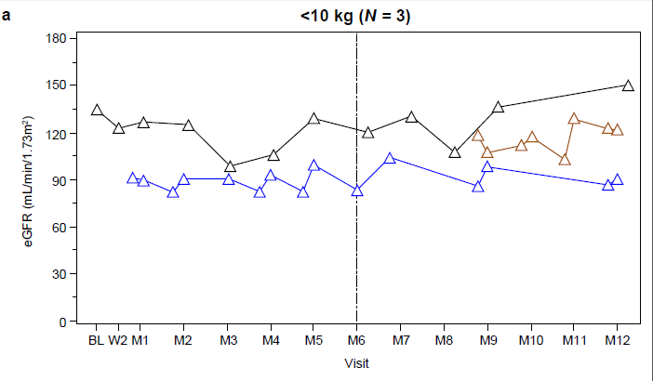

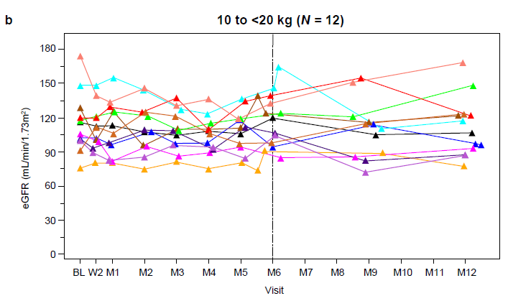

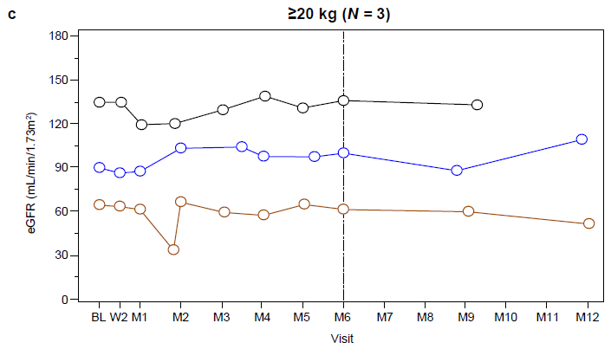
BL, baseline; eGFR, estimated glomerular filtration rate; M, month; W, week.

Fig. S3 Mean (SEM) Actual Values in (a) Plasma Glycolate and (b) Spot Urinary
Glycolate:Creatinine Ratio
Baseline value was the mean of all assessments collected prior to the first dose of lumasiran. For patients in the <10 kg weight subgroup, pharmacodynamic collections were optional at nonquarterly months. In 100 healthy adults, median plasma glycolate was 29.58 µmol/L with a range of 18.14‒54.04 µmol/L.

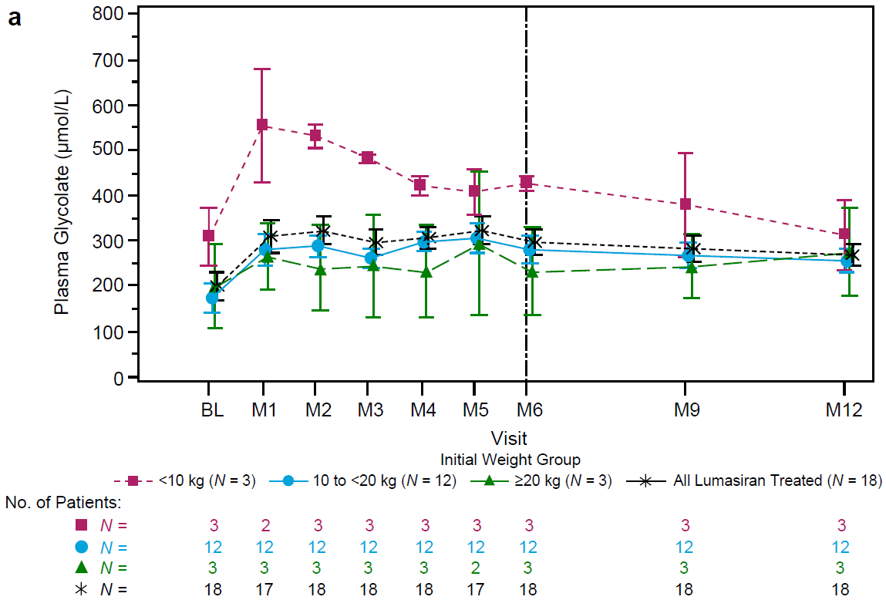
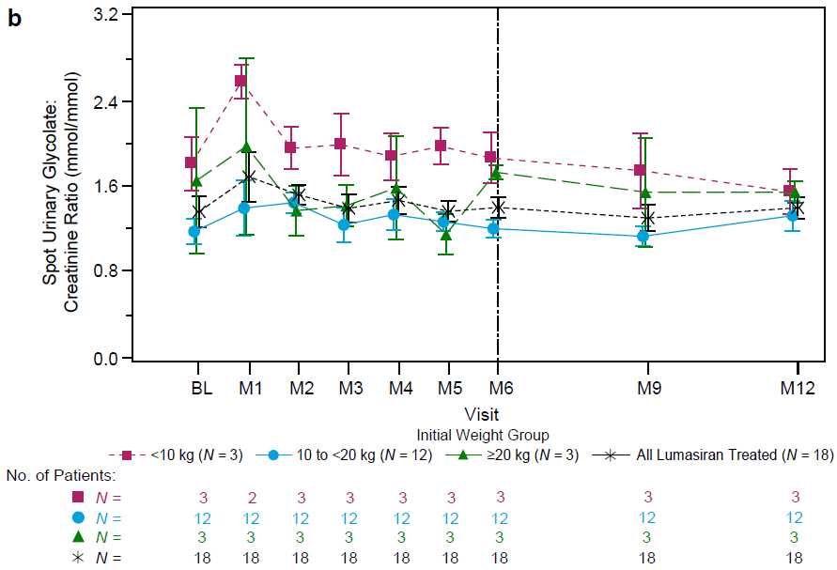

BL, baseline; M, month.

