SUPPLEMENTARY MATERIAL
Supplementary Table 1: Search terms strategy used in the literature review for MEDLINE, EMBASE, Cochrane and CINAHL for Nutritional management of children with AKI
1 | Acute kidney injury | Acute renal failure | Renal replacement therapy | CRRT | CKRT
2 | Calorie | Protein | Energy | Nutrient | Fat | Minerals
2 | Electrolyte | Trace elements | Amino acid | Carbohydrate | Vitamins | Nutrition support
 | Feeding | Malnutrition | Total parenteral nutrition | Nutrition assessment | Nutrition therapy | Enteral nutrition

Search methods:
- Electronic search using: Medline, PubMed, Embase, Cochrane library, Cinahl, manual searching (via OVID online database)
- 1980 – 2021, English language
- Reference list from review articles and clinical practice guidelines (including KDOQI, KDIGO, ASPEN, ESPEN, ESPNIC)

Supplementary Table 2: American Academy of Pediatrics grading

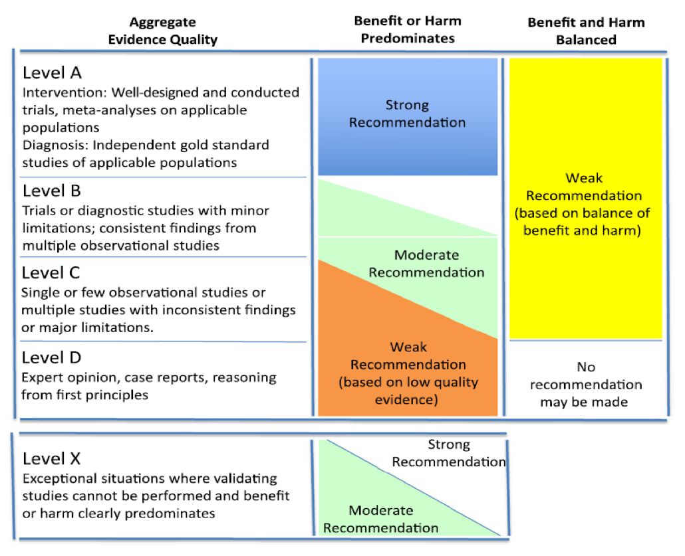

Supplementary Table 3. Repletion dosing for vitamin and trace mineral deficiencies in the general pediatric population
Micronutrient | Repletion Dosing Recommendation
Thiamine (B1) | Children: 10-25 mg/day parenterally x 1-2 week, followed by 5 mg PO for 6 weeks[143]
Pyridoxine (B6) | 5-25 mg/day of oral pyridoxine x 3 weeks, followed by 2.5 – 5 mg/day orally via multivitamin
Folate (B9) | Deficiency in infants: 0.1 mg/kg/day oral administration daily  Deficiency in children: 1.0 mg oral administration daily, followed by 0.1 to 0.5 mg daily maintenance dosing.
Vitamin C | 100 mg orally, intramuscularly, or intravenously 3x per day x 1 week, followed by 100 mg daily[144]
Zinc | Supplementation trail with 1 mg/kg; can increase to 2 mg/kg two - three times a day[145]
Selenium | 2 mcg/kg/day IV selenium for repletion followed by 1 mcg/kg/day as maintenance therapy for goal of serum level of 50 – 150 mcg/L[146]
Table adapted from Harshman et al[80] Dosing not otherwise established in pediatric CKD/ESKD
PO, per os; CKD, chronic kidney disease; ESKD, end stage kidney disease

Additional References Pertaining to Supplementary Table 3
143. Sachdev HPS, Shah D (2020) Vitamin B Complex Deficiencies and Excess. In: Kliegman R (ed) Textbook of pediatrics. Elsevier, Philadelphia, PA, pp 365-373.e361.

144. Weinstein M, Babyn P, Zlotkin S (2001) An orange a day keeps the doctor away: scurvy in the year 2000. Pediatrics 108:E55. https://doi.org/10.1542/peds.108.3.e55.

145. Hotz C, Brown K (2001) Identifying populations at risk of zinc deficiency: the use of supplementation trials. Nutr Rev 59:80-84.

146. Vinton NE, Dahlstrom KA, Strobel CT, Ament ME (1987) Macrocytosis and pseudoalbinism: manifestations of selenium deficiency. J Pediatr 111:711-717. https://doi.org/10.1016/s0022-3476(87)80247-0.
Supplementary Table 4: Indications for increased monitoring of electrolytes
Indication | Comments
Decrease in kidney function | Increased risk of hyperkalemia, hyperphosphatemia, metabolic acidosis, hypermagnesemia; sodium may increase or decrease depending on the water and sodium intake/losses
Improvement in kidney function | Increased risk of hypokalemia, hypophosphatemia or hypomagnesemia if intake restricted or non-renal losses; sodium may also decrease or increase; daily monitoring often adequate since changes usually occur gradually
Decrease in urine output | Beyond risks of decreased kidney function, risk of hyponatremia increases given inability to excrete water
Increase in urine output | Beyond risks of improved kidney function, risk of hyponatremia or hypernatremia increases given urinary losses of sodium and water
Intermittent dialysis | Increased risk of hypophosphatemia, hypokalemia, and hypomagnesemia, especially if intake restricted
CRKT | Increased risk of hypophosphatemia, hypokalemia, metabolic alkalosis and hypomagnesemia, but risk highly dependent on composition of dialysis/replacement fluid. Risk may be higher with CKRT than intermittent dialysis but depends on composition of dialysis/replacement fluid.
Citrate anticoagulation for CKRT | Increased risk of citrate lock (elevated total calcium with normal ionized calcium)
Discontinuation of dialysis | Increased risk of hyperkalemia, hyperphosphatemia, metabolic acidosis, hypermagnesemia; sodium may increase or decrease depending on the water and sodium intake/losses. Risk may be higher with CKRT than intermittent dialysis but depends on composition of dialysis/replacement fluid. Anticipation of these changes and adjustments of electrolyte delivery prior to discontinuation is ideal
CKRT, continuous kidney replacement therapy

Supplementary Table 5. Medication-based causes of electrolytes disturbances
Electrolyte Disturbance | Medication
Hyponatremia | - Thiazide diuretics  - Loop diuretics  - ACE inhibitors  - Sulfamethoxazole/trimethoprim  - NSAIDs  - Tricyclic antidepressants  - Selective serotonin reuptake inhibitors  - Monoamine oxidase inhibitors  - Carbamazepine, oxcarbazepine, sodium valproate  - Lamotrigine  - Vinca alkaloids  - Platinum compounds
Hypernatremia | - Hypertonic saline  - Amphotericin B  - Foscarnet  - Lithium, phenytoin  - Corticosteroids, mineralocorticoids  - Osmotic cathartic agents
Hypokalemia | - Insulin  - Aminophylline, theophylline  - Caffeine  - Terbutaline  - Albuterol  - Loop diuretics  - Thiazide diuretics  - Aminoglycosides  - Amphotericin B  - Sodium polystyrene sulfonate  - Corticosteroids, mineralocorticoids
Hyperkalemia | - Penicillin  - Spironolactone, eplerenone  - Trimethoprim  - Beta blockers  - Digoxin  - Ace inhibitors/Angiotensin receptor blockers  - Cyclosporine, tacrolimus  - NSAIDs  - Azole antifungals
Hypophosphatemia | - Aluminum or magnesium containing antacids  - Sucralfate  - Phosphate binders  - Albuterol  - Insulin  - Sodium bicarbonate
Hyperphosphatemia | - Phosphate-containing enema or laxative
Hypocalcemia | - Bisphosphonates  - Calcitonin  - Amphotericin B  - Foscarnet  - Citrate  - Phenytoin, phenobarbital  - Rifampicin, isoniazid  - Estrogen  - Loop diuretics  - Aminoglycosides
Hypercalcemia | - Vitamin D  - Estrogen  - Tamoxifen  - Loop diuretics
Hypomagnesemia | - Aminoglycosides  - Amphotericin B  - Cisplatin, methotrexate  - Cyclosporine  - Thiazide and loop diuretics  - Foscarnet
Hypermagnesemia | - Insulin  - Magnesium-containing enemas/laxatives/antacids
ACE, angiotensin-converting enzyme; NSAID, non-steroidal anti-inflammatory drug

