Supplementary material
Supplementary Figure 1 Flow chart of the inclusion and exclusion of patients
Supplementary Figure 2 Histograms for eGFR at baseline of two age groups
Supplementary Figure 3 (a) A 30% eGFR decline or more in pediatric and adult IgAN within 2 years (p < 0.01)
(b) A 50% eGFR decline or more in pediatric and adult IgAN within 2 years (p = 0.14)
Supplementary Figure 4 (a) A 30% eGFR decline or more in pediatric and adult IgAN with proteinuria >1 g/d after propensity score matching (p<0.01)
(b) A 50% eGFR decline or more in pediatric and adult IgAN with proteinuria >1 g/d after propensity score matching (p=0.29)
Supplementary Figure 5 (a)A 30% eGFR decline or more in pediatric and adult IgAN prescribed steroids after propensity score matching (p<0.01)
(b) A 50% eGFR decline or more in pediatric and adult IgAN prescribed steroids after propensity score matching (p=0.13)
Supplementary Figure 6 (a) A 30% eGFR decline or more in pediatric and adult IgAN entire follow up (p < 0.01)
(b) A 50% eGFR decline or more in pediatric and adult IgAN entire follow up (p = 0.07)

Supplementary table 1 Multivariate Cox regression analysis of complete remission of proteinuria in IgAN

Supplementary Figure 1
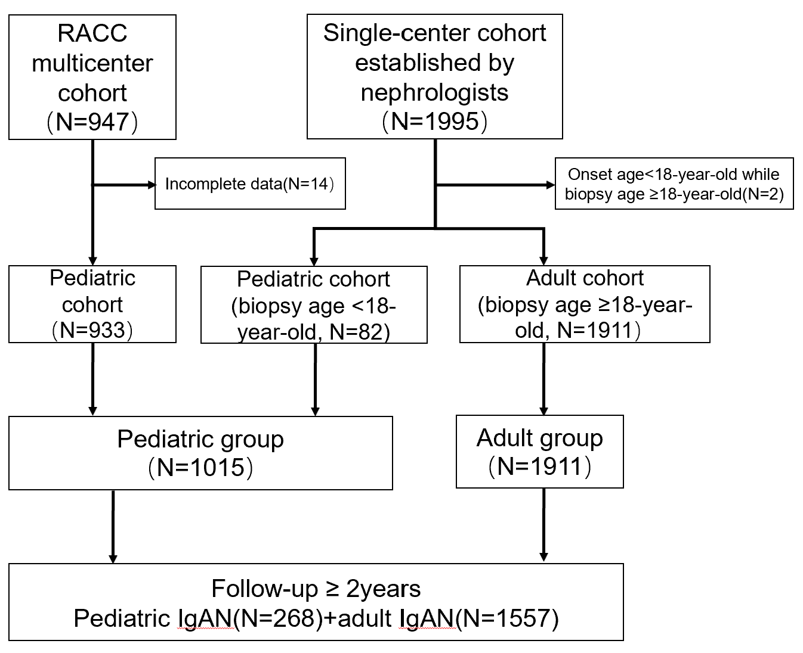

Supplementary Figure 2
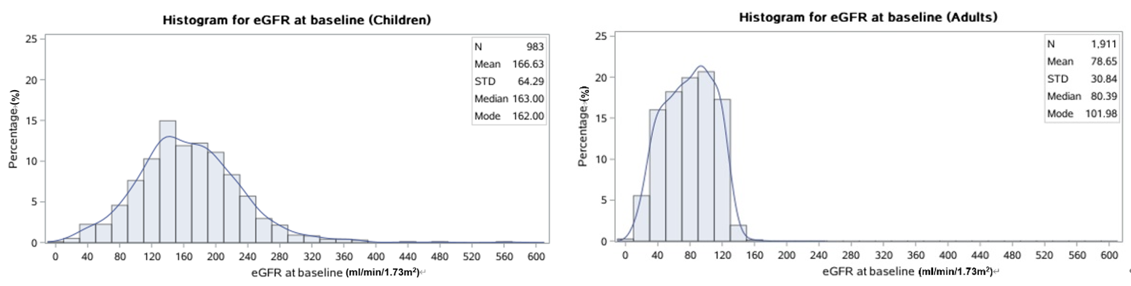

Supplementary Figure 3 (a)(b)
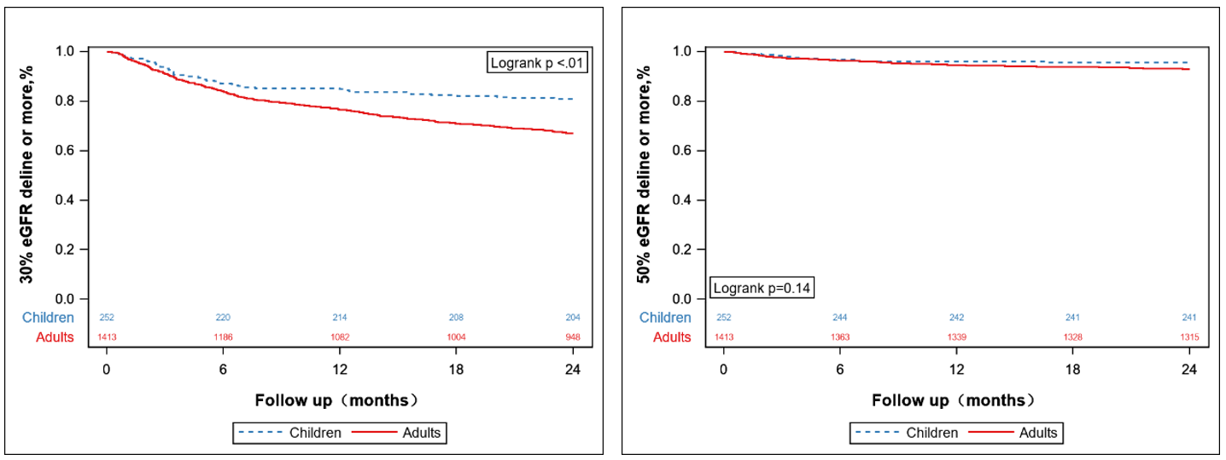
Supplementary Figure 4 (a)(b)
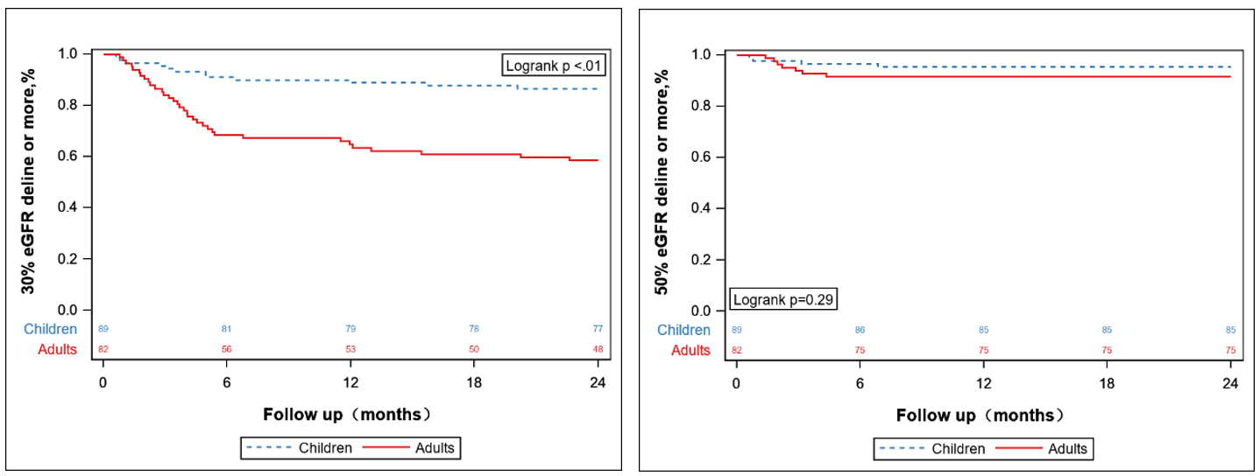
Supplementary Figure 5 (a)(b)
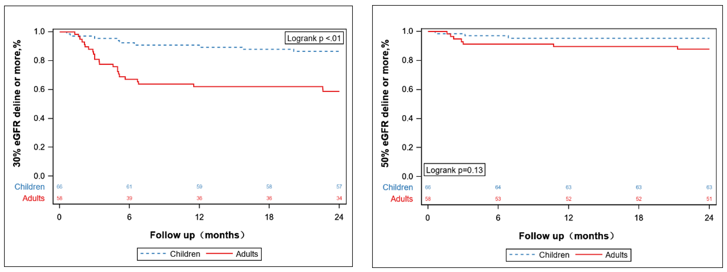
Supplementary Figure 6 (a)(b)
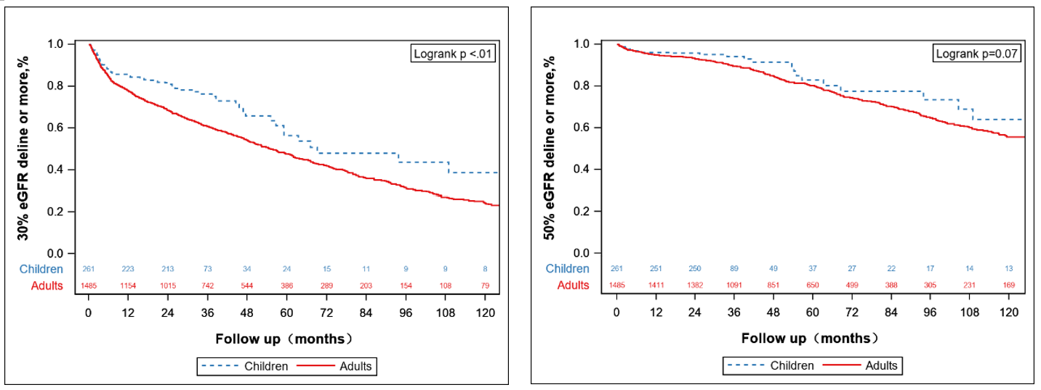

Supplementary table 1
 | HR | 95% CI | P
Children vs. Adults | 2.60 | 1.89 to 3.57 | <0.001
baseline 24-hour urinary protein concentration | 0.91 | 0.86 to 0.97 | 0.003
baseline erythrocyte count in hematuria (/μl)  (per 100/μl increase) | 1.00 | 1.00 to 1.01 | 0.21
baseline eGFR (per 10ml/min/1.73m² increase) | 1.01 | 0.98 to 1.03 | 0.64
hypertension (yes/no) | 1.11 | 0.88 to 1.39 | 0.39
M1: 0 vs. 1 | 1.00 | 0.81 to 1.22 | 0.97
E1: 0 vs. 1 | 0.89 | 0.72 to 1.08 | 0.24
S1: 0 vs. 1 | 1.39 | 1.14 to 1.71 | 0.001
T1: 0 vs. 2 | 1.20 | 0.79 to 1.82 | 0.38
T1: 1 vs. 2 | 1.03 | 0.68 to 1.57 | 0.88
C1: 0 vs. 2 | 1.17 | 0.84 to 1.62 | 0.36
C1: 1 vs. 2 | 1.04 | 0.76 to 1.42 | 0.82
Steroid use during follow-up (yes/no) | 2.86 | 1.87 to 4.36 | <0.001
Renin-angiotensin-aldosterone system (RAAS) inhibitor use during follow-up (yes/no) | 0.75 | 0.54 to 1.04 | 0.09
Immunosuppression use during follow-up (yes/no) | 0.51 | 0.33 to 0.76 | 0.001

