Clinical characteristics of immune-complex membranoproliferative glomerulonephritis and C3 glomerulopathy in Japanese children

Chika Ueda¹, Tomoko Horinouchi¹, Yuta Inoki¹, Yuta Ichikawa¹, Yu Tanaka¹, Hideaki Kitakado¹, Atsushi Kondo¹, Nana Sakakibara¹, China Nagano¹, Tomohiko Yamamura¹, Junya Fujimura², Naohiro Kamiyoshi³, Shingo Ishimori⁴, Takeshi Ninchoji⁵, Hiroshi Kaito⁶, Yuko Shima⁷, Kazumoto Iijima⁸ ⁹, Kandai Nozu¹, Norishige Yoshikawa¹⁰

Pediatric Nephrology

Corresponding author
Tomoko Horinouchi MD, PhD
Department of Pediatrics, Kobe University Graduate School of Medicine, 7-5-1 Kusunoki-cho, Chuo-ku, 650-0017, Kobe, Japan
Tel: +81-78-382-6090; Fax: +81-78-382-6099; E-mail: tohori@med.kobe-u.ac.jp
ORCID: https://orcid.org/0000-0003-1655-6030

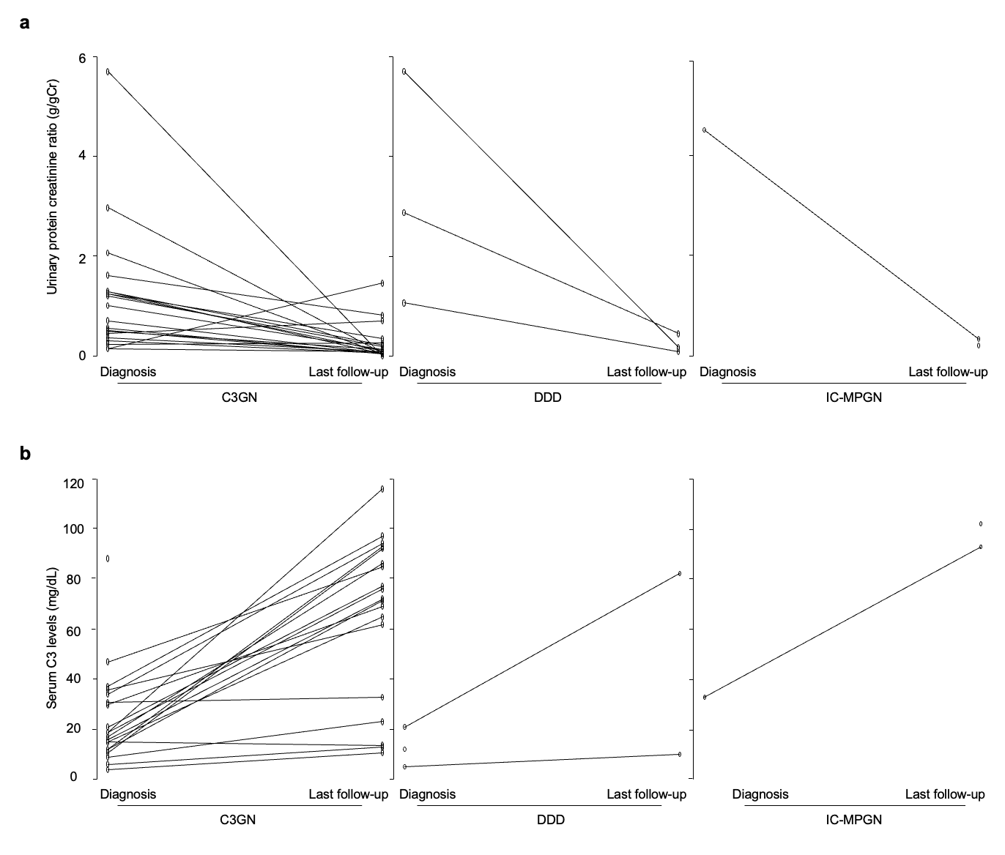Supplementary Fig. 1 Comparison of the data at diagnosis and at the last follow-up. (a) Urinary protein creatinine ratio at the last follow-up tended to be decreased compared with that at the time of diagnosis in all groups. (b) Serum C3 levels at the last follow-up tended to be increased compared with those at the time of diagnosis in all groups

Supplementary Table 1. Characteristics of normalized and non-normalized serum C3 cases in the C3GN group
 | Normalized serum C3 (N=7) | Non-normalized serum C3 (N=12) | P value
Baseline
Age at diagnosis (year) | 8.7 (7.6-9.1) | 12.7 (11.4-14.2) | 0.02
Serum Albumin (g/dL) | 3.8 (3.1-4.2) | 4.0 (3.8-4.2) | 0.44
Nephrotic syndrome, N (%) | 2 (28.6) | 0 (0) | 0.12
eGFR (ml/min/1.73m²) | 109.2 (87.8-123.8) | 131.1 (120.9-144.7) | 0.14
eGFR < 90 ml/min/1.73m², N (%) | 3 (42.9) | 1 (8.3) | 0.12
Urinary protein creatine ratio (g/gCr) | 1.25 (0.78-2.51) | 0.60 (0.28-1.26) | 0.08
Serum C3 (mg/dL) | 19.0 (14.5-35.5) | 15.6 (11.3-23.3) | 0.25
Low C3 (≤ 80 mg/dL), N (%) | 7 (100.0) | 12 (100) | 1
Histopathology
Crescents, N (%) | 2 (28.6) | 3 (25.0) | 1
Endocapillary proliferation, N (%) | 2 (28.6) | 1 (8.3) | 0.52
Global sclerosis, N (%) | 1 (14.3) | 0 (0) | 0.37
Interstitial fibrosis, N (%) | 1 (14.3) | 4 (33.3) | 0.60
Treatment
RAS-I, N (%) | 5 (71.4) | 12 (100) | 0.12
Prednisolone, N (%) | 4 (57.1) | 7 (87.5) | 1
MZR, MMF, N (%) | 0 (0) | 4 (33.3) | 0.25
Last follow-up
Serum Albumin (g/dL) | 4.5 (4.2-4.9) | 4.3 (4.1-4.5) | 0.40
eGFR (ml/min/1.73m²) | 104.6* (95.4-117.9) | 110.9 (106.3-122.5) | 0.44
eGFR < 90 ml/min/1.73m², N (%) | 1* (16.7) | 1 (8.3) | 1
Urinary protein creatine ratio (g/gCr) | 0.04 (0.04-0.08) | 0.17 (0.08-0.27) | 0.02
Remission | 7 (100.0) | 6 (50.0) | 0.04
*Lack of data for one patient.
C3GN C3 glomerulonephritis, eGFR estimated glomerular filtration rate, RAS-I renin-angiotensin system inhibitor, MZR mizoribine, MMF mycophenolate mofetil

