Supplementary Material

Impact of acute kidney injury and dysnatremia on length of stay
in infants after cardiac surgery

Kronborg JR^{1,2}, Lindhardt RB^{3,4}, Vejlstrup N⁵, Holst LM¹, Juul K⁶, Smerup MH^{7,8},
§Gjedsted J^{1,8}, §Ravn, HB^{3,4}.

§ Shared last authorship.

¹Department of Cardiothoracic Anesthesiology, Rigshospitalet, Copenhagen University Hospital, Copenhagen, Denmark
²Faculty of Health and Medical Sciences, University of Copenhagen, Copenhagen, Denmark
³Department of Anesthesiology and Intensive Care, Odense University Hospital, Odense, Denmark
⁴Department of Clinical Research, University of Southern Denmark, Odense, Denmark
⁵Department of Cardiology, Rigshospitalet, Copenhagen University Hospital, Copenhagen, Denmark
⁶Department of Pediatric Cardiology, Rigshospitalet, Copenhagen University Hospital, Copenhagen, Denmark
⁷Department of Cardiothoracic Surgery, Rigshospitalet, Copenhagen University Hospital, Copenhagen, Denmark
⁸Department of Clinical Medicine, University of Copenhagen, Copenhagen, Denmark

For information regarding this article, contact the corresponding author.

Email: Jonas.Kronborg@regionh.dk

Stage | Serum creatinine criteria |  | Urine output criteria (ml/kg/h)
Stage | Pediatric | Neonatal modifications | Pediatric | Neonatal modifications
1 | ≥0.3 mg/dl rise within 48 h or ≥1.5–1.9 × rise from baselineª | ≥0.3 mg/dl rise within 48 h or ≥1.5–1.9 × rise from reference^{b} | ≤ 0.5 for 6-12h | ≤ 1 for 24 h
2 | ≥2.0–2.9 × rise from baseline |  | ≤ 0.5 for ≥12 h | ≤ 0.5 for 24 h
3 | ≥3.0 × rise from baseline or ≥4.0 mg/dl or KRT or eGFR <35 ml/min per 1.73 m² | ≥3.0 × rise from reference or ≥2.5^{c} or KRT | ≤ 0.3 for 24 h or  anuria for ≥ 12h | ≤ 0.3 for 24 h

Table S1 Kidney Disease: Improving Global Outcomes (KDIGO) Acute Kidney Injury (AKI) Classification including neonatal modifications.
ªBaseline within the prior 3 months. A rise from baseline must be known or presumed to have occurred in the prior 7 days. ^{b} Previous lowest SCr in the prior 7 days (a rolling baseline) ^{c} Equivalent to an eGFR <10 ml/min per 1.73 m² in neonates. Abbreviations: KRT, Kidney replacement treatment

 |  | Neonates  n=61 | Infants  n= 167 | p-value
Age (days) |  | 8.0 (6.0–10.0) | 127.0 (81.0–192.0) | N/A
Weight (kg) |  | 3.5 (3.2–3.9) | 5.6 (4.5–6.8) | N/A
CPB duration (min) |  | 129.0 (108.0–182.0) | 92.0 (69.5–141.0) | N/A
Clamp time |  | 70.5 (49.8–107.5) | 57.0 (42.0–89.0) | N/A
RACHS1 Category (numerical) |  | 4.0 (3.0–4.0) | 2.0 (2.0 – 2.0) | N/A
RACHS-1 Category  (categorical) | 1-2 | 2 (3.3%) | 126 (75.4%) | N/A
RACHS-1 Category  (categorical) | 3-4 | 55 (90.2%) | 41 (24.6%) | N/A
RACHS-1 Category  (categorical) | 5-6 | 4 (6.6%) | 0 (0%) | N/A
Perioperative data
Darrow glucose (ml kg⁻¹) |  | 66.0 (50.0–82.2) | 56.1 (39.6–76.5) | 0.038
IV Glucose (ml kg⁻¹) |  | 43.5 (16.4–70.5) | 12.2 (4.7–26.9) | <0.001
Free water intake (ml kg⁻¹) |  | 85.7 (67.4–129.9) | 55.6 (38.3–79.4) | <0.001
Blood products (ml kg⁻¹) |  | 73.2 (49.4–117.4) | 31.8 (19.9–51.9) | <0.001
RBC transfusions (ml kg⁻¹) |  | 38.1 (23.6–63.2) | 16.9 (8.4–28.3) | <0.001
Cryoprecipitate (ml kg⁻¹) |  | 17.1 (11.3–26.0) | 6.6 (0.0–12.7) | <0.001
Pooled thrombocytes (ml kg⁻¹) |  | 16.8 (11.5–28.3) | 9.0 (2.9–15.8) | <0.001
Intraoperative bleeding (ml kg⁻¹ h⁻¹) |  | 11.5 (5.8–23.2) | 4.6 (2.5–8.8) | <0.001
Postoperative bleeding (ml kg⁻¹ h⁻¹) |  | 1.2 (0.9–2.0) | 0.9 (0.7–1.4) | <0.001
Furosemide dose (mg kg⁻¹) |  | 12.5 (4.7–20.3) | 6.0 (1.7–11.3) | <0.001
Diuresis§ (ml kg⁻¹ h⁻¹) |  | 7.0 (5.8–8.8) | 4.3 (3.5–5.3) | <0.001
Human albumin (g kg⁻¹) |  | 8.5 (6.7–10.0) | 4.7 (3.6–5.9) | <0.001
Cumulative-FB POD0(%) |  | 0.1 (-3.1–5.3) | 1.6 (-0.3–3.8) | 0.128
Cumulative-FB POD1(%) |  | -3.1 (-7.6–0.6) | 0.3 (-2.1–3.2) | <0.001

Table S2 Overall demographics, patient characteristics, and perioperative data.
Blood products comprise the total volume of red blood cells, cryoprecipitate, and pooled platelets.
Data presented as median (IQR) or n (%). Abbreviations: AKI; Acute kidney injury, Cumulative-FB; Cumulative Fluid Balance, N/A; Not Applicable, IV; intravenous, POD; Postoperative day, RACHS-1; Risk Adjustment for Congenital Heart Surgery 1, RBC; Red blood cells.

 | No AKI  n= 23 | AKI  n= 38 | p-value
Human albumin  (g kg⁻¹) | 7.1  (6.0 – 9.0) | 8.8  (7.3 – 10.9) | 0.019
Biarbonate  (mEq kg⁻¹) | 6.0  (4.3 – 8.4) | 8.1  (6.4 – 9.6) | 0.046
Daily fluid balance POD0  (ml kg⁻¹) | 0.8  (-33.4 – 46.4) | 6.3  (-29.3 – 58.4) | 0.582
Daily fluid balance POD1  (ml kg⁻¹) | -40.6  (-53.4 – -26.7) | -46.1  (-75.7 – -27.9) | 0.162
Dysnatremia
Normonatremia | 9 (39.1%) | 13 (34.2%) | 0.144
Hyponatremia | 5 (21.7%) | 17 (44.7%) | 0.144
Hypernatremia | 9 (39.1%) | 8 (21.1%) | 0.144
KDIGO
Stage 0 | 23 (100.0%) | 0 (0.0%) | N/A
Stage 1 | 0 (0.0%) | 26 (68.4%) | N/A
Stage 2 | 0 (0.0%) | 4 (10.5%) | N/A
Stage 3 | 0 (0.0%) | 8 (21.1%) | N/A

Table S3 In neonates, accumulated volume/doses intra- and postoperatively (first up to 48 postoperative hours).
Data presented as median (IQR) or n (%). Abbreviations: AKI; Acute kidney injury, KDIGO; Kidney disease improving global outcomes, N/A; Not Applicable, POD; Postoperative day.

 | No AKI  n= 65 | AKI  n= 102 | p-value
Human albumin  (g kg⁻¹) | 4.8  (3.8 – 5.6) | 4.7  (3.6 – 6.0) | 0.929
Biarbonate  (mEq kg⁻¹) | 3.7  (1.0 – 5.6) | 4.1  (2.6 – 5.5) | 0.436
Daily fluid balance POD0  (ml kg⁻¹) | 11.9  (-14.0 – 33.5) | 16.6  (1.8 – 42.1) | 0.054
Daily fluid balance POD1  (ml kg⁻¹) | -11.8  (-26.9 – 14.9) | -21.5  (-41.5 – 6.7) | 0.046
Dysnatremia
Normonatremia | 37 (56.9%) | 31 (30.4%) | <0.001
Hyponatermia | 15 (26.2%) | 30 (29.4%) | <0.001
Hypernatremia | 11 (16.9%) | 41 (40.2%) | <0.001
KDIGO
Stage 0 | 65(100%) | 0 (0.0%) | N/A
Stage 1 | 0 (0.0%) | 58 (56.9%) | N/A
Stage 2 | 0 (0.0%) | 39 (38.2%) | N/A
Stage 3 | 0 (0.0%) | 5 (4.9%) | N/A

Table S4 In infants, accumulated volume/doses intra- and postoperatively (first up to 48 postoperative hours).
Data presented as median (IQR) or n (%). Abbreviations: AKI; Acute kidney injury, KDIGO; Kidney disease improving global outcomes, N/A; Not Applicable, POD; Postoperative day.

Table S5 Comparison of infants excluded and included in the multivariate analysis.
Data were missing on three specific variables: intraoperative bleeding (n = 34), cryoprecipitate administration (n = 5), and red blood cell (RBC) transfusion (n = 1). Data are presented as median (IQR) or n (%). Abbreviations: AKI; Acute kidney injury, CPB; Cardiopulmonary bypass, RACHS-1; Risk Adjustment for Congenital Heart Surgery 1, POD; Postoperative day.

 | Excluded  n= 40 | Included  n= 188 | p-value
Age (days) | 89.0 (37.8 – 147.5) | 92.0 (19.2 – 181.2) | 0.956
Neonate | 10 (25.0%) | 51 (27.1%) | 0.937
Weight (kg) | 4.9 (3.6 – 6.0) | 4.8 (3.8 – 6.5) | 0.693
Sex (male) | 20 (50.0%) | 114 (60.6%) | 0.287
CPB time (minutes) | 97.5 (68.8 – 141.0) | 112.5 (79.0 – 153.0) | 0.262
AKI | 25 (62.5%) | 115 (61.2%) | 1.0
Human albumin (g kg⁻¹) | 5.4 (3.8 – 7.3) | 5.4 (4.0 – 7.3) | 0.928
IV Glucose (ml kg⁻¹) | 1.5 (1.2 – 2.0) | 1.4 (1.1 – 2.1) | 0.793
Free water intake (ml kg⁻¹) | 68.0 (46.0 – 85.2) | 62.1 (41.0 – 91.9) | 0.857
Postoperative bleeding (ml kg⁻¹ h⁻¹) | 1.0 (0.8 – 1.3) | 1.0 (0.7 – 1.5) | 0.9
Furosemide dose (mg kg⁻¹) | 6.7 (2.2 – 18.2) | 7.3 (2.2 – 15.1) | 0.742
Diuresis (ml kg⁻¹ h⁻¹) | 4.5 (3.4 – 6.8) | 4.9 (3.9 – 6.4) | 0.367
Cumulated fluid balance POD0 | 1.6% (-0.2 – 5.3) | 1.2% (-1.0 – 3.8) | 0.283
Cumulated fluid balance POD1 | 1.5% (-2.9 – 3.8) | -0.8% (-3.1 – 2.1) | 0.125
RACHS-1 category
1-2 | 21 (52.5%) | 107 (56.9%) | 0.327
3-4 | 19 (47.5%) | 77 (41.0%) | 0.327
5-6 | 0 (0.0%) | 4 (2.1%) | 0.327
Dysnatremia
Normonatremia | 19 (47.5%) | 71 (37.8%) | 0.507
Hyponatremia | 11 (27.5%) | 58 (30.9%) | 0.507
Hypernatremia | 10 (25.0%) | 59 (31.4%) | 0.507

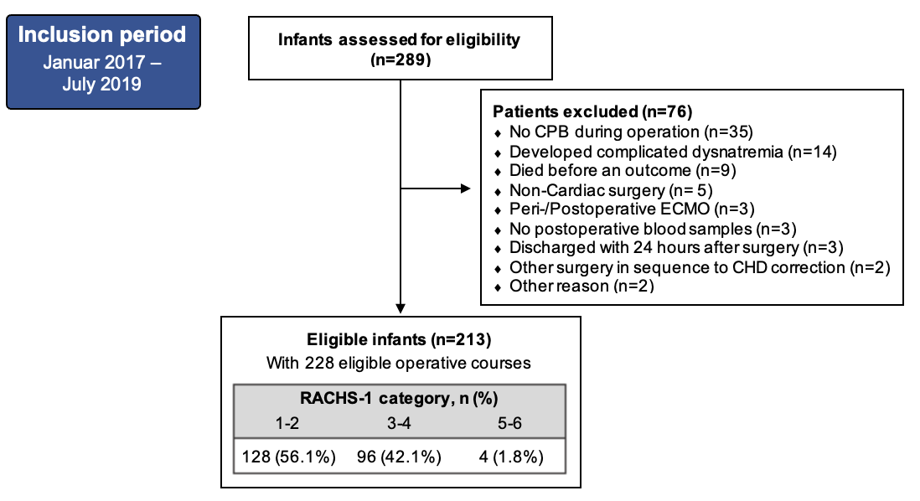

Fig. S1 STROBE diagram of the included and excluded infants in the study.
Abbreviations: CHD; Congenital heart disease, CPB; Cardiopulmonary bypass, RACHS-1; Risk Adjustment for Congenital Heart Surgery 1.

