Supplementary material
The prognosis and predictive factors in pediatric IgA nephropathy
Pediatric Nephrology
Wenpei Liang¹, Yonghua He¹, Xueqing Ma¹, Panpan Shao¹, Ling Guo¹, Jianhua Zhou¹, Yu Zhang¹, Huiqing Yuan¹, Liru Qiu^{1,2,3}
¹ Department of Pediatrics, Tongji Hospital, Tongji Medical College, Huazhong University of Science and Technology, Wuhan, China
²Hubei Provincial Clinical Research Center for Child Growth, Development, and Metabolic Diseases ³Hubei Key Laboratory for Pediatric Genetic Metabolic and Endocrine Rare Disease
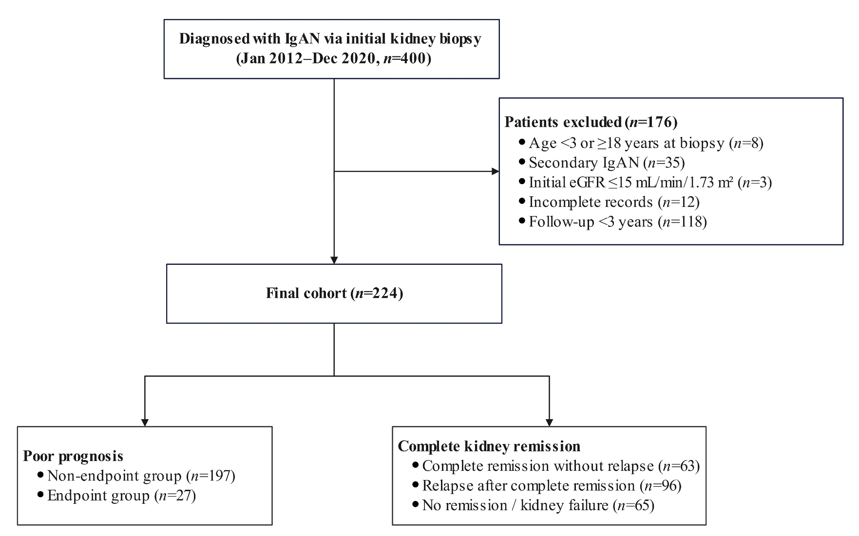
Correspondence to: Liru Qiu, MD. Department of Pediatrics, Tongji Hospital, Tongji Medical College, Huazhong University of Science and Technology, 1095 Jiefang Avenue, Qiaokou District, Wuhan 430030, China. Email: liruqiutj@163.com.
Supplementary Fig. 1 Flow diagram of included and excluded pediatric patients with IgA nephropathy

IgAN, immunoglobulin A nephropathy; eGFR, estimated glomerular filtration rate.

Supplementary Table 1 Additional clinical, pathological and follow-up data of pediatric patients with IgA nephropathy
Variables | Total group  (n = 224) | Non-endpoint group  (n = 197) | Endpoint group  (n = 27) | p-value
Kidney pathology
Lee classification, n(%) |  |  |  | 0.830
Grade Ⅱ | 21 (9.38) | 19 (9.64) | 2 (7.41)
Grade Ⅲ | 105 (46.88) | 94 (47.72) | 11 (40.74)
Grade Ⅳ | 82 (36.61) | 70 (35.53) | 12 (44.44)
Grade Ⅴ | 16 (7.14) | 14 (7.11) | 2 (7.41)
Types of immune complex deposition, n(%) |  |  |  | 0.178
IgA | 116 (51.79) | 105 (53.30) | 11 (40.74)
IgA+IgG | 14 (6.25) | 14 (7.11) | 0 (0.00)
IgA+IgM | 66 (29.46) | 55 (27.92) | 11 (40.74)
IgA+IgM+IgG | 28 (12.50) | 23 (11.68) | 5 (18.52)
Presence of complement deposition, n(%) | 131 (58.48) | 116 (58.88) | 15 (55.56) | 0.742
Degree of immune complex deposition, n(%)
IgA |  |  |  | 0.708
1+ | 14 (6.25) | 13 (6.60) | 1 (3.70)
2+ | 14 (6.25) | 11 (5.58) | 3 (11.11)
3+ | 26 (11.61) | 24 (12.18) | 2 (7.41)
4+ | 170 (75.89) | 149 (75.63) | 21 (77.78)
IgM |  |  |  | 0.164
- | 130 (58.04) | 119 (60.41) | 11 (40.74)
1+ | 46 (20.54) | 38 (19.29) | 8 (29.63)
2+ | 37 (16.52) | 30 (15.23) | 7 (25.93)
3+ | 11 (4.91) | 10 (5.08) | 1 (3.70)
IgG |  |  |  | 0.557
- | 182 (81.25) | 160 (81.22) | 22 (81.48)
1+ | 24 (10.71) | 22 (11.17) | 2 (7.41)
2+ | 10 (4.46) | 9 (4.57) | 1 (3.70)
3+ | 8 (3.57) | 6 (3.05) | 2 (7.41)
C3 |  |  |  | 0.528
- | 95 (42.41) | 83 (42.13) | 12 (44.44)
1+ | 12 (5.36) | 12 (6.09) | 0 (0.00)
2+ | 35 (15.62) | 32 (16.24) | 3 (11.11)
3+ | 45 (20.09) | 40 (20.30) | 5 (18.52)
4+ | 37 (16.52) | 30 (15.23) | 7 (25.93)
C1q |  |  |  | 0.198
- | 214 (95.54) | 190 (96.45) | 24 (88.89)
+ | 10 (4.46) | 7 (3.55) | 3 (11.11)
Clinical parameters at biopsy
Hypertension, n(%) | 74 (33.04) | 63 (31.98) | 11 (40.74) | 0.364
Urinary RBCs (/μL) | 393.3 (69.92, 1767.58) | 427.3 (81.80, 1985.90) | 319.1 (62.20, 838.35) | 0.428
Urinary WBCs (/μL) | 25.55 (8.95, 55.47) | 27.00 (10.00, 59.30) | 12.80 (3.55, 49.00) | 0.091
Epithelial cells (/μL) | 6.75 (2.60, 14.77) | 6.70 (2.80, 14.60) | 6.80 (1.95, 16.80) | 0.669
Tubular casts (/μL) | 0.85 (0.20, 1.50) | 0.80 (0.20, 1.50) | 0.90 (0.20, 1.30) | 0.835
Hyaline casts (/μL) | 0.40 (0.10, 1.00) | 0.40 (0.10, 1.00) | 0.60 (0.10, 1.00) | 0.608
Pathological casts (/μL) | 0.20 (0.00, 0.40) | 0.10 (0.00, 0.40) | 0.20 (0.05, 0.50) | 0.554
β₂-MG (mg/L) | 0.30 (0.20, 0.50) | 0.30 (0.20, 0.50) | 0.40 (0.20, 0.81) | 0.224
BUN (μmol/L) | 4.86 (4.05, 6.12) | 4.82 (4.04, 6.10) | 5.60 (4.14, 6.16) | 0.39
WBC (10⁹/L) | 7.38 (5.92, 9.26) | 7.40 (5.91, 9.26) | 7.26 (6.14, 9.43) | 0.928
NEU (10⁹/L) | 3.96 (2.88, 5.91) | 3.93 (2.83, 5.94) | 4.22 (3.19, 5.72) | 0.654
LYM (10⁹/L) | 2.50 (1.89, 3.13) | 2.50 (1.91, 3.17) | 2.32 (1.88, 2.92) | 0.292
MONO (10⁹/L) | 0.44 (0.34, 0.62) | 0.44 (0.33, 0.62) | 0.42 (0.34, 0.54) | 0.655
RBC (10⁹/L) | 4.40 (4.13, 4.71) | 4.39 (4.11, 4.71) | 4.49 (4.15, 4.74) | 0.471
HGB (g/L) | 123 (114.00, 132.00) | 122 (114.00, 131.00) | 127 (119.50, 134.50) | 0.203
PLT (10⁹/L) | 293 (242.25, 349.50) | 296 (247.00, 362.00) | 266 (219.50, 319.00) | 0.055
NLR | 1.54 (1.05, 2.68) | 1.52 (1.04, 2.61) | 1.65 (1.29, 3.24) | 0.209
LMR | 5.67 (4.04, 7.15) | 5.74 (3.91, 7.38) | 5.59 (4.30, 6.71) | 0.595
PWR | 39.58 (31.20, 48.64) | 39.74 (31.22, 49.58) | 34.14 (30.17, 42.93) | 0.111
PNR | 73.89 (48.79, 102.06) | 74.54 (49.52, 103.33) | 61.47 (44.45, 86.17) | 0.153
PLR | 116.05 (93.63, 146.90) | 115.62 (93.69, 148.02) | 118.38 (94.92, 132.87) | 0.884
PAR | 7.88 (6.11, 10.88) | 7.96 (6.29, 11.12) | 6.73 (5.68, 10.57) | 0.135
ESR (mm/h) | 12.00 (6.00, 22.25) | 12.00 (6.00, 22.00) | 7.00 (4.50, 26.00) | 0.219
TT (S) | 16.70 (16.20, 17.50) | 16.70 (16.20, 17.50) | 16.70 (16.35, 18.10) | 0.347
PTA (%) | 97.5 (89.00, 108.00) | 98 (89.00, 108.00) | 96 (85.50, 106.00) | 0.492
PT (S) | 13.30 (12.70, 13.90) | 13.30 (12.70, 13.80) | 13.50 (12.90, 14.10) | 0.361
APTT (S) | 39.25 (35.98, 42.20) | 39.20 (36.00, 41.90) | 39.50 (36.05, 43.60) | 0.846
FIB (g/L) | 3.42 (2.80, 4.08) | 3.46 (2.81, 4.10) | 3.19 (2.73, 3.84) | 0.355
INR | 1.02 (0.96, 1.08) | 1.02 (0.96, 1.07) | 1.03 (0.96, 1.10) | 0.509
FAR (mg/g) | 92.7 (68.00, 125.66) | 92.7 (68.00, 125.66) | 92.7 (68.00, 125.66) | 0.455
ALT (U/L) | 13.00 (10.00, 18.00) | 13.00 (10.00, 18.00) | 13.00 (10.50, 17.50) | 0.757
ALB (g/L) | 38.20 (30.75, 42.25) | 38.10 (30.60, 42.10) | 38.90 (32.90, 43.40) | 0.492
GLB (g/L) | 26.45 (23.78, 29.30) | 26.50 (23.80, 29.30) | 25.10 (23.65, 29.20) | 0.466
TBIL (μmol/L) | 4.40 (3.30, 6.20) | 4.40 (3.30, 6.10) | 5.10 (3.50, 6.75) | 0.536
DBIL (μmol/L) | 1.60 (0.88, 2.00) | 1.60 (0.90, 1.90) | 1.60 (0.90, 2.65) | 0.142
IBIL (μmol/L) | 3.15 (2.08, 4.23) | 3.20 (2.10, 4.20) | 3.10 (2.25, 4.40) | 0.88
LDH (U/L) | 225 (192.75, 250.00) | 226 (194.00, 251.00) | 212 (188.50, 233.50) | 0.229
TC (mmol/L) | 4.12 (3.45, 5.33) | 4.11 (3.45, 5.31) | 4.27 (3.46, 5.49) | 0.867
TG (mmol/L) | 1.38 (0.86, 2.07) | 1.33 (0.86, 2.06) | 1.70 (1.05, 2.81) | 0.14
HDL (mmol/L) | 1.23 (1.07, 1.52) | 1.25 (1.08, 1.56) | 1.15 (0.98, 1.35) | 0.163
LDL (mmol/L) | 2.37 (1.88, 3.28) | 2.34 (1.90, 3.15) | 2.50 (1.75, 3.42) | 0.878
ApoA (g/L) | 1.44 (1.23, 1.78) | 1.48 (1.23, 1.79) | 1.32 (1.17, 1.64) | 0.163
ApoB (g/L) | 0.75 (0.58, 1.01) | 0.74 (0.58, 0.98) | 0.84 (0.48, 1.08) | 0.953
ALP (U/L) | 180.88 ± 64.76 | 180.18 ± 61.15 | 185.93 ± 88.06 | 0.745
Ca²⁺ (mmol/L) | 2.25 (2.16, 2.32) | 2.25 (2.16, 2.32) | 2.29 (2.17, 2.33) | 0.325
25(OH)D (ng/mL) | 12.30 (8.00, 17.10) | 12.50 (8.00, 17.30) | 11.60 (8.50, 15.80) | 0.561
C3 (g/L) | 0.96 (0.85, 1.11) | 0.97 (0.85, 1.13) | 0.94 (0.87, 1.02) | 0.363
C4 (g/L) | 0.20 (0.15, 0.25) | 0.20 (0.15, 0.25) | 0.20 (0.17, 0.25) | 0.743
IgA (g/L) | 2.08 (1.44, 2.75) | 2.11 (1.47, 2.76) | 1.83 (1.29, 2.24) | 0.093
IgE (IU/mL) | 58.11(20.40, 222.37) | 64.91(22.42, 227.70) | 33.72(14.41, 79.10) | 0.087
IgG (g/L) | 8.10 (4.95, 10.10) | 8.10 (5.10, 10.00) | 8.70 (4.65, 10.80) | 0.502
IgM (g/L) | 1.17 (0.93, 1.52) | 1.18 (0.93, 1.51) | 1.12 (0.92, 1.53) | 0.794
C3/C4 | 4.82 (4.10, 6.22) | 4.84 (4.15, 6.23) | 4.71 (3.74, 5.68) | 0.274
IgA/C3 | 2.09 (1.47, 2.95) | 2.10 (1.47, 3.06) | 1.90 (1.46, 2.50) | 0.243
IgG/C3 | 7.61 (4.87, 10.96) | 7.59 (4.89, 10.91) | 9.88 (4.31, 11.64) | 0.341
Follow-up information
Qualitative hematuria, n(%) |  |  |  | 0.649
- | 141 (62.95) | 126 (63.96) | 15 (55.56)
± | 38 (16.96) | 33 (16.75) | 5 (18.52)
1+ | 23 (10.27) | 19 (9.64) | 4 (14.81)
2+ | 16 (7.14) | 13 (6.60) | 3 (11.11)
3+ | 6 (2.68) | 6 (3.05) | 0 (0.00)
Qualitative proteinuria, n(%) |  |  |  | 0.018
- | 166 (74.11) | 151 (76.65) | 15 (55.56)
± | 32 (14.29) | 28 (14.21) | 4 (14.81)
1+ | 12 (5.36) | 9 (4.57) | 3 (11.11)
2+ | 7 (3.12) | 5 (2.54) | 2 (7.41)
3+ | 7 (3.12) | 4 (2.03) | 3 (11.11)
ALB at last follow-up (g/L) | 46.04 ± 2.87 | 46.08 ± 2.71 | 45.80 ± 3.90
Continuous variables are expressed as mean ± SD or median (IQR), and categorical variables as number (%). Based on whether poor progenies occurred, patients were divided into non-endpoint group and endpoint group. IgA, immunoglobulin A; IgM, immunoglobulin M; IgG, immunoglobulin G; C3, complement component 3; C1q, complement component 1q; RBC, red blood cell; WBC, white blood cell; β2-MG, beta-2 microglobulin; BUN, blood urea nitrogen; NEU, neutrophil count; LYM, lymphocyte count; MONO, monocyte count; HGB, hemoglobin; PLT, platelet count; NLR, neutrophil-to-lymphocyte ratio; LMR, lymphocyte-to-monocyte ratio; PWR, platelet-to-white cell ratio; PNR, platelet-to-neutrophil ratio; PLR, platelet-to-lymphocyte ratio; PAR, platelet-to-albumin ratio; ESR, erythrocyte sedimentation rate; TT, thrombin time; PTA, prothrombin activity; PT, prothrombin time; APTT, activated partial thromboplastin time; FIB, fibrinogen; INR, international normalized ratio; FAR, fibrinogen-to-albumin ratio; AST, aspartate aminotransferase; ALT, alanine aminotransferase; ALB, albumin; GLB, globulin; TBIL, total bilirubin; DBIL, direct bilirubin; IBIL, indirect bilirubin; LDH, lactate dehydrogenase; TC, total cholesterol; TG, triglycerides; HDL, high-density lipoprotein; LDL, low-density lipoprotein; ApoA, apolipoprotein A; ApoB, apolipoprotein B; ALP, alkaline phosphatase; Ca²⁺, calcium ion; 25(OH)D, 25-hydroxyvitamin D; C4, complement component 4; IgE, immunoglobulin E.

Supplementary Table 2 Screening of time-dependent predictors of eGFR slope
Variable | Model | Overall eGFR slope |  |  |  | Chronic eGFR slope
Variable | Model | AIC | BIC | Chisq |  | AIC | BIC | Chisq
Birth weight (kg) | 1 | 28726.75 | 28770.29 |  |  | 22499.48 | 22541.85
Birth weight (kg) | 2 | 28725.56 | 28775.33 | 3.19 |  | 22499.52 | 22547.94 | 1.96
Age at biopsy (years) | 1 | 28712.55 | 28756.09 |  |  | 22479.35 | 22521.71
Age at biopsy (years) | 2 | 28701.69 | 28751.45 | 12.86*** |  | 22471.7 | 22520.12 | 9.64***
Oxford classification S score | 1 | 28716.48 | 28760.02 |  |  | 22490.43 | 22532.79
Oxford classification S score | 2 | 28717.62 | 28767.38 | 0.86 |  | 22491.93 | 22540.34 | 0.5
Oxford classification E score | 1 | 28724.77 | 28768.32 |  |  | 22499.95 | 22542.32
Oxford classification E score | 2 | 28725.77 | 28775.54 | 1 |  | 22501.81 | 22550.23 | 0.14
Gross hematuria status during follow-up | 1 | 28726.77 | 28776.53 |  |  | 22495.73 | 22538.1
Gross hematuria status during follow-up | 2 | 28710.51 | 28772.72 | 20.25*** |  | 22497.33 | 22545.75 | 0.4
Proteinuria remission status during follow-up | 1 | 28663.62 | 28713.39 |  |  | 22425.8 | 22474.22
Proteinuria remission status during follow-up | 2 | 28646.09 | 28708.29 | 21.54*** |  | 22412.54 | 22473.07 | 17.26***
Model 1 represents the baseline model, while Model 2 is the extended model incorporating interaction terms. Significant interaction (LRT-p-value<0.05 with lower AIC/BIC) indicated time-dependent effects. *p-value <0.05; **p-value <0.01; ***p-value <0.001. eGFR, estimated glomerular filtration rate; AIC, akaike information criterion; BIC, bayesian information criterion; E, endocapillary hypercellularity; S, segmental glomerulosclerosis.

