A comparative analysis of the starting modality of kidney replacement therapy amongst UK children and young adults and the association with all-cause mortality.
Camilla Pillay¹ (camilla.pillay@nhs.net) Ruth E Costello¹
Patrick Bidulka¹, Shalini Santhakumaran², Lucy Plumb ² ³, Dorothea Nitsch¹ ²

¹ Faculty of Epidemiology and Population Health, London School of Hygiene and Tropical Medicine
² UK Kidney Association, Bristol, United Kingdom
³ Population Health Sciences, University of Bristol Medical School, Bristol, United Kingdom

Keywords: epidemiology, kidney replacement therapy, mortality, kidney transplantation, dialysis, children

Supplemental Figure 1. Conceptual framework showing the hypothesised associations of hierarchal groups of covariates with the exposure (first KRT modality) and outcome (all-cause mortality).

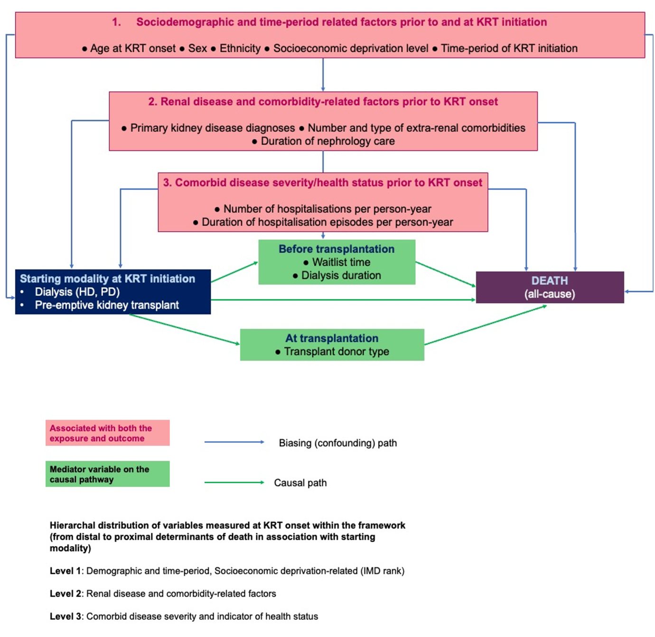

Covariates were grouped into three hierarchal levels, by their known and hypothesised distances to the exposure and outcome (Level 1, ‘first level’, most distal, to Level 3, ‘third level’, most proximal, see Figure 1). The length of time before being listed for transplantation, duration of dialysis with or without a kidney transplant and donor transplant type, identified as mediators of the association between first treatment modality at KRT start and the outcome of death were not included within regression analyses.

