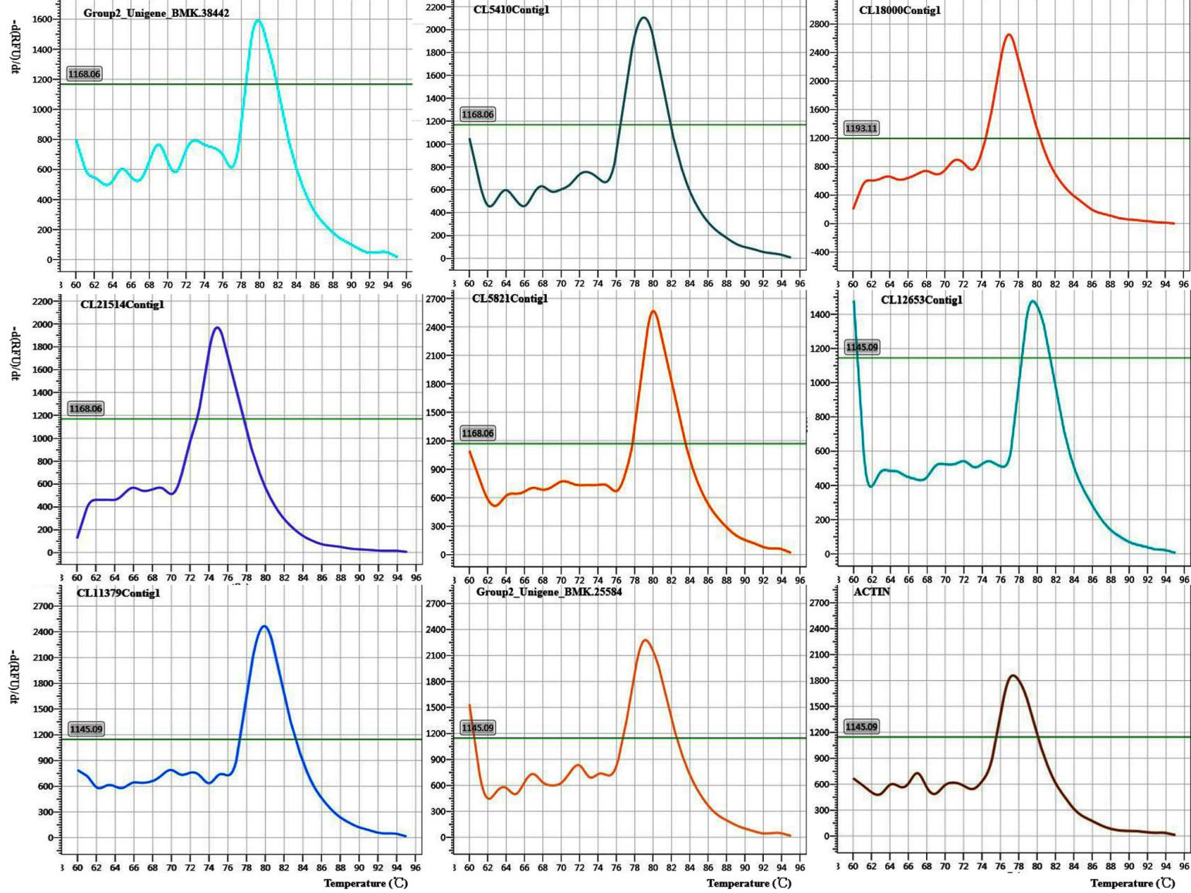
Fig. S1. The dissolution curves of primes and reference gene in two camellia seeds.

