Table S1. Regression parameters of the relation of δ¹³C to sapwood area for each genotype
Genotype | Intercept | Slope | Pr(>|t|) | adjusted.p
GT218 | -26.8860 | -0.0049 | 0.0092 | 0.1432
GT219 | -28.1128 | -0.0019 | 0.0624 | 0.2379
GT220 | -30.8492 | 0.0008 | 0.3944 | 0.6063
GT223 | -27.6859 | -0.0016 | 0.0324 | 0.1946
GT227 | -30.1607 | 0.0001 | 0.9272 | 0.9881
GT228 | -31.2180 | 0.0025 | 0.2431 | 0.4546
GT230 | -44.2472 | 0.0309 | 0.1073 | 0.3070
GT231 | -30.2283 | -0.0004 | 0.6069 | 0.8211
GT235 | -29.9560 | -0.0006 | 0.7761 | 0.9061
GT236 | -29.0595 | 0.0003 | 0.7362 | 0.8891
GT240 | -29.2017 | 0.0000 | 0.9623 | 0.9881
GT241 | -29.8420 | -0.0001 | 0.7961 | 0.9090
GT242 | -29.1261 | -0.0003 | 0.7429 | 0.8913
GT244 | -27.2238 | -0.0029 | 0.0029 | 0.0934 | .
GT248 | -27.9143 | -0.0030 | 0.0587 | 0.2357
GT251 | -28.7401 | -0.0016 | 0.0531 | 0.2357
GT252 | -27.5637 | -0.0027 | 0.0367 | 0.1984
GT253 | -31.4433 | 0.0016 | 0.1166 | 0.3121
GT255 | -30.9090 | 0.0005 | 0.5327 | 0.7664
GT257 | -29.5633 | -0.0003 | 0.7828 | 0.9068
GT258 | -35.7695 | 0.0096 | 0.1476 | 0.3377
GT259 | -30.1167 | 0.0016 | 0.5361 | 0.7664
GT260 | -27.3832 | -0.0045 | 0.0007 | 0.0387 | *
GT268 | -32.2970 | 0.0039 | 0.2210 | 0.4320
GT302 | -29.5507 | 0.0002 | 0.7928 | 0.9090
GT305 | -30.4655 | 0.0019 | 0.1028 | 0.3010
GT308 | -26.9393 | -0.0039 | 0.0001 | 0.0130 | *
GT309 | -29.8454 | -0.0013 | 0.8930 | 0.9597
GT311 | -29.4967 | -0.0002 | 0.8111 | 0.9171
GT312 | -29.8890 | 0.0000 | 0.9801 | 0.9905
GT315 | -29.7619 | 0.0002 | 0.8869 | 0.9596
GT316 | -29.7433 | -0.0002 | 0.8405 | 0.9285
GT318 | -29.3372 | -0.0006 | 0.2189 | 0.4320
GT325 | -29.5203 | 0.0004 | 0.6843 | 0.8646
GT326 | -28.2267 | -0.0015 | 0.0079 | 0.1432
GT327 | -28.7548 | -0.0007 | 0.5594 | 0.7793
GT329 | -28.4292 | -0.0010 | 0.1666 | 0.3613
GT333 | -28.2284 | -0.0020 | 0.4103 | 0.6287
GT334 | -29.1745 | -0.0002 | 0.8241 | 0.9232
GT335 | -29.6523 | 0.0005 | 0.6864 | 0.8646
GT339 | -27.9529 | -0.0035 | 0.1317 | 0.3223
GT341 | -30.1926 | -0.0005 | 0.5248 | 0.7623
GT342 | -30.3907 | 0.0003 | 0.6681 | 0.8554
GT343 | -29.2426 | -0.0010 | 0.0153 | 0.1480
GT344 | -29.4765 | 0.0001 | 0.9479 | 0.9881
GT345 | -31.5674 | 0.0025 | 0.2692 | 0.4844
GT346 | -29.5171 | 0.0008 | 0.7339 | 0.8891
GT347 | -28.9222 | -0.0012 | 0.0729 | 0.2540
GT352 | -28.4034 | -0.0017 | 0.1364 | 0.3288
GT357 | -27.9490 | -0.0011 | 0.3157 | 0.5299
GT363 | -29.3163 | -0.0006 | 0.4971 | 0.7243
GT365 | -12.3514 | -0.0236 | 0.1765 | 0.3776
GT366 | -32.7378 | 0.0017 | 0.3300 | 0.5368
GT368 | -27.0735 | -0.0029 | 0.1388 | 0.3303
GT371 | -30.1025 | 0.0007 | 0.5730 | 0.7912
GT372 | -31.2374 | 0.0008 | 0.4626 | 0.6931
GT373 | -28.1939 | -0.0015 | 0.0797 | 0.2705
GT380 | -30.2910 | 0.0000 | 0.9863 | 0.9927
GT381 | -30.6854 | 0.0000 | 0.9886 | 0.9927
GT383 | -29.8990 | 0.0013 | 0.0699 | 0.2495
GT385 | -28.6485 | -0.0015 | 0.2406 | 0.4517
GT389 | -28.2945 | -0.0038 | 0.4529 | 0.6873
GT390 | -29.4453 | -0.0001 | 0.9883 | 0.9927
GT392 | -27.4315 | -0.0016 | 0.0017 | 0.0728 | .
GT395 | -27.3470 | -0.0030 | 0.0305 | 0.1946
GT396 | -29.8277 | -0.0006 | 0.6783 | 0.8646
GT405 | -29.4365 | -0.0001 | 0.8679 | 0.9491
GT406 | -29.9352 | 0.0007 | 0.7803 | 0.9068
GT407 | -27.8063 | -0.0028 | 0.0680 | 0.2465
GT408 | -29.5780 | 0.0000 | 0.9975 | 0.9975
GT409 | -28.3930 | -0.0015 | 0.5713 | 0.7912
GT410 | -29.5848 | -0.0017 | 0.5792 | 0.7958
GT411 | -26.1127 | -0.0045 | 0.0025 | 0.0899 | .
GT413 | -29.4135 | 0.0003 | 0.9570 | 0.9881
GT414 | -28.5290 | -0.0017 | 0.0008 | 0.0416 | *
GT415 | -29.3638 | -0.0002 | 0.7999 | 0.9090
GT416 | -29.3729 | -0.0004 | 0.7620 | 0.9049
GT417 | -29.9805 | -0.0002 | 0.8712 | 0.9491
GT418 | -28.4775 | -0.0005 | 0.3556 | 0.5593
GT421 | -32.0453 | 0.0028 | 0.1179 | 0.3121
GT422 | -29.6614 | -0.0005 | 0.5797 | 0.7958
GT425 | -31.5255 | 0.0067 | 0.1132 | 0.3108
GT427 | -28.1326 | -0.0011 | 0.4709 | 0.7012
GT429 | -28.0593 | -0.0033 | 0.1229 | 0.3121
GT433 | -23.5536 | -0.0050 | 0.0432 | 0.2090
GT434 | -26.9999 | -0.0045 | 0.0239 | 0.1753
GT437 | -29.7392 | 0.0004 | 0.6180 | 0.8268
GT439 | -29.2045 | -0.0003 | 0.6609 | 0.8513
GT441 | -26.8120 | -0.0045 | 0.0006 | 0.0387 | *
GT442 | -29.5868 | -0.0010 | 0.3921 | 0.6047
GT443 | -29.9864 | -0.0005 | 0.7818 | 0.9068
GT445 | -26.8057 | -0.0038 | 0.0053 | 0.1129
GT447 | -28.4848 | -0.0005 | 0.4857 | 0.7164
GT456 | -30.5249 | 0.0015 | 0.3637 | 0.5646
GT460 | -29.9264 | -0.0009 | 0.7180 | 0.8790
GT461 | -26.3802 | -0.0046 | 0.1692 | 0.3653
GT463 | -30.0678 | -0.0004 | 0.6446 | 0.8467
GT466 | -29.1285 | -0.0016 | 0.0943 | 0.2836
GT467 | -29.7979 | -0.0001 | 0.9664 | 0.9881
GT470 | -30.0507 | 0.0001 | 0.9406 | 0.9881
GT471 | -33.4385 | 0.0050 | 0.1346 | 0.3278
GT473 | -28.0898 | -0.0018 | 0.0135 | 0.1450
GT475 | -28.9485 | -0.0025 | 0.2936 | 0.5072
GT477 | -31.1064 | 0.0008 | 0.2203 | 0.4320
GT479 | -30.7923 | 0.0010 | 0.7019 | 0.8706
GT481 | -29.6695 | -0.0001 | 0.9348 | 0.9881
GT484 | -31.0459 | 0.0011 | 0.5362 | 0.7664
GT486 | -28.2432 | -0.0018 | 0.0231 | 0.1753
GT487 | -29.1351 | -0.0004 | 0.9687 | 0.9881
GT488 | -28.8728 | -0.0006 | 0.3185 | 0.5316
GT489 | -27.3133 | -0.0034 | 0.0133 | 0.1450
GT490 | -29.2456 | 0.0000 | 0.9916 | 0.9937
GT491 | -29.2699 | -0.0028 | 0.1855 | 0.3934
GT494 | -30.5586 | 0.0003 | 0.6583 | 0.8513
GT501 | -28.6751 | -0.0009 | 0.6959 | 0.8676
GT506 | -29.0806 | 0.0006 | 0.7672 | 0.9055
GT507 | -29.2933 | 0.0009 | 0.6839 | 0.8646
GT508 | -30.8451 | 0.0030 | 0.5590 | 0.7793
GT509 | -29.3884 | -0.0010 | 0.1754 | 0.3771
GT513 | -29.2565 | -0.0003 | 0.8403 | 0.9285
GT514 | -29.7090 | 0.0000 | 0.9452 | 0.9881
GT518 | -27.7213 | -0.0023 | 0.0074 | 0.1432
GT520 | -30.5245 | 0.0011 | 0.7071 | 0.8747
GT523 | -29.6438 | -0.0003 | 0.6486 | 0.8467
GT533 | -29.2099 | -0.0003 | 0.9383 | 0.9881
GT534 | -29.9533 | -0.0005 | 0.7556 | 0.8996
GT537 | -30.1221 | -0.0003 | 0.7720 | 0.9061
GT538 | -30.1953 | -0.0004 | 0.6506 | 0.8467
GT539 | -30.0494 | 0.0003 | 0.7959 | 0.9090
GT540 | -29.6250 | 0.0001 | 0.9726 | 0.9881
GT541 | -29.5138 | -0.0012 | 0.2823 | 0.4966
GT543 | -29.9440 | -0.0005 | 0.8576 | 0.9408
GT544 | -29.0343 | -0.0007 | 0.3457 | 0.5474
GT547 | -29.7097 | 0.0001 | 0.8766 | 0.9512
GT548 | -29.3752 | -0.0006 | 0.2950 | 0.5072
GT549 | -28.1052 | -0.0009 | 0.3267 | 0.5355
GT553 | -29.5738 | -0.0002 | 0.8901 | 0.9597
GT554 | -29.6453 | 0.0002 | 0.8920 | 0.9597
GT559 | -29.3652 | -0.0007 | 0.6499 | 0.8467
GT561 | -28.4738 | -0.0013 | 0.1311 | 0.3223
GT562 | -29.5384 | 0.0002 | 0.9313 | 0.9881
GT563 | -29.7361 | 0.0000 | 0.9736 | 0.9881
GT564 | -27.9329 | -0.0028 | 0.2278 | 0.4381
GT567 | -28.9795 | -0.0013 | 0.3036 | 0.5169
GT571 | -28.9350 | -0.0011 | 0.1413 | 0.3322
GT572 | -27.9997 | -0.0017 | 0.1033 | 0.3010
GT584 | -18.3702 | -0.0181 | 0.7122 | 0.8765
GT586 | -28.4650 | -0.0027 | 0.1043 | 0.3010
GT589 | -28.9310 | -0.0024 | 0.0806 | 0.2711
GT590 | -29.8971 | -0.0008 | 0.3036 | 0.5169
GT591 | -28.0235 | -0.0014 | 0.1598 | 0.3529
GT592 | -28.2675 | -0.0012 | 0.0102 | 0.1432
GT593 | -32.2214 | 0.0051 | 0.1993 | 0.4107
GT594 | -28.6947 | -0.0014 | 0.2904 | 0.5067
GT595 | -30.3552 | -0.0002 | 0.7525 | 0.8980
GT601 | -32.0502 | 0.0037 | 0.0109 | 0.1432
GT602 | -24.3259 | -0.0108 | 0.2006 | 0.4107
GT603 | -29.2693 | -0.0010 | 0.3600 | 0.5631
GT605 | -27.2911 | -0.0047 | 0.0652 | 0.2455
GT607 | -28.9690 | -0.0009 | 0.3494 | 0.5514
GT612 | -27.8321 | -0.0018 | 0.1518 | 0.3435
GT615 | -28.6726 | -0.0019 | 0.0320 | 0.1946
GT616 | -28.3839 | -0.0007 | 0.0995 | 0.2934
GT618 | -30.8170 | 0.0003 | 0.7682 | 0.9055
GT627 | -29.6534 | -0.0006 | 0.2957 | 0.5072
GT628 | -28.2099 | -0.0013 | 0.1116 | 0.3108
GT634 | -28.7306 | -0.0005 | 0.6927 | 0.8674
GT638 | -29.6086 | 0.0001 | 0.9522 | 0.9881
GT639 | -28.3203 | -0.0029 | 0.0596 | 0.2357
GT641 | -29.9480 | -0.0002 | 0.8147 | 0.9171
GT644 | -29.2812 | -0.0008 | 0.2684 | 0.4844
GT645 | -30.3151 | -0.0002 | 0.7748 | 0.9061
GT647 | -29.6482 | 0.0000 | 0.9707 | 0.9881
GT648 | -29.3317 | -0.0001 | 0.9796 | 0.9905
GT649 | -31.0525 | 0.0046 | 0.1398 | 0.3303
GT651 | -29.6647 | -0.0001 | 0.8556 | 0.9408
GT652 | -29.7878 | -0.0006 | 0.7667 | 0.9055
GT654 | -30.0337 | -0.0003 | 0.7357 | 0.8891
GT655 | -28.7976 | -0.0013 | 0.1479 | 0.3377
GT657 | -35.3513 | 0.0103 | 0.1197 | 0.3121
GT659 | -29.9275 | -0.0007 | 0.3373 | 0.5394
GT660 | -32.2873 | 0.0025 | 0.5503 | 0.7793
GT661 | -30.8173 | 0.0023 | 0.2856 | 0.5006
GT663 | -29.2383 | 0.0007 | 0.7375 | 0.8891
GT665 | -29.5047 | -0.0010 | 0.2594 | 0.4738
GT666 | -22.5707 | -0.0115 | 0.0015 | 0.0717 | .
GT667 | -28.9905 | -0.0007 | 0.4154 | 0.6344
GT669 | -29.4902 | -0.0013 | 0.6613 | 0.8513
GT670 | -30.9431 | 0.0026 | 0.2085 | 0.4182
GT672 | -29.1905 | -0.0011 | 0.2351 | 0.4466
GT675 | -32.0424 | 0.0030 | 0.3114 | 0.5245
GT676 | -32.4347 | 0.0023 | 0.2321 | 0.4446
GT678 | -28.8288 | -0.0010 | 0.2540 | 0.4659
GT681 | -29.6311 | -0.0001 | 0.9336 | 0.9881
GT687 | -30.8304 | 0.0001 | 0.9637 | 0.9881
GT689 | -30.0362 | -0.0002 | 0.8146 | 0.9171
GT690 | -29.4495 | 0.0005 | 0.6347 | 0.8444
GT691 | -28.6267 | -0.0015 | 0.0587 | 0.2357
GT696 | -30.4713 | 0.0002 | 0.8573 | 0.9408
GT706 | -27.7666 | -0.0038 | 0.0870 | 0.2754
GT710 | -29.0311 | 0.0003 | 0.8362 | 0.9285
GT711 | -29.3796 | -0.0007 | 0.7965 | 0.9090
GT712 | -25.6303 | -0.0048 | 0.0816 | 0.2711
GT714 | -30.2001 | 0.0002 | 0.8771 | 0.9512
GT716 | -28.7760 | -0.0007 | 0.5976 | 0.8111
GT717 | -30.1175 | -0.0003 | 0.9344 | 0.9881
GT720 | -28.6249 | -0.0025 | 0.1128 | 0.3108
GT721 | -30.3865 | 0.0026 | 0.1145 | 0.3118
GT724 | -29.8935 | -0.0011 | 0.5536 | 0.7793
GT725 | -28.8197 | -0.0010 | 0.5556 | 0.7793
GT726 | -29.0529 | -0.0010 | 0.2502 | 0.4606
GT730 | -29.1154 | -0.0008 | 0.4745 | 0.7021
GT731 | -29.7260 | -0.0007 | 0.6464 | 0.8467
GT734 | -28.9255 | -0.0010 | 0.2794 | 0.4966
GT735 | -29.7532 | -0.0005 | 0.8390 | 0.9285
GT736 | -29.8076 | -0.0001 | 0.9310 | 0.9881
GT737 | -28.9798 | -0.0003 | 0.7261 | 0.8866
GT87101 | -29.4597 | 0.0006 | 0.6856 | 0.8646
GT8722 | -30.4829 | 0.0002 | 0.8129 | 0.9171
GT8723 | -29.4163 | -0.0001 | 0.9080 | 0.9736
GT8725 | -29.5705 | 0.0001 | 0.9625 | 0.9881
GT8733 | -29.7454 | -0.0002 | 0.8351 | 0.9285
GT8739 | -30.3486 | -0.0003 | 0.7884 | 0.9090
GT8759 | -28.3628 | -0.0016 | 0.2064 | 0.4182
GT8761 | -27.9518 | -0.0021 | 0.2662 | 0.4826
GT8768 | -28.8574 | -0.0014 | 0.6466 | 0.8467
GT8769 | -31.0190 | 0.0007 | 0.3617 | 0.5632
GT8770 | -30.2132 | 0.0005 | 0.6939 | 0.8674
GT8771 | -28.4749 | -0.0014 | 0.3393 | 0.5408
GT8777 | -30.7565 | 0.0010 | 0.6407 | 0.8467
GT8778 | -29.9488 | 0.0012 | 0.6984 | 0.8685
GT8781 | -29.2484 | -0.0021 | 0.1083 | 0.3079
GT8784 | -27.3789 | -0.0029 | 0.2160 | 0.4292
GT8788 | -28.5749 | -0.0006 | 0.7158 | 0.8785
GT8792 | -23.3593 | -0.0137 | 0.5283 | 0.7627
GT8795 | -22.8021 | -0.0120 | 0.0041 | 0.1055

Table S2. Regression parameters of the relation of δ¹⁸O to sapwood area for each genotype
GENOTYPE | Intercept | Slope | Pr(>|t|) | adjusted.p
GT218 | 18.2082 | 0.0015 | 0.4055 | 0.6716
GT219 | 19.4123 | 0.0003 | 0.7795 | 0.8989
GT220 | 18.8826 | 0.0012 | 0.1674 | 0.5088
GT223 | 19.1810 | -0.0001 | 0.8544 | 0.9279
GT227 | 19.1839 | -0.0001 | 0.9493 | 0.9778
GT228 | 19.8835 | -0.0008 | 0.6992 | 0.8495
GT230 | 12.2310 | 0.0170 | 0.3633 | 0.6468
GT231 | 19.0268 | 0.0009 | 0.1885 | 0.5093
GT235 | 19.8722 | -0.0002 | 0.9114 | 0.9589
GT236 | 20.7020 | -0.0015 | 0.0875 | 0.4690
GT240 | 19.4422 | -0.0008 | 0.3185 | 0.6046
GT241 | 19.5568 | 0.0000 | 0.8966 | 0.9564
GT242 | 19.7618 | -0.0011 | 0.1800 | 0.5093
GT244 | 20.2162 | -0.0012 | 0.2196 | 0.5320
GT248 | 20.8440 | -0.0029 | 0.0620 | 0.4140
GT251 | 20.4885 | -0.0010 | 0.2095 | 0.5289
GT252 | 19.8956 | 0.0000 | 0.9932 | 0.9954
GT253 | 19.0367 | 0.0002 | 0.8523 | 0.9278
GT255 | 18.8353 | -0.0002 | 0.7539 | 0.8824
GT257 | 20.1303 | -0.0005 | 0.5513 | 0.7757
GT258 | 18.3543 | 0.0021 | 0.7471 | 0.8811
GT259 | 17.7118 | 0.0033 | 0.1917 | 0.5093
GT260 | 22.3176 | -0.0038 | 0.0005 | 0.0030 | **
GT268 | 16.3586 | 0.0061 | 0.0536 | 0.4013
GT302 | 18.5425 | 0.0004 | 0.5832 | 0.7880
GT305 | 20.0637 | 0.0001 | 0.9141 | 0.9589
GT308 | 20.3351 | -0.0014 | 0.0087 | 0.0119 | *
GT309 | 21.4247 | -0.0038 | 0.6966 | 0.8495
GT311 | 20.8427 | -0.0009 | 0.3290 | 0.6171
GT312 | 20.2382 | -0.0008 | 0.4890 | 0.7356
GT315 | 20.1629 | -0.0007 | 0.6218 | 0.8072
GT316 | 20.2513 | -0.0012 | 0.1446 | 0.5088
GT318 | 20.5942 | -0.0007 | 0.1554 | 0.5088
GT325 | 20.2613 | -0.0005 | 0.4620 | 0.7191
GT326 | 20.2019 | -0.0008 | 0.1348 | 0.5088
GT327 | 21.4170 | -0.0024 | 0.0514 | 0.4013
GT329 | 21.7280 | -0.0008 | 0.2708 | 0.5775
GT333 | 18.5468 | 0.0028 | 0.2387 | 0.5518
GT334 | 21.0455 | -0.0014 | 0.0966 | 0.4690
GT335 | 21.3613 | -0.0020 | 0.0722 | 0.4216
GT339 | 18.5744 | 0.0035 | 0.1263 | 0.5088
GT341 | 18.8726 | 0.0010 | 0.1795 | 0.5093
GT342 | 21.1336 | -0.0018 | 0.0021 | 0.1378
GT343 | 19.2270 | 0.0003 | 0.3998 | 0.6672
GT344 | 20.0528 | 0.0000 | 0.9995 | 0.9995
GT345 | 21.9725 | -0.0034 | 0.1206 | 0.5072
GT346 | 20.3985 | 0.0004 | 0.8630 | 0.9330
GT347 | 19.6504 | 0.0008 | 0.2443 | 0.5518
GT352 | 22.2940 | -0.0033 | 0.0024 | 0.1388
GT357 | 19.4387 | 0.0008 | 0.4452 | 0.7025
GT363 | 20.8013 | -0.0013 | 0.1612 | 0.5088
GT365 | 29.8414 | -0.0127 | 0.4541 | 0.7092
GT366 | 16.7430 | 0.0025 | 0.1447 | 0.5088
GT368 | 18.0993 | 0.0016 | 0.4070 | 0.6717
GT371 | 18.8155 | 0.0015 | 0.2449 | 0.5518
GT372 | 19.4294 | 0.0007 | 0.5163 | 0.7559
GT373 | 18.8238 | 0.0011 | 0.1817 | 0.5093
GT380 | 18.8394 | 0.0023 | 0.0799 | 0.4604
GT381 | 18.0023 | 0.0020 | 0.1459 | 0.5088
GT383 | 21.3401 | -0.0015 | 0.0261 | 0.3982
GT385 | 21.0913 | -0.0016 | 0.1821 | 0.5093
GT389 | 21.5006 | -0.0027 | 0.5815 | 0.7880
GT390 | 35.1234 | -0.0200 | 0.0323 | 0.3982
GT392 | 20.0267 | 0.0003 | 0.6191 | 0.8072
GT395 | 20.8786 | -0.0023 | 0.0853 | 0.4690
GT396 | 21.7831 | -0.0020 | 0.1656 | 0.5088
GT405 | 21.4653 | -0.0013 | 0.0531 | 0.4013
GT406 | 19.8418 | 0.0002 | 0.9271 | 0.9612
GT407 | 21.1763 | -0.0014 | 0.3611 | 0.6468
GT408 | 20.4088 | -0.0007 | 0.0351 | 0.3982
GT409 | 18.8061 | 0.0014 | 0.5671 | 0.7843
GT410 | 17.5559 | 0.0048 | 0.1192 | 0.5063
GT411 | 21.3680 | -0.0016 | 0.2754 | 0.5784
GT413 | 19.5382 | 0.0033 | 0.5637 | 0.7835
GT414 | 20.0591 | -0.0001 | 0.4505 | 0.4505
GT415 | 19.7341 | -0.0005 | 0.5568 | 0.7785
GT416 | 21.6716 | -0.0019 | 0.0973 | 0.4690
GT417 | 20.2941 | -0.0003 | 0.7793 | 0.8989
GT418 | 19.4041 | 0.0006 | 0.3085 | 0.6041
GT421 | 20.4311 | -0.0007 | 0.6657 | 0.8357
GT422 | 19.8949 | 0.0006 | 0.4895 | 0.7356
GT425 | 19.9262 | 0.0006 | 0.8854 | 0.9527
GT427 | 19.9403 | -0.0007 | 0.6510 | 0.8262
GT429 | 20.1743 | -0.0018 | 0.3848 | 0.6582
GT433 | 24.0959 | -0.0037 | 0.1282 | 0.5088
GT434 | 19.2188 | 0.0002 | 0.9158 | 0.9589
GT437 | 19.2844 | 0.0009 | 0.2199 | 0.5320
GT439 | 19.7051 | 0.0004 | 0.5700 | 0.7843
GT441 | 20.6567 | -0.0018 | 0.0103 | 0.0119 | *
GT442 | 18.5052 | 0.0004 | 0.6936 | 0.8495
GT443 | 19.7760 | 0.0002 | 0.9283 | 0.9612
GT445 | 19.3779 | 0.0002 | 0.8970 | 0.9564
GT447 | 19.1800 | -0.0004 | 0.6220 | 0.8072
GT456 | 18.1402 | 0.0032 | 0.0458 | 0.3982
GT460 | 20.2475 | -0.0022 | 0.3554 | 0.6458
GT461 | 19.9107 | 0.0003 | 0.9258 | 0.9612
GT463 | 19.4045 | -0.0004 | 0.5983 | 0.7983
GT466 | 19.7434 | -0.0012 | 0.1965 | 0.5154
GT467 | 18.8867 | 0.0001 | 0.9713 | 0.9818
GT470 | 19.8798 | 0.0004 | 0.7910 | 0.9050
GT471 | 21.1710 | -0.0025 | 0.4509 | 0.7090
GT473 | 20.5233 | -0.0002 | 0.7414 | 0.8787
GT475 | 19.6775 | 0.0007 | 0.7493 | 0.8814
GT477 | 19.0058 | 0.0002 | 0.7657 | 0.8896
GT479 | 19.7276 | -0.0003 | 0.8999 | 0.9572
GT481 | 17.2462 | 0.0016 | 0.1627 | 0.5088
GT484 | 20.1217 | -0.0012 | 0.4981 | 0.7407
GT486 | 19.8752 | -0.0001 | 0.9224 | 0.9612
GT487 | 19.4363 | 0.0011 | 0.9088 | 0.9589
GT488 | 19.6367 | -0.0003 | 0.5855 | 0.7880
GT489 | 19.4446 | 0.0005 | 0.7248 | 0.8679
GT490 | 20.5106 | -0.0011 | 0.3934 | 0.6620
GT491 | 18.7486 | 0.0023 | 0.2550 | 0.5564
GT494 | 20.5777 | -0.0004 | 0.6038 | 0.8010
GT501 | 18.7219 | 0.0010 | 0.6504 | 0.8262
GT506 | 19.8761 | 0.0001 | 0.9638 | 0.9778
GT507 | 20.1014 | -0.0006 | 0.7854 | 0.9012
GT508 | 19.7767 | -0.0019 | 0.7043 | 0.8499
GT509 | 20.3603 | -0.0016 | 0.0245 | 0.3982
GT513 | 19.1114 | 0.0006 | 0.6751 | 0.8385
GT514 | 20.3545 | -0.0016 | 0.0050 | 0.1786
GT518 | 19.9047 | -0.0001 | 0.9219 | 0.9612
GT520 | 21.9969 | -0.0051 | 0.0683 | 0.4140
GT523 | 19.6905 | 0.0002 | 0.8029 | 0.9092
GT533 | 24.7667 | -0.0050 | 0.1910 | 0.5093
GT534 | 19.3405 | 0.0005 | 0.7576 | 0.8845
GT537 | 19.7133 | -0.0008 | 0.4966 | 0.7407
GT538 | 20.8510 | -0.0027 | 0.0029 | 0.1520
GT539 | 21.0246 | -0.0022 | 0.0675 | 0.4140
GT540 | 20.7957 | -0.0017 | 0.2962 | 0.5962
GT541 | 19.8545 | -0.0011 | 0.3169 | 0.6041
GT543 | 19.1003 | 0.0002 | 0.9435 | 0.9748
GT544 | 19.3595 | 0.0002 | 0.7410 | 0.8787
GT547 | 19.5153 | 0.0000 | 0.9563 | 0.9778
GT548 | 20.5831 | -0.0012 | 0.0269 | 0.3982
GT549 | 20.0692 | -0.0004 | 0.6238 | 0.8072
GT553 | 16.4976 | 0.0022 | 0.1547 | 0.5088
GT554 | 19.7325 | 0.0007 | 0.6785 | 0.8395
GT559 | 18.5231 | 0.0011 | 0.4819 | 0.7355
GT561 | 19.8296 | 0.0000 | 0.9539 | 0.9778
GT562 | 18.5632 | 0.0018 | 0.3740 | 0.6498
GT563 | 20.1269 | -0.0008 | 0.3781 | 0.6539
GT564 | 20.9847 | -0.0019 | 0.3938 | 0.6620
GT567 | 20.9694 | -0.0023 | 0.0625 | 0.4140
GT571 | 20.1468 | -0.0009 | 0.2473 | 0.5518
GT572 | 21.0262 | -0.0016 | 0.1147 | 0.5063
GT584 | 28.0116 | -0.0122 | 0.7988 | 0.9092
GT586 | 20.5791 | -0.0022 | 0.1765 | 0.5093
GT589 | 21.0452 | -0.0018 | 0.1919 | 0.5093
GT590 | 19.3817 | 0.0002 | 0.8387 | 0.9216
GT591 | 21.3982 | -0.0015 | 0.1139 | 0.5063
GT592 | 21.0873 | -0.0007 | 0.1361 | 0.5088
GT593 | 19.2350 | 0.0005 | 0.8930 | 0.9564
GT594 | 21.1218 | -0.0015 | 0.2432 | 0.5518
GT595 | 21.9254 | -0.0024 | 0.0004 | 0.0448 | *
GT601 | 19.6598 | -0.0015 | 0.2999 | 0.5962
GT602 | 16.1811 | 0.0069 | 0.4033 | 0.6702
GT603 | 20.9994 | -0.0015 | 0.1573 | 0.5088
GT605 | 20.9713 | -0.0029 | 0.2466 | 0.5518
GT607 | 20.3590 | -0.0016 | 0.1030 | 0.4764
GT612 | 22.1204 | -0.0019 | 0.1248 | 0.5088
GT615 | 19.8554 | 0.0005 | 0.5710 | 0.7843
GT616 | 20.7229 | -0.0007 | 0.0884 | 0.4690
GT618 | 19.6345 | -0.0002 | 0.8079 | 0.9092
GT627 | 19.0471 | -0.0001 | 0.8496 | 0.9270
GT628 | 19.9061 | 0.0000 | 0.9875 | 0.9917
GT634 | 21.2115 | -0.0006 | 0.6230 | 0.8072
GT638 | 18.5004 | 0.0041 | 0.0359 | 0.3982
GT639 | 20.2150 | -0.0010 | 0.5237 | 0.7631
GT641 | 19.1982 | 0.0009 | 0.3568 | 0.6459
GT644 | 19.3561 | 0.0005 | 0.4286 | 0.6927
GT645 | 20.4938 | -0.0013 | 0.0700 | 0.4189
GT647 | 20.0157 | -0.0002 | 0.7336 | 0.8762
GT648 | 19.6009 | 0.0013 | 0.5554 | 0.7785
GT649 | 20.3628 | -0.0009 | 0.7627 | 0.8883
GT651 | 19.8060 | 0.0005 | 0.5395 | 0.7728
GT652 | 20.0292 | 0.0000 | 0.9856 | 0.9917
GT654 | 20.3353 | -0.0004 | 0.6511 | 0.8262
GT655 | 22.4177 | -0.0026 | 0.0035 | 0.1581
GT657 | 17.4981 | 0.0050 | 0.4409 | 0.7025
GT659 | 20.2591 | -0.0010 | 0.1824 | 0.5093
GT660 | 21.2300 | -0.0041 | 0.3127 | 0.6041
GT661 | 21.4394 | -0.0012 | 0.5843 | 0.7880
GT663 | 21.6917 | -0.0029 | 0.1287 | 0.5088
GT665 | 19.2153 | 0.0004 | 0.5906 | 0.7903
GT666 | 21.3341 | -0.0023 | 0.5156 | 0.7559
GT667 | 20.8335 | -0.0011 | 0.1829 | 0.5093
GT669 | 21.2549 | -0.0012 | 0.6860 | 0.8431
GT670 | 20.4130 | 0.0005 | 0.8018 | 0.9092
GT672 | 20.3081 | -0.0002 | 0.8270 | 0.9164
GT675 | 17.3437 | 0.0034 | 0.2441 | 0.5518
GT676 | 19.2861 | 0.0008 | 0.6813 | 0.8395
GT678 | 20.7922 | -0.0009 | 0.3011 | 0.5962
GT681 | 17.5127 | 0.0019 | 0.1339 | 0.5088
GT687 | 18.9119 | -0.0011 | 0.5837 | 0.7880
GT689 | 20.1127 | -0.0009 | 0.3813 | 0.6546
GT690 | 19.8215 | -0.0016 | 0.0977 | 0.4690
GT691 | 19.7004 | -0.0006 | 0.4430 | 0.7025
GT696 | 17.3373 | 0.0044 | 0.0009 | 0.0886 | .
GT706 | 22.7546 | -0.0070 | 0.0013 | 0.1004
GT710 | 19.1145 | 0.0021 | 0.2031 | 0.5225
GT711 | 21.6535 | -0.0024 | 0.3668 | 0.6468
GT712 | 23.3743 | -0.0038 | 0.1562 | 0.5088
GT714 | 18.0090 | 0.0025 | 0.0337 | 0.3982
GT716 | 18.5809 | 0.0016 | 0.2253 | 0.5365
GT717 | 15.1537 | 0.0065 | 0.0456 | 0.3982
GT720 | 20.2619 | -0.0002 | 0.9123 | 0.9589
GT721 | 20.2081 | -0.0014 | 0.3743 | 0.6498
GT724 | 19.7835 | 0.0006 | 0.7458 | 0.8811
GT725 | 17.3547 | 0.0023 | 0.1473 | 0.5088
GT726 | 20.0331 | -0.0005 | 0.5491 | 0.7757
GT730 | 19.5966 | -0.0003 | 0.7792 | 0.8989
GT731 | 20.3350 | -0.0015 | 0.2994 | 0.5962
GT734 | 20.7644 | -0.0012 | 0.1917 | 0.5093
GT735 | 19.9679 | 0.0001 | 0.9652 | 0.9778
GT736 | 20.2300 | 0.0003 | 0.8266 | 0.9164
GT737 | 20.8885 | -0.0016 | 0.0430 | 0.3982
GT87101 | 19.6972 | -0.0004 | 0.7926 | 0.9050
GT8722 | 19.6550 | 0.0003 | 0.6257 | 0.8072
GT8723 | 20.1338 | -0.0010 | 0.3648 | 0.6468
GT8725 | 19.4614 | 0.0008 | 0.6119 | 0.8049
GT8733 | 20.9917 | -0.0013 | 0.1935 | 0.5104
GT8739 | 20.9260 | -0.0018 | 0.0656 | 0.4140
GT8759 | 19.9833 | 0.0006 | 0.6114 | 0.8049
GT8761 | 21.6318 | -0.0017 | 0.3479 | 0.6445
GT8768 | 19.8463 | 0.0004 | 0.9023 | 0.9572
GT8769 | 18.7538 | 0.0006 | 0.4252 | 0.6894
GT8770 | 21.4587 | -0.0028 | 0.0408 | 0.3982
GT8771 | 20.0184 | -0.0010 | 0.4779 | 0.7342
GT8777 | 22.1883 | -0.0039 | 0.0582 | 0.4140
GT8778 | 19.7870 | 0.0015 | 0.6030 | 0.8010
GT8781 | 20.6015 | -0.0001 | 0.9634 | 0.9778
GT8784 | 18.2937 | 0.0034 | 0.1466 | 0.5088
GT8788 | 19.2943 | 0.0015 | 0.3659 | 0.6468
GT8792 | 13.3284 | 0.0150 | 0.4796 | 0.7344
GT8795 | 17.5442 | 0.0052 | 0.2017 | 0.5225

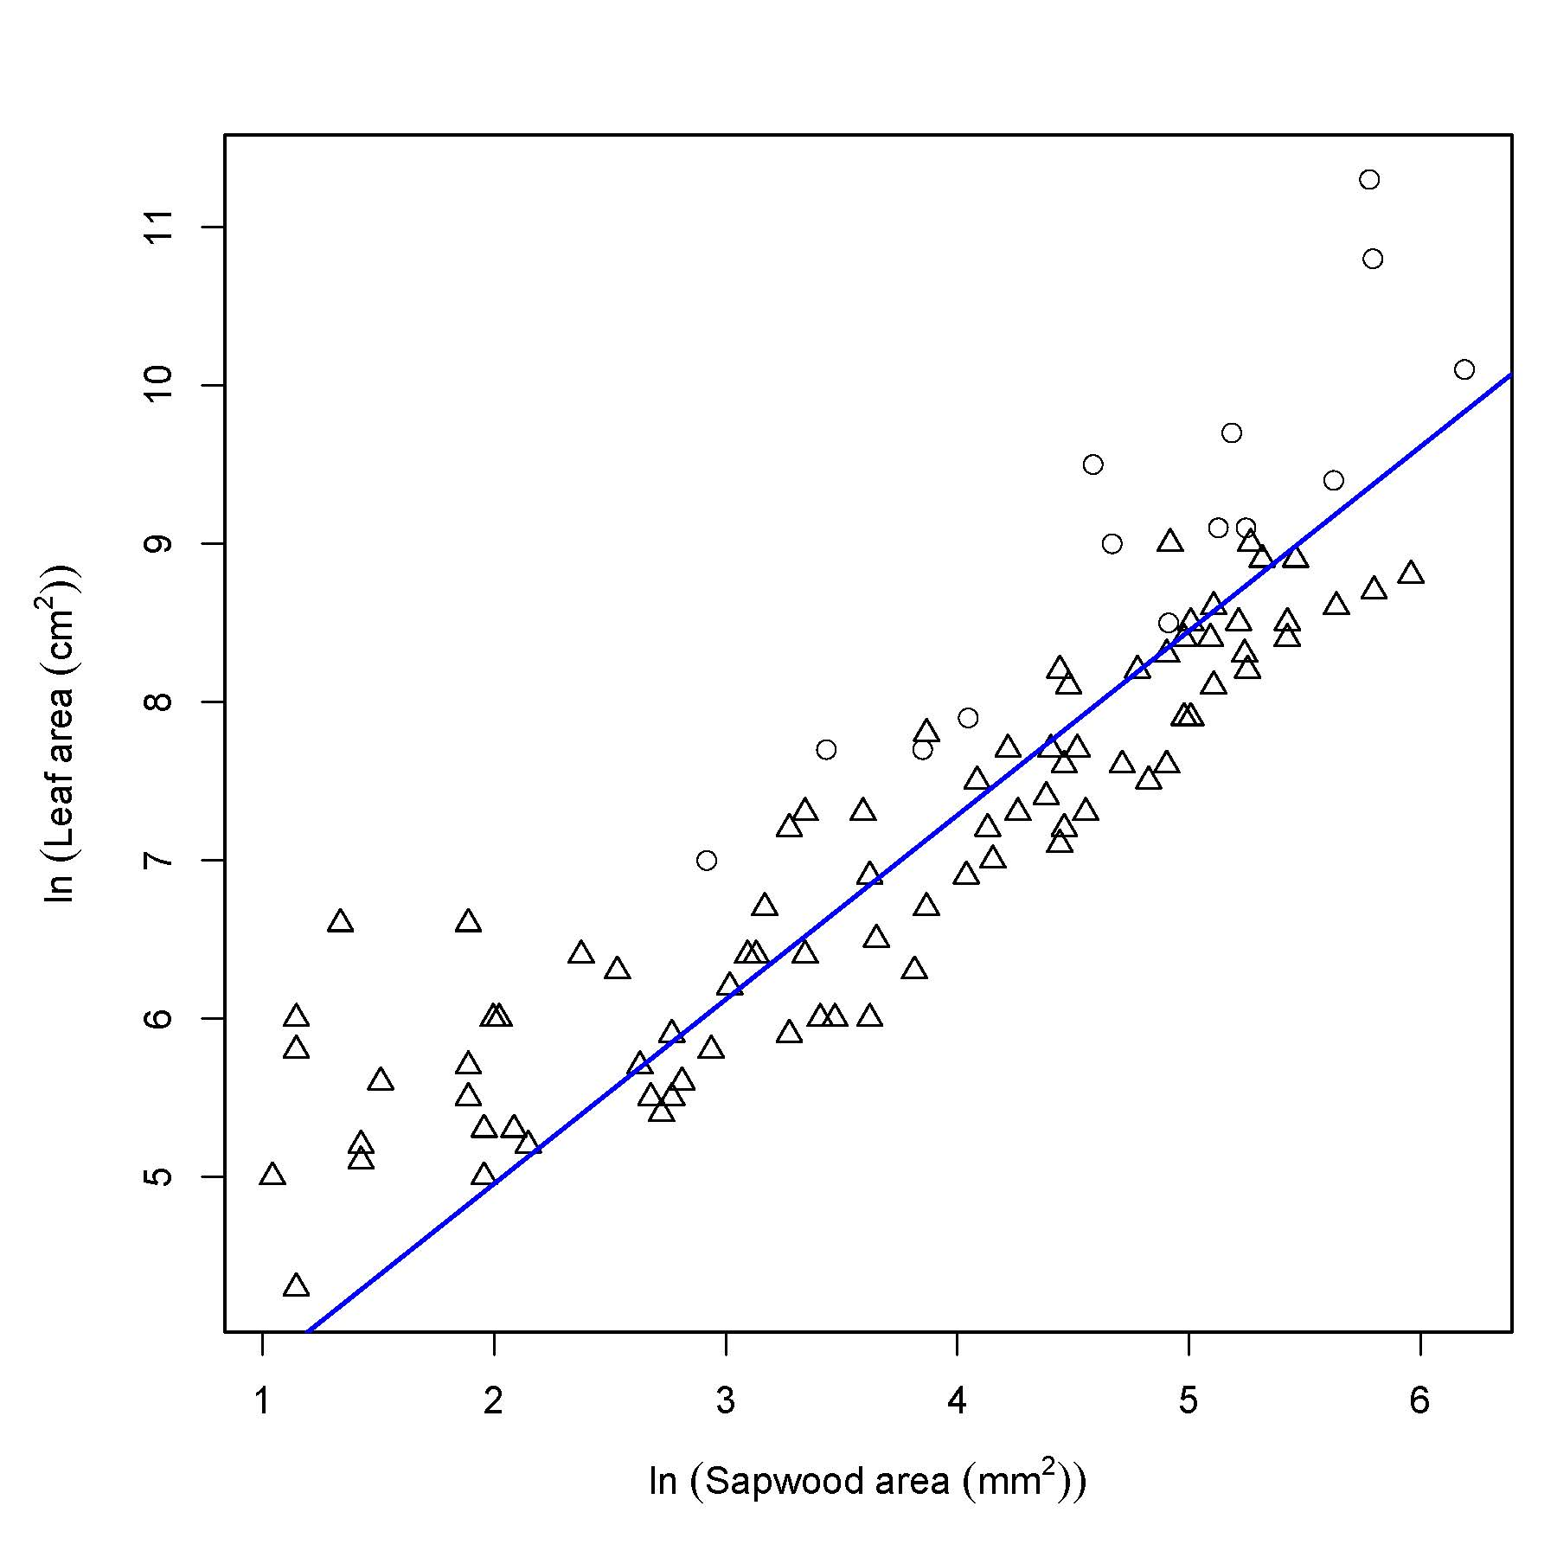
Figure S1. Leaf area (ln) as function of sapwood area (ln) (y=1.1634x+2.631) at 1.20 m height of 98 shoots from the field trial in Sweden (n=84, triangles) and Italy (n=14, dots), R² adj.= 0.71, P<0.0001.

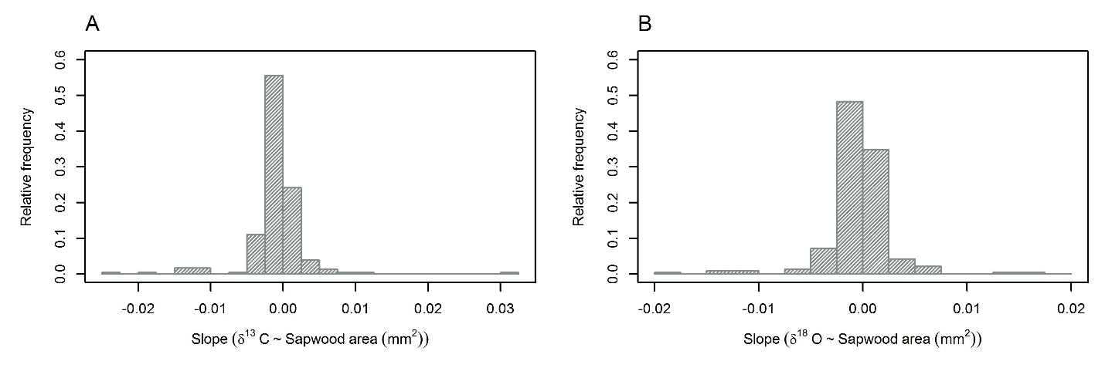
Figure S2. Histograms of regression slopes of the 236 Salix genotypes for a) regression of δ¹³C against Sapwood area (mm²) and b) regression of δ¹⁸O against Sapwood area (mm²).
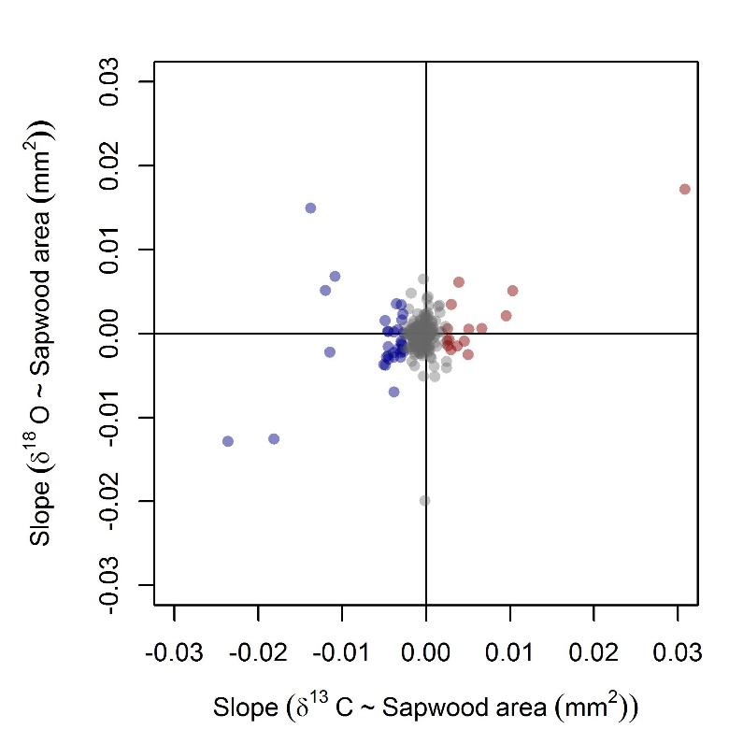
Figure S3. Scatterplot of the slopes of the δ¹⁸O – Sapwood area regressions against the slopes of the δ¹³C– Sapwood area regressions for the 236 Salix genotypes. Colors are indicative of the Water Use Strategy of the single genotypes: blue: intensive water users, grey: neutral water users, red: conservative water users.

