Supplementary information
Table S1. Pearson’s correlations (r values) between constitutive (N=36 per region) and induced chemical defences (N=36 per region and treatment) in Quercus ilex leaves (total phenols Tp, total tannins Tt, and condensed tannins Ct) by regions and stressors. Regions of origin (ordered from highest to lowest latitude): Picos de Europa (P), Ordesa (O), Guadarrama (G), Monfragüe (M), Cabañeros (C) and Sierra Nevada (S). Applied treatments: inoculation with Phytophthora cinnamomi (Pc), mechanical defoliation (d) and double treatment pathogen infection/mechanical defoliation (dPc).
P | Tp by Pc | Ct by Pc | Tt by Pc | Tp by d | Ct by d | Tt by d | Tp by dPc | Ct by dPc | Tt by dPc
Constitutive Tp | -0.59* |  |  | -0.72* |  |  | -0.6*
Constitutive Ct |  | -0.55 |  |  | -0.54 |  |  | -0.61*
Constitutive Tt |  |  | -0.69* |  |  | -0,7.* |  |  | -0.61*

O | Tp by Pc | Ct by Pc | Tt by Pc | Tp by d | Ct by d | Tt by d | Tp by dPc | Ct by dPc | Tt by dPc
Constitutive Tp | -0.91* |  |  | -0.68* |  |  | -0.53
Constitutive Ct |  | -0.57 |  |  | -0.68* |  |  | -0.49
Constitutive Tt |  |  | -0.84* |  |  | -0.41 |  |  | -0.47

G | Tp by Pc | Ct by Pc | Tt by Pc | Tp by d | Ct by d | Tt by d | Tp by dPc | Ct by dPc | Tt by dPc
Constitutive Tp | 0.22 |  |  | -0.12 |  |  | 0.78
Constitutive Ct |  | -0.24 |  |  | -0.37 |  |  | -0.64
Constitutive Tt |  |  | 0.79 |  |  | 0.32 |  |  | 0.51

M | Tp by Pc | Ct by Pc | Tt by Pc | Tp by d | Ct by d | Tt by d | Tp by dPc | Ct by dPc | Tt by dPc
Constitutive Tp | -0.56 |  |  | -0.24 |  |  | -0.73
Constitutive Ct |  | -0.39 |  |  | -0.69* |  |  | -0.79*
Constitutive Tt |  |  | -0.58 |  |  | 0.14 |  |  | -0.78*

C | Tp by Pc | Ct by Pc | Tt by Pc | Tp by d | Ct by d | Tt by d | Tp by dPc | Ct by dPc | Tt by dPc
Constitutive Tp | -0.57 |  |  | -0.8* |  |  | -0.87*
Constitutive Ct |  | -0.39 |  |  | -0.48 |  |  | -0.51
Constitutive Tt |  |  | -0.59 |  |  | -0.67* |  |  | -0.69*

S | Tp by Pc | Ct by Pc | Tt by Pc | Tp by d | Ct by d | Tt by d | Tp by dPc | Ct by dPc | Tt by dPc
Constitutive Tp | -0.8* |  |  | -0.73* |  |  | -0.68*
Constitutive Ct |  | -0.62* |  |  | -0.25 |  |  | -0.64*
Constitutive Tt |  |  | -0.74* |  |  | -0.78* |  |  | -0.75*
* r-values with statistical significance: *p < 0.05; ns p > 0.05
Table S2. Pearson’s correlations (r values) at region level (N=12 families per region) among induced chemical defences, total defences and survival in Quercus ilex leaves (total phenols, total tannins and condensed tannins). Regions of origin (ordered from highest to lowest latitude): Picos de Europa (P), Ordesa (O), Guadarrama (G), Monfragüe (M), Cabañeros (C) and Sierra Nevada (S).
 | Induced defences |  |  | Total defences (constitutive+induced)
Survival in region | Total phenolics | Total tannins | Condensed tannins |  | Total phenolics | Total tannins | Condensed tannins
P | 0.24 | 0.09 | 0.28 |  | 0.29 | 0.12 | 0.39*
O | 0.19 | 0.23 | 0.37* |  | 0.27 | 0.28 | 0.43*
G | -0.28 | -0.01 | -0.15 |  | -0.24 | -0.01 | -0.19
M | -0.12 | -0.17 | -0.05 |  | -0.17 | -0.21 | -0.03
C | -0.09 | 0.32 | 0.1 |  | -0.13 | 0.39 | 0.1
S | -0.21 | -0.002 | -0.55* |  | -0.29 | -0.04 | -0.59*
* r-values with statistical significance: *p < 0.05; ns p > 0.05

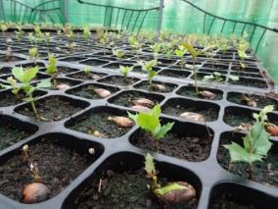  a) |  | 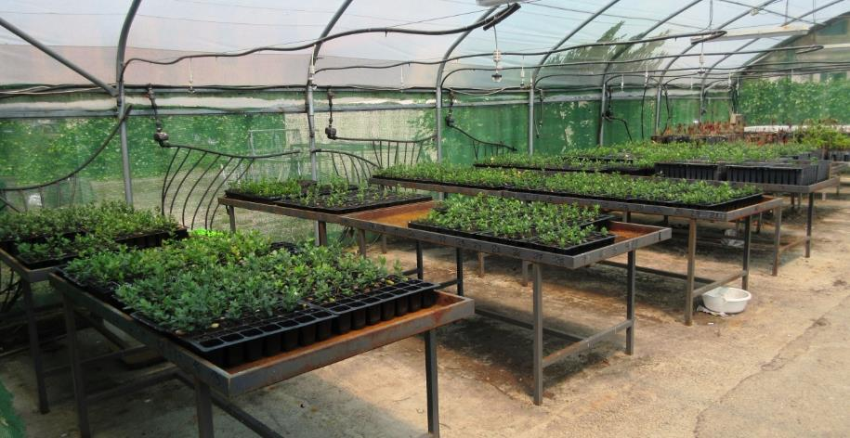  b) |  |  |  | 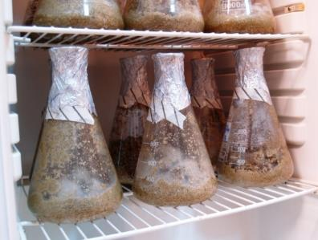  c)
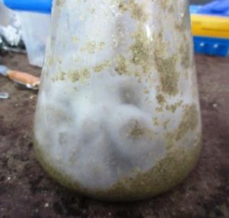  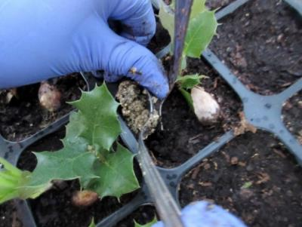  d) |  | 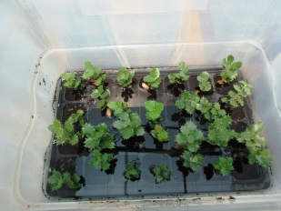  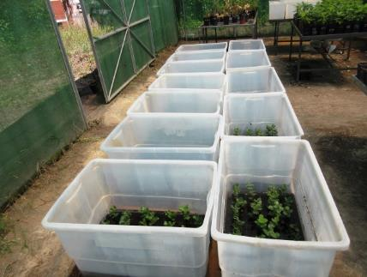  e) f) |  | 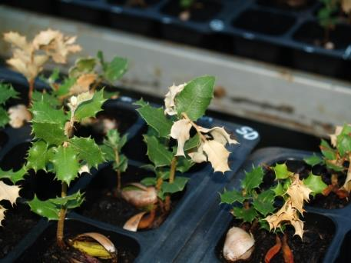  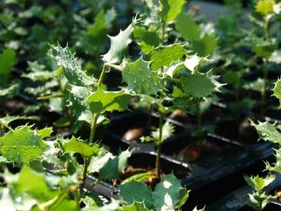  f  g)
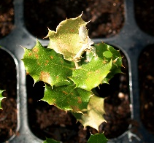  h) | 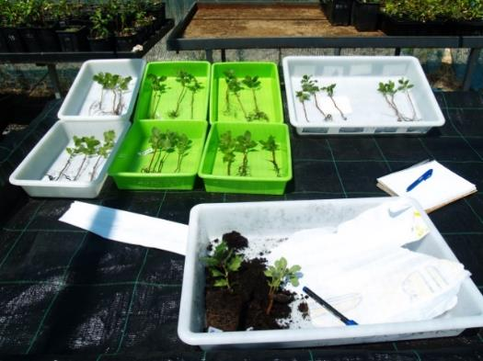  i) |  | 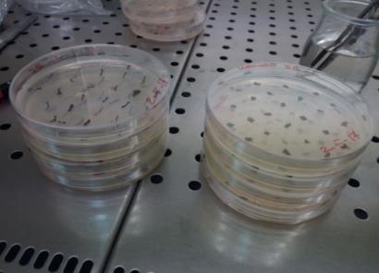  j) |  | 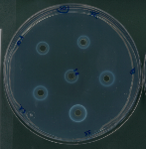  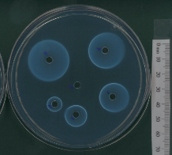  k)
Fig.S1. a) germination of seedlings with 2 acorns per alveolus, b) pots placed in metal trays with a 2-cm deep water line to avoid water stress, c) Phytophthora cinnamomi inoculum growing in an incubator at 22ºC, d) inoculation with 20 cc of the mycelial culture into each cell, e) seedling flooding to stimulate sporangia production and release of infective zoospores, f) mechanical wounding or mechanical defoliation of the upper third of the seedling, g) seedlings with "mechanical defoliation" treatment (d) one week later, h) inoculated seedlings (p) one week later, i) sampling for phenolic extraction, j) tests to confirm the infection in inoculated plant roots and the absence of the pathogen in the non-inoculated ones by means of seeding in selective NARPH medium, k) agarose gel radial diffusion method to determine total tannins content.
I)
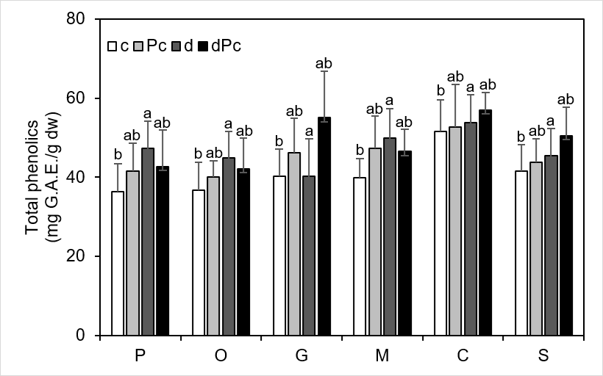
II)
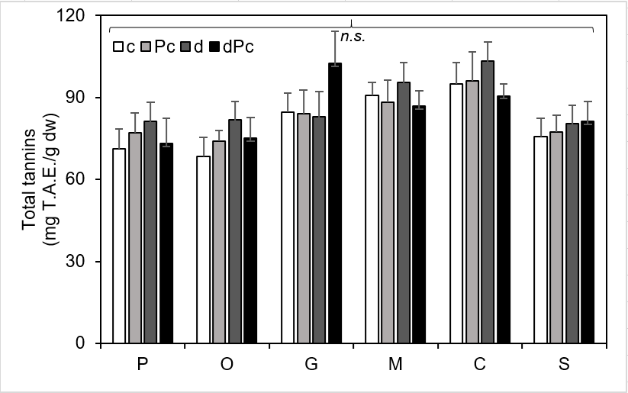
III)
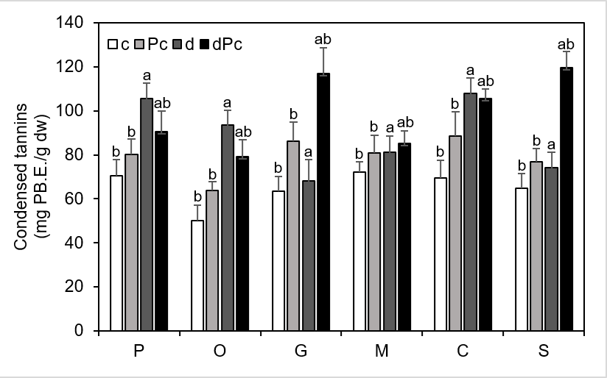
Fig.S2. Chemical analysis of phenolic compounds in Quercus ilex leaves after application of biotic stress treatment according to the region of origin (ordered from highest to lowest latitude): Picos de Europa (P), Ordesa (O), Guadarrama (G), Monfragüe (M), Cabañeros (C) and Sierra Nevada (S). (I) Total phenolics, (II) Total tannins, (III) Condensed tannins. Applied treatments: control treatment (c), inoculation with Phytophthora cinnamomi (Pc), mechanical defoliation (d) and double treatment pathogen infection/mechanical defoliation (dPc). Bar height represents the mean and whiskers are standard deviations. Different letters denote statistically significant differences.

