Supplementary information
Article: Insights into the relationship between hydraulic safety, hydraulic efficiency and tree structural complexity from terrestrial laser scanning and fractal analysis
Journal: Trees – Structure and Function
Authors: Yonten Dorji^{*1,2}, Emilie Isasa³, Kerstin Pierick¹, Juliano Sarmento Cabral^{4,5}, Tashi Tobgay², Peter Annighöfer⁶, Bernhard Schuldt^{3,7}, Dominik Seidel¹
¹ Department for Spatial Structures and Digitization of Forests, Faculty of Forest Sciences, Georg-August-Universität Göttingen, Büsgenweg 1, 37077 Göttingen, Germany
²Department of Forest Science, College of Natural Resources, Royal University of Bhutan, 1264 Punakha, Bhutan
³ Ecophysiology and Vegetation Ecology, Julius-von-Sachs-Institute of Biological Sciences, University of Würz-burg, Julius-von-Sachs-Platz, 97082 Würzburg, Germany
⁴ Ecosystem Modeling Group, Center for Computational and Theoretical Biology, University of Würzburg, Klara-Oppenheimer-Weg 32, 97074 Würzburg, Germany
⁵ Biodiversity Modelling and Environmental Change, School of Biosciences, College of Life and Environmental Sciences, University of Birmingham, Birmingham B15 2TT, United Kingdom
⁶ Forest and Agroforest Systems, Technical University of Munich, Hans-Carl-v.-Carlowitz-Platz 2, 85354 Freising, Germany
⁷ Chair of Forest Botany, Institute of Forest Botany and Forest Zoology, Technical University of Dresden, Pienner Str. 7, 01737 Tharandt, Germany
* Corresponding author: Yonten.dorji@uni-goettingen.de; Tel.: +49 551 3923680
ORCID ID: https://orcid.org/0000-0002-6508-9582

Testing for phylogenetic signal in residual errors of linear regressions
One of the main assumptions of linear regression is the independence of errors (Gelman et al. 2021, p154). This assumption is commonly hurt in multi-species analyses by the phenomenon that more closely related species tend to have more similar traits (Symonds & Blomberg 2014, p105). To test whether phylogenetic non-independence of errors is an issue in our regressions, we tested whether there is a significant phylogenetic signal in the residuals of all regression analyses conducted in this study. In the case of significant phylogenetic signal, a Phylogenetic Generalized Least Square (PGLS) regression would be necessary, whereas otherwise, a standard linear regression is appropriate (Revell 2010).
We used the R package V.PhyloMaker (v. 0.1.0, Jin & Quian 2019) to prune an underlying megatree (‘BGOTB.extended.tre`) to the species in this study in order to obtain their phylogeny. As a measure of phylogenetic signal, we calculated Pagel’s λ (Pagel 1999) with the phylosig () function from the phytools R package (v. 2.0.3, Revell 2012). Simultaneously, the function also performs a likelihood ratio test for the null hypothesis of λ = 0, meaning no phylogenetic signal. Therefore, in case of non-significant test results, there is no evidence for a phylogenetic signal different from 0.
Table 1: Results from the likelihood ratio tests that assess whether Pagel's λ of the residual errors is different from 0. Cases where a significant difference was found are highlighted in bold font. Apart from the abbreviation used in the main text: BrA1-3: Mean of BRangle 1st to 3rd order; CSA: MeanCSA, CV: MeanCV.
Response | Predictor | λ | log-Likelihood (λ) | Likelihood Ratio (λ = 0) | p value
P₁₂ | D_{b} | >0.01 | -23.98 | -8.29 | 1.000
P₅₀ | D_{b} | 0.71 | -27.39 | 0.51 | 0.473
P₈₈ | D_{b} | 0.75 | -30.98 | 0.84 | 0.359
K_{s} | D_{b} | 0.33 | -6.41 | 0.66 | 0.418
D_{h} | D_{b} | 0.26 | -53.88 | 0.85 | 0.357
P₅₀ | K_{s} | 0.71 | -23.38 | 3.97 | 0.046
P₁₂ | BrA1 | 0.76 | -23.93 | 1.72 | 0.189
P₅₀ | BrA1 | 0.89 | -26.41 | 5.49 | 0.019
P₈₈ | BrA1 | 0.92 | -29.51 | 7.57 | 0.006
P₁₂ | BrA2 | 0.81 | -22.69 | 2.03 | 0.154
P₅₀ | BrA2 | 0.93 | -24.55 | 6.25 | 0.012
P₈₈ | BrA2 | 0.96 | -27.42 | 8.48 | 0.004
P₁₂ | BrA3 | 0.86 | -22.82 | 2.48 | 0.115
P₅₀ | BrA3 | 0.98 | -24.50 | 6.67 | 0.010
P₈₈ | BrA3 | 1.01 | -27.20 | 8.92 | 0.003
P₁₂ | CSA | 0.59 | -24.41 | 1.92 | 0.166
P₅₀ | CSA | 0.66 | -28.02 | 2.72 | 0.099
P₈₈ | CSA | 0.66 | -31.80 | 2.89 | 0.089
P₁₂ | CV | 0.50 | -24.51 | 1.25 | 0.263
P₅₀ | CV | 0.58 | -28.20 | 1.90 | 0.168
P₈₈ | CV | 0.59 | -31.99 | 2.12 | 0.146

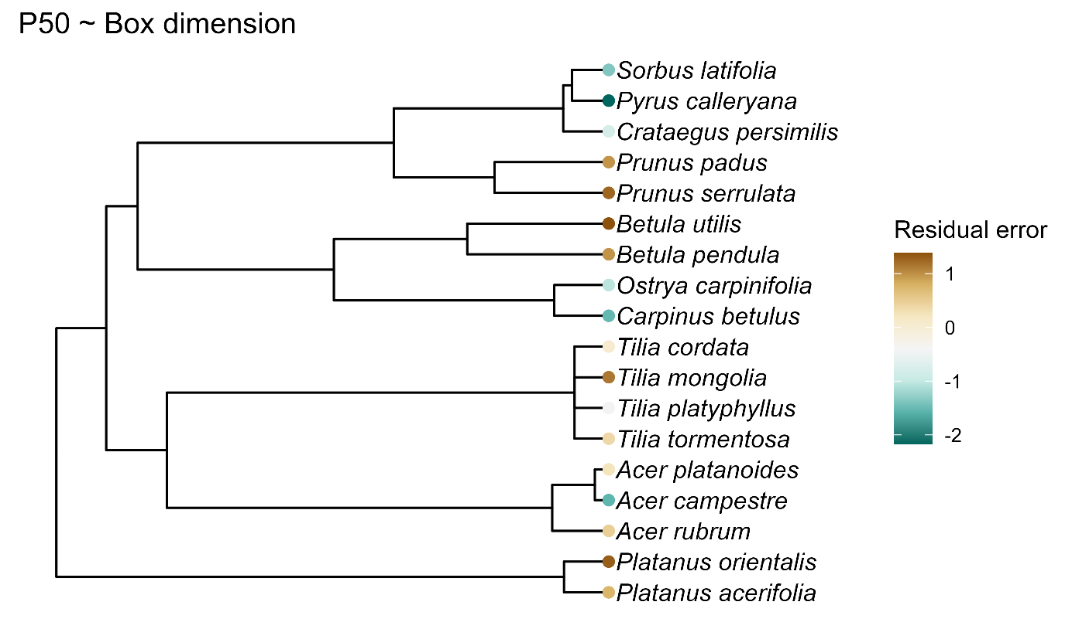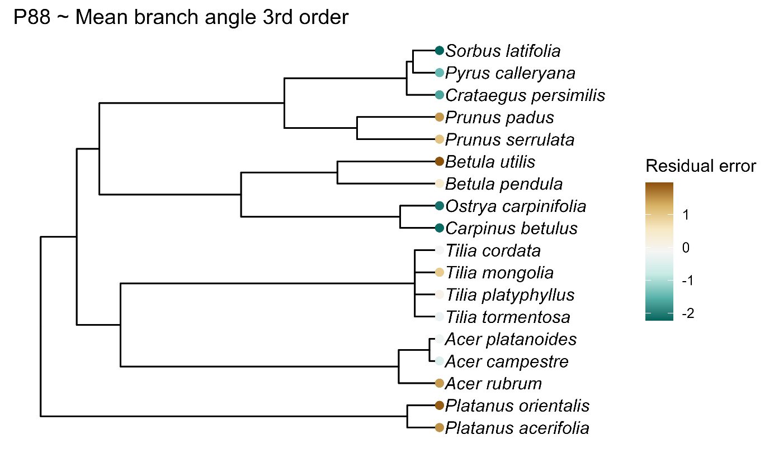
Figure 1: Two examples illustrating the distribution of residual errors throughout the phylogeny. The relationship of P₅₀ in dependency of box dimension is the main relationship of interest in this study and had no significant evidence for a phylogenetic signal different from 0 in the residuals. The relationship of P₈₈ in dependency of Mean branch angle of the 3rd order was among the regression analyses in this study the one with the highest estimate for Pagel’s λ in the residuals.

The results show that phylogenetic non-independence was not an issue in most tested relationships. Especially the relationships with box dimension, the main predictor of interest in this study, were not affected. For the cases where significant phylogenetic signal was found, we conducted additional PGLS analyses and present the results here. We first used the function corPagel () from the R package ape (v. 5.7.1, Paradis & Schliep 2019) to create a phylogenetic variance-covariance matrix based on the species’ phylogeny, and then fitted a PGLS model with the nlme package (v. 3.1.162, Pinheiro et al. 2023), using the phylogenetic variance-covariance matrix as correlation structure.
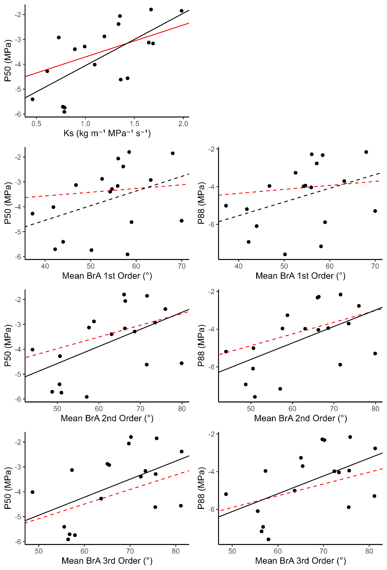
Figure 2: Regression lines from PGLS analyses (red) compared with linear regressions (black) for all pairwise relationships with significant phylogenetic signals in their residuals. Solid lines indicate slope parameters significantly different from 0 (p < 0.05), and dashed lines indicate non-significant slope parameters.

References
Gelman A, Hill J, Vetahri A (2021) Regression and other stories. Cambridge University Press, Cambridge, UK.
Jin Y, Qian H (2019) V.PhyloMaker: an R package that can generate very large phylogenies for vascular plants. Ecography 42 (8): 1353–1359. https://doi.org/10.1111/ecog.04434
Pagel M (1999) Inferring the historical patterns of biological evolution. Nature 401, 877-884. https://doi.org/10.1038/44766
Paradis E, Schliep K (2019) ape 5.0: an environment for modern phylogenetics and evolutionary analyses in R. Bioinformatics 35, 526-528. https://doi.org/10.1093/bioinformatics/bty633.
Pinheiro J, Bates D, R Core Team (2023) nlme: Linear and Nonlinear Mixed Effects Models. R package version 3.1-162, https://CRAN.R-project.org/package=nlme.
Revell LJ (2010) Phylogenetic signal and linear regression on species data. Methods in Ecology and Evolution 1: 319-329. https://doi.org/10.1111/j.2041-210X.2010.00044.x
Revell LJ (2012) phytools: An R package for phylogenetic comparative biology (and other things). Methods in Ecology and Evolution 3: 217-223. https://doi.org/10.1111/j.2041-210X.2011.00169.x
Symonds MRE, Blomberg SP (2014) A primer on phylogenetic generalized least squares. In: Garamszegi LZ (Editor) (2014) Modern phylogenetic comparative methods and their application in evolutionary biology. Springer, Berlin Heidelberg, Germany.

