Supplementary Information
A non-native pathogen meets a native host: Austropuccinia psidii infection reduces photosynthesis and alters non-structural carbohydrates in seedlings of Metrosideros excelsa

Hoa Nguyen¹, Peter J. Bellingham^{2,3}, Mahajabeen Padamsee^{3,4}, Luitgard Schwendenmann^{1*}
¹School of Environment, University of Auckland, Private Bag 92019, Auckland 1142, New Zealand
²Manaaki Whenua Landcare Research, PO Box 69040, Lincoln 7640, New Zealand
³School of Biological Sciences, University of Auckland, Private Bag 92019, Auckland 1142, New Zealand
⁴Manaaki Whenua Landcare Research, 231 Morrin Road, St Johns, Auckland 1072, New Zealand

*Corresponding author: l.schwendenmann@auckland.ac.nz

Table S1 Leaf gas exchange and non-structural carbohydrate content of Metrosideros excelsa (host plant) between control and Austropuccinia psidii (non-native pathogen) inoculation (infected) treatment. Values are medians of all time points. Kruskal-Wallis for each variance of each treatment. Pn = photosynthetic rate, Gs = stomatal conductance, DLA = diseased leaf area, LL = lesion level
Characteristics | Infected |  | Control
Characteristics | Median (range) | p | Median (range) | p
Leaf gas exchange: 1-20 weeks after inoculation
Pn (μmol CO₂ m⁻²s⁻¹) | 0.1 (-1.35-6) | <0.0001 | 8.3 (7.7-9.5) | 0.132
Gs (mmol H₂O m⁻²s⁻¹) | 74 (31-114) | <0.0001 | 80.5 (73-101) | 0.002
Non-structural carbohydrates: 2, 4, 8, 12, and 20 weeks after inoculation
Starch (mg g⁻¹) | 13.80 (7.39-46.20) | 0.006 | 10.22 (8.22-15.10) | 0.158
Glucose+fructose (mg g⁻¹) | 86.46 (51.85-92.71) | 0.06 | 69.96 (66.58-75.17) | 0.293
Sucrose (mg g⁻¹) | 36.26 (28.53-42.60) | 0.02 | 23.3 (19.87-30.73) | 0.029
Disease severity: 1-20 weeks after inoculation
DLA (%) | 54.28 (7.90-95.10) |  | 0
LL (scale) | 1-5 |  | 0

Table S2 Results from mixed-effects models (simple models and complex models) to estimate the effect of Austropuccinia psidii (non-native pathogen) infection on Metrosideros excelsa (plant host) leaf gas exchange and non-structural carbohydrate content. WAI = weeks after inoculation, DLA = diseased leaf area, LL = lesion level
Models | Leaf gas exchange |  |  |  | Non-structural carbohydrate content (mg g⁻¹)
Models | Pn (μmol CO₂ m⁻²s⁻¹) |  | Gs (mmol H₂O m⁻²s⁻¹) |  | Starch |  | Glucose+fructose |  | Sucrose
Models | p | AIC | p | AIC | p | AIC | p | AIC | p | AIC
I Time after infection and treatment (treatment and control)
Simple model
WAI | 0.014 | 978.5 | 0.289 | 2087.4 | 0.001 | 268.2 | 0.049 | 284.2 | 0.060 | 247.3
Treatment | <0.0001 | 870.4 | 0.014 | 2082.5 | 0.002 | 254.9 | 0.002 | 270.7 | <0.0001 | 205.6
Complex model |  | 862.9 |  | 2082.9 |  | 250.7 |  | 269.1 |  | 200.6
WAI | 0.004 |  | 0.241 |  | 0.0003 |  | 0.014 |  | 0.003
Treatment | <0.0001 |  | 0.012 |  | 0.0003 |  | 0.001 |  | <0.0001
II Diseased leaf area and lesion level (treatment only)
Simple model
DLA | <0.0001 | 239.4 | <0.0001 | 905.3 | 0.015 | 117.5 | 0.029 | 140.2 | 0.153 | 113.0
LL | <0.0001 | 258.2 | <0.0001 | 886.3 | 0.040 | 117.6 | 0.050 | 141.1 | 0.368 | 113.8
Complex model |  | 241.6 |  | 876.9 |  | 120.5 |  | 141.4 |  | 116.0
DLA | <0.0001 |  | 0.0007 |  | 0.015 |  | 0.028 |  | 0.110
LL | 0.125 |  | <0.0001 |  | 0.275 |  | 0.293 |  | 0.044

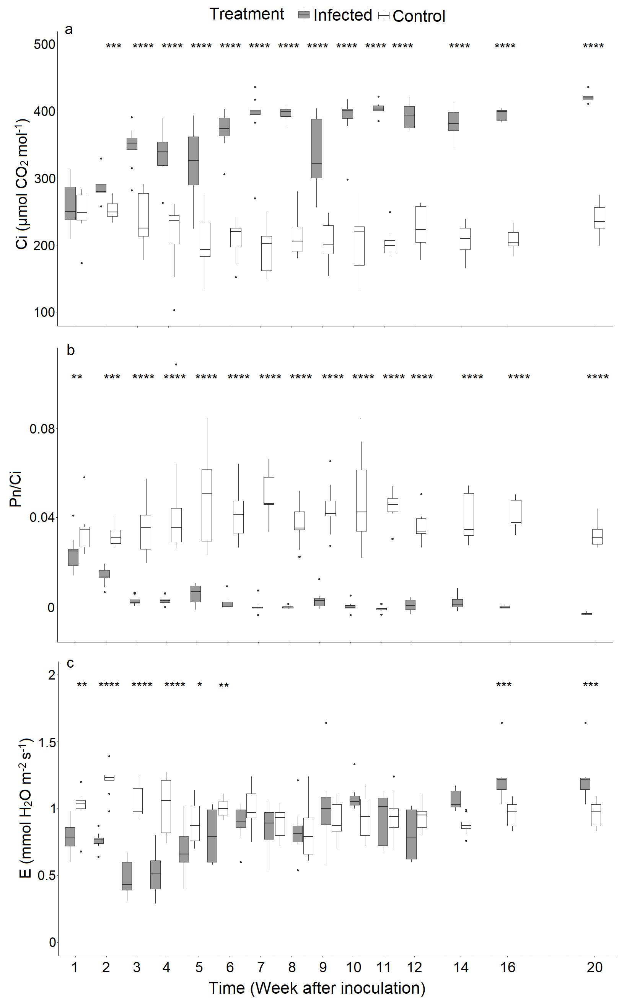
Figure S1 (a) Leaf intercellular CO₂ concentration (Ci), (b) transpiration (E), and (c) instantaneous carboxylation efficiency (Pn/Ci ratio) of Metrosideros excelsa (plant host) between control and Austropuccinia psidii (non-native pathogen) inoculation (infected) treatment. Boxes represent the 25th and 75th percentile with a horizontal line at the median. Whiskers above and below the box indicate the largest and smallest observations falling within the 10th and 90th percentile. *Indicates a significant difference between infected and control plants at p < 0.05, ** p < 0.01, *** p < 0.001, and **** p < 0.0001.
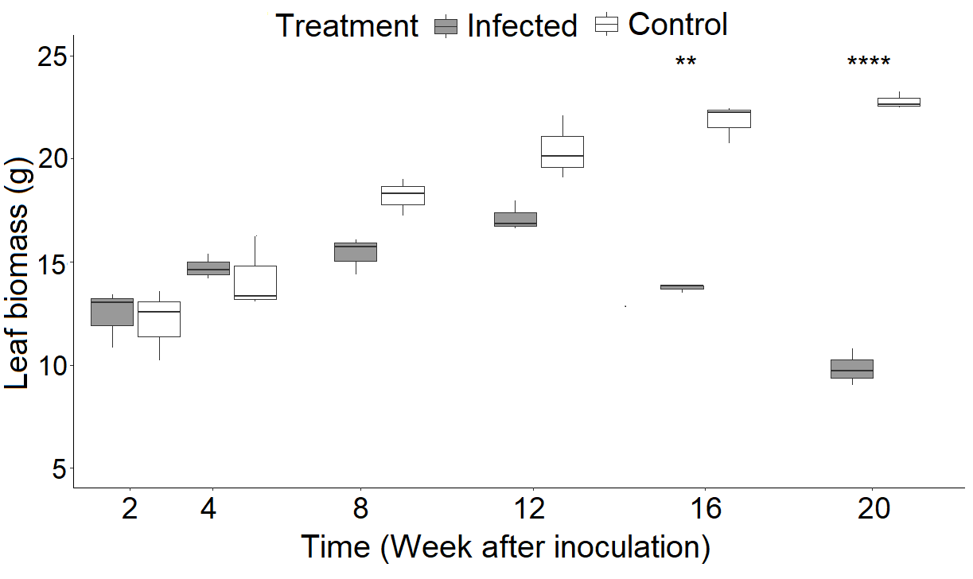

Figure S2 Leaf biomass of Metrosideros excelsa (plant host) between control and Austropuccinia psidii (non-native pathogen) inoculation (infected) treatment. Boxes represent the 25th and 75th percentile with a horizontal line at the median. Whiskers above and below the box indicate the largest and smallest observations falling within the 10th and 90th percentile. *Indicates a significant difference between infected and control plants at p < 0.05, ** p < 0.01, *** p < 0.001, and **** p < 0.0001.

