Impact of meteorological conditions on the foliar nutrition of old-growth European beech (Fagus sylvatica L.) stands – results of long-term serial analysis of macro- and micronutrients

Alexander Borys*, Barbara Wieczorek, Jens Schumacher, Anka Nicke, Jutta Walstab

*Corresponding author: Universität Halle-Wittenberg, Universitätsplatz 10, 06120 Halle (Saale), Germany; e-mail: alexander.borys@uni-erfurt.de

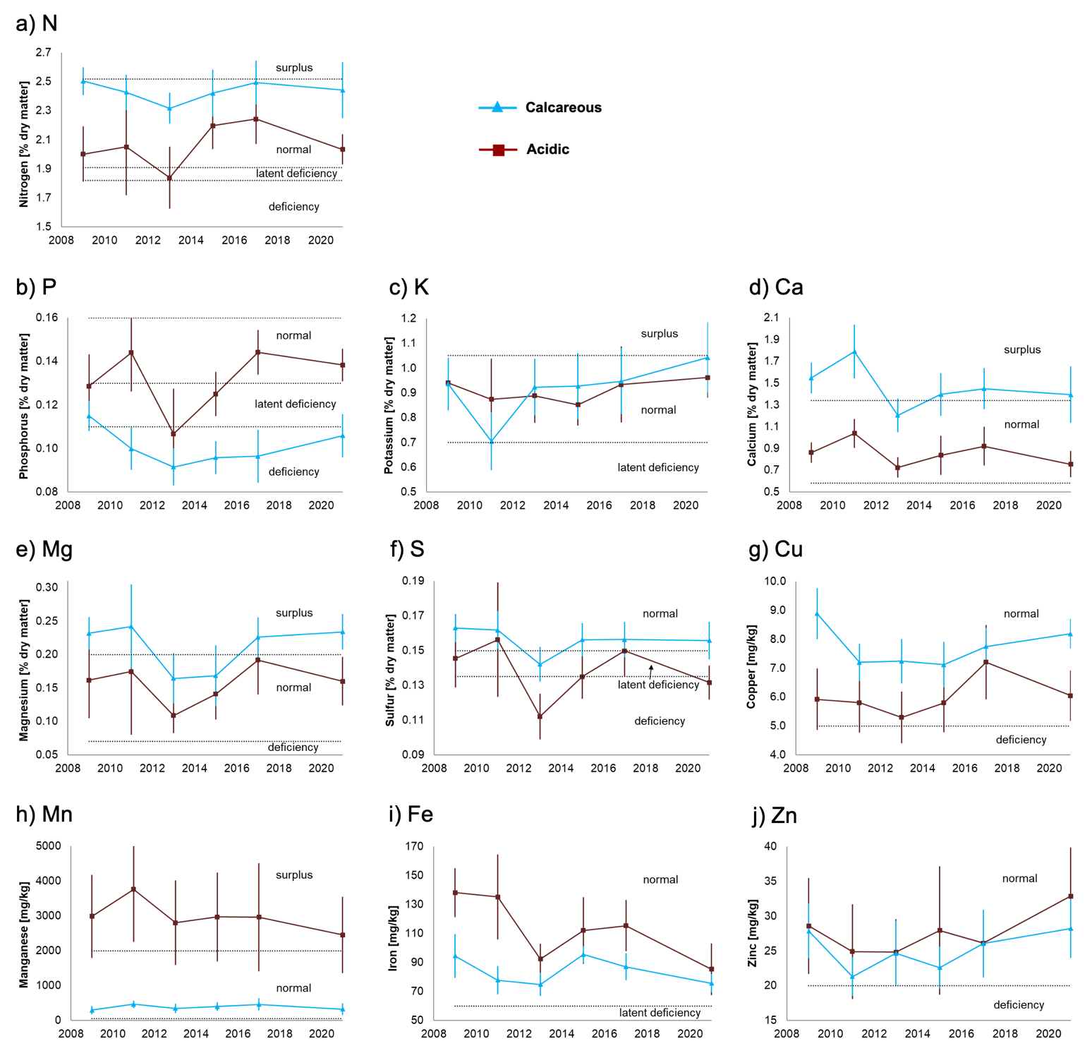

Suppl Fig. 1 Leaf nutrition (macronutrients, micronutrients) of European beech by means of serial foliar analysis from 2009 to 2021
Shown are arithmetic means ± standard deviations of 12 (calcareous site) or 6 (acidic site) trees. Nutritional levels according to critical values for European beech (Göttlein 2015) are indicated; horizontal dashed lines represent thresholds of nutrition levels

Suppl Table 1 Fixed-effect estimates of linear mixed-effects models on the association of meteorological conditions with nutritional status over time, depending on the site (soil type: calcareous or acidic)&
 | Parameter | Fixed-effect estimate
Macronutrients
Nitrogen (N) | constant term | -9.005
 | site | -1.833
 | MATcurr | 2.463
 | MATcurr² | -0.129
 | site*MATcurr | 0.160
 | MAPprev | -4.340•10⁻⁴
Phosphorus (P) | constant term | -2.342
 | site | -1.127
 | MATcurr | 0.543
 | MATcurr² | 3.006•10⁻²
 | site*MATcurr | 0.239
 | site*MATcurr² | -1.226•10⁻²
Potassium (K) | constant term | -0.131
 | site | 0.824
 | MATprev | 9.410•10⁻²
 | site*MATprev | 8.991•10⁻²
 | MAPcurr | 3.370•10⁻⁴
Calcium (Ca) | constant term | 2.766
 | site | -0.586
 | MATprev | -0.114
 | MAPcurr | -5.240•10⁻⁴
Magnesium (Mg) | constant term | -8.731
 | site | -5.743•10⁻²
 | MATcurr | 1.963
 | MATcurr² | -0.107
Sulfur (S) | constant term | -1.700
 | site | -1.422
 | MATcurr | 0.403
 | MATcurr² | -2.179•10⁻²
 | site*MATcurr | 0.301
Micronutrients
Copper (Cu) | constant term | -108.446
 | site | -10.055
 | MATcurr | 26.148
 | MATcurr² | -1.443
 | site*MATcurr | 0.913
 | MAPprev | -3.458•10⁻³
Manganese (Mn) | constant term | -519.964
 | site | 2599.142
 | MATcurr | 99.816
Iron (Fe) | constant term | -24.429
 | site | 28.881
 | MATcurr | 14.078
 | MAPprev | -3.570•10⁻²
Zinc (Zn) | constant term | -409.460
 | site | 2.294
 | MATcurr | 98.325
 | MATcurr² | -5.456
 | MAPprev | -1.219•10⁻²
&The table only shows the variables that were retained in the final models (= the variables for which a significant correlation to the nutrient concentration was found).
Negative values for MAT/MAP indicate a decreasing nutrient concentration with increasing MAT/MAP.
MAT/MAPcurr/prev: mean annual temperature (MAT)/mean annual precipitation (MAP) of the current (curr) or previous (prev) year

Göttlein A (2015) [Grenzwertbereiche für die ernährungsdiagnostische Einwertung der Hauptbaumarten Fichte, Kiefer, Eiche, Buche]. German Journal of Forest Research. 186(5/6):110-116.

