Supplemental information

Table S1 List of the geographical coordinates of all sampled trees.
Tree | North | East
Bot. Garden #1 | 54.346333 | 10.118551
Bot. Garden #2 | 54.346227 | 10.118788
Bot. Garden #3 | 54.346742 | 10.118002
Bot. Garden #4 | 54.346558 | 10.118510
Bot. Garden cv. latifolia | 54.346731 | 10.118308
Bot. Garden cv. horizontalis | 54.346680 | 10.118455
Aschberg 1 | 54.420400 | 9.696470
Aschberg 2 | 54.20200 | 9.696930
Aschberg 3 | 54.420200 | 9.696870
Aschberg 4 | 54.415600 | 9.695760
Aschberg 5 | 54.416500 | 9.696210

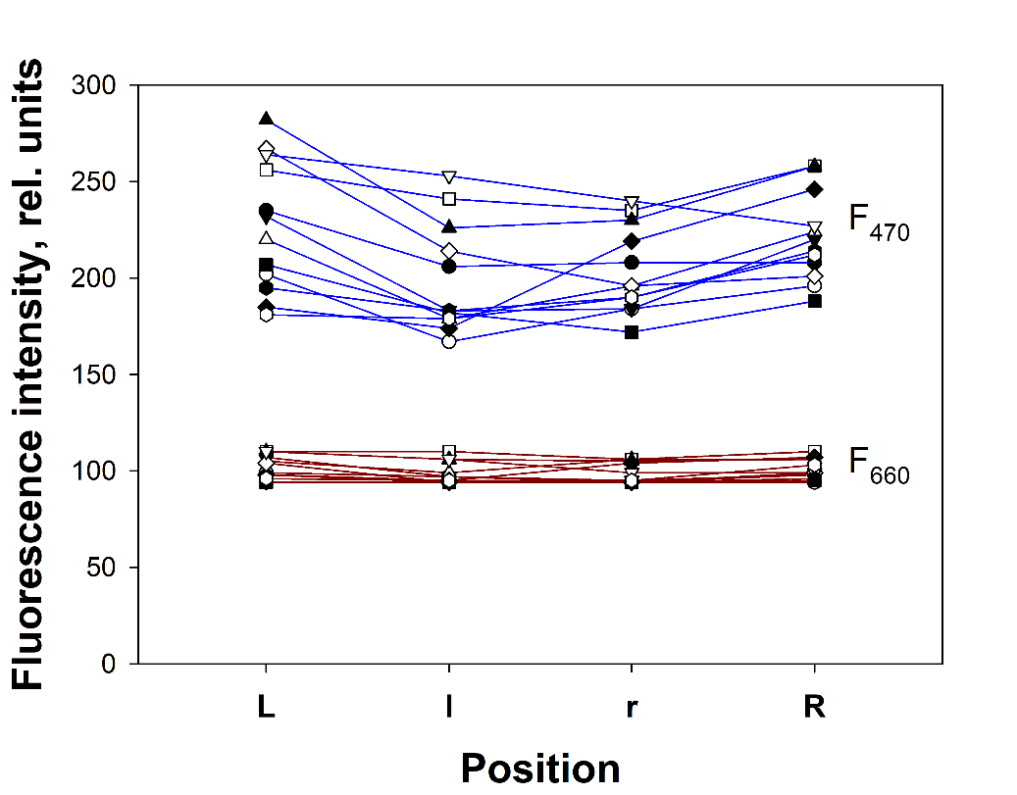
Fig. S1 Fluorescence intensity excited with a blue beam (F470) and with a red beam (F660) for 12 different leaves as function of the relative position across rolled sun leaves of F. sylvatica. The positions are designated with letters from left to the on the adaxial side of the leaves. Data for each leaf are connected by the lines

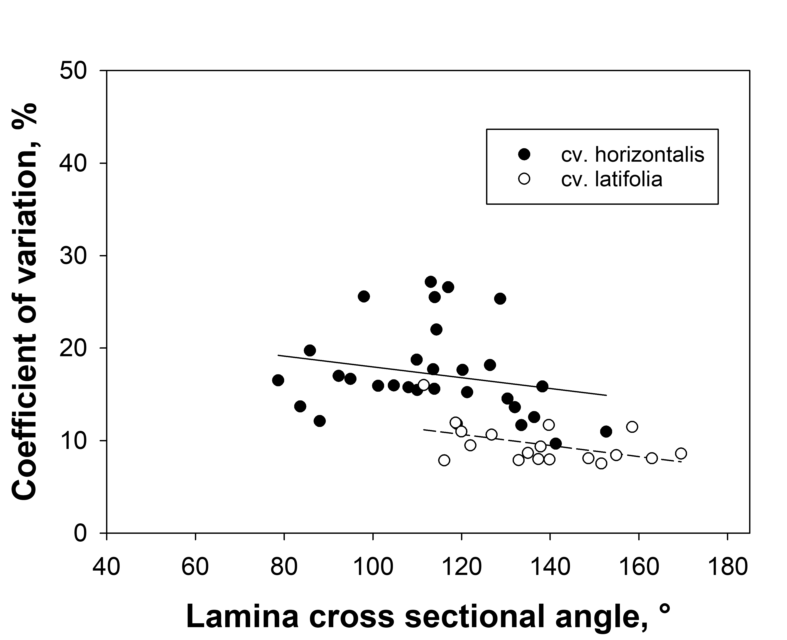
Fig. S2 Coefficient of variation of F_{M} over the whole leaf lamina as a function of the degree of leaf rolling, represented by the lamina cross sectional angle Θ (see Fig. 1) in two beech varieties from the Botanical Garden. The lines were drawn by linear regression; r² for F. s. cv. horizontalis, 0.049; r² for F. s. cv. latifolia, 0.217.

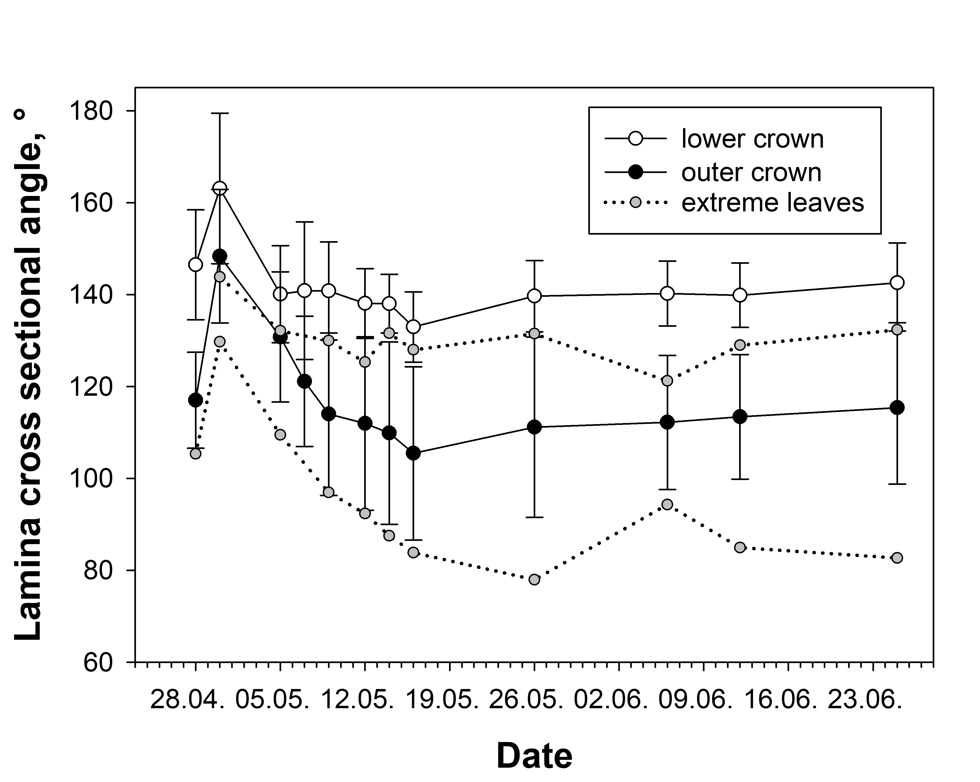
Fig. S3 Development of the average lamina cross sectional angle Θ (see Fig. 1) during spring 2025 of 19 leaves from the lower crown (open circles) and 18 leaves from the sun exposed part of the crown (closed circles) of tree no. 1. The error bars show the standard deviation. In addition, the time course of the two sun leaves with the lowest and largest cross-sectional angle are shown (gray circles, dotted lines).

