Supplementary Material:
Journal of Trees

Sub-annual growth responses of Persian oak (Quercus brantii Lindl.) to climate in the Zagros Mountains, western Iran: regional climate imprint is stronger than the influences of microclimate and elevation
Mohsen Arsalani ^{a,}*, Jussi Grießinger ^{b}, Sugam Aryalª, Achim Bräuning ª
ª Institute of Geography, Friedrich-Alexander-University Erlangen-Nürnberg, Wetterkreuz 15, 91058 Erlangen, Germany
^{b} Department of Environmental and Biodiversity, University of Salzburg, Salzburg 5020, Austria
*) Corresponding author; mohsen.arsalani@fau.de. Tel: +49 9131 85-22920. Fax: +49 9131 85-22013

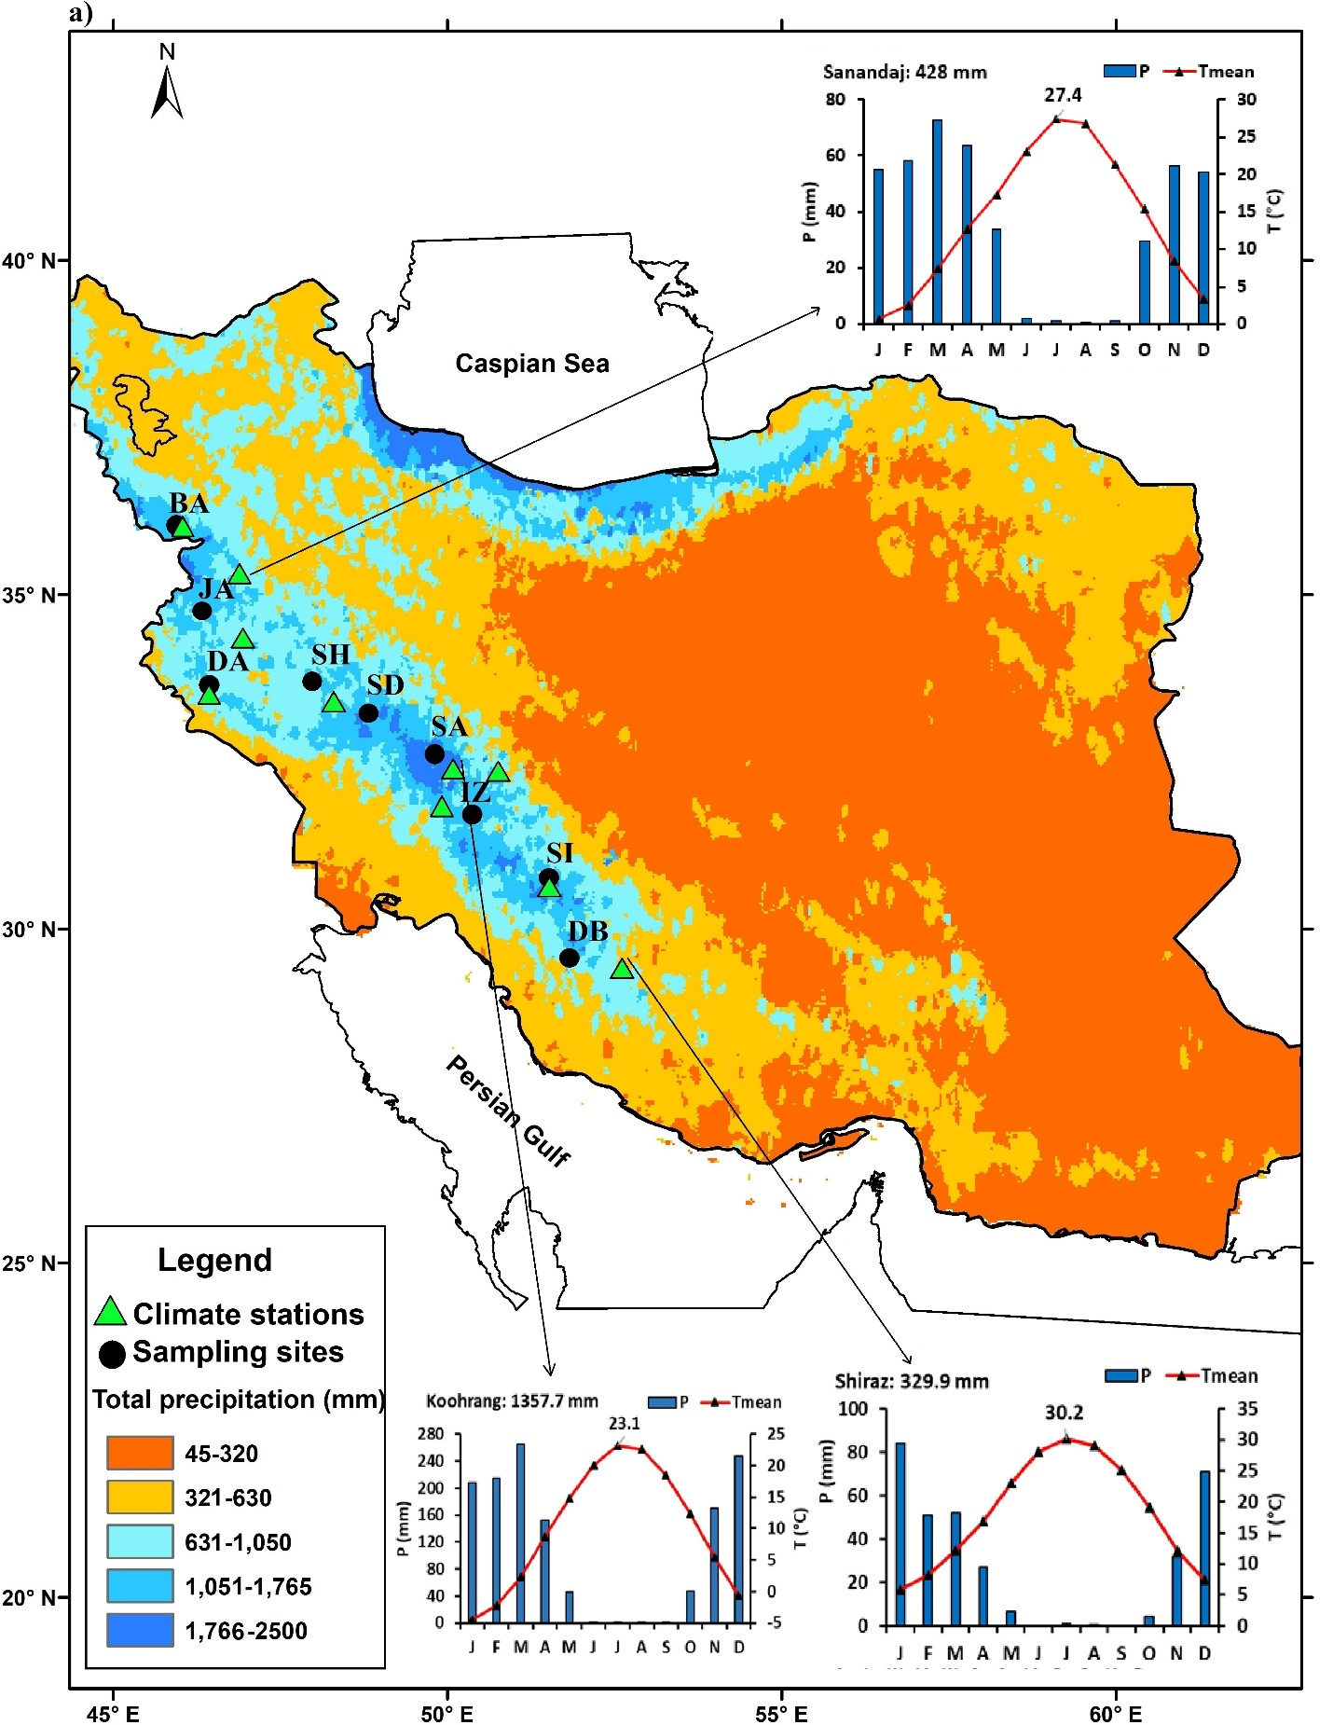
Fig. S1: a) Mean annual precipitation (1980–2020) of Iran (recorded by climate stations) and the locations of climate stations and sampling sites (BA: Baneh, JR: Javanrood, DA: Dalao, SH: Shineh, SD: Shabandar, SA: Sar Aga Seyed, IZ: Izeh, SI: Sisakht, DB: Dasht Barm). Climate diagrams of Snandaj, Koohrang, and Shiraz climate stations represent monthly precipitation (P) and Tmean in the northern, central, and southern Zagros Mountains, respectively. The inserted values in the diagrams show Tmean of July (the warmest month) and total annual precipitation recorded at each station. b) Isohyets of total annual precipitation, based on the same data as in (a), illustrating the steep vertical humidity gradients in the study area.

Fig. S2 A surface picture from a smoothed sample of Q. brantii, illustrating the earlywood width (EWW), latewood width (LWW) and total ring-width (TRW) boundaries and vessel distribution of the species. The red and white arrows show the ray and the growth direction, respectively.

Fig. S3 Total ring-width (TRW), earlywood width (EWW), and latewood width (LWW) site chronologies in the Zagros Mountains, Iran including the respective sample depth. Chronology site codes refer to Table 1 in the main text.

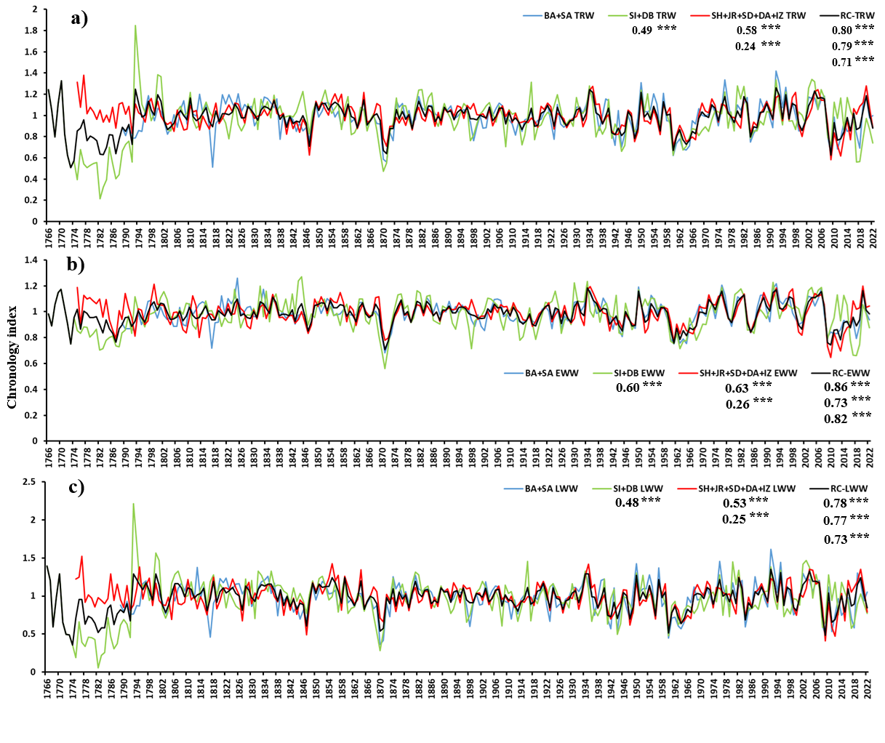
Fig. S4 Comparison between the regional mean of the three PC groups and total ring-width (TRW), earlywood width (EWW), and latewood width (LWW) regional chronologies (RC). Three asterisks indicate significance at the 0.01 level.
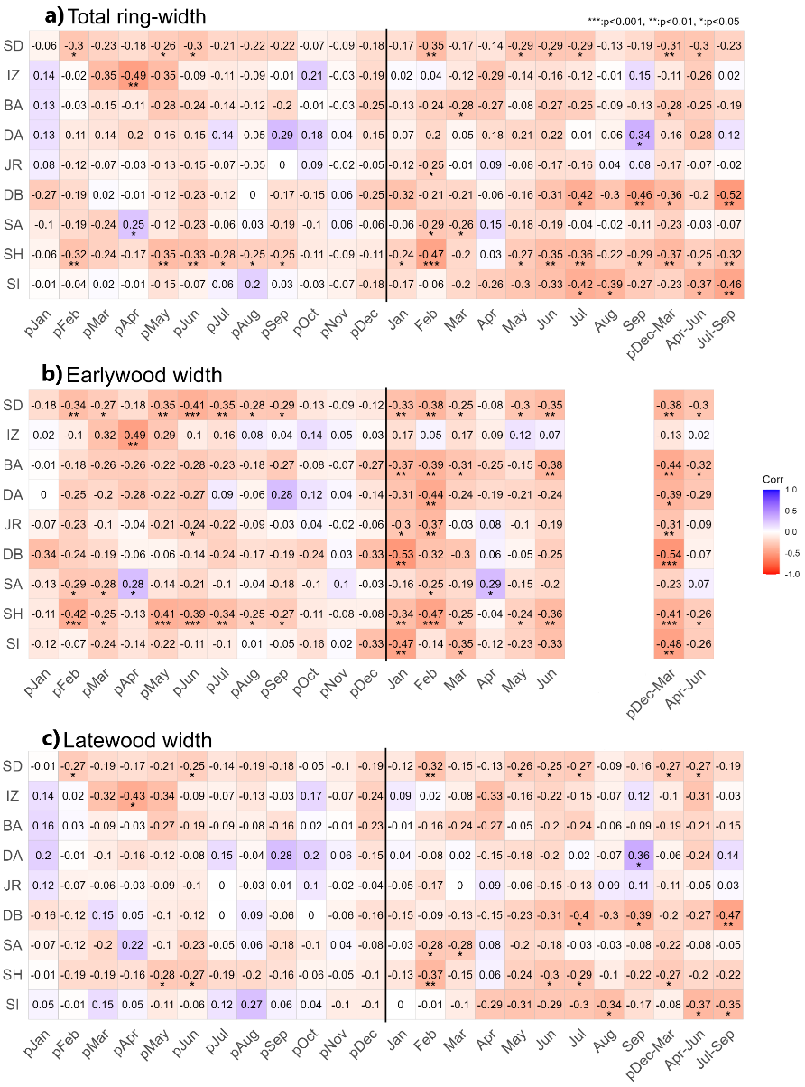
Fig. S5 Pearson's correlation between mean monthly (Tmean) temperatures and a) total ring-width (TRW), b) earlywood width (EWW) and, c) latewood width (LWW) standard chronologies.

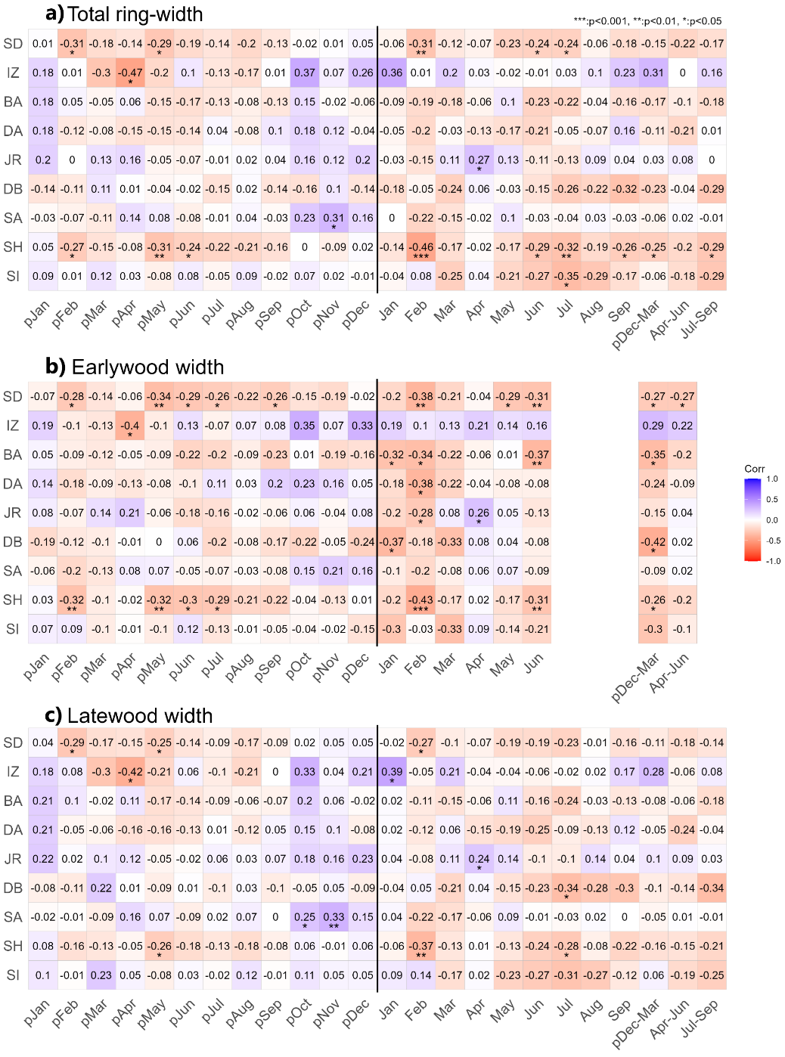
Fig. S6 Pearson's correlation between mean monthly minimum (Tmin) temperatures and a) total ring-width (TRW), b) earlywood width (EWW) and, c) latewood width (LWW) standard chronologies.

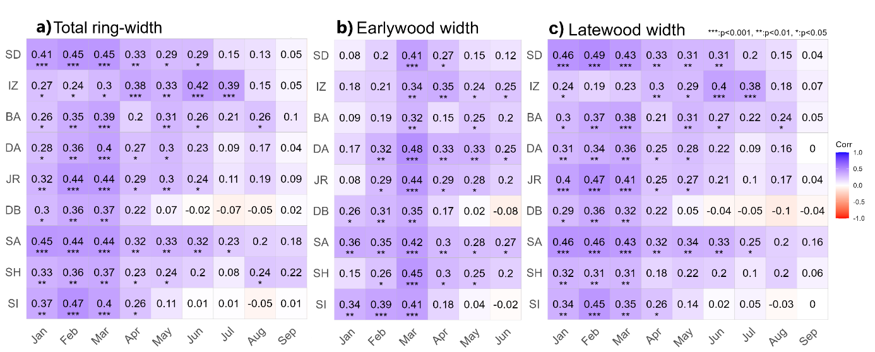Fig. S7 Correlations between Standardized Precipitation-Evapotranspiration Index calculated at 04-month accumulation period (SPEI-04) and a) total ring-width, b) earlywood width, and c) latewood width standard chronologies.

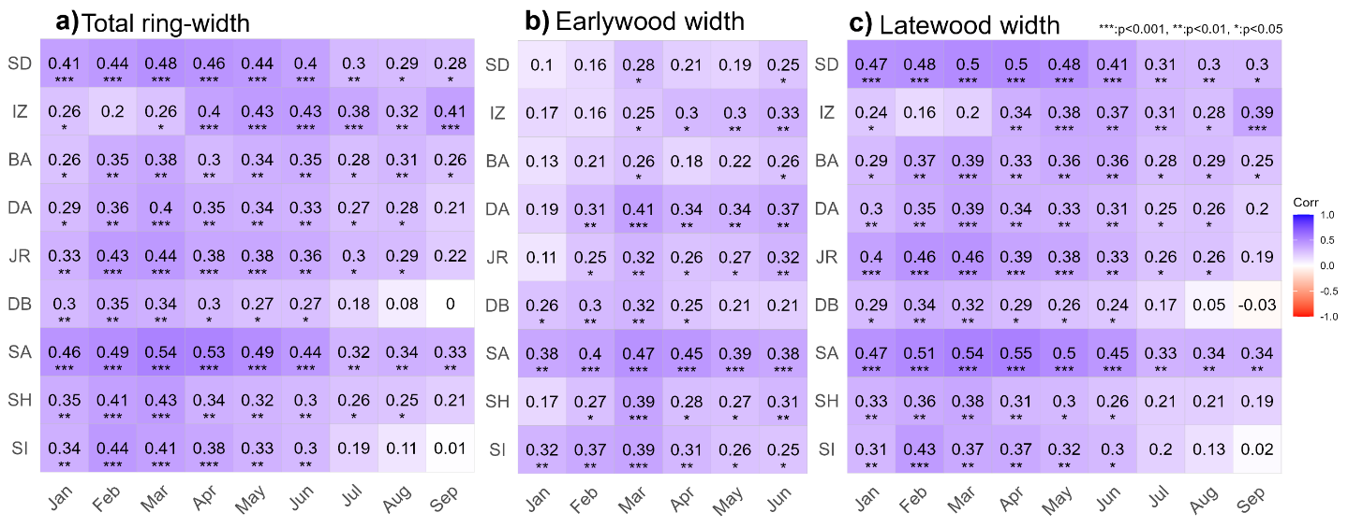
Fig. S8 Correlations between Standardized Precipitation-Evapotranspiration Index calculated at 07-month accumulation period (SPEI-07) and a) total ring-width, b) earlywood width, and c) latewood width standard chronologies.

