Supplementary Information
Contrasting diurnal and seasonal root water uptake patterns among different plant life forms in a neotropical dry forest
(Trees – Structure and Function)
Laura Würzberg*, Heinz Coners, Roger Mundry, Jürgen Homeier, Jorge Gonzaga, David Windhorst, Katja Trachte, Sebastian Scholz, Jörg Bendix, Christoph Leuschner
* corresponding author: Plant Ecology and Ecosystem Research, University of Göttingen, Göttingen, Germany; laura.wuerzberg@biologie.uni-goettingen.de
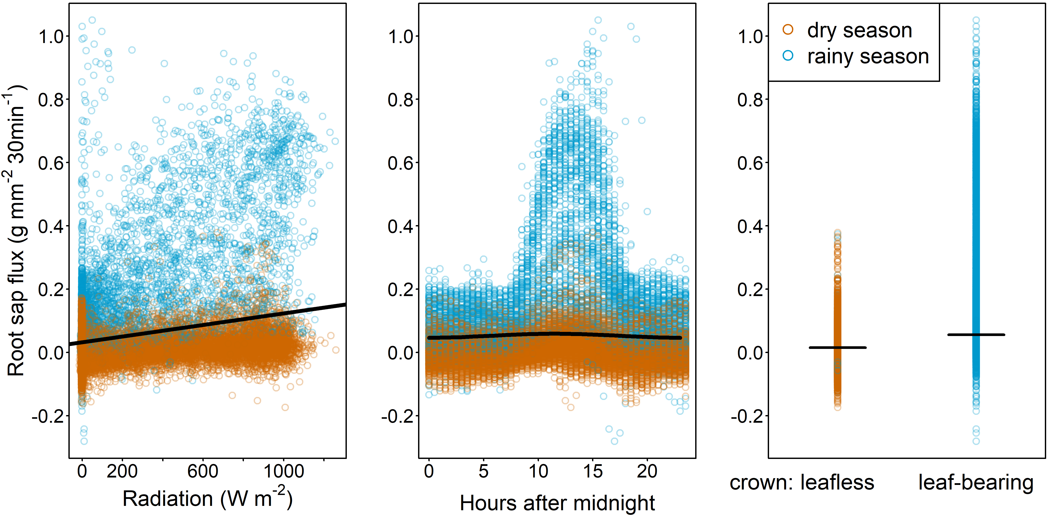
Fig. S1 Root sap flux density in Eriotheca ruizii as a function of radiation (left, R²=0.03, P<0.001), time of day (middle, R²=0.001, P<0.001), and crown status (right, R²=0.02, P<0.001). Lines show the fitted model with all other predictors, being at their average. The extremely narrow confidence limits (see Table 1) are not displayed (n=23529)
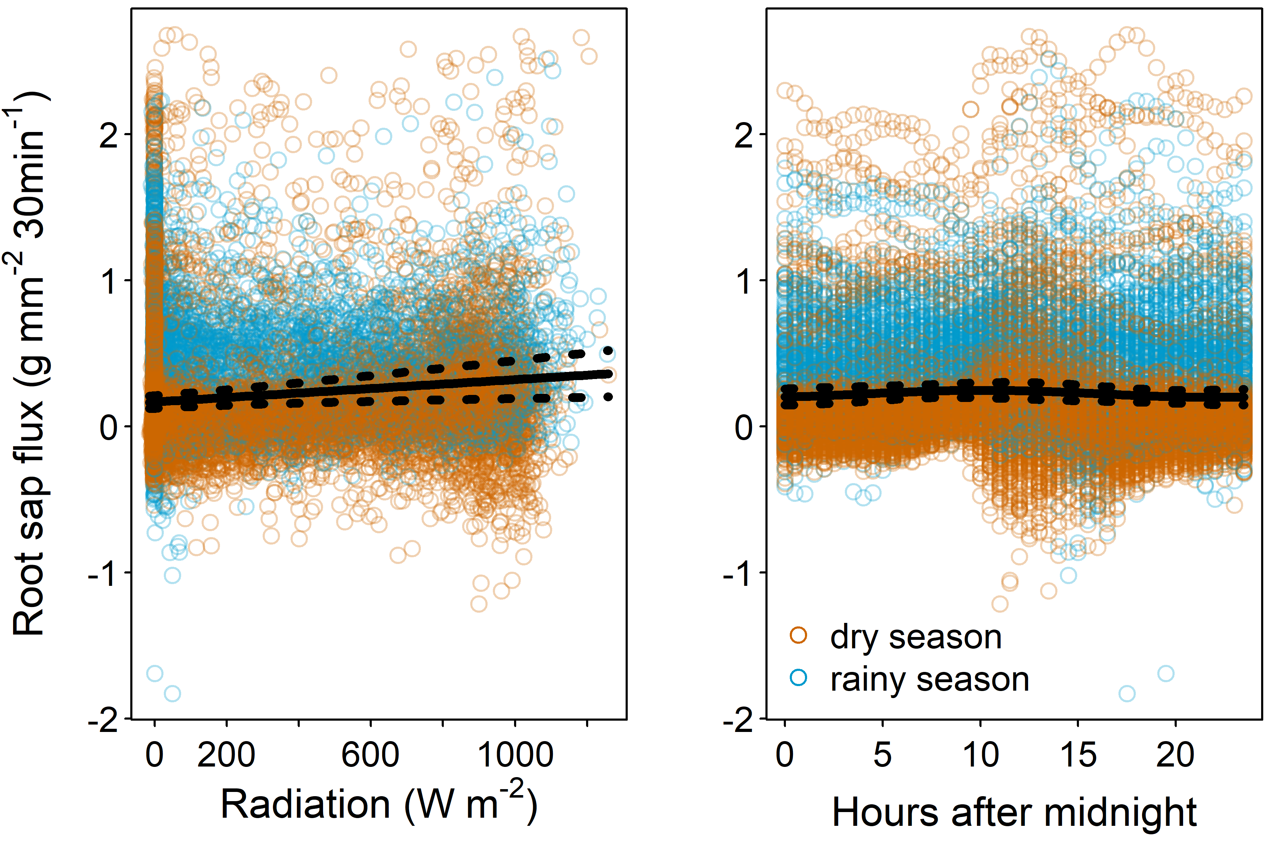
Fig. S2 Root sap flux density in Amatocereus laetus as a function of radiation intensity (left, R²=0.007, P=0.256) and time of day (right, R²=0.001, P<0.001). Lines show the fitted model with all other predictors being at their average. Dotted lines show the 95% confidence intervals. (n=974)
Table S1 Results of the root sap flux model for Amatocereus laetus with the interaction between VPD and SWC included. Given are estimates, their standard errors, 95% confidence intervals, and results of significance tests for the predictors VPD, SWC, time of day, radiation intensity, and the VPD x SWC interaction. Also given are minimum and maximum values of model estimates obtained by the of individual sap flux measurements from the model, one at a time
term | estimate | SE | CI_{lower} | CI_{upper} | F | df | P | min | max
(Intercept) | -0.603 | 0.157 |  |  |  |  |  | -0.621 | -0.548
VPD ⁽¹⁾ | -0.153 | 0.074 | -0.298 | 0.008 |  |  | 0.039 | -0.175 | -0.141
SWC ⁽¹⁾ | 0.336 | 0.051 | 0.236 | 0.436 |  |  | < 0.001 | 0.321 | 0.343
sin(daytime) ⁽²⁾ | -0.001 | 0.021 | -0.042 | 0.040 | 0.261 | 2 | 0.768 | -0.006 | 0.003
cos(daytime) | 0.018 | 0.026 | -0.033 | 0.069 |  |  |  | 0.013 | 0.027
radiation | < 0.001 | < 0.001 | < 0.001 | < 0.001 | 6.942 | 1 | < 0.001 | < 0.001 | < 0.001
VPD x SWC ⁽¹⁾ | 0.043 | 0.026 | -0.008 | 0.094 | 0.038 | 1 | 0.102 | 0.039 | 0.052
⁽¹⁾ log-transformed and then z-transformed to a mean of 0 and a standard deviation (sd) of 1
orig. means (sd): natural log. of VPD: 1.727 (0.984) and natural log. of SWC: 2.559 (0.440)
⁽²⁾ the indicated test refers to the overall effect of daytime
Statistical significance of all predictors was tested using F-tests with denominator degrees of freedom of 962
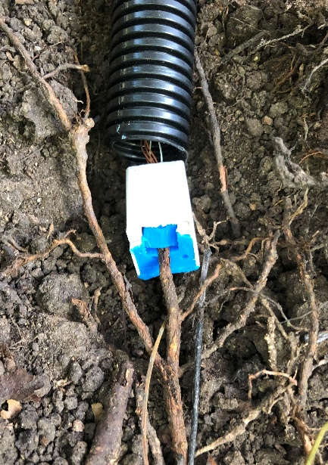


Fig. S3 Miniature sap flow sensor head (left picture) with two thermocouples and the heat resistor in between, and the installation of a miniature sap flow sensor on a living small-diameter root in the upper soil (right picture) (© Laura Würzberg, 2022)
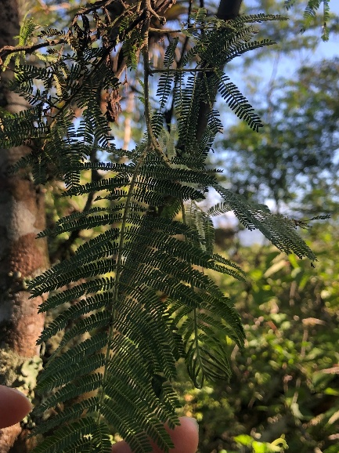
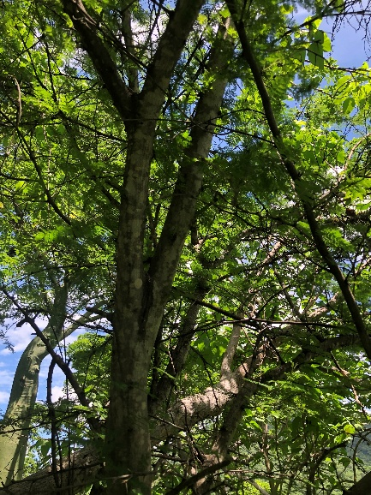
Fig. S4 Leaves (left picture) and tree (right picture) of a Vachellia macracantha tree in the study area at 600 m a.s.l. during the early dry season in May 2022 (© Laura Würzberg, 2022)
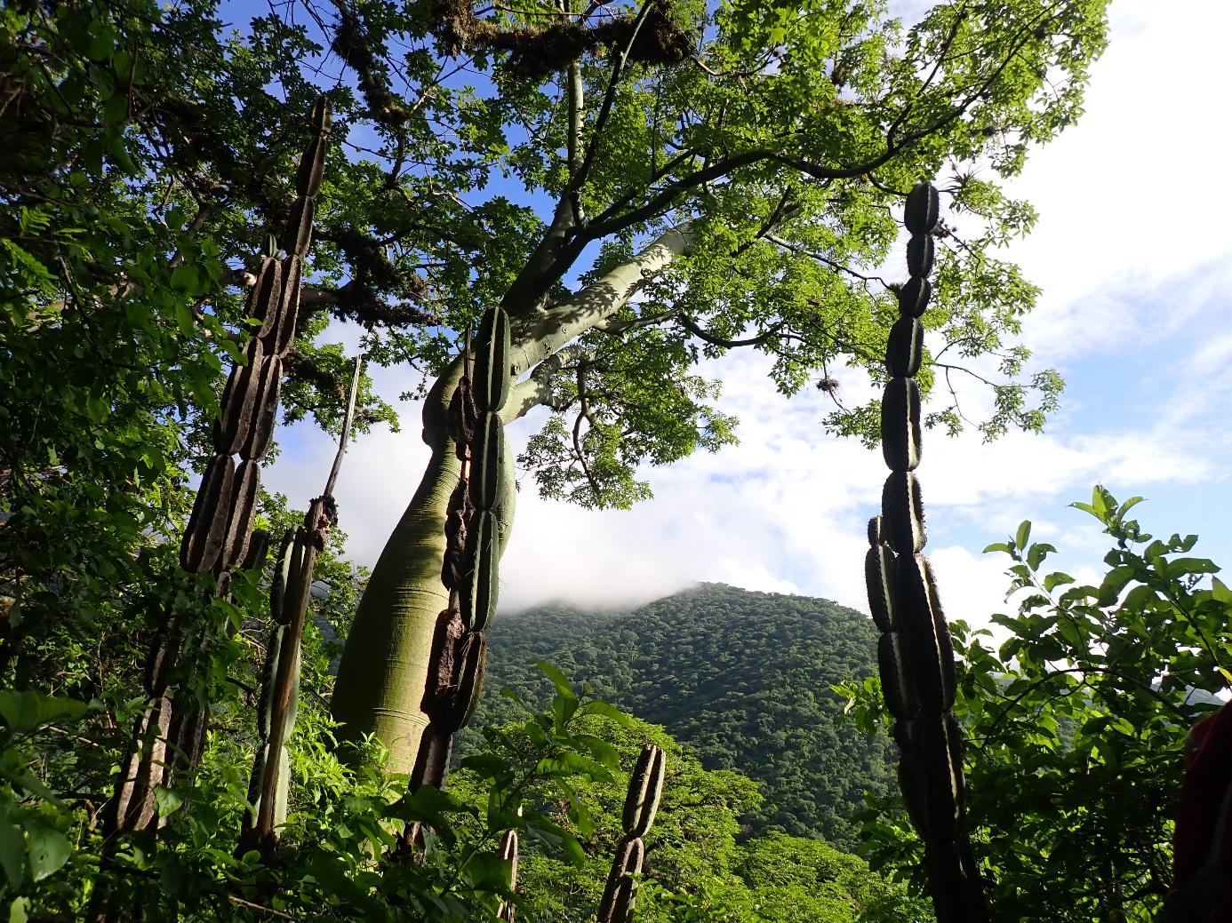
Fig. S5 Armatocereus laetus individuals (front) and a fully foliated, deciduous stem-succulent Ceiba trischistandra tree (background) in the study area at 600 m a.s.l. during the rainy season in March 2023 (© Lea Kerwer, 2023)
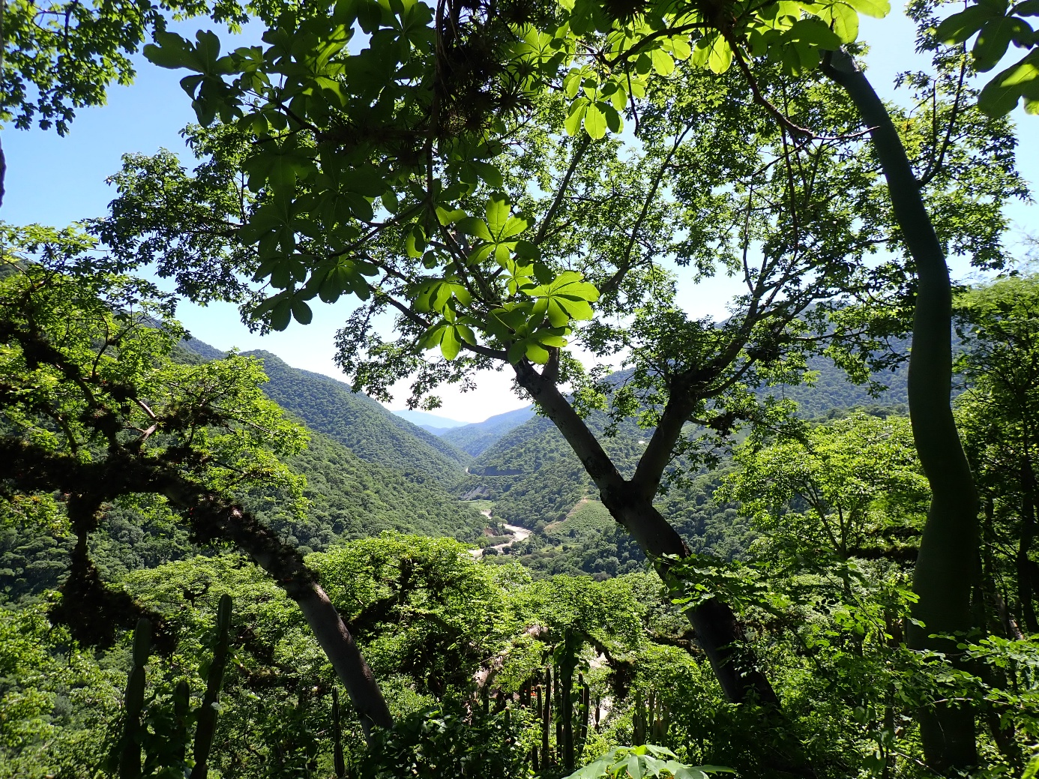
Fig. S6 Depicted are fully foliated individuals of the deciduous root-succulent Eriotheca ruizii (two trees on the left) in the study area at 600 m a.s.l. during the rainy season in March 2023 (© Lea Kerwer, 2023)
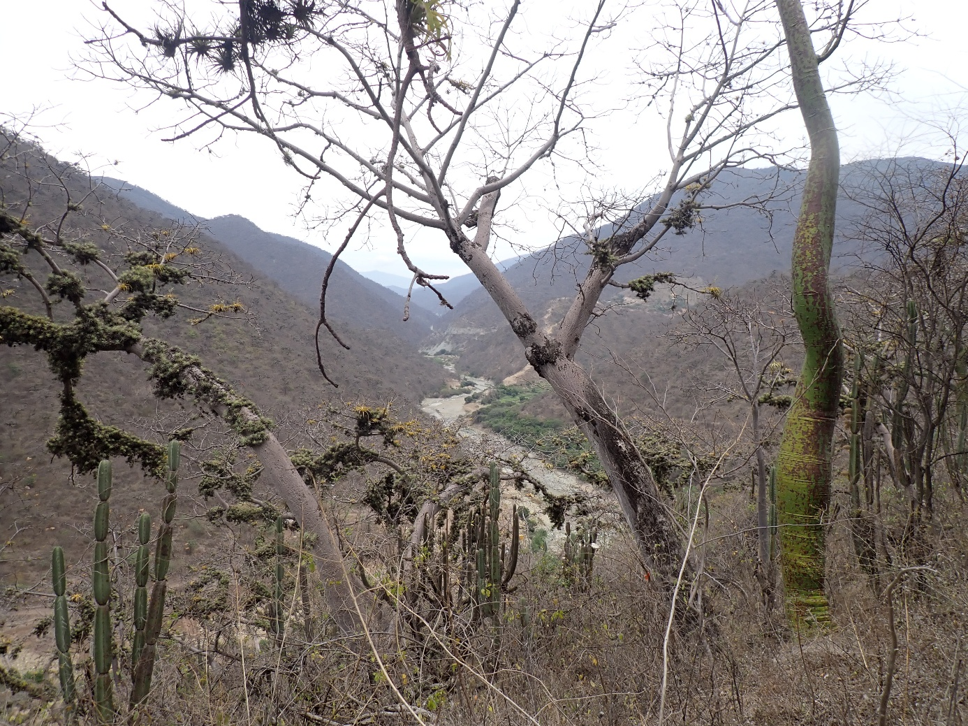
Fig. S7 Depicted are individuals of the tall, evergreen cactus Armatocereus laetus (on the left, in the middle and on the right), of the deciduous root-succulent Eriotheca ruizii (grey bark, two individuals in the middle), and of the deciduous stem-succulent Ceiba trischistandra (green bark, on the right) in the study area at 600 m a.s.l. during the late dry season in November 2023. All deciduous species are leafless (© Lea Kerwer, 2023)
Detailed information on “2.4 The physical background and sensor calibration”
We excised all root segments after the field measurements and calibrated each sensor individually in the laboratory on the respective root segment. For transport and storage, we conserved the segments in 70% ethanol. In the laboratory, the segments were re-cut under water (outermost 5 mm discarded) and connected via PVC tubes to the Xyl’em apparatus (Cochard et al. 2013), a flow meter which measures flow in the root segment under a pressure of 0.12 MPa supplied by a reservoir containing water under pressure. A Liquiflow flow meter (Bronkhorst, Kamen, Germany) and flow-regulator placed between the water source and the segment was used to measure and control water flow through the segment. Flow was decreased in steps of 0.2 g h⁻¹ within the range of 5 to 0 g h⁻¹, starting at 5 g h⁻¹. With the flow gauge attached to the root segment, we recorded the HRM values simultaneously, with the heat pulses set every 15 min. After finishing a HRM measurement cycle, the datalogger set the flow meter to the next flow rate, thus enabling an automated calibration run for each flow gauge and root segment over a period of several hours.
Preliminary experiments proved the conclusion of Clearwater et al. (2009) that the correlation between HRM values and measured water flow is linear in the range of 0 to approximately 2 g h⁻¹. At higher flow rates, the curve flattened and a linear relationship can no longer be assumed. However, the observed HRM values in the field never exceeded this range. The laboratory calibration was thus restricted to a measurement range from 0 to 2 g h⁻¹.
Detailed information on “2.6 Data processing and statistical analyses”
We further assessed whether collinearity among the predictors of each model was an issue by calculating Variance Inflation Factors (VIF, Field 2005), which were derived using the function vif of the R package car (version 3.1-2; Fox and Weisberg 2011). The highest VIF values were 6.002 and 4.783 for SWC and crown status, respectively, in the model for E. ruizii. We therefore plotted SWC against crown status (leafless vs. leaf-bearing) and detected a higher dispersion of SWC values when leaves were present. However, as SWC varied considerably for leafless and leaf-bearing crown status, we are confident that the model is able to differentiate the effects of both predictors on the response. As an overall test of the effect of SWC, VPD, and their interaction on sap flux and to avoid “cryptic multiple testing” (Forstmeier and Schielzeth 2011), we compared the fit of each full model with that of a respective null model lacking these terms and their interaction. To obtain significance tests for the effect of daytime, radiation intensity, and crown status (the latter only for E. ruizii, since the cactus is evergreen) on mean sap flux, we further compared each full model with a corresponding reduced model lacking these predictors one at a time by applying an F-test (model for A. laetus) or a likelihood ratio test (model for E. ruizii). To test for the effect of daytime, we removed the sine and cosine of daytime from the full model. The main reason to do so was that daytime was represented by two terms in the model (sind and cosine of daytime) which can only be interpreted in conjuction, but an overall test of their effects was needed. We then tested the other effects using the same approach for reasons of consistency (but it should be noted that the obtained P-values should be essentially the same as those revealed by the standard model output). The reason for using a likelihood ratio test in case of the fitted model for E. ruizii was that the model was fitted using Maximum Likelihood in which case a likelyhood ratio test is the only option when using the function glmmTMB.

References
Clearwater MJ, Luo Z, Mazzeo M, Dichio B (2009) An external heat pulse method for measurement of sap flow through fruit pedicels, leaf petioles and other small-diameter stems. Plant Cell Environ 32:1652-1663. https://doi.org/10.1111/j.1365-3040.2009.02026.x
Cochard H, Badel E, Herbette S, Delzon S, Choat B, Jansen S 2013 Methods for measuring plant vulnerability to cavitation: a critical review. J Exp Bot 64: 4779-4791. https://doi.org/10.1093/jxb/ert193
Field A (2005) Discovering Statistics using SPSS. Sage Publications, London
Forstmeier W, Schielzeth H (2011) Cryptic multiple hypotheses testing in linear models: overestimated effect sizes and the winner’s curse. Behav Ecol and Sociobiol 65:47-55. https://doi.org/10.1007/s00265-010-1038-5
Fox J, Weisberg S (2011) An R Companion to Applied Regression. Sage, Thousand Oaks CA, second edition

