Supplementary Material

Variation in apparent wood density of Tachigali vulgaris as affected by tree diameter, height, forking, and soil conditions in Amazonian plantations

Jonathan Dias Marques^{1*}, Gabriela Morais Olmedo², Michael Douglas Roque Lima³, Gabriel Assis-Pereira⁴, Elvis Vieira dos Santos⁵, Delman de Almeida Gonçalves⁶, Arystides Resende Silva⁷, Lina Bufalino¹, Marciel José Ferreira⁸, Mario Tomazello‑Filho⁴, Thiago de Paula Protásio⁵

¹Institute of Agricultural Sciences, Federal Rural University of Amazonia – UFRA, Zip code 66077-901, Belém, Pará, Brazil
²Center of Nuclear Energy in Agriculture, University of São Paulo – USP, Zip code 13416-000, Piracicaba, São Paulo, Brazil
³Department of Forestry Science, State University of the Tocantina Region of Maranhão – UEMASUL, Zip code 65900‑001, Imperatriz, Maranhão, Brazil
⁴Department of Forest Sciences, Luiz de Queiroz College of Agriculture, University of São Paulo – USP, Zip code 13418-900, Piracicaba, São Paulo, Brazil
⁵Department of Forest Science, Federal University of Lavras – UFLA, Zip code 37203-202, Lavras, Minas Gerais, Brazil
⁶Brazilian Agricultural Research Corporation/Eastern Amazonia Embrapa, Zip code 66095-903, Belém, Pará, Brazil
⁷Brazilian of Agricultural Research Corporation/Embrapa Maize and Sorghum, Zip code 35701-970, Sete Lagoas, Minas Gerais, Brazil
⁸Federal University of Amazonas – UFAM, Department of Forest Sciences, Zip code 69080-900, Manaus, Amazonas, Brazil

*Corresponding author
Email address: jonathandiasmarques.2015@gmail.com
ORCiD: 0000-0002-4792-752X

Authors' ORCiD
Author | ORCiD
Jonathan Dias Marques | 0000-0002-4792-752X
Gabriela Morais Olmedo | 0000-0002-2206-0691
Michael Douglas Roque Lima | 0000-0002-4789-1205
Gabriel de Assis-Pereira | 0000-0001-5274-0033
Elvis Vieira dos Santos | 0000-0002-0821-6143
Delman de Almeida Gonçalves | 0000-0002-6876-4192
Arystides Resende Silva | 0000-0002-5128-7932
Lina Bufalino | 0000-0002-7688-3140
Marciel José Ferreira | 0000-0002-7164-2284
Mario Tomazello‑Filho | 0000-0002-9814-0778
Thiago de Paula Protásio | 0000-0002-5560-8350

List of Tables

Tested factor | Age (months) | Objective | Methodology (density) | Reference
Restoration of degraded areas | Up to 48 | To evaluate how varying levels of biochar impact the survival and growth of T. vulgaris trees and Eucalyptus hybrids in depleted soils. | - | Farias et al. (2016)
Spacing | 87 | To evaluate different spacings on the chemical, physical, anatomical, and yield properties of T. vulgaris. | NBR 11941 standard (ABNT, 2003) | Silva et al. (2021)
Spacing and forking | 87 | To evaluate the effect of spacing and forking on the basic density of T. vulgaris wood. | NBR 11941 standard (ABNT, 2003) | Barros-Junior et al. (2022)
Spacing and forking | 87 and 102 | To evaluate the effects of spacing, forking, and age on growth variables and basic density of T. vulgaris wood. | NBR 11941 standard (ABNT, 2003) | Lima et al. (2023)
Spacing and forking | 102 | To evaluate the impact of stem spacing and type on basic density, X-ray densitometry, and heartwood/sapwood ratio. | NBR 11941 standard (ABNT, 2003); X-ray densitometry | Moraes et al. (2023)
Spacing | 87 | To evaluate the export of nutrient in T. vulgaris trees and investigating the technological implications of ash deposition from wood combustion at different spacings. | - | (Santos et al. 2024)
Fertilization | Up to 120 | To evaluate the influence of nutritional doses on dendrometric variables in two different soil textures. | - | Teixeira et al. (2023)
Fertilization, soil texture, and forking | 132 | To evaluate the effects of fertilization and forking in two soil texture classes on the variation of apparent density using X-ray densitometry. | X-ray densitometry | Current study
Table S1 Literature on T. vulgaris plantations

Table S2 Percentage of forking, mortality, and dendrometric information of the 11-year-old experimental areas of T. vulgaris evaluated in Monte Dourado, district of the municipality of Almeirim, Pará, Brazil
Texture | Fertilization | Forked trees  (%) | Mortality  (%) | TH  (m) | Vwb  (m³ ha⁻¹)
Sandy loam | 0P-0K | 75 ± 24 | 33 ± 24 | 18.80 ± 4.38 | 251.05 ± 87.75
Sandy loam | 780P-343K | 44 ± 40 | 42 ± 17 | 18.14 ± 4.61 | 297.97 ± 147.48
Very clayey | 0P-0K | 55 ± 42 | 42 ± 22 | 19.68 ± 5.06 | 318.03 ± 167.09
Very clayey | 780P-343K | 26 ± 22 | 54 ± 28 | 19.91 ± 5.44 | 248.41 ± 108.13
TH: total height, Vwb: volume without bark. Average ± standard deviation

Table S3 Summary of Student's t-test and Mann–Whitney U-test results for apparent wood density assessed for between stem types, between two soil textural classes, and the presence or absence of fertilization across cambial ages and along the longitudinal direction in T. vulgaris trees
 |  | Source of variation
 |  | Stem type |  |  | Textural class |  |  | Fertilization
 |  | t-value¹/  U-value² | p-value | p-Bonf | t-value¹/  U-value² | p-value | p-Bonf | t-value¹/  U-value² | p-value | p-Bonf
Cambial age (years)
1 |  | -0.87¹ | 0.39 | 1.00 | 2.12¹ | 0.04 | 0.48 | 0.54¹ | 0.59 | 1.00
2 |  | -0.09¹ | 0.93 | 1.00 | -0.01¹ | 0.99 | 1.00 | 0.22¹ | 0.83 | 1.00
3 |  | -0.05¹ | 0.96 | 1.00 | -0.67¹ | 0.51 | 1.00 | 0.32¹ | 0.75 | 1.00
4 |  | -0.14¹ | 0.89 | 1.00 | -0.84¹ | 0.41 | 1.00 | 0.23¹ | 0.82 | 1.00
5 |  | -0.16¹ | 0.88 | 1.00 | -63.0² | 0.30 | 1.00 | 0.12¹ | 0.90 | 1.00
6 |  | -0.35¹ | 0.73 | 1.00 | -57.0² | 0.44 | 1.00 | -0.11¹ | 0.91 | 1.00
7 |  | -0.49¹ | 0.63 | 1.00 | -58.0² | 0.42 | 1.00 | -0.29¹ | 0.78 | 1.00
8 |  | -25.0² | 0.42 | 0.84 | -66.0² | 0.24 | 1.00 | 5.00² | 0.96 | 1.00
9 |  | -21.0² | 0.54 | 1.00 | -67.0² | 0.22 | 1.00 | 1.00² | 0.82 | 1.00
10 |  | -0.12¹ | 0.90 | 1.00 | -2.03¹ | 0.05 | 0.58 | 0.79¹ | 0.44 | 1.00
11 |  | 0.53¹ | 0.60 | 1.00 | -42.0² | 0.11 | 0.79 | -0.02¹ | 0.98 | 1.00
Height
Meters (m) | Relative (%)
0.12 | 0 | 0.25¹ | 0.80 | 1.00 | -0.83¹ | 0.42 | 1.00 | -0.43¹ | 0.67 | 1.00
1.3 | DBH | -53.0² | 0.31 | 1.00 | -7.00² | 0.98 | 1.00 | 6.00² | 0.61 | 1.00
4.73 | 25 | -1.65¹ | 0.11 | 0.65 | -0.43¹ | 0.67 | 1.00 | -0.11¹ | 0.91 | 1.00
9.47 | 50 | -2.19¹ | 0.04 | 0.22 | -2.00² | 0.84 | 1.00 | -38.0² | 0.27 | 0.53
14.2 | 75 | -0.58¹ | 0.56 | 1.00 | 0.95¹ | 0.35 | 1.00 | -0.52¹ | 0.61 | 1.00
18.93 | 100 | -0.58¹ | 0.57 | 1.00 | 2.27¹ | 0.03 | 0.18 | -1.83¹ | 0.08 | 0.47
p-Bonf: p-value adjusted using the Bonferroni correction, ¹Student's t-test statistic, ²Mann–Whitney U-test statistic

Table S4 Fixed-effect coefficients of the complete Linear Mixed Model (LMM) fitted to assess the effects of quadratic mean diameter (QMD), commercial height, stem type, soil textural class, fertilization, and the interaction between soil textural class and fertilization on the weighted apparent wood density (WWD) of T. vulgaris
Parameters |  | Estimate | Std. Error | DF | t value | Pr(>|t|)
 | (a) complete model = WWD ~ QMD + commercial height + Stem type + Textural class*Fertilization + (1|block)
(Intercept) |  | 0.543913 | 0.06357 | 30.609 | 8.557 | <0.001***
QMD |  | 0.01644 | 0.00305 | 30.040 | 5.385 | <0.001***
Commercial height |  | -0.00962 | 0.00382 | 30.722 | -2.516 | 0.0173*
Stem type |  | -0.01841 | 0.01778 | 26.617 | -1.035 | 0.3098^{ns}
Textural class |  | 0.01536 | 0.02348 | 24.091 | 0.654 | 0.5194^{ns}
Fertilization |  | 0.02920 | 0.02246 | 24.328 | 1.300 | 0.2058^{ns}
Textural class x Fertilization |  | -0.06160 | 0.03089 | 24.049 | -1.994 | 0.0576†
DF: degrees of freedom, †: marginally significant (0.05 < p < 0.10), *: significant at 5% level (p < 0.05), ***: significant at 0.1% level (p < 0.001), ns: not significant at 5% level (p > 0.10)

Table S5 Averages and standard deviations of the weighted apparent density of the growth ring (WRD), the density of the earlywood (EWD) and latewood (LWD), and the minimum (RDmin) and maximum (RDmax) densities in the different positions of the commercial height (in meters and relative) of T. vulgaris trees
Variables | Height  meters (m) - relative (%) | Group 1 | Group 2 | Group 3 | Group 4 | Group 5 | Group 6 | Group 7 | Group 8 | General average
WRD  (g cm⁻³) | 0.12 – Base | 0.723  ± 0.045 | 0.753  ± 0.054 | 0.693  ±0.054 | 0.692  ± 0.034 | 0.701  ± 0.103 | 0.733  ± 0.046 | 0.768  ± 0.026 | 0.723  ± 0.064 | 0.725  ± 0.055
WRD  (g cm⁻³) | 0.54 - Forked base | - | 0.749  ± 0.093 | - | 0.673  ± 0.012 | - | 0.738  ± 0.058 | - | 0.710  ± 0.106 | 0.725  ± 0.077
WRD  (g cm⁻³) | 0.64 – BS | - | 0.731  ± 0.103 | - | 0.720  ± 0.023 | - | 0.679  ± 0.046 | - | 0.719  ± 0.025 | 0.710  ± 0.058
WRD  (g cm⁻³) | 1.30 – DBH | 0.664  ± 0.035 | 0.650  ± 0.093 | 0.623  ± 0.098 | 0.632  ± 0.075 | 0.596  ± 0.102 | 0.613  ± 0.100 | 0.715  ± 0.025 | 0.631  ± 0.043 | 0.641  ± 0.076
WRD  (g cm⁻³) | 4.73 - 25% | 0.589  ± 0.077 | 0.534  ± 0.109 | 0.525  ± 0.157 | 0.513  ± 0.029 | 0.558  ± 0.016 | 0.519  ± 0.052 | 0.605  ± 0.064 | 0.536  ± 0.045 | 0.546  ± 0.079
WRD  (g cm⁻³) | 9.47 - 50% | 0.612  ± 0.068 | 0.531  ± 0.078 | 0.539  ± 0.141 | 0.500  ± 0.026 | 0.531  ± 0.036 | 0.501  ± 0.053 | 0.594  ± 0.122 | 0.511  ± 0.070 | 0.539  ± 0.084
WRD  (g cm⁻³) | 14.20 - 75% | 0.614  ± 0.111 | 0.627  ± 0.150 | 0.599  ± 0.082 | 0.536  ± 0.049 | 0.545  ± 0.074 | 0.560  ± 0.072 | 0.587  ± 0.024 | 0.565  ± 0.108 | 0.580  ± 0.086
WRD  (g cm⁻³) | 18.93 - 100% | 0.623  ± 0.040 | 0.686  ± 0.051 | 0.623  ± 0.056 | 0.591  ± 0.027 | 0.639  ± 0.081 | 0.567  ± 0.061 | 0.570  ± 0.077 | 0.561  ± 0.051 | 0.605  ± 0.065
WRD  (g cm⁻³) | Average (group) | 0.638  ± 0.075 | 0.658  ± 0.120 | 0.600  ± 0.110 | 0.595  ± 0.087 | 0.595  ± 0.088 | 0.614  ± 0.105 | 0.640  ± 0.096 | 0.620  ± 0.104 | 0.621  ± 0.101
WRD  (g cm⁻³) | CV% | 11.76 | 18.24 | 18.29 | 14.59 | 14.84 | 17.13 | 15.04 | 16.75 | 16.31
EWD  (g cm⁻³) | 0.12 – Base | 0.701  ± 0.051 | 0.739  ± 0.066 | 0.681  ± 0.079 | 0.684  ± 0.098 | 0.671  ± 0.100 | 0.704  ± 0.075 | 0.748  ± 0.093 | 0.711  ± 0.105 | 0.707  ± 0.087
EWD  (g cm⁻³) | 0.54 - Forked base | - | 0.713  ± 0.104 | - | 0.658  ± 0.072 | - | 0.708  ± 0.086 | - | 0.695  ± 0.111 | 0.699  ± 0.097
EWD  (g cm⁻³) | 0.64 – BS | - | 0.703  ± 0.105 | - | 0.708  ± 0.088 | - | 0.651  ± 0.069 | - | 0.681  ± 0.057 | 0.682  ± 0.083
EWD  (g cm⁻³) | 1.30 – DBH | 0.648  ± 0.068 | 0.614  ± 0.087 | 0.614  ± 0.096 | 0.617  ± 0.081 | 0.579  ± 0.099 | 0.590  ± 0.090 | 0.693  ± 0.057 | 0.603  ± 0.058 | 0.621  ± 0.086
EWD  (g cm⁻³) | 4.73 - 25% | 0.567  ± 0.085 | 0.516  ± 0.098 | 0.514  ± 0.146 | 0.498  ± 0.047 | 0.547  ± 0.045 | 0.505  ± 0.072 | 0.576  ± 0.071 | 0.517  ± 0.053 | 0.529  ± 0.088
EWD  (g cm⁻³) | 9.47 - 50% | 0.586  ± 0.070 | 0.518  ± 0.072 | 0.539  ± 0.136 | 0.482  ± 0.035 | 0.528  ± 0.048 | 0.488  ± 0.068 | 0.585  ± 0.121 | 0.494  ± 0.075 | 0.528  ± 0.092
EWD  (g cm⁻³) | 14.20 - 75% | 0.614  ± 0.103 | 0.613  ± 0.116 | 0.597  ± 0.098 | 0.523  ± 0.054 | 0.558  ± 0.076 | 0.549  ± 0.079 | 0.589  ± 0.078 | 0.558  ± 0.143 | 0.576  ± 0.100
EWD  (g cm⁻³) | 18.93 - 100% | 0.625  ± 0.066 | 0.691  ± 0.050 | 0.629  ± 0.084 | 0.574  ± 0.036 | 0.620  ± 0.067 | 0.554  ± 0.076 | 0.559  ± 0.077 | 0.556  ± 0.061 | 0.598  ± 0.080
EWD  (g cm⁻³) | Average (group) | 0.628  ± 0.088 | 0.642  ± 0.123 | 0.598  ± 0.124 | 0.592  ± 0.108 | 0.588  ± 0.094 | 0.607  ± 0.112 | 0.644  ± 0.112 | 0.617  ± 0.117 | 0.616  ± 0.113
EWD  (g cm⁻³) | CV% | 13.99 | 19.14 | 20.69 | 18.21 | 16.03 | 18.50 | 17.34 | 19.03 | 18.39
LWD  (g cm⁻³) | 0.12 – Base | 0.901  ± 0.090 | 0.928  ± 0.077 | 0.868  ± 0.109 | 0.873  ± 0.105 | 0.841  ± 0.150 | 0.871  ± 0.103 | 0.923  ± 0.115 | 0.902  ± 0.132 | 0.890  ± 0.113
LWD  (g cm⁻³) | 0.54 - Forked base | - | 0.909  ± 0.099 | - | 0.882  ± 0.088 | - | 0.903  ± 0.107 | - | 0.884  ± 0.120 | 0.897  ± 0.106
LWD  (g cm⁻³) | 0.64 – BS | - | 0.898  ± 0.076 | - | 0.881  ± 0.101 | - | 0.858  ± 0.097 | - | 0.893  ± 0.074 | 0.881  ± 0.088
LWD  (g cm⁻³) | 1.30 – DBH | 0.884  ± 0.078 | 0.835  ± 0.084 | 0.829  ± 0.112 | 0.814  ± 0.102 | 0.797  ± 0.147 | 0.814  ± 0.119 | 0.900  ± 0.084 | 0.856  ± 0.097 | 0.842  ± 0.108
LWD  (g cm⁻³) | 4.73 - 25% | 0.784  ± 0.112 | 0.702  ± 0.094 | 0.731  ± 0.159 | 0.725  ± 0.087 | 0.796  ± 0.128 | 0.717  ± 0.114 | 0.816  ± 0.137 | 0.767  ± 0.108 | 0.752  ± 0.123
LWD  (g cm⁻³) | 9.47 - 50% | 0.783  ± 0.113 | 0.708  ± 0.082 | 0.748  ± 0.134 | 0.696  ± 0.078 | 0.801  ± 0.114 | 0.723  ± 0.094 | 0.864  ± 0.152 | 0.741  ± 0.133 | 0.755  ± 0.123
LWD  (g cm⁻³) | 14.20 - 75% | 0.793  ± 0.134 | 0.792  ± 0.105 | 0.787  ± 0.109 | 0.722  ± 0.073 | 0.764  ± 0.097 | 0.732  ± 0.111 | 0.788  ± 0.076 | 0.758  ± 0.129 | 0.767  ± 0.108
LWD  (g cm⁻³) | 18.93 - 100% | 0.744  ± 0.050 | 0.812  ± 0.060 | 0.741  ± 0.086 | 0.748  ± 0.064 | 0.754  ± 0.056 | 0.690  ± 0.080 | 0.677  ± 0.100 | 0.725  ± 0.089 | 0.734  ± 0.085
LWD  (g cm⁻³) | Average (group) | 0.830  ± 0.115 | 0.832  ± 0.120 | 0.794  ± 0.132 | 0.793  ± 0.116 | 0.800  ± 0.130 | 0.805  ± 0.129 | 0.853  ± 0.133 | 0.832  ± 0.129 | 0.818  ± 0.127
LWD  (g cm⁻³) | CV% | 13.80 | 14.44 | 16.66 | 14.57 | 16.18 | 15.98 | 15.62 | 15.53 | 15.48
RDmin | 0.12 – Base | 0.515  ± 0.102 | 0.578  ± 0.097 | 0.520  ± 0.090 | 0.521  ± 0.125 | 0.509  ± 0.124 | 0.546  ± 0.120 | 0.602  ± 0.111 | 0.551  ± 0.165 | 0.545  ± 0.121
RDmin | 0.54 - Forked base | - | 0.564  ± 0.127 | - | 0.525  ± 0.080 | - | 0.566  ± 0.106 | - | 0.538  ± 0.162 | 0.552  ± 0.125
RDmin | 0.64 – BS | - | 0.572  ± 0.114 | - | 0.565  ± 0.111 | - | 0.497  ± 0.078 | - | 0.532  ± 0.079 | 0.537  ± 0.099
RDmin | 1.30 – DBH | 0.482  ± 0.111 | 0.483  ± 0.092 | 0.457  ± 0.096 | 0.481  ± 0.072 | 0.418  ± 0.077 | 0.450  ± 0.076 | 0.529  ± 0.084 | 0.448  ± 0.055 | 0.470  ± 0.089
RDmin | 4.73 - 25% | 0.421  ± 0.077 | 0.395  ± 0.095 | 0.372  ± 0.110 | 0.357  ± 0.050 | 0.418  ± 0.045 | 0.380  ± 0.057 | 0.436  ± 0.069 | 0.370  ± 0.060 | 0.393  ± 0.078
RDmin | 9.47 - 50% | 0.437  ± 0.106 | 0.394  ± 0.079 | 0.400  ± 0.142 | 0.332  ± 0.046 | 0.375  ± 0.070 | 0.356  ± 0.053 | 0.445  ± 0.112 | 0.354  ± 0.072 | 0.387  ± 0.097
RDmin | 14.20 - 75% | 0.478  ± 0.095 | 0.492  ± 0.128 | 0.446  ± 0.109 | 0.394  ± 0.047 | 0.424  ± 0.074 | 0.415  ± 0.055 | 0.436  ± 0.091 | 0.403  ± 0.126 | 0.438  ± 0.099
RDmin | 18.93 - 100% | 0.515  ± 0.095 | 0.574  ± 0.061 | 0.514  ± 0.087 | 0.418  ± 0.040 | 0.474  ± 0.080 | 0.420  ± 0.058 | 0.417  ± 0.093 | 0.401  ± 0.084 | 0.464  ± 0.095
RDmin | Average (group) | 0.472  ± 0.104 | 0.508  ± 0.126 | 0.451  ± 0.119 | 0.448  ± 0.113 | 0.438  ± 0.096 | 0.466  ± 0.110 | 0.496  ± 0.117 | 0.464  ± 0.135 | 0.470  ± 0.119
RDmin | CV% | 22.08 | 24.81 | 26.33 | 25.13 | 21.93 | 23.69 | 23.59 | 29.05 | 25.24
RDmax | Base | 1.034  ± 0.098 | 1.052  ± 0.092 | 0.978  ± 0.126 | 0.982  ± 0.114 | 0.937  ± 0.165 | 0.963  ± 0.113 | 1.013  ± 0.116 | 0.983  ± 0.134 | 0.994  ± 0.124
RDmax | Forked base | - | 1.029  ± 0.085 | - | 0.976  ± 0.099 | - | 0.982  ± 0.118 | - | 0.982  ± 0.137 | 0.994  ± 0.113
RDmax | OF | - | 0.997  ± 0.078 | - | 0.972  ± 0.092 | - | 0.961  ± 0.103 | - | 0.995  ± 0.080 | 0.981  ± 0.090
RDmax | DBH | 1.007  ± 0.073 | 0.950  ± 0.097 | 0.939  ± 0.103 | 0.919  ± 0.115 | 0.952  ± 0.180 | 0.921  ± 0.128 | 1.011  ± 0.096 | 0.973  ± 0.085 | 0.959  ± 0.115
RDmax | 25% | 0.924  ±0.087 | 0.837  ± 0.098 | 0.835  ± 0.173 | 0.829  ± 0.095 | 0.888  ± 0.132 | 0.820  ± 0.124 | 0.953  ± 0.132 | 0.875  ± 0.107 | 0.869  ± 0.128
RDmax | 50% | 0.924  ± 0.095 | 0.821  ± 0.087 | 0.850  ± 0.120 | 0.820  ± 0.090 | 0.878  ± 0.116 | 0.828  ± 0.106 | 0.972  ± 0.168 | 0.859  ± 0.133 | 0.867  ± 0.125
RDmax | 75% | 0.909  ± 0.118 | 0.896  ± 0.108 | 0.889  ± 0.096 | 0.812  ± 0.080 | 0.861  ± 0.115 | 0.825  ± 0.126 | 0.907  ± 0.079 | 0.865  ± 0.128 | 0.870  ± 0.112
RDmax | 100% | 0.846  ± 0.068 | 0.914  ± 0.042 | 0.834  ± 0.095 | 0.858  ± 0.063 | 0.853  ± 0.072 | 0.777  ± 0.095 | 0.777  ± 0.112 | 0.843  ± 0.063 | 0.835  ± 0.089
RDmax | Average (group) | 0.959  ± 0.108 | 0.947  ± 0.121 | 0.899  ± 0.136 | 0.897  ± 0.119 | 0.906  ± 0.147 | 0.901  ± 0.135 | 0.964  ± 0.135 | 0.936  ± 0.126 | 0.926  ± 0.131
 | CV% | 11.20 | 12.80 | 15.16 | 13.26 | 16.22 | 15.01 | 14.06 | 13.49 | 14.10
BS: beginning of the stem, CV: Coefficient of variation, group 1: non-forked trees + sandy loam soil + 0P-0K, group 2: forked trees + sandy loam soil + 0P-0K, group 3: non-forked trees + sandy loam soil + 780P-343K, group 4: forked trees + sandy loam soil + 780P-343K, group 5: non-forked trees + very clayey soil + 0P-0K, group 6: forked trees + very clayey soil + 0P-0K, group 7: non-forked trees + very clayey soil + 780P-343K, group 8: forked trees + very clayey soil + 780P-343K. Average ± standard deviation
Table S6 Multivariate analysis of variance addressing the variability of apparent density at different positions along the stem for 32 T. vulgaris trees
Source of variation | Sum of squares | p
Among trees | 0.65916 | 0.001
Within trees | 1.4643
Total | 2.1234

Table S7 Weighted apparent tree ring density (WRD), earlywood (EWD) and latewood (LWD) density, mean tree ring width (GRW), earlywood (EWW) and latewood (LWW) width, and earlywood/latewood width ratio (EW/LW) by groups and overall mean across DBH position of T. vulgaris trees
Groups | Cambial age (years)
Groups | 1 | 2 | 3 | 4 | 5 | 6 | 7 | 8 | 9 | 10
 | ------------------------------------------------------------------------ WRD (g cm⁻³) ------------------------------------------------------------------------
Group 1 | 0.637 | 0.631 | 0.638 | 0.644 | 0.656 | 0.668 | 0.677 | 0.675 | 0.662 | 0.664
Group 2 | 0.574 | 0.585 | 0.595 | 0.606 | 0.615 | 0.630 | 0.643 | 0.647 | 0.650 | 0.650
Group 3 | 0.640 | 0.588 | 0.592 | 0.605 | 0.613 | 0.623 | 0.628 | 0.627 | 0.624 | 0.701
Group 4 | 0.606 | 0.597 | 0.601 | 0.615 | 0.626 | 0.637 | 0.642 | 0.639 | 0.633 | 0.663
Group 5 | 0.610 | 0.559 | 0.570 | 0.578 | 0.583 | 0.596 | 0.599 | 0.600 | 0.596 | 0.696
Group 6 | 0.569 | 0.593 | 0.606 | 0.605 | 0.606 | 0.611 | 0.614 | 0.614 | 0.611 | 0.682
Group 7 | 0.652 | 0.694 | 0.706 | 0.713 | 0.714 | 0.718 | 0.720 | 0.722 | 0.717 | 0.721
Group 8 | 0.560 | 0.574 | 0.600 | 0.605 | 0.612 | 0.619 | 0.624 | 0.651 | 0.646 | 0.658
Average | 0.605 | 0.604 | 0.615 | 0.622 | 0.629 | ‘0.638 | 0.644 | 0.648 | 0.644 | 0.676
 | ------------------------------------------------------------------------ EWD (g cm⁻³) ------------------------------------------------------------------------
Group 1 | 0.633 | 0.618 | 0.632 | 0.668 | 0.684 | 0.709 | 0.690 | 0.619 | 0.586 | 0.637
Group 2 | 0.555 | 0.575 | 0.596 | 0.624 | 0.638 | 0.631 | 0.646 | 0.609 | 0.643 | 0.626
Group 3 | 0.624 | 0.579 | 0.594 | 0.640 | 0.642 | 0.652 | 0.619 | 0.593 | 0.583 | 0.661
Group 4 | 0.586 | 0.592 | 0.600 | 0.636 | 0.667 | 0.680 | 0.649 | 0.591 | 0.570 | 0.612
Group 5 | 0.597 | 0.535 | 0.582 | 0.578 | 0.564 | 0.606 | 0.598 | 0.581 | 0.553 | 0.673
Group 6 | 0.554 | 0.590 | 0.609 | 0.579 | 0.584 | 0.600 | 0.593 | 0.605 | 0.578 | 0.633
Group 7 | 0.638 | 0.716 | 0.730 | 0.716 | 0.698 | 0.698 | 0.690 | 0.729 | 0.663 | 0.674
Group 8 | 0.537 | 0.570 | 0.623 | 0.589 | 0.594 | 0.615 | 0.628 | 0.643 | 0.588 | 0.701
Average | 0.589 | 0.599 | 0.622 | 0.629 | 0.635 | 0.649 | 0.639 | 0.622 | 0.597 | 0.646
 | ------------------------------------------------------------------------ LWD (g cm⁻³) ------------------------------------------------------------------------
Group 1 | 0.90 | 0.84 | 0.89 | 0.90 | 0.94 | 0.95 | 0.93 | 0.79 | 0.79 | 0.87
Group 2 | 0.80 | 0.81 | 0.81 | 0.85 | 0.81 | 0.84 | 0.91 | 0.82 | 0.86 | 0.84
Group 3 | 0.87 | 0.77 | 0.80 | 0.85 | 0.89 | 0.91 | 0.86 | 0.79 | 0.77 | 0.75
Group 4 | 0.82 | 0.78 | 0.78 | 0.87 | 0.84 | 0.89 | 0.80 | 0.74 | 0.80 | 0.84
Group 5 | 0.83 | 0.86 | 0.78 | 0.88 | 0.83 | 0.86 | 0.77 | 0.74 | 0.66 | 0.71
Group 6 | 0.88 | 0.90 | 0.88 | 0.85 | 0.89 | 0.91 | 0.85 | 0.82 | 0.79 | 0.83
Group 7 | 0.86 | 0.87 | 0.90 | 0.86 | 0.91 | 0.84 | 0.84 | 0.75 | 0.83 | 0.89
Group 8 | 0.86 | 0.87 | 0.90 | 0.86 | 0.91 | 0.84 | 0.84 | 0.75 | 0.83 | 0.89
Average | 0.86 | 0.83 | 0.85 | 0.87 | 0.87 | 0.88 | 0.85 | 0.79 | 0.79 | 0.82
 | ------------------------------------------------------------------------ GRW (cm) ------------------------------------------------------------------------
Group 1 | 1.26 | 1.15 | 1.12 | 0.60 | 0.59 | 0.62 | 0.66 | 0.69 | 0.98 | 0.64
Group 2 | 1.34 | 1.30 | 0.91 | 0.52 | 0.32 | 0.39 | 0.49 | 0.36 | 0.60 | 0.49
Group 3 | 1.61 | 1.36 | 0.77 | 0.40 | 0.57 | 0.40 | 0.49 | 0.64 | 0.49 | 0.30
Group 4 | 1.18 | 1.13 | 0.65 | 0.52 | 0.26 | 0.25 | 0.29 | 0.40 | 0.38 | 0.34
Group 5 | 1.14 | 1.04 | 0.65 | 0.58 | 0.67 | 0.47 | 0.37 | 0.50 | 0.41 | 0.14
Group 6 | 1.27 | 1.19 | 0.95 | 0.63 | 0.47 | 0.44 | 0.38 | 0.43 | 0.40 | 0.47
Group 7 | 1.90 | 1.14 | 0.81 | 0.52 | 0.74 | 0.80 | 0.57 | 0.37 | 0.48 | 0.33
Group 8 | 1.16 | 1.15 | 0.78 | 0.58 | 0.67 | 0.62 | 0.39 | 0.47 | 0.56 | 0.53
Average | 1.36 | 1.19 | 0.84 | 0.55 | 0.53 | 0.50 | 0.46 | 0.48 | 0.54 | 0.44
 | ------------------------------------------------------------------------- EWW (cm) -------------------------------------------------------------------------
Group 1 | 1.18 | 1.09 | 1.05 | 0.54 | 0.53 | 0.52 | 0.57 | 0.52 | 0.84 | 0.55
Group 2 | 1.24 | 1.23 | 0.86 | 0.47 | 0.24 | 0.23 | 0.42 | 0.27 | 0.49 | 0.42
Group 3 | 1.50 | 1.29 | 0.69 | 0.36 | 0.53 | 0.36 | 0.37 | 0.55 | 0.42 | 0.25
Group 4 | 1.08 | 1.08 | 0.59 | 0.48 | 0.22 | 0.21 | 0.22 | 0.30 | 0.34 | 0.30
Group 5 | 1.09 | 1.00 | 0.61 | 0.53 | 0.60 | 0.42 | 0.33 | 0.42 | 0.37 | 0.12
Group 6 | 1.21 | 1.14 | 0.97 | 0.59 | 0.43 | 0.40 | 0.32 | 0.41 | 0.42 | 0.41
Group 7 | 1.83 | 1.05 | 0.75 | 0.46 | 0.67 | 0.67 | 0.44 | 0.33 | 0.43 | 0.27
Group 8 | 1.09 | 1.10 | 0.74 | 0.53 | 0.61 | 0.55 | 0.34 | 0.40 | 0.49 | 0.47
Average | 1.28 | 1.13 | 0.78 | 0.49 | 0.47 | 0.42 | 0.37 | 0.39 | 0.47 | 0.38
 | ------------------------------------------------------------------------- LWW (cm) -------------------------------------------------------------------------
Group 1 | 0.08 | 0.06 | 0.07 | 0.06 | 0.06 | 0.11 | 0.09 | 0.18 | 0.14 | 0.10
Group 2 | 0.10 | 0.07 | 0.06 | 0.05 | 0.07 | 0.16 | 0.08 | 0.09 | 0.12 | 0.07
Group 3 | 0.11 | 0.06 | 0.08 | 0.05 | 0.04 | 0.04 | 0.12 | 0.09 | 0.07 | 0.05
Group 4 | 0.10 | 0.04 | 0.05 | 0.04 | 0.04 | 0.04 | 0.07 | 0.10 | 0.04 | 0.04
Group 5 | 0.05 | 0.03 | 0.04 | 0.05 | 0.07 | 0.05 | 0.04 | 0.08 | 0.04 | 0.02
Group 6 | 0.06 | 0.04 | 0.06 | 0.06 | 0.05 | 0.05 | 0.09 | 0.05 | 0.05 | 0.06
Group 7 | 0.07 | 0.08 | 0.06 | 0.06 | 0.03 | 0.14 | 0.12 | 0.04 | 0.05 | 0.05
Group 8 | 0.08 | 0.05 | 0.05 | 0.06 | 0.07 | 0.07 | 0.06 | 0.07 | 0.07 | 0.06
Average | 0.08 | 0.06 | 0.06 | 0.05 | 0.05 | 0.08 | 0.08 | 0.09 | 0.07 | 0.06
 | --------------------------------------------------------------------------- EW/LW ---------------------------------------------------------------------------
Group 1 | 19.67 | 17.60 | 18.00 | 11.03 | 8.30 | 5.00 | 7.00 | 3.37 | 6.05 | 5.26
Group 2 | 13.83 | 18.82 | 15.28 | 10.02 | 3.60 | 1.80 | 5.68 | 3.15 | 8.94 | 9.24
Group 3 | 17.40 | 23.74 | 12.88 | 11.56 | 16.00 | 11.05 | 6.03 | 6.69 | 7.43 | 5.64
Group 4 | 18.58 | 28.24 | 12.78 | 14.08 | 8.23 | 5.87 | 6.46 | 6.65 | 8.75 | 7.69
Group 5 | 20.51 | 34.68 | 17.22 | 11.29 | 12.28 | 10.74 | 11.03 | 9.33 | 13.65 | 6.87
Group 6 | 32.56 | 28.68 | 22.76 | 12.28 | 9.65 | 8.43 | 5.47 | 7.96 | 6.23 | 7.41
Group 7 | 28.80 | 13.93 | 13.67 | 8.61 | 16.83 | 6.81 | 5.78 | 9.18 | 9.19 | 5.27
Group 8 | 14.18 | 21.77 | 23.58 | 11.66 | 10.73 | 9.41 | 7.50 | 8.09 | 6.55 | 8.21
Average | 21.07 | 23.25 | 17.19 | 11.35 | 10.42 | 7.31 | 6.69 | 6.67 | 8.23 | 6.96
group 1: non-forked trees + sandy loam soil + 0P-0K, group 2: forked trees + sandy loam soil + 0P-0K, group 3: non-forked trees + sandy loam soil + 780P-343K, group 4: forked trees + sandy loam soil + 780P-343K, group 5: non-forked trees + very clayey soil + 0P-0K, group 6: forked trees + very clayey soil + 0P-0K, group 7: non-forked trees + very clayey soil + 780P-343K, group 8: forked trees + very clayey soil + 780P-343K

List of Figures

Fig. S1 Radial variation in apparent wood density at the DBH position of representative T. vulgaris trees from the eight combinations of soil textural class, fertilization treatment (0P–0K and 780P–343K), and stem type (non-forked and forked). For forked trees, only the main stem is presented.
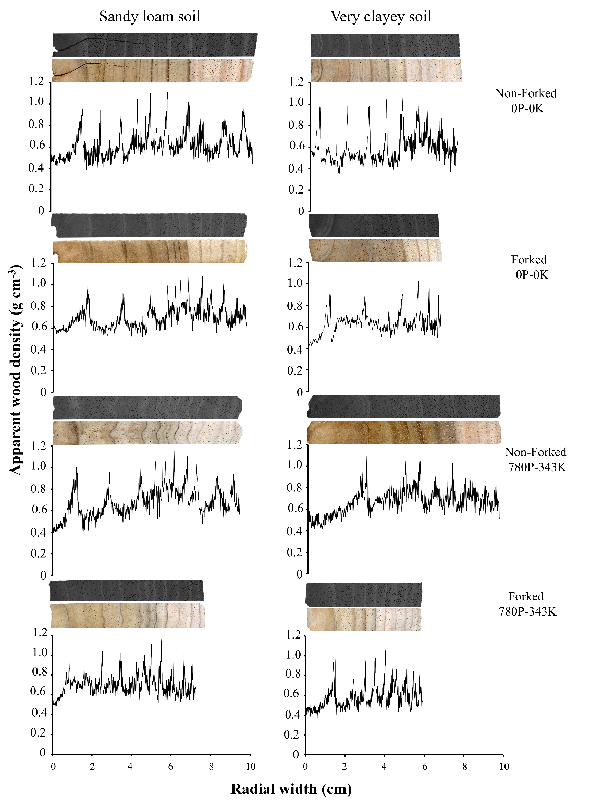

Fig. S2 Growth rings of T. vulgaris trees
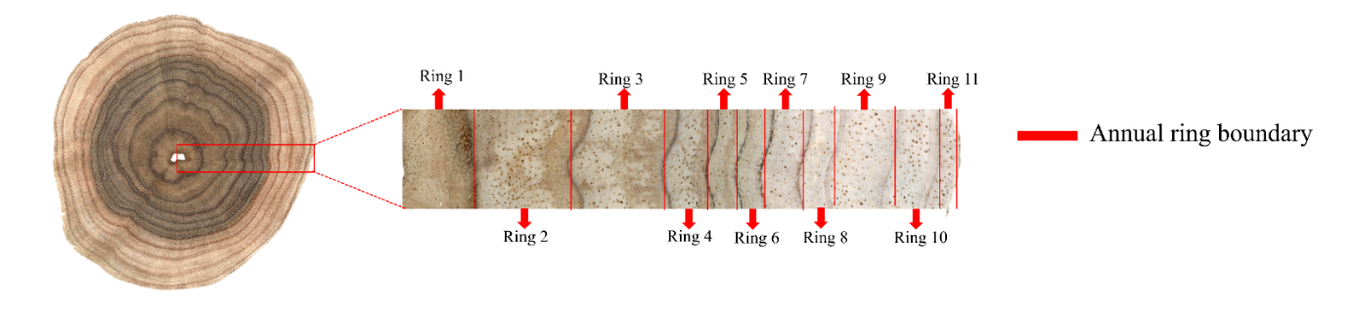
Fig. S3 Diagnostic plots of the linear mixed-effects model fitted for apparent wood density in T. vulgaris, including assessments of linearity, homogeneity of variance, influential observations, multicollinearity (VIF), normality of residuals, and normality of random effects
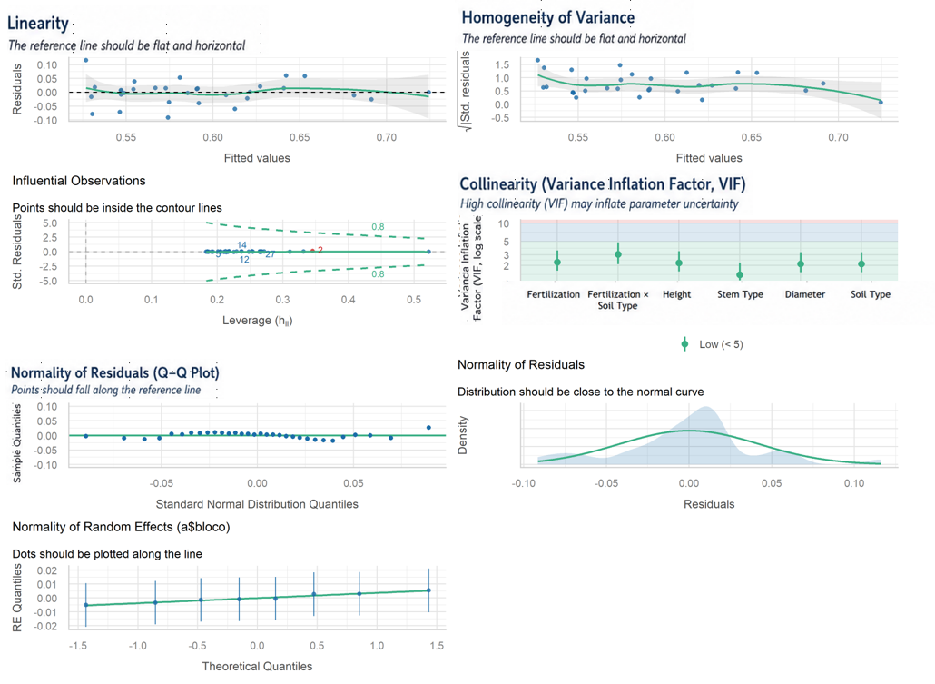

Fig. S4 Relationship between the earlywood-to-latewood width ratio (EW/LW) and cambial age at the DBH position of T. vulgaris trees. Gray circles represent the average values of the experimental groups, whereas black triangles represent the overall mean for each cambial age. The solid line represents the fitted quadratic regression model
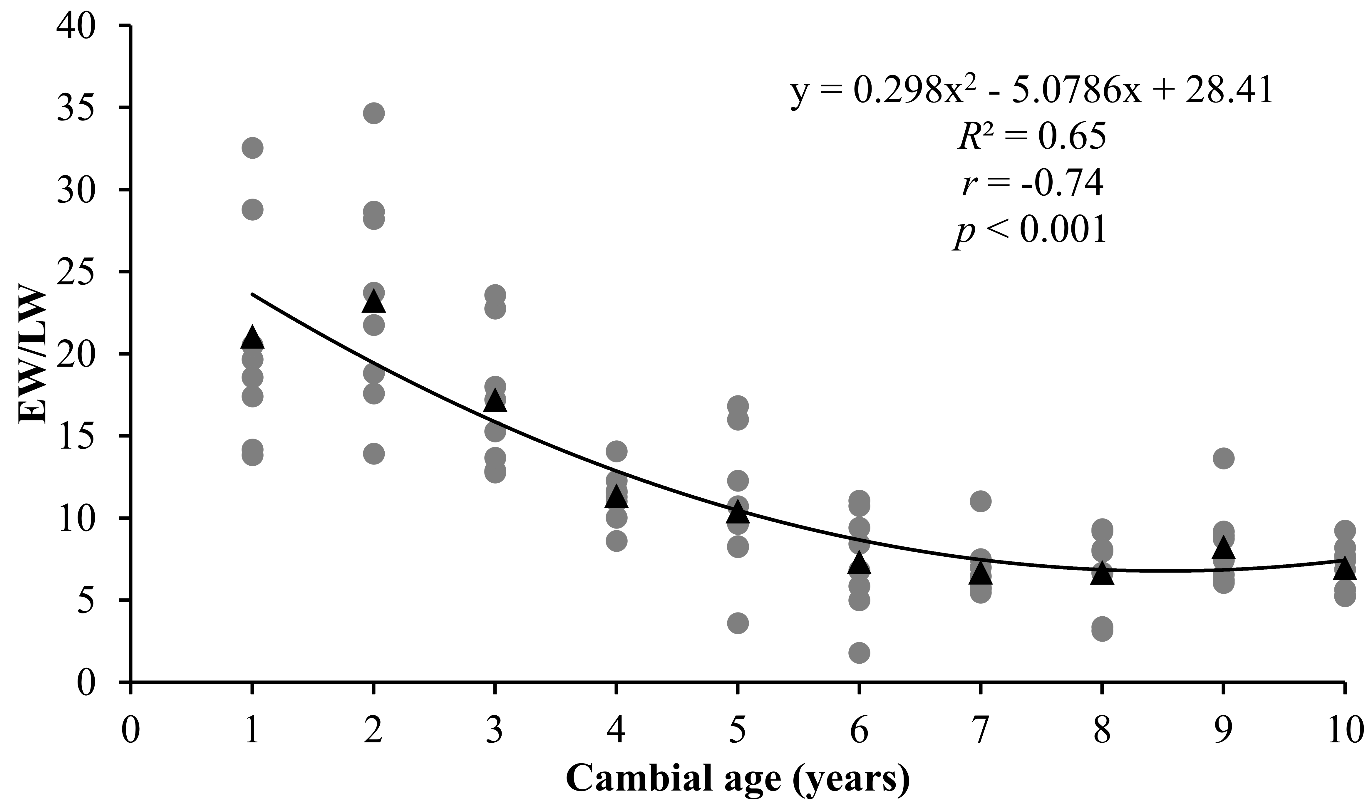

References
Barros-Junior UO, Rosário WAS, Lima MDR, et al (2022) Effects of tree spacing and forking on the modification of wood density in a trial plantation of Tachigali vulgaris for energy in Amazonia. Journal of Tropical Forest Science 34:11–23. https://doi.org/10.26525/jtfs2022.34.1.11
Farias J, Marimon BS, de Carvalho Ramos Silva L, et al (2016) Survival and growth of native Tachigali vulgaris and exotic Eucalyptus urophylla × Eucalyptus grandis trees in degraded soils with biochar amendment in southern Amazonia. For Ecol Manage 368:173–182. https://doi.org/10.1016/j.foreco.2016.03.022
Lima MDR, Moraes LG, Silva R de CC, et al (2023) Tachigali vulgaris energy forests: understanding spacing, age, and stem type effects on tree growth patterns and wood density. New For (Dordr) 54:491–513. https://doi.org/10.1007/s11056-022-09932-y
Moraes LG, Lima MDR, Assis-Pereira G, et al (2023) Forking and planting spacing impacts on wood density, X-ray density, and heartwood proportion of Tachigali vulgaris. Trees - Structure and Function 37:1567–1581. https://doi.org/10.1007/s00468-023-02443-z
Santos EV dos, Lima MDR, Dantas K das GF, et al (2024) The Inorganic Composition of Tachigali vulgaris Wood: Implications for Bioenergy and Nutrient Balances of Planted Forests in the Amazonia. Bioenergy Res 17:114–128. https://doi.org/10.1007/s12155-023-10679-3
Silva MOS, Silva MG, Bufalino L, et al (2021) Variations in productivity and wood properties of Amazonian tachi-branco trees planted at different spacings for bioenergy purposes. J For Res (Harbin) 32:211–224. https://doi.org/10.1007/s11676-019-01068-8
Teixeira RAC, Lima MDR, Silva AR, et al (2023) Dynamics of experimental plantations of Tachigali vulgaris in response to fertilization and soil texture. New For (Dordr). https://doi.org/10.1007/s11056-023-09999-1

